Charlie Seifert

ME 495 – Artificial Life

Lab 1

For this lab, I chose to modify diffmpm_simple.py. The first modification I made was a simple increase in the grid width of the shape, which caused some interesting behavior.

The end of the final simulation as well as the optimization graph are shown below. Note the delamination of the vertical layers of the shape with its now more spread out structure. Also note the spikes in the loss function about halfway through the simulation; these were from when the rectangle found an initial velocity that caused it to quickly delaminate itself and therefore not get very close to the dot.

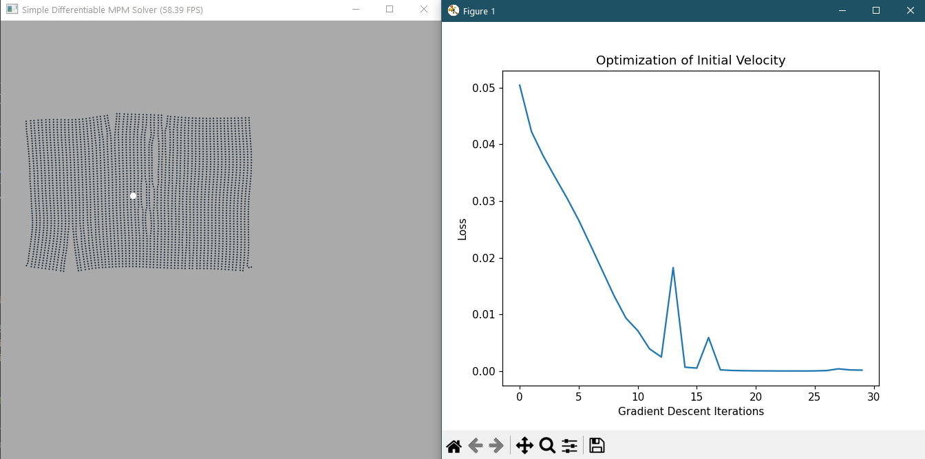

After trying this, I decided to examine the material properties of the object as set up in the simulation parameters to see if I could change this delamination behavior by other means.

To do this, I investigated which simulation parameters would alter the material properties of the particles. ChatGPT indicated that there were four: the elastic modulus (E), Lamé parameters (mu and la), and the particle mass and volume (p_mass and p_vol). I first tried increasing the shear modulus mu to 2*E instead of E, which entirely prevented the delamination from occurring. This was boring, so I changed mu to ½*E instead, and got a far more interesting simulation; the ideal initial velocity that difftaichi ended up finding was quite fast and caused the rectangle to nearly fly apart as it found its way to the target. The result is shown below. (It was also at this point that I decreased the memory available to the program from 1.5 GB to 1 GB, which, to my pleasant surprise, drastically increased the FPS of the simulation; I suppose the graphics card on my computer was probably not being allowed enough memory to actually display the graphics well.)

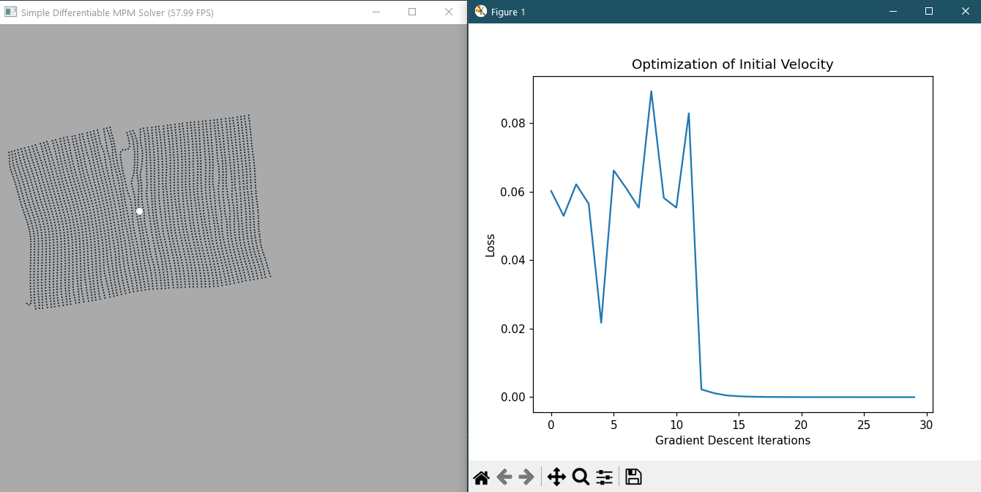

At this point, I decided I would like my final program to produce a simulation result that showed the particles basically entirely tearing themselves apart, but with their center of mass still being close to the target.

The following material parameters ended up yielding a result that was mostly satisfactory:

* E = 50
* mu = 0.2*E
* la = 0.2*E

I also changed the location of the target to [0.7, 0.5] as that seemed to be a better spot to produce fracturing in the material, and lowered the iteration count to 25 to go through more alteration quicker. The final result is shown below; it is nearly torn into two and has several pieces about ready to tear off.

