Artificial Life – Lab 2

Charlie Seifert

I modified diffmpm_simple.py example script to generate a snake with several random parameters:

- Random segment width and particle density

- Random number of segments

- Random appearance of a tail or not

This meant I primarily altered the portions of the code that set up the initial positions of the mpm particles, and I mostly focused on geometry. The topology is simple and mostly snake-like. I tried to work within the framework already set up by the example program, as that performed well on my machine, so it performs quite well. It does not use more memory than the normal example, probably because I modified fields that were already present in the original program instead of adding new fields for each particle, or other such changes that would add computation to a large number of objects.

A photo of one example of a randomly-generated “snake” is shown below.

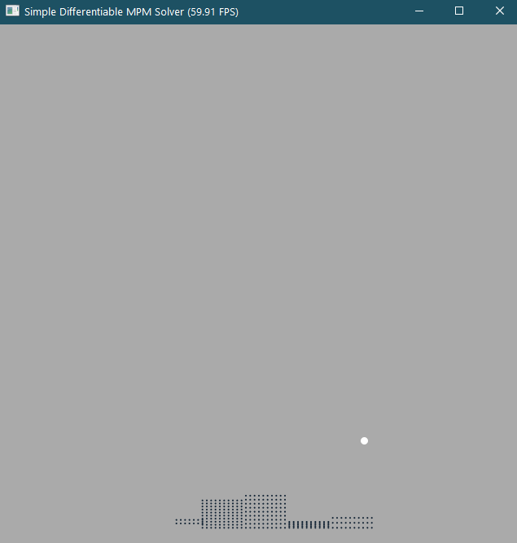

I also modified the position of the target and the origin position of the creature to better match the morphology I had created. It generally had trouble reaching the target, though, and so I think I will have to think more about the strategies the program is using to bring the creature to the target in future labs.