Artificial Life – Lab 4

Charlie Seifert

Link to demo video (for some reason Canvas wouldn’t take it): <https://youtu.be/nraLmzwMekw>

For Lab 4, I switched to diffmpm.py as my base example project and reconfigured the actuators so that they worked as segments on the snake. The initial topology will be randomly generated, and the simulation loop will find the best way within its allotted number of cycles to actuate each segment to move as far to the right as possible.

For the actuation, I mostly took advantage of the example code, which had four “half-legs” already included underneath a passive body rectangle. Each of these was added as a rectangle using a function written in the example code that took in x and y position and then width and height. Therefore, I used these as well as the actuator ID assignment to identify 1 passive head and 4 actuated body segments. A photo of the snake in action is shown below, in its 50th iteration.

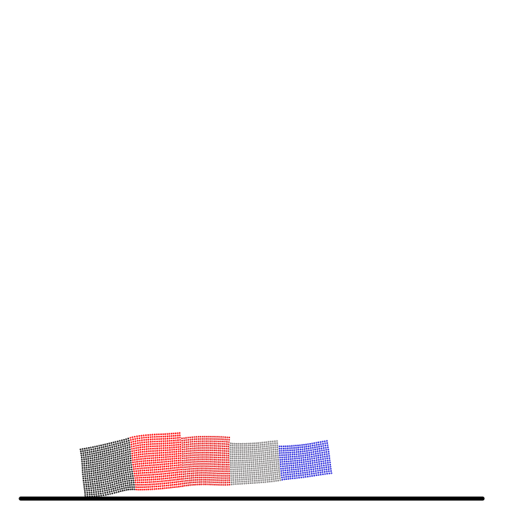

The control demonstrated by my approach is closed-loop, where a gradient descent calculation decides how to actuate the muscles better on the next iteration. The code that performs that calculation using taichi’s built-in functions is shown below.

|  |
| --- |
| @ti.kernel  def compute_actuation(t: ti.i32):      for i in range(n_actuators):          act = 0.0          for j in ti.static(range(n_sin_waves)):              act += weights[i, j] * ti.sin(actuation_omega * t * dt +                                            2 * math.pi / n_sin_waves * j)          act += bias[i]          actuation[t, i] = ti.tanh(act) |

As shown in the code, sinusoidal functions are applied to the actuators with different weights (amplitude scale factor) and frequencies. These parameters are what are tuned by the gradient descent control feedback. The outcome of this procedure is a snake that gradually learns to move further and further to the right, as shown in the decreasing loss function in the graph below, where iteration is on the x-axis.

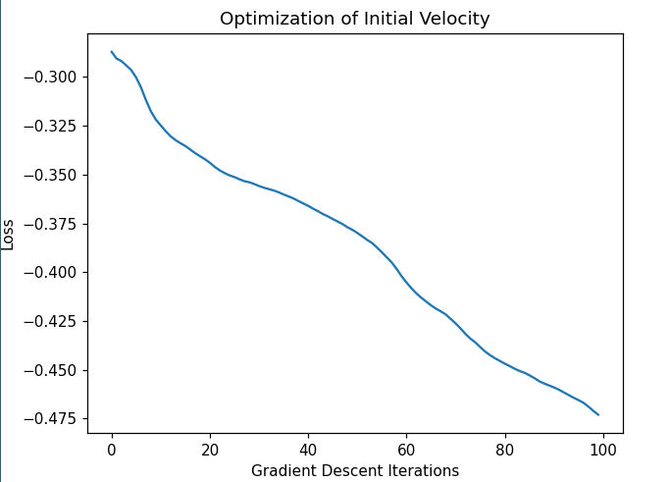

My main challenge was properly setting up the body of the snake to begin with a random shape. There were a few particularities with how taichi preferred its fields, so I had to work within that, which was a useful thing to know.