Open GitHUB Desktop and sign in:

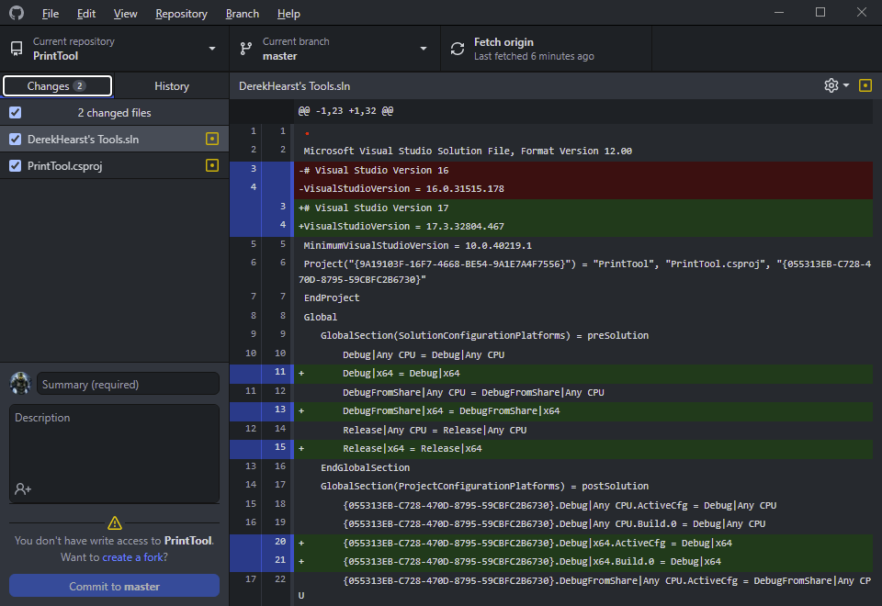

Clone Dereks print tool repo:

<https://github.com/derekhearst/printtool>

Destination is: C:\Users\croslinr\Documents\GitHub\printtool

Then launch VS 2022 Community IDE and open the Solutions file.

Ensure the Solutions Explorer is visible:

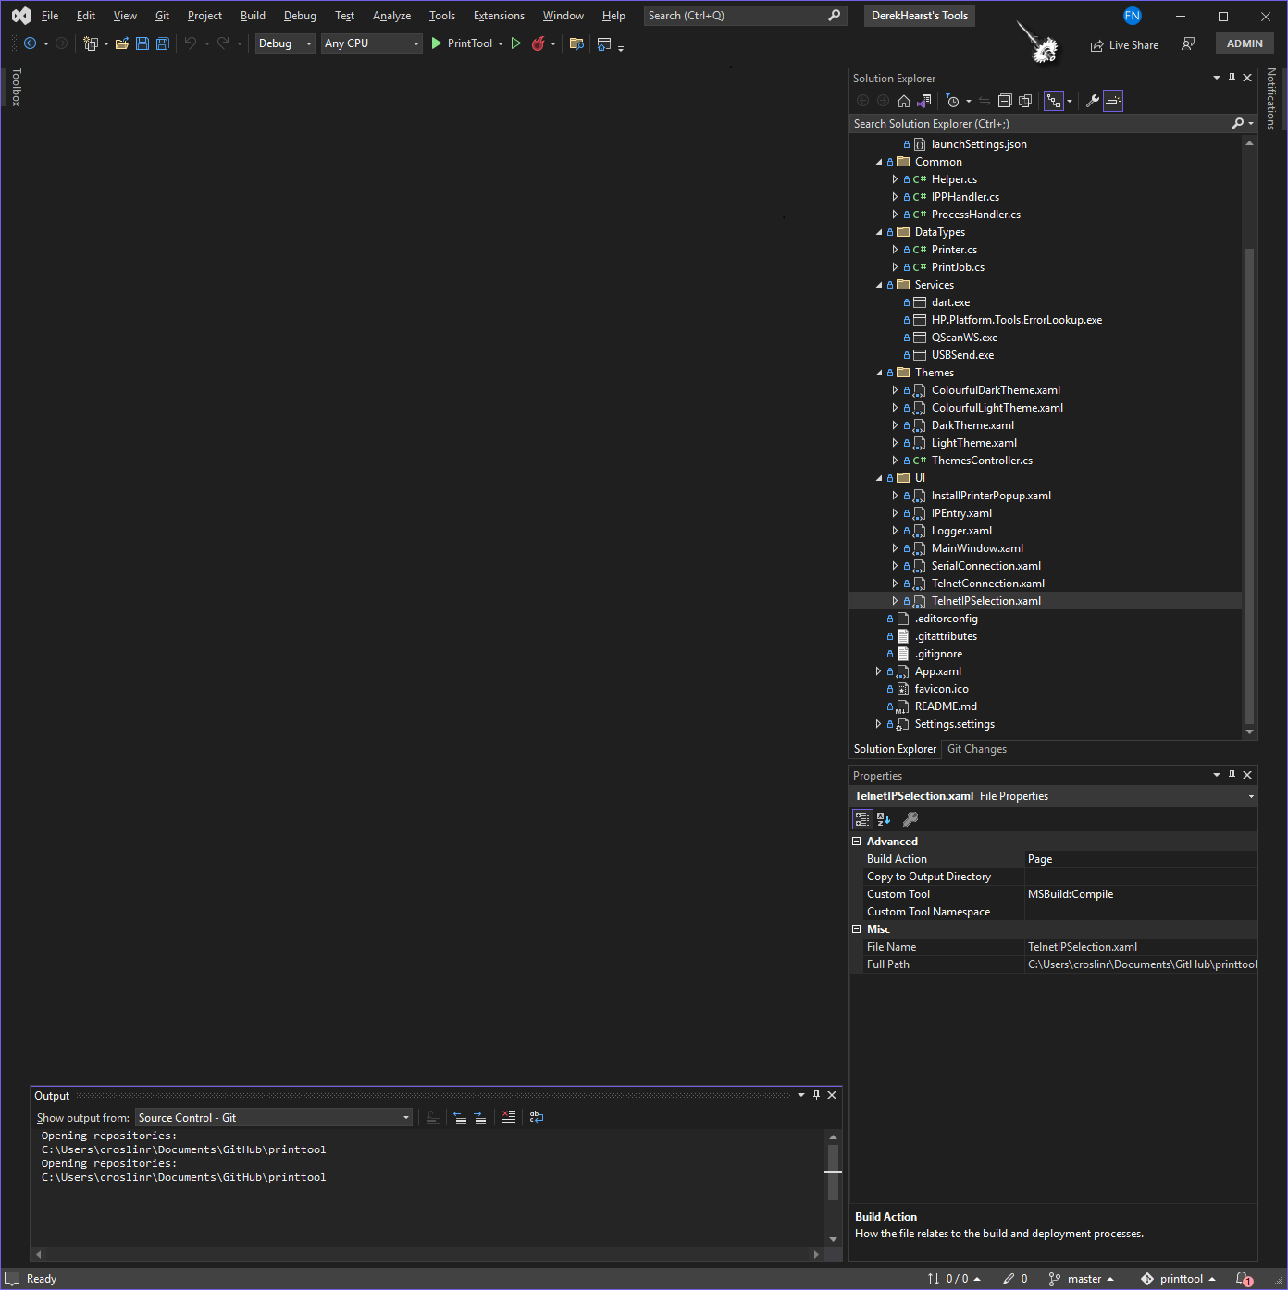

Set DEBUG and ANY CPU accordingly: x64 is needed for PrintTool

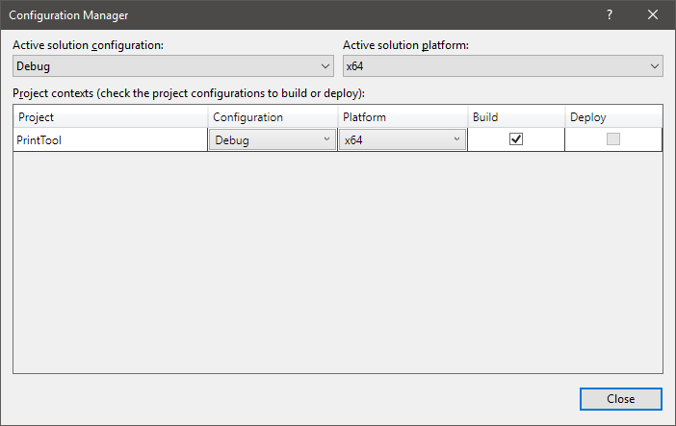

Select the GREEN Arrow on the PRINTTOOL drop down menu to build:

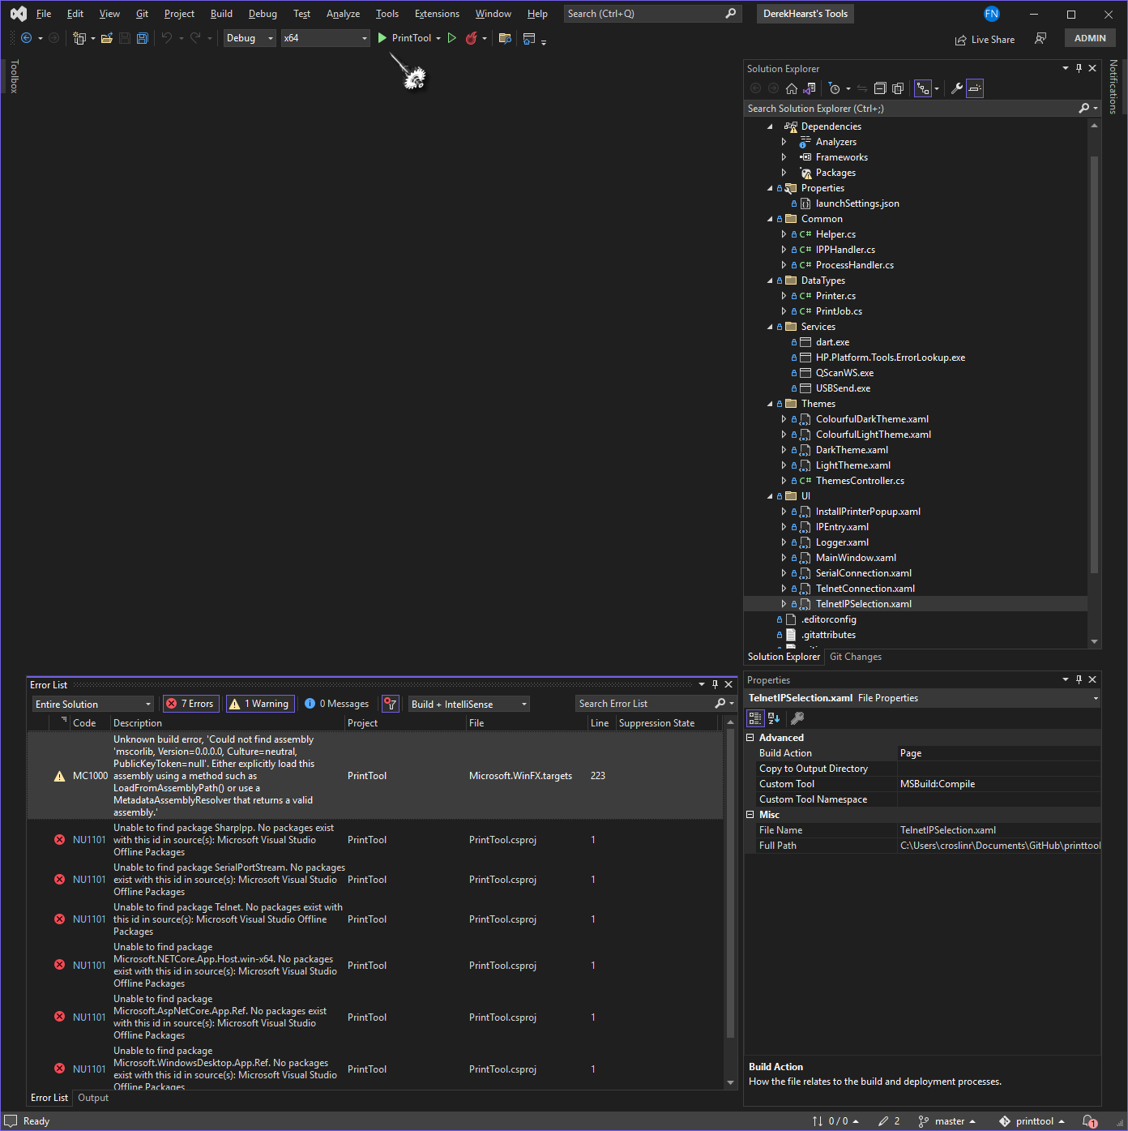

There may be errors seen:

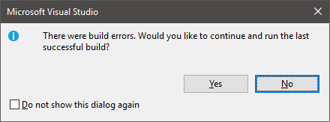

Review the Error List for items that should be resolved:



Make sure the following NuGet Package Manager is configured as seen here:

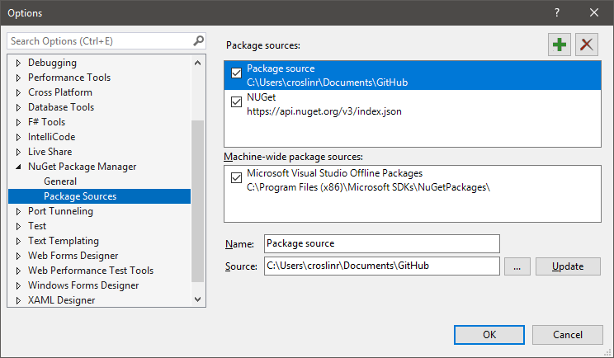

https://api.nuget.org/v3/index.json

Installed Packages should be seen here:

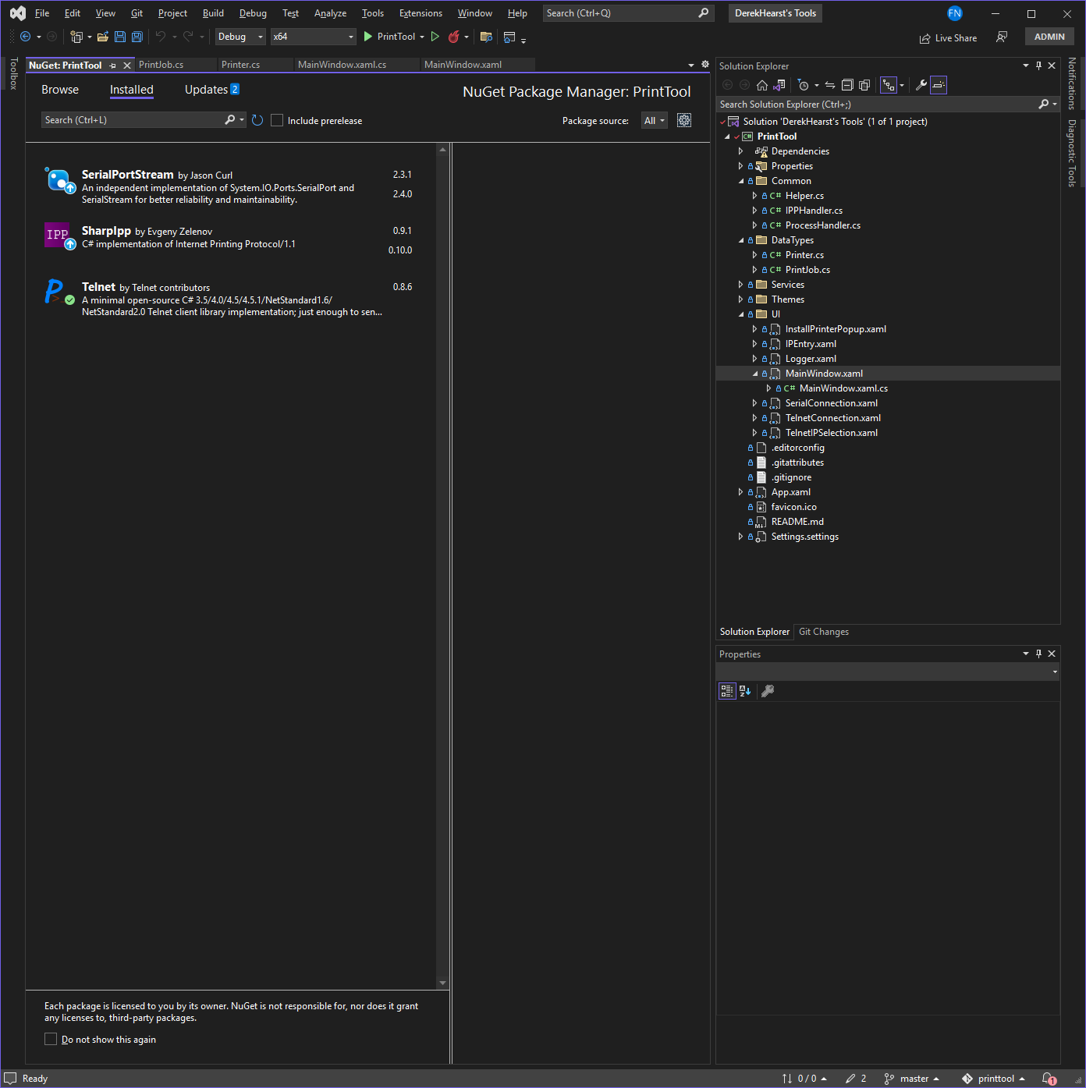

Select GREEN arrow next to PrintTool and the build should now succeed:

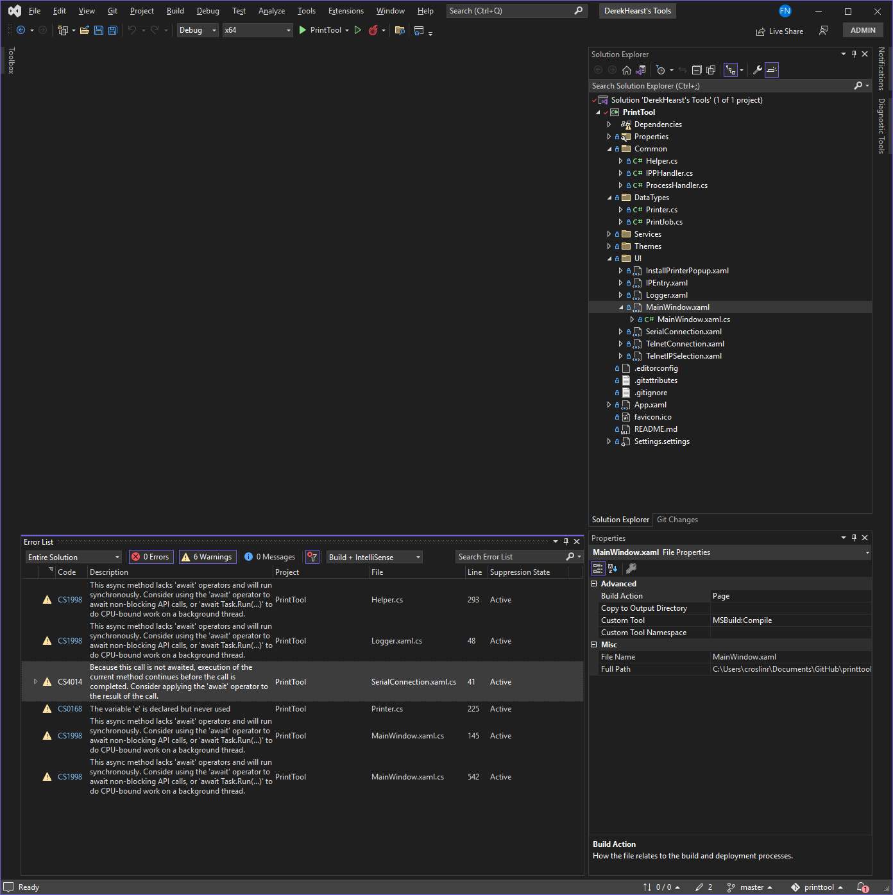

The PrintTool program should run and appear on the screen: