Using MDK

1. Load File

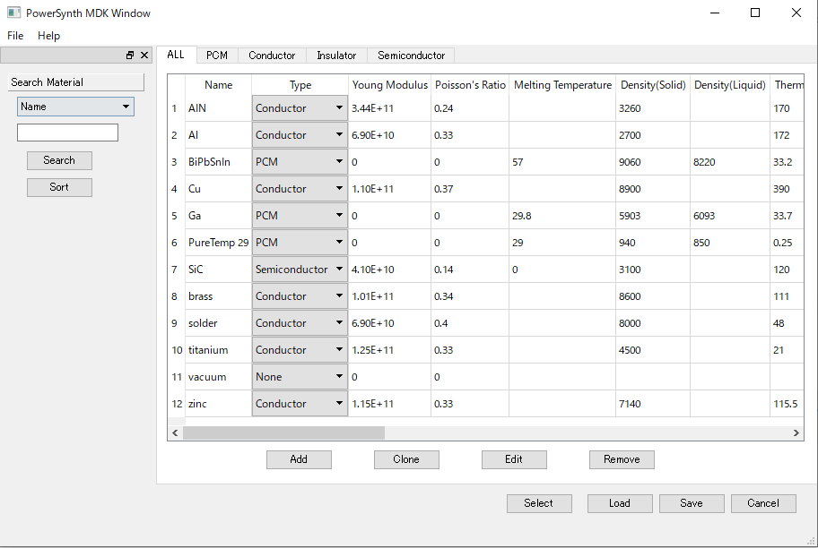Material window shows blank table. The user

can load the Materials.csv file and show it to

the table with clicking “Load” button.

1. Modify Materials
   1. 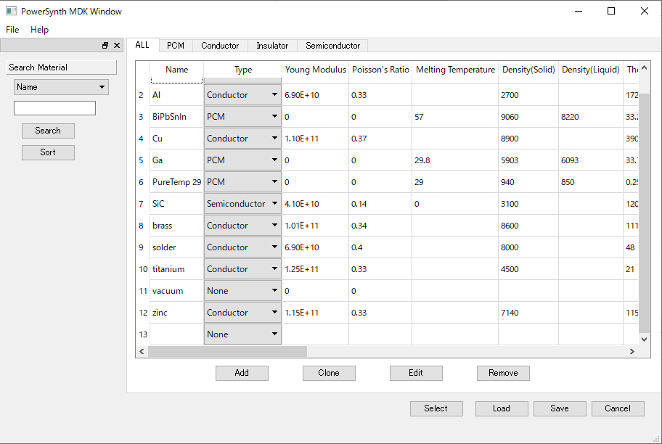Add Material

The user can add a material by clicking “Add”

button. After click the button, blank line is

shown in the end of the table.

Ex) Right figure shows blank line is shown bottom.ur

* 1. Clone Material

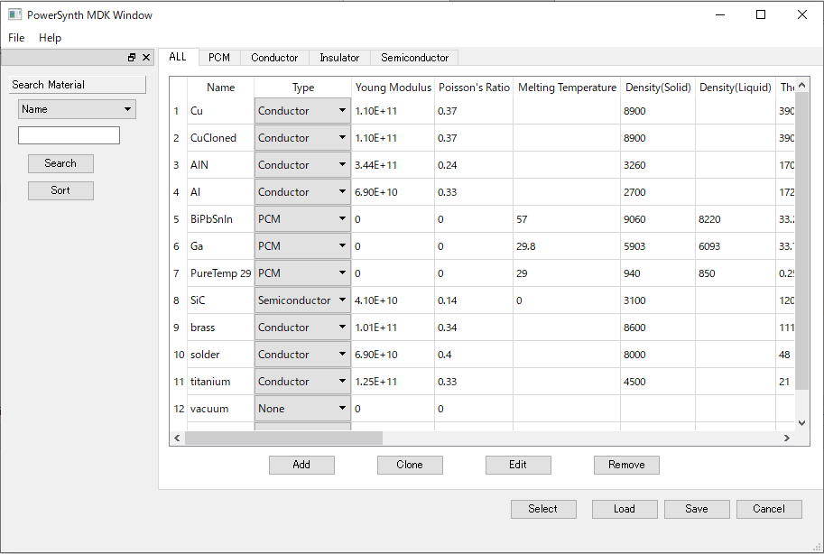Clone creates a material which has the same value

of the base material. The user can create clone by

click the name of the material and click “Clone”

button. Chosen material and cloned material are

shown top of the table.

Note: Cloned material’s name is shown *nameCloned.*

Ex) Right figure shows base material (Cu) and cloned

material (CuCloned)

* 1. 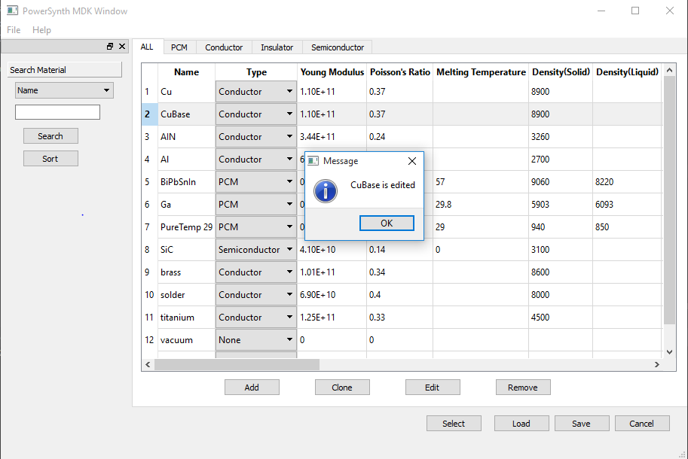Edit Material

Edit makes it possible for the user to change values of

materials. Initially, click specific cell the user wants to

change, and modify the values. Then, click name of

material which the user modified, and click “Edit”

button. If the user implements other function before

clicking “Edit”, the modified values are deleted.

Note: Modified values are not saved to csv file until the user save library.

Ex) Right figure shows CuCloned is changed to CuBase

* 1. 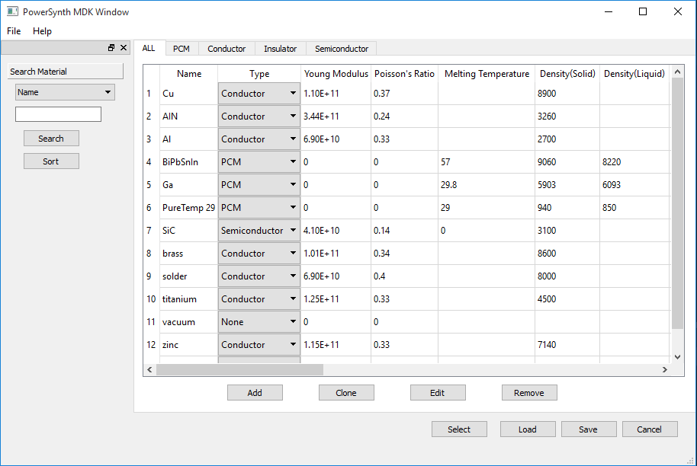Remove Material

The user can remove material by clicking the material

and clicking “Remove” button. The table is updated,

and the material is deleted.

Ex) Right figure shows CuBase material is removed.

1. 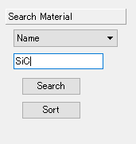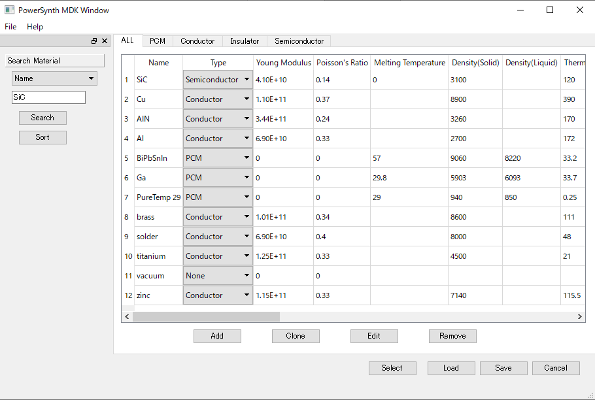Search/Sort Material

If the user wants to find specific

material or search some materials,

Search/Sort are useful. Search find

specific material from all materials.

Initially, choose a field of material.

Then, type value of the material.

If there exists a material which matches to typed value, the material is shown on the top of the table.

If the user want to sort material, Sort is useful. If click “Sort” button, materials are shown based on the name order.

1. 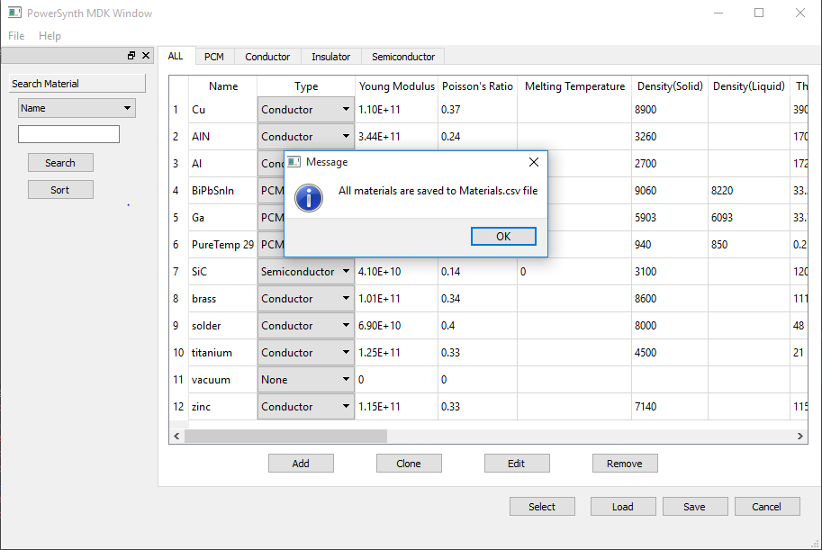Save File

Save can save materials’ information from the table to

Materials.csv file. If click “Save” button, all values are

saved to the file.

Note: If the user close window before click the save

button, all modified values are not kept. DO NOT click

“Save” button before loading file. It deletes all materials from the main file

1. Import/Export

Import can load the user’s file to the table. Click File >> Import, and “Select Open File” pop up. Then, choose file and click “open”, file is loaded to the table. After importing file, previous materials are not shown on table, only materials of importing file are shown.

Ex) TestFile is chosen, and that file is opened and shows on the table

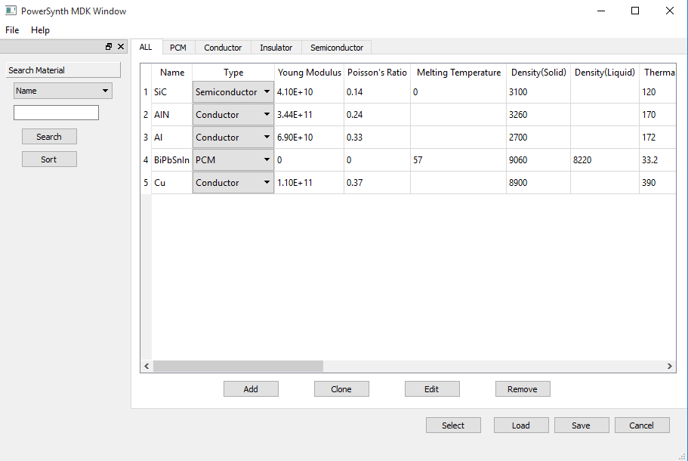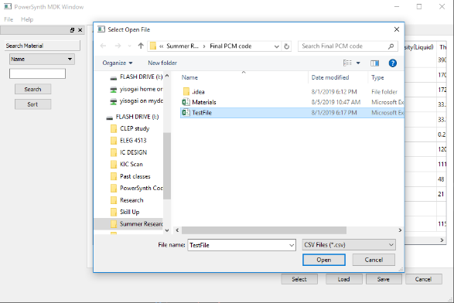

Export makes it possible for the user to save all materials’ information to the user’s file. Click File >> Export, and “Select Save File” pop up. Then, choose specific file or create file which the user wants to save.

Ex) Below shows that Save file is created, and materials are saved correctly.

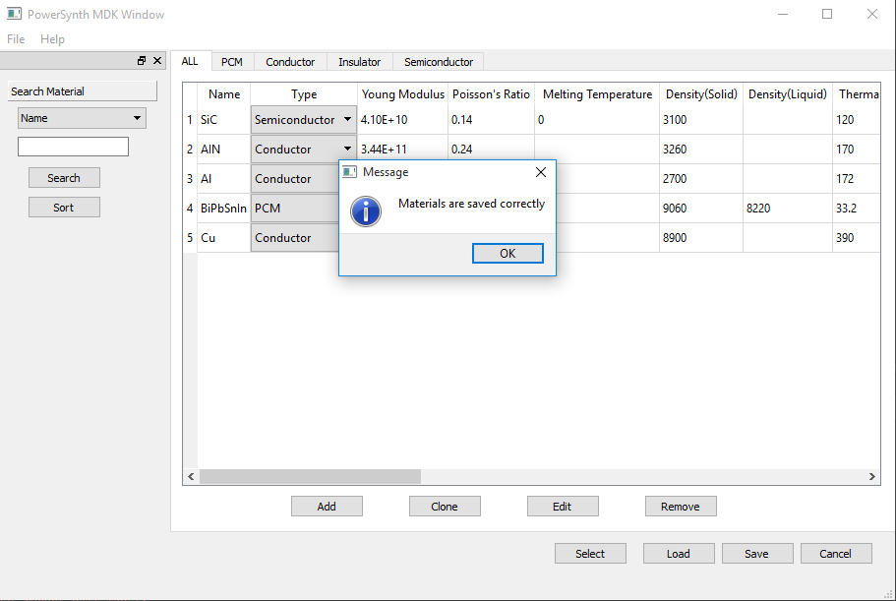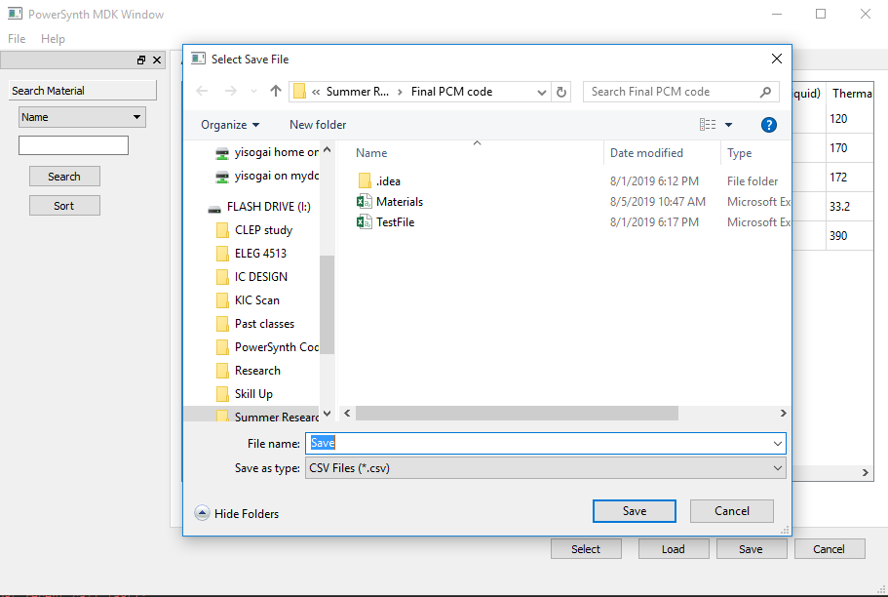

1. 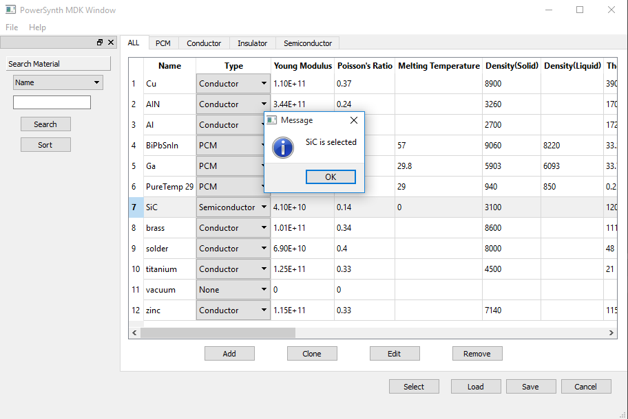Select Material

Select makes it possible for the user to get one material

information. Click name of the material, and click “Select”

button. Then, selected material’s information is returned.

Right figure shows SiC is selected.