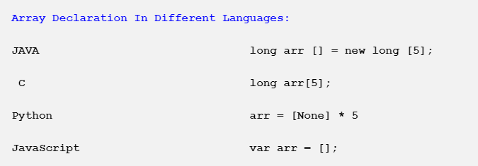

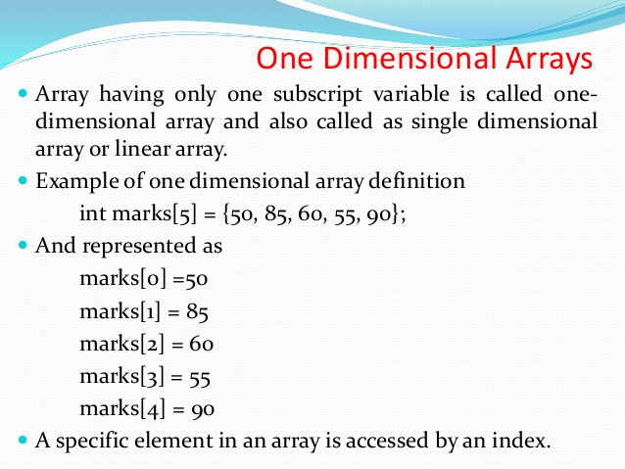

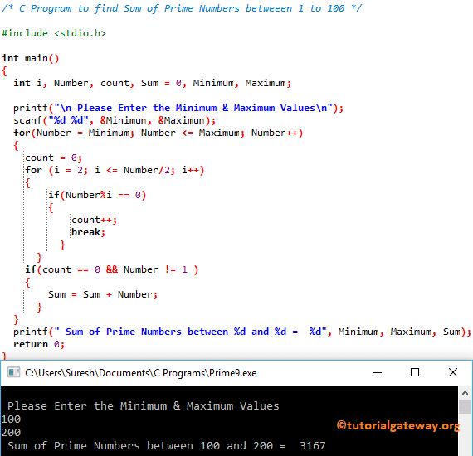

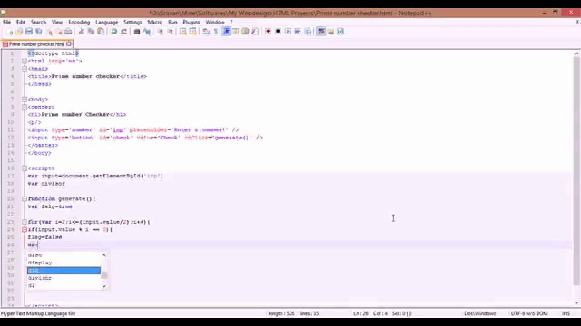

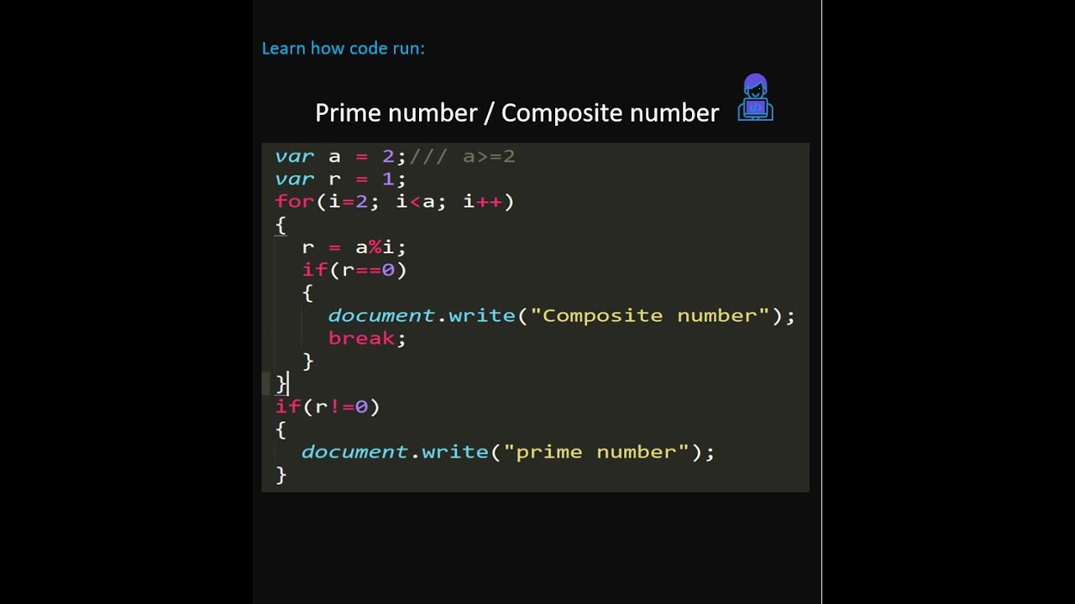

<!DOCTYPE html>

<html>

<head>

<title>Grade Calculation</title>

<style>

input{

display: block;

}

</style>

</head>

<body>

Bangla <input type="text" id ="bangla">

English <input type="text" id ="english">

Math <input type="text" id ="math">

Islamic Studies <input type="text" id ="islamic">

<input type="button" onclick="calResult()" value="Calculate Result"/>

<input type="button" onclick="resetAll()" value="resest"/>

<script>

function calResult(){

var result = "";

var bangla =parseFloat( document.getElementById('bangla').value);

var english = parseFloat(document.getElementById('english').value);

var math = parseFloat(document.getElementById('math').value);

var islamic =parseFloat( document.getElementById('islamic').value);

if(bangla<33 || english <33 || math <33 || islamic < 33){

result = "failed";

}else {

var total = bangla+ english+ math + islamic;

var avg = total/4;

console.log(avg);

////

if(avg >= 80){

result = "A+";

}else if(avg <=79 && avg >69 ){

result = "A-";

}else if(avg <=69 && avg >59 ){

result = "B";

}else if(avg <=59 && avg >49 ){

result = "C";

}else if(avg <=49 && avg >39 ){

result = "D";

}

}

alert(result);

}

function resetAll(){

document.getElementById('bangla').value="";

document.getElementById('english').value="";

document.getElementById('math').value="";

document.getElementById('islamic').value="";

}

</script>

</body>

</html>