Convex

Optimization

ANSWERS FOR CODING ASSIGNMENT

Submitted By

Rahul Madhavan

Student, MTech AI

Contents

Helpers 3

Remarks 5

1. Solving Norm as LPs 6

Method 6

Implementation Notes 6

Outputs 7

I1. Least Squares Fitting 10

Implementation Notes 10

Challenges 10

OUTPUTS 11

Remarks 12

Results with old values 13

III SVM Fitting 20

Remarks 20

Challenges 20

*Part 1 Proof of Correctness* 21

Accuracies using Gaussian Kernels 30

Question 4 32

Remarks 32

Results 32

*Part 2* 32

Question 5 34

Challenges 34

Part 1 – Prove that the max-cut problem can be expressed as an SDP 35

Answer – part 2 38

Results Part 2 38

Answers Part 3 40

Results Part 3 41

Problem 6 43

Remarks 43

Answers 43

Results 45

*Part 2 Results* 45

Packages Required to run 47

Additional Details 47

Colab Details 47

Github Details 47

APPENDIX 48

# Helpers

Throughout all the files, we make use of certain helper functions. At the outset, we detail them for ease of programming notation later

1. **Utilities.py**

import numpy as np  
  
def L1Norm(vector):  
 return np.sum(np.abs(vector))  
  
def LInfNorm(vector):  
 return np.max(np.abs(vector))  
  
def sumSquares(vector):  
 return np.sum(np.square(vector))  
  
def L2Norm(vector):  
 return np.sqrt(sumSquares(vector))

1. **randomMatrix.py**

import numpy as np  
import numpy.random as random  
  
  
def generateUniformRandomMatrices(rows, columns, lo=-1, hi=1):  
 return random.uniform(lo, hi, (rows, columns))  
  
  
def generateStdNormalRandomMatrices(rows, columns):  
 return random.randn(rows, columns)  
  
  
def sparseRandomNormalMatrix(rows, columns, density):  
 A = generateStdNormalRandomMatrices(rows, columns)  
 sparseA = A.copy()  
 for i in range(rows):  
 for j in range(columns):  
 r = random.uniform(0, 1)  
 if (r > density):  
 sparseA[i, j] = 0  
 return sparseA  
  
  
def gendata_lasso(m=500, n=2500, noise=0, option=1):  
 # function to generate test data for lasso  
 # Input: m: no. of observations  
 # n: no. of features  
 # noise: standard deviation  
 # option: 0: no noise  
 # 1: noise added by gaussian distribution  
 # 2: noise added as an outlier (selecting any 1 of the  
 # observations)  
 ##  
 x0 = sparseRandomNormalMatrix(n, 1, 0.05)  
 A = generateStdNormalRandomMatrices(m, n)  
 # normalize columns  
 ANormalizer = np.square(A)  
 ANormalizer = np.sum(ANormalizer, axis=0)  
 ANormalizer = np.sqrt(ANormalizer)  
 ANormalizer = 1 / ANormalizer  
 A = A.dot(np.diag(ANormalizer))  
  
 v = np.sqrt(0.001) * generateStdNormalRandomMatrices(m, 1)  
 b = A.dot(x0) + v  
  
 if option == 1:  
 b = b + noise * random.rand(b.shape[0], b.shape[1])  
 return A, b  
  
 if option == 2:  
 randomRow = random.randint(m)  
 b[randomRow] = b[randomRow] + noise * random.uniform(0, 1)  
 return A, b  
  
 return A, b  
  
  
def generateLowRank(m, n, rank):  
 randomMatrix = np.random.rand(m, n)  
 U, Diag, V = np.linalg.svd(randomMatrix)  
 Diag[rank:] = Diag[rank:] * 0  
 out = (U @ np.diag(Diag)) @ V  
 return out  
  
  
def rgg(num_vertices=5, lo=1, hi=10, density=0.5):  
 if num_vertices <= 0:  
 print("No. of vertices must be positive")  
 return  
  
 Weight = lo + (hi - lo + 1) * generateUniformRandomMatrices(num_vertices, num_vertices, lo=0, hi=1)  
 Weight = 0.5 * (Weight + Weight.T)  
  
 probMat = generateUniformRandomMatrices(num_vertices, num_vertices, lo=0, hi=1)  
 Connectivity = probMat >= density  
 Connectivity = np.triu(Connectivity, 1)  
 Connectivity = Connectivity + Connectivity.T  
 adjacencyMatrix = np.multiply(Connectivity, Weight)  
 return adjacencyMatrix  
  
  
def generateCompleteBipartite(k1, k2):  
 numNodes = k1 + k2  
 list_of_nodes = list(range(numNodes))  
 np.random.shuffle(list_of_nodes)  
 first_part = list_of_nodes[:k1]  
 second_part = list_of_nodes[k1:]  
 out = np.zeros((numNodes, numNodes))  
 for f in first_part:  
 for s in second_part:  
 out[f, s] = 1  
 out[s, f] = 1  
 return out  
  
  
def svm_gendata(Np, Nn,distance):  
 Xp = np.array([[2, -1], [2, 1]]) / np.sqrt(2) @ random.randn(2, Np)  
 Xp[0, :] = Xp[0, :] + distance  
 yp = np.ones(Np)  
  
 Xn = np.array([[2, -1], [2, 1]]) / np.sqrt(2) @ random.randn(2, Nn)  
 Xn[0, :] = Xn[0, :] - distance  
  
 yn = - np.ones(Nn)  
  
 X = np.hstack((Xp, Xn))  
 y = np.hstack((yp, yn))  
  
 return X, y  
  
def svm_gendata2(Np, Nn,distance):  
 Xp = np.array([[2, -1], [2, 1]]) / np.sqrt(2) @ random.randn(2, Np)  
 Xp[0, :] = Xp[0, :] + distance  
 Xp[1, :] = Xp[1, :] - distance  
 yp = np.ones(Np)  
  
 Xn = np.array([[2, -1], [2, 1]]) / np.sqrt(2) @ random.randn(2, Nn)  
 Xn[0, :] = Xn[0, :] - distance  
 Xn[1, :] = Xn[1, :] + distance  
  
 yn = - np.ones(Nn)  
  
 X = np.hstack((Xp, Xn))  
 y = np.hstack((yp, yn))  
  
 return X, y

## Remarks

1. Notice that we have recreated ALL the Matlab functions again in Python for convenience of use. This enabled the user to fully tweak the functions as per requirement
2. We have also created wrappers for several numpy functions so that we can change the default values of the original functions as per our requirements
3. Many of the functions have been optimized for speed of use. Generally, one may think of a call to a vector generator as being O(n) and matrix generator as O(n2), but the constants are very low as memory access is in constant time of nanoseconds.

# 1. Solving Norm as LPs

## Method

Since this was the first Question, I tried using CVXOPT. While many of the features are quite good in CVXOPT, it is overall not as suitable for the assignment as CVXPY. So this is the only part of the assignment that has been done using CVXOPT, and the rest of the assignment often uses CVXPY with CVXOPT or MOSEK used as the solver

## Implementation Notes

PART 1

# https://math.stackexchange.com/questions/1639716/how-can-l-1-norm-minimization-with-linear-equality-constraints-basis-pu  
We formulate the LP as minimize

sum(t_i) for |A_ix - b_i| \leq t_i

or in other words

minimize sum(t_i) for (A_ix - b_i) \leq t_i and (A_ix - b_i) \geq -t_i

Which can be written as

minimize 1.T.dot(t) for (A_ix - b_i) \leq t_i and (A_ix - b_i) \geq -t_i

OR minimize 0.T.dot(x) + 1.T.dot(t)  
such that  
(A_i x - t_i) \leq +b_i  
\forall i in [n]  
and  
-(A_ix + t_i) \leq -b_i  
and  
-t_i < 0  
\forall i in [n], where x \in R^r, t in R^n

#  
OR

minimize 0.T.dot(x) + 1.T.dot(t)  
such that  
(A x - I t) \leq b  
and  
-Ax - I t \leq -b  
and  
0x - I t \leq 0

PART 1I

In the above formulation, instead of a vector t, we can just use a scalar t  
Then we write

minimize t  
such that  
(A_ix - b_i) \leq t  
and  
(A_ix - b_i) \geq -t  
and  
t \geq 0

The problem can be restated as

minimize t  
such that  
(A_ix - t) \leq b_i  
and  
(-A_ix - t) \leq -b_i

OR

minimize 0.dot(x) + t  
such that  
(Ax - t1) \leq b  
and  
(-Ax - t1) \leq -b

## Outputs

pcost dcost gap pres dres k/t  
 0: 0.0000e+00 1.1102e-16 4e+02 4e+00 1e-16 1e+00  
 1: 4.4132e+01 4.4134e+01 7e+01 6e-01 6e-16 2e-01  
 2: 7.8640e+01 7.8641e+01 2e+01 2e-01 4e-15 4e-02  
 3: 8.5193e+01 8.5193e+01 6e+00 5e-02 5e-15 1e-02  
 4: 8.7495e+01 8.7496e+01 2e+00 2e-02 5e-15 5e-03  
 5: 8.8207e+01 8.8207e+01 7e-01 6e-03 9e-15 2e-03  
 6: 8.8471e+01 8.8471e+01 1e-01 1e-03 4e-15 3e-04  
 7: 8.8515e+01 8.8515e+01 3e-02 3e-04 4e-15 9e-05  
 8: 8.8527e+01 8.8527e+01 1e-02 9e-05 3e-14 3e-05  
 9: 8.8531e+01 8.8531e+01 5e-04 4e-06 3e-14 1e-06  
10: 8.8531e+01 8.8531e+01 5e-06 4e-08 3e-14 1e-08  
Optimal solution found.  
  
-------------------------------------------------------------------------------------------------------  
  
Results for l1Norm though LP  
  
-------------------------------------------------------------------------------------------------------  
  
x= [-0.15145901 -0.04173573 -0.04512145 0.05624462 -0.07281424 0.26913976  
 0.08056713 -0.03613971 0.00596245 0.15144689]  
  
---------------------------  
  
A.dot(x) - b = [-1.21967741 -0.25450525 -0.12747449 ... 0.55274729 0.43633053  
 0.21275996]  
L1Norm(A.dot(x)-b) = 88.5313506065077  
LInfNorm(A.dot(x)-b) = 1.3605621194599204  
L2Norm(A.dot(x)-b) = 7.746547475037685  
  
-------------------------------------------------------------------------------------------------------  
  
  
-------------------------------------------------------------------------------------------------------  
  
Results for l1Norm though CVXPY  
  
-------------------------------------------------------------------------------------------------------  
  
x= [-0.15145901 -0.04173573 -0.04512145 0.05624462 -0.07281424 0.26913976  
 0.08056713 -0.03613971 0.00596245 0.15144689]  
  
---------------------------  
  
A.dot(x) - b = [-1.21967741 -0.25450525 -0.12747449 ... 0.55274729 0.43633053  
 0.21275996]  
L1Norm(A.dot(x)-b) = 88.53135060650769  
LInfNorm(A.dot(x)-b) = 1.36056211945992  
L2Norm(A.dot(x)-b) = 7.746547475037685  
  
-------------------------------------------------------------------------------------------------------  
  
 pcost dcost gap pres dres k/t  
 0: -3.2027e-18 4.7705e-18 2e+00 4e+00 4e-16 1e+00  
 1: 2.9759e-01 2.1593e-01 9e-01 1e+00 2e-16 3e-01  
 2: 4.8084e-01 3.5245e-01 9e-01 1e+00 2e-16 2e-01  
 3: 8.4660e-01 7.8297e-01 2e-01 3e-01 2e-16 2e-02  
 4: 8.9946e-01 8.7107e-01 9e-02 1e-01 6e-16 2e-03  
 5: 9.2863e-01 9.1791e-01 3e-02 4e-02 7e-16 6e-04  
 6: 9.4017e-01 9.3631e-01 1e-02 2e-02 1e-15 2e-04  
 7: 9.4546e-01 9.4468e-01 2e-03 3e-03 2e-15 2e-05  
 8: 9.4632e-01 9.4601e-01 1e-03 1e-03 1e-14 6e-06  
 9: 9.4687e-01 9.4684e-01 1e-04 1e-04 2e-14 6e-07  
10: 9.4692e-01 9.4692e-01 9e-06 1e-05 5e-15 4e-08  
11: 9.4693e-01 9.4693e-01 9e-08 1e-07 1e-14 4e-10  
12: 9.4693e-01 9.4693e-01 9e-10 1e-09 1e-14 4e-12  
Optimal solution found.  
  
-------------------------------------------------------------------------------------------------------  
  
Results for lInfNorm though LP  
  
-------------------------------------------------------------------------------------------------------  
  
x= [-0.07646696 -0.02833069 -0.08875803 -0.04566501 0.00828258 -0.01264084  
 -0.02596891 -0.03976349 -0.01617378 0.00940567]  
  
---------------------------  
  
A.dot(x) - b = [-0.93695265 -0.12128035 -0.13647516 ... 0.75428597 0.46370047  
 0.0471121 ]  
L1Norm(A.dot(x)-b) = 92.6214422686107  
LInfNorm(A.dot(x)-b) = 0.9469281769410074  
L2Norm(A.dot(x)-b) = 7.728424484060358  
  
-------------------------------------------------------------------------------------------------------  
  
  
-------------------------------------------------------------------------------------------------------  
  
Results for lInfNorm though CVXPY  
  
-------------------------------------------------------------------------------------------------------  
  
x= [-0.07646696 -0.02833069 -0.08875803 -0.04566501 0.00828258 -0.01264084  
 -0.02596891 -0.03976349 -0.01617378 0.00940567]  
  
---------------------------  
  
A.dot(x) - b = [-0.93695265 -0.12128035 -0.13647516 ... 0.75428597 0.46370047  
 0.0471121 ]  
L1Norm(A.dot(x)-b) = 92.6214422686107  
LInfNorm(A.dot(x)-b) = 0.9469281769410074  
L2Norm(A.dot(x)-b) = 7.728424484060359  
  
-------------------------------------------------------------------------------------------------------  
  
Solutions for the two methods for both L-Inf norma nd L-1 Norm are exactly the same

# I1. Least Squares Fitting

## Implementation Notes

This was one of the hardest questions in the assignment as there were several parts to this question.

## Challenges

The main challenge for the first part was that there was no direct means to access the iteration counter. To get through this challenge, I wrote a simple text parser as below

def getIterationErrors(problem, tempFile, column):  
 originalOut = sys.stdout  
 sys.stdout = open(tempFile, "w")  
 a = problem.solve(verbose=True)  
 sys.stdout.close()  
 sys.stdout = originalOut  
 f = open(tempFile, "r")  
 linenum = 0  
 iterationErrors = []  
 for line in f:  
 linenum += 1  
 if linenum < 5:  
 continue  
 if line == "**\n**":  
 break  
 cols = line.split(" ")  
  
 iterationErrors.append(float(cols[column]))  
 return iterationErrors

This pipes the output from the function from STDOUT into a file. From here, we can simply do a linewise parsing to obtain the column number required. In our case, we require the objective value in the second question and the error of the primal problem in the third question. We are able to get both, programmatically due to this simple parser.

## OUTPUTS

Part 1

### Remarks

We notice that the above graphs show that the objective value for L1 is the largest. We shouldn’t let this fool us into thinking that L1Norm doesn’t work well. In fact it is the best alternative of the chosen methods. This is because the L1Norm tends to be the highest norm that the objective value is going slightly higher.

Otherwise all of the methods give the same value for the least squares part

Part 2

Here we see that the limits given in the question are extremely constraining, and thus we will expand the limits to see much better results.

### Results with old values

Actuals: L1 Regularizer

Vs Log Scale: L1 Regularizer

As one can notice, the above curves are extremely jagged especially for L1 norm regularization. **This called for further investigation** as the curve did not make too much sense

Therefore we plot a much wider range of lambda values below which gives good results

Notice in the above graph how nicely we see the various coordinates going to zero. These actually go to zero much below the lowest earlier value investigated, that is 5.

Notice that our objective function for L2 norm goes to zero as early as around 2.25 and for L1 norm at around 0.1

We plot the norm plus regularizer to see the results more clearly. The inflection in our data was at around 2.25 lambda value

Similarly, the inflection point for L1 is seen at around 0.1

Part 3

We now plot the RMSE values vs sigma for various values of sigma chosen. Note that we use lambda = 0.1 for L1 Reg and lambda = 2.25 for L2 Reg

Notice that the error values uniformly go up with higher sigma values. Notice that L1 norm regularizer performs the best and L2 doesn’t really add any value

Part 4

Here, instead of Gaussian Noise, we add a individual noise component

Again, we notice that L2 norm regularizer indeed performs the worst.

# III SVM Fitting

## Remarks

* **We were able to find the error function per iteration, even though clarification was issued that this is not required**
* Problem solved for different extended parameters even apart from those asked
* Proof of correctness provided in the following page
* We provide plenty of graphs for ease of understanding of implementation
* All code provided in the appendix
* Works only with certain solvers like CVXOPT
* Some of the results of the digits separation were surprising. In some cases, similar looking digits were classified well and very different digits were not that well classified
* We got better results from the regular solver than the Gaussian Kernel
* Training Data is 0 as we need linear separation in second part

## Challenges

This problem along with the second problem is one of the hardest problems of the entire assignment. This was particularly challenging due to unexplained failures of solvers in DCP (disciplined convex programming). Finally the error did not get fixed on a local machine but was fixed when one ran the same code on Google Collab.

## Part 1 Proof of Correctness

This problem along with the second problem is one of the hardest problems of the entire assignment. This was particularly challenging due to unexplained failures of solvers in DCP (disciplined convex programming). Finally the error did not get fixed on a local machine but was fixed when one ran the same code on Google Collab. 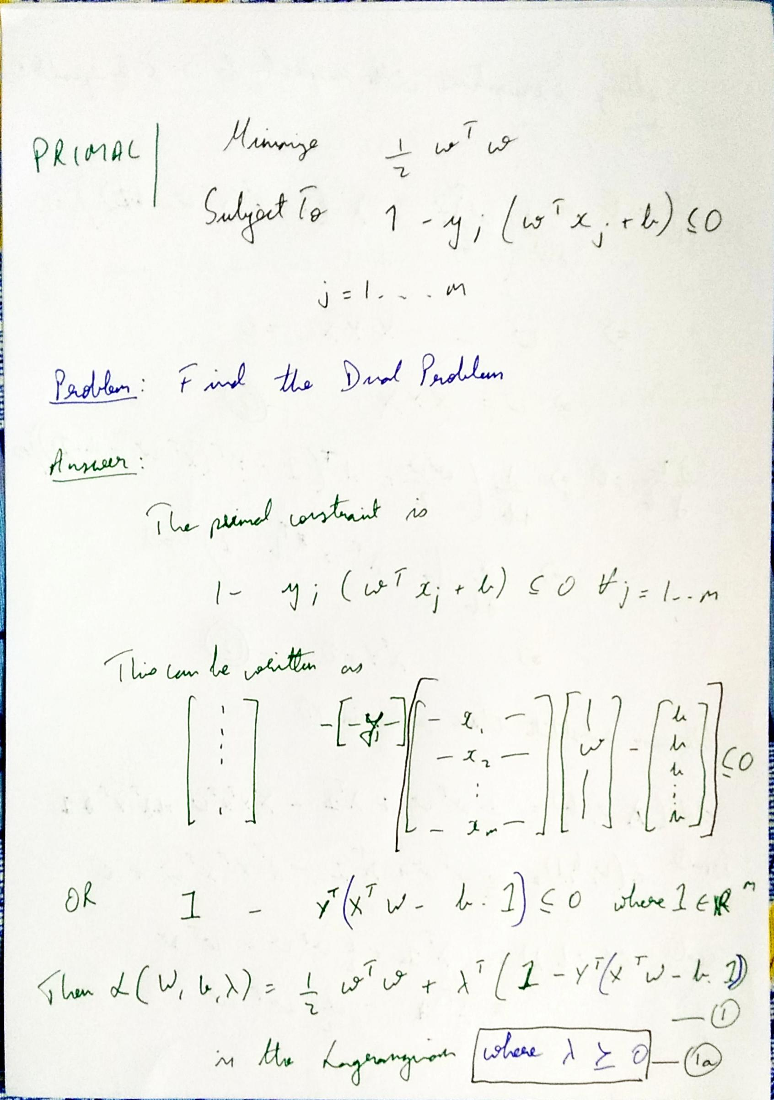

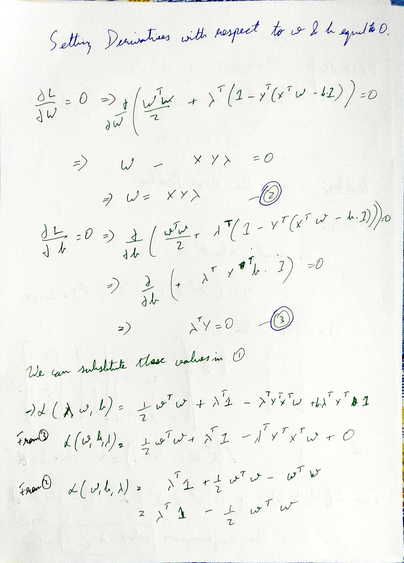

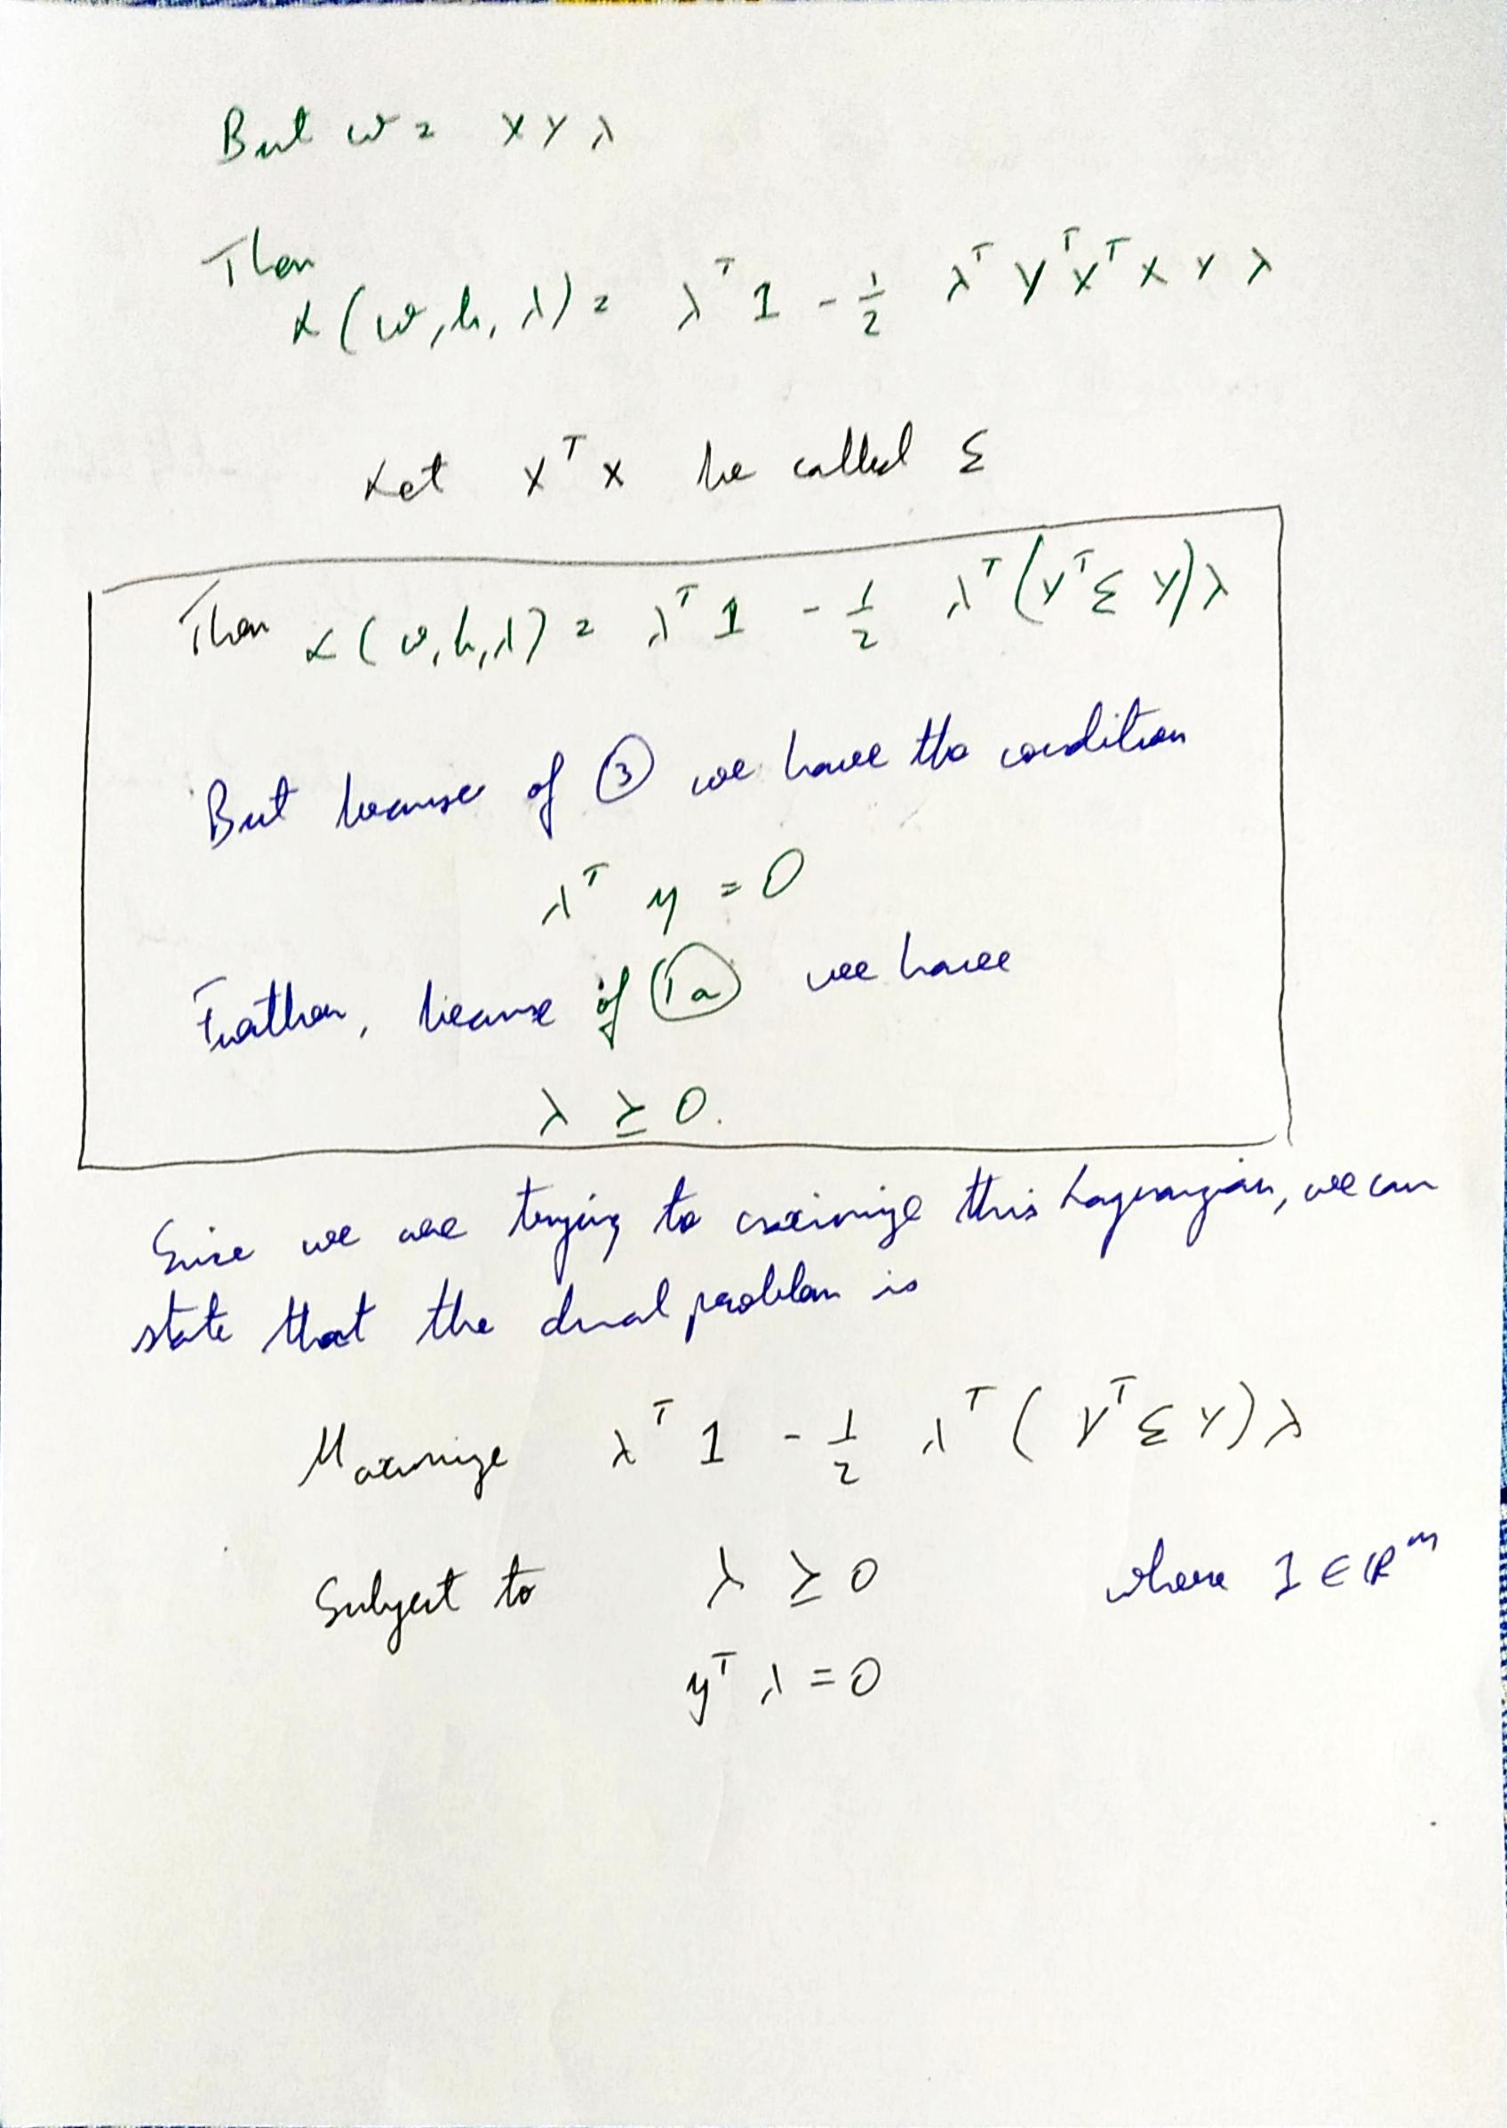

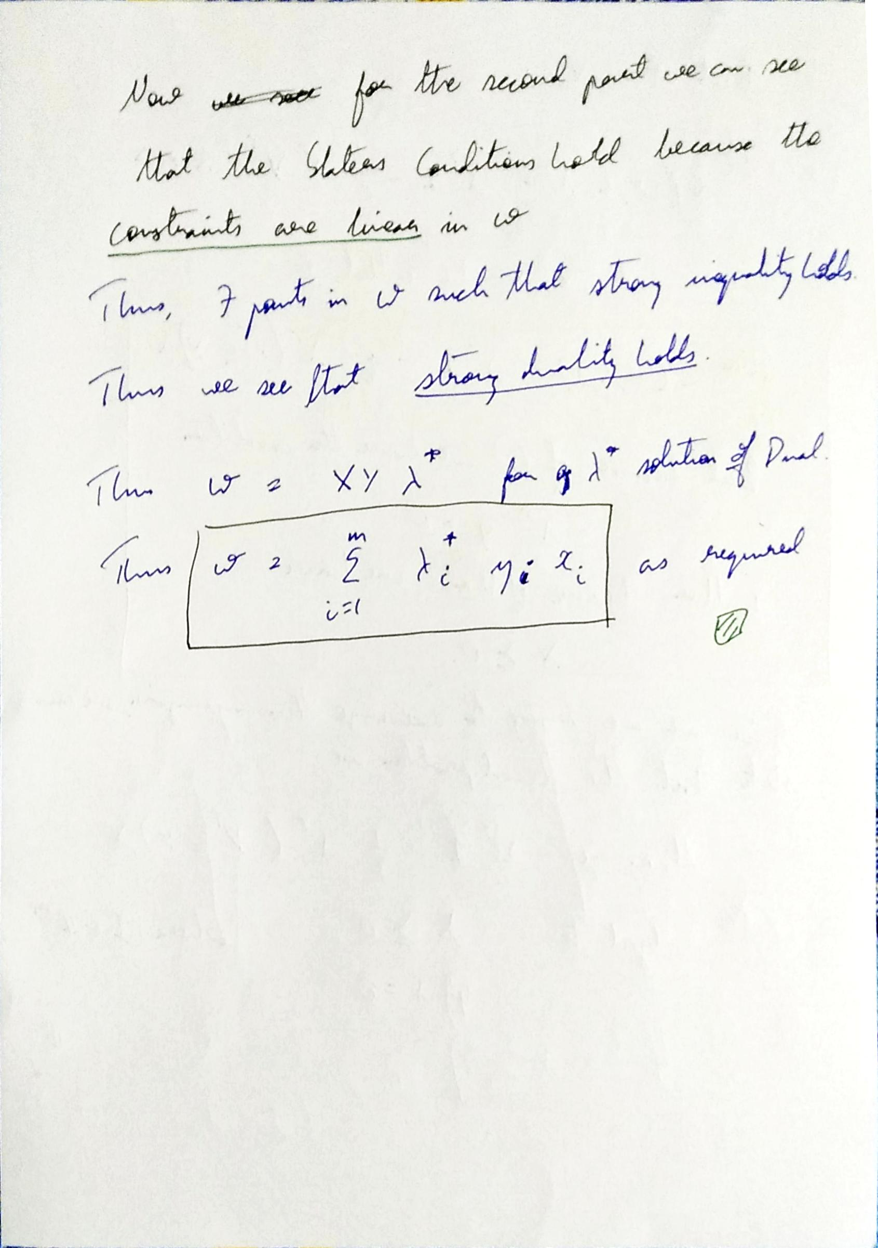

Part 2

Here we have been able to plot the training error per iteration, even though this was cancelled in the original question

Part 3



The above graph is quite arbitrary and indicates no major dependence

Part 4

We now indicate the test errors between various digits under consideration. Notice that these have been given as surface plots, where the surface colour indicates the error for that pair. The graphs are clearly symmetric



### Accuracies using Gaussian Kernels

We see that we get much lower accuracy values using Gaussian Kernels. The reason for this is not immediately apparent

On average, the accuracies here are lower by a factor of around 0.2



# Question 4

## Remarks

As pointed out by others in class, the first part of Question 4 has not been solvable using our computers. It was even not solvable on Google Colab. Thus we have not taken up this subsection. We instead move straight to the second subsection

## Results

### Part 2

We now indicate the errors with various lambda values

We first note that the errors between the L matrices and S matrices have the same norm but opposing signs. This is because the L and S matrices sum to a constant and thus their difference also would be the same. Thus from now we only look at LError

We plot the LError as below

We deep dive in the part where errors are low, ie from 1 to 10.

# Question 5

## Challenges

* This section was theoretically the most challenging as we had to model a graph through an LP
* I recreated the rgg function in python so that we could run the code easily
* I wasted many hours on the problem as I was solving min-cut, instead of max-cut, which happens to be an equally interesting problem from the computer science stand-point!

## Part 1 – Prove that the max-cut problem can be expressed as an SDP

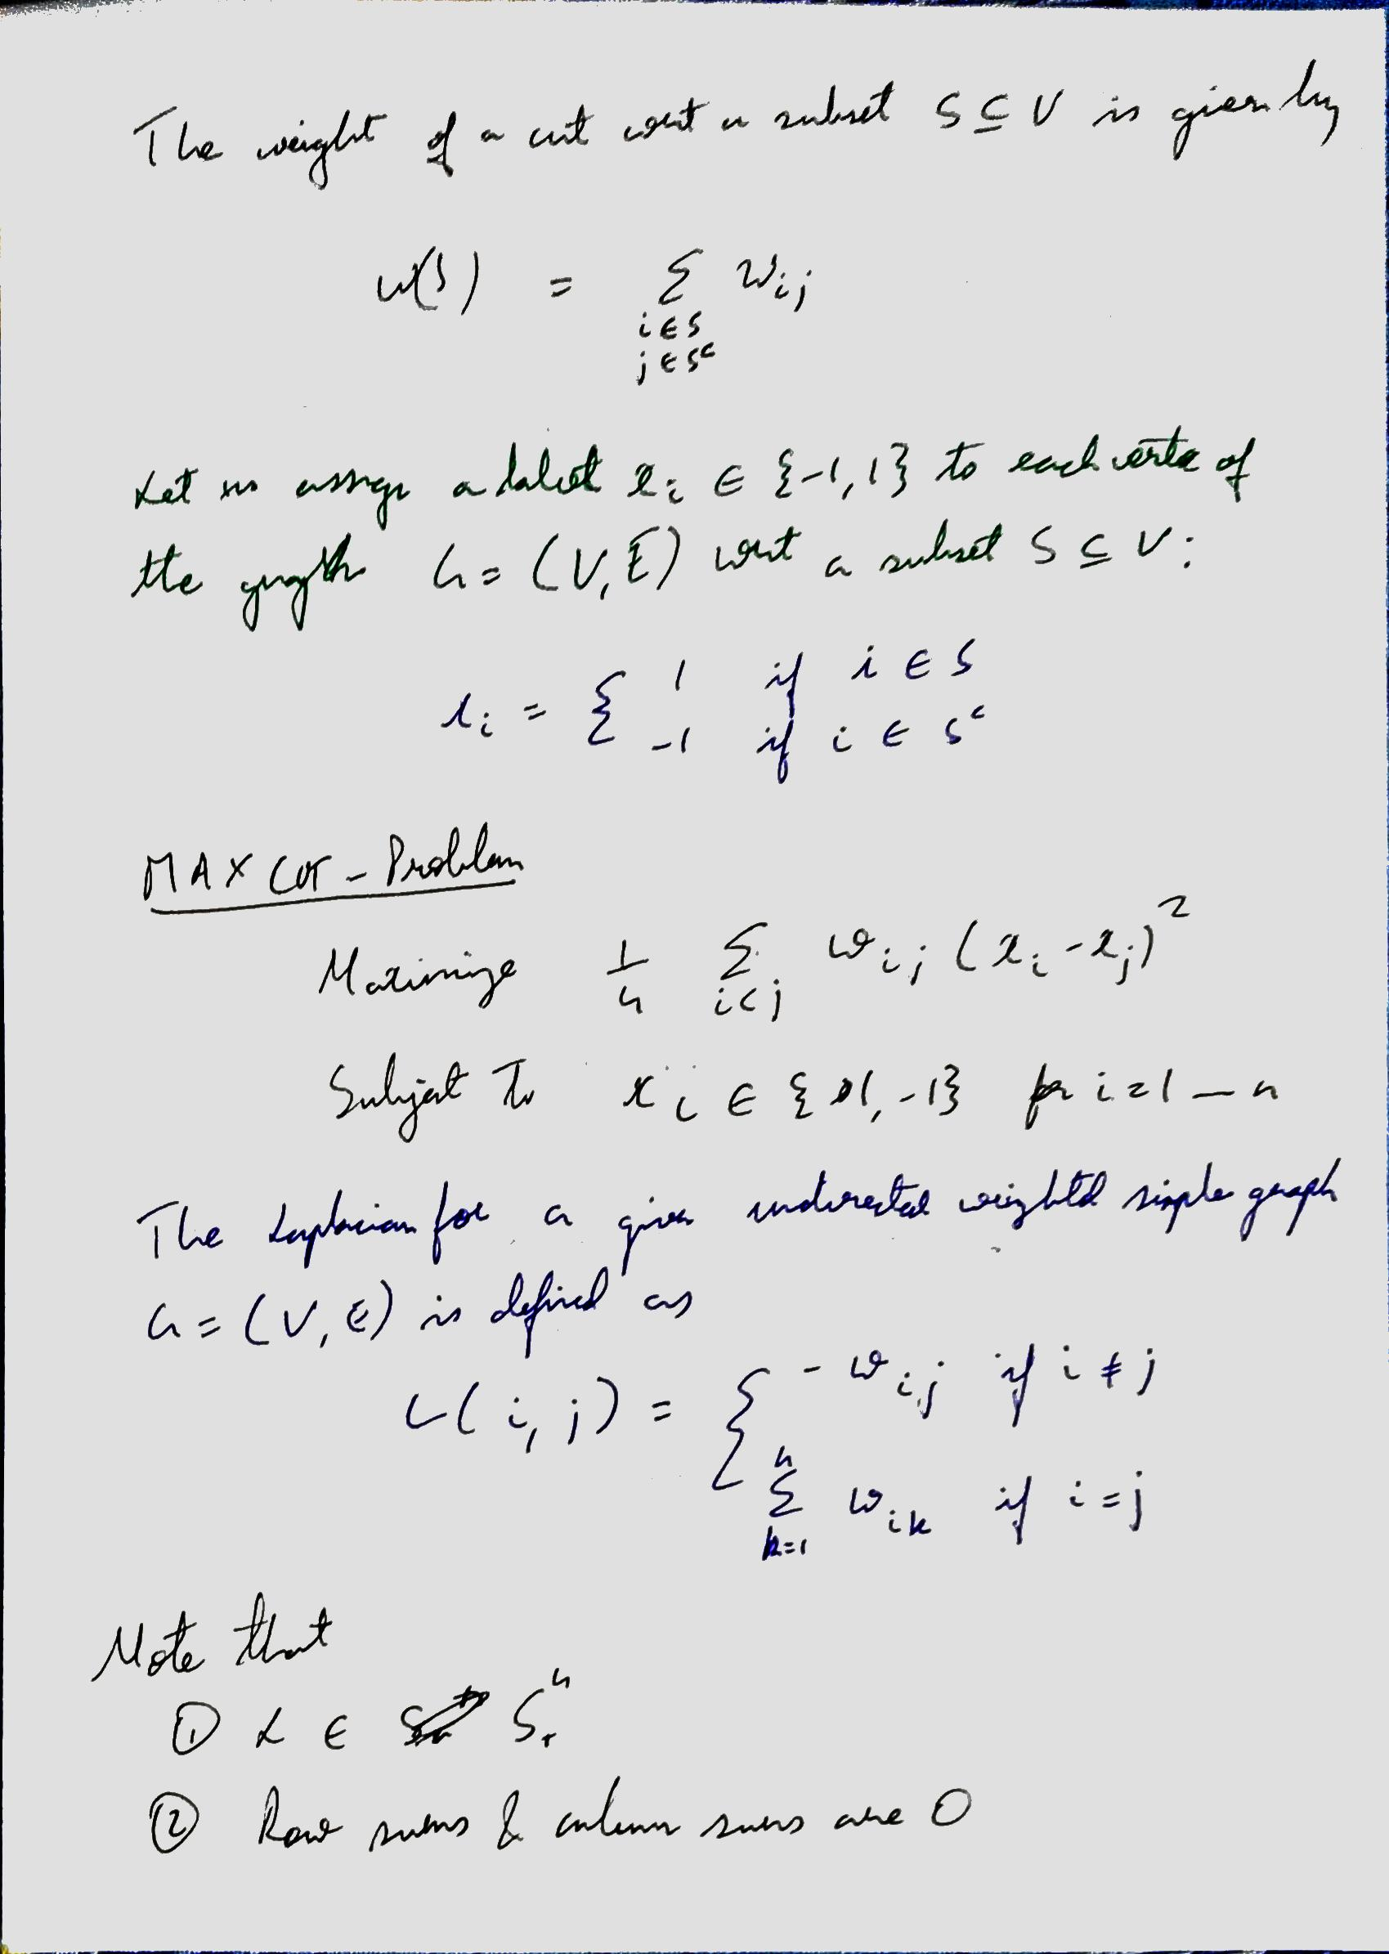

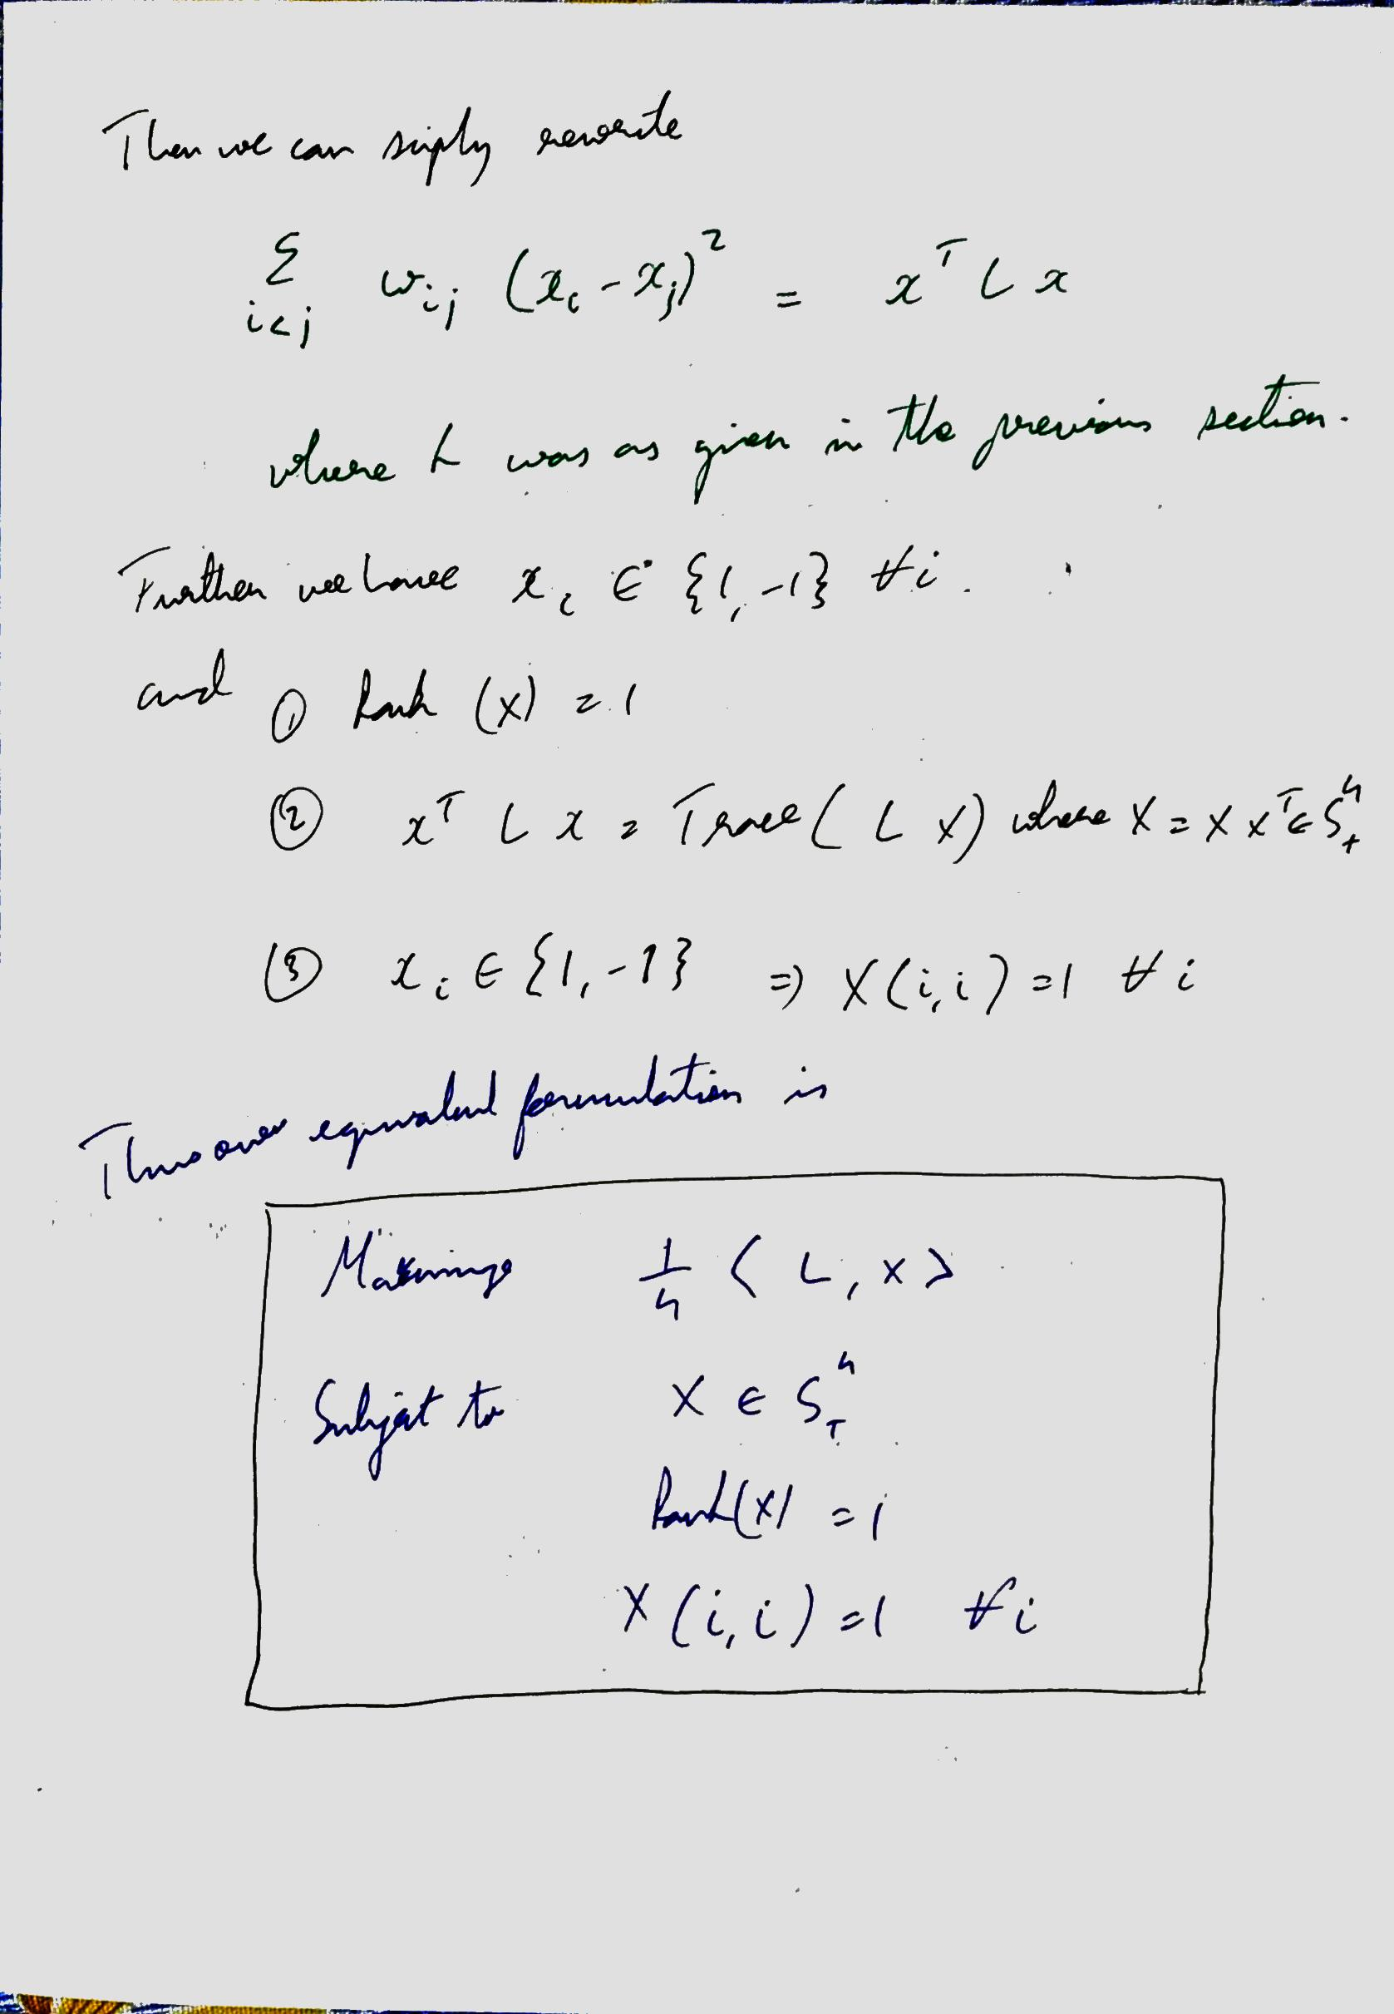

## Answer – part 2

* In part 1 we are asked to comment on the tightness of the approximation if the rank is 1. We can say that if the rank is 1, we have an exact approximation.
* In other words, we say that the rounding will give an exact match with the SDP OPTimum solution
* This is because, since there is only rank 1 in the SDP solution, the rounding with the random vector is able to replicate an exact cut on the real adjacency matrix
* Thus when we see a rank 1 approximation, we can say that the rounding gives exact solution

## Results Part 2

## Answers Part 3

* The optimal cut In a complete bipartite K(m,n) graph is clearly m * n
* This is because we can cut through the center of the graph
* Our solutions indicate that we never get a rank 1 matrix
* Thus all we have is an approximation to the solution. We plot the approximation ratios below and see that it lies at theoretical bounds in expectation
* We therefore suggest that the result is tight in expectation with a approximation ratio of 0.87856 which is as per theory

## Results Part 3

We now show a surface plot of what happens in a bipartite graph. We can see that in a Kn,m bipartite, the max-cut will have to be m*n as we can cut through the center of the bipartite.

# Problem 6

## Remarks

* This was one of the easiest problems in the question paper. And didn’t take long to solve
* The nature of the problem is convex because -xlog(x) is a concave function, which we are maximizing
* Conversely, xlog(x) is a concave function, which we are minimizing

## Answers

* **Verify that the optimal distribution is uniform:**
  + For this we can note the following
  + - X log(x) is a concave function
  + X log(x) is a convex function
  + We are trying to minimize this
  + Thus, we can apply Jensen’s inequality
  + (f(p1) + f(p2))/2 > f((p1 + p2)/2)
  + More pertinently,
  + (f(p1) + f(p 2)+… f(p n))/n > f((p 1+ p 2+… p n)/n)
  + Thus (p 1+ p 2+… p n)/n is the minimizer of the entropy function when there are n variables to assign the probability to
  + Since the probabilities are uniform, the variates they describe are in uniform distribution

## Results

##### Part 1 Results

We plot the results not just for the variables asked, but for all values between 2 and 20. Notice that the p values are of the form [1/n…1/n]



## Part 2 Results

# Packages Required to run

1. NUMPY
2. CVXPY
3. CVXOPT
4. MOSEK
5. SCIPY

# Additional Details

## Colab Details

Collab was run from this link:

**Problem 3**

<https://colab.research.google.com/drive/1BsZP1Jwx5yu1C10GuLG0KMJ6iCIGy3F1?usp=sharing>

**Problem 3.4**

<https://colab.research.google.com/drive/1pv4jd0W3GOdX_cqLt318Z8T2s8-6M67u?usp=sharing>

## Github Details

The entire code is stored here:

<https://github.com/p10rahulm/convexOpt>

# APPENDIX

FILES FOR CODING ASSIGNMENT

1. Question1.py

import numpy as np, numpy.random as random, cvxpy as cp  
import randomMatrix, utilities  
from cvxopt import matrix, solvers  
  
  
# https://math.stackexchange.com/questions/1639716/how-can-l-1-norm-minimization-with-linear-equality-constraints-basis-pu  
# We formulate the LP as minimize sum(t_i) for |A_ix - b_i| \leq t_i  
# or in other words minimize sum(t_i) for (A_ix - b_i) \leq t_i and (A_ix - b_i) \geq -t_i  
# Which can be written as minimize 1.T.dot(t) for (A_ix - b_i) \leq t_i and (A_ix - b_i) \geq -t_i  
# OR minimize 0.T.dot(x) + 1.T.dot(t)  
# such that  
# (A_i x - t_i) \leq +b_i  
# \forall i in [n]  
# and  
# -(A_ix + t_i) \leq -b_i  
# and  
# -t_i < 0  
# \forall i in [n], where x \in R^r, t in R^n  
#  
# OR  
# minimize 0.T.dot(x) + 1.T.dot(t)  
# such that  
# (A x - I t) \leq b  
# and  
# -Ax - I t \leq -b  
# and  
# 0x - I t \leq 0  
  
def minimizeL1NormLP(A, b, n, d):  
 opt_coeffs_x = np.zeros((d))  
 opt_coeffs_t = np.ones((n))  
 opt_coeffs = np.concatenate((opt_coeffs_x, opt_coeffs_t))  
 opt_coeffs = matrix(opt_coeffs)  
 # The third constraint is actually redundant  
 # constraint_coeffs = np.vstack((np.hstack((A, -np.eye(n))),np.hstack((-A, -np.eye(n))),np.hstack((np.zeros(A.shape), -np.eye(n)))))  
 # constraint_offsets = np.concatenate((-b,b,np.zeros(n)))  
  
 constraint_coeffs = np.vstack((np.hstack((A, -np.eye(n))), np.hstack((-A, -np.eye(n)))))  
 constraint_coeffs = matrix(constraint_coeffs)  
 constraint_offsets = np.concatenate((b, -b))  
 constraint_offsets = matrix(constraint_offsets)  
 sol = solvers.lp(opt_coeffs, constraint_coeffs, constraint_offsets)  
 out = sol['x'][:d, 0]  
 return np.array(out)  
  
  
# In the above formulation, instead of a vector t, we can just use a scalar t  
# Then we write  
# minimize t  
# such that  
# (A_ix - b_i) \leq t  
# and  
# (A_ix - b_i) \geq -t  
# and  
# t \geq 0  
#  
# The problem can be restated as  
# minimize t  
# such that  
# (A_ix - t) \leq b_i  
# and  
# (-A_ix - t) \leq -b_i  
# OR  
# minimize 0.dot(x) + t  
# such that  
# (Ax - t1) \leq b  
# and  
# (-Ax - t1) \leq -b  
  
def minimizeLInfNormLP(A, b, n, d):  
 opt_coeffs_x = np.zeros((d))  
 opt_coeffs_t = np.ones((1))  
 opt_coeffs = np.concatenate((opt_coeffs_x, opt_coeffs_t))  
 opt_coeffs = matrix(opt_coeffs)  
 # The third constraint is actually redundant  
 # constraint_coeffs = np.vstack((np.hstack((A, -np.eye(n))),np.hstack((-A, -np.eye(n))),np.hstack((np.zeros(A.shape), -np.eye(n)))))  
 # constraint_offsets = np.concatenate((-b,b,np.zeros(n)))  
  
 constraint_coeffs = np.vstack((np.hstack((A, -np.ones((n, 1)))), np.hstack((-A, -np.ones((n, 1))))))  
 constraint_coeffs = matrix(constraint_coeffs)  
 constraint_offsets = np.concatenate((b, -b))  
 constraint_offsets = matrix(constraint_offsets)  
 sol = solvers.lp(opt_coeffs, constraint_coeffs, constraint_offsets)  
 out = sol['x'][:d, 0]  
 return np.array(out)  
  
  
def minimizeL1NormCVX(A, b, n, d):  
 x_out = cp.Variable(d)  
 # cvxL1Prob = cp.Problem(cp.Minimize(cp.norm(cp.matmul(A,x_out)-b,1)))  
 cvxL1Prob = cp.Problem(cp.Minimize(cp.norm(A @ x_out - b, 1)))  
 cvxL1Prob.solve("CVXOPT")  
 # x = cp.Variable(d)  
 # prob1 = cp.Problem(cp.Minimize(cp.norm(A.dot(x)-b,1)))  
 return x_out.value  
  
  
def minimizeLInfNormCVX(A, b, n, d):  
 x_out = cp.Variable(d)  
 # cvxL1Prob = cp.Problem(cp.Minimize(cp.norm(cp.matmul(A,x_out)-b,1)))  
 cvxL1Prob = cp.Problem(cp.Minimize(cp.norm(A @ x_out - b, np.inf)))  
 cvxL1Prob.solve("CVXOPT")  
 # x = cp.Variable(d)  
 # prob1 = cp.Problem(cp.Minimize(cp.norm(A.dot(x)-b,1)))  
 return x_out.value  
  
  
def fullprint(*args, **kwargs):  
 from pprint import pprint  
 import numpy  
 opt = numpy.get_printoptions()  
 numpy.set_printoptions(threshold=numpy.inf)  
 pprint(*args, **kwargs)  
 numpy.set_printoptions(**opt)  
  
  
def printResults(A, b, x, typeMessage):  
 d = A.shape[1]  
 print("**\n**-------------------------------------------------------------------------------------------------------**\n**")  
 print(typeMessage)  
 print("**\n**-------------------------------------------------------------------------------------------------------**\n**")  
 print("x=", np.ndarray.flatten(x))  
 print("**\n**---------------------------**\n**")  
 Adotxb1 = np.matmul(A, x.reshape(d, 1)) - b.reshape((n, 1))  
  
 adotxprint = np.ndarray.flatten(Adotxb1)  
 printOpt = np.get_printoptions()  
 np.set_printoptions(threshold=d + 1)  
 print("A.dot(x) - b =", adotxprint)  
 np.set_printoptions(**printOpt)  
  
 print("L1Norm(A.dot(x)-b) = ", utilities.L1Norm(Adotxb1))  
 print("LInfNorm(A.dot(x)-b) = ", utilities.LInfNorm(Adotxb1))  
  
 print("L2Norm(A.dot(x)-b) = ", utilities.L2Norm(Adotxb1))  
 print("**\n**-------------------------------------------------------------------------------------------------------**\n**")  
  
  
if __name__ == "__main__":  
 random.seed(8)  
 n = 200  
 d = 10  
 A = randomMatrix.generateUniformRandomMatrices(n, d)  
 b = randomMatrix.generateUniformRandomMatrices(n, 1)[:, 0]  
 x = minimizeL1NormLP(A, b, n, d)  
 printResults(A, b, x, "Results for l1Norm though LP")  
 x = minimizeL1NormCVX(A, b, n, d)  
 printResults(A, b, x, "Results for l1Norm though CVXPY")  
  
 x = minimizeLInfNormLP(A, b, n, d)  
 printResults(A, b, x, "Results for lInfNorm though LP")  
  
 x = minimizeLInfNormCVX(A, b, n, d)  
 printResults(A, b, x, "Results for lInfNorm though CVXPY")  
 print("Solutions for the two methods for both L-Inf norma nd L-1 Norm are exactly the same")

1. Question2.py

import numpy as np, numpy.random as random, cvxpy as cp, matplotlib.pyplot as plt  
import randomMatrix, utilities  
import sys  
  
  
def loss_fn(A, b, x):  
 return cp.pnorm(A @ x - b, p=2) ** 2  
  
  
def regularizer(x, norm=2, pow=2):  
 return cp.pnorm(x, p=norm) ** pow  
  
  
def objective_fn(A, b, x, lmbda, norm=2, pow=2):  
 return loss_fn(A, b, x) + lmbda * regularizer(x, norm, pow)  
  
  
def mse(A, b, x):  
 return (1.0 / A.shape[0]) * loss_fn(A, b, x).value  
  
  
def plot_regularization_path(lmbda_values, x_values):  
 num_coeffs = len(x_values[0])  
 for i in range(num_coeffs):  
 plt.plot(lmbda_values, [wi[i] for wi in x_values])  
 plt.xlabel(r"$\lambda$", fontsize=16)  
 plt.xscale("log")  
 plt.title("Regularization Path")  
 plt.show()  
  
  
def plot_train_test_errors(train_errors, test_errors, lmbda_values):  
 plt.plot(lmbda_values, train_errors, label="Train error")  
 # plt.plot(lmbda_values, test_errors, label="Test error")  
 plt.xscale("log")  
 plt.legend(loc="upper left")  
 plt.xlabel(r"$\lambda$", fontsize=16)  
 plt.title("Mean Squared Error (MSE)")  
 plt.show()  
  
  
def getIterationErrors(problem, tempFile, column):  
 originalOut = sys.stdout  
 sys.stdout = open(tempFile, "w")  
 a = problem.solve(verbose=True)  
 sys.stdout.close()  
 sys.stdout = originalOut  
 f = open(tempFile, "r")  
 linenum = 0  
 iterationErrors = []  
 for line in f:  
 linenum += 1  
 if linenum < 5:  
 continue  
 if line == "**\n**":  
 break  
 cols = line.split(" ")  
  
 iterationErrors.append(float(cols[column]))  
 return iterationErrors  
  
  
def solveRegression(A, b, m, n, method=0, lmbda=0.1, showIterationErrors=0, tempFile="outputs/temp.txt",  
 outFile="outputs/iterations.txt"):  
 x = cp.Variable(n)  
  
 if method == 0:  
 problem = cp.Problem(cp.Minimize(objective_fn(A, b, x, 0)))  
 elif method == 1:  
 problem = cp.Problem(cp.Minimize(objective_fn(A, b, x, lmbda, norm=2, pow=2)))  
 elif method == 2:  
 problem = cp.Problem(cp.Minimize(objective_fn(A, b, x, lmbda, norm=1, pow=1)))  
 else:  
 problem = cp.Problem(cp.Minimize(objective_fn(A, b, x, 0)))  
  
 if showIterationErrors:  
 iterationErrors = getIterationErrors(problem, tempFile, 1)  
 f = open(outFile, "w")  
 f.write("IterationNumber,Errors**\n**")  
 iterCounter = 1  
 for iterError in iterationErrors:  
 f.write(str(iterCounter) + "," + str(iterError) + '**\n**')  
 iterCounter += 1  
 f.close()  
  
 else:  
 problem.solve()  
 return x.value  
  
  
def Part1(A, b, m, n):  
 solveRegression(A, b, m, n, method=0, lmbda=0.1, showIterationErrors=1, tempFile="outputs/temp.txt",  
 outFile="outputs/2.1iterationErrorMethod0.txt")  
 solveRegression(A, b, m, n, method=1, lmbda=0.1, showIterationErrors=1, tempFile="outputs/temp.txt",  
 outFile="outputs/2.1iterationErrorMethod1.txt")  
 solveRegression(A, b, m, n, method=2, lmbda=0.1, showIterationErrors=1, tempFile="outputs/temp.txt",  
 outFile="outputs/2.1iterationErrorMethod2.txt")  
  
  
def LambdasCoordinatewiseWriteFile(xArray, lambdas, filename, multicoordinates=1):  
 f = open(filename, "w")  
 if multicoordinates:  
 f.write("lambda," + ",".join(("Coordinate" + str(i + 1)) for i in range(len(xArray[0]))) + "**\n**")  
 else:  
 f.write("lambda,value" + "**\n**")  
  
 for iter in range(len(xArray)):  
 x = xArray[iter]  
 lmbda = lambdas[iter]  
 if multicoordinates:  
 f.write(str(lmbda) + "," + ",".join(str(i) for i in x) + "**\n**")  
 else:  
 f.write(str(lmbda) + "," + str(x) + "**\n**")  
  
 f.close()  
  
  
def Part2(A, b, m, n, lambda_vals):  
 method_xs = []  
 lambdas = []  
  
 for lmbda in lambda_vals:  
 x = solveRegression(A, b, m, n, method=1, lmbda=lmbda, showIterationErrors=0)  
 method_xs.append(x)  
 lambdas.append(lmbda)  
 methodFile = "outputs/2.2.1x.txt"  
 LambdasCoordinatewiseWriteFile(method_xs, lambdas, methodFile, 1)  
  
 AdotXMinusB = []  
 L2Norms = []  
 L2NormPlusRegs = []  
 for i in range(len(method_xs)):  
 x = method_xs[i]  
 lmbda = lambdas[i]  
 # normTwoSq = loss_fn(A, b, x)  
 normTwoSq = utilities.L2Norm(A @ x - b.reshape(m, 1))  
 regularizer = lmbda * (utilities.L2Norm(x))  
 normTwoSqPlusReg = normTwoSq + regularizer  
 AdotXMinusB.append(normTwoSq)  
 L2Norms.append(regularizer)  
 L2NormPlusRegs.append(normTwoSqPlusReg)  
 methodFile = "outputs/2.2.1L2Adotxminusb.txt"  
 LambdasCoordinatewiseWriteFile(AdotXMinusB, lambdas, methodFile, 0)  
  
 methodFile = "outputs/2.2.1L2regularizer.txt"  
 LambdasCoordinatewiseWriteFile(L2Norms, lambdas, methodFile, 0)  
  
 methodFile = "outputs/2.2.1L2NormPlusRegularizer.txt"  
 LambdasCoordinatewiseWriteFile(L2NormPlusRegs, lambdas, methodFile, 0)  
  
 method_xs = []  
 lambdas = []  
  
 for lmbda in lambda_vals:  
 x = solveRegression(A, b, m, n, method=2, lmbda=lmbda, showIterationErrors=0)  
 method_xs.append(x)  
 lambdas.append(lmbda)  
 methodFile = "outputs/2.2.2x.txt"  
 LambdasCoordinatewiseWriteFile(method_xs, lambdas, methodFile)  
  
 AdotXMinusB = []  
 L2Norms = []  
 L2NormPlusRegs = []  
 for i in range(len(method_xs)):  
 x = method_xs[i]  
 lmbda = lambdas[i]  
 # normTwoSq = loss_fn(A, b, x)  
 normTwoSq = utilities.L2Norm(A.dot(x) - b.reshape(m, 1))  
 regularizer = lmbda * (utilities.L1Norm(x))  
 normTwoSqPlusReg = normTwoSq + regularizer  
 AdotXMinusB.append(normTwoSq)  
 L2Norms.append(regularizer)  
 L2NormPlusRegs.append(normTwoSqPlusReg)  
 methodFile = "outputs/2.2.2L1Adotxminusb.txt"  
 LambdasCoordinatewiseWriteFile(AdotXMinusB, lambdas, methodFile, 0)  
  
 methodFile = "outputs/2.2.2L1regularizer.txt"  
 LambdasCoordinatewiseWriteFile(L2Norms, lambdas, methodFile, 0)  
  
 methodFile = "outputs/2.2.1L1NormPlusRegularizer.txt"  
 LambdasCoordinatewiseWriteFile(L2NormPlusRegs, lambdas, methodFile, 0)  
  
  
def Part3(m, n, lambda2, lambda3):  
 sigma_min = 0.1  
 sigma_step = 0.1  
 method1Errors=[]  
 method2Errors = []  
 method3Errors = []  
 sigmas = []  
 for i in range(20):  
 sigma = sigma_min + i * sigma_step  
 sigmas.append(sigma)  
 A, b = randomMatrix.gendata_lasso(m, n,sigma,1)  
 b = np.ndarray.flatten(b)  
 x = solveRegression(A, b, m, n, method=0)  
 rmse_error = np.sqrt(mse(A, b, x))  
 method1Errors.append(rmse_error)  
  
 x = solveRegression(A, b, m, n, method=1, lmbda=lambda2)  
 rmse_error = np.sqrt(mse(A, b, x))  
 method2Errors.append(rmse_error)  
  
 x = solveRegression(A, b, m, n, method=2, lmbda=lambda3)  
 rmse_error = np.sqrt(mse(A, b, x))  
 method3Errors.append(rmse_error)  
 f = open("outputs/2.iii.txt","w")  
 f.write("Sigma,RMSE_LSQ,RMSE_L2Norm,RMSE_L1Norm**\n**")  
 for i in range(20):  
 sigma = sigmas[i]  
 m1e = method1Errors[i]  
 m2e = method2Errors[i]  
 m3e = method3Errors[i]  
 f.write(str(sigma)+","+str(m1e)+","+str(m2e)+","+str(m3e)+"**\n**")  
  
 f.close()  
  
def Part4(m, n, lambda2, lambda3):  
 sigma_min = 0.1  
 sigma_step = 0.1  
 method1Errors=[]  
 method2Errors = []  
 method3Errors = []  
 sigmas = []  
 for i in range(20):  
 sigma = sigma_min + i * sigma_step  
 sigmas.append(sigma)  
 A, b = randomMatrix.gendata_lasso(m, n,sigma,2)  
 b = np.ndarray.flatten(b)  
 x = solveRegression(A, b, m, n, method=0)  
 rmse_error = np.sqrt(mse(A, b, x))  
 method1Errors.append(rmse_error)  
  
 x = solveRegression(A, b, m, n, method=1, lmbda=lambda2)  
 rmse_error = np.sqrt(mse(A, b, x))  
 method2Errors.append(rmse_error)  
  
 x = solveRegression(A, b, m, n, method=2, lmbda=lambda3)  
 rmse_error = np.sqrt(mse(A, b, x))  
 method3Errors.append(rmse_error)  
 f = open("outputs/2.iv.txt","w")  
 f.write("Sigma,RMSE_LSQ,RMSE_L2Norm,RMSE_L1Norm**\n**")  
 for i in range(20):  
 sigma = sigmas[i]  
 m1e = method1Errors[i]  
 m2e = method2Errors[i]  
 m3e = method3Errors[i]  
 f.write(str(sigma)+","+str(m1e)+","+str(m2e)+","+str(m3e)+"**\n**")  
  
 f.close()  
  
  
  
  
  
if __name__ == "__main__":  
 random.seed(8)  
 m = 200  
 n = 10  
 A, b = randomMatrix.gendata_lasso(m, n)  
 b = np.ndarray.flatten(b)  
 # print("A.shape=", A.shape)  
 # print("b.shape", b.shape)  
  
 Part1(A, b, m, n)  
 lambda_vals = np.logspace(-2, 3, 50)  
 # lambda_vals = range(5, 105, 5)  
 Part2(A, b, m, n, lambda_vals)  
  
 # For Part 3, we will use lambda = 2.25 for Part 2 and lambda = 0.1 for part 3  
  
 Part3(200, 50, 2.25, 0.1)  
  
 Part4(200, 50, 2.25, 0.1)

1. Question3.py

import randomMatrix, utilities  
import numpy as np, numpy.random as random, cvxpy as cp  
from math import exp  
  
  
def svm_gendata(Np, Nn, distance):  
 Xp = np.array([[2, -1], [2, 1]]) / np.sqrt(2) @ np.random.randn(2, Np)  
 Xp[0, :] = Xp[0, :] + distance  
 Xp[1, :] = Xp[1, :] - distance  
 yp = np.ones(Np)  
  
 Xn = np.array([[2, -1], [2, 1]]) / np.sqrt(2) @ np.random.randn(2, Nn)  
 Xn[0, :] = Xn[0, :] - distance  
 Xn[1, :] = Xn[1, :] + distance  
  
 yn = - np.ones(Nn)  
  
 X = np.hstack((Xp, Xn))  
 y = np.hstack((yp, yn))  
  
 return X, y  
  
  
def runforNum(numPos, NumNeg, distance=2.5, verboseRes=False):  
 numPos = 50  
 numNeg = 50  
 distance = 3  
 X, y = svm_gendata(numPos, numNeg, distance)  
 m = numPos + numNeg  
 one = np.ones(m)  
 lambd = cp.Variable(m)  
 constraints = [lambd >= 0, lambd.T @ y == 0]  
 Y = np.diag(y)  
 sigma = X.T @ X  
  
 obj = cp.Maximize(lambd.T @ one + cp.quad_form(lambd, -Y @ sigma @ Y) / 2)  
 prob = cp.Problem(obj, constraints)  
 opt = prob.solve(solver="CVXOPT", verbose=verboseRes)  
 if verboseRes:  
 print("optimal value", opt)  
 print("lambda values are ", lambd.value)  
 objectiveVal = lambd.value.T @ one - 0.5 * lambd.value.T @ Y @ sigma @ Y @ lambd.value  
 print("opt = ", opt, "obj = ", objectiveVal)  
 return opt  
  
  
# 3.2  
def Part2(numPos, numNeg, sizeRange):  
 runforNum(numPos, numNeg, True)  
 opts = []  
 f = open("Q3.1.txt", "w")  
 f.write("numPoints,separation,optimal**\n**")  
 for i in sizeRange:  
 for j in range(1):  
 min_distance = 2.5  
 distance_step = 0.5  
 distance = min_distance + j * distance_step  
 opt = runforNum(i, i, distance, False)  
 # print(i,",",opt)  
 f.write(str(i) + "," + str(distance) + "," + str(opt) + "**\n**")  
 opts.append(opt)  
 # print(opts)  
 f.close()  
  
  
def compute_K(x1, x2, sigma):  
 return exp((-np.linalg.norm(x1 - x2) ** 2) / (sigma * sigma))  
  
  
def compose_K_sigma(X, sigma, m):  
 K = np.zeros((m, m))  
 for i in range(m):  
 for j in range(m):  
 K[i, j] = compute_K(X.T[i], X.T[j], sigma)  
 return K  
  
  
def getError(X, sigma, lambd, y, m):  
 # First count the negs  
 maxIterate = -10 ** 3  
 for i in range(m):  
 if y[i] == -1:  
 sum1 = 0  
 for j in range(m):  
 sum1 += lambd.value[j] * y[j] * compute_K(X.T[i], X.T[j], sigma)  
 if sum1 > maxIterate:  
 maxIterate = sum1  
  
 # First count the positive pts  
 minIterate = 10 ** 3  
 for i in range(m):  
 if y[i] == 1:  
 sum1 = 0  
 for k in range(m):  
 sum1 += lambd.value[k] * y[k] * compute_K(X.T[i], X.T[k], sigma)  
 if sum1 < minIterate:  
 minIterate = sum1  
  
 # Set b as mid  
 b = -(maxIterate + minIterate) / 2  
  
 # We expect this to be 0 anyways  
 errors = 0  
 for i in range(m):  
 finalsum = 0  
 for j in range(m):  
 finalsum += lambd.value[j] * y[j] * compute_K(X.T[i], X.T[j], sigma)  
 pred = finalsum + b  
 if np.sign(pred) != y[i]:  
 errors += 1  
 return errors  
  
  
# 3.3  
def Part3(numPos, numNeg, distance):  
 X, y = svm_gendata(numPos, numNeg, distance)  
 m = numPos + numNeg  
 # sigmas = np.array([10**-2, 10**-1, 0.5, 10, 10**2])  
 sigmas = np.logspace(-2, 3, 100)  
 lambd = cp.Variable(m)  
 one = np.ones(m)  
 constraints = [lambd >= 0, lambd.T @ y == 0]  
 train_errors = []  
 lambda_values = []  
 opts = []  
 sigmasArr = []  
 for i in range(len(sigmas)):  
 sigma = sigmas[i]  
 Sigma = compose_K_sigma(X, sigma, m)  
 obj = cp.Maximize(lambd.T @ one + cp.quad_form(lambd, -Y @ Sigma @ Y) / 2)  
 prob = cp.Problem(obj, constraints)  
 opt = prob.solve()  
 print("optimal value", opt)  
 # print("lambda values are ", lambd.value)  
 sigmasArr.append(sigma)  
 opts.append(opt)  
 lambda_values.append(lambd.value)  
 tError = getError(X, sigma, lambd, y, m)  
  
 train_errors.append(tError / m)  
 print(train_errors[i])  
  
 f = open("Q3.2.txt", "w")  
 f.write("sigma,error,tError**\n**")  
 for i in range(len(sigmasArr)):  
 sigma = sigmasArr[i]  
 opt = opts[i]  
 tError = train_errors[i]  
 f.write(str(sigma) + "," + str(opt) + "," + str(tError) + "**\n**")  
  
 # print(opts)  
 f.close()  
  
  
if __name__ == "__main__":  
 seed = 10  
 numPos = 50  
 numNeg = 50  
 sizeRange = range(2, 101, 2)  
 Part2(numPos, numNeg, sizeRange)  
 Part3(numPos, numNeg, 2.5)

1. Question3.4.py

import numpy as np, cvxpy as cp  
from scipy.io import loadmat  
from math import exp  
  
def LoadData():  
 imageTrain = loadmat('QuestionFiles/imageTrain.mat')['imageTrain'].reshape(784, 5000)  
 labelTrain = np.squeeze(np.array(loadmat('QuestionFiles/labelTrain.mat')['labelTrain']))  
  
 imageTest = loadmat('QuestionFiles/imageTest.mat')['imageTest'].reshape(784, 500)  
 labelTest = np.squeeze(np.array(loadmat('QuestionFiles/labelTest.mat')['labelTest']))  
 return imageTrain, labelTrain, imageTest, labelTest  
  
  
def getDataForDigit(imageTrain, labelTrain, imageTest, labelTest, digit):  
 DigitTrain = []  
 for i in range(len(labelTrain)):  
 if labelTrain[i] == digit:  
 DigitTrain.append(imageTrain[:, i])  
  
 lenTrain = len(DigitTrain)  
 DigitTest = []  
 for i in range(len(labelTest)):  
 if labelTest[i] == digit:  
 DigitTest.append(imageTest[:, i])  
  
 lenTest = len(DigitTest)  
 return DigitTrain, lenTrain, DigitTest, lenTest  
  
  
def getTwoDigitsTrainTest(digit1, digit2, imageTrain, labelTrain, imageTest, labelTest):  
 DigitTrain6, lenTrain6, DigitTest6, lenTest6 = getDataForDigit(imageTrain, labelTrain, imageTest, labelTest, digit1)  
  
 DigitTrain8, lenTrain8, DigitTest8, lenTest8 = getDataForDigit(imageTrain, labelTrain, imageTest, labelTest, digit2)  
  
 numOnenumTwoTrainLabel = np.hstack((-np.ones(lenTrain6), np.ones(lenTrain8)))  
 numOnenumTwoTestLabel = np.hstack((-np.ones(lenTest6), np.ones(lenTest8)))  
 numOnenumTwo_TrainImage = np.array(DigitTrain6 + DigitTrain8)  
 numOnenumTwo_TestImage = np.array(DigitTest6 + DigitTest8)  
 return numOnenumTwoTrainLabel, numOnenumTwoTestLabel, numOnenumTwo_TrainImage, numOnenumTwo_TestImage  
  
  
def getAccuracyBetweenDigits(digit1, digit2, imageTrain, labelTrain, imageTest, labelTest):  
  
 numOnenumTwoTrainLabel, numOnenumTwoTestLabel, numOnenumTwo_TrainImage, numOnenumTwo_TestImage = getTwoDigitsTrainTest(  
 digit1, digit2, imageTrain, labelTrain, imageTest, labelTest)  
 # print(numOnenumTwo_TrainImage.shape)  
 # print(numOnenumTwo_TestImage.shape)  
  
 n = numOnenumTwo_TrainImage.shape[1]  
 W = cp.Variable((n))  
 b = cp.Variable()  
 ones = np.array(np.ones(numOnenumTwo_TrainImage.shape[0]))  
 Y = np.diag(numOnenumTwoTrainLabel)  
  
 obj = cp.Minimize((cp.pnorm(W, p=2) ** 2) / 2)  
 constraints = [ones - Y @ (numOnenumTwo_TrainImage @ W - b * ones) <= 0]  
 prob = cp.Problem(obj, constraints)  
 prob.solve()  
  
 W_final = W.value  
 b_final = b.value  
 # print(W_final.shape)  
 errors = 0  
 ones_test = ones = np.array(np.ones(numOnenumTwo_TestImage.shape[0]))  
 # numOnenumTwoTestImage@W_final +b*ones  
 pred = np.sign(numOnenumTwo_TestImage @ W_final + b_final * ones_test)  
 # pred  
 inAcc = (np.sign(numOnenumTwo_TestImage @ W_final + b_final * ones_test) != numOnenumTwoTestLabel).sum() / \  
 numOnenumTwo_TestImage.shape[0]  
 acc = 1 - inAcc  
 return acc  
  
def compute_K(x1, x2, sigma):  
 return exp((-np.linalg.norm(x1 - x2) ** 2) / (sigma * sigma))  
  
  
def compose_K_sigma(X, sigma,m):  
 K = np.zeros((m, m))  
 for i in range(m):  
 for j in range(m):  
 K[i, j] = compute_K(X.T[i], X.T[j], sigma)  
 return K  
  
def getAccuracyBetweenDigitsGaussianKerner(digit1, digit2, imageTrain, labelTrain, imageTest, labelTest):  
  
  
 # Variable  
 trainNum1Num2_label, testNum1Num2_label, trainNum1Num2_image, testNum1Num2_image = getTwoDigitsTrainTest(  
 digit1, digit2, imageTrain, labelTrain, imageTest, labelTest)  
  
  
 y = trainNum1Num2_label  
 X = trainNum1Num2_image.T  
 Y = np.diag(trainNum1Num2_label)  
 m = y.shape[0]  
 one = np.ones(m)  
 lambd = cp.Variable(m)  
 y_test = testNum1Num2_label  
 X_test = testNum1Num2_image.T  
 m_test = y_test.shape[0]  
  
  
 constraints = [lambd >= 0, lambd.T @ y == 0]  
 lambda_values = []  
 sigma = 2.5  
 Sigma = compose_K_sigma(X,sigma,m)  
 obj = cp.Maximize(lambd.T @ one + cp.quad_form(lambd, -Y @ Sigma @ Y) / 2)  
 prob = cp.Problem(obj, constraints)  
 prob.solve()  
 lambda_values.append(lambd.value)  
 maxi = -999  
 for j in range(m):  
 if y[j] == -1:  
  
 sum1 = 0  
 for k in range(m):  
 sum1 = sum1 + lambd.value[k] * y[k] * compute_K(np.squeeze(np.array(X.T[j])),  
 np.squeeze(np.array(X.T[k])), sigma)  
 if sum1 > maxi:  
 maxi = sum1  
  
 mini = 1000  
 for j in range(m):  
 if y[j] == 1:  
  
 sum1 = 0  
 for k in range(m):  
 sum1 = sum1 + lambd.value[k] * y[k] * compute_K(np.squeeze(np.array(X.T[j])),  
 np.squeeze(np.array(X.T[k])), sigma)  
 if sum1 < mini:  
 mini = sum1  
  
 b = -(maxi + mini) / 2  
  
 errors = 0  
 for j in range(m_test):  
 finalsum = 0  
 for k in range(m):  
 finalsum += lambd.value[k] * y[k] * compute_K(np.squeeze(np.array(X_test.T[j])),  
 np.squeeze(np.array(X.T[k])), sigma)  
 pred = finalsum + b  
 if np.sign(pred) != y_test[j]:  
 errors += 1  
 accuracy = 1 - (errors / m_test)  
 return accuracy  
  
  
if __name__ == "__main__":  
 imageTrain, labelTrain, imageTest, labelTest = LoadData()  
 print(labelTrain)  
 # Making required Training Data  
 accuracy = getAccuracyBetweenDigits(6, 8, imageTrain, labelTrain, imageTest, labelTest)  
 print("accuracy =", accuracy)  
  
 accuracies = []  
 num1s = []  
 num2s = []  
 for i in range(1, 10, 1):  
 for j in range(i + 1, 10, 1):  
 accuracy = getAccuracyBetweenDigits(i, j, imageTrain, labelTrain, imageTest, labelTest)  
 accuracies.append(accuracy)  
 num1s.append(i)  
 num2s.append(j)  
 filename = "outputs/output3.4.txt"  
 f = open(filename, "w")  
 f.write("num1,num2,accuracy**\n**")  
 for i in range(len(num1s)):  
 num1 = num1s[i]  
 num2 = num2s[i]  
 accuracy = accuracies[i]  
 f.write(str(num1) + "," + str(num2) + "," + str(accuracy) + "**\n**")  
 f.close()  
  
 accuracies = []  
 num1s = []  
 num2s = []  
 for i in range(1, 10, 1):  
 for j in range(i + 1, 10, 1):  
 accuracy = getAccuracyBetweenDigitsGaussianKerner(i, j, imageTrain, labelTrain, imageTest, labelTest)  
 print("num1=",i,"num1=",j,"accuracy=",accuracy)  
 accuracies.append(accuracy)  
 num1s.append(i)  
 num2s.append(j)  
 filename = "outputs/output3.4Gaussian.txt"  
 f = open(filename, "w")  
 f.write("num1,num2,accuracy**\n**")  
 for i in range(len(num1s)):  
 num1 = num1s[i]  
 num2 = num2s[i]  
 accuracy = accuracies[i]  
 f.write(str(num1) + "," + str(num2) + "," + str(accuracy) + "**\n**")  
 f.close()

1. Question4.py

import cvxpy as cp, numpy as np, numpy.random as random  
from scipy import sparse  
import matplotlib.pyplot as plt  
import randomMatrix  
  
  
def runSolver(mConstraint, L_Initial, S_Initial, m, n, lmbda=0.1):  
 L = cp.Variable((m, n))  
 S = cp.Variable((m, n))  
 cost = cp.norm(L, "nuc") + lmbda * cp.norm(S, 1)  
 constr = [L + S == mConstraint]  
 prob = cp.Problem(cp.Minimize(cost), constr)  
 prob.solve("MOSEK")  
 lError = np.linalg.norm(L.value - L_Initial, 'fro')  
 sError = np.linalg.norm(S.value - S_Initial, 'fro')  
 return lError, sError  
  
  
def generateLowRankMatrixPlusSparseMatrix(m, n, rank, density):  
 lInitial = randomMatrix.generateLowRank(m, n, rank)  
 sInitial = randomMatrix.sparseRandomNormalMatrix(m, n, density=density)  
 M = lInitial + sInitial  
 return M, lInitial, sInitial  
  
  
def getErrors(mConstraint, L_Initial, S_Initial, m, n, lambda_vals):  
 LErrors = []  
 SErrors = []  
 for lmbda in lambda_vals:  
 print("Now running for lambda = ", lmbda)  
 lError, sError = runSolver(mConstraint, L_Initial, S_Initial, m, n, lmbda)  
 LErrors.append(lError)  
 SErrors.append(sError)  
 return LErrors, SErrors  
  
  
if __name__ == "__main__":  
 m = 50  
 n = 50  
 lambda_vals = np.logspace(-2, 3, 20)  
 lambda_vals = range(1, 11)  
  
 rank = 5  
 density = 0.1  
 mConstraint, L_Initial, S_Initial = generateLowRankMatrixPlusSparseMatrix(m, n, rank, density)  
 LErrors, SErrors = getErrors(mConstraint, L_Initial, S_Initial, m, n, lambda_vals)  
 filename = "outputs/4.2Errors.txt"  
 f = open(filename, "w")  
 f.write("Lambda,LErrors,SErrors**\n**")  
 for i in range(len(LErrors)):  
 lmbda = lambda_vals[i]  
 lError = LErrors[i]  
 sError = SErrors[i]  
 f.write(str(lmbda) + "," + str(lError) + "," + str(sError) + "," + str(lError+sError) + "**\n**")

1. Question5.py

import cvxpy as cp, numpy as np, numpy.random as random  
import randomMatrix,utilities  
  
  
def getLaplacian(adjacencyMatrix):  
 degree = np.sum(adjacencyMatrix, axis=0)  
 degree = np.diag(degree)  
 Laplacian = degree - adjacencyMatrix  
 return Laplacian  
  
def solveProblem(Laplacian,numNodes,solver):  
 eye = np.ones(numNodes)  
 X = cp.Variable((numNodes, numNodes), PSD=True)  
 cost = (0.25) * cp.trace(Laplacian @ X)  
 constr = [X >> 0, cp.diag(X) == eye]  
 prob = cp.Problem(cp.Maximize(cost), constr)  
 opt = prob.solve(solver=solver)  
 # print("prob=",prob,"opt=",opt,"prob.value=",prob.value)  
 return X,prob.value  
  
  
def getCutWeight(X,adjacencyMatrix,numNodes,method=0):  
 # print("X=", X)  
 M = np.linalg.cholesky(X)  
 # print("M=", M)  
 u = np.random.uniform(-1, 1, numNodes)  
 u = u / utilities.L2Norm(u)  
 # print("u=", u)  
 labels = M.T @ u  
 # Shortcut for setting all positive to 1 and negative to -1  
 labels = (((labels >= 0) * 1) - 0.5) * 2  
 # print("labels=", labels)  
 cutWt = 0  
 for i in range(numNodes):  
 for j in range(i + 1, numNodes):  
 if labels[i] != labels[j]:  
 cutWt = cutWt + adjacencyMatrix[i, j]  
  
 # print("MaxCut = ",cutWt)  
 return cutWt  
  
  
def runSolver(numNodes,method=0,k1=8,k2=12):  
 if method==1:  
 adjacencyMatrix = randomMatrix.generateCompleteBipartite(k1, k2)  
 # print("adjacencyMatrix=\n",adjacencyMatrix)  
 numNodes=k1+k2  
 else:  
 adjacencyMatrix = randomMatrix.rgg(numNodes, density=0.5)  
 averageWt = np.sum(adjacencyMatrix) / ((numNodes ** 2 - numNodes))  
 Laplacian = getLaplacian(adjacencyMatrix)  
 X, opt = solveProblem(Laplacian, numNodes, "CVXOPT")  
 rank = np.linalg.matrix_rank(X.value)  
 # print("X=\n",X.value)  
  
 cutwt = getCutWeight(X.value, adjacencyMatrix, numNodes)  
 print("numNodes = ", numNodes, "averageWt = ", averageWt, "rank = ", rank, "cut weight = ", cutwt, "opt = ", opt)  
 return numNodes,averageWt,rank,cutwt,opt  
  
  
def PartsRunner(nodesRange,filename,method,k1Range,k2Range):  
 random.seed(8)  
 if method==1:  
 k1s = []  
 k2s = []  
 else:  
 nodes = []  
 opts = []  
 averageWts = []  
 ranks = []  
 cutwts = []  
 if method==1:  
 for k1 in k1Range:  
 for k2 in k2Range:  
 numNodes, averageWt, rank, cutwt, opt = runSolver(k1+k2, method, k1, k2)  
 k1s.append(k1)  
 k2s.append(k2)  
 averageWts.append(averageWt)  
 ranks.append(rank)  
 cutwts.append(cutwt)  
 opts.append(opt)  
  
 else:  
 for numNodes in nodesRange:  
 numNodes, averageWt, rank, cutwt,opt = runSolver(numNodes,method,k1=0,k2=0)  
 nodes.append(numNodes)  
 averageWts.append(averageWt)  
 ranks.append(rank)  
 cutwts.append(cutwt)  
 opts.append(opt)  
  
 f = open(filename,"w")  
 if method==1:  
 f.write("k1,k2,AverageWeight,Rank,CutWeight,Opt**\n**")  
 i=0  
 for k1 in k1Range:  
 for k2 in k2Range:  
 k1 = k1s[i]  
 k2 = k2s[i]  
 averageWt = averageWts[i]  
 rank = ranks[i]  
 cutwt = cutwts[i]  
 opt = opts[i]  
 f.write(str(k1) + "," + str(k2) + "," + str(averageWt) + "," + str(rank) + "," + str(cutwt) + "," + str(  
 opt) + "**\n**")  
 i+=1  
 else:  
 f.write("numNodes,AverageWeight,Rank,CutWeight,Opt**\n**")  
 i = 0  
 for i in range(len(nodes)):  
 numNodes = nodes[i]  
 averageWt = averageWts[i]  
 rank = ranks[i]  
 cutwt = cutwts[i]  
 opt = opts[i]  
 f.write(str(numNodes) + "," + str(averageWt) + "," + str(rank) + "," + str(cutwt) + "," + str(opt) + "**\n**")  
 i += 1  
 f.close()  
  
  
  
  
  
if __name__ == "__main__":  
 # We follow the sequence provided by Prof Chirayu in his notes  
 nodesRange = range(2,101,2)  
 filename = "outputs/Q5.2.txt"  
 PartsRunner(nodesRange,filename,0,0,0)  
  
 k1Range = range(2,21,2)  
 k2Range = range(2,21,2)  
 filename = "outputs/Q5.3.txt"  
  
 PartsRunner(nodesRange, filename, 1, k1Range, k2Range)

1. Question6.py

import numpy as np, cvxpy as cp, numpy.random as random  
  
  
def Solver(numVars, method=0):  
 mOnes = np.ones(numVars)  
 a = np.sort(random.uniform(-1, 1, numVars))  
  
 p = cp.Variable(numVars)  
 entropy = cp.sum(cp.entr(p))  
 if method == 1:  
 aSq = np.power(a, 2)  
 aExp = 3 * np.power(a, 3) - 2 * a  
 aLessPoint5 = [a < 0.5] * 1  
 constraints = [p >= 0,  
 cp.matmul(mOnes, p) == 1,  
 p @ a <= 0.1,  
 p @ a >= -0.1,  
 p @ aSq >= 0.5,  
 p @ aSq <= 0.6,  
 p @ aExp >= -0.3,  
 p @ aExp <= -0.2,  
 p @ aLessPoint5 >= 0.3,  
 p @ aLessPoint5 <= 0.4]  
 else:  
 constraints = [p >= 0, cp.matmul(mOnes, p) == 1]  
  
 prob = cp.Problem(cp.Maximize(entropy), constraints)  
 prob.solve()  
 print("numVars = ", numVars, "p.value=", p.value)  
 return a, p.value  
  
  
def PartsRunner(filename, numRange, method=0):  
 f = open(filename, "w")  
 f.write("numVariables,p values->**\n**")  
 f.close()  
  
 for numVars in numRange:  
 f = open(filename, "a")  
 a, pVals = Solver(numVars, method)  
  
 if pVals is not None:  
 f.write(str(numVars) + "-random-vals:" + ",")  
 f.write(",".join(str(i) for i in a) + "**\n**")  
 f.write(str(numVars) + "-probabilities:" + ",")  
 f.write(",".join(str(i) for i in pVals) + "**\n**")  
 else:  
 f.write("Equations Not Satisfied for matrix size:"+str(numVars) + "**\n**")  
 f.close()  
  
  
if __name__ == "__main__":  
 random.seed(8)  
 numRange = range(2, 21, 2)  
 filename = "outputs/pVals6.1.txt"  
 PartsRunner(filename, numRange, 0)  
 numRange = range(10, 31, 2)  
 filename = "outputs/pVals6.2.txt"  
 PartsRunner(filename, numRange, 1)

THANK YOU