**Experiment 6**

Nidhi Parab

Subject: DWM

Class: TE4

Roll no: 35

Batch: C

Aim: Perform data Pre-processing task and demonstrate Classification, Clustering, Association algorithm on data sets using data mining tool WEKA.

Knowledge Flow:

**J48**

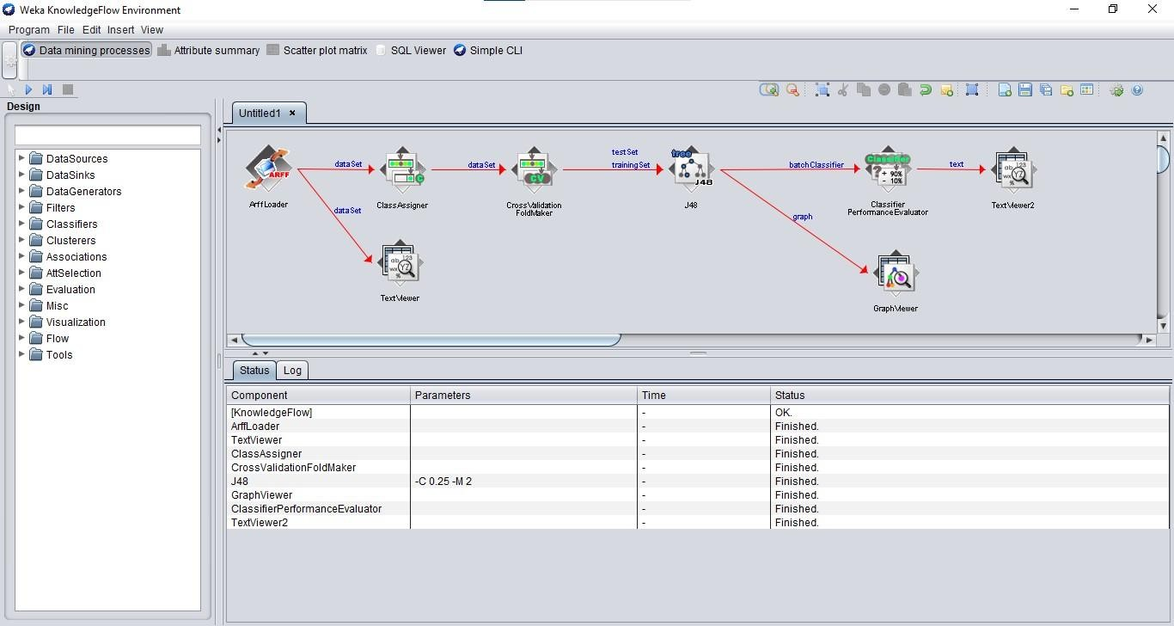

**Iris Data Set Text Viewer**

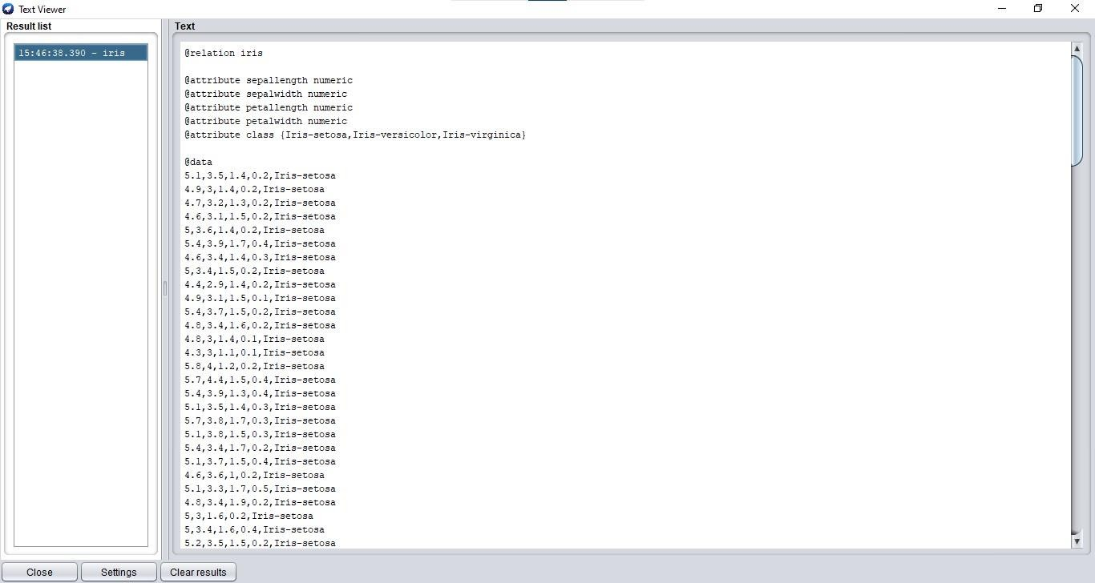

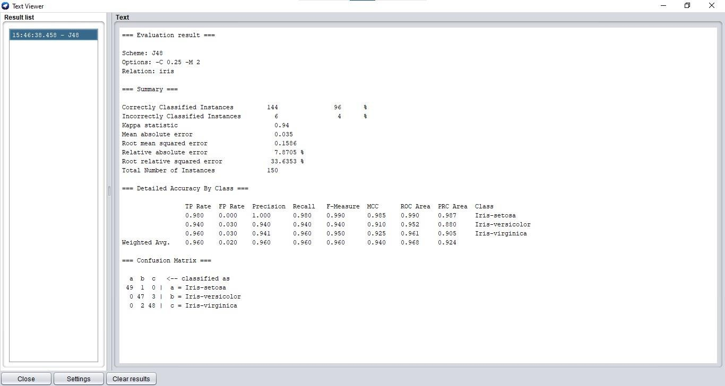**Evaluation Result Text Viewer**

**Graph Viewer**

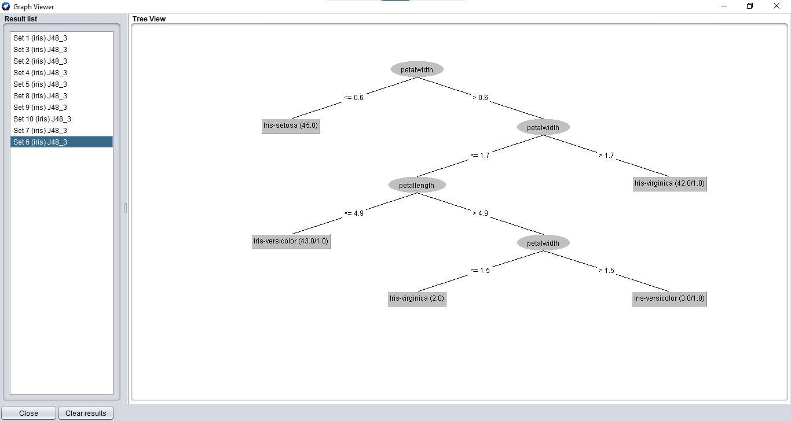

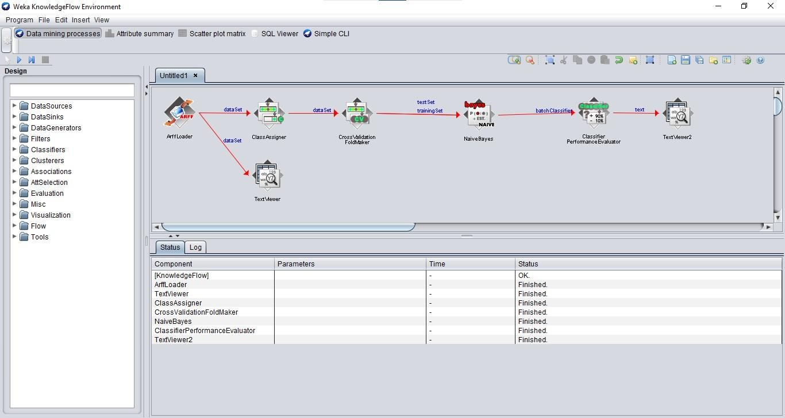**Naïve Bayes**

**Iris Data Set Text Viewer**

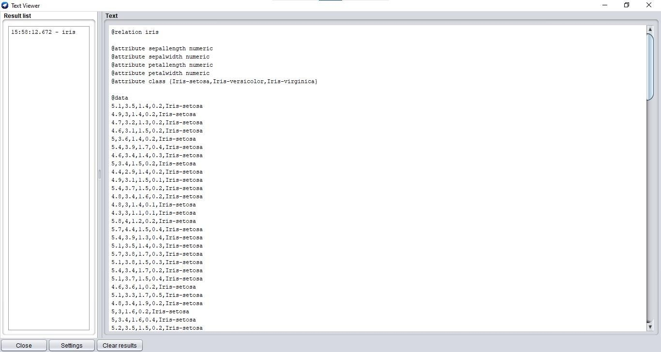

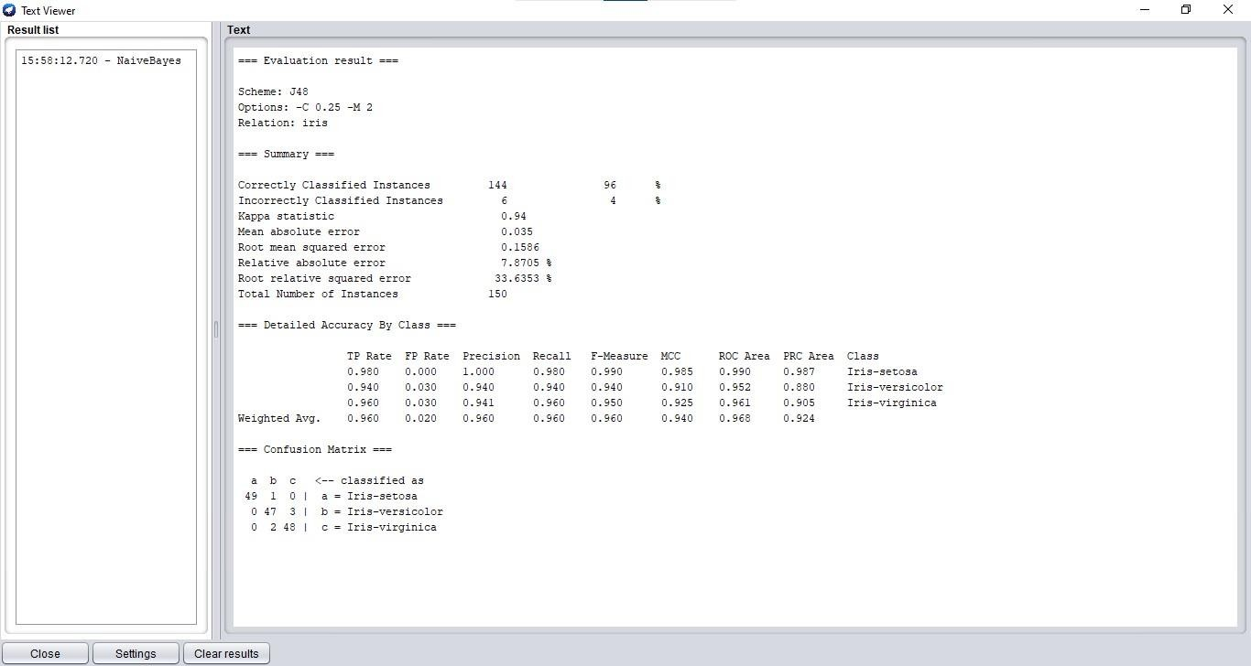**Evaluation Result**

Explorer:

**Weather Data Set**

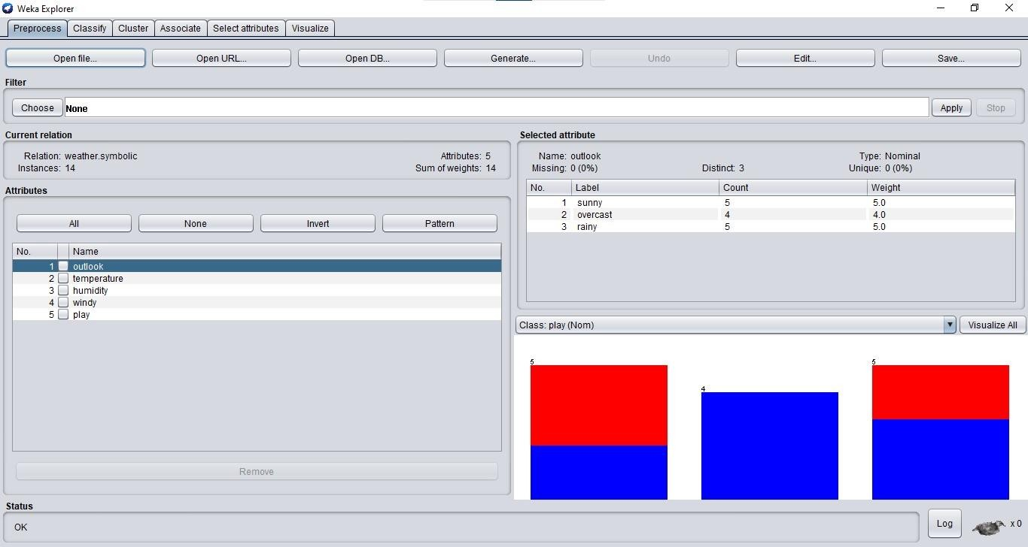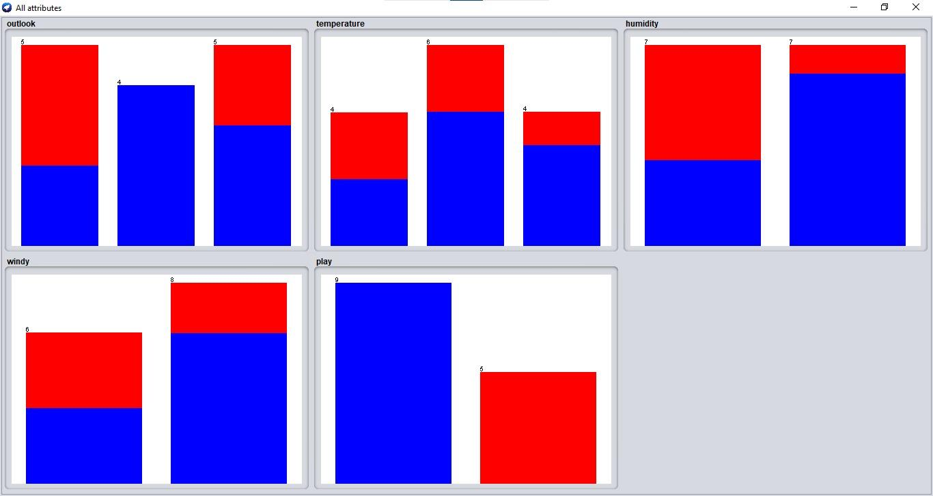

**J48 Classifier**

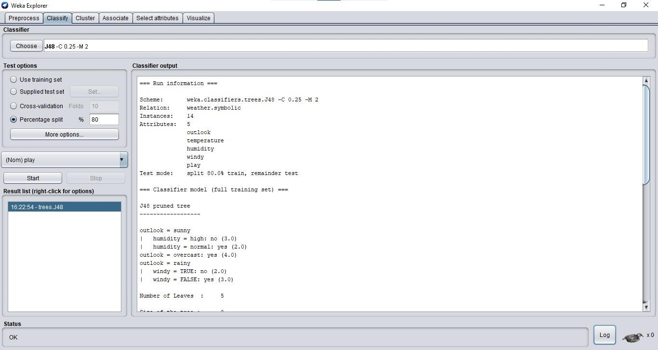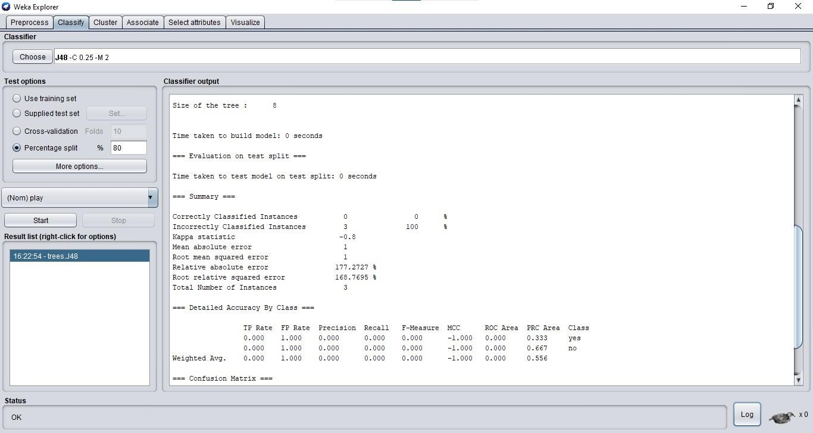

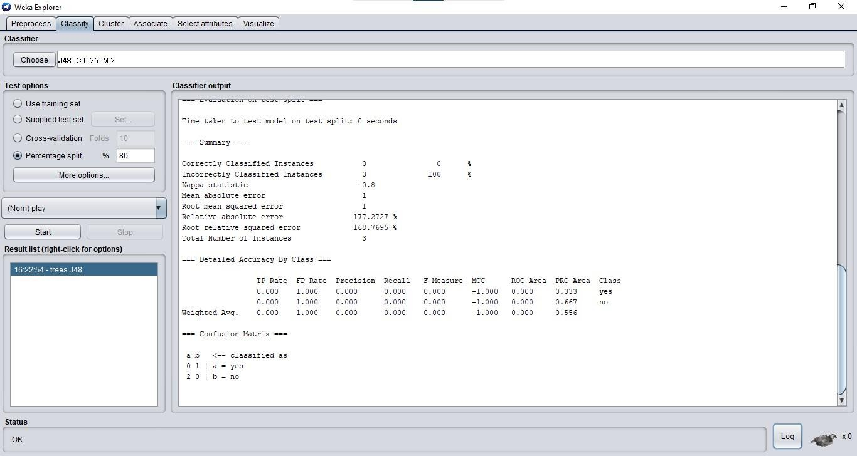

**Tree View**

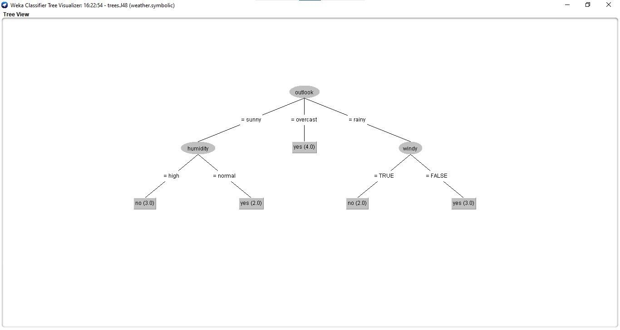

**Naïve Bayes Classifier**

