**Experiment 7**

Nidhi Parab

Subject: DWM

Class: TE4

Roll no: 35

Batch: C

**Aim:Implementation of Clustering algorithm K-means 2D**

**2d K-means Clustering**

**Program:**

package expt;

import java.util.ArrayList;

import java.util.*;

public class Clustter_2d {

public static void main(String[] args) {

int[] columnOne = new int[] {

185,

170,

168,

179,

182,

188,

180,

180,

183,

180,

180,

177

};

int[] columnTwo = new int[] {

72,

56,

60,

68,

72,

77,

71,

70,

84,

88,

67,

76

};

if (columnOne.length != columnTwo.length)

System.out.println("Wrong Dataset");

List < Integer > groupOne =

new ArrayList < Integer > ();

List < Integer > groupTwo =

new ArrayList < Integer > ();

groupOne.add(0);

groupTwo.add(1);

int x1 = columnOne[0];

int y1 = columnTwo[0];

int sumX1 = columnOne[0];

int sumY1 = columnTwo[0];

int x2 = columnOne[1];

int y2 = columnTwo[1];

int sumX2 = columnOne[1];

int sumY2 = columnTwo[1];

int length = columnOne.length;

double calc1;

double calc2;

for (int i = 2; i < length; i++) {

int xi = columnOne[i];

int yi = columnTwo[i];

calc1 = Math.sqrt((xi - x1) * (xi - x1) + (yi - y1) * (yi -

y1));

calc2 = Math.sqrt((xi - x2) * (xi - x2) + (yi - y2) * (yi -

y2));

if (calc1 > calc2) {

groupTwo.add(i);

sumX2 += x2;

sumY2 += y2;

x2 = sumX2 / groupTwo.size();

y2 = sumY2 / groupTwo.size();

} else {

groupOne.add(i);

sumX1 += x1;

sumY1 += y1;

x1 = sumX1 / groupOne.size();

y1 = sumY1 / groupOne.size();

}

}

System.out.println("Cluster 1: " + groupOne);

System.out.println("Cluster 2: " + groupTwo);

}

}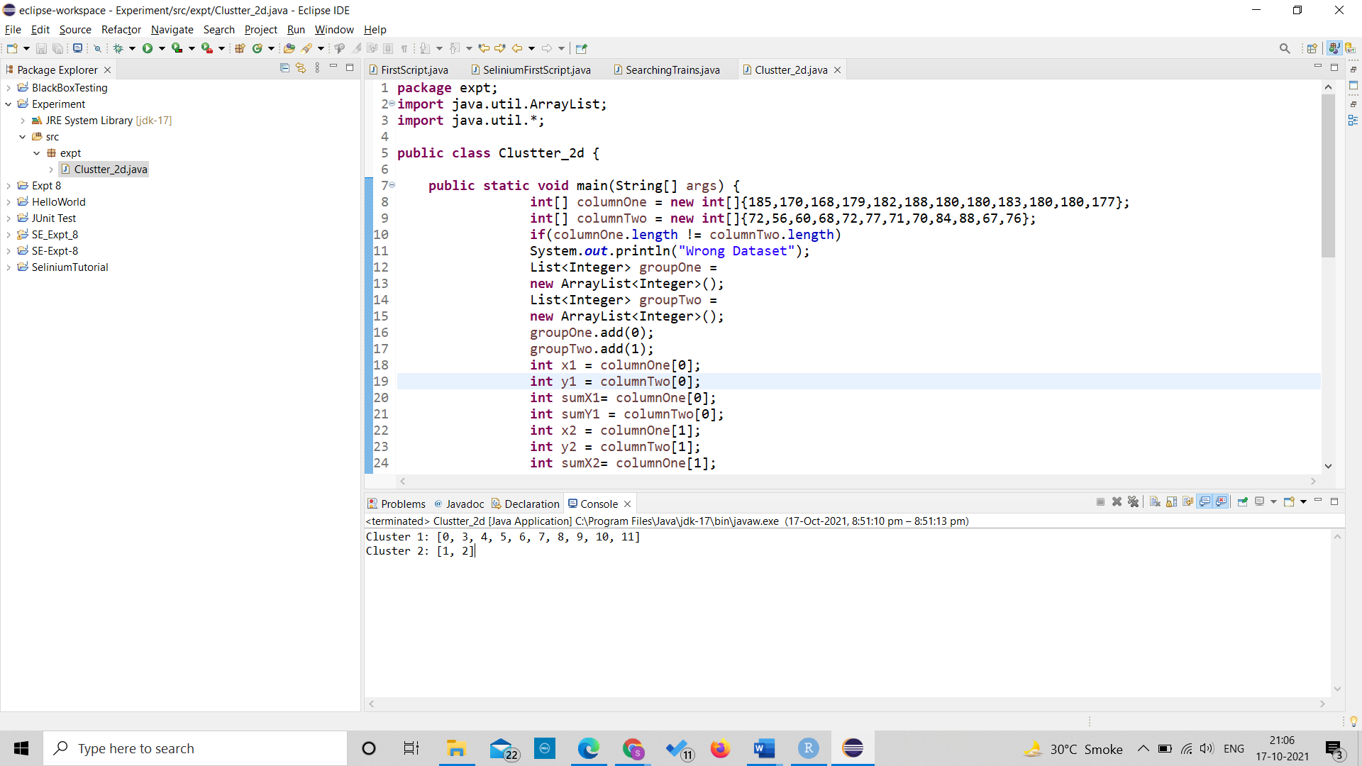**Output:**