**Experiment 9**

Nidhi Parab

Subject: DWM

Class: TE4

Roll no: 35

Batch: C

Aim: Implementation of Association Rule Mining algorithm (Apriori)

Dataset:

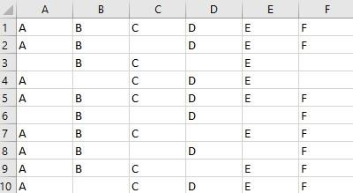

Code:

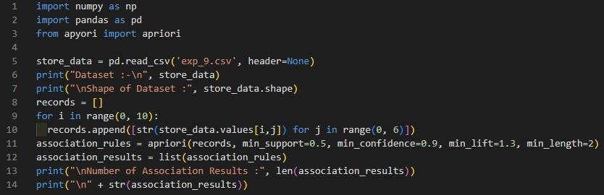

Output:

