**Experiment 10**

Nidhi Parab

Subject: DWM

Class: TE4

Roll no: 35

Batch: C

**Aim:** Implementation of Page rank algorithm.

**Code:**

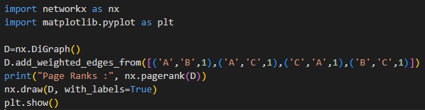

**Output:**



