**Experiment 3**

Snehil Shah

Subject: DWM

Class: TE4

Roll no: 49

Batch: D

SLICE

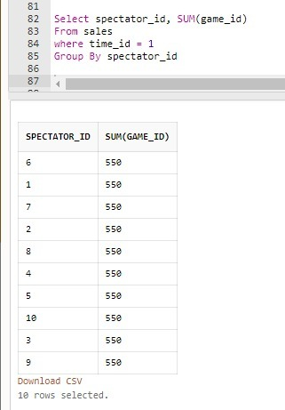

DICE

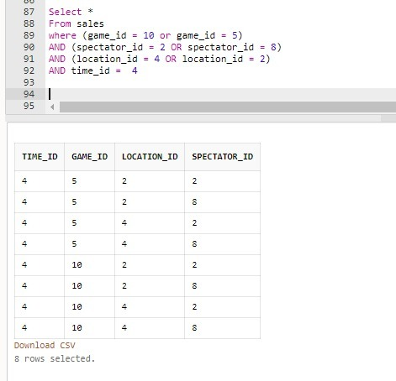

ROLLUP

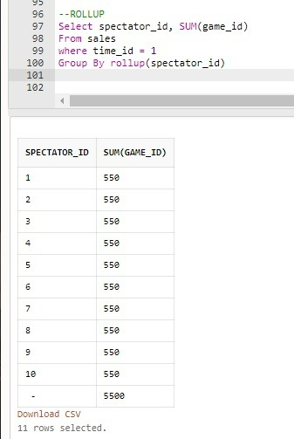

DRILLDOWN

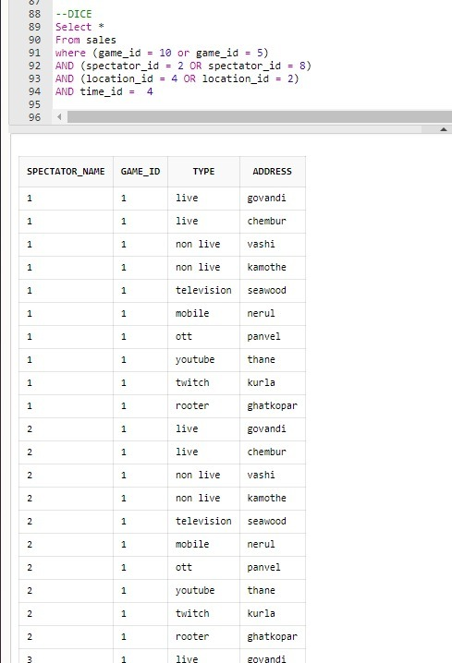

PIVOT

