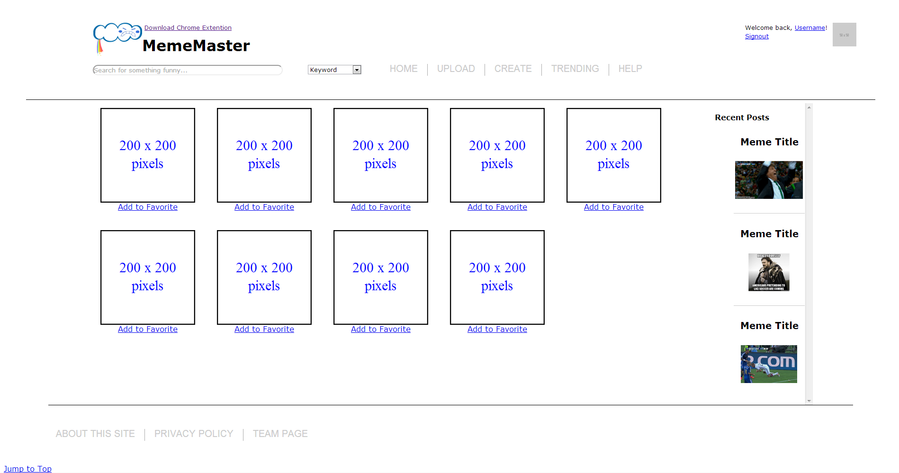

The principal of the design of the result page is we want the page is clear and simple to use so that users can focus on the result of their searching and spent times on browsing them. We understand that memes themselves are attractive so we hope users can spent the most attention on the results.

In the result page, the layout can be split into three main parts.

* + In the header users can navigate themselves to other pages of our web.
  + In the result area users will see the search results list on the page. They can also click the “Add to Favorite” button to save the meme into their own account and review them later.
  + In the recent post area user can see the latest meme that have been uploaded.