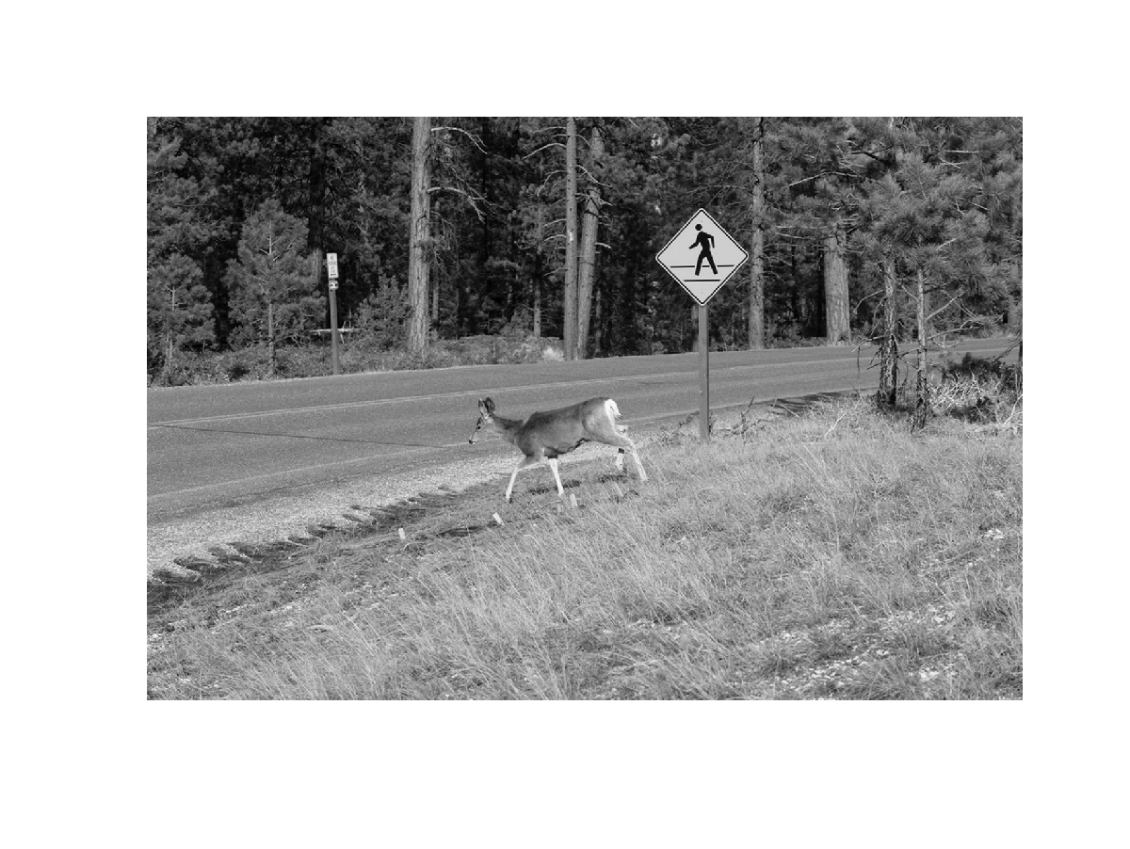
(a) Original image:

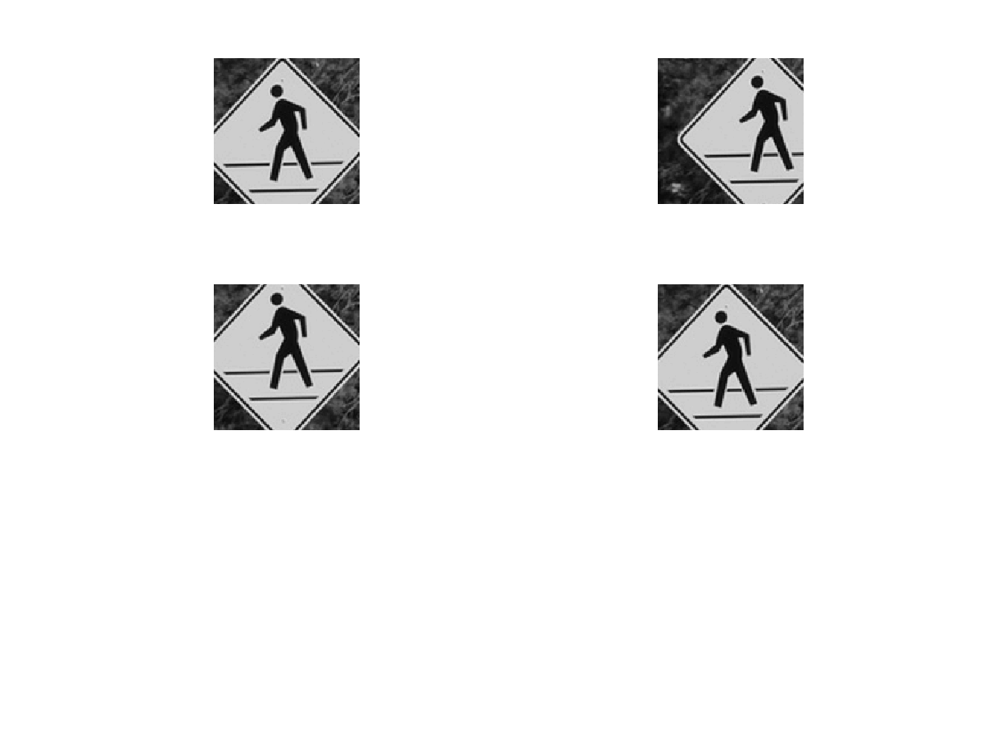
Training samples:

Template
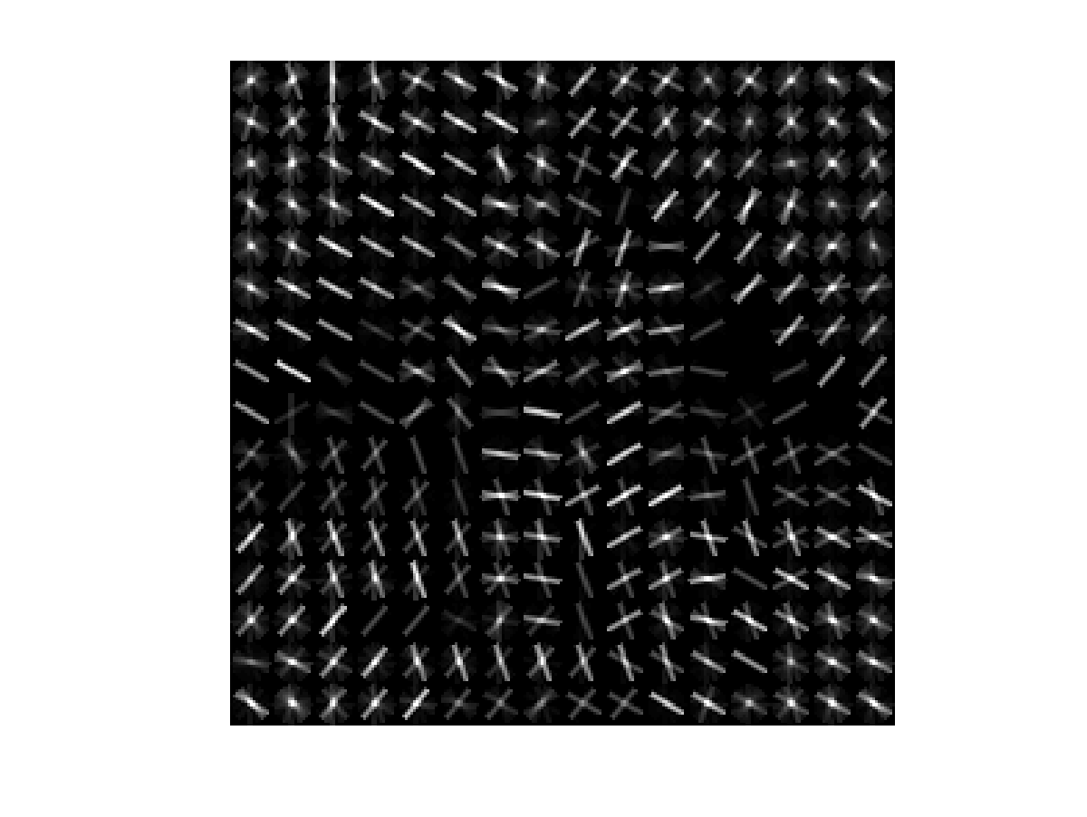

Detection
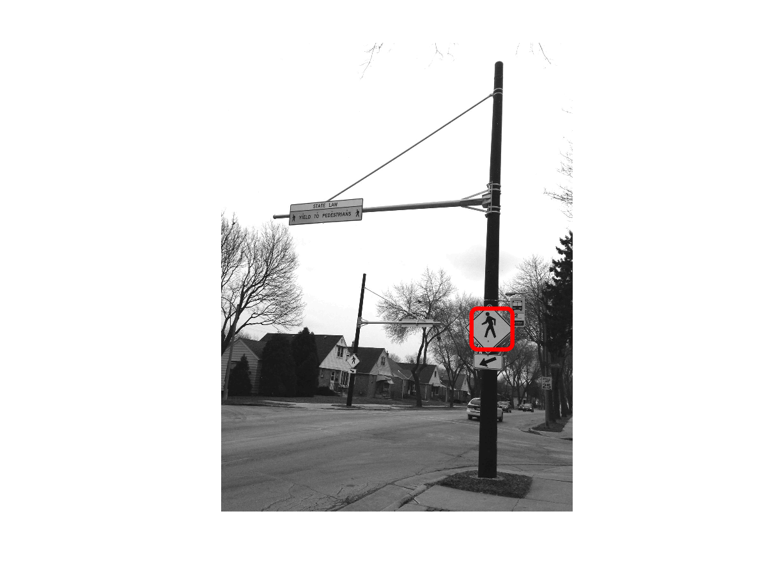

(b)
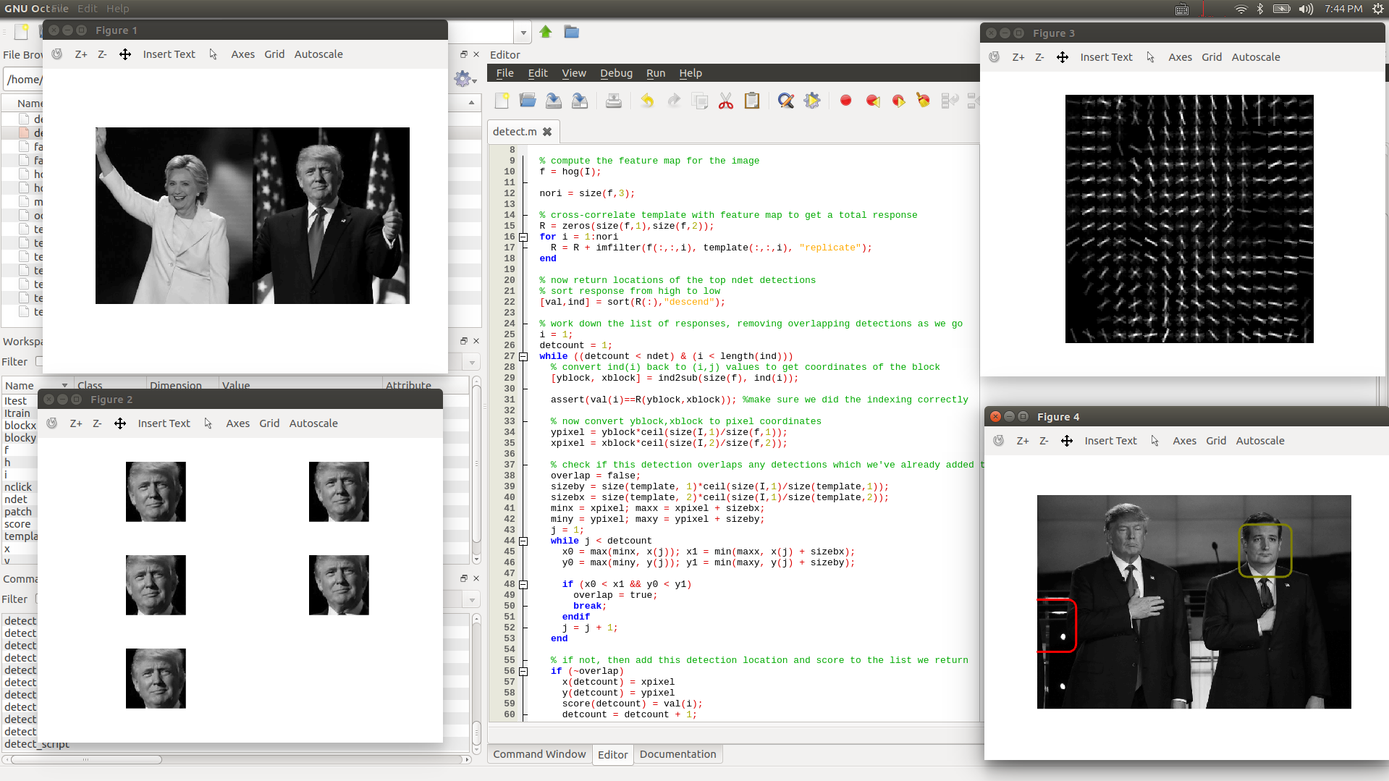
(c)
The detector fails when the template size doesn’t match the object in the target image. It doesn’t work well in many cases when the template looks similar while the actual image is completely different, possibly due to insufficient training set (# of samples and amount of variation) and the lack of ways to subtract away wrong examples, especially for complicated objects like faces. However, It works pretty well on simpler objects like road symbols even for one training sample.

