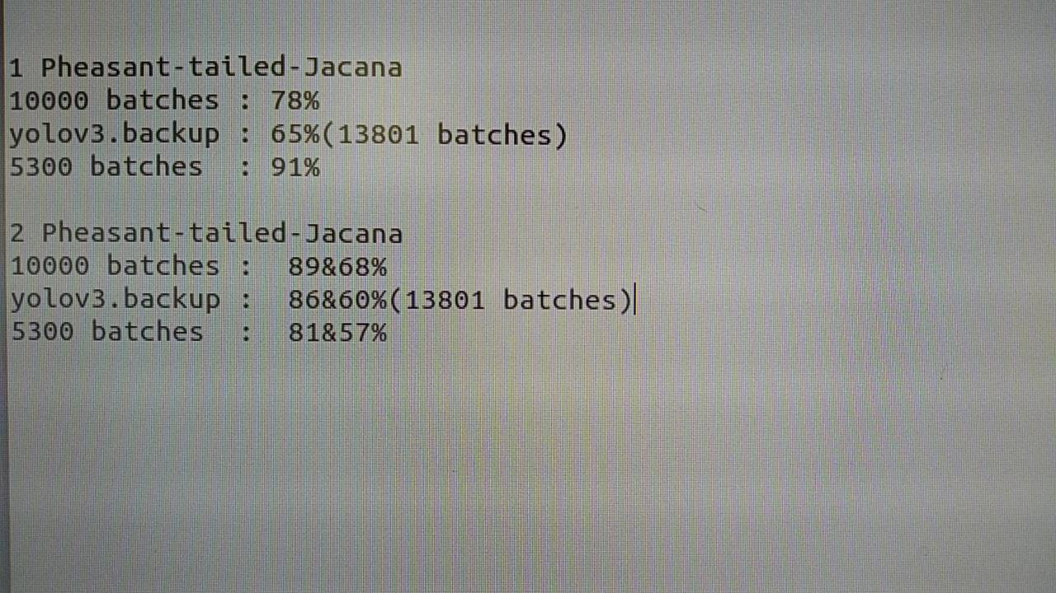

**測試結果：**

單隻水雉(圖一)辨識率

10000次batches:78%

13801次batches:65%

5300次batches:91%

兩隻水雉(圖二)辨識率

10000次batches:89%和68%

13801次batches:86%和60%

5300次batches:81%和57%

**辨識之圖片參考下頁圖一及圖二**

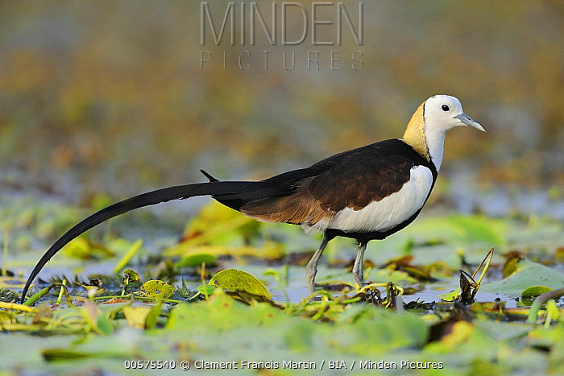

**圖一**

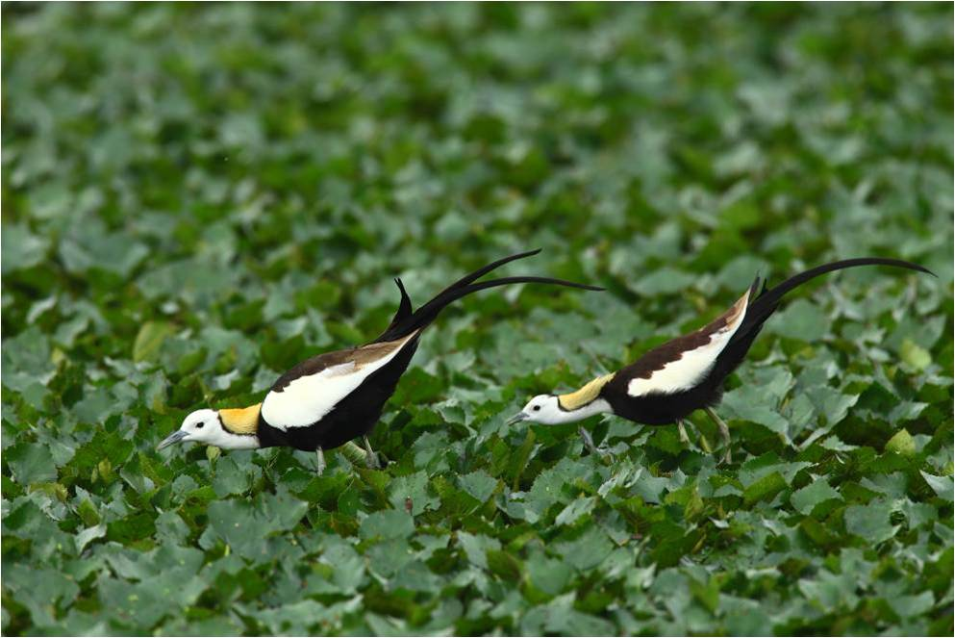

**圖二**

[Python影像辨識筆記(九之四)：可視化YOLOv3訓練過程中的loss、IOU、avg Recall等的曲線圖](https://medium.com/@yanweiliu/python%E5%BD%B1%E5%83%8F%E8%BE%A8%E8%AD%98%E7%AD%86%E8%A8%98-%E4%B9%9D%E4%B9%8B%E5%9B%9B-%E5%8F%AF%E8%A6%96%E5%8C%96yolov3%E8%A8%93%E7%B7%B4%E9%81%8E%E7%A8%8B%E4%B8%AD%E7%9A%84loss-iou-avg-recall%E7%AD%89%E7%9A%84%E6%9B%B2%E7%B7%9A%E5%9C%96-ef3d36daa5ec)

[NVIDIA Jetson TX2學習筆記（五）: 安裝matplotlib和pandas](https://medium.com/@yanweiliu/nvidia-jetson-tx2%E5%AD%B8%E7%BF%92%E7%AD%86%E8%A8%98-%E4%BA%94-%E5%AE%89%E8%A3%9Dmatplotlib%E5%92%8Cpandas-d8b274034fb2)