Early E9 fuse block
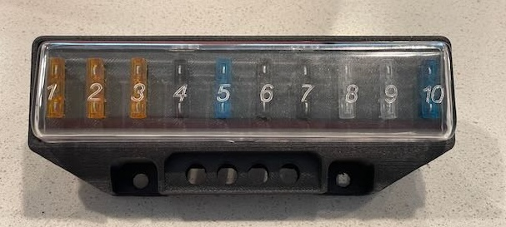

Parts Used:
Name | Link | Cost | Date
Polymaker PPS-CF | https://www.amazon.com/dp/B0D4QFF6VM?ref_=ppx_hzsearch_conn_dt_b_fed_asin_title_1 | Approx $10 for part.  $70 per role | 11/7/2024
Kadrick M2*3 * 3 heat insert | https://www.amazon.com/dp/B0D142BCLX?ref_=ppx_hzsearch_conn_dt_b_fed_asin_title_6&th=1 | $8.99 box of 200 | 6/7/2024
PCB from JLCPCB | https://jlcpcb.com/ | $57.04 Qty 20 | 6/12/2024
Screws M2. Length? Maybe 4 or 6mm comes in set. | https://www.amazon.com/dp/B09TVP1G5B?ref_=ppx_hzsearch_conn_dt_b_fed_asin_title_5&th=1 | $8.99 Assorted | 6/6/2024
Fuse clip  36-3557-ND | https://www.digikey.com/en/products/detail/keystone-electronics/3557/2092485 | $383 Qty 25 | 5/22/2024
Blade Connector  1217125-1 | https://www.digikey.com/en/products/detail/te-connectivity-amp-connectors/1217125-1/2308469?s=N4IgTCBcDaIIxjgdgQVgLR3QZQJLoDkAREAXQF8g | $9.90 Qty 50 | 5/22/2024

Cost for 14 (2 roles filament) is $25 for 1. Blade connector is much cheaper at 500 qty. If all parts purchased for 20 units cost would be around $20 each.
Not including clear cover from Wallothnesch, at $16.76 12/24/202

3D Print:
Used Qidi Plus 4 printer with default settings for their PPS. Worked fine with the Polymaker filament.
Supports were used but its a bit painful to remove and care needs to be taken to not break off the supports. In the image the vertical lines support the board. Should be printed with the front of the fuse block facing away from the bed
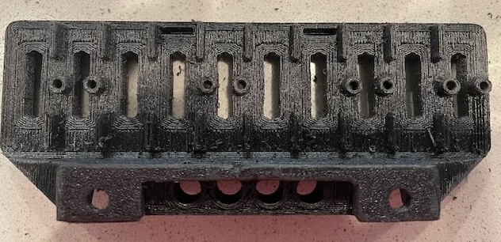
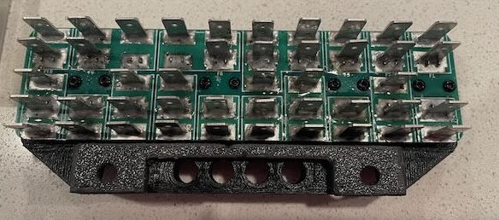

Files:
All Project Files:
https://github.com/e9frank/e9diyparts/tree/main/EarlyE9FuseBlock
Kicad schematic and Gerbers: (FuseBlockBlankV2.zip sent to JLCPCB)
https://github.com/e9frank/e9diyparts/tree/main/EarlyE9FuseBlock/pcb/FuseBlockBlank
FreeCad and STL:
https://github.com/e9frank/e9diyparts/tree/main/EarlyE9FuseBlock/3d/FuseBlockV2

