Back Trim
This contains details of the back side card and wood trim under the back side window.
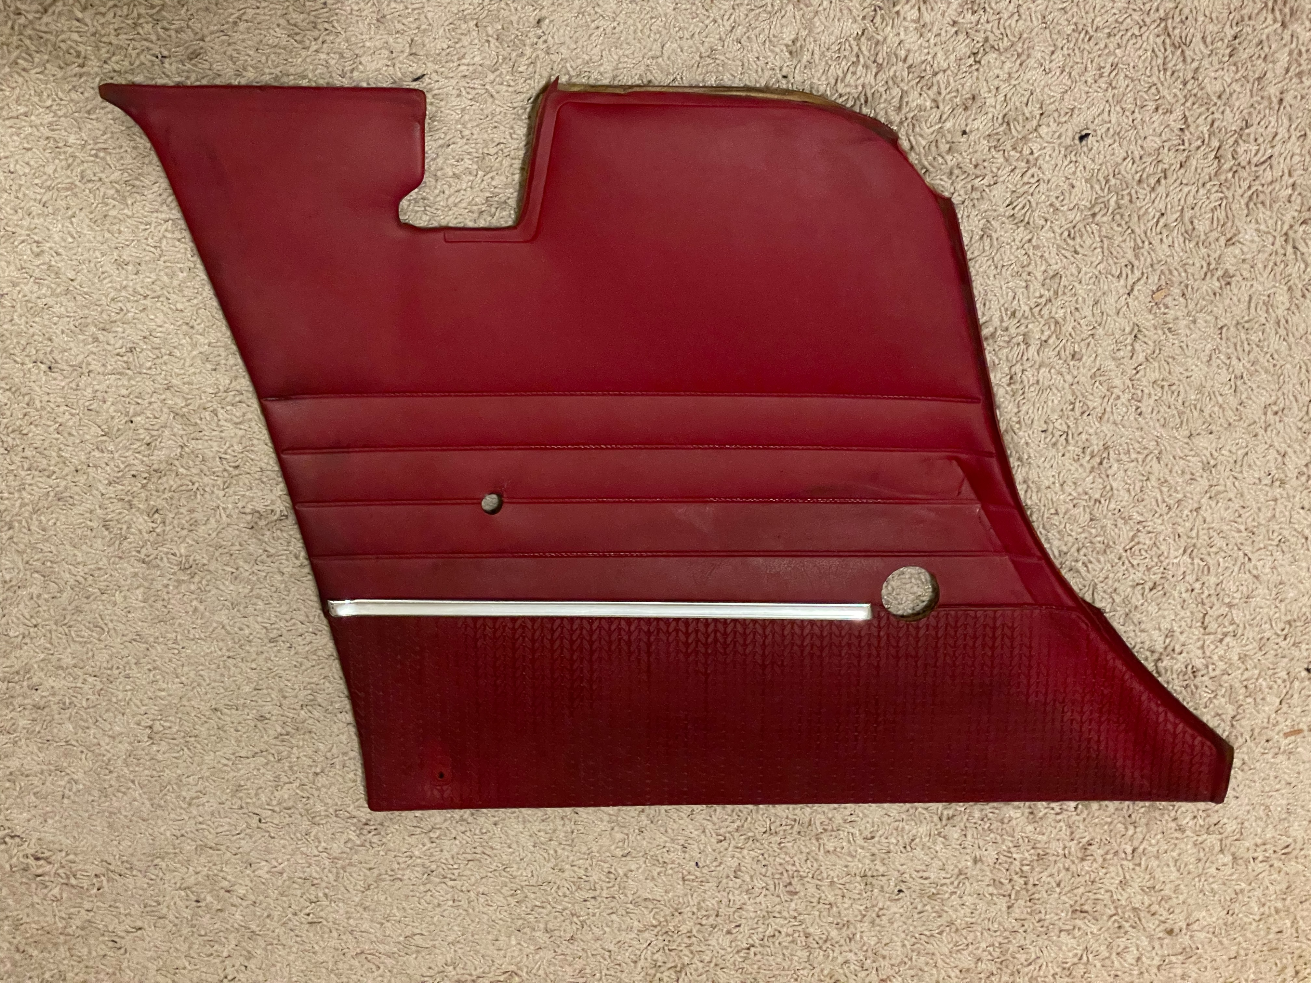
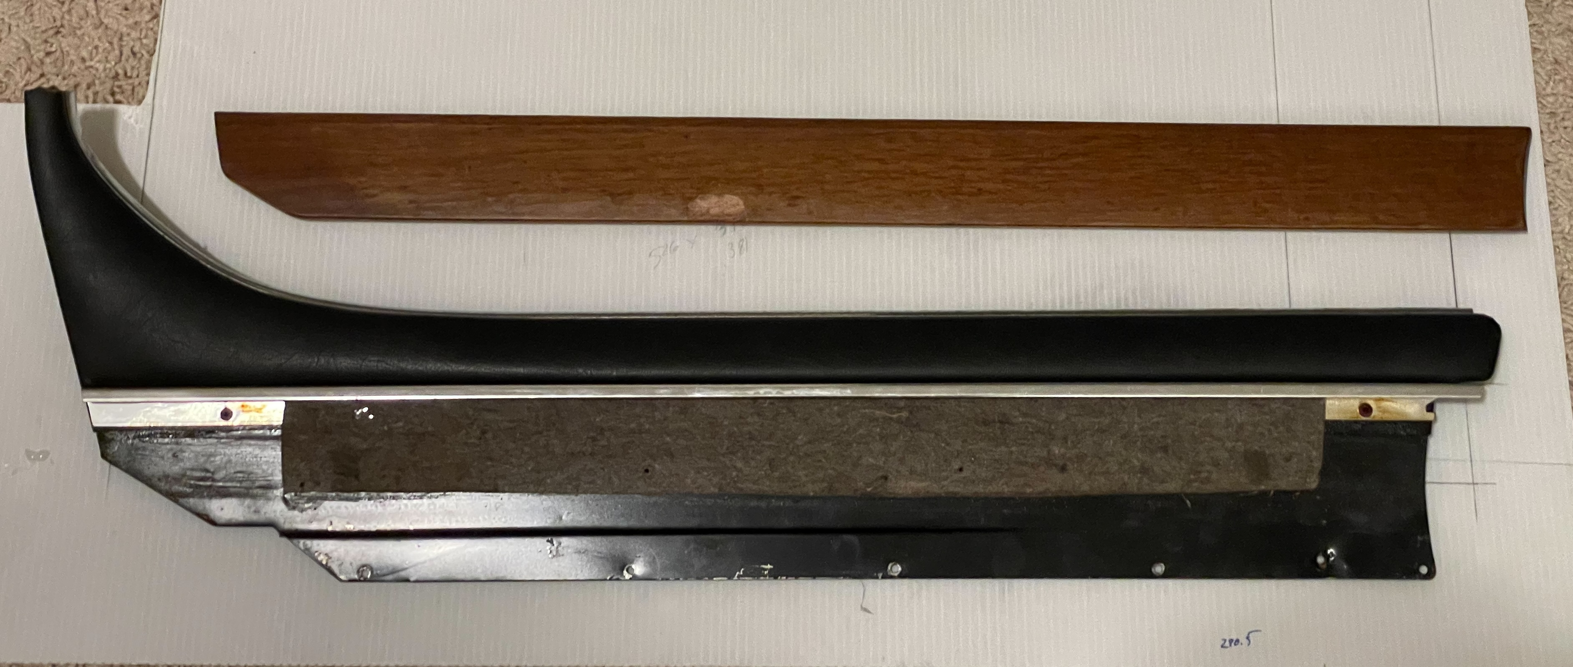
This is the hardware holding the trim. There is a seat belt hook held on by a Phillips head screw. This needs to be taken off before the card can be removed. The screw is shown above the hook.
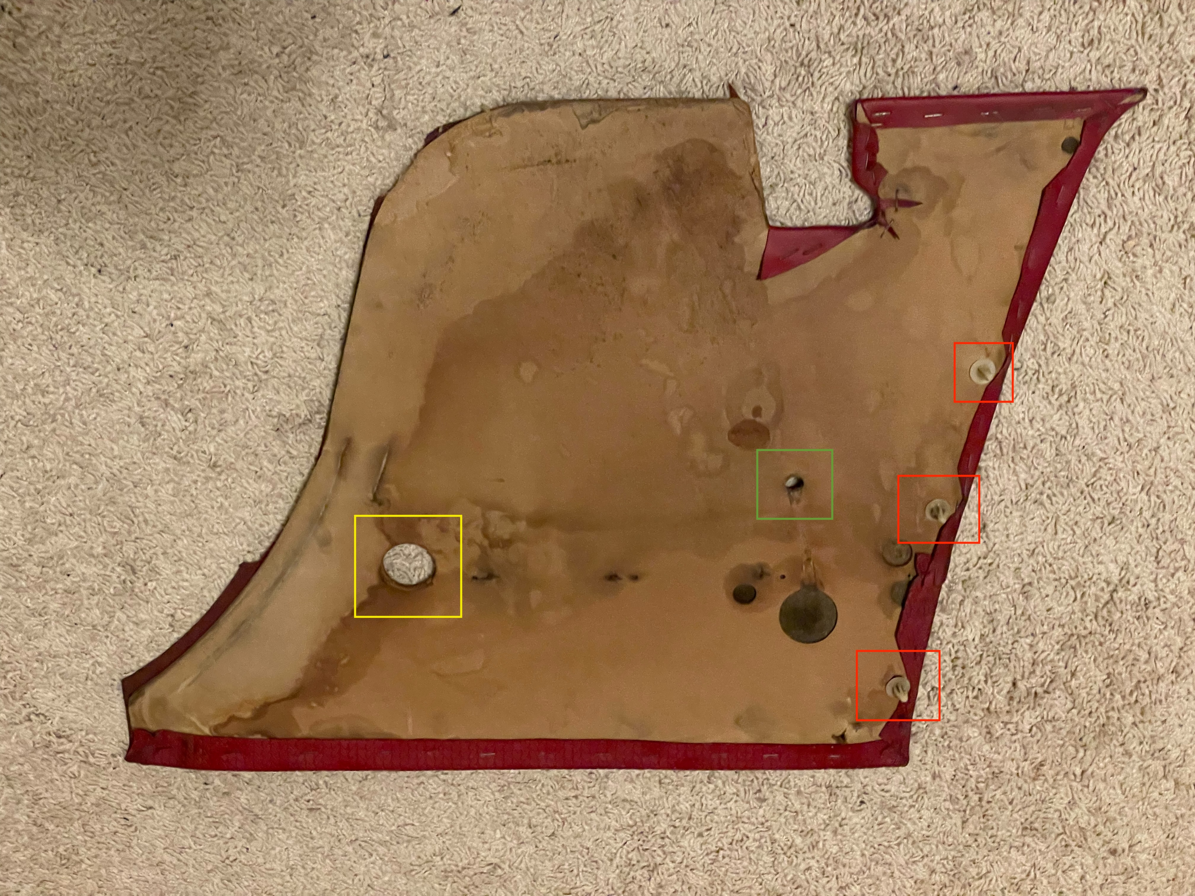
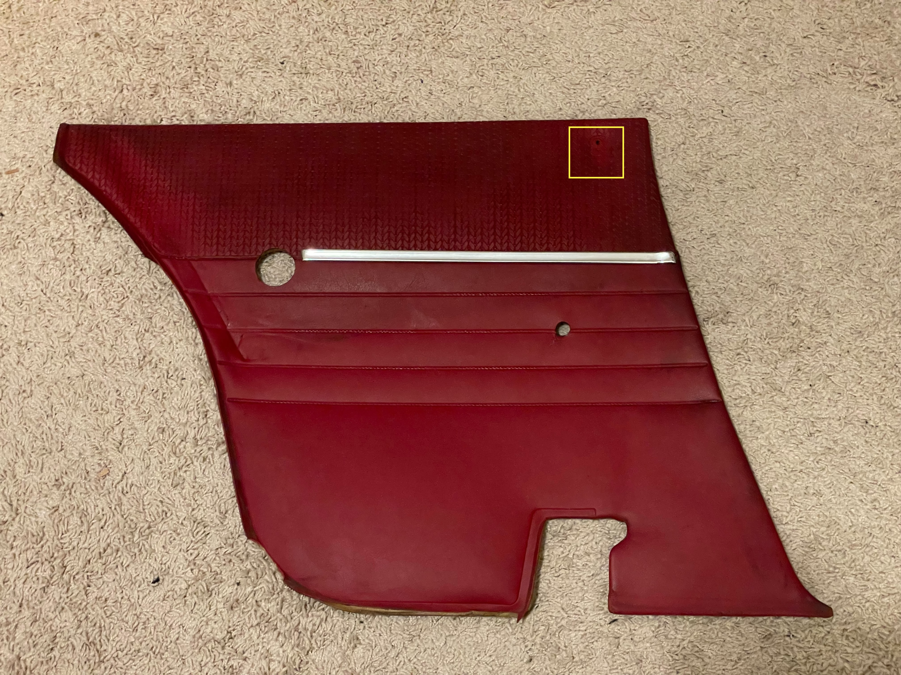
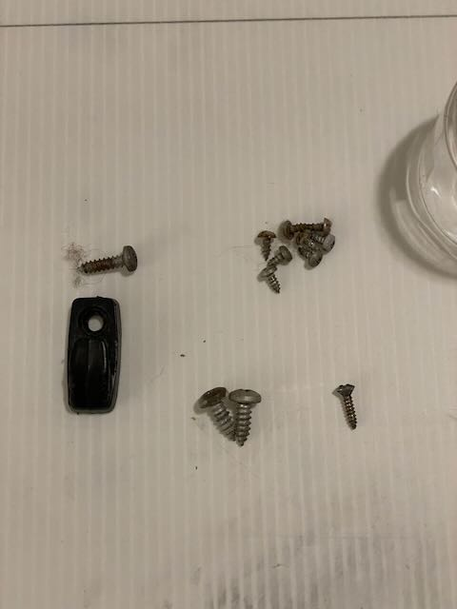
The red side card is clipped in with 3 door card clips. Use a door trim puller tool to get under the clips and pull pop them out. The 3 red boxes show the location of the clips. The green box is a hole where the power window wire goes through. This goes to the arm rest which needs to be removed first before the side card. The yellow box on the back cover is what I believe to be the manual crank hole. I believe this should have a plastic cap. Mine was missing.

With the clips popped out pull the card down from behind the wood trim piece.
Remove 5 small screw from the trim as shown by the 5 red boxes. Do not pull on the trim the is one hidden screw.
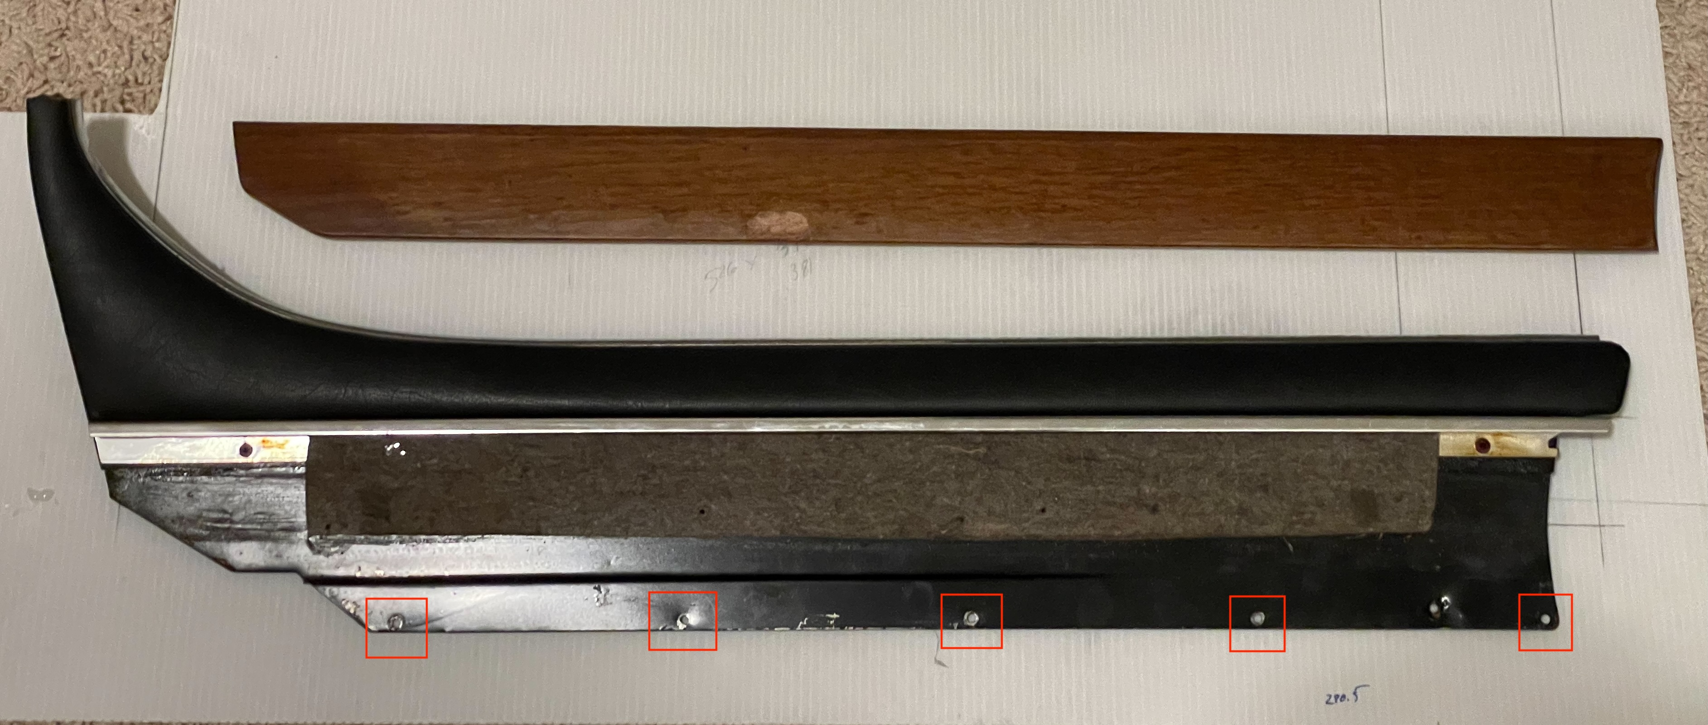
To get to the hidden screw you need to lower the back window a few inches. Once low enough you should see the screw as shown in the red box. This is looking into the car from the outside. The screw is already removed and the hole is showing.
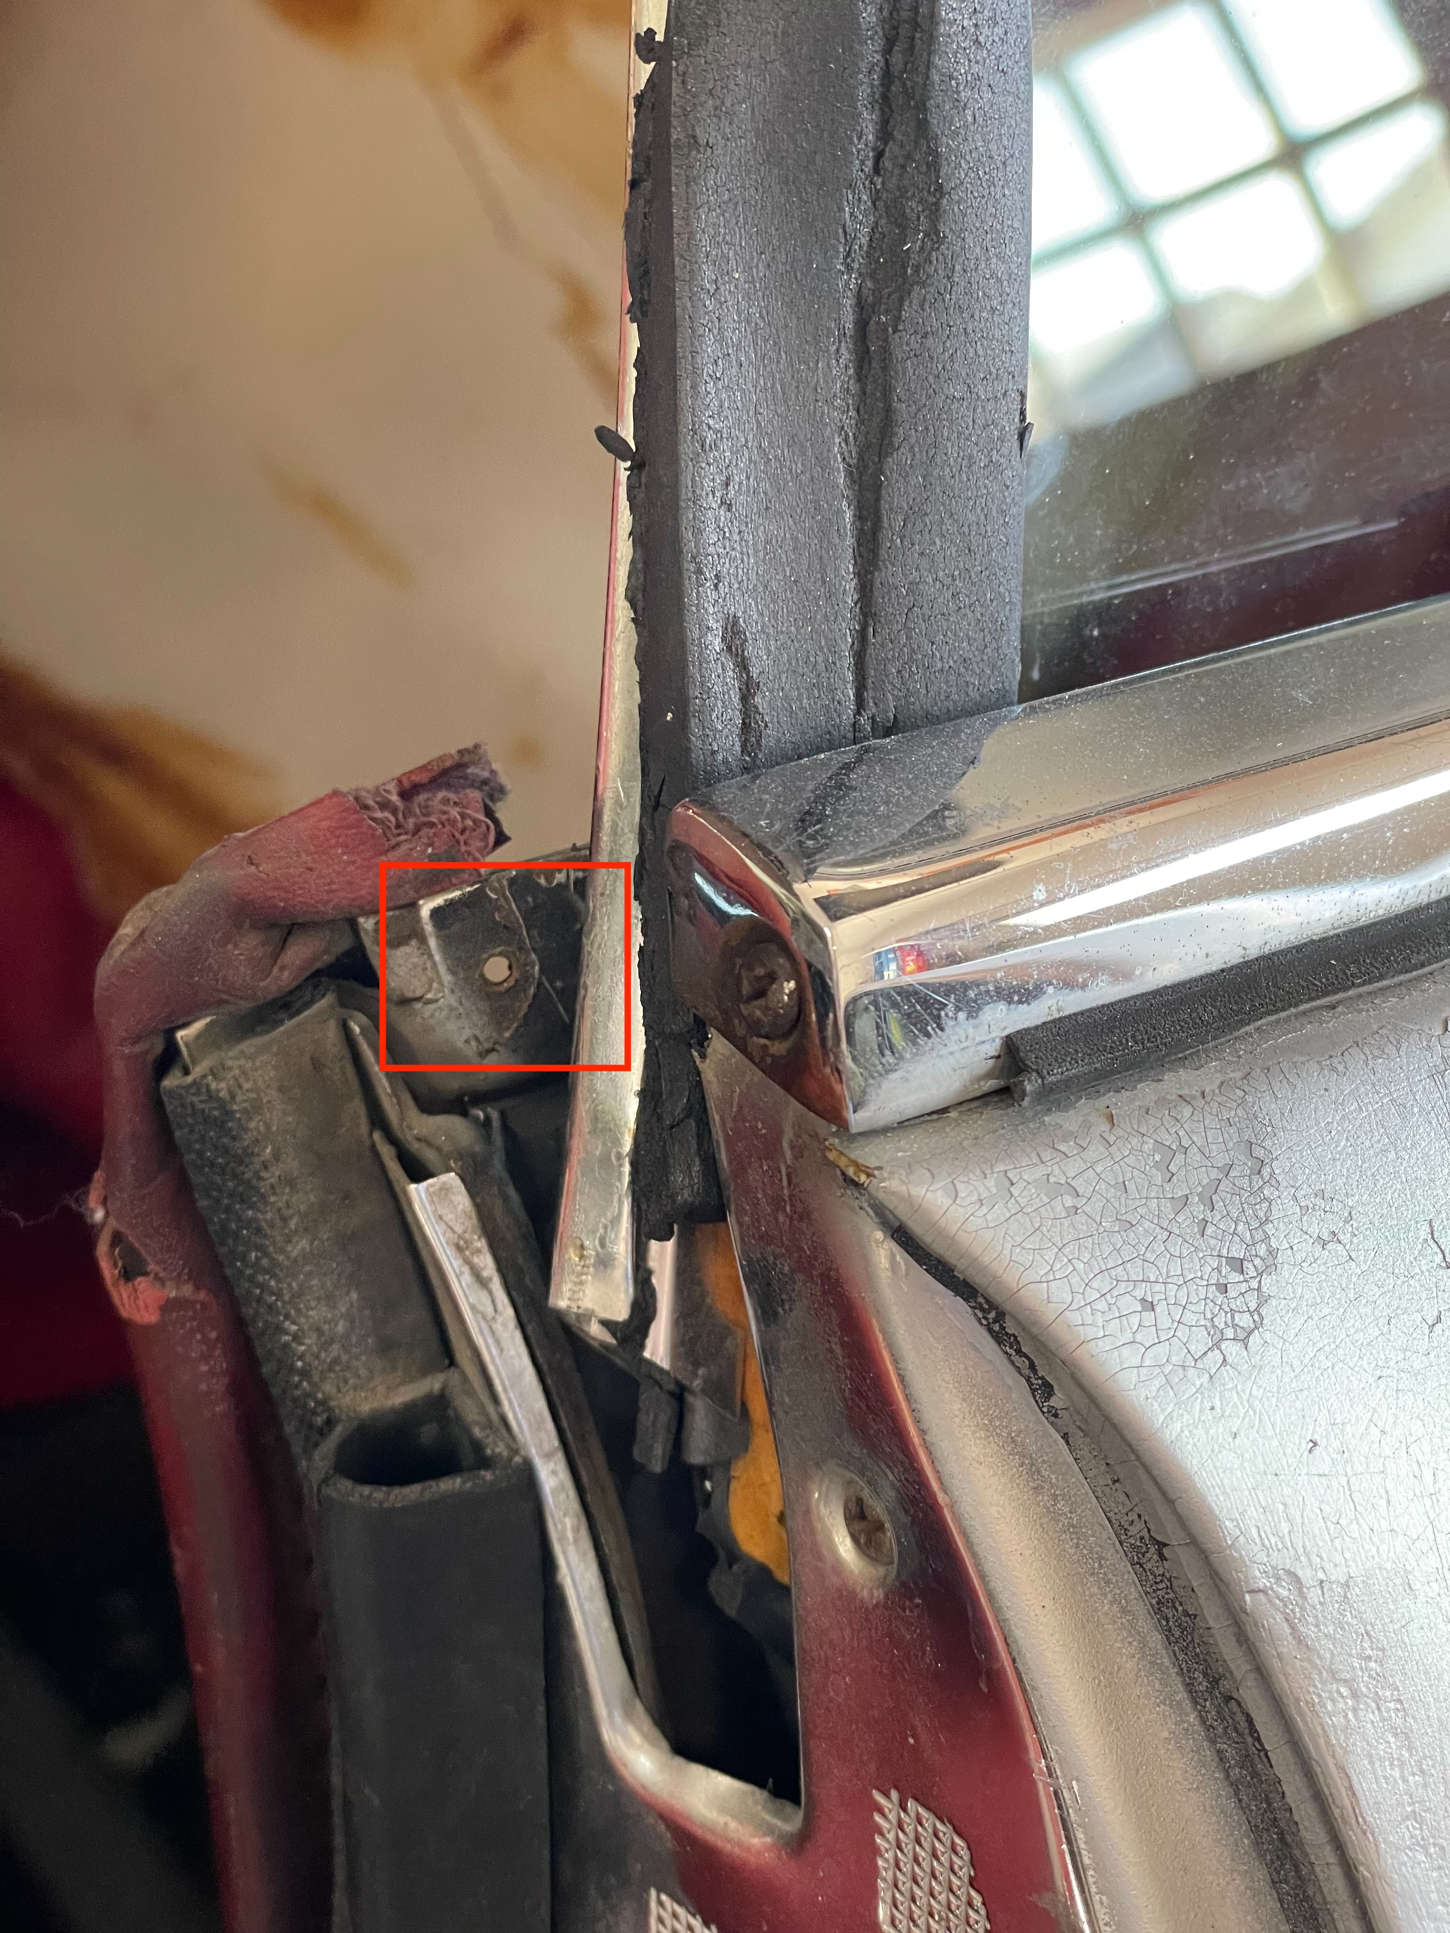
With the hidden screw removed, the entire trim piece should lift up and out.
To remove the wood from the rest of the trim there are 4 small screws holding it on. The last yellow box has the wood block and some ply missing. The screws are under the felt. Once the screws are removed the wood slides from under some metal trim at the top.
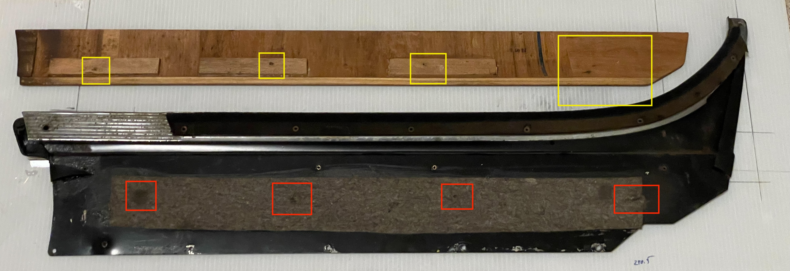
Interesting side note is that the window felt is riveted on along with the metal trim. Drilling is required to replace it.

The screws used are all Phillips with sizes as follows, hook screw: Pan head M3.5x16, Small screws holding trim and wood: Pan head Measured as M2.5x7 (cant find this size), Hidden trim screw: Oval head M2.9x13. The other 2 screws shown in the middle bottom are the arm rest screws sized M4.8x13.

