Climate Controls
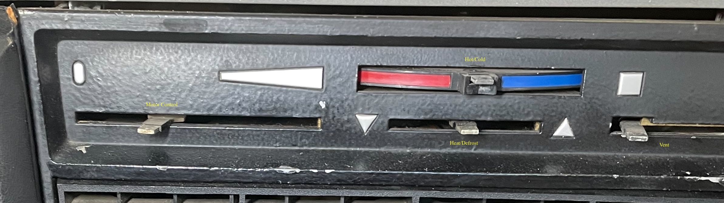
This is the set of levers for the heater from a 1970 2800CS. The knobs have already been removed.

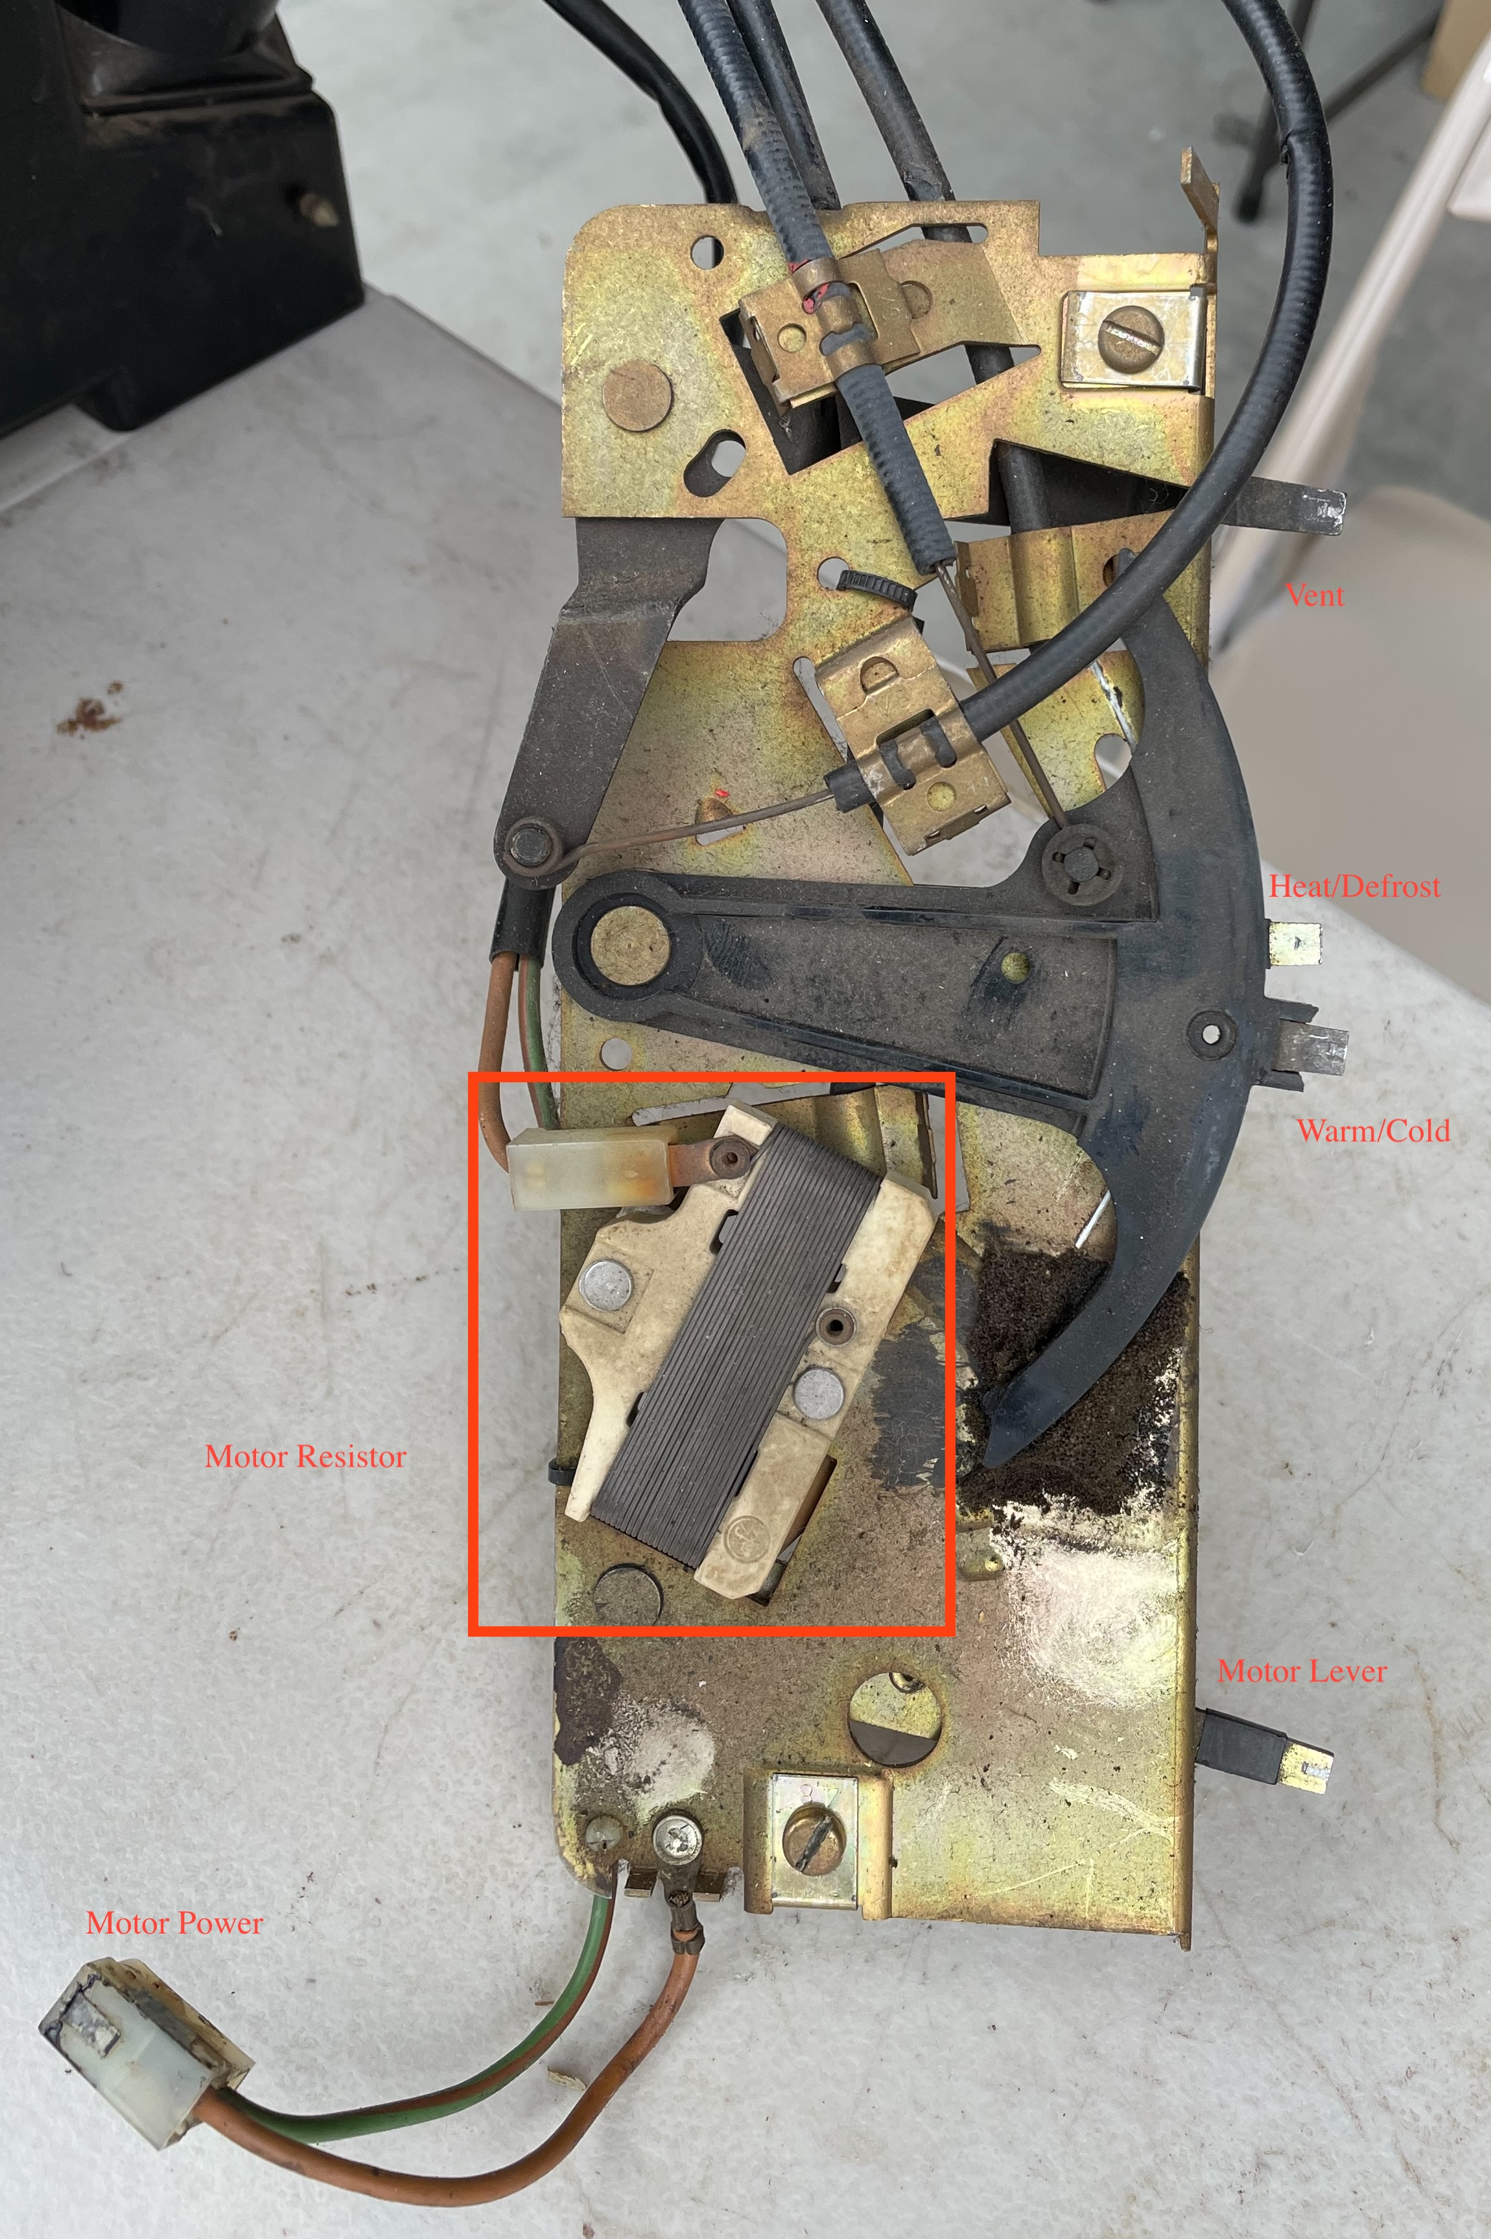
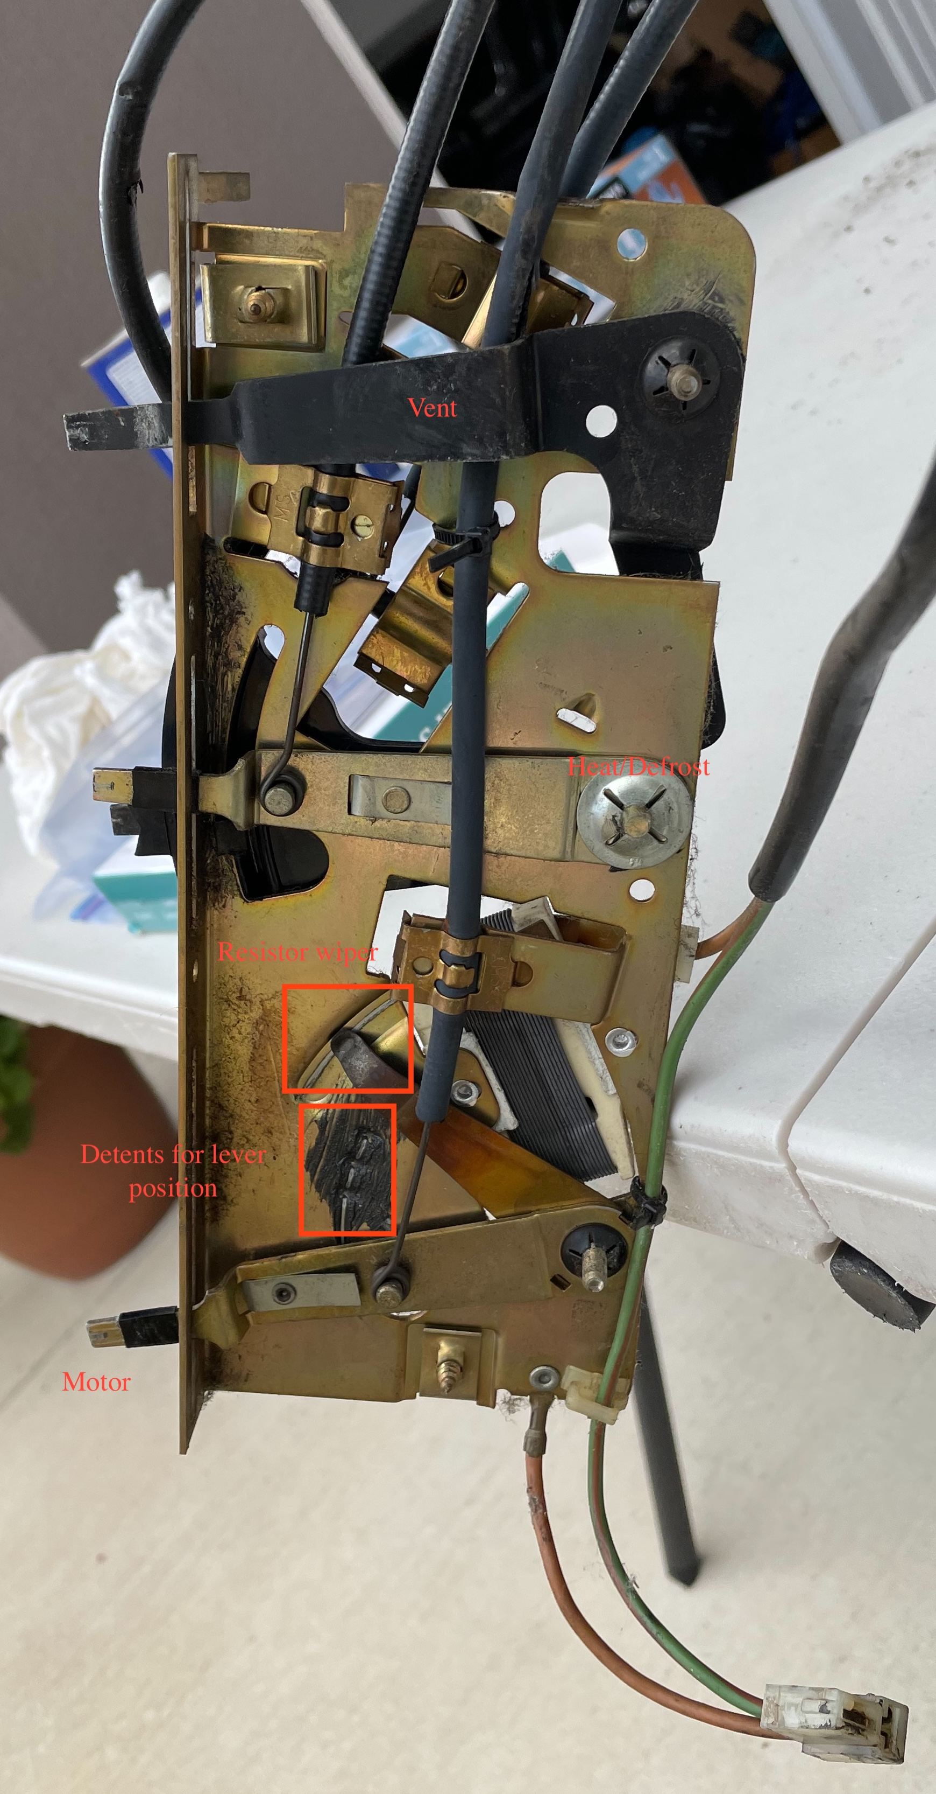

Motor control:
The lever furthest to the left controls the speed of the motor. This is done through the use of the wire wound resistor. There are several detents in the frame that the lever can locate into. The lever also controls a duct that lets in the outside air. The following pictures show the outside of the motor and then the inside behind the blower is the flap half way open.

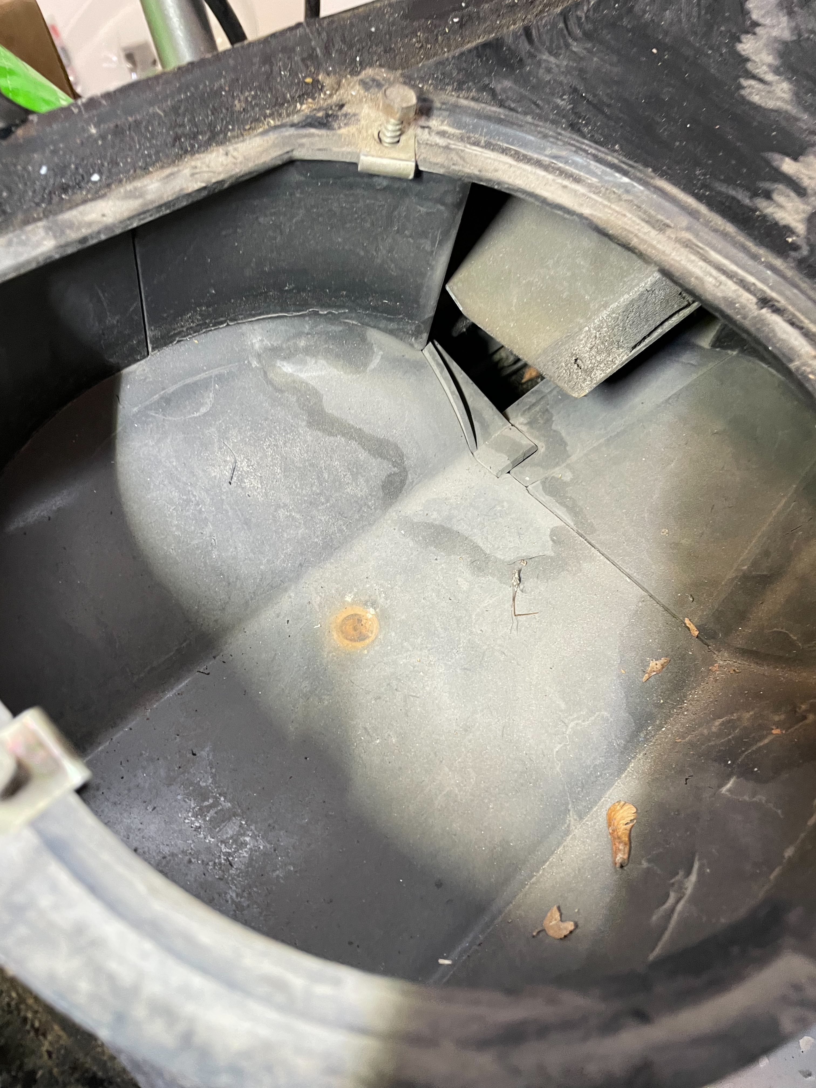
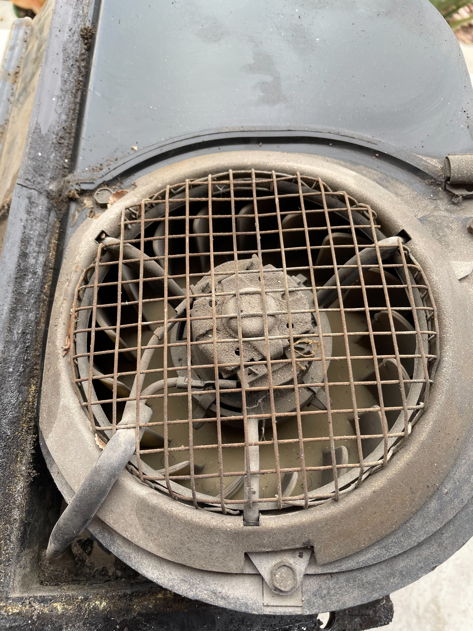
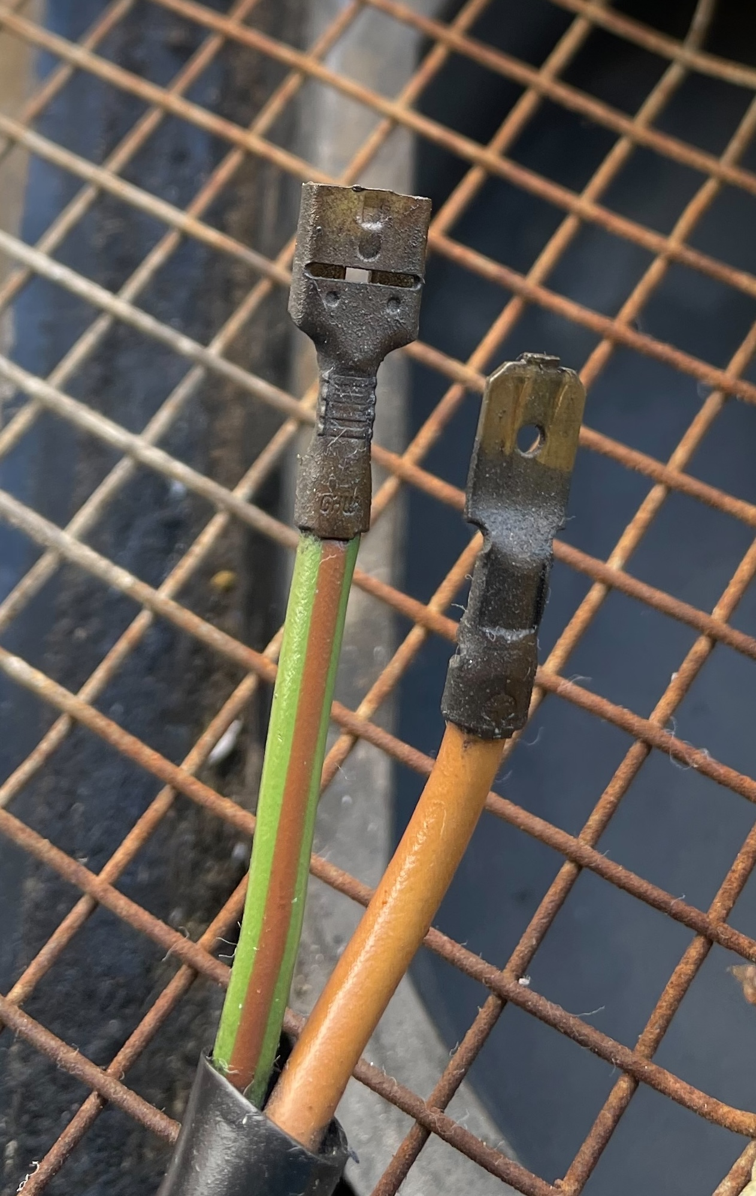

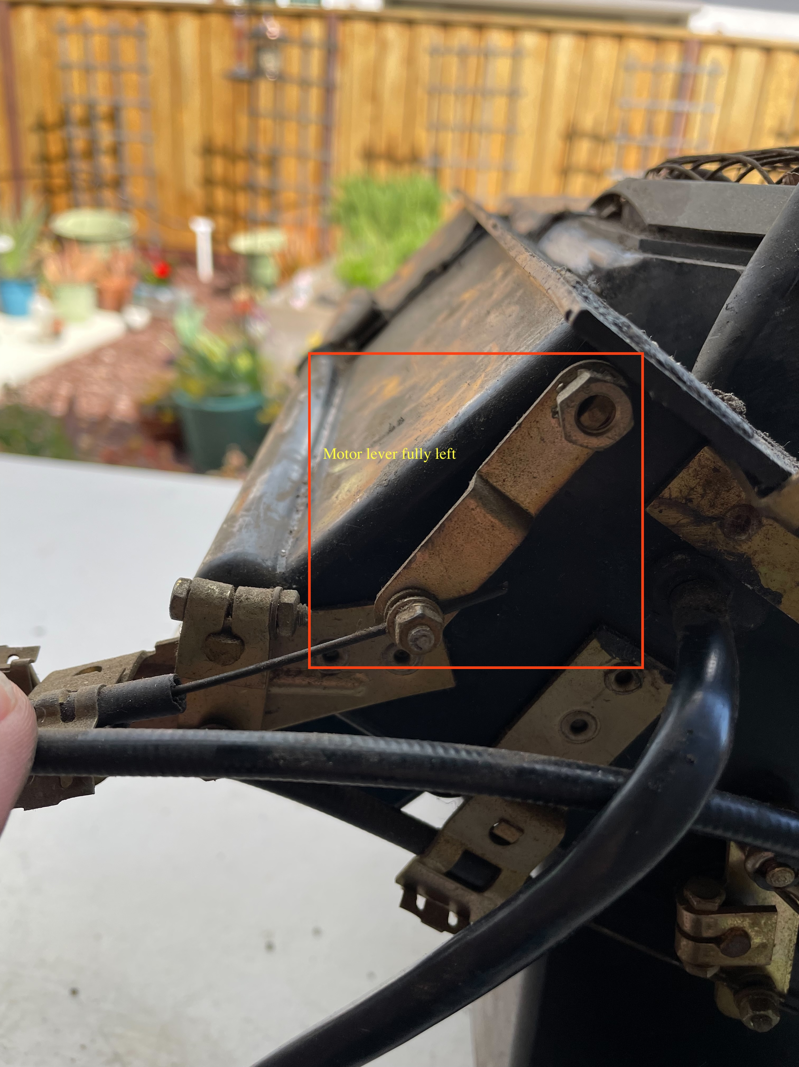
The flap is fully closed when the motor lever is all the way to the left. The center picture shows the motor wires and which connector type should be ground (brown) and which is power (green/brown).
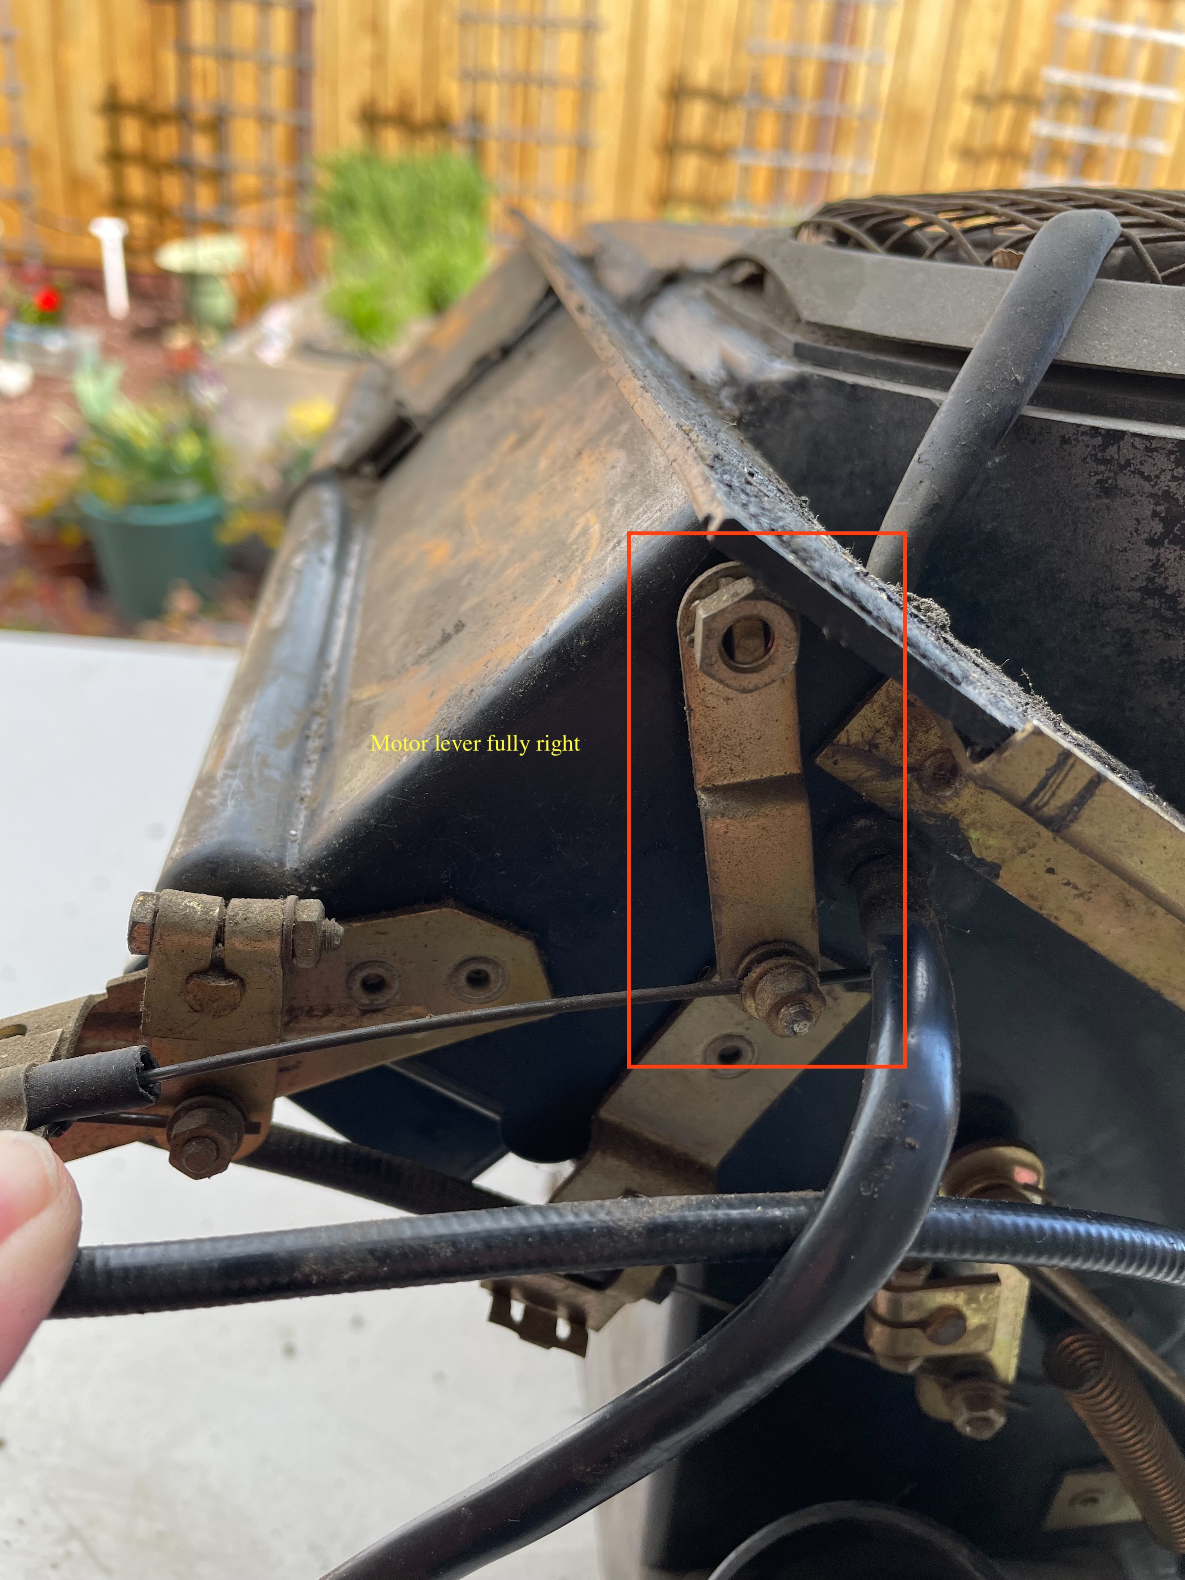
The pictures above show the position of the lever on the heater box in the fully closed and open positions.

Hot / Cold control:
The hot/cold lever controls to linkages on the heater box. The first 2 images are with the lever to the far left which would be cold.
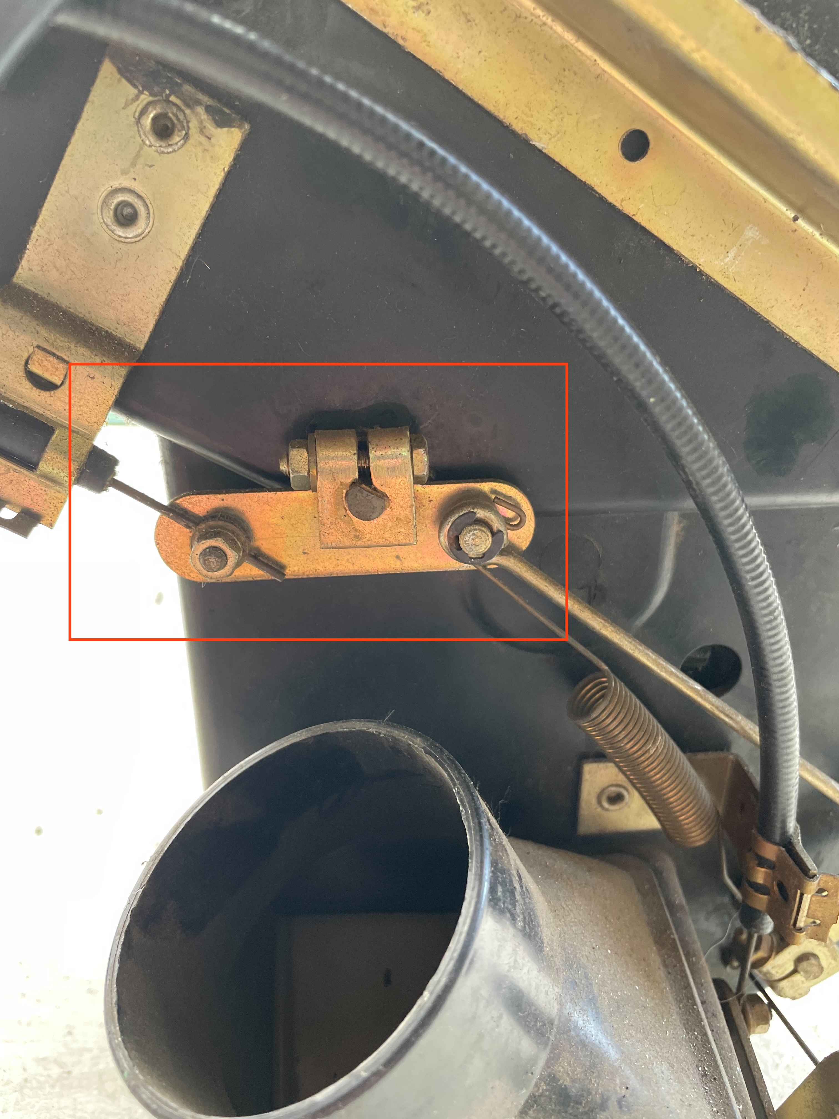
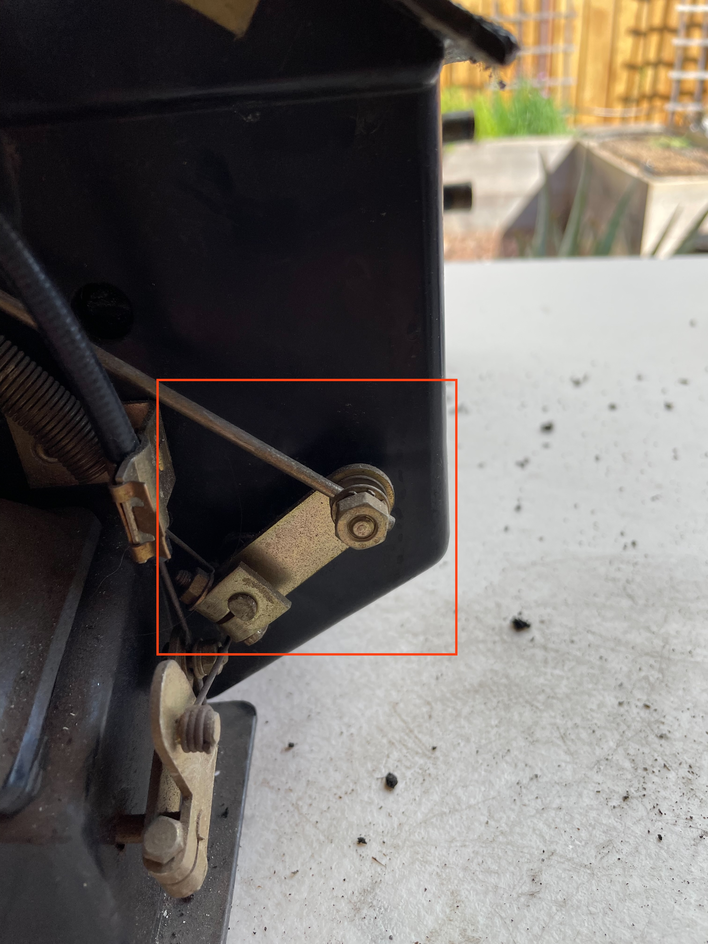
These pictures are with the lever all the way to the right.
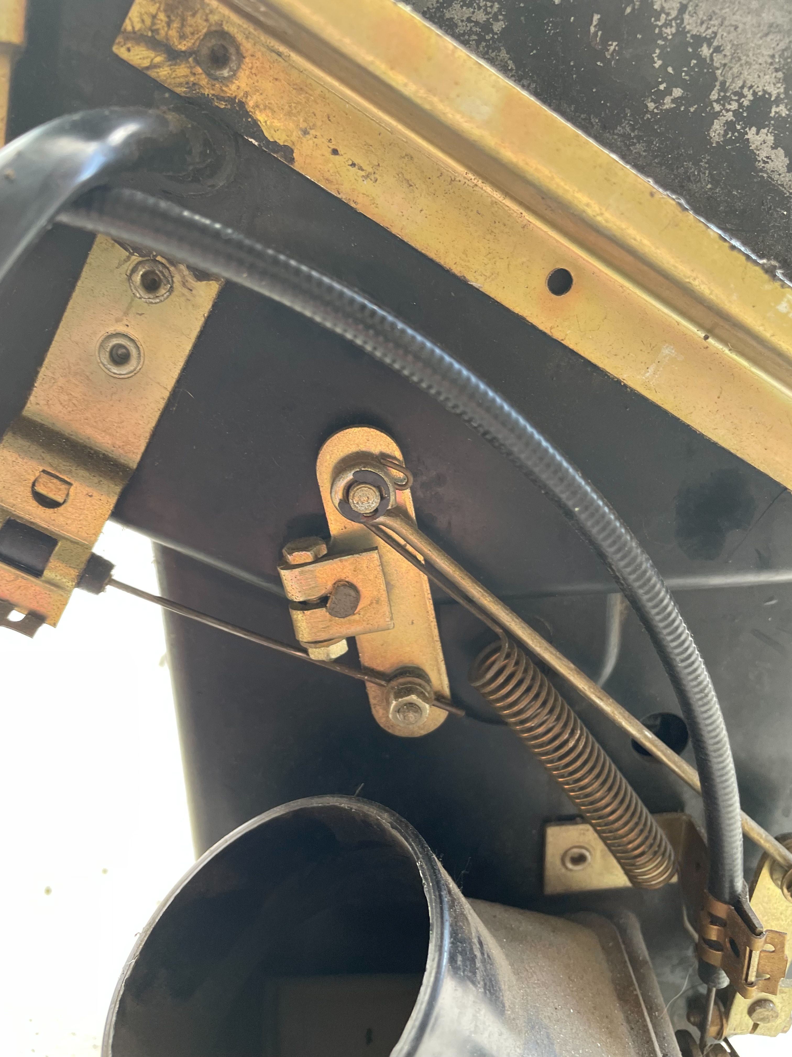
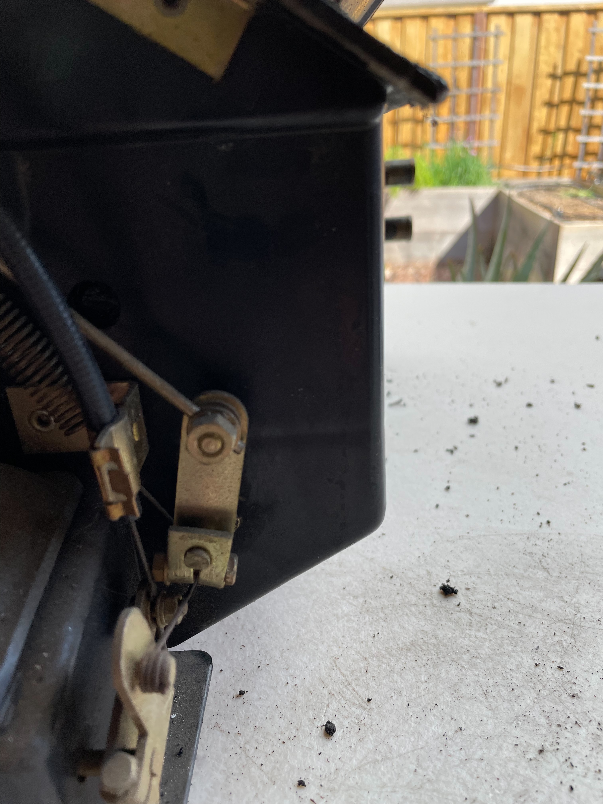
There is little to see of these levers from the outside.

Heat Defrost control:
This lever opens up the tubes that run to the top of the dash. With the lever to the left the dash duct is closed. The third image shows the duct from the bottom and you can just see the tube leading to the top. This should be blowing heat to the floor.
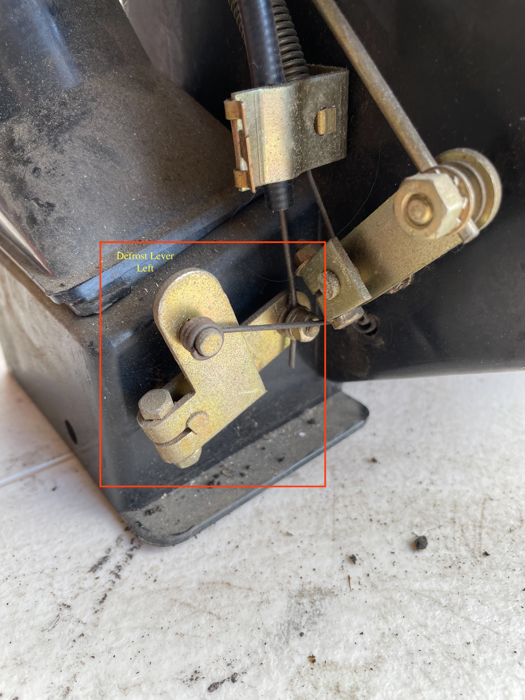
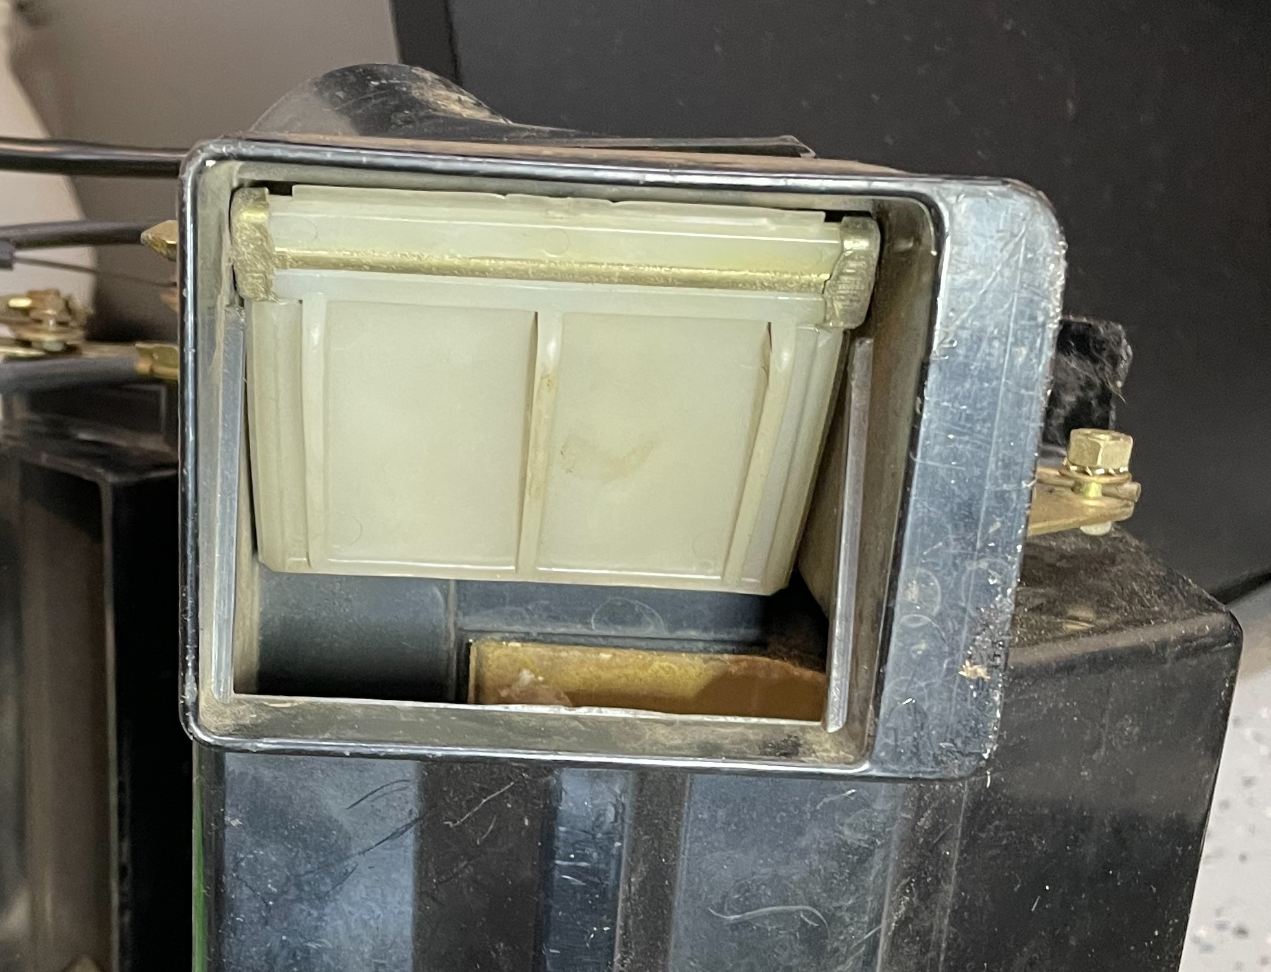
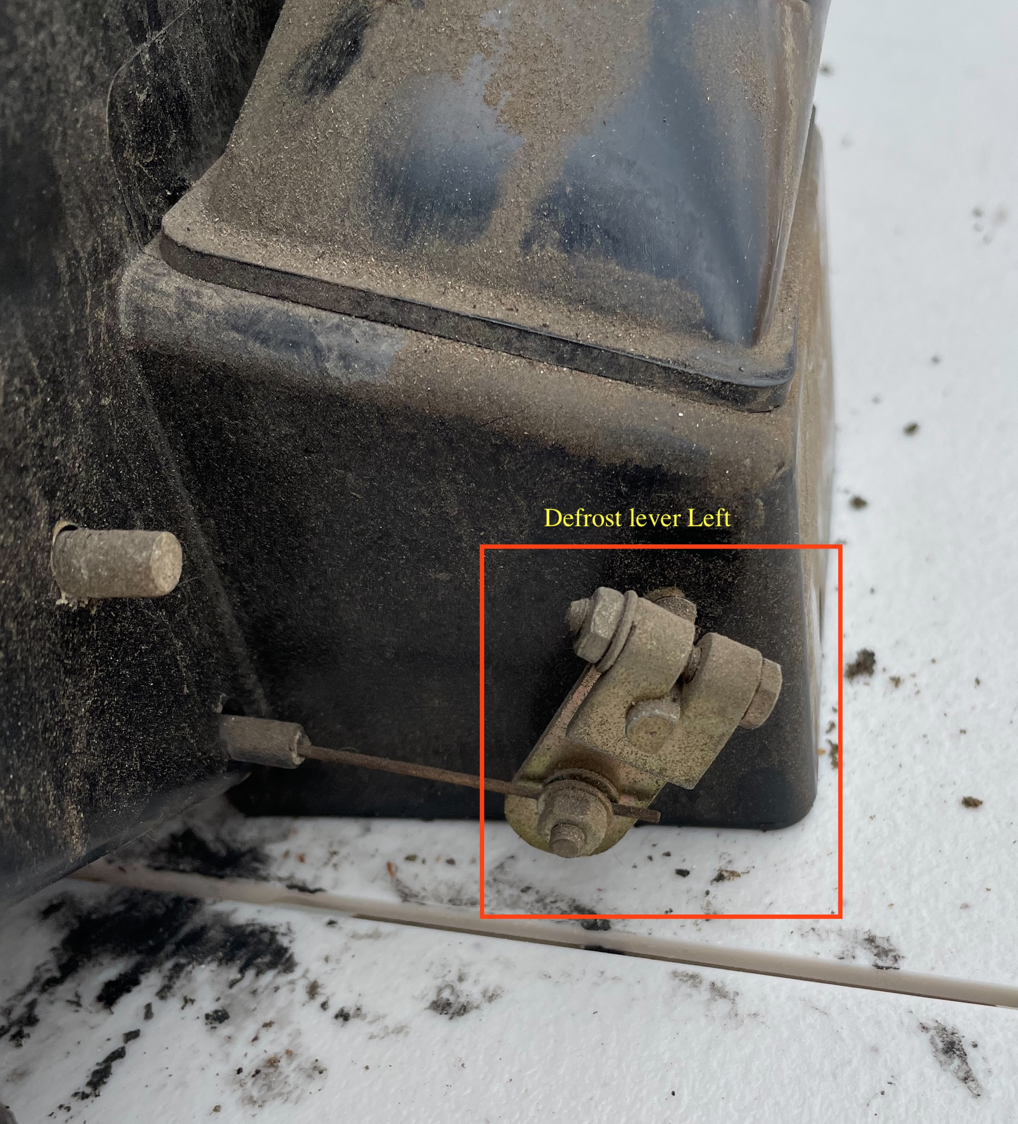

This is the lever position all the way to the right. The air is now directed to the dash duct.
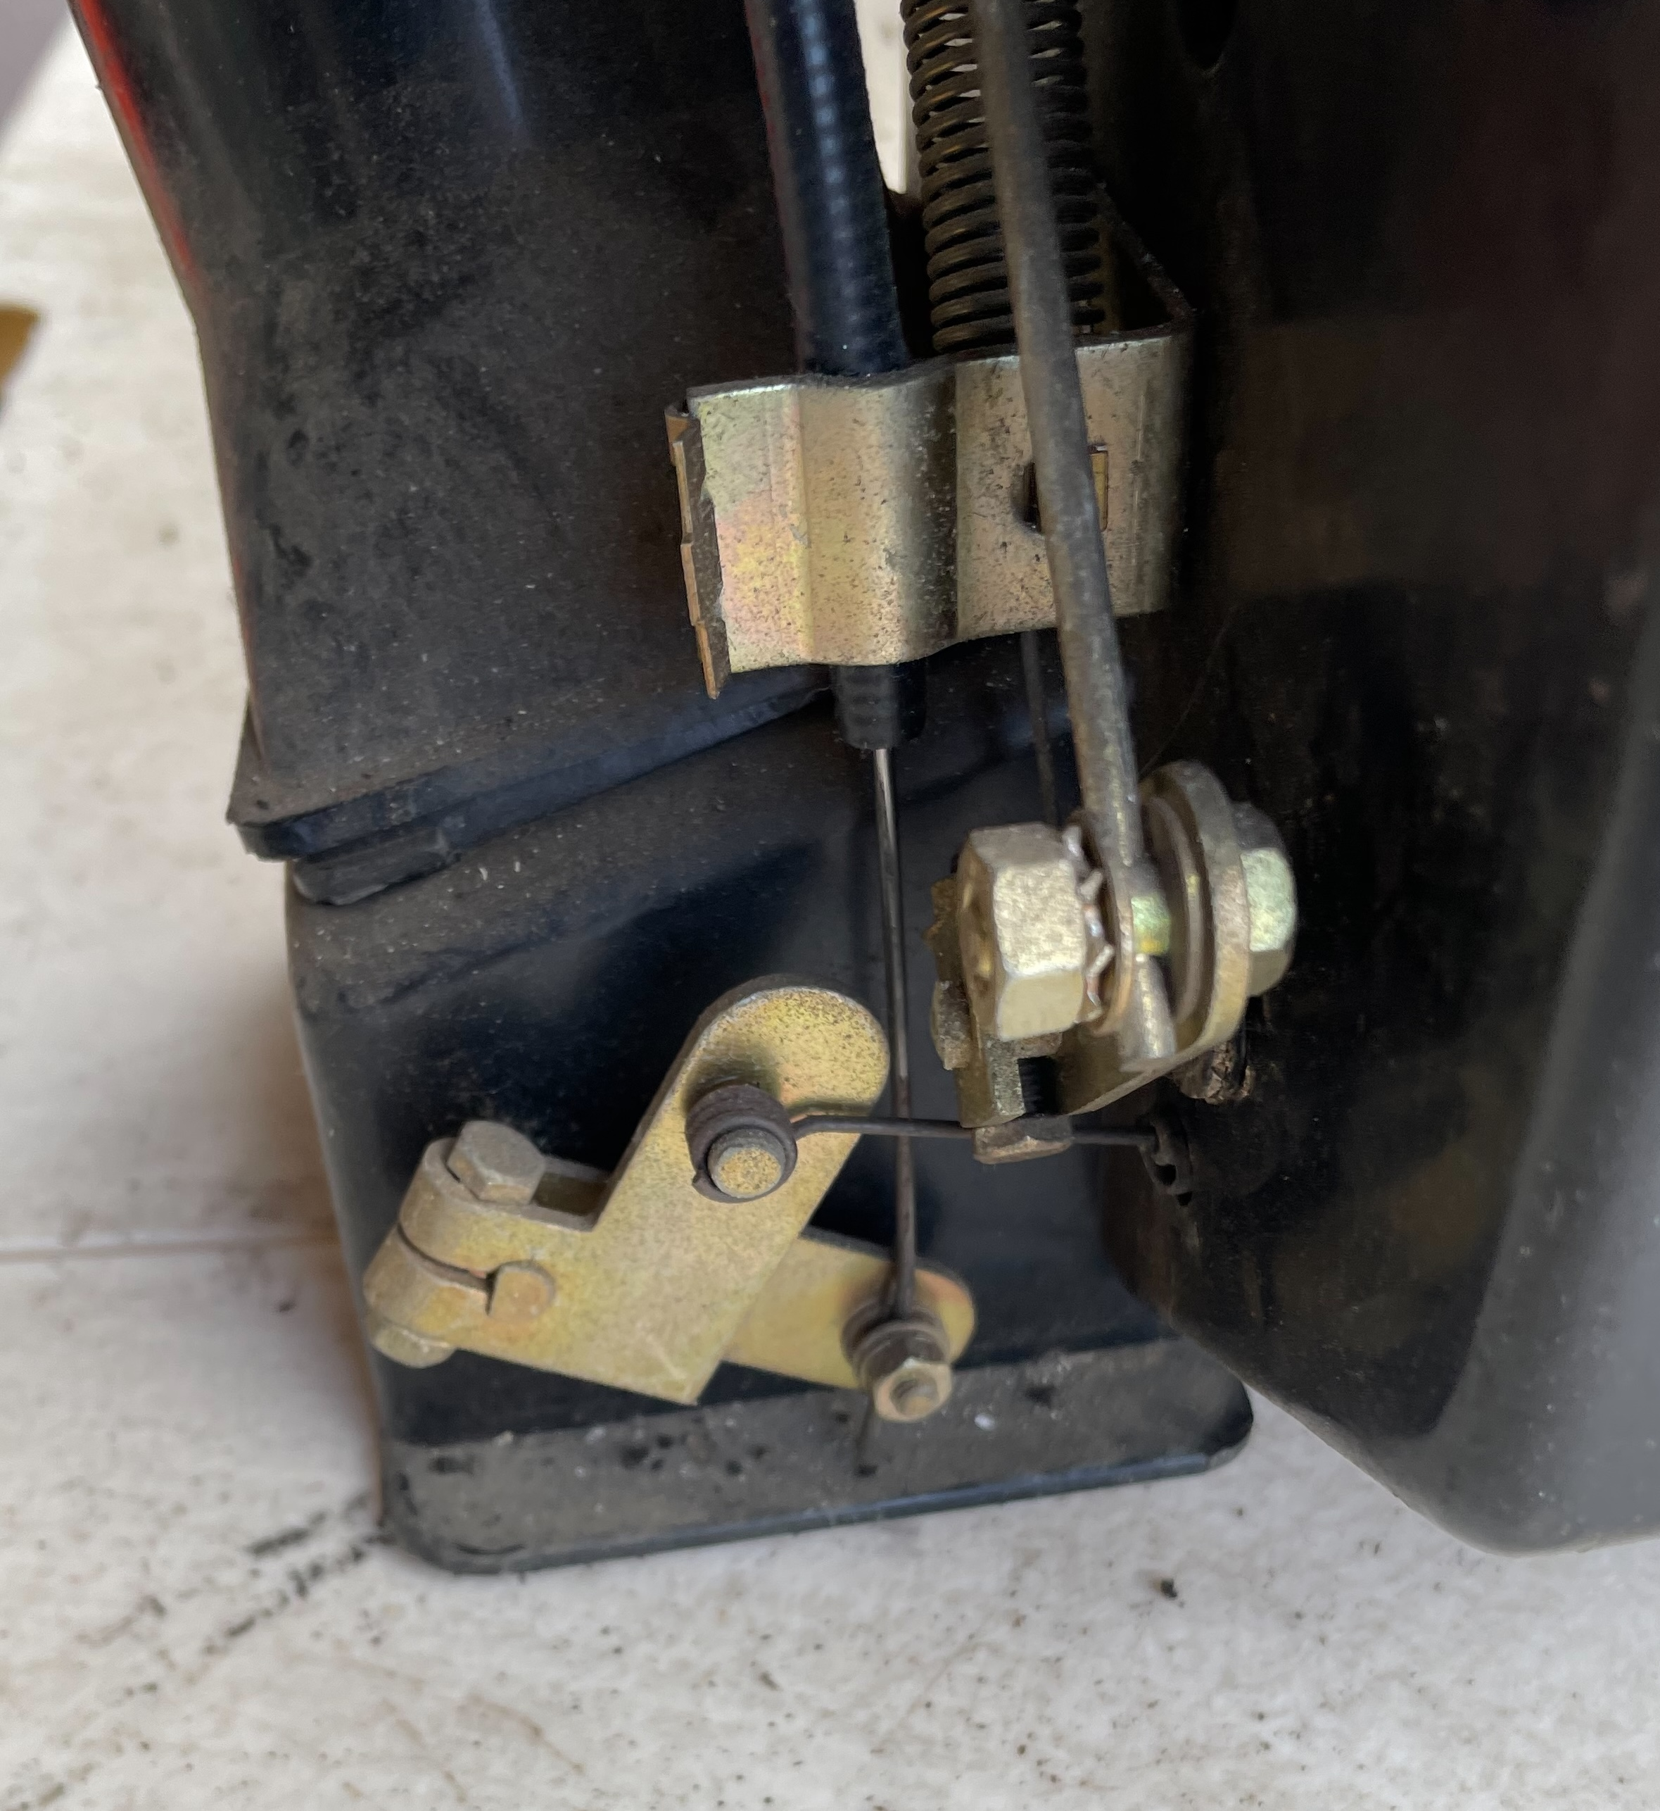
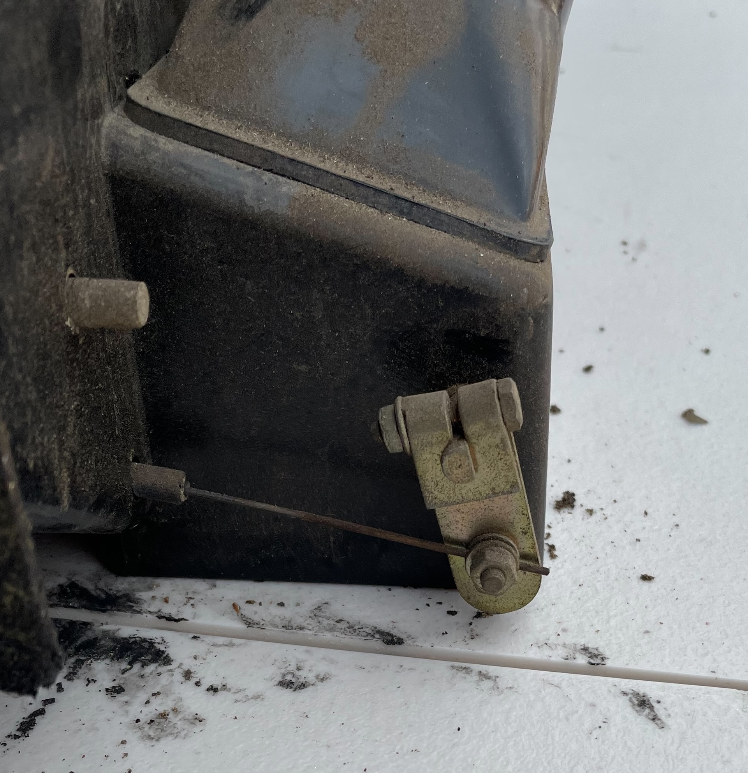
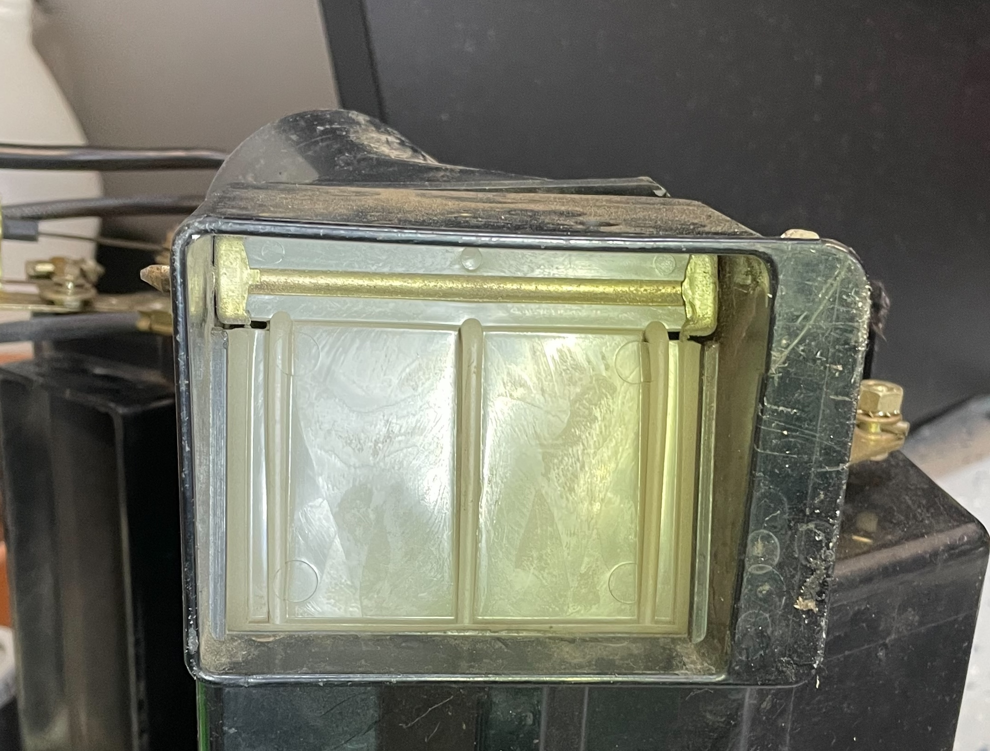

Vent control:
This lever opens the flap that goes to the box between the heater box and the A/C unit. It also leads to the front vents over the radio. This is with the vent lever fully to the left. Front vents are closed.
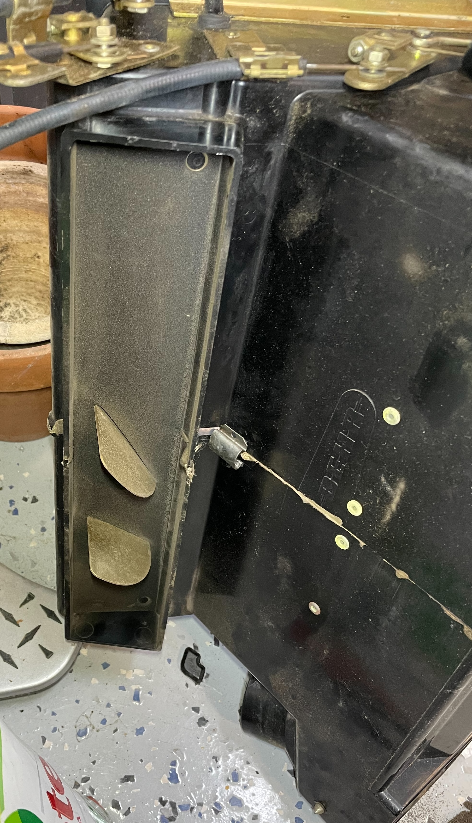
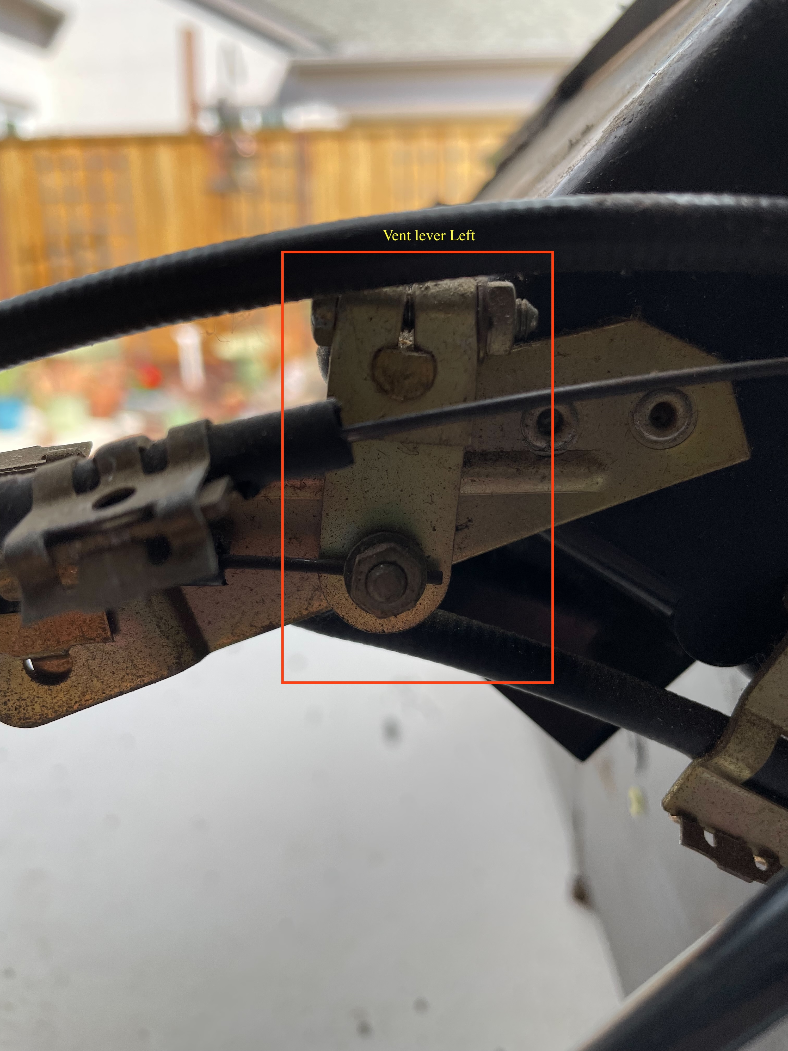
This is with the vent lever to the right. Air is directed to the vents in front.


