Wood Dash
The bottom dash plate and back panels are attached by 13 screws (DIN 97 3x25) and 1 small plate with 4 smaller screws (DIN 97 2x16).
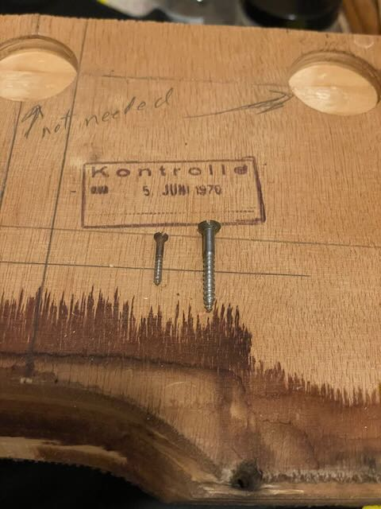
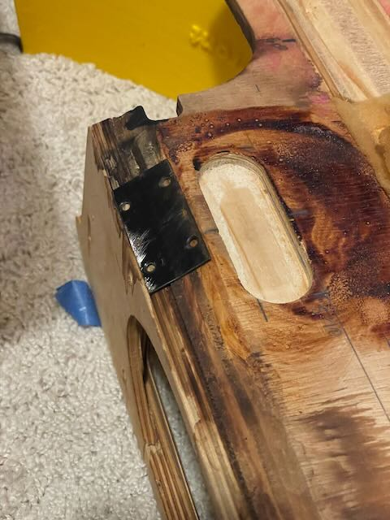
The screws are all slotted flat head wood screws. The 13 long screws all go through the bottom wood plate and into the back wood that has the fancy veneer glued on top. The 4 short screws attach the plate to the bottom plate and the end of the long back piece.
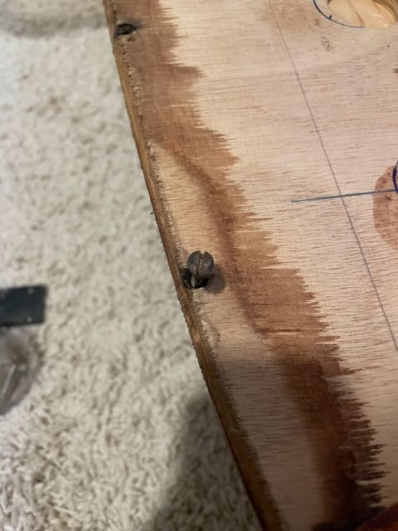
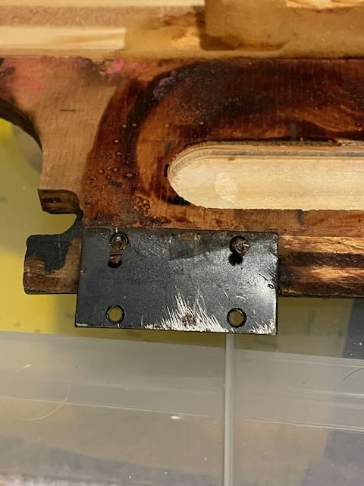
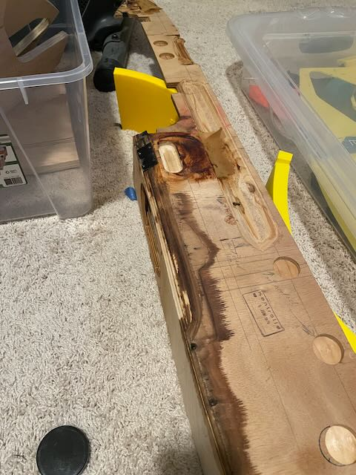
The small plate dimension is 25x50mm with hole spacing of approximately 29mm & 18mm. The hole size is a bit over 3mm.
DIN 97 3x25 and DIN 97 2x16
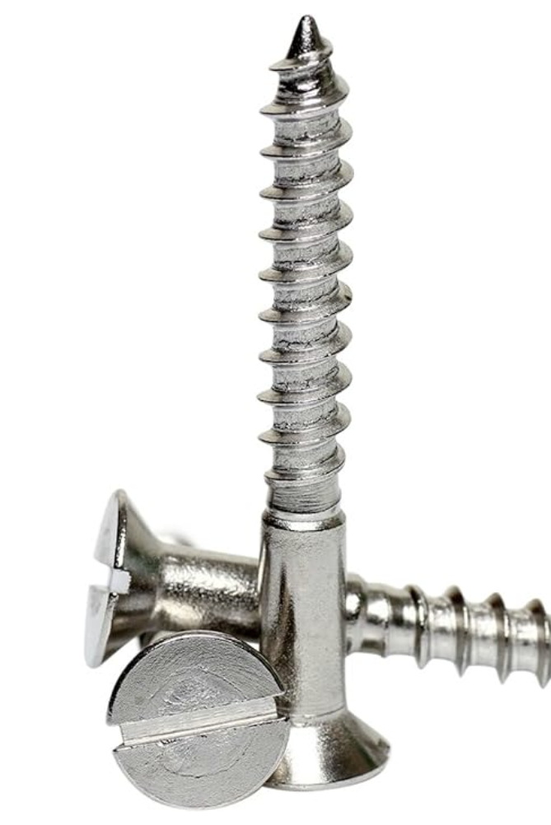
This hardware is for mounting the dash plate to the car. The bolt is M6-1 x 20 with a split locking washer.
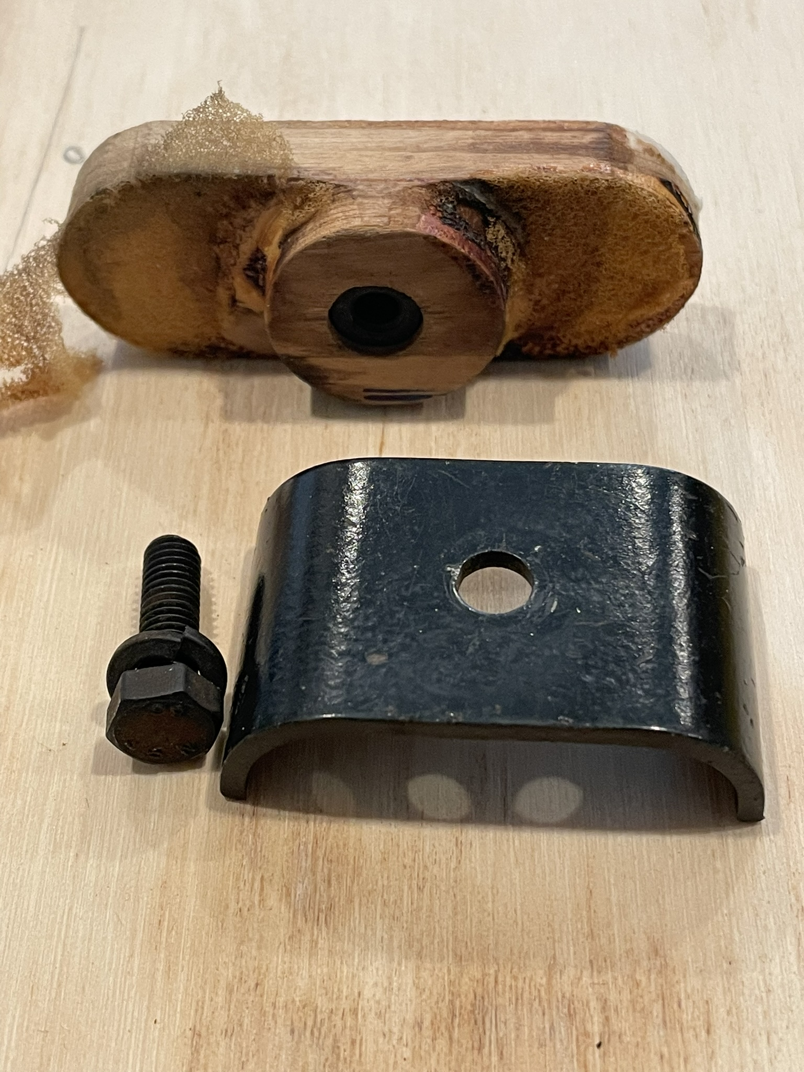
Here the black screw is same as above. The larger sheet metal screw screws in the metal trim above the wood into speed clips that are inserted into the sheetmetal behind the dash. The smaller screw goes through the trim and into the top of the wood. The sheetmetal screw is a Phillips pan head 3.5x13 and the small screw is a Phillips flat head 2.9x9.5.
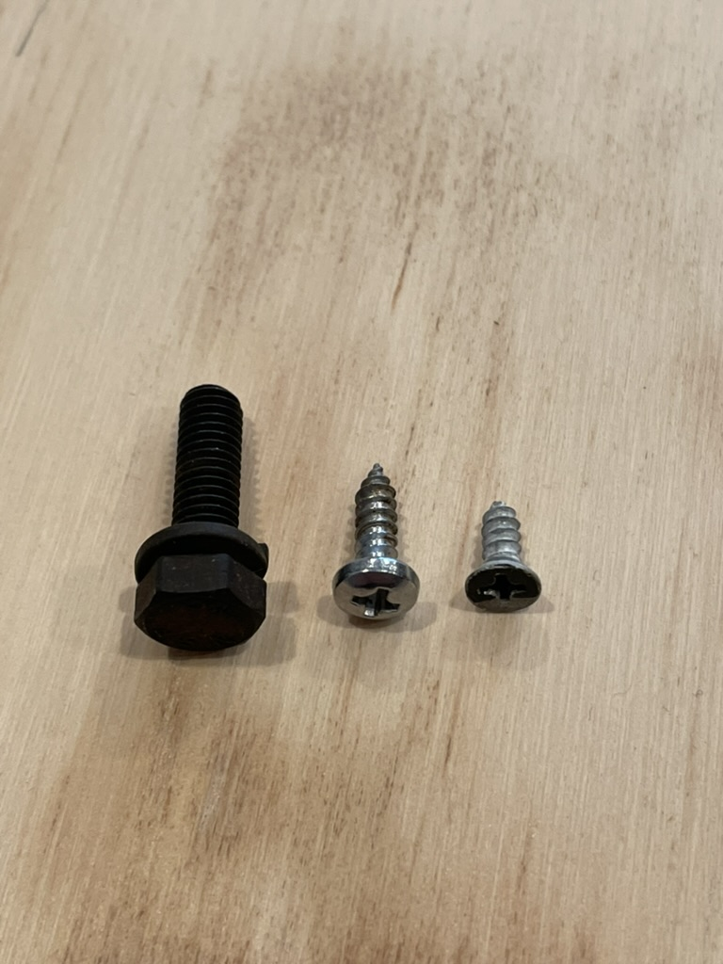
Here is the trim piece laying on top of the wood and a picture of some of the speed clips.
