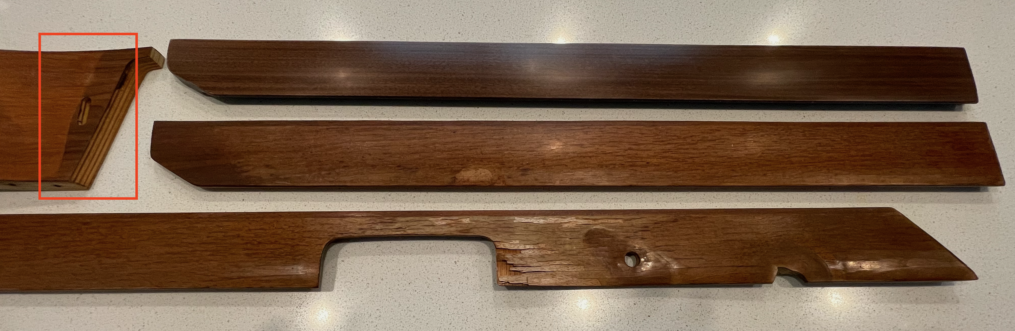
Top is the reproduction American Walnut
Middle is the original European Walnut
Bottom show the damage from the front door trim.
Left red box shows probably what was the original unfaded color. This part was hidden behind the instrument cluster.

