Dip and Relay sockets
These are resin printed but they can also be done with an FDM printer.
These are the final resin prints. The 3 at the top left are samples.
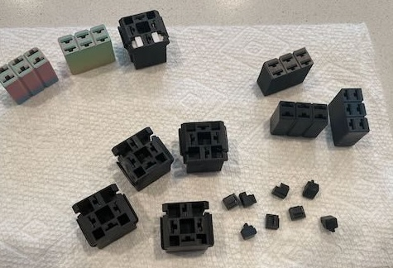

The prints are made on an Elegoo Saturn 4 Ultra using Elegoo ABS like black resin.
My 1970 2800CS has a dip switch with a 4 pin connector and 1 loose wire. I don’t think this was the right switch. Maybe its from a newer car. Here is the before and after. The original wiring did not function right. Matching the wire colors on the switch to the wire harness made it work.
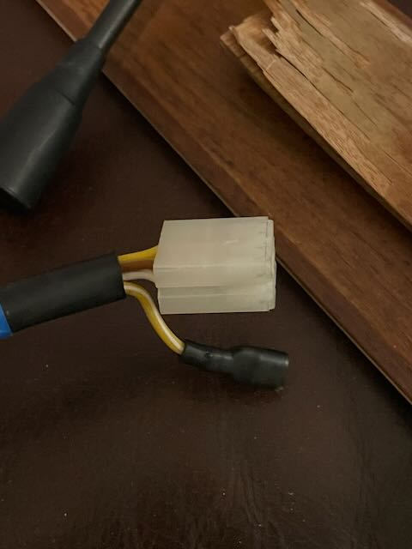
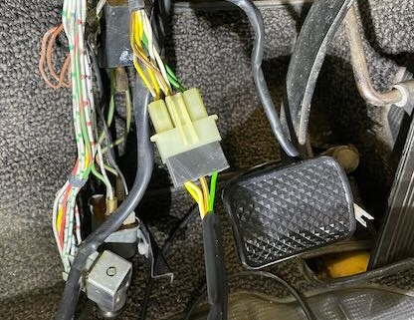
One problem with the plug is its too tight to remove. If a wire is plugged into the wrong pin then the connector needs to be cut apart to get the wire out. The plug is a tight fit. The original wires were used except for the yellow with white stripe. For this I used connectors from Amazon (Baomain Female Spade Quick Splice Crimp Terminals 6.3mm Crimp Connector Non Insulated 100 Pcs $6.89 ).
To get the wires loose enough about 10mm of the black sheathing was removed.

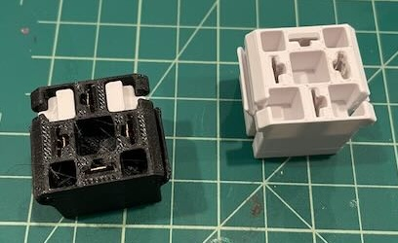
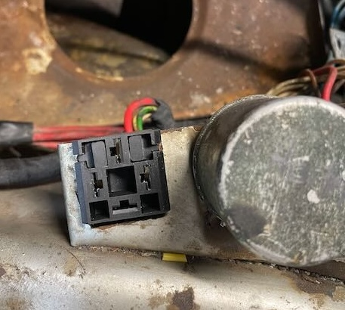
In my 2800CS one of the relay spots is available. I’m thinking of using this for a headlight relay which is why I created this plug. On the left are sample prints. Notice the white pieces inside the black. These are retaining plugs. On the original these were little fingers that pushed into a divot in the metal. I could not get it flexible enough so they kept breaking. These work by inserting the 2 plugs once the socket is slid onto the sheet metal. On the right the socket is installed without plugs or wires.

One issue with the plug is the side fin as shown in the yellow section. This is supposed to bend and put pressure on the plug so it sits firm. This did not bend enough and would break off. To get around this I filed the fin so it fit the thickness of the metal. My sample was made with PETG filament and this did bend and worked fine. Then I made it with ABS and it easily snapped. With the resin prints it also broke. Filing the fins only takes a minute and its snug if not filed too much.
