[CprE 381] Computer Organization and Assembly-Level Programming, Fall 2017

Project A Report

Name(s) _____Zhanghao Wen____________________________________

Section /Lab Time ___________B______________

Refer to the highlighted language in the Project A instruction for the context of the following questions.

- [Part 1.a] Provide a description of how each of the control values in the architecture (i.e., the outputs of the main control unit) is used. (15 pts)
- Output signals of the main control unit are
  - o_reg_dest
  - o_jump
  - o_branch
  - o_mem_to_reg
  - o_ALU_op
  - o_mem_write
  - o_ALU_src
  - o_reg_write
- For each output control signal, explain how it is used (i.e., what does it do?) (5 pts)
  - o_reg_dest
  - o_jump
  - o_branch
  - o_mem_to_reg
  - o_ALU_op : ALU op code determines instructions and format.
  - o_mem_write
  - o_ALU_src
  - o_reg_write
- For the 6 MIPS instructions to support, ADD, ADDI, LW, SW, BEQ and J, complete the following table. (5 pts)
 | ADD | ADDI | LW | SW | BEQ | J
o_reg_dest | 1 | 0 | 0 | 0 | - | -
o_jump | 0 | 0 | 0 | 0 | 0 | 1
o_branch | 0 | 0 | 0 | 0 | 1 | 0
o_mem_to_reg | 0 | 0 | 1 | 0 | - | -
o_ALU_op | 0000 | 0000 | 0000 | 0000 | 0001 | ----
o_mem_write | 0 | 1 | 0 | 1 | 0 | 0
o_ALU_src | 0 | 1 | 1 | 0 | 0 | -
o_reg_write | 1 | 1 | 1 | 0 | 0 | 0

- (continuing from the previous question) For each of the 6 MIPS instruction, explain why you set the values as you described in the table above. (5 pts)
  - ADD
o_mem_to_reg <= '0'; -- write ALU output to reg file
o_ALU_op <= "0000"; -- addition operation in ALU
o_mem_write <= '0'; -- don't write to memory
o_ALU_src <= '0'; -- select rt data as second input to ALU
o_reg_write <= '1'; -- write enable to write register file (write rd)
  - ADDI
o_reg_dest <= '0'; -- not writing to rd
o_mem_to_reg <= '0'; -- write ALU output to reg file
o_ALU_op <= "0000"; -- addition operation in ALU
o_mem_write <= '0'; -- don't write to memory
o_ALU_src <= '1'; -- select sign extended IMM as second input
o_reg_write <= '1'; -- write enable to write register file (write rd)
  - LW
o_reg_dest <= '0'; -- not writing to rd
o_mem_to_reg <= '1'; -- write ALU output to reg file // should be 1 since we want to see the memory data
o_ALU_op <= "0000"; -- addition operation in ALU
o_mem_write <= '0'; -- don't write to memory
o_ALU_src <= '1'; -- select sign extended IMM as second input
o_reg_write <= '1'; -- write enable to write register file (write rd)
  - SW
o_mem_to_reg <= '-'; -- don't write ALU output to reg file, don't care
o_ALU_op <= "0001"; -- subtraction operation in ALU
o_mem_write <= '0'; -- don't write to memory
o_ALU_src <= '0'; -- select rt data as second input to ALU
o_reg_write <= '0'; -- don't write enable to write register file (write rd)
  - BEQ
o_mem_to_reg <= '-'; -- don't write ALU output to reg file, don't care
o_ALU_op <= "0001"; -- subtraction operation in ALU
o_mem_write <= '0'; -- don't write to memory
o_ALU_src <= '0'; -- select rt data as second input to ALU
o_reg_write <= '0'; -- don't write enable to write register file (write rd)
  - J
o_mem_to_reg <= '-'; -- write ALU output to reg file
o_ALU_op <= "----"; -- addition operation in ALU // not sure about the add instruction
o_mem_write <= '0'; -- don't write to memory
o_ALU_src <= '-'; -- select rt data as second input to ALU
o_reg_write <= '0'; -- write enable to write register file (write rd)

- [Part 1.a] How is the zero flag from the ALU used? (5 pts)

In control unit, there is 1-bit signal used in determining whether to possible branch, and an AND gate output controls the selection of the next PC. If branch/zero flag is set to 0, PC just equals PC + 4. Otherwise, jump to branch specified by the instruction.

- [Part 2] Simulate your processor in ModelSim and run the provided program in imem.mif with the data in dmem.mif. (20 pts)
- The [projectA > ASM Files > test_with_data_seg.asm ] file has the assembly code with data specified which is equivalent to the given imem/dmem.mif. Before simulating the final design, just by studying the code, please explain (3 pts)
  - What the code does

First, the code read and store how many elements in the array, and then go through the loop, basically if the array size is n, then go through loops n times and each time add next array element into sum which store the value in the register $s0.

  - Which values will be written on DMEM at the locations of the first 11 words staring from the address 0.
Nothing because the number of words is 10 so the loop only iterate 10 times and then exit.
  - Which values will be written on the following registers: $8 (=$t0), $9 (=$t1), $10 (=$t2), and $16 (=$s0).
$t0 = 10 then 9,8,7,6,5,4,3,2,1,0
$t1 = 1,2,3,4,5,6,7,8,9,10

$s0 = 0 + 0 = 0
$s0 = 0 + 1 = 1
$s0 = 1 + 2 = 3
$s0 = 3 + 3 = 6
$s0 = 0 + 4 = 10
$s0 = 10 + 5 = 15
$s0 = 15 + 6 = 21
$s0 = 21 + 7 = 28
$s0 = 28 + 8 = 36
$s0 = 36 + 9 = 45
$s0 = 45 + 10 = 55

- Provide a screenshot for each of the 6 MIPS instructions to support showing the correct functionality and explain how the instruction is working in accordance with the screenshot (12 pts)
  - ADDI
    - Attach a screenshot & explain
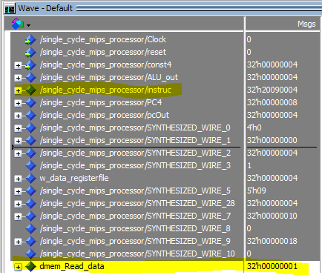
20090004 %0010 0000 0000 1001 0000 0000 0000 0100
Read data is 1(the first element in the array)

  - ADD
    - Attach a screenshot & explain
    - 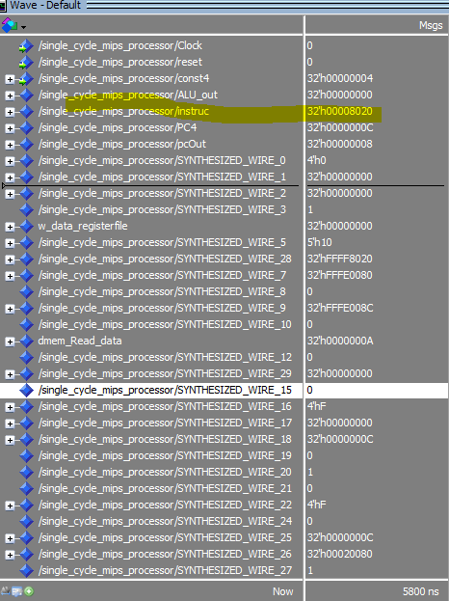
    - 00008020 %0000 0000 0000 0000 1000 0000 0010 0000 add
  - LW
    - Attach a screenshot & explain
    - 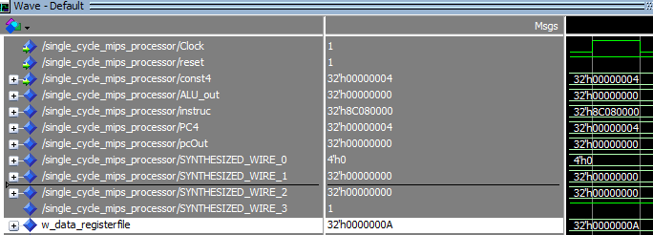
Instruction : 1000 1100 0000 1000 0000 0000 0000 0000
W_data_register file is the data thtat needs to be writen into register which is 10
  - SW
    - Attach a screenshot & explain
    - 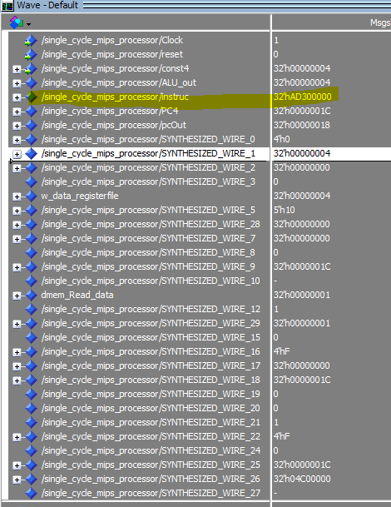
    - ad300000 %1010 1101 0011 0000 0000 0000 0000 0000 sw
  - BEQ
    - Attach a screenshot & explain
    - 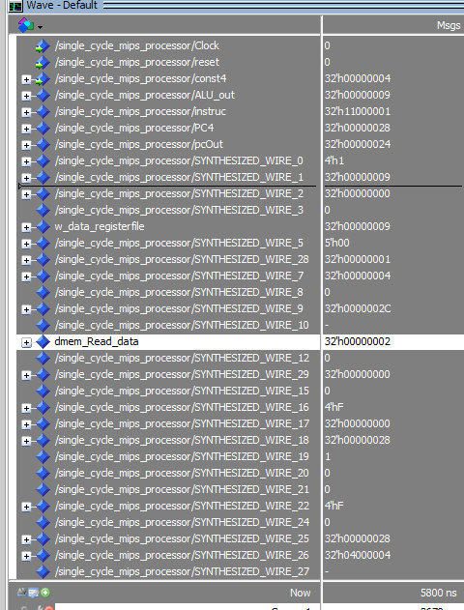
    - 11000001 %0001 0001 0000 0000 0000 0000 0000 0001 beq
  - J
    - Attach a screenshot & explain
    - 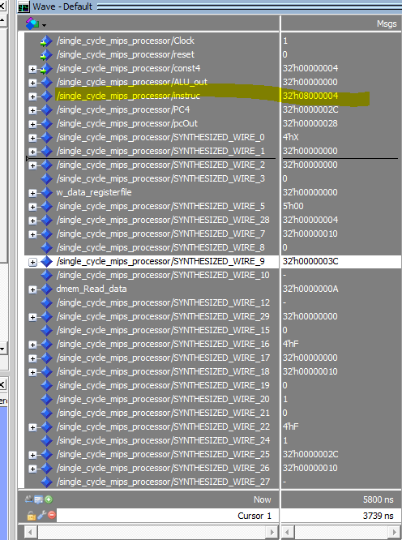
    - 08000009 %0000 1000 0000 0000 0000 0000 0000 1001 j
- Provide screenshots showing the final values of the dmem and registers (5 pts)
  - DMEM (for the first 11 words starting from address 0)
  - REGISTERS

