Thought-Box

Eric Chadwick

University of Missouri – Kansas City

Table of Contents
Vision Statement 3
Requirements 4
Product Backlog 5
Sprint #1 6
Review 6
Retrospective 6
Sprint #2 7
Review 7
Retrospective 7
Sprint #3 8
Review 8
Retrospective 8
Sprint #4 9
Review 9
Retrospective 9
Sprint #5 10
Review 10
Retrospective 10
Sprint #6 11
Review 11
Retrospective 11

Vision Statement
“The mind in its natural state can be compared to the sky, covered by layers of cloud which hide its true nature.” ~Kalu Rinpoche

Thought-Box is philosophically, an application to store one’s thoughts and allow one to focus on what is immediately at hand. It is a response to the dozen of post-it notes which often checker my desktop. The idea is that one need only input the thought to Thought-Box and then it may be erased from the mind. The app will provide easy functionality to categorize and prioritize the thought at a later time (Or not. They are your thoughts, do with them as you will).

On a technical level, Thought-Box is essentially and enhanced list app. Each thought is represented by a list item. Thoughts can be uncategorized (like “Remember to pick up pet wombat from daycare”) or categorized (like “Bars/Restaurants that allow wombats”). Categorized thoughts are also able to be prioritized within their category (for instance “acquire materials” would be of higher priority than “leash wombat” in the prioritized category “build wombat shelter”). A thought is able to belong to multiple categories with different priorities in each category (for example “acquire materials” may be top priority in the “build wombat shelter” prioritized categorized but it may be below “feed wombat” in the prioritized category “today’s to-do list”.

Future releases may include google maps integration for location based thoughts and reminder alerts for time dependent thoughts.

Requirements
A discussion of what your application is required to have in functionality. It should identify user roles and goals/actions, and what the key features of the app should be.
Actor | Goal
User | Store a thought (with or without categorization/prioritization
User | View a previously stored thought
User | Create a category (stand alone and from new thought creation activity)
User | Add existing thoughts to existing categories (many-to-many, with or without prioritization).
User | Add/change priority of thoughts already existing in a category.
User | “Complete” a thought. Should involve some sort of psychological reward for checking off the task.
User | Remove a thought (completed or not).

Product Backlog
This will be updated throughout the semester as new PBIs are added, larger items are broken into smaller ones, and completed items removed.

Story ID | Story | Story Points  (in est. hours) | Priority | Status
1 | Decided on, design and implement persistent storage strategy (probably a db) | 8 | 1 | Cancelled
2 | Create a thought | 8 | 1 | Done
3 | View list of thoughts | 8 | 1
4 | Create a category and add thoughts | 8 | 3
5 | Prioritize thoughts in categories | 8 | 4
6 | Remove a thought | 3 | 1
7 | Complete a thought | 5 | 1

Sprint #1

Sprint Backlog
Story ID | Story / Task | Estimated  Hours | Actual  Hours
1 | Research and decide on persistent storage strategy. | 2 | 1.5
2 | Design storage strategy | 2 | .5
3 | Implement storage strategy  Not going to complete. Will incorporate this work in other tasks. | 4 | 0
3a | Create entities | 2 | 0
3b | Create DAOs | 2 | 0
3c | Create Room Database | 2 | 0
3d | Determine whether I need a Repository | 1 | .5
4 | Create a thought | 8 | 10
4a | Create new thought Activity | 2 | 3
4b | Persist thought to db | 4 | 3
4c | Test that thought is stored in db | 2 | 4

Review

This sprint I added an activity to allow a user to input a thought and set up all the necessary plumbing for the thought to be persisted to the database.
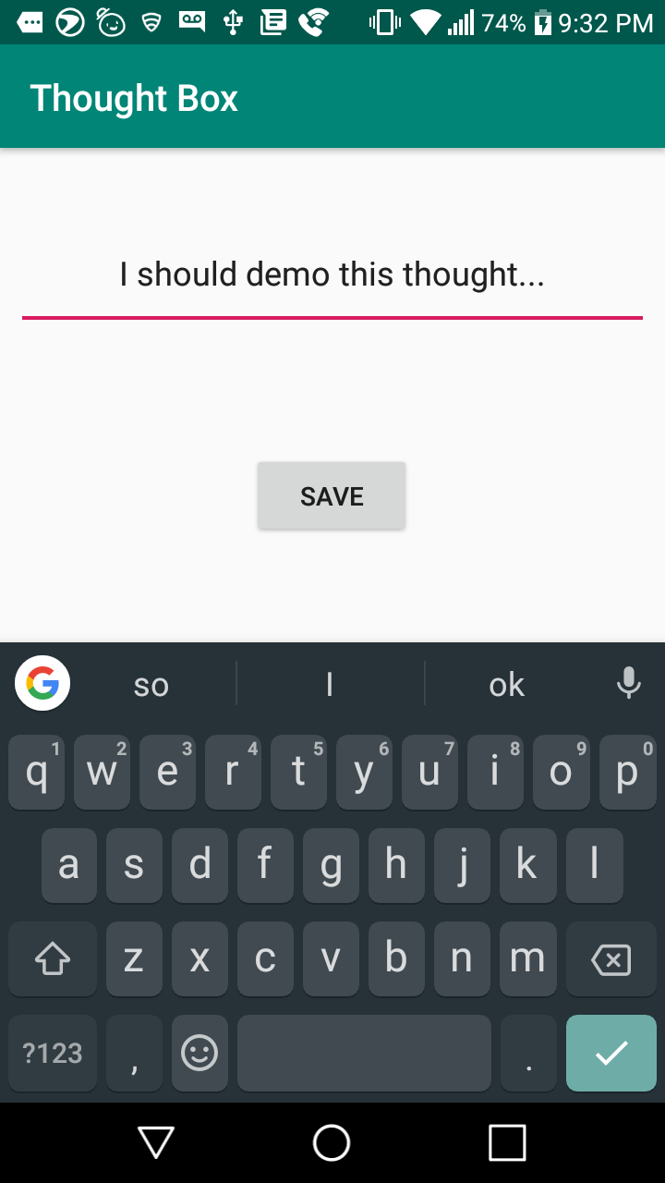
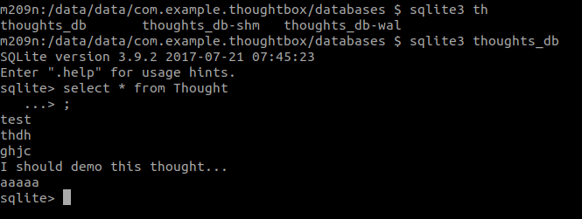

Retrospective
I initially planned to do all the back end setup at once. I have determined that this approach puts too many design decisions up from so I will instead implement the back end incrementally along with the high level features it will support.
I think my estimates where fairly accurate. There was a significant amount of unknowns in setting up the database and I feel I accounted for the well in my planning.
There is nothing materially abnormal in the next sprint so I will use my velocity from this sprint as a baseline for planning the next.

Sprint #2

Sprint Backlog
Story ID | Story / Task | Estimated  Hours | Actual  Hours
1 | View list of all thoughts | 5
1a | Modify db test to create multiple test thoughts | 1
1b | Get list of thoughts from back end and serve it to UI | 2
1c | Display thoughts in UI activity | 2
2 | Delete a thought | 5.5
2a | Modify db test to test deletion | 2
2b | Add delete button to UI somewhere | 1.5
2c | Create the plumbing to actually delete the thought and link it up to the UI button | 2

Review

[Screenshots, etc go here. This is where you discuss the product, describing what was done this sprint (potentially shippable product increment) and what was planned for the sprint but was not done. ]

Retrospective
[This is where you discuss the process. What went well (and are you planning to do more of that?) What didn’t go so well (and do you have a way to do less of that)? What changes are you planning to make in how you plan & carry out the next sprint?]

Sprint #3

Sprint Backlog
Story ID | Story / Task | Estimated  Hours | Actual  Hours

Review

[Screenshots, etc go here. This is where you discuss the product, describing what was done this sprint (potentially shippable product increment) and what was planned for the sprint but was not done. ]

Retrospective
[This is where you discuss the process. What went well (and are you planning to do more of that?) What didn’t go so well (and do you have a way to do less of that)? What changes are you planning to make in how you plan & carry out the next sprint?]

Sprint #4

Sprint Backlog
Story ID | Story / Task | Estimated  Hours | Actual  Hours

Review

[Screenshots, etc go here. This is where you discuss the product, describing what was done this sprint (potentially shippable product increment) and what was planned for the sprint but was not done. ]

Retrospective
[This is where you discuss the process. What went well (and are you planning to do more of that?) What didn’t go so well (and do you have a way to do less of that)? What changes are you planning to make in how you plan & carry out the next sprint?]

Sprint #5

Sprint Backlog
Story ID | Story / Task | Estimated  Hours | Actual  Hours

Review

[Screenshots, etc go here. This is where you discuss the product, describing what was done this sprint (potentially shippable product increment) and what was planned for the sprint but was not done. ]

Retrospective
[This is where you discuss the process. What went well (and are you planning to do more of that?) What didn’t go so well (and do you have a way to do less of that)? What changes are you planning to make in how you plan & carry out the next sprint?]

Sprint #6

Sprint Backlog
Story ID | Story / Task | Estimated  Hours | Actual  Hours

Review

[Screenshots, etc go here. This is where you discuss the product, describing what was done this sprint (potentially shippable product increment) and what was planned for the sprint but was not done. ]

Retrospective
[This is where you discuss the process. What went well (and are you planning to do more of that?) What didn’t go so well (and do you have a way to do less of that)? What changes are you planning to make in how you plan & carry out the next sprint?]

