Thought-Box

Eric Chadwick

University of Missouri – Kansas City

Table of Contents
Vision Statement 3
Requirements 4
Product Backlog 5
Sprint #1 6
Review 6
Retrospective 6
Sprint #2 7
Review 7
Retrospective 7
Sprint #3 8
Review 8
Retrospective 8
Sprint #4 9
Review 9
Retrospective 9
Sprint #5 10
Review 10
Retrospective 10
Sprint #6 11
Review 11
Retrospective 11

Vision Statement
“The mind in its natural state can be compared to the sky, covered by layers of cloud which hide its true nature.” ~Kalu Rinpoche

Thought-Box is philosophically, an application to store one’s thoughts and allow one to focus on what is immediately at hand. It is a response to the dozen of post-it notes which often checker my desktop. The idea is that one need only input the thought to Thought-Box and then it may be erased from the mind. The app will provide easy functionality to categorize and prioritize the thought at a later time (Or not. They are your thoughts, do with them as you will).

On a technical level, Thought-Box is essentially and enhanced list app. Each thought is represented by a list item. Thoughts can be uncategorized (like “Remember to pick up pet wombat from daycare”) or categorized (like “Bars/Restaurants that allow wombats”). Categorized thoughts are also able to be prioritized within their category (for instance “acquire materials” would be of higher priority than “leash wombat” in the prioritized category “build wombat shelter”). A thought is able to belong to multiple categories with different priorities in each category (for example “acquire materials” may be top priority in the “build wombat shelter” prioritized categorized but it may be below “feed wombat” in the prioritized category “today’s to-do list”.

Future releases may include google maps integration for location based thoughts and reminder alerts for time dependent thoughts.

Requirements
A discussion of what your application is required to have in functionality. It should identify user roles and goals/actions, and what the key features of the app should be.
Actor | Goal
User | Store a thought (with or without categorization/prioritization
User | View a previously stored thought
User | Create a category (stand alone and from new thought creation activity)
User | Add existing thoughts to existing categories (many-to-many, with or without prioritization).
User | Add/change priority of thoughts already existing in a category.
User | “Complete” a thought. Should involve some sort of psychological reward for checking off the task.
User | Remove a thought (completed or not).

Product Backlog
This will be updated throughout the semester as new PBIs are added, larger items are broken into smaller ones, and completed items removed.

Story ID | Story | Story Points  (in est. hours) | Priority | Status
1 | Decided on, design and implement persistent storage strategy (probably a db) | 8 | 1 | Cancelled
2 | Create a thought | 8 | 1 | Done
3 | View list of thoughts | 8 | 1 | Done
4 | Create a category and add thoughts | 8 | 3
5 | Prioritize thoughts in categories | 8 | 4
6 | Remove a thought | 3 | 1
7 | Complete a thought | 5 | 1
8 | Edit a thought | 5 | 1

Sprint #1

Sprint Backlog
Story ID | Story / Task | Estimated  Hours | Actual  Hours
1 | Research and decide on persistent storage strategy. | 2 | 1.5
2 | Design storage strategy | 2 | .5
3 | Implement storage strategy  Not going to complete. Will incorporate this work in other tasks. | 4 | 0
3a | Create entities | 2 | 0
3b | Create DAOs | 2 | 0
3c | Create Room Database | 2 | 0
3d | Determine whether I need a Repository | 1 | .5
4 | Create a thought | 8 | 10
4a | Create new thought Activity | 2 | 3
4b | Persist thought to db | 4 | 3
4c | Test that thought is stored in db | 2 | 4

Review

This sprint I added an activity to allow a user to input a thought and set up all the necessary plumbing for the thought to be persisted to the database.
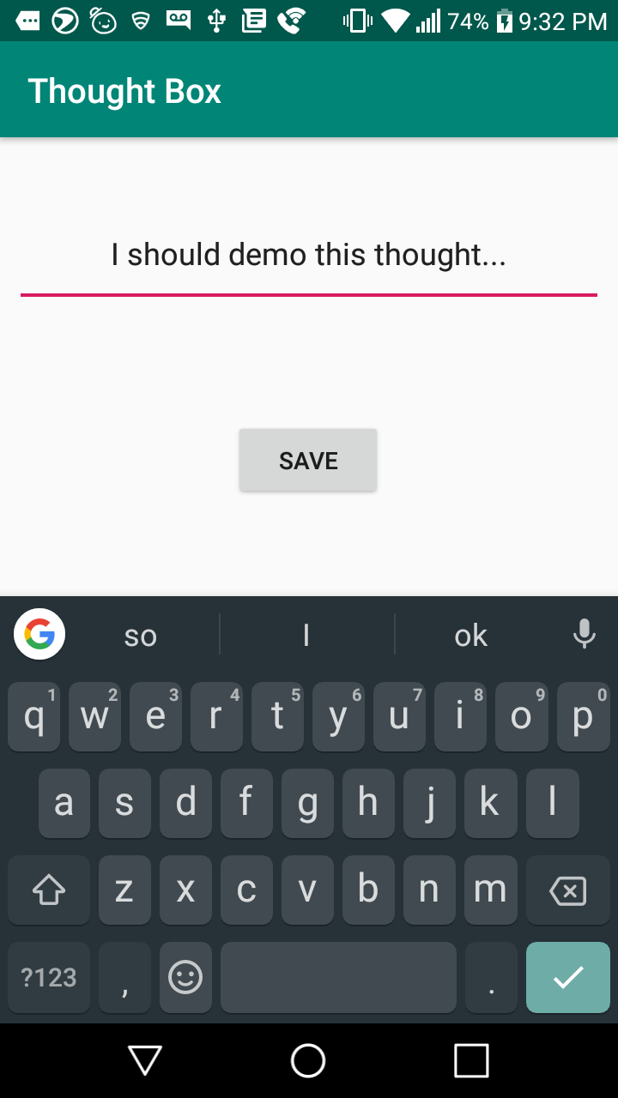
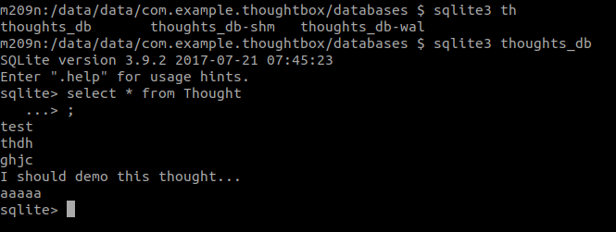

Retrospective
I initially planned to do all the back end setup at once. I have determined that this approach puts too many design decisions up from so I will instead implement the back end incrementally along with the high level features it will support.
I think my estimates where fairly accurate. There was a significant amount of unknowns in setting up the database and I feel I accounted for the well in my planning.
There is nothing materially abnormal in the next sprint so I will use my velocity from this sprint as a baseline for planning the next.

Sprint #2

Sprint Backlog
Story ID | Story / Task | Estimated  Hours | Actual  Hours
1 | View list of all thoughts | 5 | 12.5(in progress)
1a | Modify db test to create multiple test thoughts | 1 | 1.5
1b | Get list of thoughts from back end and serve it to UI | 2 | 4
1c | Display thoughts in UI activity | 2 | 7
2 | Delete a thought | 5.5
2a | Modify db test to test deletion | 2
2b | Add delete button to UI somewhere | 1.5
2c | Create the plumbing to actually delete the thought and link it up to the UI button | 2

Review

I was not able to complete anything this iteration. See Retrospective for details.

Retrospective
This iteration was not good. There were technical and external challenges that prevented me from totally completing anything.
I had a lot of work come up in my other classes after the beginning of the sprint. This forced me to work on Thought-Box in short duration blocks and late at night, neither of which benefit my cognitive ability. Unfortunately timing of assignments is outside of my control so I don’t think there is much I can do to avoid this work time segmentation issue. The best alternative is probably to reduce system complexity as discussed next.
Most of the tutorials involving piping data from a DB to a UI in Android involve several layers of abstraction in the middle. In most of the cases I have seen, several of these layers are nothing more than wrappers on functions of another layer. While this may have some benefits in terms of extensibility, the over-abstraction makes it difficult to understand the purpose of each layer and makes debugging overly complicated. In the next sprint I plan to tear out as much of the abstraction as possible to get things running. Additional abstraction will be added back in only at such a time as it becomes necessary for some particular feature.

Sprint #3

Sprint Backlog
Story ID | Story / Task | Estimated  Hours | Actual  Hours
1 | View List of Thoughts | 8 | 9.5
1a | Rip out with extreme prejudice all unnecessary abstraction | 2 | .5
1b | Connect UI to DB via controller | 4 | 2
1c | Connect button to CreateThought view (and more appropriate button icon) | 2 | 3
1d | UI refinement | 2 | 4
2 | (STRECH) View/Delete a thought | 13
2a | Add a View Single Thought view | 1
2b | Open View Single Thought view from tap on thought list | 6
2c | Add button to delete thought and return to Thought List View | 6

Review

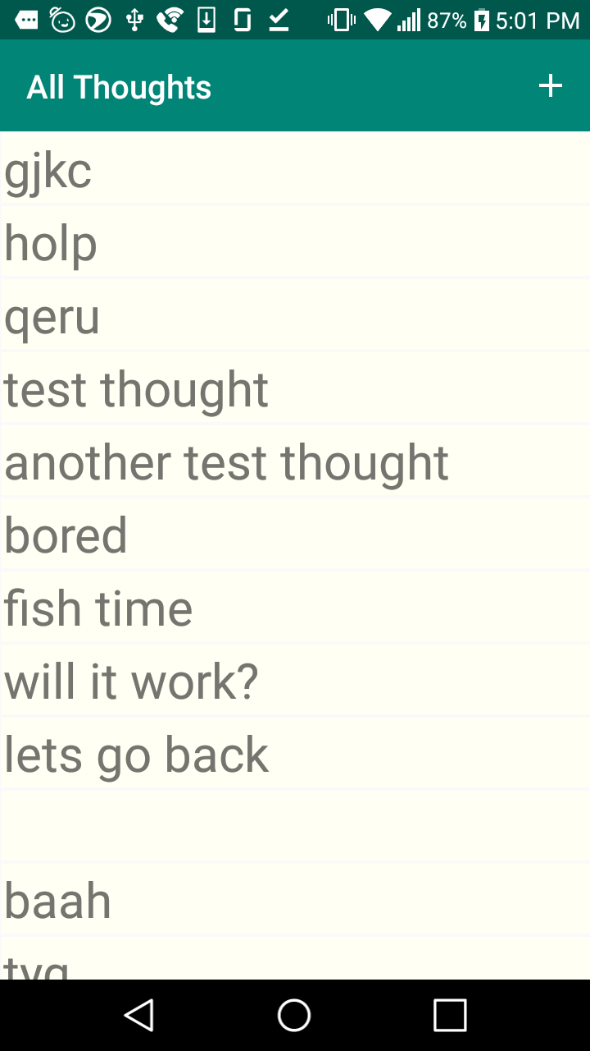
I completed the All Thoughts view and connected it to the Add a Thought view via a button in the Toolbar. The list scrolls and displays each thought in a card like layout. The buttons on the Add a Thought view also now trigger loading of the All Thoughts list.

Retrospective
This iteration went relatively well. Limiting the amount of abstraction in the project made adding new functionality much faster. I did not end up having as much time as I wanted to work on my stretch goals because of lots of things being forcibly added to my sprint by my instructors. I think I will continue to schedule fewer points per iteration but include a stretch goal in case my instructors ever decide not to do that.

Sprint #4

Sprint Backlog
Story ID | Story / Task | Estimated  Hours | Actual  Hours
1 | Pop up box with edit and delete buttons onclick of thought in list view | 5 | 4
2 | Delete a thought | 11 | 7

Review

This iteration I added a pop up that appears when a user taps a thought in the thought list that gives them the option to edit or delete the thought. I also implemented functionality for the delete button.
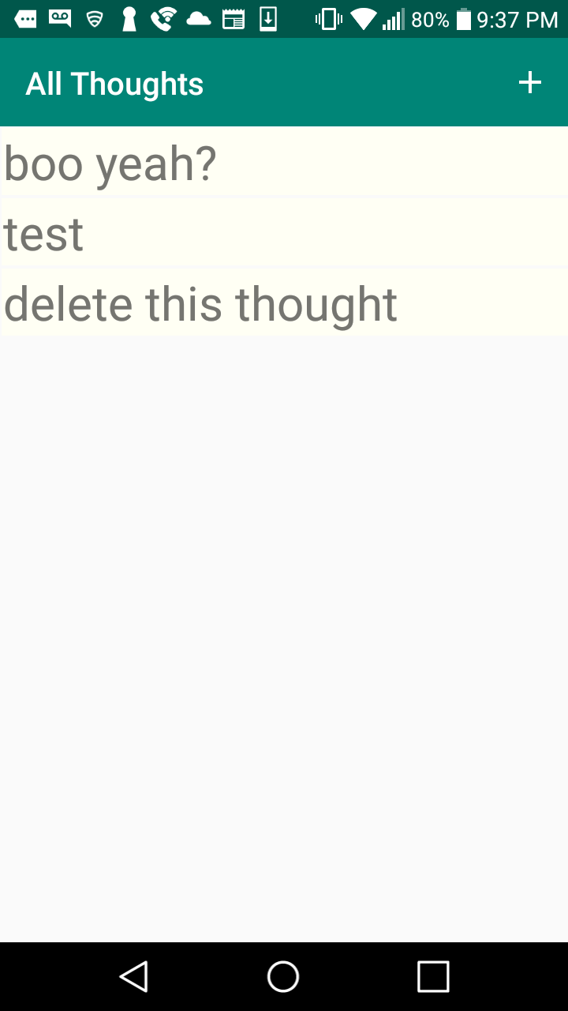
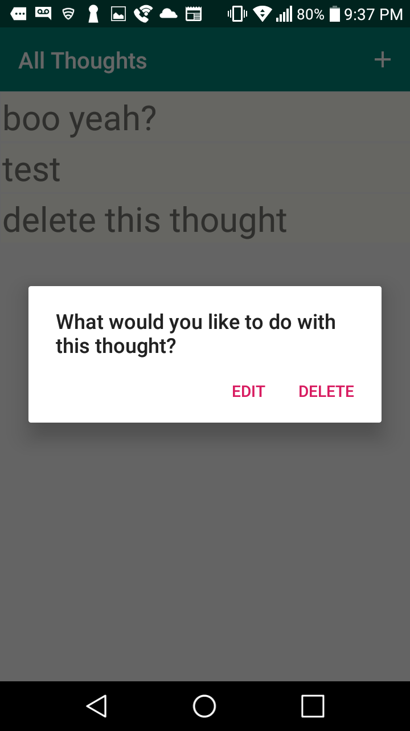
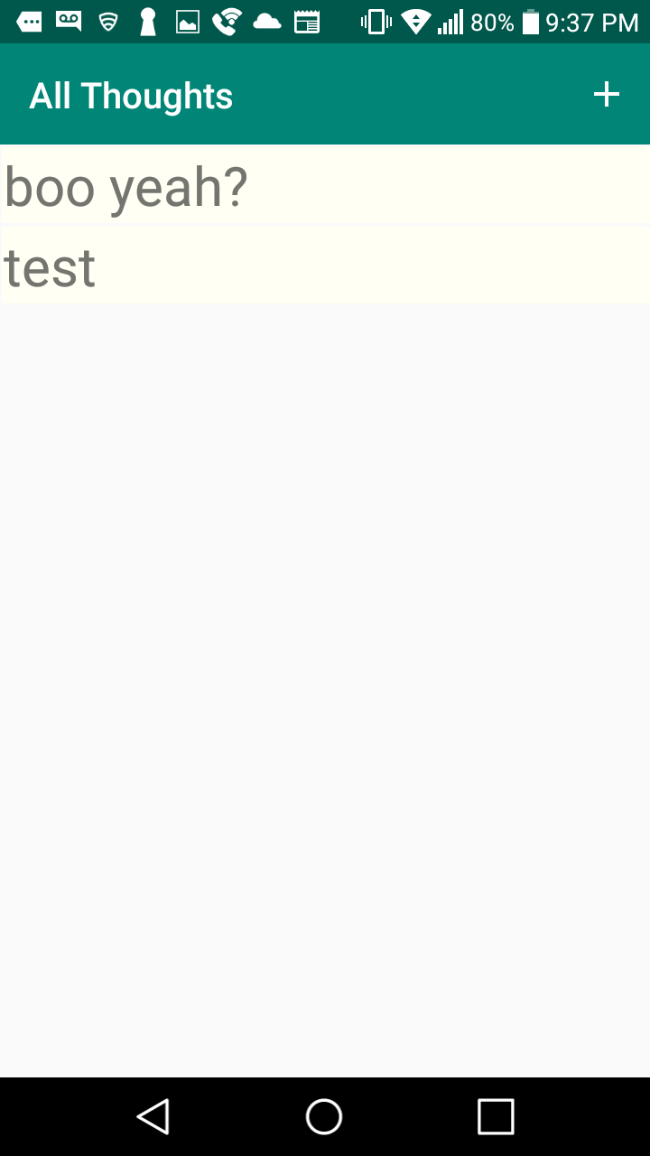

Retrospective
The scope of this iteration changed somewhat midway through. The task of deleting a thought turned out to be 2 tasks because the RecyclerView that I used as a container for the list does not implement the onClick interface so I had to learn about and implement my own click listener. That task displaced the task for being able to edit a thought. However with the onclick popup working, I’m confident that I’ll be able to get the edit functionality completed next iteration.

Sprint #5

Sprint Backlog
Story ID | Story / Task | Estimated  Hours | Actual  Hours
1 | Edit a thought | 6 | 4.5
2 | Create a Category | 6 | 4
3 | Show all Categories | 6 | 2
4 | Delete a Category | 6 | .5

Review

[Screenshots, etc go here. This is where you discuss the product, describing what was done this sprint (potentially shippable product increment) and what was planned for the sprint but was not done. ]

Retrospective
[This is where you discuss the process. What went well (and are you planning to do more of that?) What didn’t go so well (and do you have a way to do less of that)? What changes are you planning to make in how you plan & carry out the next sprint?]

Sprint #6

Sprint Backlog
Story ID | Story / Task | Estimated  Hours | Actual  Hours

Review

[Screenshots, etc go here. This is where you discuss the product, describing what was done this sprint (potentially shippable product increment) and what was planned for the sprint but was not done. ]

Retrospective
[This is where you discuss the process. What went well (and are you planning to do more of that?) What didn’t go so well (and do you have a way to do less of that)? What changes are you planning to make in how you plan & carry out the next sprint?]

