**Public Homepage**



* Add bottom margin of 10px (both public and logged in)



* Change grey dots to blue, white on hover

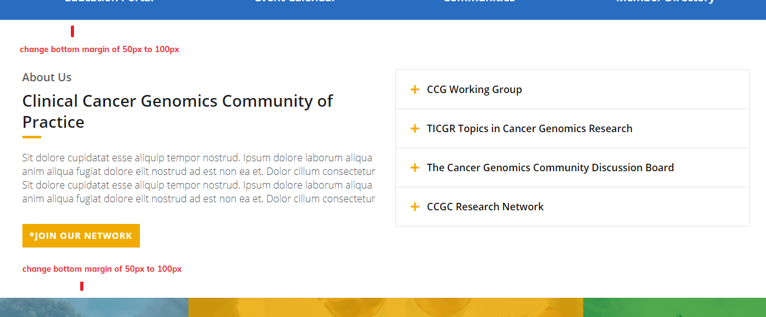

* Increase bottom margin from 50px to 100px – feel this section is too narrow

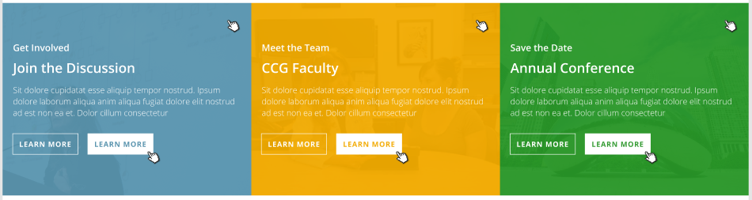

* Add ‘learn more’ buttons to bottom

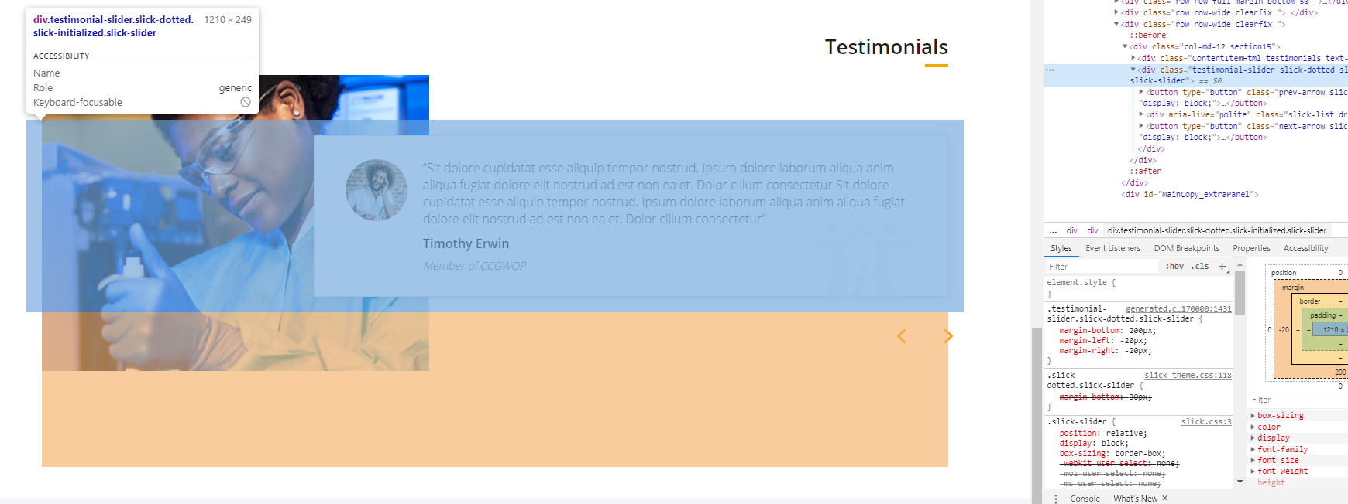

* Reduce bottom margin of 200px to 100px

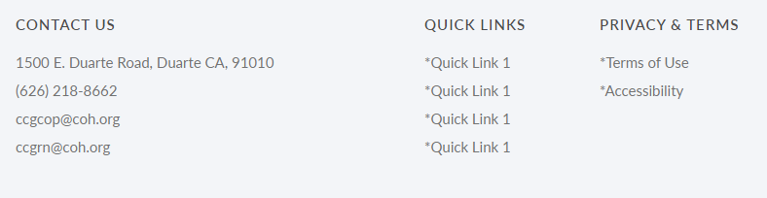

* Contact Us / Quick Links / Privacy & Terms – remove margin of 10 (I think it’s doubling up here to 20px because it has a bottom padding of 10px)
* Address, Phone, Emails, Quick Links, Terms of Use, etc – reduce spacing in between, bottom margin from 10px to 8px.

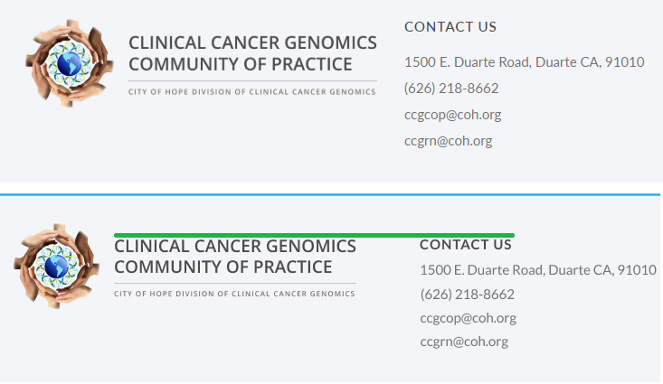

* Is it possible to bring their logo up a tad to match the text alignment of the quick link titles similar to my mock?

Font rendering issue – ask Nicola / Emeri

**Logged In Homepage**



* **Is it possible to put the date on top? Similar to the mock/blue tile?**
* **Also, I’m assuming these events don’t have a location? Can we somehow pull it what type they are? Ie: webinar, online, etc.** 
  + **The tile seems too empty to me, perhaps we may need to add the learn more button similar to what I have on the home page?**

**+ Footer stuff – same changes as public home page.**

**General – Navigation**

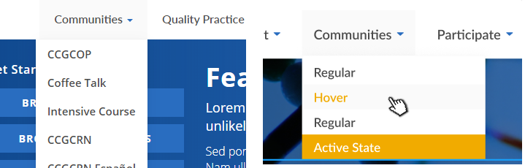

* **Can we align the drop down to the left as opposed to the right?**