unfoldingWord | OPEN BIBLE STORIES
an unrestricted visual mini-Bible in any language
http://openbiblestories.com
Open Bible Stories, v. 3.1.1
Created by Distant Shores Media (http://distantshores.org) and the Door43 world missions community (http://door43.org).
License:
This work is made available under a Creative Commons Attribution-ShareAlike 4.0 International License (http://creativecommons.org/licenses/by-sa/4.0/).
You are free:
* Share — copy and redistribute the material in any medium or format * Adapt — remix, transform, and build upon the material for any purpose, even commercially.
Under the following conditions:
* Attribution — You must attribute the work as follows: “Original work available at http://openbiblestories.com.” Attribution statements in derivative works should not in any way suggest that we endorse you or your use of this work. * ShareAlike — If you remix, transform, or build upon the material, you must distribute your contributions under the same license as the original.
Use of trademarks: unfoldingWord is a trademark of Distant Shores Media and may not be included on any derivative works created from this content. Unaltered content from http://openbiblestories.com must include the unfoldingWord logo when distributed to others. But if you alter the content in any way, you must remove the unfoldingWord logo before distributing your work.
Attribution of artwork: All images used in these stories are © Sweet Publishing (www.sweetpublishing.com) and are made available under a Creative Commons Attribution-Share Alike License (http://creativecommons.org/licenses/by-sa/3.0).
To our brothers and sisters in Christ all over the world—the global church. It is our prayer that God would use this visual overview of His Word to bless, strengthen, and encourage you.

1. The Creation

This is how the beginning of everything happened. God created the universe and everything in it in six days. After God created the earth it was dark and empty, and nothing had been formed in it. But God’s Spirit was there over the water.

Then God said, “Let there be light!” And there was light. God saw that the light was good and called it “day.” He separated it from the darkness, which he called “night.” God created the light on the first day of creation.
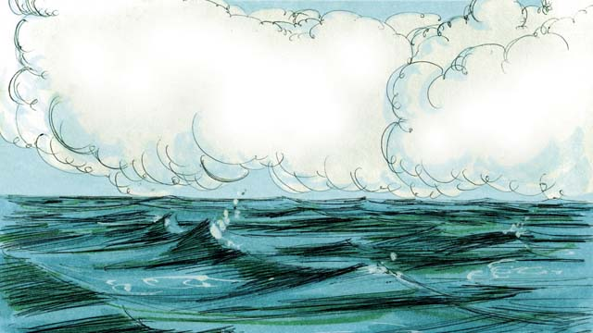
On the second day of creation, God spoke and created the sky above the earth. He made the sky by separating the water above from the water below.
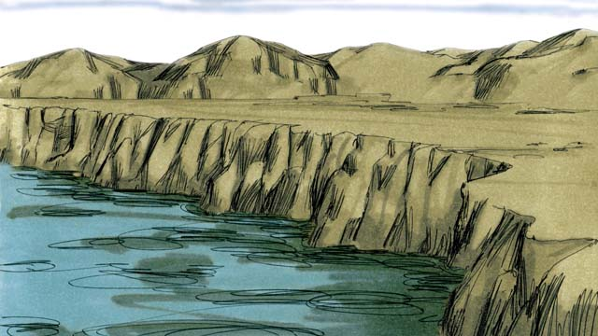
On the third day, God spoke and separated the water from the dry land. He called the dry land “earth,” and he called the water “seas.” God saw that what he had created was good.
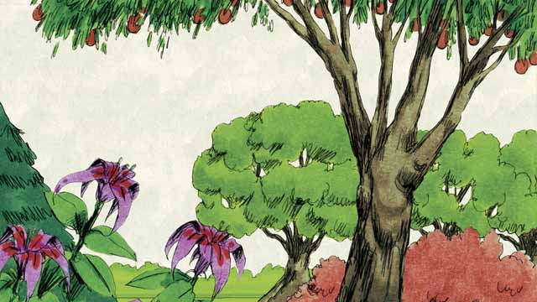
Then God said, “Let the earth produce all kinds of trees and plants.” And that is what happened. God saw that what he had created was good.

On the fourth day of creation, God spoke and made the sun, the moon, and the stars. God made them to give light to the earth and to mark day and night, seasons and years. God saw that what he had created was good.
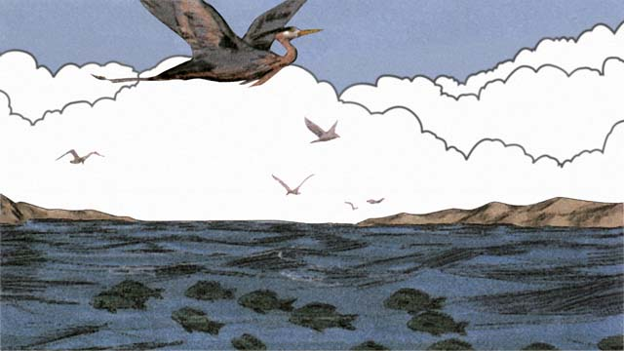
On the fifth day, God spoke and made everything that swims in the water and all the birds. God saw that it was good, and he blessed them.
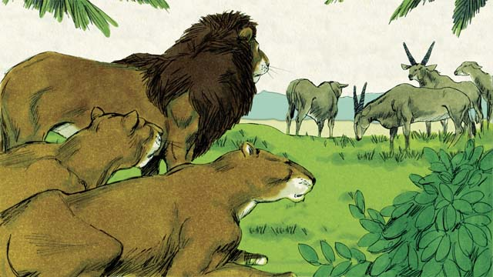
On the sixth day of creation, God said, “Let there be all kinds of land animals!” And it happened just like God said. Some were farm animals, some crawled on the ground, and some were wild. And God saw that it was good.
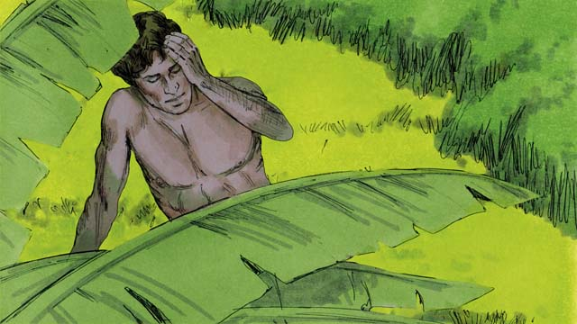
Then God said, “Let us make human beings in our image to be like us. They will have authority over the earth and all the animals.”

So God took some dirt, formed it into a man, and breathed life into him. This man’s name was Adam. God planted a garden where Adam could live, and put him there to care for it.
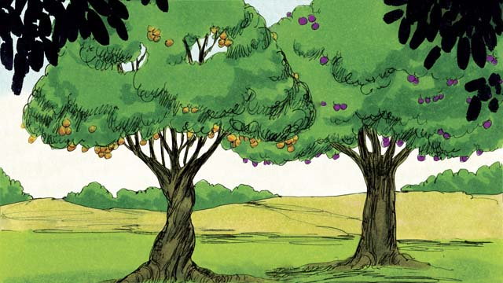
In the middle of the garden, God planted two special trees—the tree of life and the tree of the knowledge of good and evil. God told Adam that he could eat from any tree in the garden except from the tree of the knowledge of good and evil. If he ate from this tree, he would die.
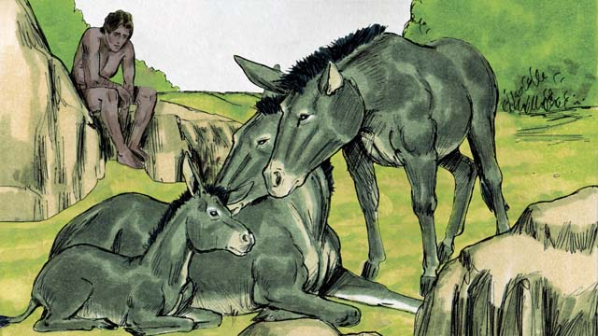
Then God said, “It is not good for man to be alone.” But none of the animals could be Adam’s helper.
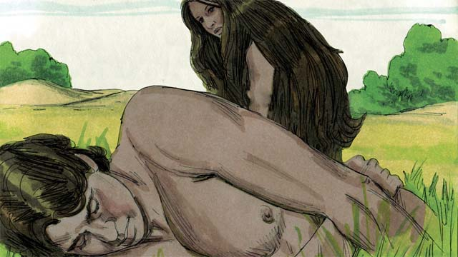
So God made Adam fall into a deep sleep. Then God took one of Adam’s ribs and made it into a woman and brought her to him.
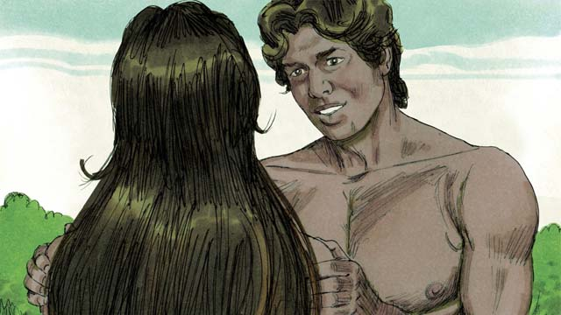
When Adam saw her, he said, “At last! This one is like me! Let her be called ‘Woman,’ for she was made from Man.” This is why a man leaves his father and mother and becomes one with his wife.
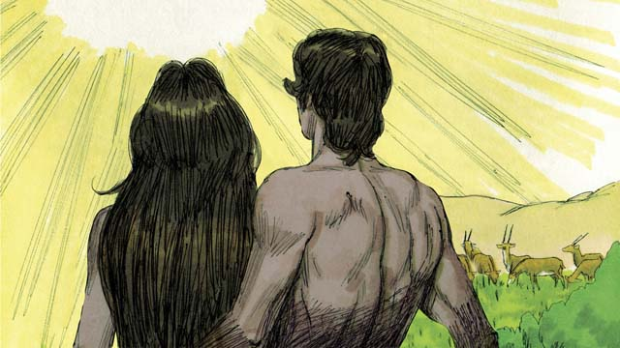
God made man and woman in his own image. He blessed them and told them, “Have many children and grandchildren and fill the earth!” And God saw that everything he had made was very good, and he was very pleased with all of it. This all happened on the sixth day of creation.
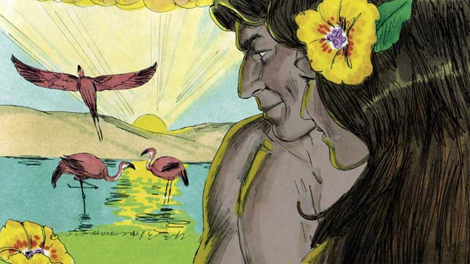
When the seventh day came, God had finished his work. So God rested from all he had been doing. He blessed the seventh day and made it holy, because on this day he rested from his work. This is how God created the universe and everything in it.
A Bible story from: Genesis 1-2

2. Sin Enters the World
Adam and his wife were very happy living in the beautiful garden God had made for them. Neither of them wore clothes, but this did not cause them to feel any shame, because there was no sin in the world. They often walked in the garden and talked with God.

But there was a crafty snake in the garden. He asked the woman, “Did God really tell you not to eat the fruit from any of the trees in the garden?”
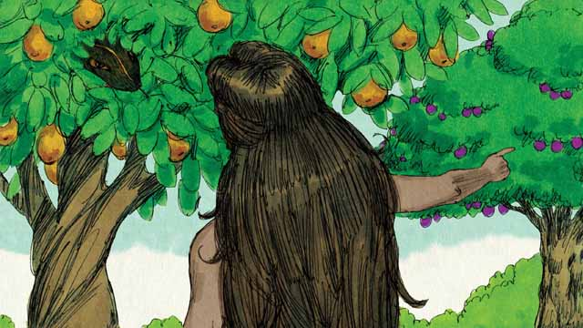
The woman answered, “God told us we could eat the fruit of any tree except from the tree of the knowledge of good and evil. God told us, ‘If you eat that fruit or even touch it, you will die.’”

The snake responded to the woman, “That is not true! You will not die. God just knows that as soon as you eat it, you will be like God and will understand good and evil like he does.”

The woman saw that the fruit was beautiful and looked delicious. She also wanted to be wise, so she picked some of the fruit and ate it. Then she gave some to her husband, who was with her, and he ate it, too.

Suddenly, their eyes were opened, and they realized they were naked. They tried to cover their bodies by sewing leaves together to make clothes.

Then the man and his wife heard the sound of God walking through the garden. They both hid from God. Then God called to the man, “Where are you?” Adam replied, “I heard you walking in the garden, and I was afraid, because I was naked. So I hid.”
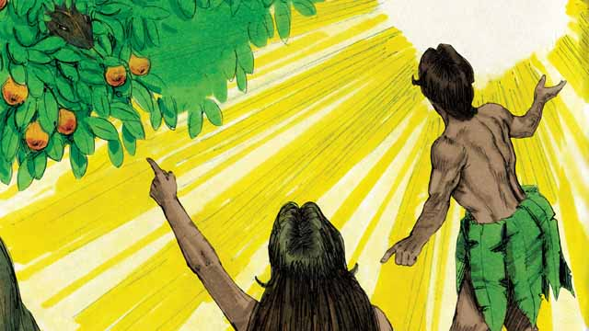
Then God asked, “Who told you that you were naked? Did you eat the fruit I told you not to eat?” The man answered, “You gave me this woman, and she gave me the fruit.” Then God asked the woman, “What have you done?” The woman replied, “The snake tricked me.”

God said to the snake, “You are cursed! You will slide on your belly and eat dirt. You and the woman will hate each other, and your children and her children will hate each other, too. The woman’s descendant will crush your head, and you will wound his heel.”

God then said to the woman, “I will make childbirth very painful for you. You will desire your husband, and he will rule over you.”

God said to the man, “You listened to your wife and disobeyed me. Now the ground is cursed, and you will need to work hard to grow food. Then you will die, and your body will return to dirt.” The man named his wife Eve, which means “life-giver,” because she would become the mother of all people. And God clothed Adam and Eve with animal skins.
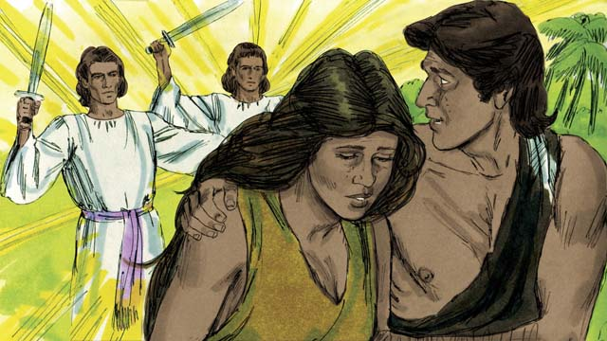
Then God said, “Now that the human beings have become like us by knowing good and evil, they must not be allowed to eat the fruit of the tree of life and live forever.” So God sent Adam and Eve away from the beautiful garden. God placed powerful angels at the entrance to the garden to keep anyone from eating the fruit of the tree of life.
A Bible story from: Genesis 3

3. The Flood
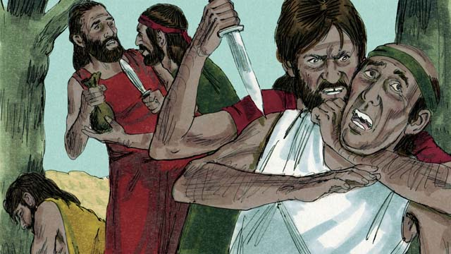
After a long time, many people were living in the world. They had become very wicked and violent. It became so bad that God decided to destroy the whole world with a huge flood.
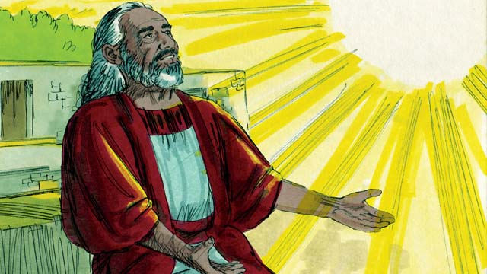
But Noah found favor with God. He was a righteous man, living among wicked people. God told Noah about the flood He was planning to send. He told Noah to build a huge boat.
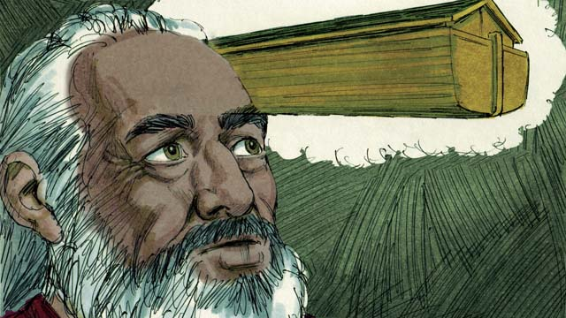
God told Noah to make the boat about 140 meters long, 23 meters wide, and 13.5 meters high. Noah was to build it with wood and to make three levels, many rooms, a roof, and a window. The boat would keep Noah, his family, and every kind of land animal safe during the flood.
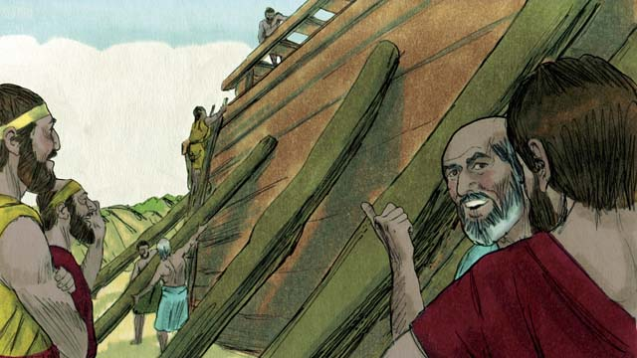
Noah obeyed God. He and his three sons built the boat just the way God had told them. It took many years to build the boat, because it was so big. Noah warned the people about the flood that was coming and told them to turn to God, but they did not believe him.
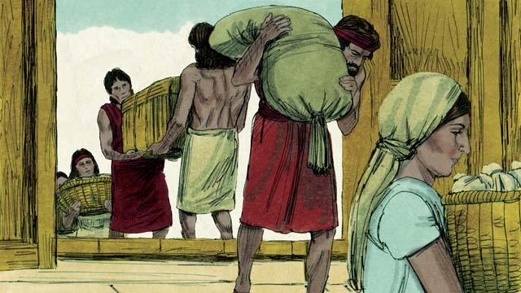
God also commanded Noah and his family to gather enough food for themselves and the animals. When everything was ready, God told Noah it was time for him, his wife, his three sons, and their wives to get into the boat—eight people in all.
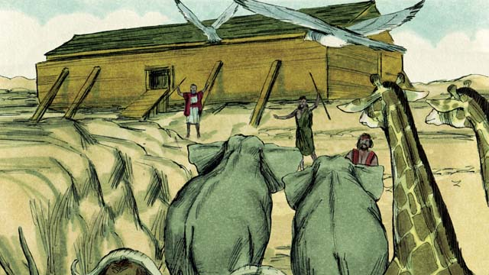
God sent a male and a female of every animal and bird to Noah so they could go into the boat and be kept safe during the flood. God sent seven males and seven females of every type of animal that could be used for sacrifices. When they were all in the boat, God himself closed the door.
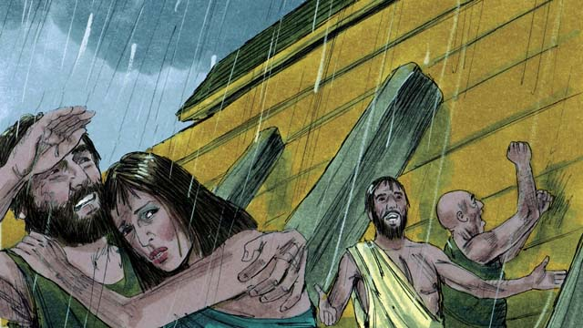
Then it began to rain, and rain, and rain. It rained for forty days and forty nights without stopping! Water also came gushing up out of the earth. Everything in the whole world was covered with water, even the highest mountains.
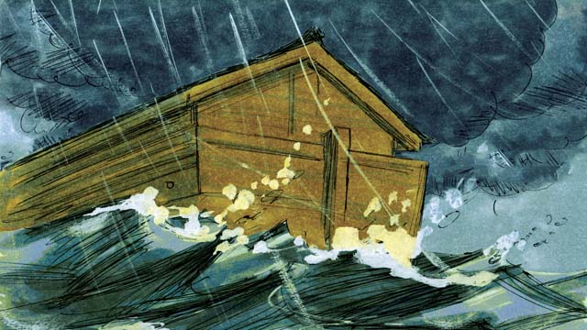
Everything that lived on the dry land died, except the people and animals that were in the boat. The boat floated on the water and kept everything inside the boat safe from drowning.
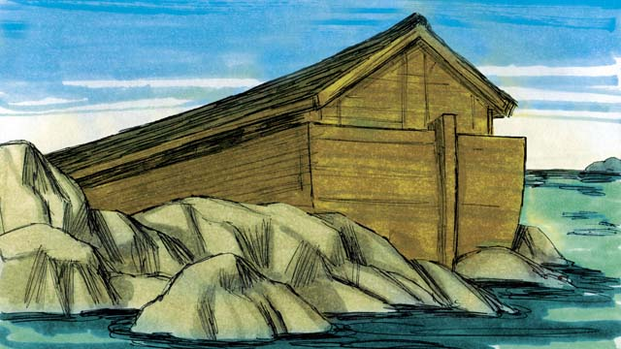
After the rains stopped, the boat floated on the water for five months, and during this time the water started going down. Then one day the boat rested on the top of a mountain, but the world was still covered with water. After three more months, the tops of the mountains were visible.
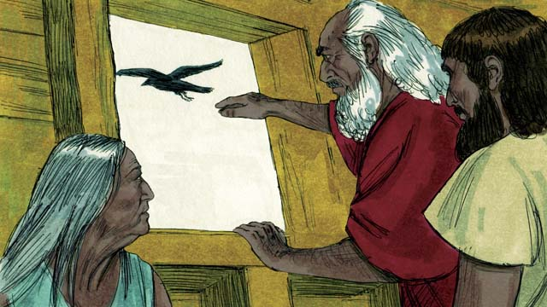
After forty more days, Noah sent out a bird called a raven to see if the water had dried up. The raven flew back and forth looking for dry land, but it could not find any.
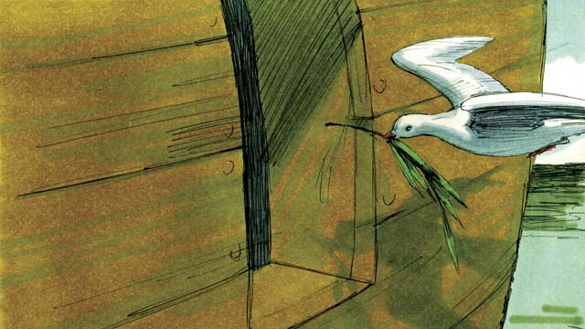
Later Noah sent out a bird called a dove. But it also could not find any dry land, so it came back to Noah. A week later he sent the dove out again, and it came back with an olive branch in its beak! The water was going down, and the plants were growing again!
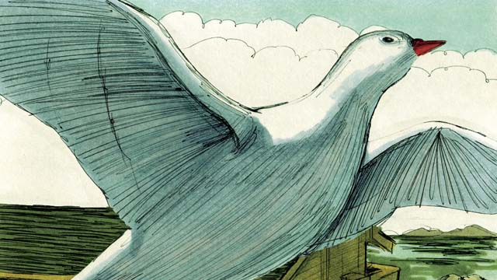
Noah waited another week and sent out the dove a third time. This time, it found a place to rest and did not come back. The water was drying up!
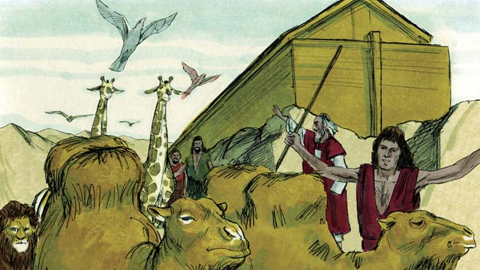
Two months later God said to Noah, “You and your family and all the animals may leave the boat now. Have many children and grandchildren and fill the earth.” So Noah and his family came out of the boat.
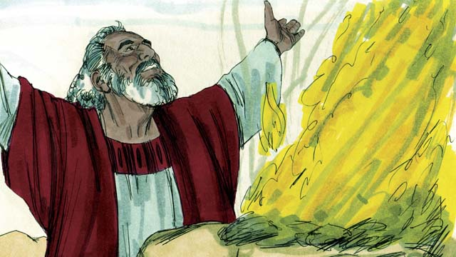
After Noah got off the boat, he built an altar and sacrificed some of each kind of animal that could be used for a sacrifice. God was happy with the sacrifice and blessed Noah and his family.
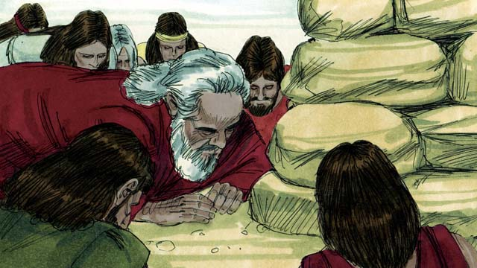
God said, “I promise I will never again curse the ground because of the evil things that people do, or destroy the world by causing a flood, even though people are sinful from the time they are children.”
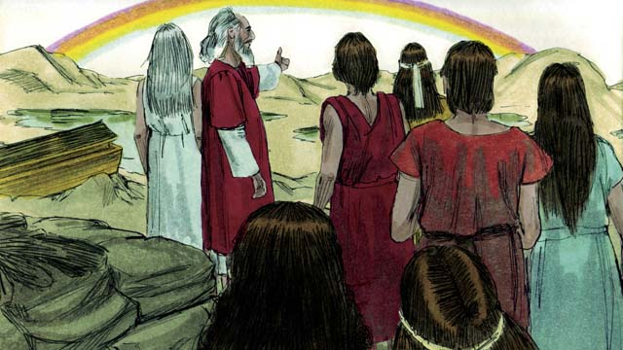
God then made the first rainbow as a sign of his promise. Every time the rainbow appeared in the sky, God would remember what he promised and so would his people.
A Bible story from: Genesis 6-8

4. God’s Covenant with Abraham
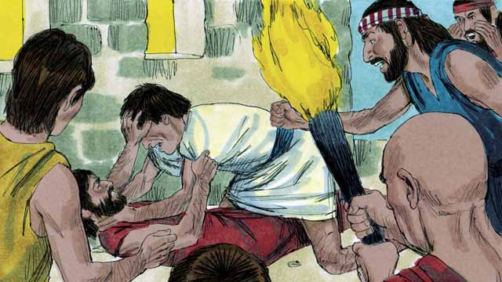
Many years after the flood, there were again many people in the world, and they all spoke the same language. Instead of filling the earth as God had commanded, they gathered together and built a city.
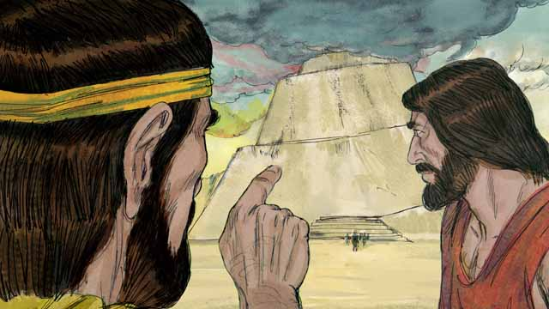
They were very proud, and they did not care about what God said. They even began building a tall tower to reach heaven. God saw that if they all kept working together to do evil, they could do many more sinful things.
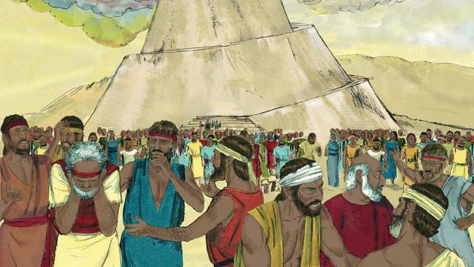
So God changed their language into many different languages and spread the people out all over the world. The city they had begun to build was called Babel, which means, “confused.”
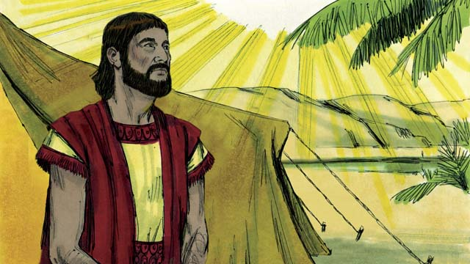
Hundreds of years later, God spoke to a man named Abram. God told him, “Leave your country and family and go to the land I will show you. I will bless you and make you a great nation. I will make your name great. I will bless those who bless you and curse those who curse you. All families on earth will be blessed because of you.”
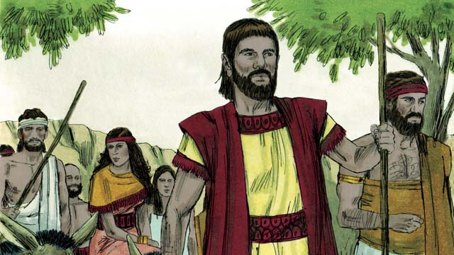
So Abram obeyed God. He took his wife, Sarai, together with all of his servants and everything he owned and went to the land God showed him, the land of Canaan.
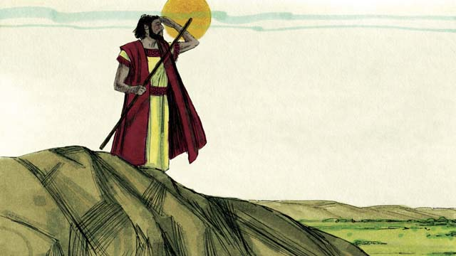
When Abram arrived in Canaan, God said, “Look all around you. I will give to you and your descendants all the land that you can see as an inheritance.” Then Abram settled in the land.
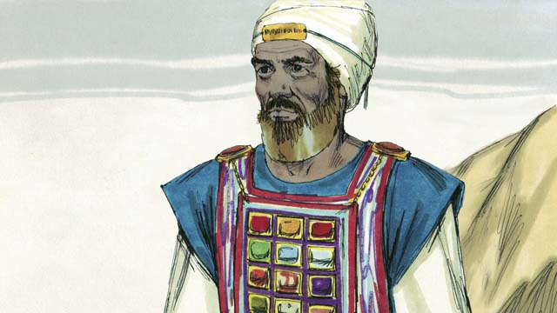
One day, Abram met Melchizedek, the priest of God Most High. Melchizedek blessed Abram and said, “May God Most High who owns heaven and earth bless Abram.” Then Abram gave Melchizedek a tenth of all he owned.
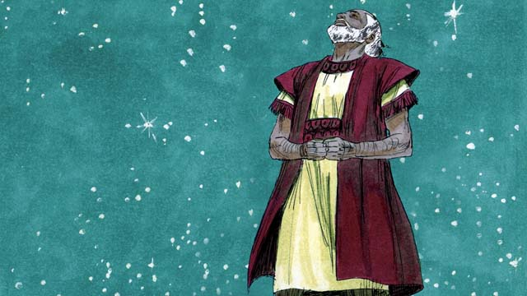
Many years went by, but Abram and Sarai still did not have a son. God spoke to Abram and promised again that he would have a son and as many descendants as the stars in the sky. Abram believed God’s promise. God declared that Abram was righteous because he believed in God’s promise.
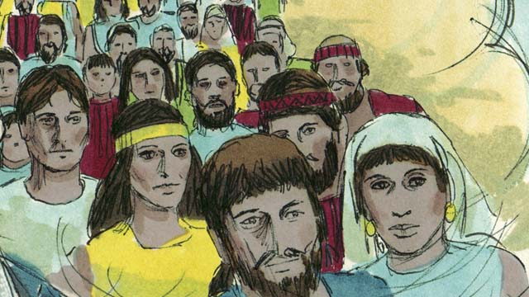
Then God made a covenant with Abram. A covenant is an agreement between two parties. God said, “I will give you a son from your own body. I give the land of Canaan to your descendants.” But Abram still did not have a son.
A Bible story from: Genesis 11-15

5. The Son of Promise
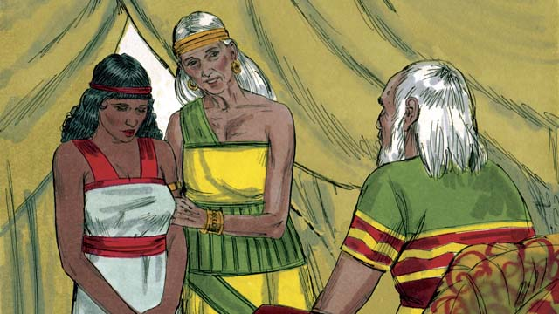
Ten years after Abram and Sarai arrived in Canaan, they still did not have a child. So Abram’s wife, Sarai, said to him, “Since God has not allowed me to have children and now I am too old to have children, here is my servant, Hagar. Marry her also so she can have a child for me.”
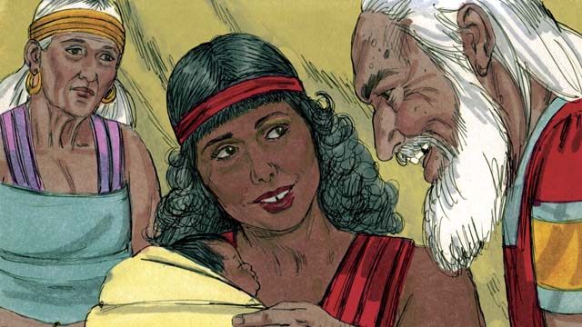
So Abram married Hagar. Hagar had a baby boy, and Abram named him Ishmael. But Sarai became jealous of Hagar. When Ishmael was thirteen years old, God again spoke to Abram.
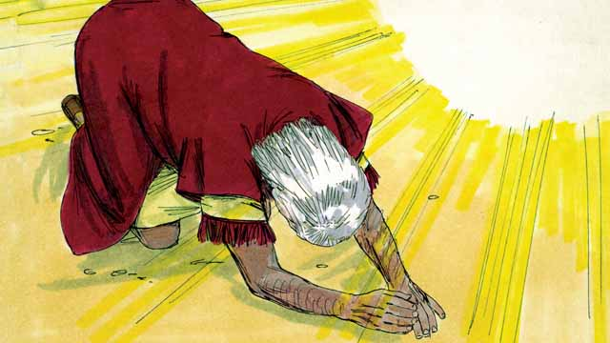
God said, “I am God Almighty. I will make a covenant with you.” Then Abram bowed to the ground. God also told Abram, “You will be the father of many nations. I will give you and your descendants the land of Canaan as their possession and I will be their God forever. You must circumcise every male in your family.”
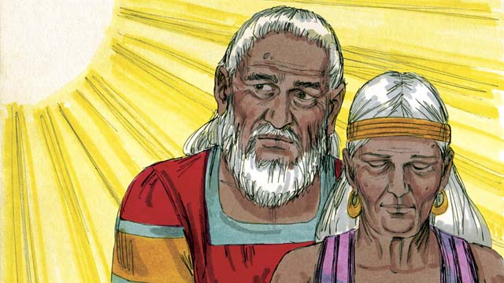
“Your wife, Sarai, will have a son—he will be the son of promise. Name him Isaac. I will make my covenant with him, and he will become a great nation. I will make Ishmael a great nation, too, but my covenant will be with Isaac.” Then God changed Abram’s name to Abraham, which means “father of many.” God also changed Sarai’s name to Sarah, which means “princess.”
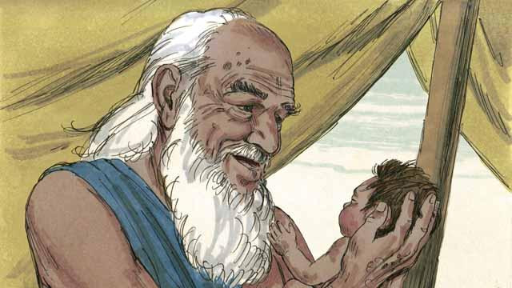
That day Abraham circumcised all the males in his household. About a year later, when Abraham was 100 years old and Sarah was 90, Sarah gave birth to Abraham’s son. They named him Isaac as God had told them to do.
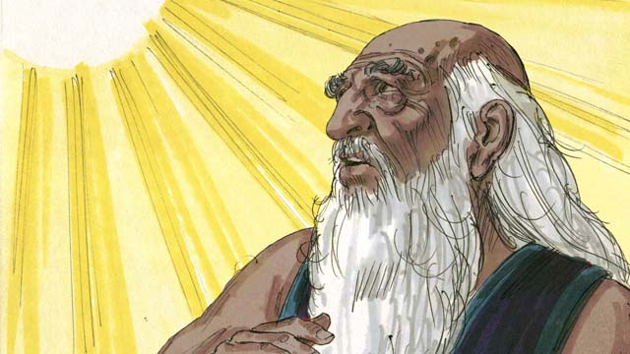
When Isaac was a young man, God tested Abraham’s faith by saying, “Take Isaac, your only son, and kill him as a sacrifice to me.” Again Abraham obeyed God and prepared to sacrifice his son.
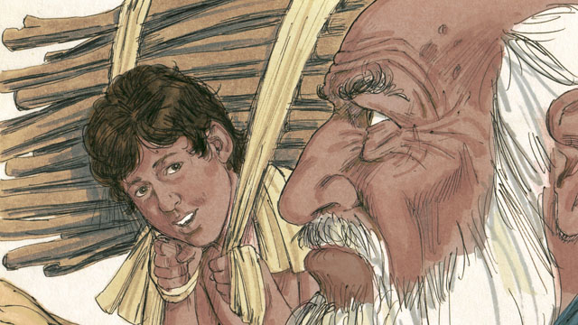
As Abraham and Isaac walked to the place of sacrifice, Isaac asked, “Father, we have wood for the sacrifice, but where is the lamb?” Abraham replied, “God will provide the lamb for the sacrifice, my son.”
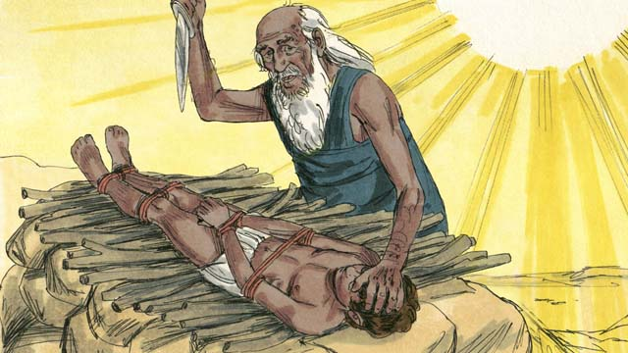
When they reached the place of sacrifice, Abraham tied up his son Isaac and laid him on an altar. He was about to kill his son when God said, “Stop! Do not hurt the boy! Now I know that you fear me because you did not keep your only son from me.”
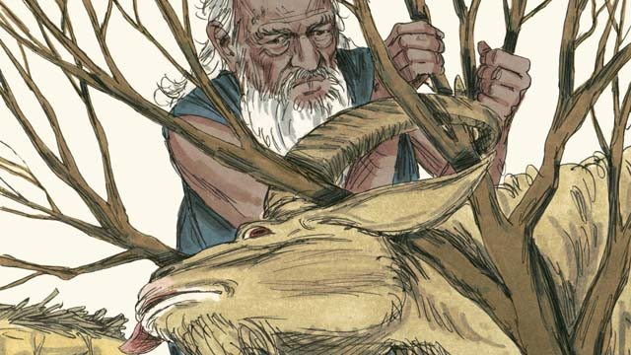
Nearby Abraham saw a ram that was stuck in a bush. God had provided the ram to be the sacrifice instead of Isaac. Abraham happily offered the ram as a sacrifice.
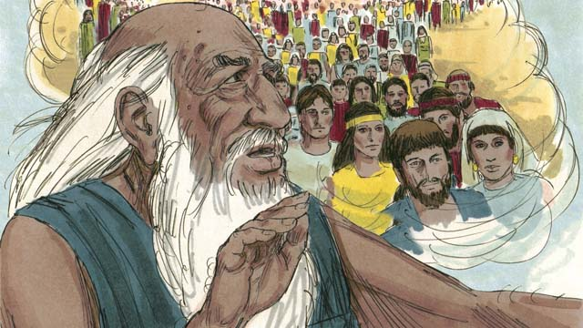
Then God said to Abraham, “Because you were willing to give me everything, even your only son, I promise to bless you. Your descendants will be more than the stars in the sky. Because you have obeyed me, all the families of the world will be blessed through your family.”
A Bible story from: Genesis 16-22

6. God Provides for Isaac
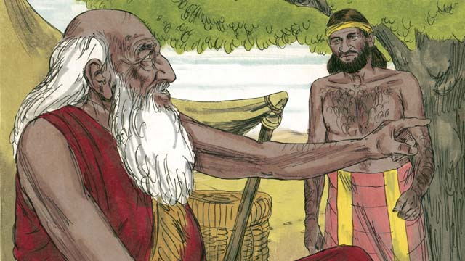
When Abraham was very old, his son, Isaac, had grown to be a man. So Abraham sent one of his servants back to the land where his relatives lived to bring back a wife for his son, Isaac.
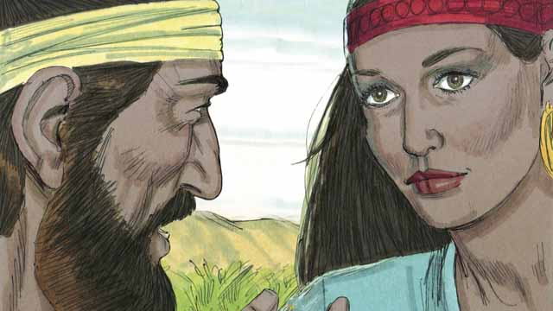
After a very long journey to the land where Abraham’s relatives lived, God led the servant to Rebekah. She was the granddaughter of Abraham’s brother.
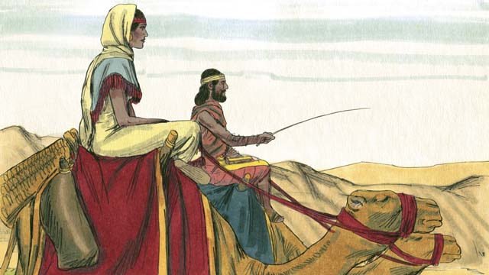
Rebekah agreed to leave her family and go back with the servant to Isaac’s home. Isaac married her as soon as she arrived.
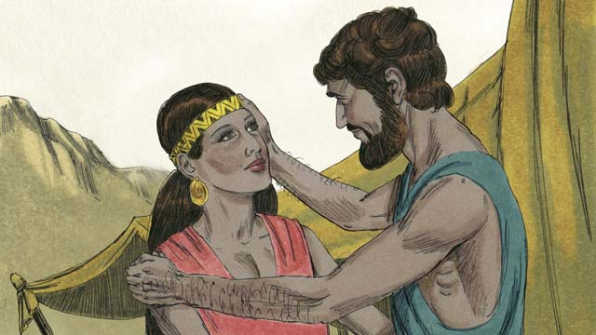
After a long time, Abraham died and all of the promises that God had made to him in the covenant were passed on to Isaac. God had promised that Abraham would have countless descendants, but Isaac’s wife, Rebekah, could not have children.
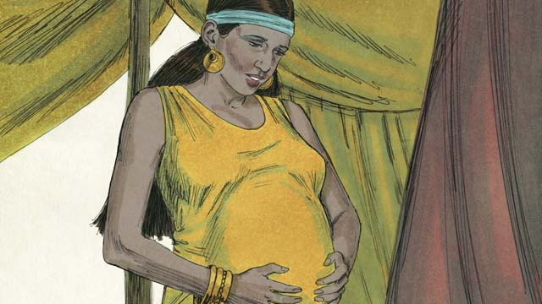
Isaac prayed for Rebekah, and God allowed her to get pregnant with twins. The two babies struggled with each other while they were still in Rebekah’s womb, so Rebekah asked God what was happening.

God told Rebekah, “Two nations will come from the two sons inside of you. They will struggle with each other and the older son will serve the younger one.”
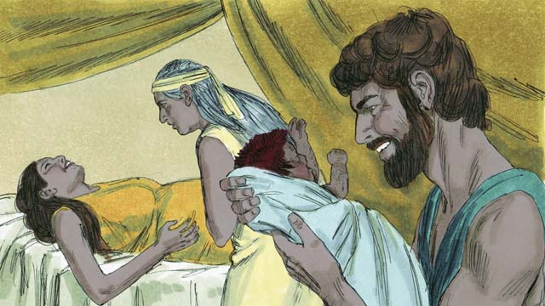
When Rebekah’s babies were born, the older son came out red and hairy, and they named him Esau. Then the younger son came out holding on to Esau’s heel, and they named him Jacob.
A Bible story from: Genesis 24:1-25:26

7. God Blessed Jacob
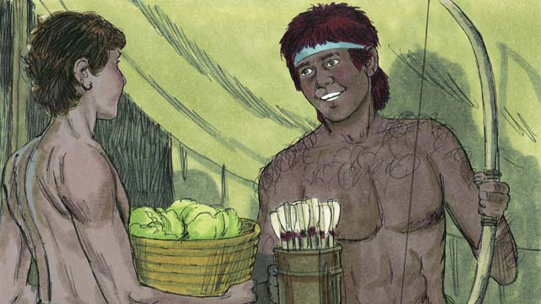
As the boys grew up, Jacob loved to stay at home, but Esau loved to hunt. Rebekah loved Jacob, but Isaac loved Esau.
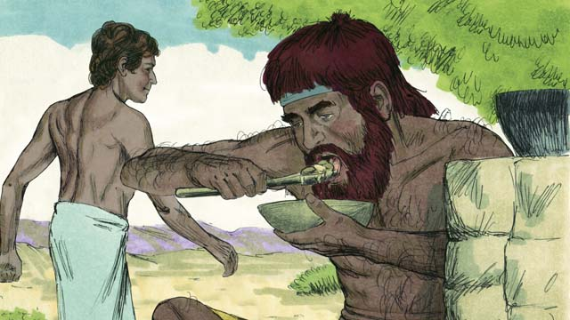
One day, when Esau came back from hunting, he was very hungry. Esau said to Jacob, “Please give me some of the food you have made.” Jacob responded, “First, give me your rights as the oldest son.” So Esau gave Jacob his rights as the oldest son. Then Jacob gave him some food.
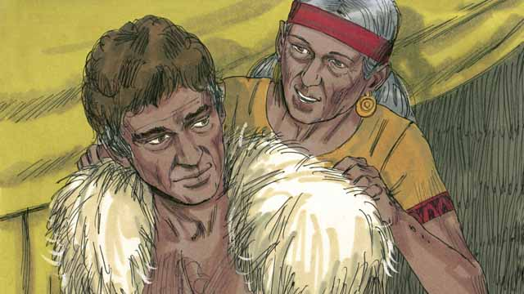
Isaac wanted to give his blessing to Esau. But before he did, Rebekah and Jacob tricked him by having Jacob pretend to be Esau. Isaac was old and could no longer see. So Jacob put on Esau’s clothes and put goatskins on his neck and hands.
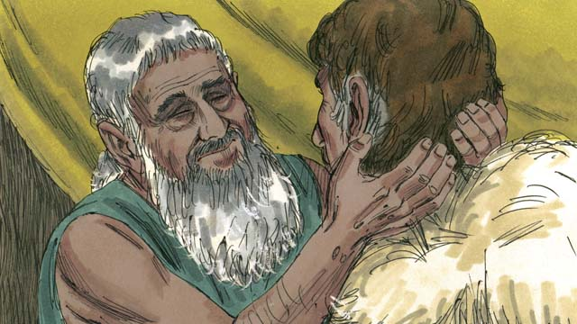
Jacob came to Isaac and said, “I am Esau. I have come so that you can bless me.” When Isaac felt the goat hair and smelled the clothes, he thought it was Esau and blessed him.
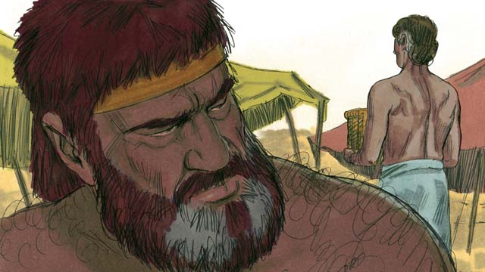
Esau hated Jacob because Jacob had stolen his rights as oldest son and also his blessing. So he planned to kill Jacob after their father died.
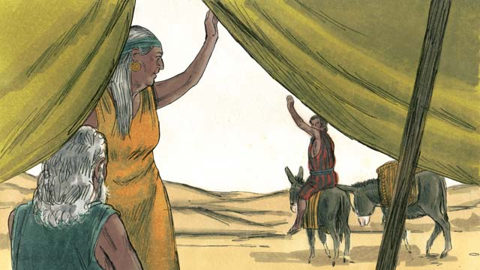
But Rebekah heard of Esau’s plan. So she and Isaac sent Jacob far away to live with her relatives.
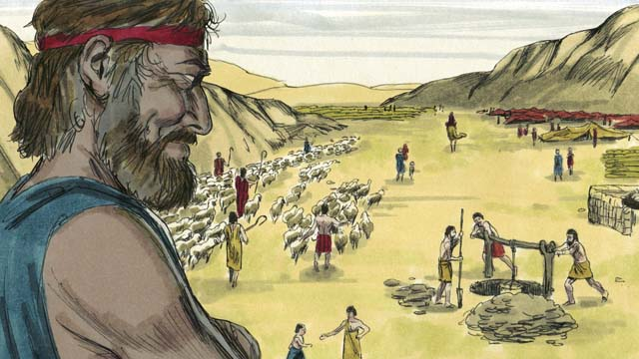
Jacob lived with Rebekah’s relatives for many years. During that time he married and had twelve sons and a daughter. God made him very wealthy.
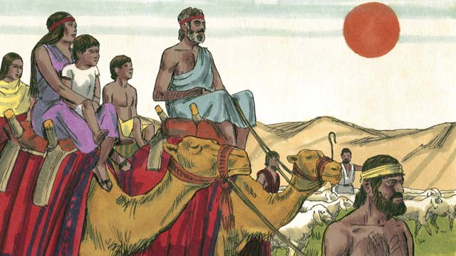
After twenty years away from his home in Canaan, Jacob returned there with his family, his servants, and all his herds of animals.
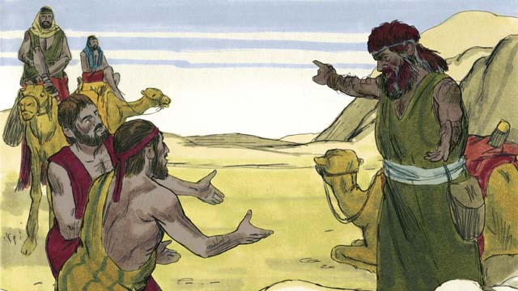
Jacob was very afraid because he thought Esau still wanted to kill him. So he sent many herds of animals to Esau as a gift. The servants who brought the animals said to Esau, “Your servant, Jacob, is giving you these animals. He is coming soon.”
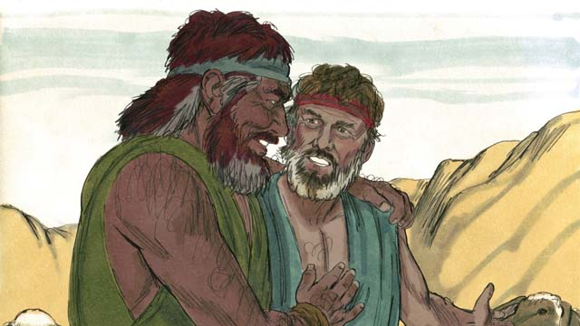
But Esau had already forgiven Jacob, and they were happy to see each other again. Jacob then lived peacefully in Canaan. Then Isaac died, and Jacob and Esau buried him. The covenant promises God had promised to Abraham now passed on from Isaac to Jacob.
A Bible story from: Genesis 25:27-33:20

8. God Saves Joseph and His Family
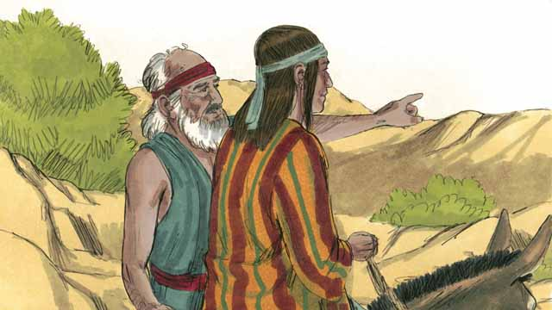
Joseph’s brothers hated him because their father loved him most and because Joseph had dreamed that he would be their ruler. When Joseph came to his brothers, they kidnapped him and sold him to some slave traders.
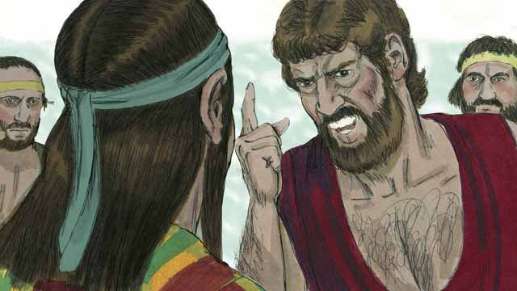
Many years later, when Jacob was an old man, he sent his favorite son, Joseph, to check on his brothers who were taking care of the herds.
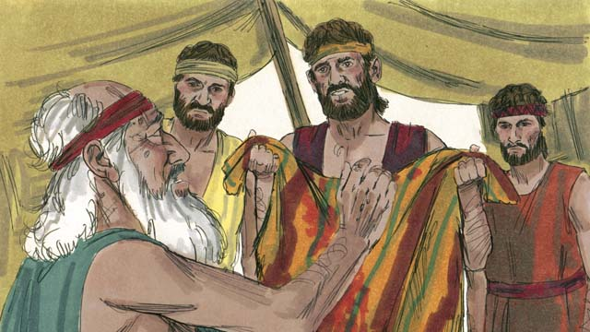
Before Joseph’s brothers returned home, they tore Joseph’s robe and dipped it in goat’s blood. Then they showed the robe to their father so he would think that a wild animal had killed Joseph. Jacob was very sad.
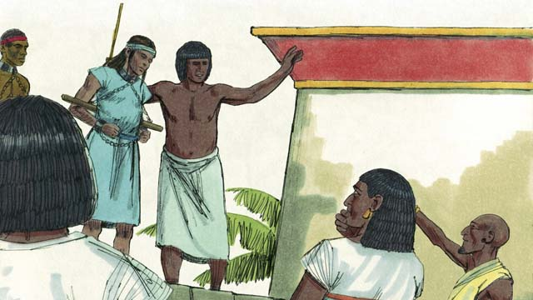
The slave traders took Joseph to Egypt. Egypt was a large, powerful country located along the Nile River. The slave traders sold Joseph as a slave to a wealthy government official. Joseph served his master well, and God blessed Joseph.
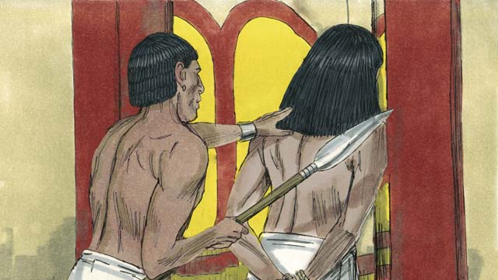
His master’s wife tried to sleep with Joseph, but Joseph refused to sin against God in this way. She became angry and falsely accused Joseph so that he was arrested and sent to prison. Even in prison, Joseph remained faithful to God, and God blessed him.
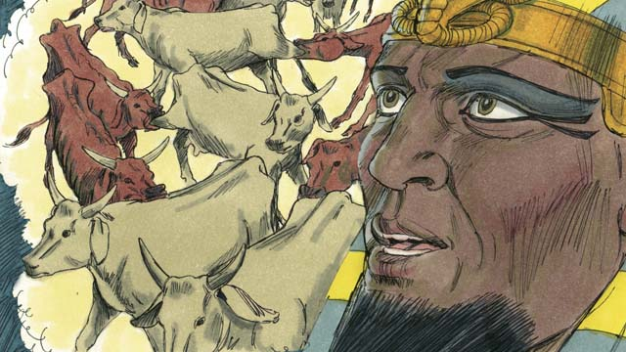
After two years, Joseph was still in prison, even though he was innocent. One night, the Pharaoh, which is what the Egyptians called their kings, had two dreams that disturbed him greatly. None of his advisors could tell him the meaning of the dreams.
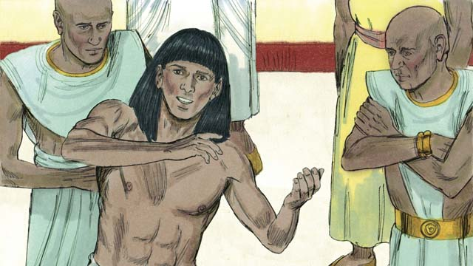
God had given Joseph the ability to interpret dreams, so Pharaoh had Joseph brought to him from the prison. Joseph interpreted the dreams for him and said, “God is going to send seven years of plentiful harvests, followed by seven years of famine.”
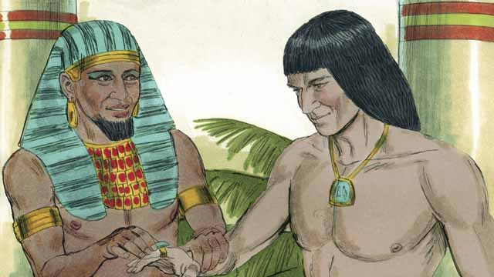
Pharaoh was so impressed with Joseph that he appointed him to be the second most powerful man in all of Egypt!
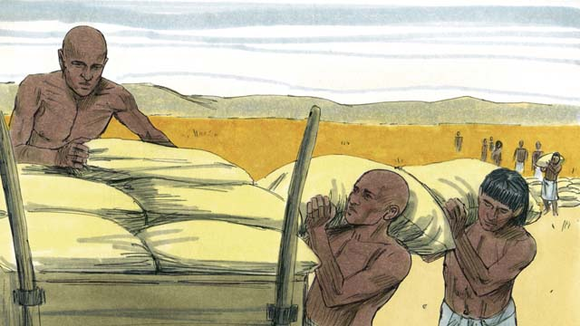
Joseph told the people to store up large amounts of food during the seven years of good harvests. Then Joseph sold the food to the people when the seven years of famine came so they would have enough to eat.
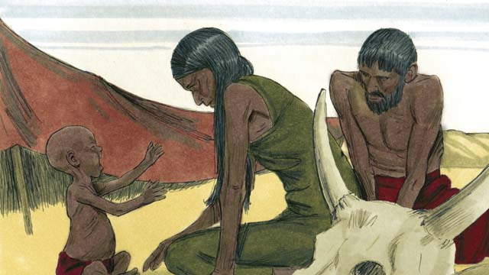
The famine was severe not only in Egypt, but also in Canaan where Jacob and his family lived.
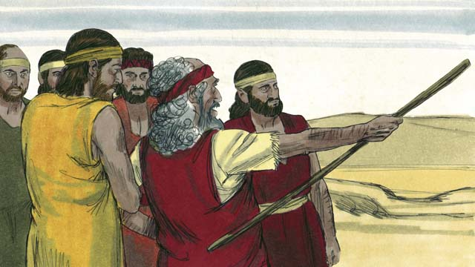
So Jacob sent his older sons to Egypt to buy food. The brothers did not recognize Joseph when they stood before him to buy food. But Joseph recognized them.
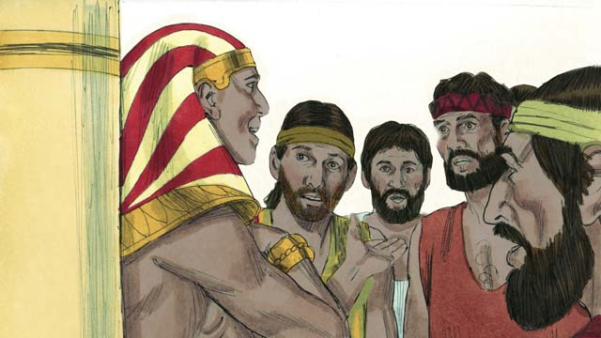
After testing his brothers to see if they had changed, Joseph said to them, “I am your brother, Joseph! Do not be afraid. You tried to do evil when you sold me as a slave, but God used the evil for good! Come and live in Egypt so I can provide for you and your families.”
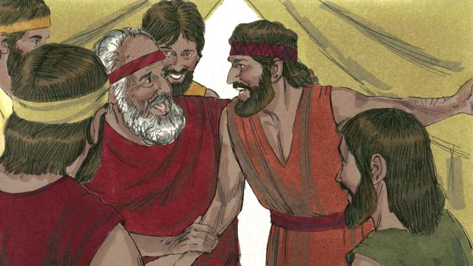
When Joseph’s brothers returned home and told their father, Jacob, that Joseph was still alive, he was very happy.
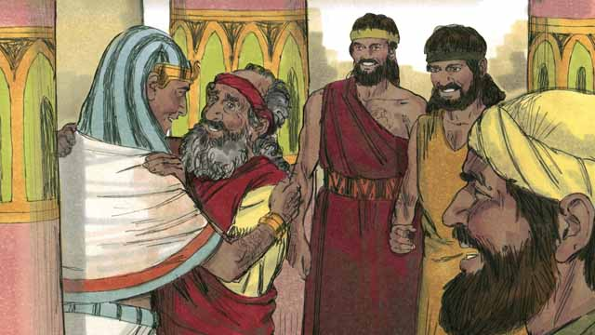
Even though Jacob was an old man, he moved to Egypt with all of his family, and they all lived there. Before Jacob died, he blessed each of his sons.
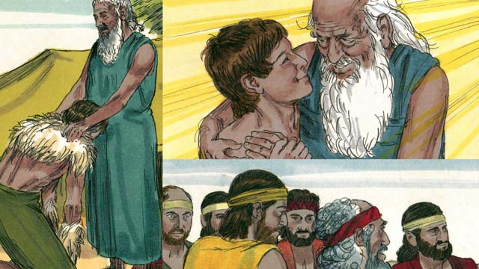
The covenant promises that God gave to Abraham were passed on to Isaac, then to Jacob, and then to Jacob’s twelve sons and their families. The descendants of the twelve sons became the twelve tribes of Israel.
A Bible story from: Genesis 37-50

9. God Calls Moses
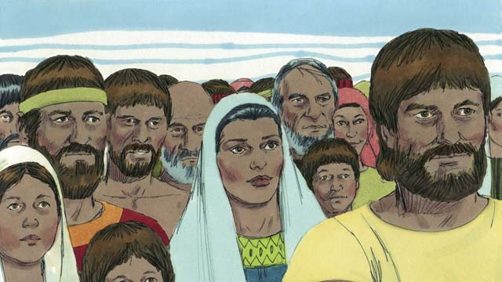
After Joseph died, all of his relatives stayed in Egypt. They and their descendants continued to live there for many years and had many children. They were called the Israelites.
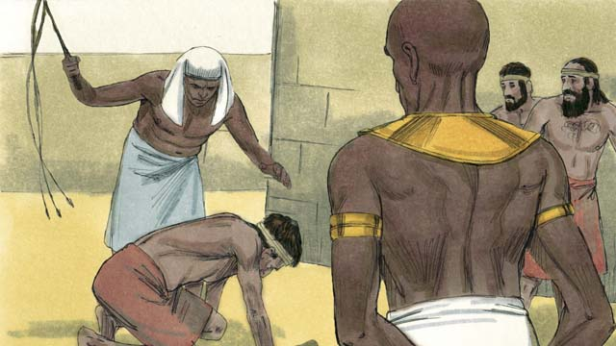
After hundreds of years, the number of Israelites had become very large. The Egyptians no longer remembered Joseph and all he had done to help them. They became afraid of the Israelites because there were so many of them. So the Pharaoh who was ruling Egypt at that time made the Israelites slaves to the Egyptians.
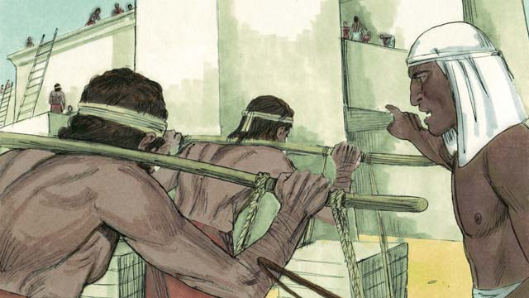
The Egyptians forced the Israelites to build many buildings and even whole cities. The hard work made their lives miserable, but God blessed them, and they had even more children.
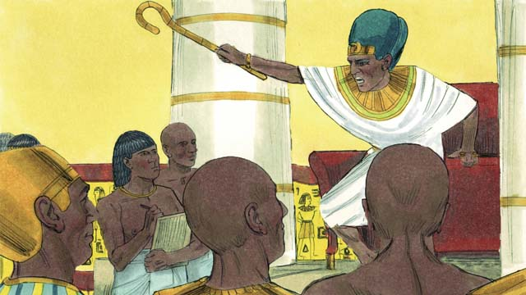
Pharaoh saw that the Israelites were having many babies, so he ordered his people to kill all Israelite baby boys by throwing them into the Nile River.
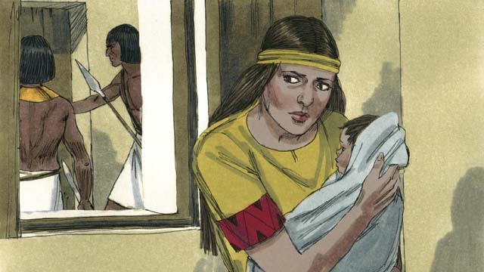
A certain Israelite woman gave birth to a baby boy. She and her husband hid the baby for as long as they could.
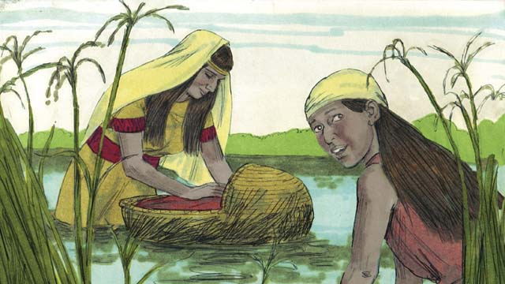
When the boy’s parents could no longer hide him, they put him in a floating basket among the reeds along the edge of the Nile River in order to save him from being killed. His older sister watched to see what would happen to him.
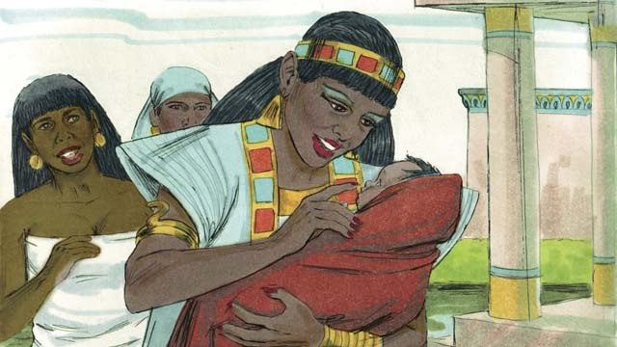
A daughter of Pharaoh saw the basket and looked inside. When she saw the baby, she took him as her own son. She hired an Israelite woman to nurse him without realizing the woman was the baby’s own mother. When the child was old enough that he no longer needed his mother’s milk, she returned him to Pharaoh’s daughter, who named him Moses.
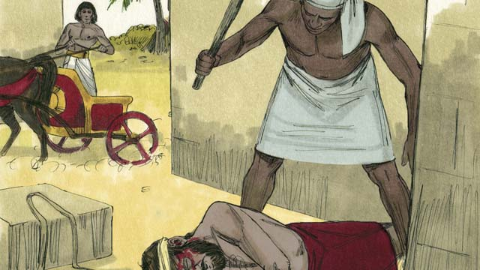
One day, when Moses had grown up, he saw an Egyptian beating an Israelite slave. Moses tried to save his fellow Israelite.
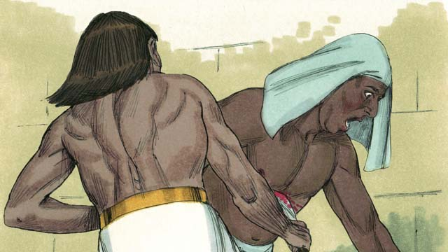
When Moses thought nobody would see, he killed the Egyptian and buried his body. But someone saw what Moses had done.
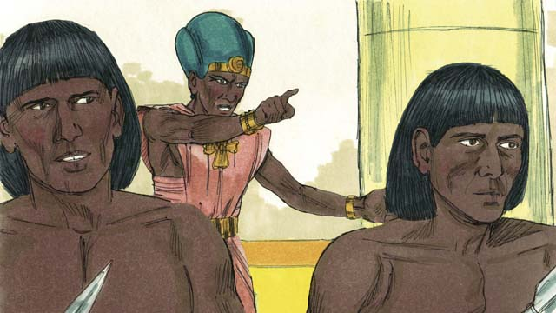
When Pharaoh heard what Moses had done, he tried to kill him. Moses ran away from Egypt to the wilderness where he would be safe from Pharaoh’s soldiers.
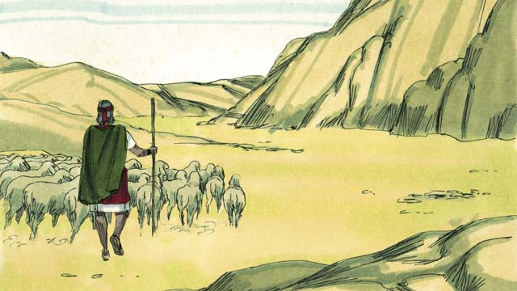
Moses became a shepherd in the wilderness far away from Egypt. He married a woman from that place and had two sons.
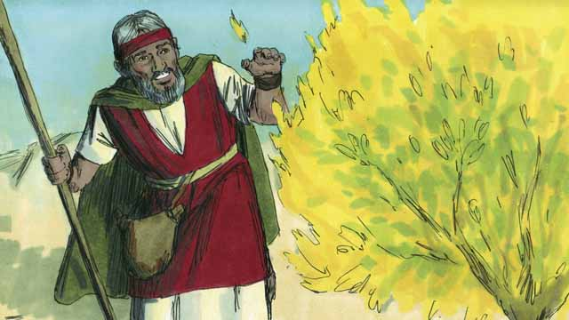
One day while Moses was taking care of his sheep, he saw a bush that was on fire. But the bush did not burn up. Moses went towards the bush to be able to see it better. As he approached the burning bush, the voice of God said, “Moses, take off your shoes. You are standing on holy ground.”
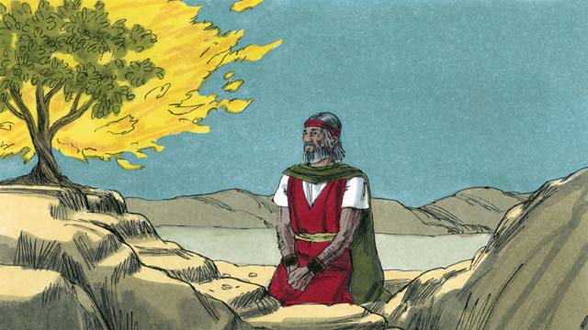
God said, “I have seen the suffering of my people. I will send you to Pharaoh so that you can bring the Israelites out of their slavery in Egypt. I will give them the land of Canaan, the land I promised to Abraham, Isaac, and Jacob.”
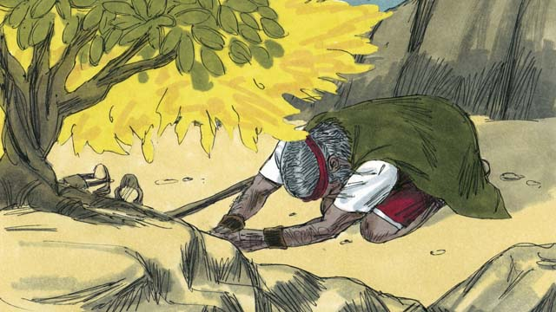
Moses asked, “What if the people want to know who sent me, what should I say?” God said, “I AM WHO I AM. Tell them, ‘I AM has sent me to you.’ Also tell them, ‘I am Yahweh, the God of your ancestors Abraham, Isaac, and Jacob.’ This is my name forever.”
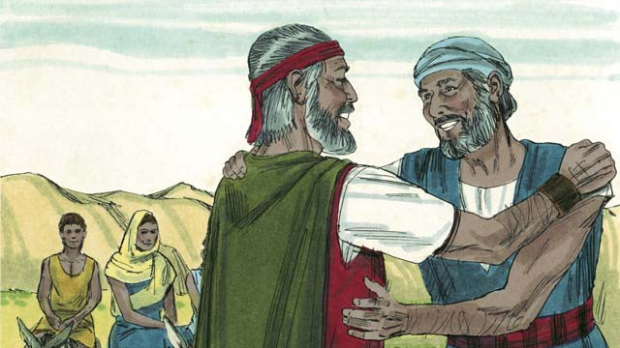
Moses was afraid and did not want to go to Pharaoh because he thought he could not speak well, so God sent Moses’ brother, Aaron, to help him. God warned Moses and Aaron that Pharaoh would be stubborn.
A Bible story from: Exodus 1-4

10. The Ten Plagues
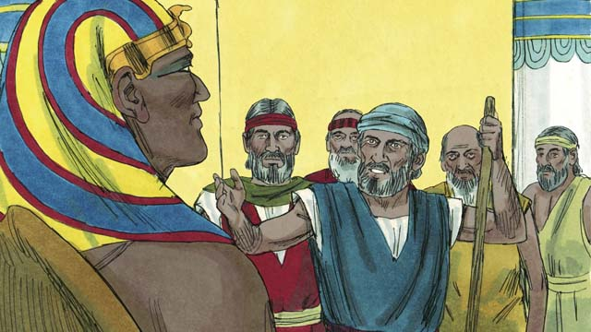
Moses and Aaron went to Pharaoh. They said, “This is what the God of Israel says, ‘Let my people go!’” Pharaoh did not listen to them. Instead of letting the Israelites go free, he forced them to work even harder!
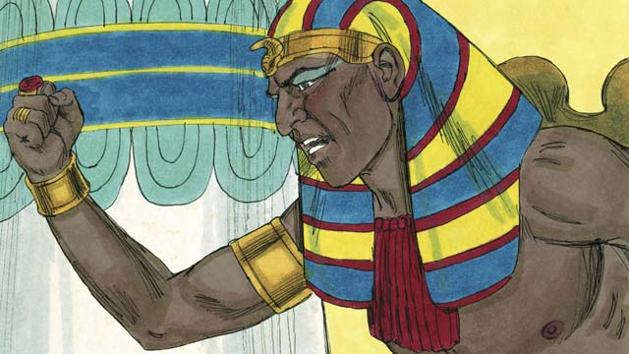
Pharaoh kept refusing to let the people go, so God sent ten terrible plagues on Egypt. Through these plagues, God showed Pharaoh that he is more powerful than Pharaoh and all of Egypt’s gods.
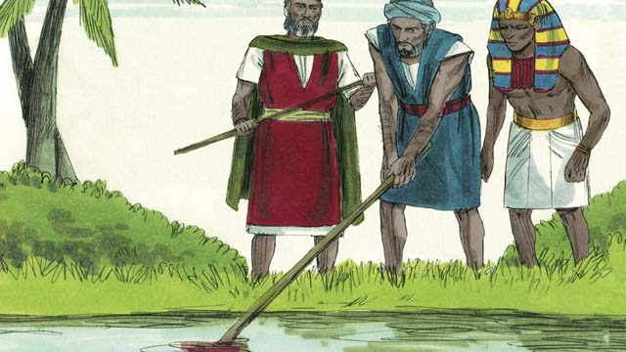
God turned the Nile River into blood, but Pharaoh still would not let the Israelites go.
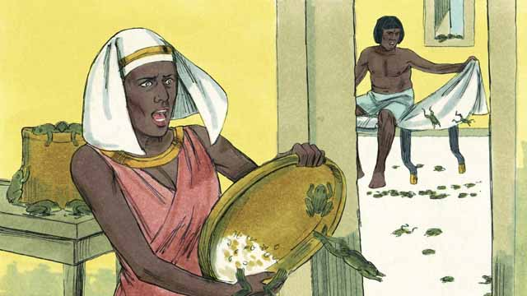
God sent frogs all over Egypt. Pharaoh begged Moses to take away the frogs. But after all the frogs died, Pharaoh hardened his heart and would not let the Israelites leave Egypt.
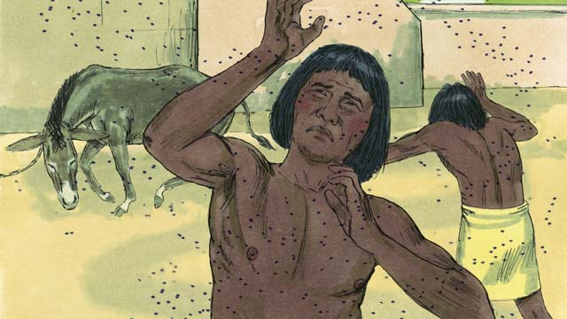
So God sent a plague of gnats. Then he sent a plague of flies. Pharaoh called Moses and Aaron and told them that if they stopped the plague, the Israelites could leave Egypt. When Moses prayed, God removed all the flies from Egypt. But Pharaoh hardened his heart and would not let the people go free.
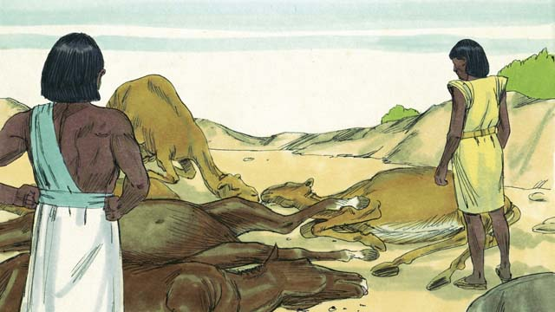
Next, God caused all the farm animals that belonged to the Egyptians to get sick and die. But Pharaoh’s heart was hardened, and he would not let the Israelites go.
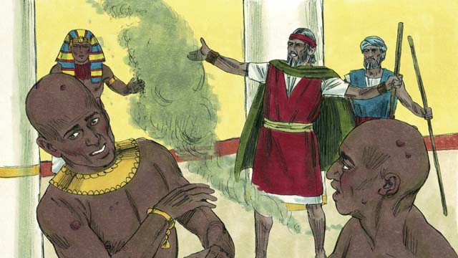
Then God told Moses to throw ashes into the air in front of Pharaoh. When he did, painful skin sores appeared on the Egyptians, but not on the Israelites. God hardened Pharaoh’s heart, and Pharaoh would not let the Israelites go free.
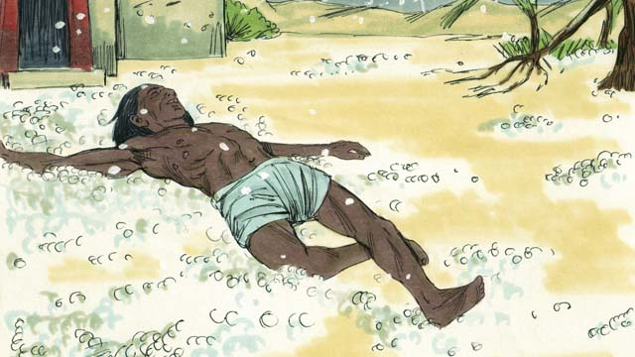
After that, God sent hail that destroyed most of the crops in Egypt and killed anybody who went outside. Pharaoh called Moses and Aaron and told them, “I have sinned. You may go.” So Moses prayed, and the hail stopped falling from the sky.
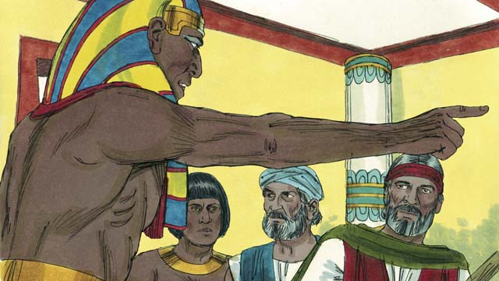
But Pharaoh sinned again and hardened his heart. He would not let the Israelites go free.
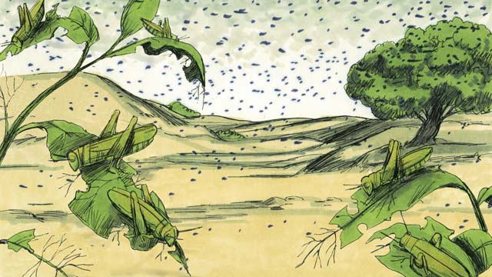
So God caused swarms of locusts to come over Egypt. These locusts ate all the crops that the hail had not destroyed.
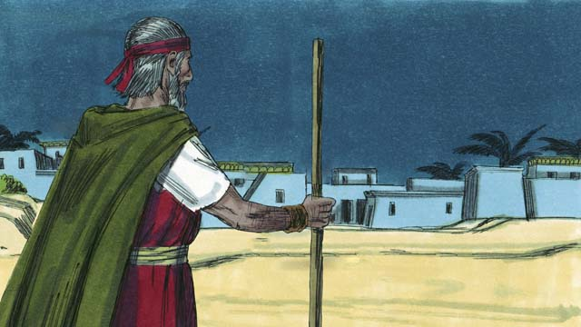
Then God sent darkness that lasted for three days. It was so dark that the Egyptians could not leave their houses. But there was light where the Israelites lived.
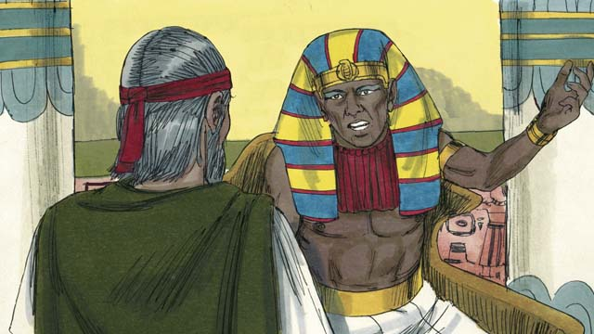
Even after these nine plagues, Pharaoh still refused to let the Israelites go free. Since Pharaoh would not listen, God planned to send one last plague. This would change Pharaoh’s mind.
A Bible story from: Exodus 5-10

11. The Passover
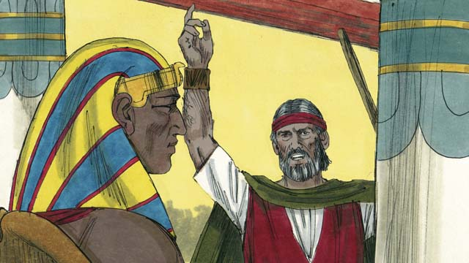
God warned Pharaoh that if he did not let the Israelites go, then he would kill all the firstborn males of both people and animals. When Pharaoh heard this he still refused to believe and obey God.
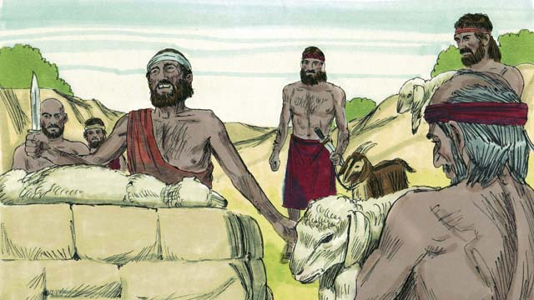
God provided a way to save the firstborn son of anyone who believed in him. Each family had to choose a perfect lamb and kill it.
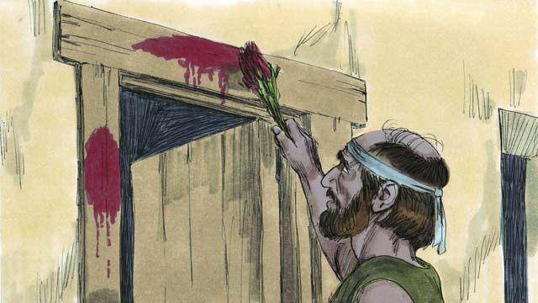
God told the Israelites to put some of the lamb’s blood around the door of their house, and to roast the meat and eat it quickly, along with bread that was made without yeast. He also told them to be ready to leave Egypt when they ate.
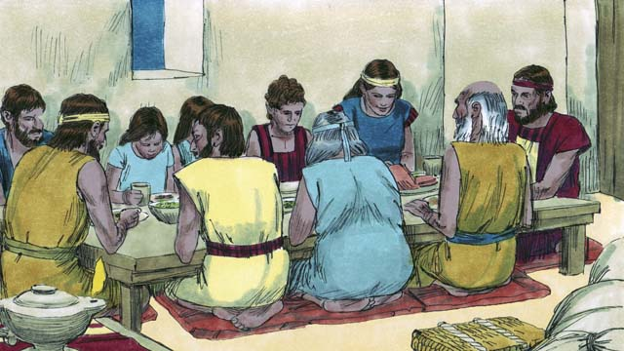
The Israelites did everything just as God had commanded them to do. In the middle of the night, God went throughout Egypt killing every firstborn son.
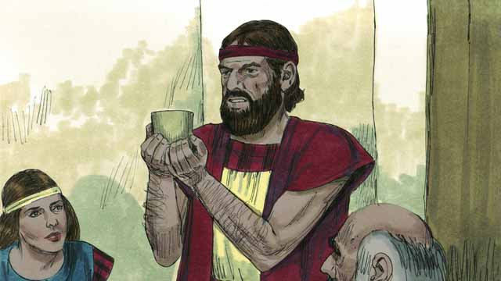
All the houses of the Israelites had blood around the doors, so God passed over those houses. Everybody inside them was safe. They were saved because of the lamb’s blood.
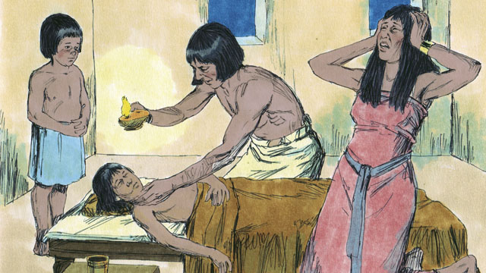
But the Egyptians did not believe God or obey his commands. So God did not pass over their houses. God killed every one of the Egyptians’ firstborn sons.
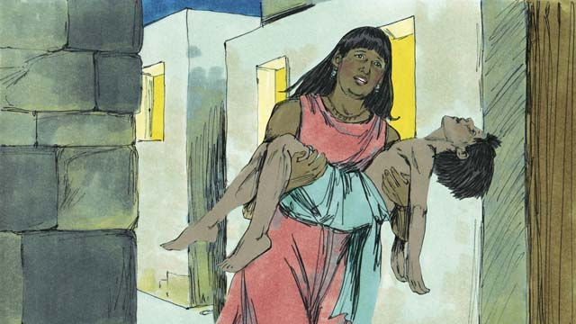
Every Egyptian firstborn male died, from the firstborn of the prisoner in jail, to the firstborn of Pharaoh. Many people in Egypt were crying and wailing because of their deep sadness.
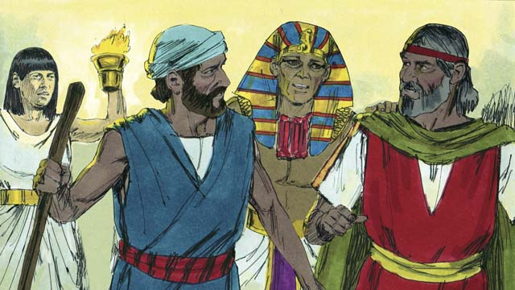
That same night, Pharaoh called for Moses and Aaron and said, “Take the Israelites and leave Egypt immediately!” The Egyptian people also urged the Israelites to leave immediately.
A Bible story from: Exodus 11:1-12:32

12. The Exodus
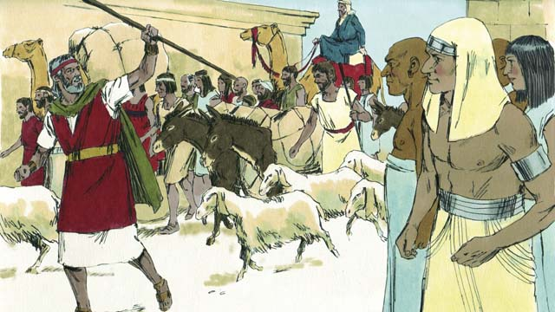
The Israelites were very happy to leave Egypt. They were no longer slaves, and they were going to the Promised Land! The Egyptians gave the Israelites whatever they asked for, even gold and silver and other valuable things. Some people from other nations believed in God and went along with the Israelites as they left Egypt.
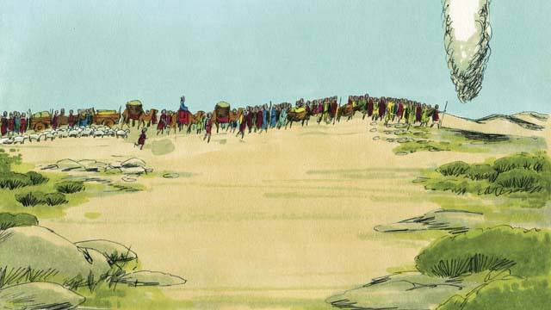
God led them with a tall pillar of cloud that went ahead of them during the day, and which became a tall pillar of fire at night. God was always with them and guided them as they traveled. All they had to do was follow him.
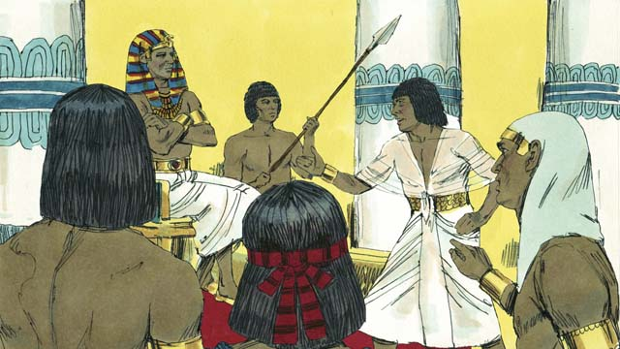
After a short time, Pharaoh and his people changed their minds and wanted the Israelites to be their slaves again. God caused Pharaoh to be stubborn so that people would see he is the One True God, and understand that he, Yahweh, is more powerful than Pharaoh and his gods.
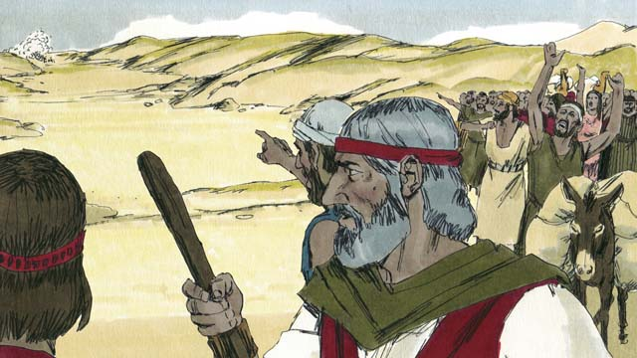
So Pharaoh and his army chased after the Israelites to make them their slaves again. When the Israelites saw the Egyptian army coming, they realized they were trapped between Pharaoh’s army and the Red Sea. They were very afraid and cried out, “Why did we leave Egypt? We are going to die!”
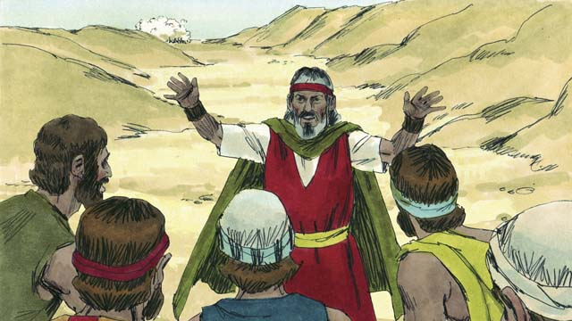
Moses told the Israelites, “Stop being afraid! God will fight for you today and save you.” Then God told Moses, “Tell the people to move toward the Red Sea.”
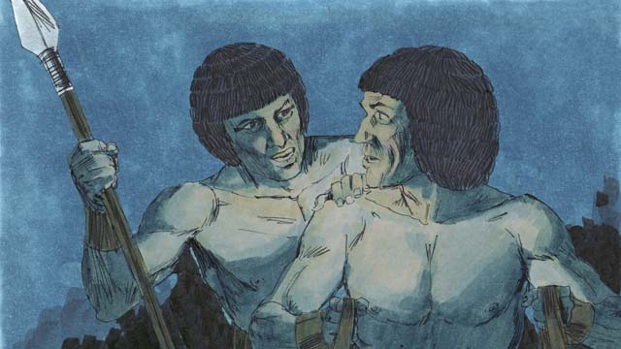
Then God moved the pillar of cloud and placed it between the Israelites and the Egyptians so the Egyptians could not see the Israelites.
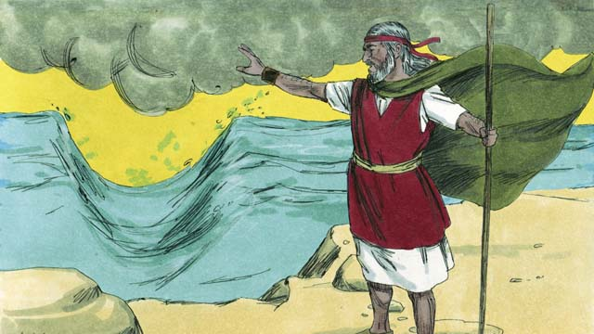
God told Moses to raise his hand over the sea and divide the waters. Then God caused wind to push the water in the sea to the left and the right, so that a path formed through the sea.
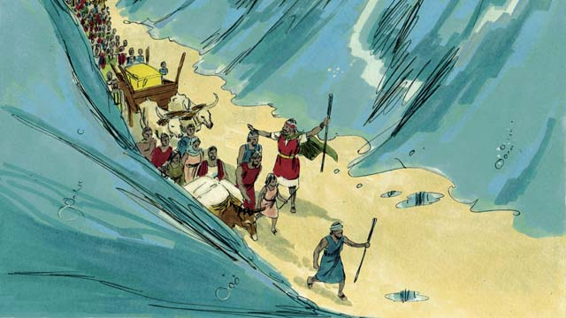
The Israelites marched through the sea on dry ground with a wall of water on either side of them.
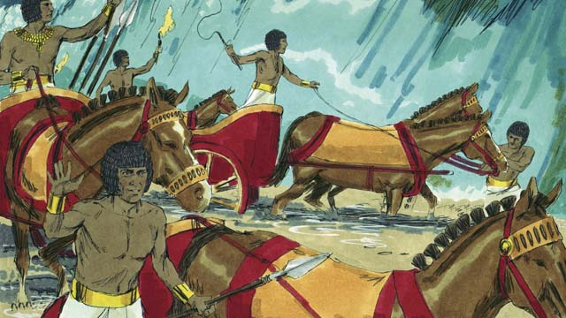
Then God moved the cloud up and out of the way so that the Egyptians could see the Israelites escaping. The Egyptians decided to chase after them.
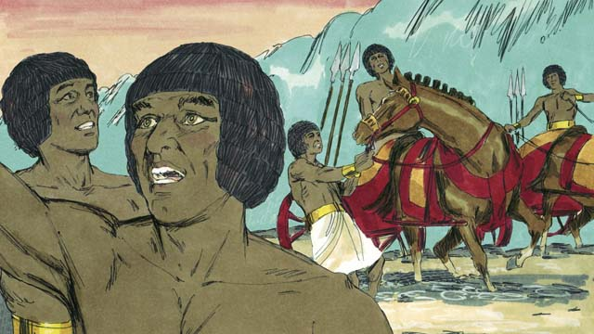
So they followed the Israelites onto the path through the sea, but God caused the Egyptians to panic and caused their chariots to get stuck. They shouted, “Run away! God is fighting for the Israelites!”
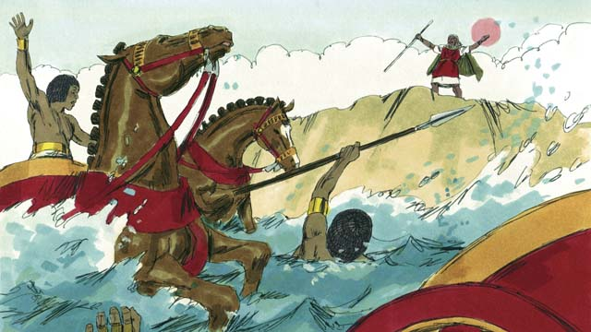
After the Israelites all made it safely to the other side of the sea, God told Moses to stretch out his arm again. When he obeyed, the water fell on the Egyptian army and returned to its normal place. The whole Egyptian army drowned.
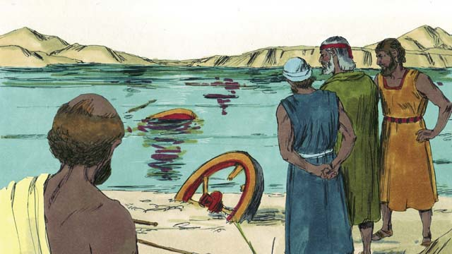
When the Israelites saw that the Egyptians were dead, they trusted in God and believed that Moses was a prophet of God.
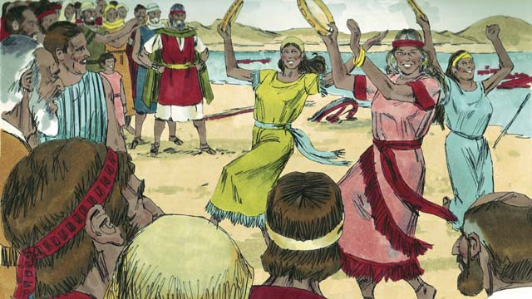
The Israelites also rejoiced with much excitement because God had saved them from death and slavery! Now they were free to serve God. The Israelites sang many songs to celebrate their new freedom and to praise God because he saved them from the Egyptian army.
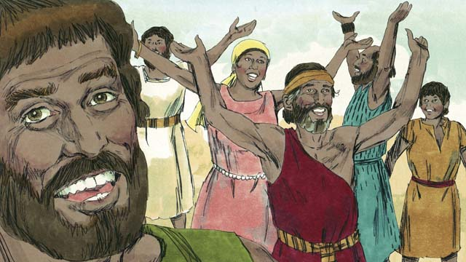
God commanded the Israelites to celebrate the Passover every year in order to remember how God gave them victory over the Egyptians and rescued them from being slaves. They celebrated by killing a perfect lamb, eating it with unleavened bread.
A Bible story from: Exodus 12:33-15:21

13. God’s Covenant with Israel
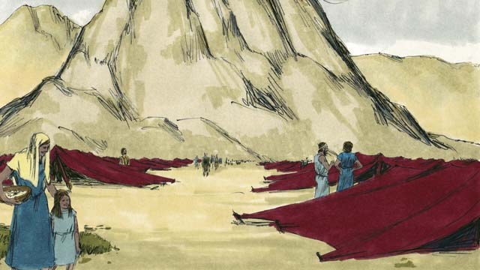
After God led the Israelites through the Red Sea, he led them through the wilderness to a mountain called Sinai. This was the same mountain where Moses had seen the burning bush. The people set up their tents at the base of the mountain.
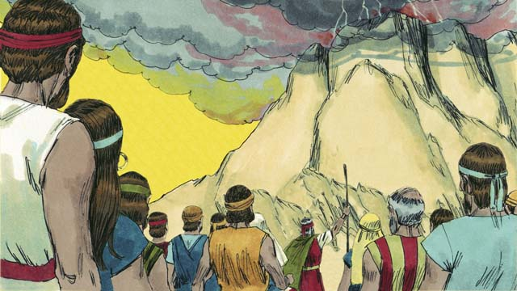
God said to Moses and the people of Israel, “If you will obey me and keep my covenant, you will be my prized possession, a kingdom of priests, and a holy nation.”
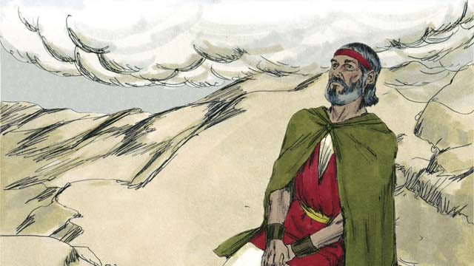
Three days later, after the people had prepared themselves spiritually, God came down on top of Mount Sinai with thunder, lightning, smoke, and a loud trumpet blast. Only Moses was allowed to go up the mountain.
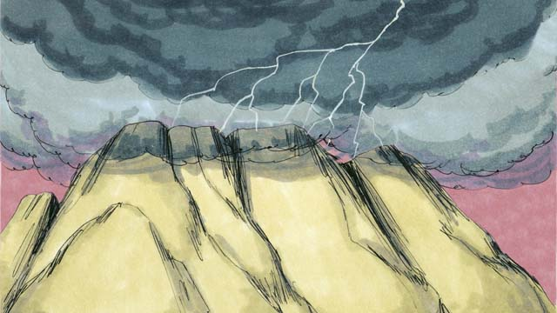
Then God gave them the covenant and said, “I am Yahweh, your God, who saved you from slavery in Egypt. Do not worship other gods.”
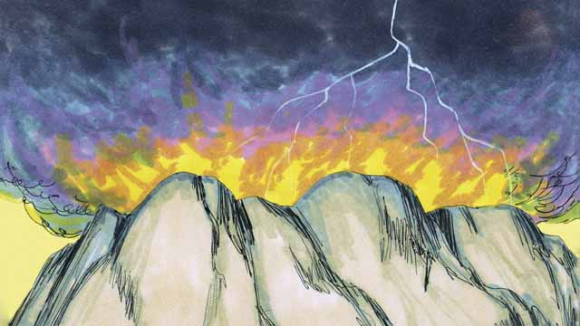
“Do not make idols and do not worship them, because I, Yahweh, am a jealous God. Do not use my name in a disrespectful way. Be sure to keep the Sabbath day holy. That is, do all your work in six days, for the seventh day is a day for you to rest and to remember me.”
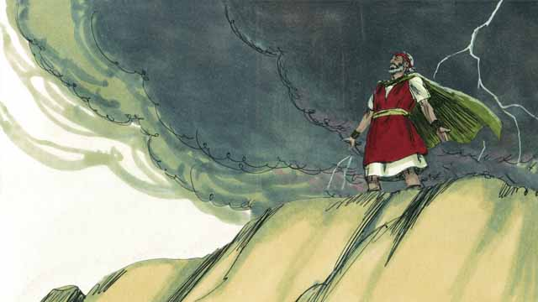
“Honor your father and your mother. Do not murder. Do not commit adultery. Do not steal. Do not lie. Do not desire to have your neighbor’s wife, his house, or anything that belongs to him.”
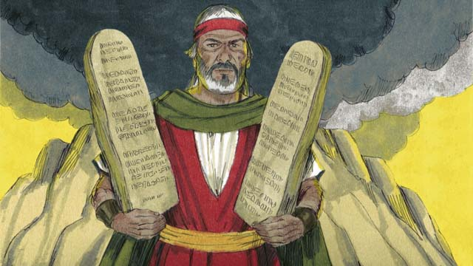
Then God wrote these Ten Commandments on two stone tablets and gave them to Moses. God also gave many other laws and rules to follow. If the people obeyed these laws, God promised that he would bless and protect them. If they disobeyed them, God would punish them.
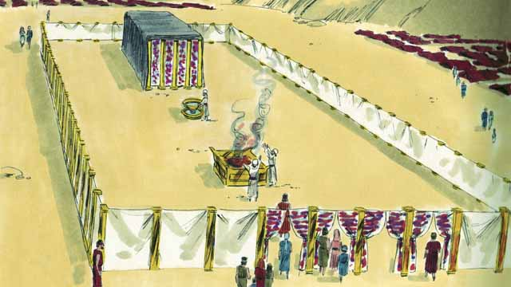
God also gave the Israelites a detailed description of a tent he wanted them to make. It was called the Tent of Meeting, and it had two rooms, separated by a large curtain. Only the high priest was allowed to go into the room behind the curtain, because God lived there.
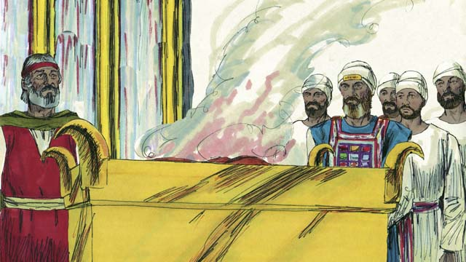
Anyone who disobeyed God’s law could bring an animal to the altar in front of the Tent of Meeting as a sacrifice to God. A priest would kill the animal and burn it on the altar. The blood of the animal that was sacrificed covered the person’s sin and made that person clean in God’s sight. God chose Moses’ brother, Aaron, and Aaron’s descendants to be his priests.
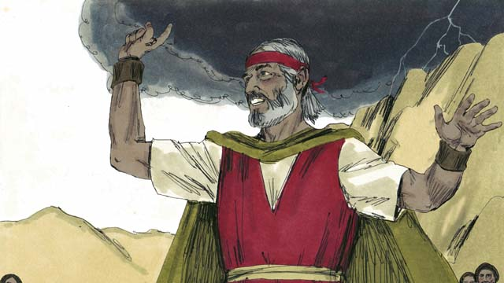
The people all agreed to obey the laws that God had given them, to worship only God, and to be his special people. But a short time after they promised to obey God, they sinned terribly.
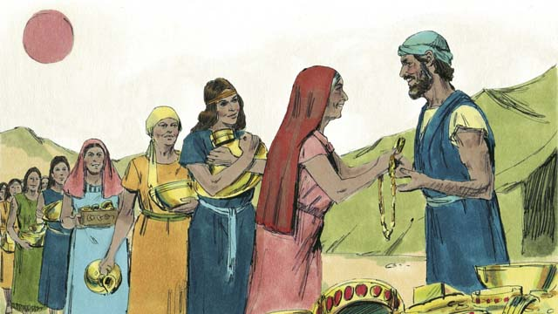
For many days, Moses was on top of Mount Sinai talking with God. The people became tired of waiting for him to return. So they brought gold to Aaron and asked him to make an idol for them!
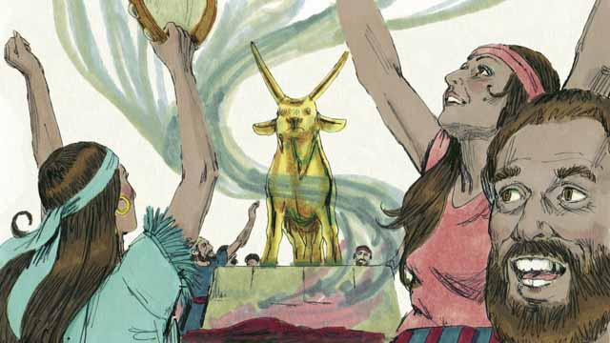
Aaron made a golden idol in the shape of a calf. The people began to wildly worship the idol and make sacrifices to it! God was very angry with them because of their sin and planned to destroy them. But Moses prayed for them, and God listened to his prayer and did not destroy them.
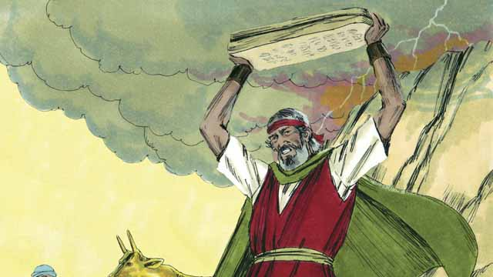
When Moses came down the mountain and saw the idol, he was so angry that he smashed the stones on which God had written the Ten Commandments.
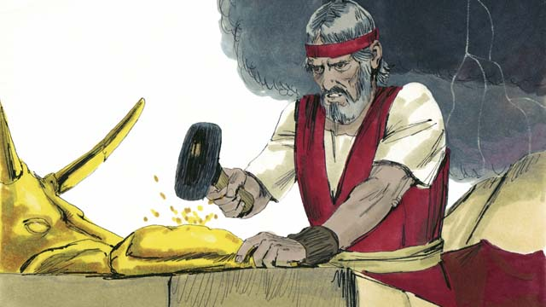
Then Moses beat the idol into powder, threw the powder into some water and made the people drink the water. God sent a plague on the people and many of them died.
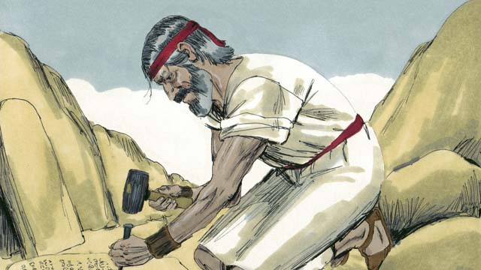
Moses climbed the mountain again and prayed that God would forgive the people. God listened to Moses and forgave them. Moses wrote the Ten Commandments on new stone tablets to replace the ones he had broken. Then God led the Israelites away from Mount Sinai toward the Promised Land.
A Bible story from: Exodus 19-34

14. Wandering in the Wilderness
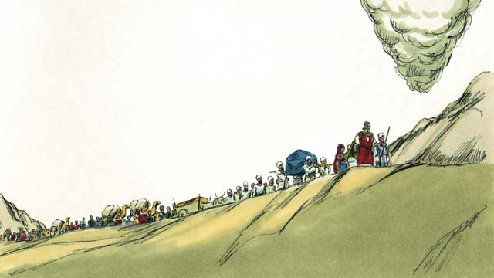
After God had told the Israelites the laws he wanted them to obey as part of his covenant with them, they left Mount Sinai. God began leading them from toward the Promised Land, which was also called Canaan. The pillar of cloud went ahead of them towards Canaan and they followed it.
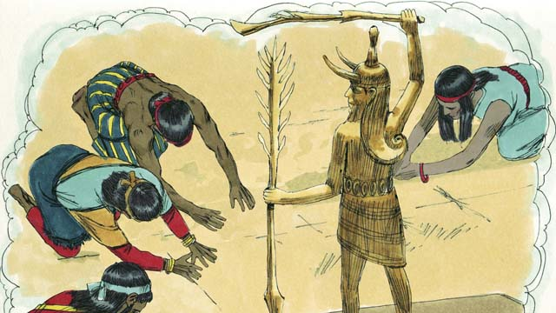
God had promised Abraham, Isaac, and Jacob that he would give the Promised Land to their descendants, but now there were many people groups living there. They were called Canaanites. The Canaanites did not worship or obey God. They worshiped false gods and did many evil things.
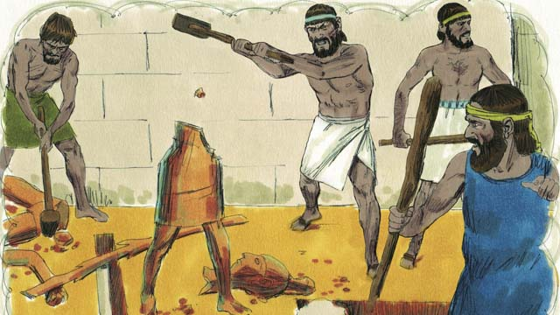
God told the Israelites, “You must get rid of all the Canaanites in the Promised Land. Do not make peace with them and do not marry them. You must completely destroy all of their idols. If you do not obey me, you will worship their idols instead of me.”
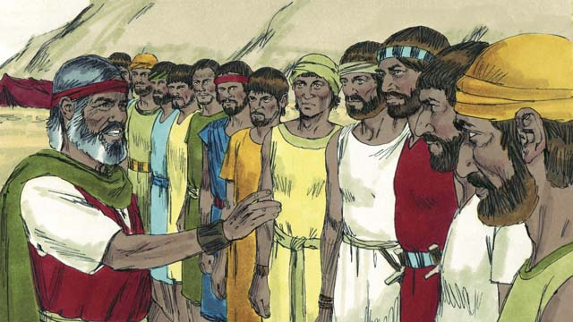
When the Israelites reached the border of Canaan, Moses chose twelve men, one from each tribe of Israel. He gave the men instructions to go and spy on the land to see what it was like. They were also to spy on the Canaanites to see if they were strong or weak.
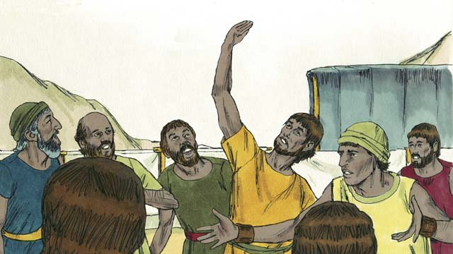
The twelve men traveled through Canaan for forty days and then they came back. They told the people, “The land is very fertile and the crops are plentiful!” But ten of the spies said, “The cities are very strong and the people are giants! If we attack them, they will certainly defeat us and kill us!”
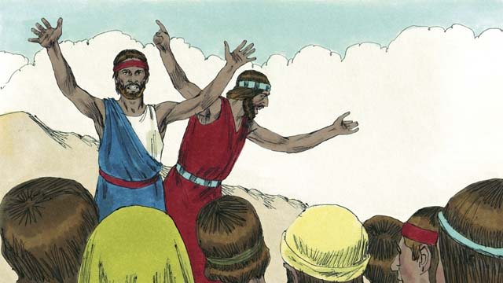
Immediately Caleb and Joshua, the other two spies, said, “It is true that the people of Canaan are tall and strong, but we can certainly defeat them! God will fight for us!”
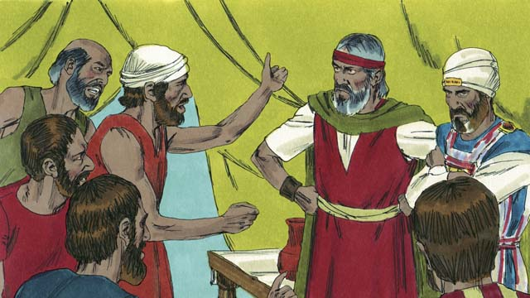
But the people did not listen to Caleb and Joshua. They became angry with Moses and Aaron and said, “Why did you bring us to this horrible place? We should have stayed in Egypt rather than be killed in battle and our wives and children made slaves.” The people wanted to choose a different leader to take them back to Egypt.
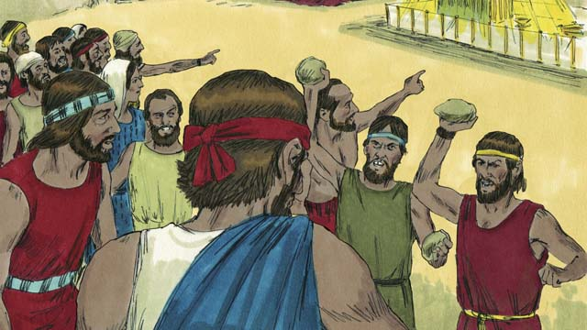
God was very angry and came to the Tent of Meeting. God said, “Because you have rebelled against me, all of the people will have to wander in the wilderness. Except for Joshua and Caleb, everyone who is twenty years or older will die there and never enter the Promised Land.”
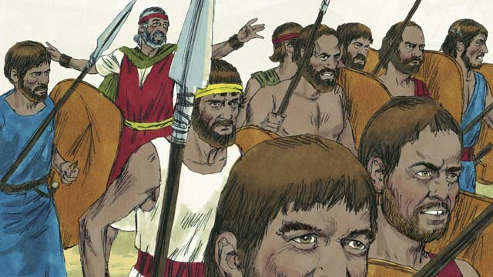
When the people heard this, they were sorry they had sinned. They took their weapons and went to attack the people of Canaan. Moses warned them not to go because God was not with them, but they did not listen to him.
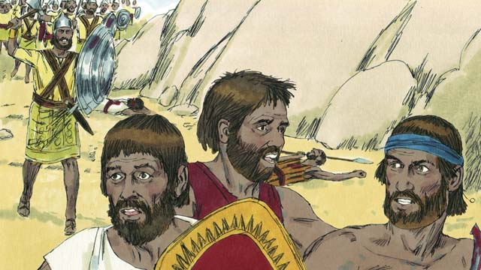
God did not go with them into this battle, so they were defeated and many of them were killed. Then the Israelites turned back from Canaan and wandered through the wilderness for forty years.
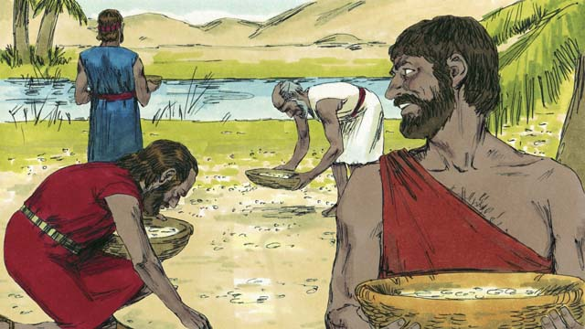
During the forty years that the people of Israel wandered in the wilderness, God provided for them. He gave them bread from heaven, called “manna.” He also sent flocks of quail (which are medium-sized birds) into their camp so they could have meat to eat. During all that time, God kept their clothes and sandals from wearing out.
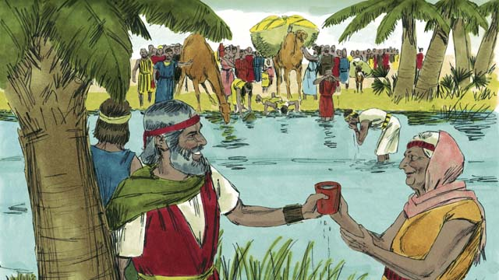
God even miraculously gave them water from a rock. But despite all this, the people of Israel complained and grumbled against God and against Moses. Even so, God was still faithful to his promises to Abraham, Isaac, and Jacob.
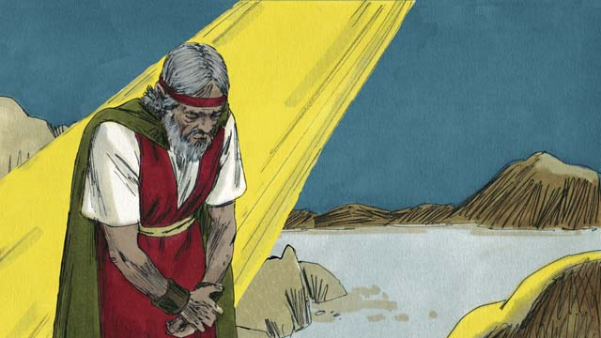
Another time when the people did not have any water, God told Moses, “Speak to the rock, and water will come out of it.” But Moses dishonored God in front of all the people by hitting the rock twice with a stick instead of speaking to it. Water came out of the rock for everyone to drink, but God was angry with Moses and said, “You will not enter the Promised Land.”
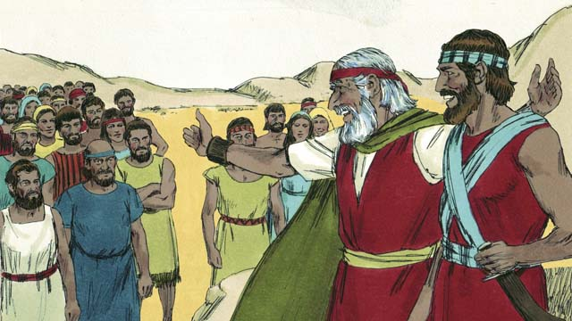
After the Israelites had wandered in the wilderness for forty years, all of them who had rebelled against God were dead. Then God led the people to the edge of the Promised Land again. Moses was now very old, so God chose Joshua to help him lead the people. God also promised Moses that one day, he would send another prophet like Moses.
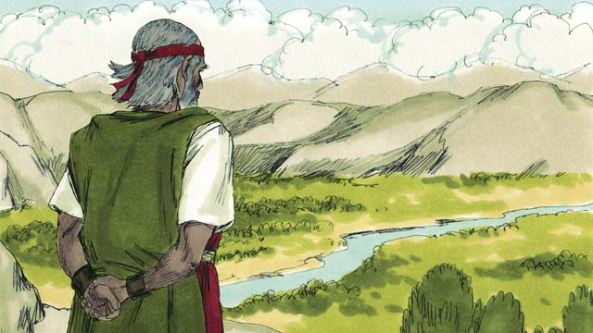
Then God told Moses to go to the top of a mountain so he could see the Promised Land. Moses saw the Promised Land but God did not permit him to enter it. Then Moses died, and the Israelites mourned for thirty days. Joshua became their new leader. Joshua was a good leader because he trusted and obeyed God.
A Bible story from: Exodus 16-17; Numbers 10-14; 20; 27; Deuteronomy 34

15. The Promised Land
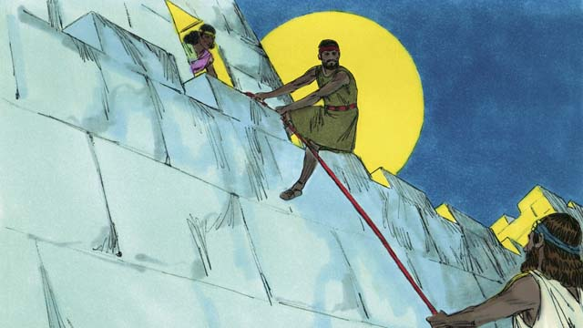
At last it was time for the Israelites to enter Canaan, the Promised Land. Joshua sent two spies to the Canaanite city of Jericho that was protected by strong walls. In that city there lived a prostitute named Rahab who hid the spies and later helped them to escape. She did this because she believed God. They promised to protect Rahab and her family when the Israelites would destroy Jericho.
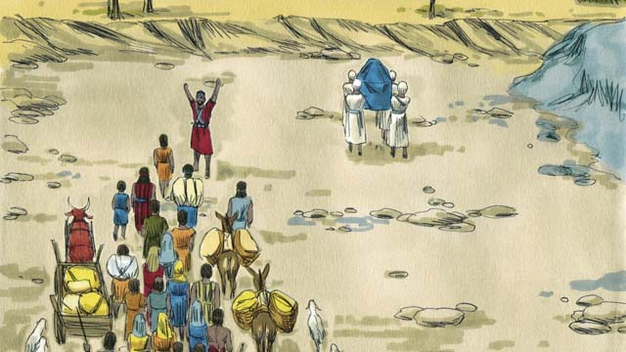
The Israelites had to cross the Jordan River to enter into the Promised Land. God told Joshua, “Have the priests go first.” When the priests started to step into the Jordan River, the water upstream stopped flowing so the Israelites could cross over to the other side of the river on dry ground.
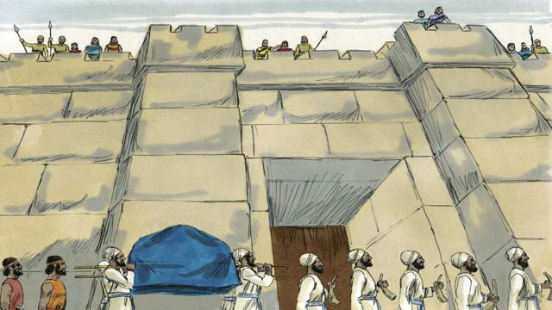
After the people crossed the Jordan River, God told Joshua how to attack the powerful city of Jericho. The people obeyed God. Just as God told them to do, the soldiers and priests marched around the city of Jericho once a day for six days.
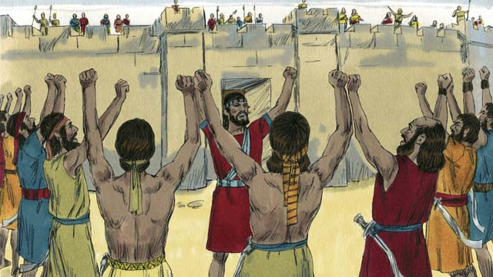
Then on the seventh day, the Israelites marched around the city seven more times. While they marched around the city for the last time, the soldiers shouted while the priests blew their trumpets.
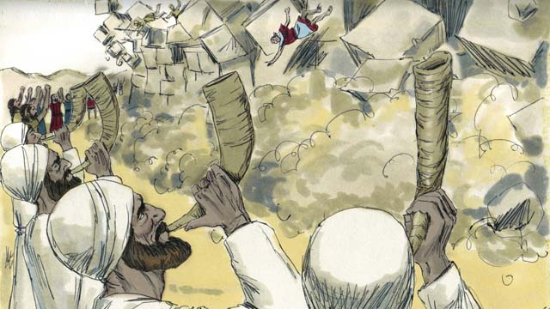
Then the walls around Jericho fell down! The Israelites destroyed everything in the city as God had commanded. They only spared Rahab and her family, who became part of the Israelites. When the other people living in Canaan heard that the Israelites had destroyed Jericho, they were terrified that the Israelites would attack them also.
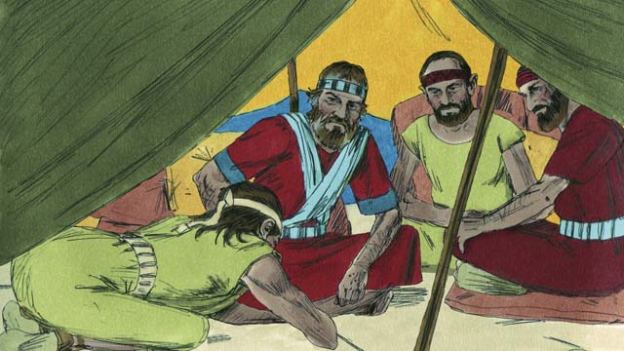
God had commanded the Israelites not to make a peace treaty with any of the people groups in Canaan. But one of the Canaanite people groups, called the Gibeonites, lied to Joshua and said they were from a place far from Canaan. They asked Joshua to make a peace treaty with them. Joshua and the Israelites did not ask God where the Gibeonites were from. So Joshua made a peace treaty with them.
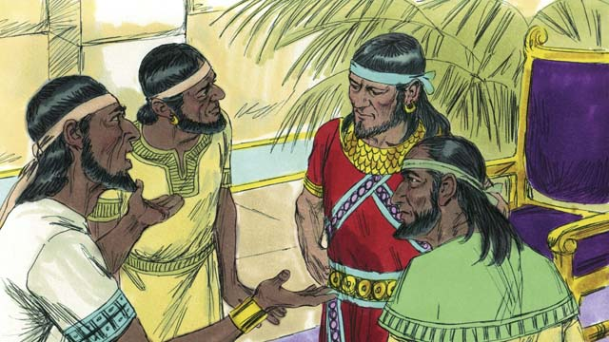
The Israelites were angry when they found out that the Gibeonites had deceived them, but they kept the peace treaty they had made with them because it was a promise before God. Sometime later, the kings of another people group in Canaan, the Amorites, heard that the Gibeonites had made a peace treaty with the Israelites, so they combined their armies into one large army and attacked Gibeon. The Gibeonites sent a message to Joshua asking for help.
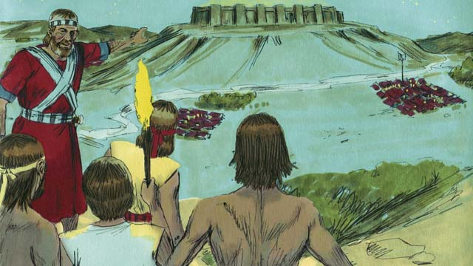
So Joshua gathered the Israelite army and they marched all night to reach the Gibeonites. In the early morning they surprised the Amorite armies and attacked them.
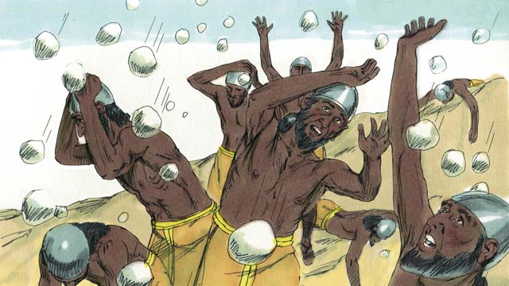
God fought for Israel that day. He caused the Amorites to be confused and he sent large hailstones that killed many of the Amorites.
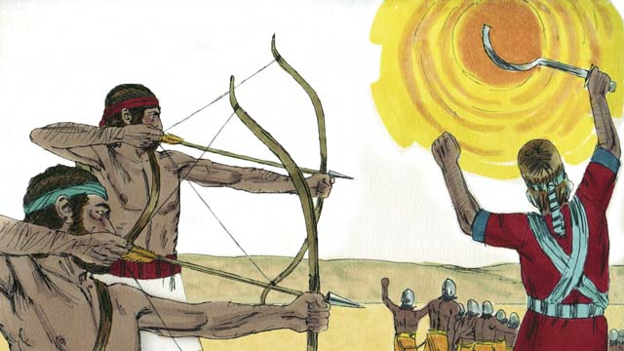
God also caused the sun to stay in one place in the sky so that Israel would have enough time to completely defeat the Amorites. On that day, God won a great victory for Israel.
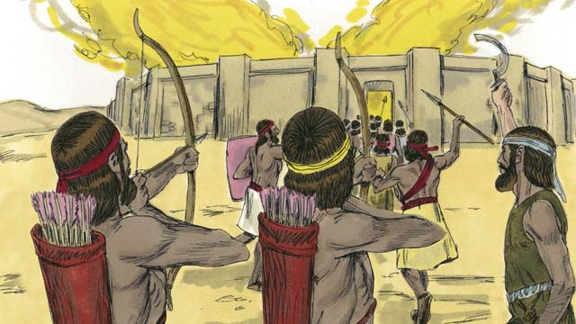
After God defeated those armies, many of the other Canaanite people groups gathered together to attack Israel. Joshua and the Israelites attacked and destroyed them.
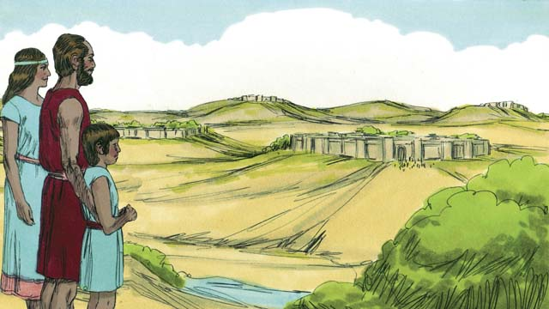
After this battle, God gave each tribe of Israel its own section of the Promised Land. Then God gave Israel peace along all its borders.
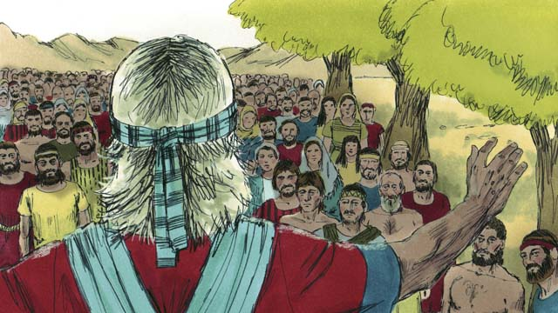
When Joshua was an old man, he called all the people of Israel together. Then Joshua reminded the people of their obligation to obey the covenant that God had made with the Israelites at Sinai. The people promised to remain faithful to God and follow his laws.
A Bible story from: Joshua 1-24

16. The Deliverers
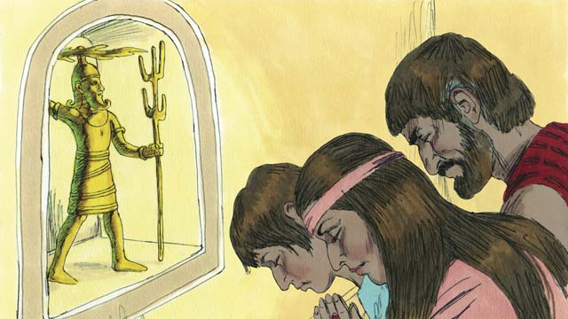
After Joshua died, the Israelites disobeyed God and did not drive out the rest of the Canaanites or obey God’s laws. The Israelites began to worship the Canaanite gods instead of Yahweh, the true God. The Israelites had no king, so everyone did what they thought was right for them.
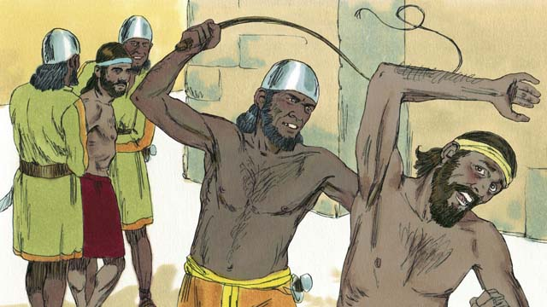
Because the Israelites kept disobeying God, he punished them by allowing their enemies to defeat them. These enemies stole things from the Israelites, destroyed their property, and killed many of them. After many years of disobeying God and being oppressed by their enemies, the Israelites repented and asked God to rescue them.
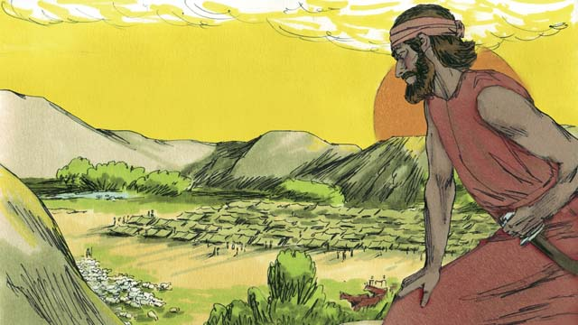
Then God provided a deliverer who rescued them from their enemies and brought peace to the land. But then the people forgot about God and started worshiping idols again. So God allowed the Midianites, a nearby enemy people group, to defeat them.
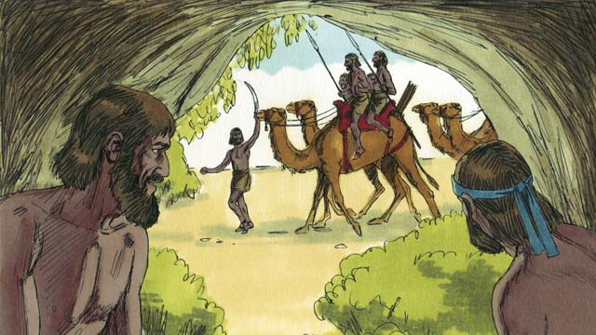
The Midianites took all of the Israelites’ crops for seven years. The Israelites were so scared; they hid in caves so the Midianites would not find them. Finally, they cried out to God to save them.
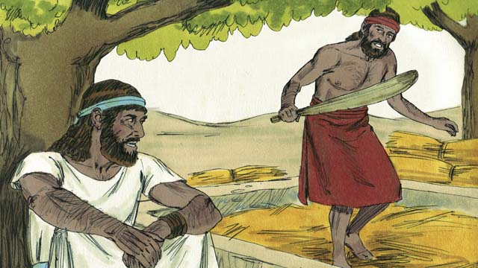
One day, a man of Israel named Gideon was threshing grain secretly so the Midianites would not steal it. The angel of Yahweh came to Gideon and said, “God is with you, mighty warrior. Go and save Israel from the Midianites.”
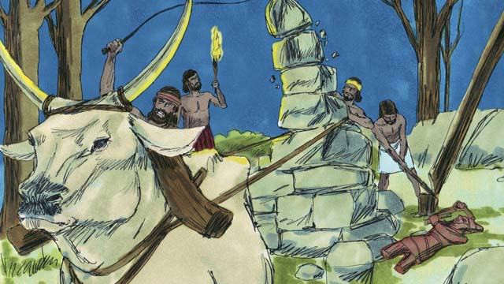
Gideon’s father had an altar dedicated to an idol. God told Gideon to tear down that altar. But Gideon was afraid of the people, so he waited until nighttime. Then he tore down the altar and smashed it to pieces. He built a new altar to God near where the altar to the idol used to be and made a sacrifice to God on it.
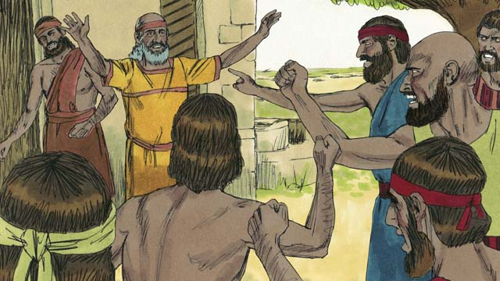
The next morning the people saw that someone had torn down and destroyed the altar, and they were very angry. They went to Gideon’s house to kill him, but Gideon’s father said, “Why are you trying to help your god? If he is a god, let him protect himself!” Because he said this, the people did not kill Gideon.
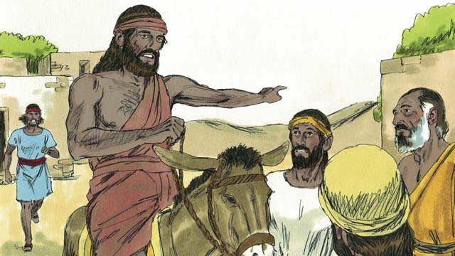
Then the Midianites came again to steal from the Israelites. There were so many of them that they could not be counted. Gideon called the Israelites together to fight them. Gideon asked God for two signs so he could be sure that God would use him to save Israel.
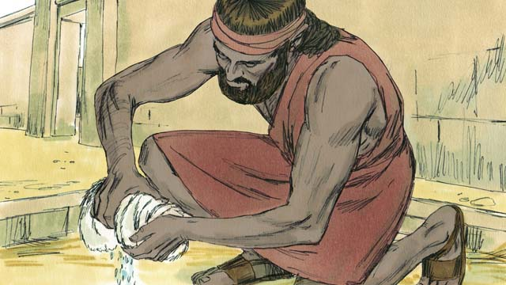
For the first sign, Gideon laid a cloth on the ground and asked God to let the morning dew fall only on the cloth and not on the ground. God did that. The next night, he asked that the ground be wet but the cloth dry. God did that too. These two signs convinced Gideon that God would use him to save Israel from the Midianites.
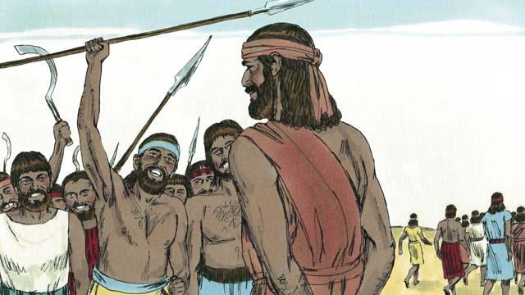
32,000 Israelite soldiers came to Gideon, but God told him this was too many. So Gideon sent home 22,000 who were afraid to fight. God told Gideon that he still had too many men. So Gideon sent all of them home except for 300 soldiers.
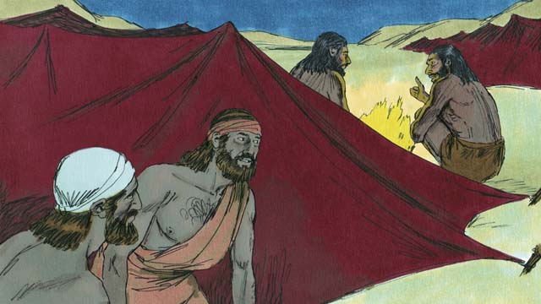
That night God told Gideon, “Go down to the Midianite camp and when you hear what they say, you will no longer be afraid.” So that night, Gideon went down to the camp and heard a Midianite soldier telling his friend about something he had dreamed. The man’s friend said, “This dream means that Gideon’s army will defeat the Midianite army!” When Gideon heard this, he worshiped God.
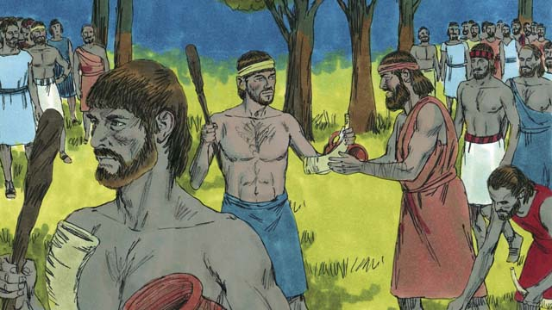
Then Gideon returned to his soldiers and gave each of them a horn, a clay pot, and a torch. They surrounded the camp where the Midianite soldiers were sleeping. Gideon’s 300 soldiers had the torches in the pots so the Midianites could not see the light of the torches.
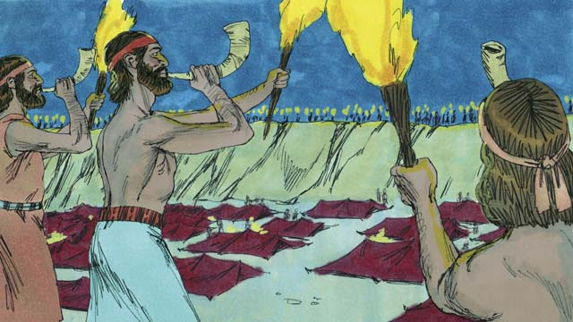
Then, all of Gideon’s soldiers broke their pots at the same moment, suddenly revealing the fire of the torches. They blew their horns and shouted, “A sword for Yahweh and for Gideon!”
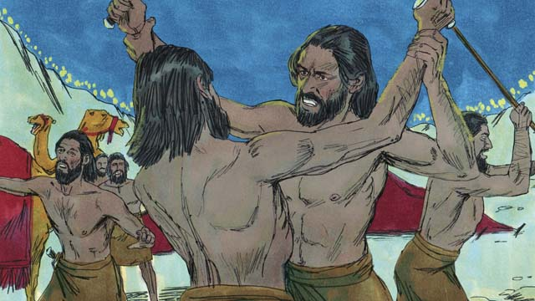
God confused the Midianites, so that they started attacking and killing each other. Immediately, the rest of the Israelites were called from their homes to come help chase the Midianites. They killed many of them and chased the rest of them out of the Israelites’ land. 120,000 Midianites died that day. God had saved Israel.
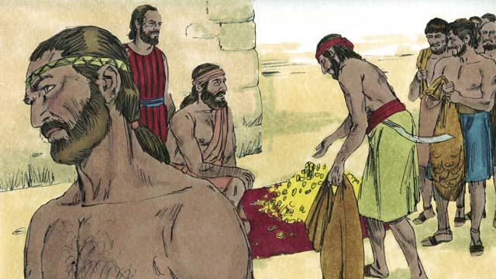
The people wanted to make Gideon their king. Gideon did not allow them to do this, but he asked them for some of the gold rings that each of them had taken from the Midianites. The people gave Gideon a large amount of gold.
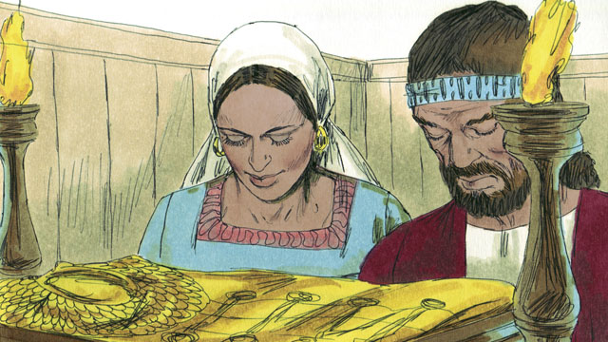
Then Gideon used the gold to make a special garment like the high priest used to wear. But the people started worshiping it as if it were an idol. So God punished Israel again because they worshiped idols. God allowed their enemies to defeat them. They finally asked God for help again, and God sent them another deliverer.
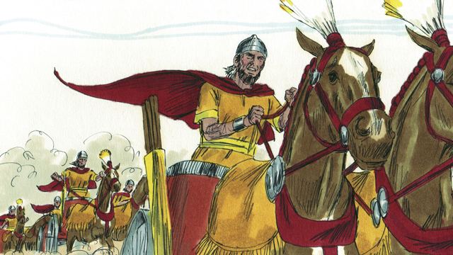
This pattern repeated many times: the Israelites would sin, God would punish them, they would repent, and God would send a deliverer to save them. Over many years, God sent many deliverers who saved the Israelites from their enemies.
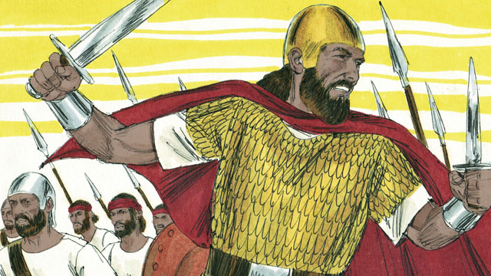
Finally, the people asked God for a king like all the other nations had. They wanted a king who was tall and strong, and who could lead them into battle. God did not like this request, but he gave them a king just as they had asked.
A Bible story from: Judges 1-3; 6-8

17. God’s Covenant with David
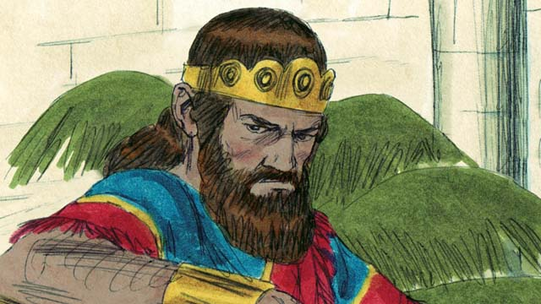
Saul was the first king of Israel. He was tall and handsome, just like the people wanted. Saul was a good king for the first few years that he ruled over Israel. But then he became a wicked man who did not obey God, so God chose a different man who would one day be king in his place.
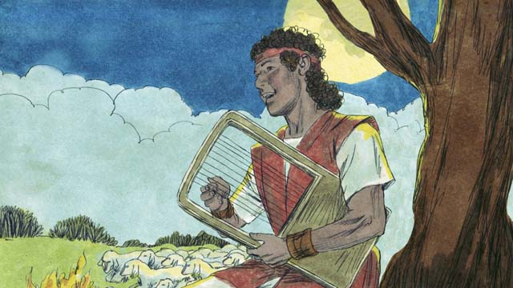
God chose a young Israelite named David to be king after Saul. David was a shepherd from the town of Bethlehem. At different times while he was watching his father’s sheep, David had killed both a lion and a bear that had attacked the sheep. David was a humble and righteous man who trusted and obeyed God.
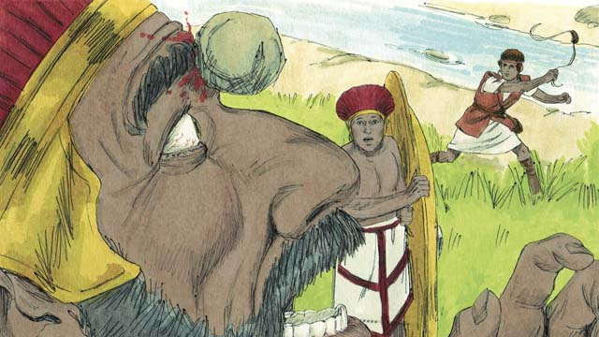
David became a great soldier and leader. When David was still a young man, he fought against a giant named Goliath. Goliath was a trained soldier, very strong, and almost three meters tall! But God helped David kill Goliath and save Israel. After that, David won many victories over Israel’s enemies, for which the people praised him.
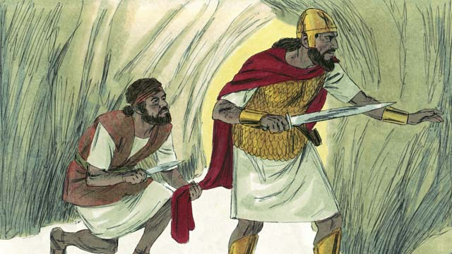
Saul became jealous of the people’s love for David. Saul tried many times to kill him, so David hid from Saul. One day, Saul was looking for David so he could kill him. Saul went into the same cave where David was hiding from Saul, but Saul did not see him. David was now very close to Saul and could have killed him, but he did not. Instead, David cut off a piece of Saul’s clothes to prove to Saul that he would not kill him in order to become king.
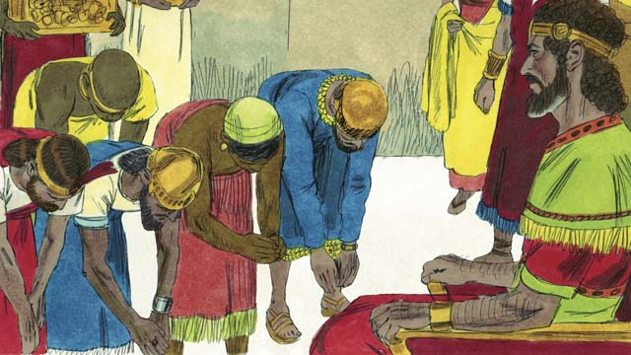
Eventually, Saul died in battle, and David became king of Israel. He was a good king, and the people loved him. God blessed David and made him successful. David fought many battles and God helped him defeat Israel’s enemies. David conquered Jerusalem and made it his capital city. During David’s reign, Israel became powerful and wealthy.
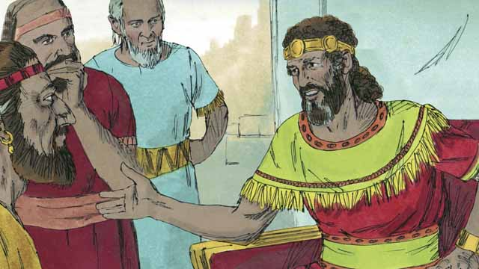
David wanted to build a temple where all the Israelites could worship God and offer him sacrifices. For about 400 years, the people had been worshiping God and offering sacrifices to him at the Tent of Meeting that Moses had built.
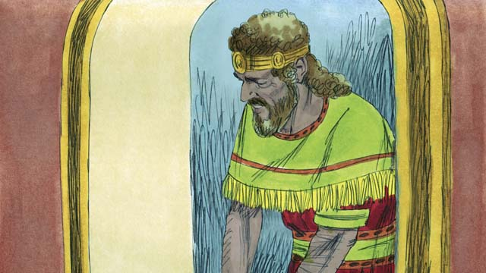
But God sent the prophet Nathan to David with this message, “Because you are a man of war, you will not build this Temple for me. Your son will build it. But, I will bless you greatly. One of your descendants will rule as king over my people forever!” The only descendant of David who could rule forever was the Messiah." The Messiah was God’s Chosen One who would save the people of the world from their sin.
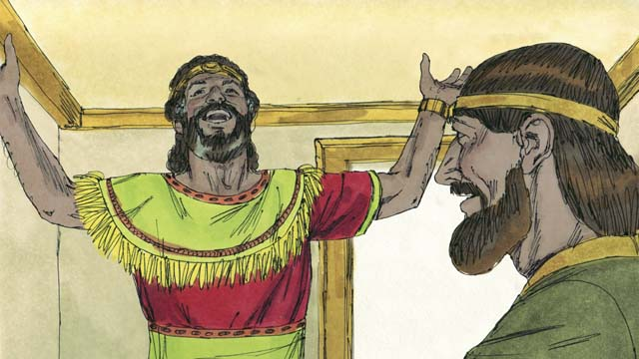
When David heard these words, he immediately thanked and praised God because he had promised David this great honor and many blessings. David did not know when God would do these things. But as it happened, the Israelites would have to wait a long time before the Messiah came, almost 1,000 years.
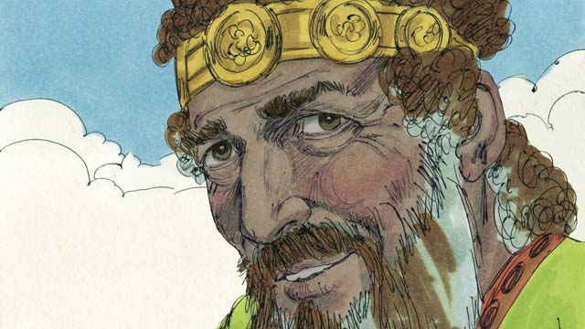
David ruled with justice and faithfulness for many years, and God blessed him. However, toward the end of his life he sinned terribly against God.
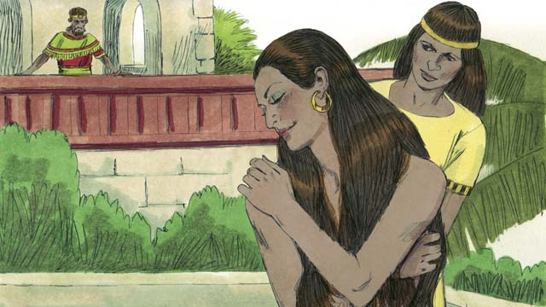
One day, when all of David’s soldiers were away from home fighting battles, he looked out from his palace and saw a beautiful woman bathing. Her name was Bathsheba.
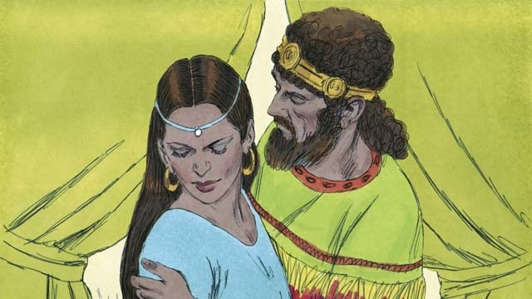
Instead of looking away, David sent someone to bring her to him. He slept with her and sent her back home. A short time later Bathsheba sent a message to David saying that she was pregnant.
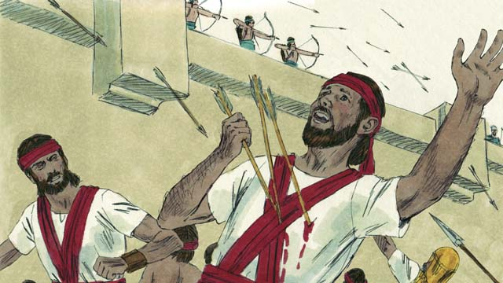
Bathsheba’s husband, a man named Uriah, was one of David’s best soldiers. David called Uriah back from the battle and told him to go be with his wife. But Uriah refused to go home while the rest of the soldiers were in battle. So David sent Uriah back to the battle and told the general to place him where the enemy was strongest so that he would be killed.
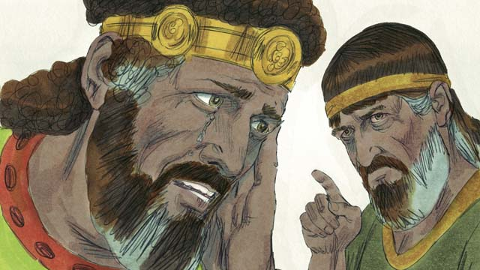
After Uriah was killed, David married Bathsheba. Later, she gave birth to David’s son. God was very angry about what David had done, so he sent the prophet Nathan to tell David how evil his sin was. David repented of his sin and God forgave him. For the rest of his life, David followed and obeyed God, even in difficult times.
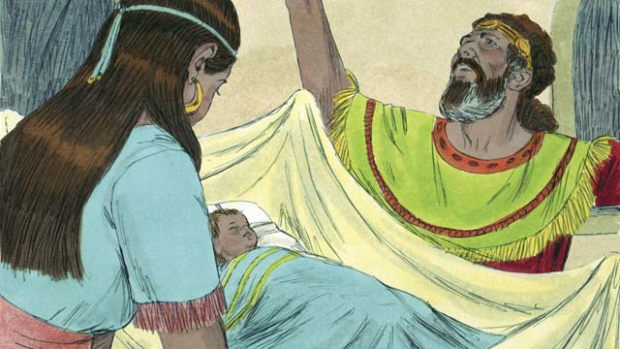
But as punishment for David’s sin, his baby boy died. There was also fighting in David’s family for the rest of his life, and David’s power was greatly weakened. Though David had been unfaithful to God, God was still faithful to his promises. Later, David and Bathsheba had another son, and they named him Solomon.
A Bible story from: 1 Samuel 10; 15-19; 24; 31; 2 Samuel 5; 7; 11-12

18. The Divided Kingdom
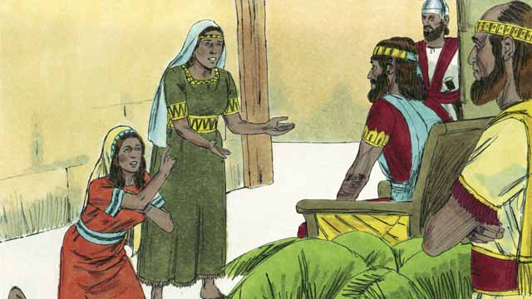
After many years, David died, and his son Solomon began to rule over Israel. God spoke to Solomon and asked him what he wanted most. When Solomon asked for wisdom, God was pleased and made him the wisest man in the world. Solomon learned many things and was a very wise judge. God also made him very wealthy.
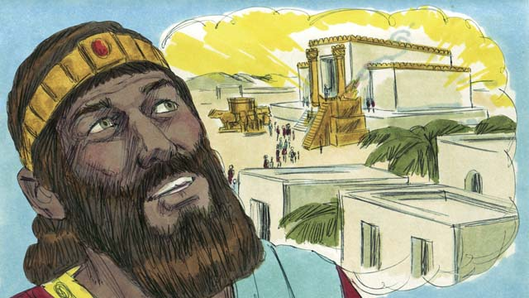
In Jerusalem, Solomon built the Temple for which his father David had planned and gathered materials. People now worshiped God and offered sacrifices to him at the Temple instead of at the Tent of Meeting. God came and was present in the Temple, and he lived there with his people.
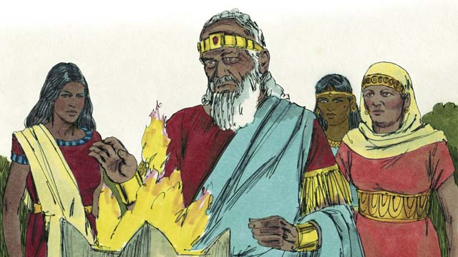
But Solomon loved women from other countries. He disobeyed God by marrying many women, almost 1,000 of them! Many of these women came from foreign countries and brought their gods with them and continued to worship them. When Solomon was old, he also worshiped their gods.
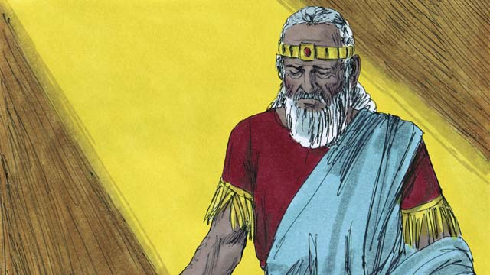
God was angry with Solomon and, as a punishment for Solomon’s unfaithfulness, he promised to divide the nation of Israel into two kingdoms after Solomon’s death.
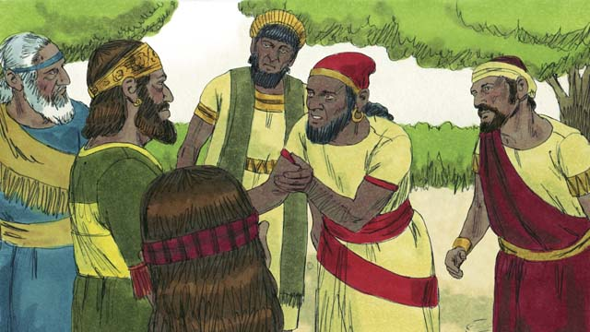
After Solomon died, his son, Rehoboam, became king. Rehoboam was a foolish man. All the people of the nation of Israel came together to confirm him as king. They complained to Rehoboam that Solomon had made them do a lot of hard work and pay a lot of taxes.
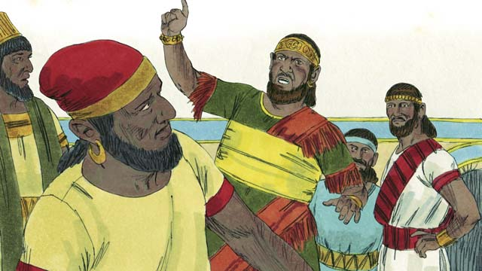
Rehoboam foolishly answered them, “You thought my father Solomon made you work hard, but I will make you work harder than he did, and I will punish you more harshly than he did.”
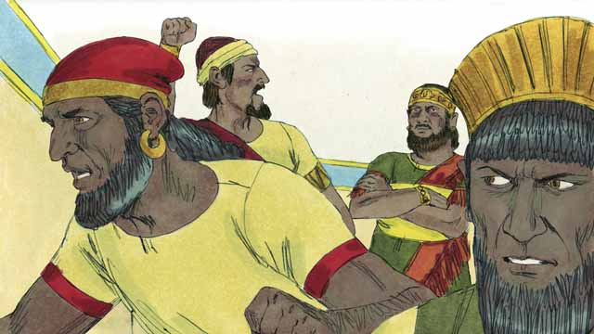
Ten of the tribes of the nation of Israel rebelled against Rehoboam. Only two tribes remained faithful to him. These two tribes became the kingdom of Judah.
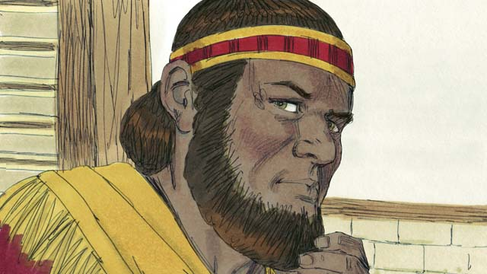
The other ten tribes of the nation of Israel that rebelled against Rehoboam appointed a man named Jeroboam to be their king. They set up their kingdom in the northern part of the land and were called the kingdom of Israel.
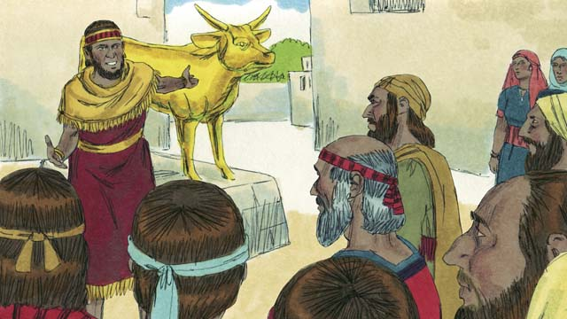
Jeroboam rebelled against God and caused the people to sin. He built two idols for his people to worship instead of worshiping God at the Temple in the kingdom of Judah.
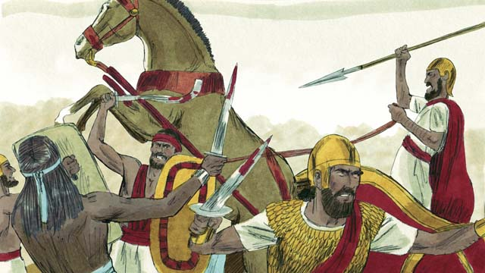
The kingdoms of Judah and Israel became enemies and often fought against each other.
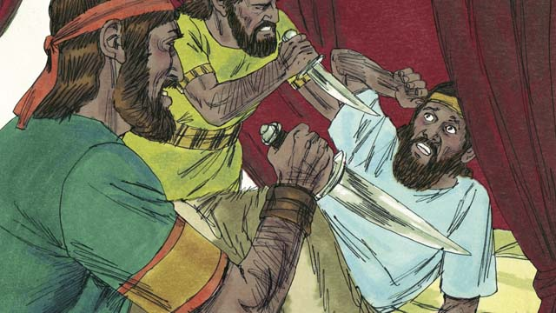
In the new kingdom of Israel, all the kings were evil. Many of these kings were killed by other Israelites who wanted to become king in their place.
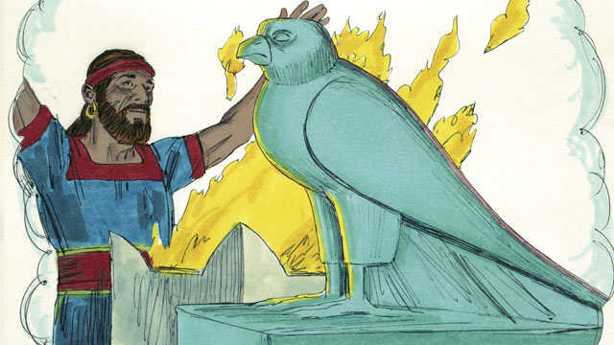
All of the kings and most of the people of the kingdom of Israel worshiped idols. Their idol worship often included sexual immorality and sometimes even child sacrifice.
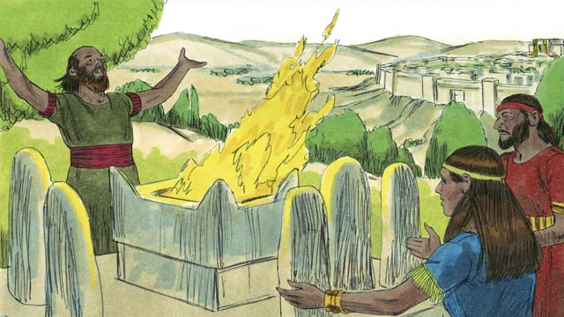
The kings of Judah were descendants of David. Some of these kings were good men who ruled justly and worshiped God. But most of Judah’s kings were evil, corrupt, and they worshiped idols. Some of the kings even sacrificed their children to false gods. Most of the people of Judah also rebelled against God and worshiped other gods.
A Bible story from: 1 Kings 1-6; 11-12

19. The Prophets
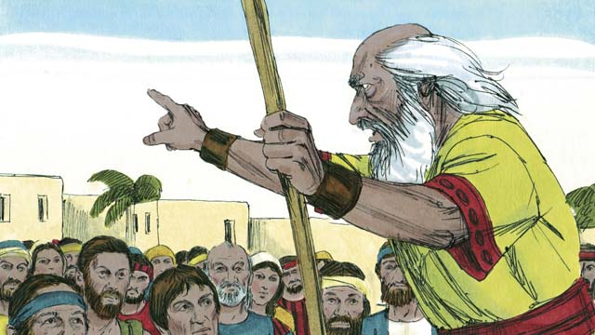
Throughout the history of the Israelites, God sent them prophets. The prophets heard messages from God and then told the people God’s messages.
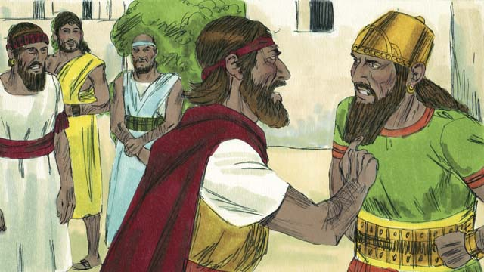
Elijah was a prophet when Ahab was king over the kingdom of Israel. Ahab was an evil man who encouraged people to worship a false god named Baal. Elijah said to Ahab, “There will be no rain or dew in the kingdom of Israel until I say so.” This made Ahab very angry.
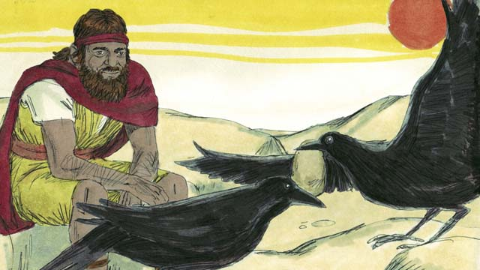
God told Elijah to go to a stream in the wilderness to hide from Ahab who wanted to kill him. Every morning and every evening, birds would bring him bread and meat. Ahab and his army looked for Elijah, but they could not find him. The drought was so severe that the stream eventually dried up.
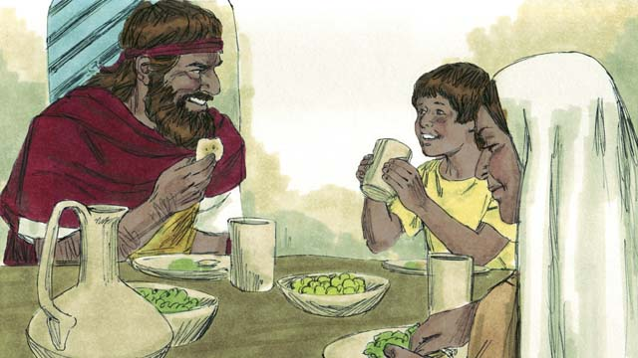
So Elijah went to a neighboring country. A widow and her son in that country had almost run out of food because of the famine. But they took care of Elijah, and God provided for them so that their flour jar and their bottle of oil never became empty. They had food through the whole famine. Elijah stayed there for several years.
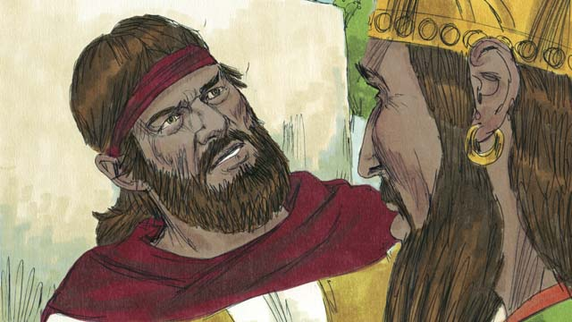
After three and a half years, God told Elijah to return to the kingdom of Israel and speak with Ahab because he was going to send rain again. When Ahab saw Elijah he said, “There you are, you troublemaker!” Elijah replied to him, “You are the troublemaker! You have abandoned Yahweh, the true God, and worshiped Baal. Bring all the people of the kingdom of Israel to Mount Carmel.”
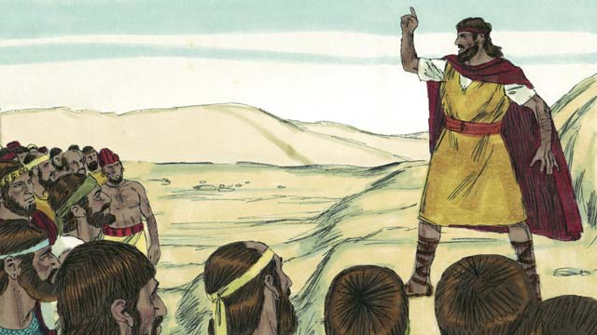
All the people of the kingdom of Israel, including the 450 prophets of Baal, came to Mount Carmel. Elijah said to the people, “How long will you keep changing your mind? If Yahweh is God, serve him! If Baal is God, serve him!”
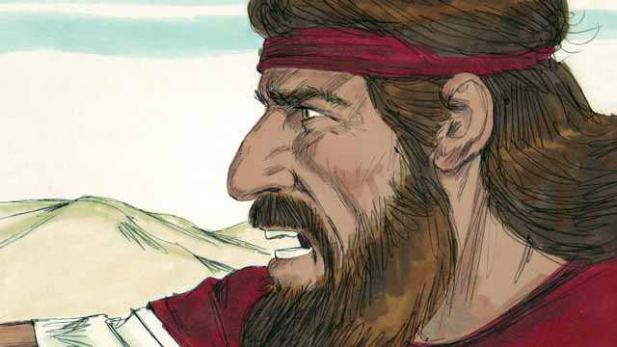
Then Elijah said to the prophets of Baal, “Kill a bull and prepare it as a sacrifice, but do not light the fire. I will do the same. The God who answers with fire is the real God.” So the priests of Baal prepared a sacrifice but did not light the fire.
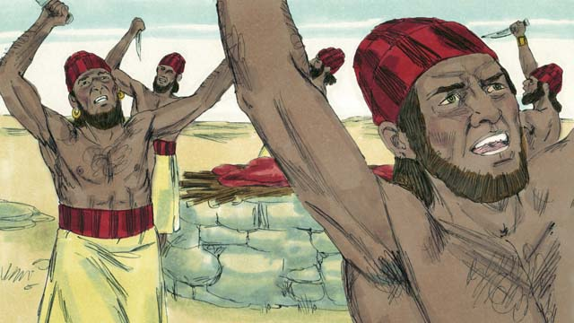
Then the prophets of Baal prayed to Baal, “Hear us, Baal!” All day long they prayed and shouted and even cut themselves with knives, but there was no answer.
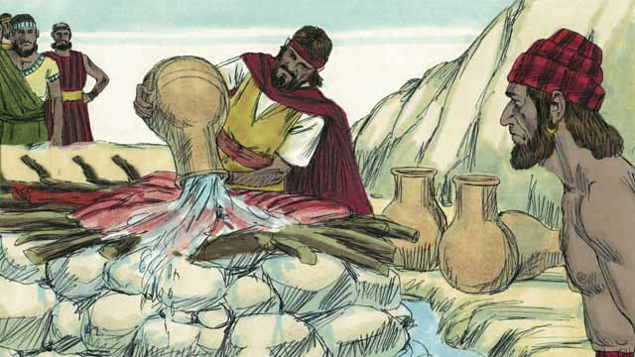
At the end of the day, Elijah prepared a sacrifice to God. Then he told the people to pour twelve huge pots of water on top of the sacrifice until the meat, the wood, and even the ground around the altar were completely wet.
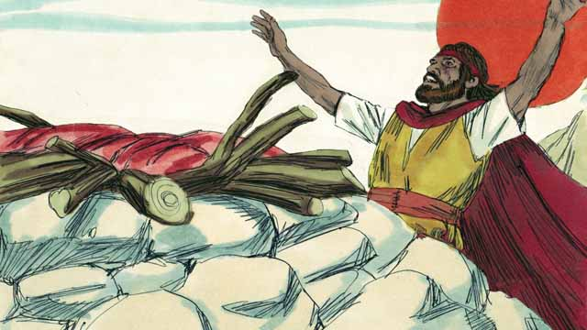
Then Elijah prayed, “Yahweh, God of Abraham, Isaac, and Jacob, show us today that you are the God of Israel and that I am your servant. Answer me so that these people will know that you are the true God.”
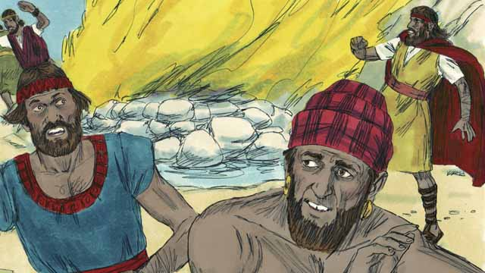
Immediately, fire fell from the sky and burned up the meat, the wood, the rocks, the dirt, and even the water that was around the altar. When the people saw this, they fell on the ground and said, “Yahweh is God! Yahweh is God!”
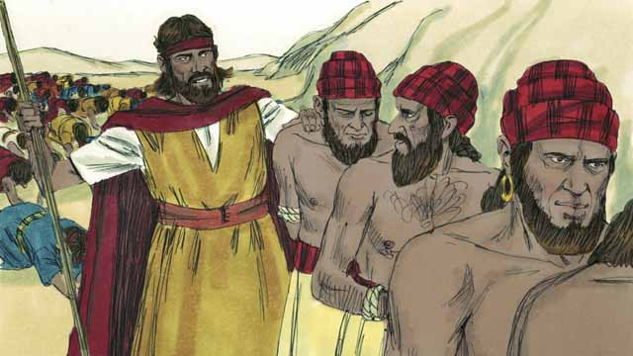
Then Elijah said, “Do not let any of the prophets of Baal escape!” So the people captured the prophets of Baal and took them away from there and killed them.
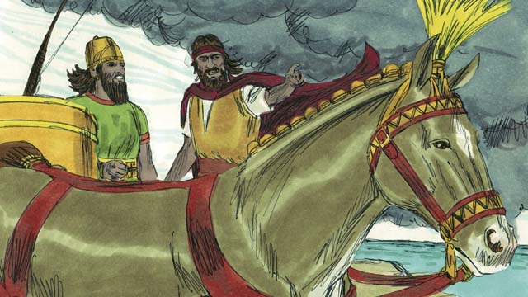
Then Elijah said to King Ahab, “Return immediately to the city, because the rain is coming.” Soon the sky grew black, and a heavy rain began. Yahweh had ended the drought and proved that he is the true God.
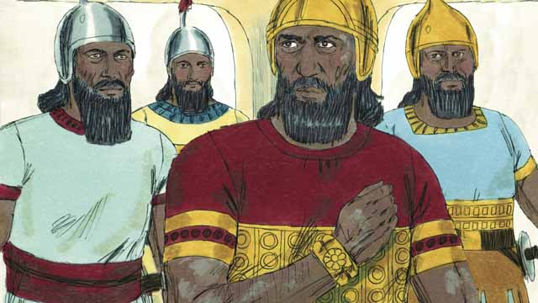
After the time of Elijah, God chose a man named Elisha to be his prophet. God did many miracles through Elisha. One of the miracles happened to Naaman, an enemy commander, who had a horrible skin disease. He had heard of Elisha so he went and asked Elisha to heal him. Elisha told Naaman to dip himself seven times in the Jordan River.
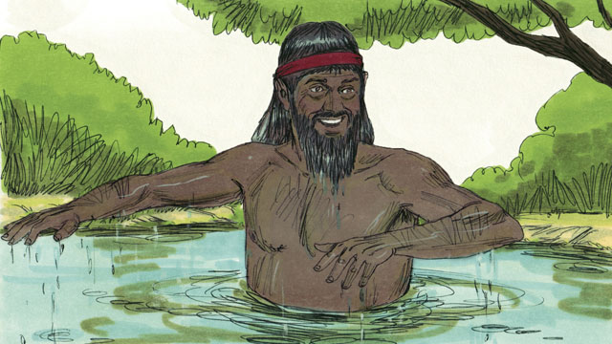
At first Naaman was angry and would not do it because it seemed foolish. But later he changed his mind and dipped himself seven times in the Jordan River. When he came up the last time, his skin was completely healed! God had healed him.
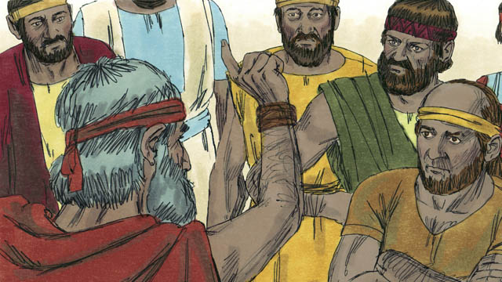
God sent many other prophets. They all told the people to stop worshiping idols and to start showing justice and mercy to others. The prophets warned the people that if they did not stop doing evil and start obeying God, then God would judge them as guilty, and he would punish them.
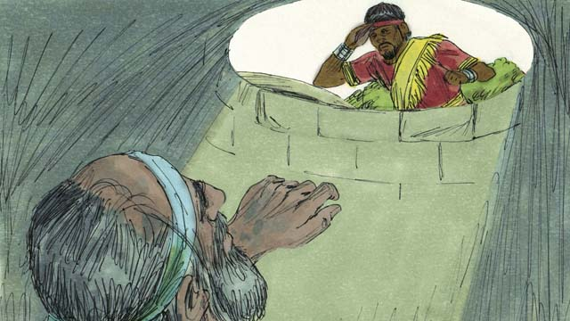
Most of the time, the people did not obey God. They often mistreated the prophets and sometimes even killed them. Once, the prophet Jeremiah was put into a dry well and left there to die. He sank down into the mud that was in the bottom of the well, but then the king had mercy on him and ordered his servants to pull Jeremiah out of the well before he died.
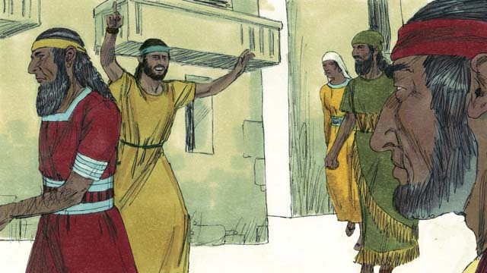
The prophets continued to speak for God even though the people hated them. They warned people that God would destroy them if they did not repent. They also reminded people of the promise that God’s Messiah would come.
A Bible story from: 1 Kings 16-18; 2 Kings 5; Jeremiah 38

20. The Exile and Return
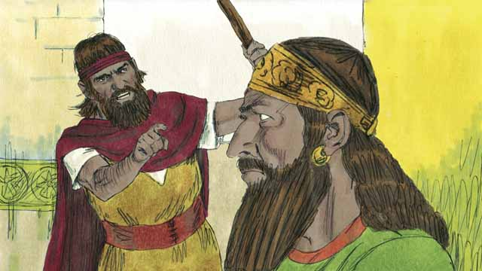
The kingdom of Israel and the kingdom of Judah both sinned against God. They broke the covenant that God had made with them at Sinai. God sent his prophets to warn them to repent and worship him again, but they refused to obey.
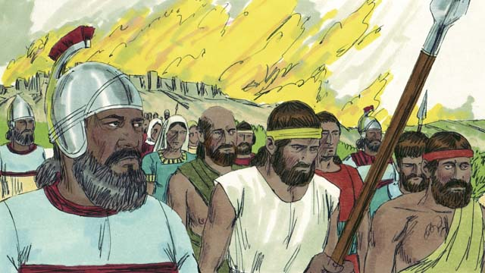
So God punished both kingdoms by allowing their enemies to destroy them. The Assyrian Empire, a powerful, cruel nation, destroyed the kingdom of Israel. The Assyrians killed many people in the kingdom of Israel, took away everything of value, and burned much of the country.
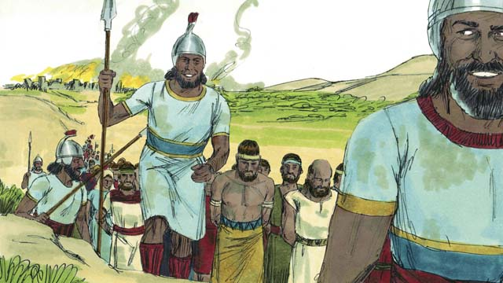
The Assyrians gathered all the leaders, the rich people, and the people with skills and took them to Assyria. Only the very poor Israelites who had not been killed remained in the kingdom of Israel.
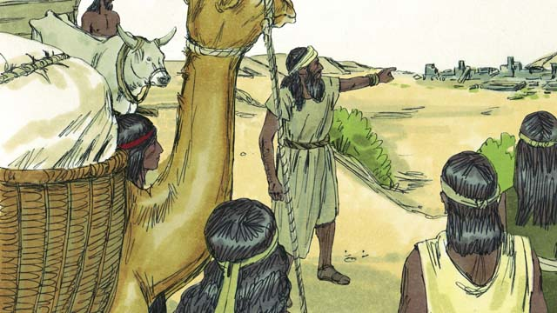
Then the Assyrians brought foreigners to live in the land where the kingdom of Israel had been. The foreigners rebuilt the destroyed cities and married the Israelites who were left there. The descendants of the Israelites who married foreigners were called Samaritans.
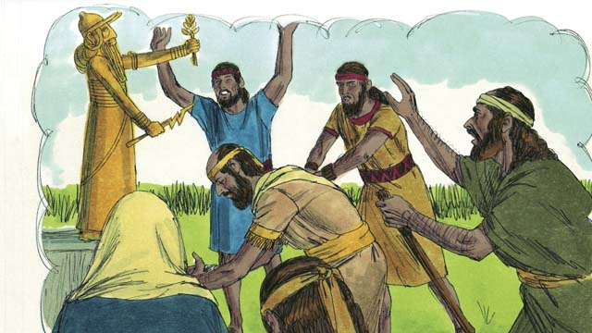
The people in the kingdom of Judah saw how God had punished the people of the kingdom of Israel for not believing and obeying him. But they still worshiped idols, including the gods of the Canaanites. God sent prophets to warn them, but they refused to listen.
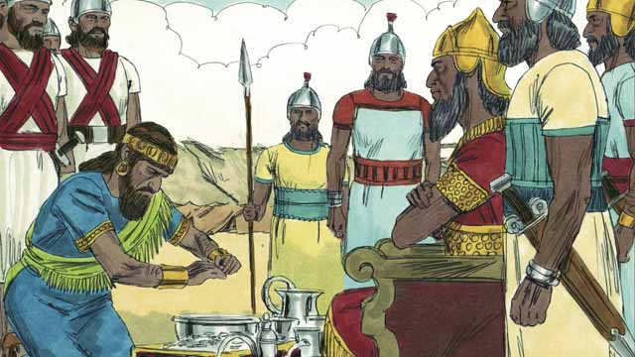
About 100 years after the Assyrians destroyed the kingdom of Israel, God sent Nebuchadnezzar, king of the Babylonians, to attack the kingdom of Judah. Babylon was a powerful empire. The king of Judah agreed to be Nebuchadnezzar’s servant and pay him a lot of money every year.
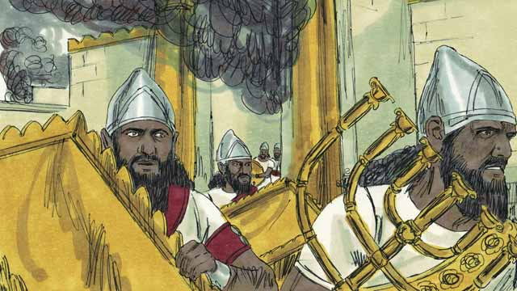
But after a few years, the king of Judah rebelled against Babylon. So, the Babylonians came back and attacked the kingdom of Judah. They captured the city of Jerusalem, destroyed the Temple, and took away all the treasures of the city and the Temple.
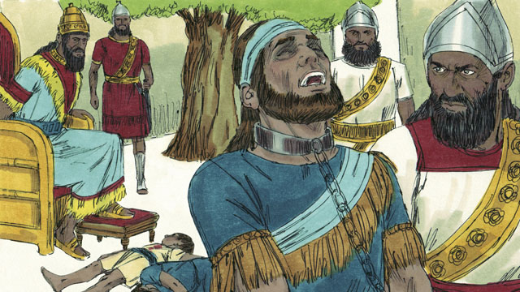
To punish the king of Judah for rebelling, Nebuchadnezzar’s soldiers killed the king’s sons in front of him and then made him blind. After that, they took the king away to die in prison in Babylon.
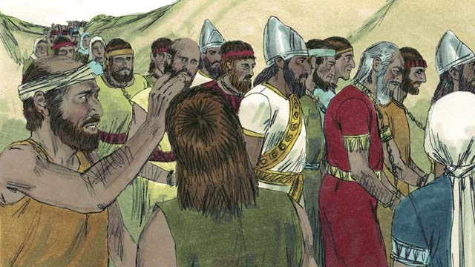
Nebuchadnezzar and his army took almost all of the people of the kingdom of Judah to Babylon, leaving only the poorest people behind to plant the fields. This period of time when God’s people were forced to leave the Promised Land is called the Exile.
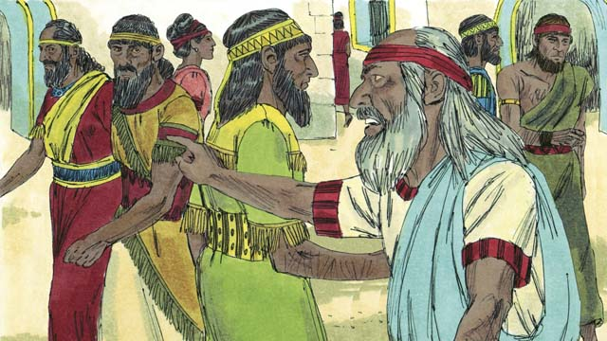
Even though God punished his people for their sin by taking them away into exile, he did not forget them or his promises. God continued to watch over his people and speak to them through his prophets. He promised that, after seventy years, they would return to the Promised Land again.
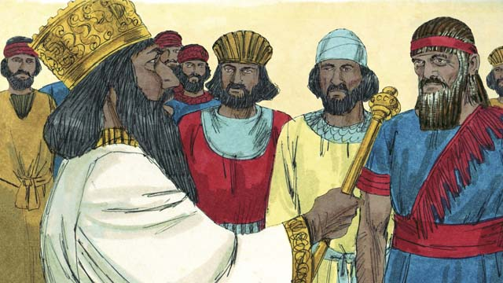
About seventy years later, Cyrus, the king of the Persians, defeated Babylon, so the Persian Empire replaced the Babylonian Empire. The Israelites were now called Jews and most of them had lived their whole lives in Babylon. Only a few very old Jews even remembered the land of Judah.
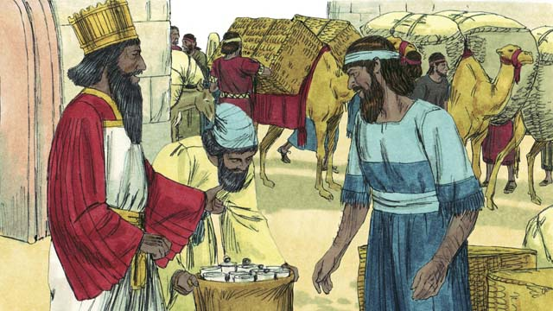
The Persian Empire was strong but merciful to the people it conquered. Shortly after Cyrus became king of the Persians, he gave an order that any Jew who wanted to return to Judah could leave Persia and go back to Judah. He even gave them money to rebuild the Temple! So, after seventy years in exile, a small group of Jews returned to the city of Jerusalem in Judah.
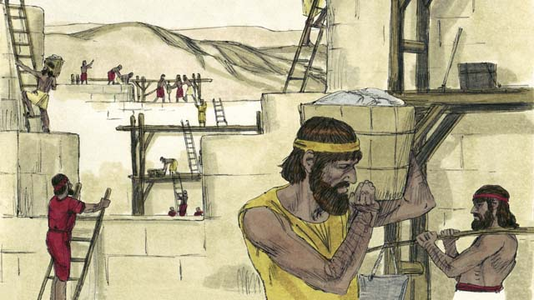
When the people arrived in Jerusalem, they rebuilt the Temple and the wall around the city. Although they were still ruled by other people, once again they lived in the Promised Land and worshiped at the Temple.
A Bible story from: 2 Kings 17; 24-25; 2 Chronicles 36; Ezra 1-10; Nehemiah 1-13

21. God Promises the Messiah
From the very beginning, God planned to send the Messiah. The first promise of the Messiah came to Adam and Eve. God promised that a descendant of Eve would be born who would crush the snake’s head. The snake who deceived Eve was Satan. The promise meant that the Messiah would defeat Satan completely.
God promised Abraham that through him all people groups of the world would receive a blessing. This blessing would be fulfilled when the Messiah would come sometime in the future. He would make it possible for people from every people group in the world to be saved.
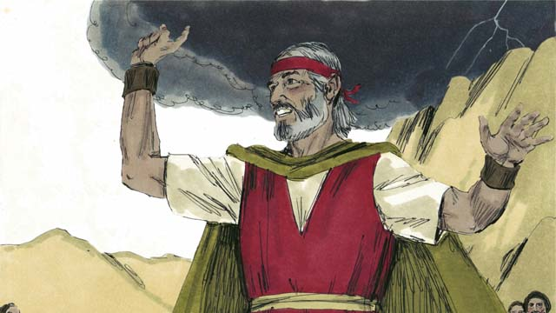
God promised Moses that in the future he would raise up another prophet like Moses. This was another promise about the Messiah who would come at some later time.
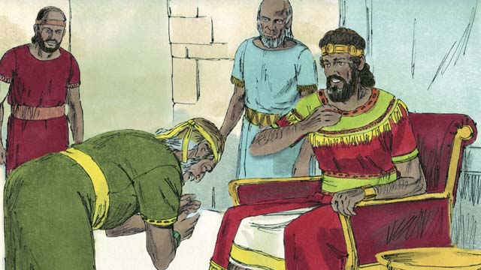
God promised King David that one of his own descendants would rule as king over God’s people forever. That meant that the Messiah would be one of David’s own descendants.
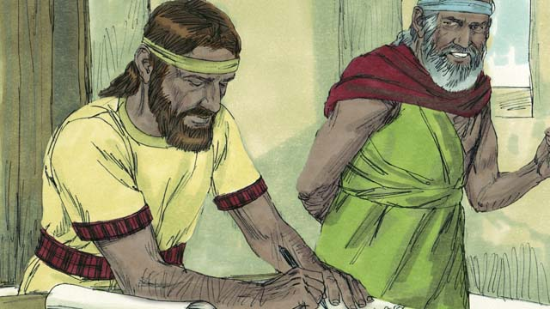
Through the prophet Jeremiah, God promised that he would make a New Covenant, but not like the covenant God made with Israel at Sinai. In the New Covenant, God would write his law on the people’s hearts, the people would know God personally, they would be his people, and God would forgive their sins. The Messiah would start the New Covenant.
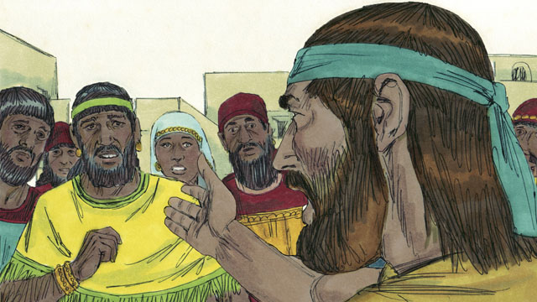
God’s prophets also said that the Messiah would be a prophet, a priest, and a king. A prophet is a person who hears the words of God and then proclaims God’s words to the people. The Messiah that God promised to send would be the perfect prophet.
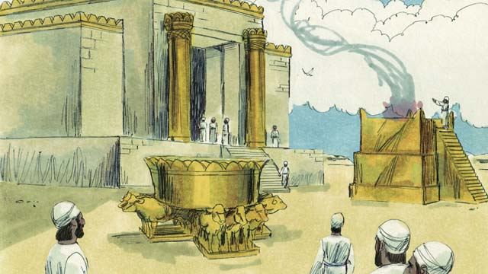
Israelite priests made sacrifices to God on behalf of the people as a substitute for the punishment for their sins. Priests also prayed to God for the people. The Messiah would be the perfect high priest who would offer himself as a perfect sacrifice to God.
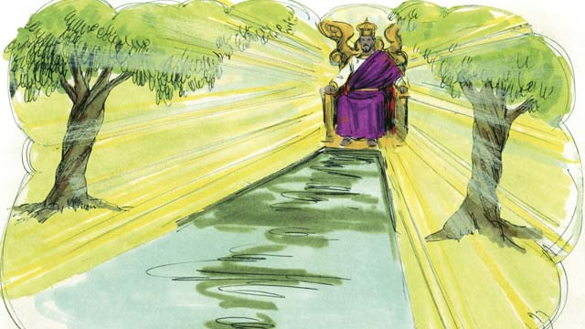
A king is someone who rules over a kingdom and judges the people. The Messiah would be the perfect king who would sit on the throne of his ancestor David. He would reign over the whole world forever, and would always judge honestly and make the right decisions.
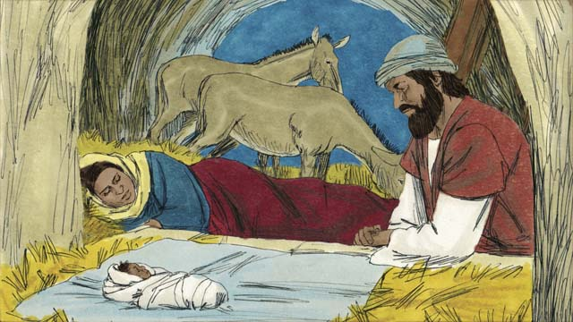
God’s prophets predicted many other things about the Messiah. The prophet Malachi foretold that a great prophet would come before the Messiah came. The prophet Isaiah prophesied that the Messiah would be born from a virgin. The prophet Micah said that he would be born in the town of Bethlehem.
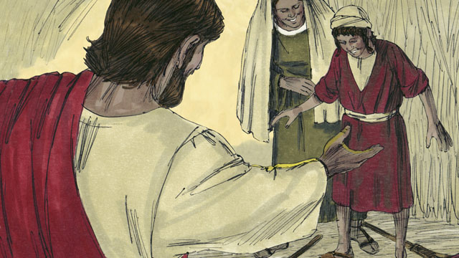
The prophet Isaiah said the Messiah would live in Galilee, comfort broken-hearted people, and proclaim freedom to captives and release to prisoners. He also predicted that the Messiah would heal sick people and those who could not hear, see, speak, or walk.
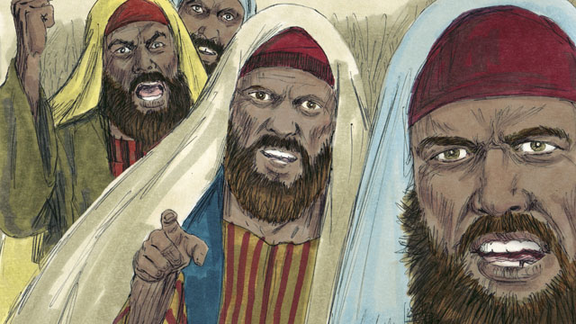
The prophet Isaiah also prophesied that the Messiah would be hated without reason and rejected. Other prophets foretold that those who killed the Messiah would gamble for his clothes and that a friend would betray him. The prophet Zechariah predicted that the friend would be paid thirty silver coins as payment for betraying the Messiah.
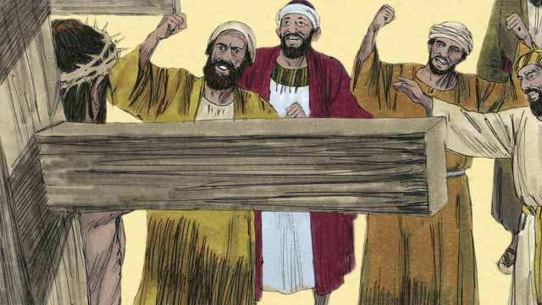
The prophets also told about how the Messiah would die. Isaiah prophesied that people would spit on, mock, and beat the Messiah. They would pierce him and he would die in great suffering and agony, even though he had not done anything wrong.
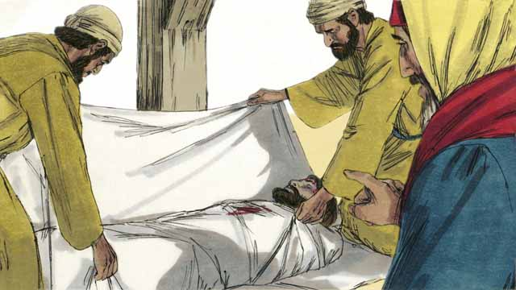
The prophets also said that the Messiah would be perfect, having no sin. He would die to receive the punishment for other people’s sin. His punishment would bring peace between God and people. For this reason, it was God’s will to crush the Messiah.
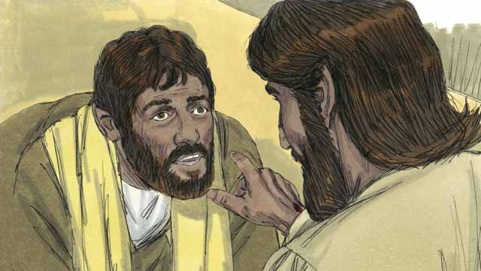
The prophets foretold that the Messiah would die and that God would also raise him from the dead. Through the Messiah’s death and resurrection, God would accomplish his plan to save sinners and start the New Covenant.
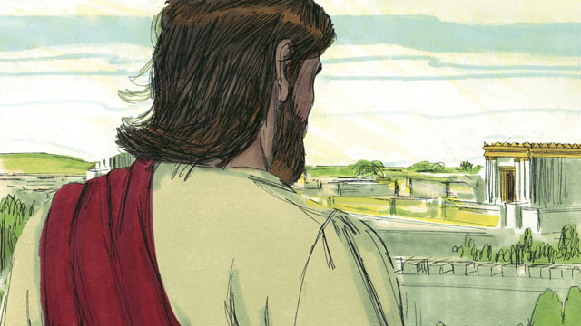
God revealed to the prophets many things about the Messiah, but the Messiah did not come during the time of any of those prophets. More than 400 years after the last of these prophecies was given, at exactly the right time, God would send the Messiah into the world.
A Bible story from: Genesis 3:15; 12:1-3; Deuteronomy 18:15; 2 Samuel 7; Jeremiah 31; Isaiah 59:16; Daniel 7; Malachi 4:5; Isaiah 7:14; Micah 5:2; Isaiah 9:1-7; 35:3-5; 61; 53; Psalm 22:18; 35:19; 69:4; 41:9; Zechariah 11:12-13; Isaiah 50:6; Psalm 16:10-11

22. The Birth of John
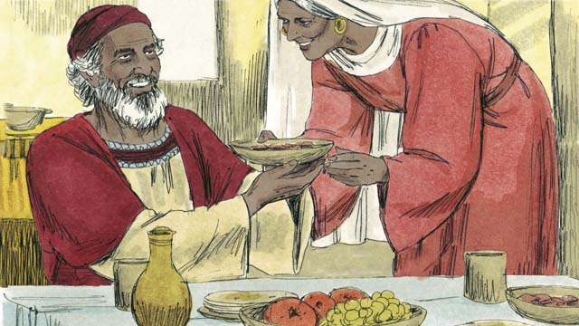
In the past, God had spoken to his people through his angels and prophets. But then 400 years went by when he did not speak to them. Suddenly an angel came with a message from God to an old priest named Zechariah. Zechariah and his wife, Elizabeth, were godly people, but she had not been able to have any children.
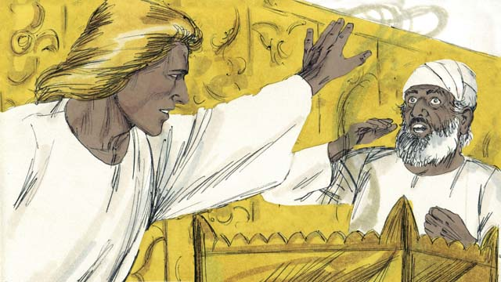
The angel said to Zechariah, “Your wife will have a son. You will name him John. He will be filled with the Holy Spirit, and will prepare the people for the Messiah!” Zechariah responded, “My wife and I are too old to have children! How will I know this will happen?”
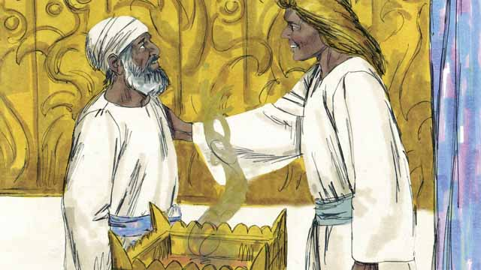
The angel responded to Zechariah, “I was sent by God to bring you this good news. Because you did not believe me, you will not be able to speak until the child is born.” Immediately, Zechariah was unable to speak. Then the angel left Zechariah. After this, Zechariah returned home and his wife became pregnant.
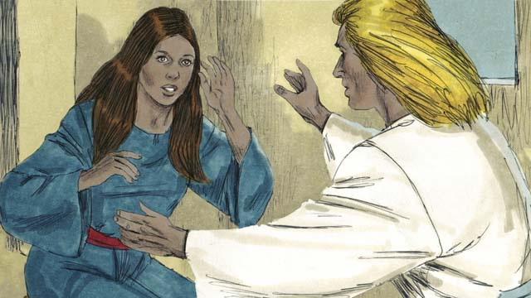
When Elizabeth was six months pregnant, the same angel suddenly appeared to Elizabeth’s relative, whose name was Mary. She was a virgin and was engaged to be married to a man named Joseph. The angel said, “You will become pregnant and give birth to a son. You are to name him Jesus. He will be the Son of the Most High God and will rule forever.”
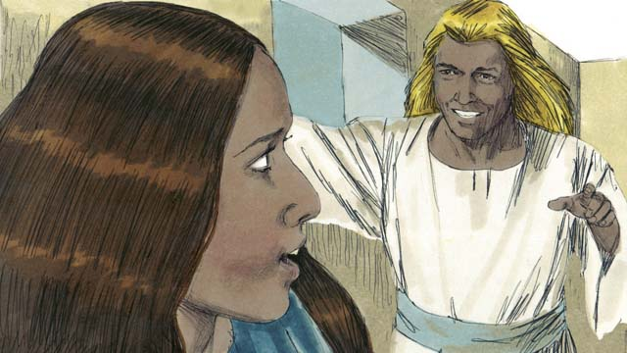
Mary replied, “How can this be, since I am a virgin?” The angel explained, “The Holy Spirit will come to you, and the power of God will overshadow you. So the baby will be holy, the Son of God.” Mary believed and accepted what the angel said.
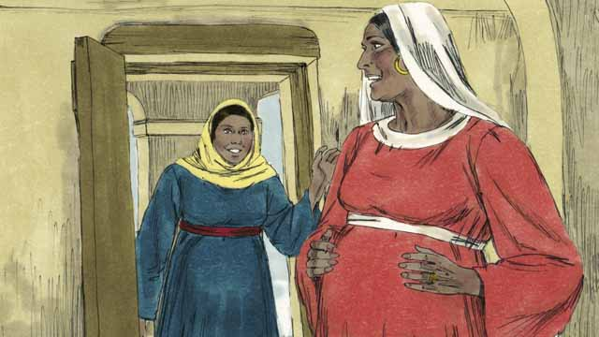
Soon after the angel spoke to Mary, she went and visited Elizabeth. As soon as Elizabeth heard Mary’s greeting, Elizabeth’s baby jumped inside her. The women rejoiced together about what God had done for them. After Mary visited Elizabeth for three months, Mary returned home.
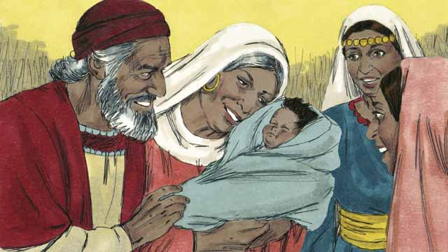
After Elizabeth gave birth to her baby boy, Zechariah and Elizabeth named the baby John, as the angel had commanded. Then God allowed Zechariah to speak again. Zechariah said, “Praise God, because he has remembered his people! You, my son, will be called the prophet of the Most High God who will tell the people how they can receive forgiveness for their sins!”
A Bible story from: Luke 1

23. The Birth of Jesus
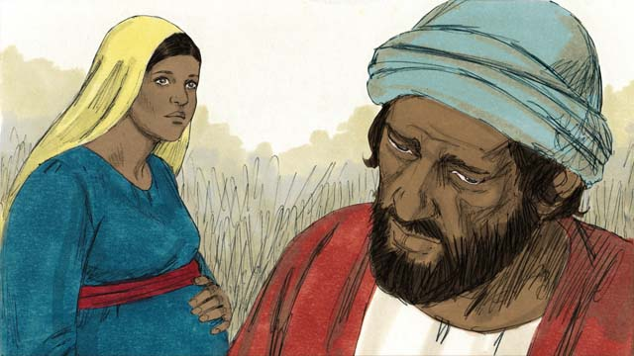
Mary was engaged to a righteous man named Joseph. When he heard that Mary was pregnant, he knew it was not his baby. He did not want to shame Mary, so he planned to quietly divorce her. Before he could do that, an angel came and spoke to him in a dream.
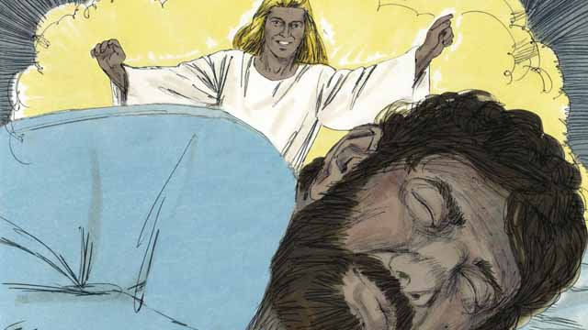
The angel said, “Joseph, do not be afraid to take Mary as your wife. The baby that is in her is from the Holy Spirit. She will give birth to a son. Name him Jesus (which means, ‘Yahweh saves’), because he will save the people from their sins.”
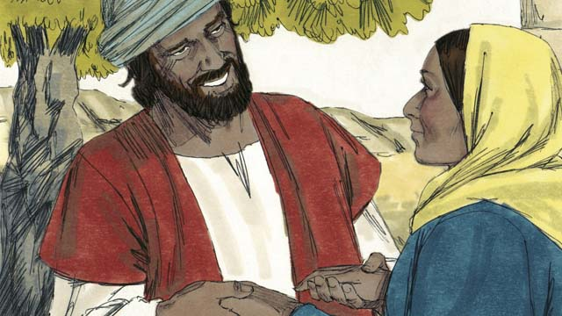
So Joseph married Mary and took her home as his wife, but he did not sleep with her until she had given birth.
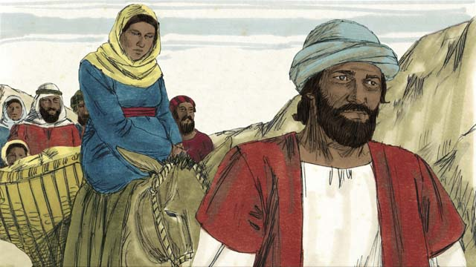
When the time was near for Mary to give birth, the Roman government told everyone to go for a census to the town where their ancestors had lived. Joseph and Mary had to make a long journey from where they lived in Nazareth to Bethlehem because their ancestor was David whose hometown was Bethlehem.
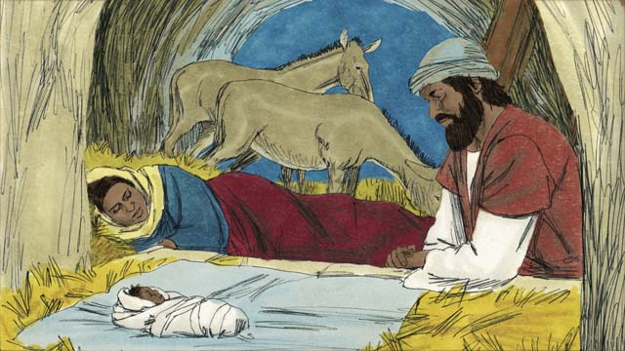
When they arrived in Bethlehem, there was no place to stay. The only room they could find was a place where animals stayed. The baby was born there and his mother laid him in a feeding trough, since they did not have a bed for him. They named him Jesus.
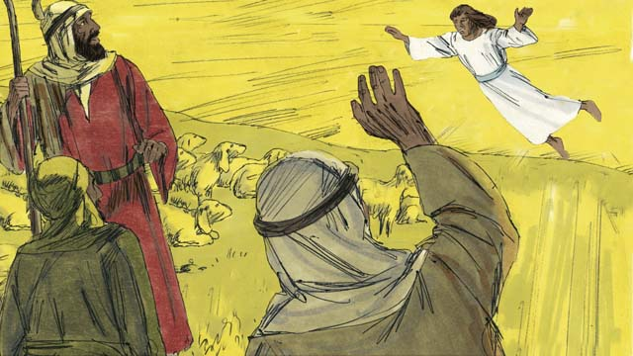
That night, there were some shepherds in a nearby field guarding their flocks. Suddenly, a shining angel appeared to them, and they were terrified. The angel said, “Do not be afraid, because I have some good news for you. The Messiah, the Master, has been born in Bethlehem!”
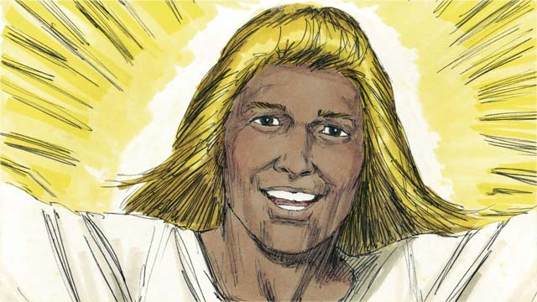
“Go search for the baby, and you will find him wrapped in pieces of cloth and lying in a feeding trough.” Suddenly, the skies were filled with angels praising God, saying, “Glory to God in heaven and peace on earth to the people he favors!”
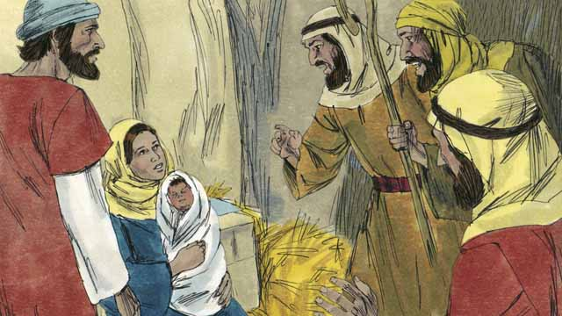
The shepherds soon arrived at the place where Jesus was and they found him lying in a feeding trough, just as the angel had told them. They were very excited. Mary was very happy, too. The shepherds returned to the fields where their sheep were, praising God for all they had heard and seen.
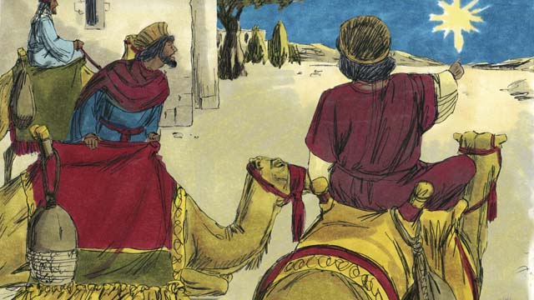
Sometime later, wise men from countries far to the east saw an unusual star in the sky. They realized it meant a new king of the Jews had been born. So, they traveled a great distance to see this king. They came to Bethlehem and found the house where Jesus and his parents were staying.
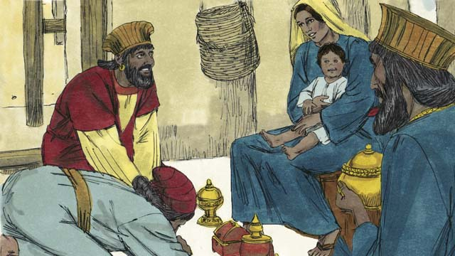
When the wise men saw Jesus with his mother, they bowed down and worshiped him. They gave Jesus expensive gifts. Then they returned home.
A Bible story from: Matthew 1; Luke 2

24. John Baptizes Jesus
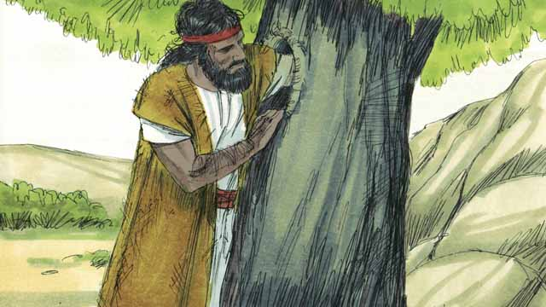
John, the son of Zechariah and Elizabeth, grew up and became a prophet. He lived in the wilderness, ate wild honey and locusts, and wore clothes made from camel hair.
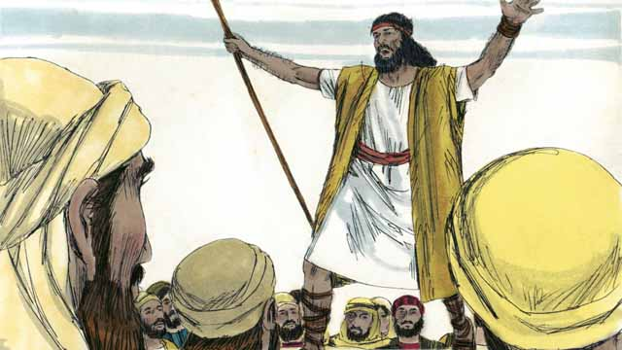
Many people came out to the wilderness to listen to John. He preached to them, saying, “Repent, for the kingdom of God is near!”
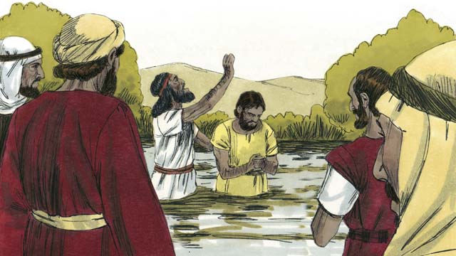
When people heard John’s message, many of them repented from their sins, and John baptized them. Many religious leaders also came to be baptized by John, but they did not repent or confess their sins.
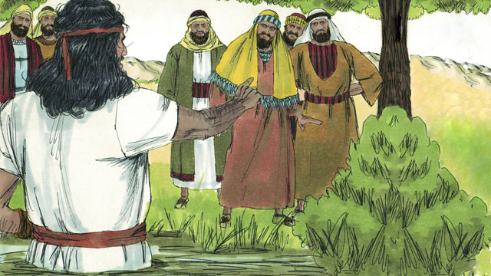
John said to the religious leaders, “You poisonous snakes! Repent and change your behavior. Every tree that does not bear good fruit will be cut down and thrown into the fire.” John fulfilled what the prophets said, “See, I send my messenger ahead of you, who will prepare your way.”
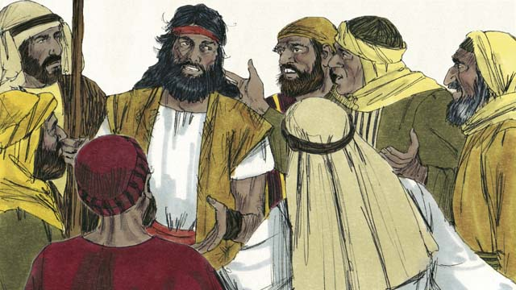
Some Jews asked John if he was the Messiah. John replied, “I am not the Messiah, but there is someone coming after me. He is so great that I am not even worthy to untie his sandals.”
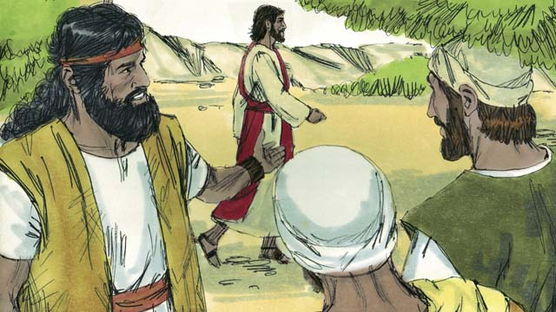
The next day, Jesus came to be baptized by John. When John saw him, he said, “Look! There is the Lamb of God who will take away the sin of the world.”
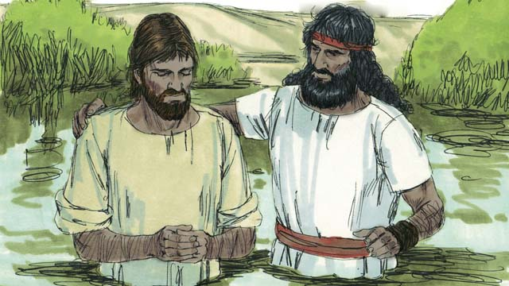
John said to Jesus, “I am not worthy to baptize you. You should baptize me instead.” But Jesus said, “You should baptize me, because it is the right thing to do.” So John baptized him, even though Jesus had never sinned.
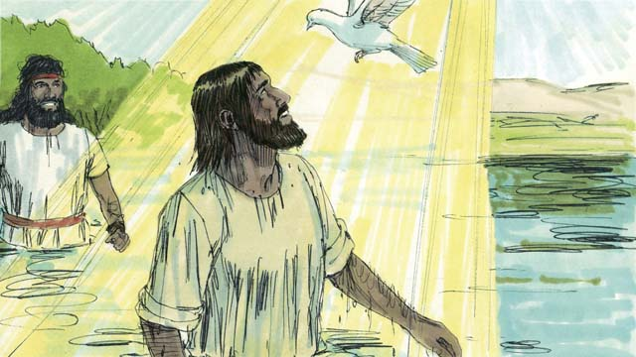
When Jesus came up out of the water after being baptized, the Spirit of God appeared in the form of a dove and came down and rested on him. At the same time, God’s voice spoke from heaven, saying, “You are my Son whom I love, and I am very pleased with you.”
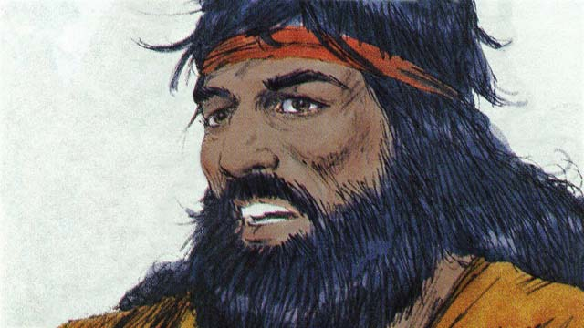
God had told John, “The Holy Spirit will come down and rest on someone you baptize. That person is the Son of God.” There is only one God. But when John baptized Jesus, he heard God the Father speak, saw God the Son, who is Jesus, and he saw the Holy Spirit.
A Bible story from: Matthew 3; Mark 1:9-11; Luke 3:1-23

25. Satan Tempts Jesus
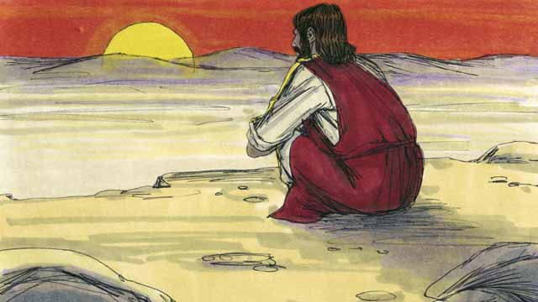
Immediately after Jesus was baptized, the Holy Spirit led him out into the wilderness, where he fasted for forty days and forty nights. Then Satan came to Jesus and tempted him to sin.
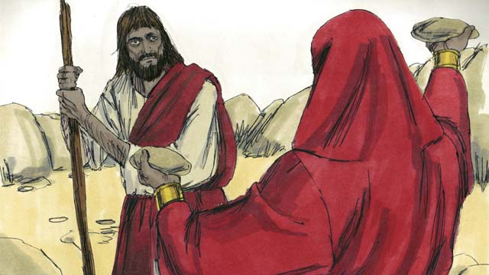
Satan tempted Jesus by saying, “If you are the Son of God, turn these rocks into bread so you can eat!”
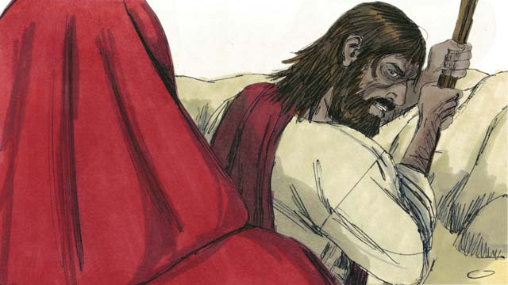
Jesus replied, “It is written in God’s word, ‘People do not only need bread in order to live, but they need every word that God speaks!’”
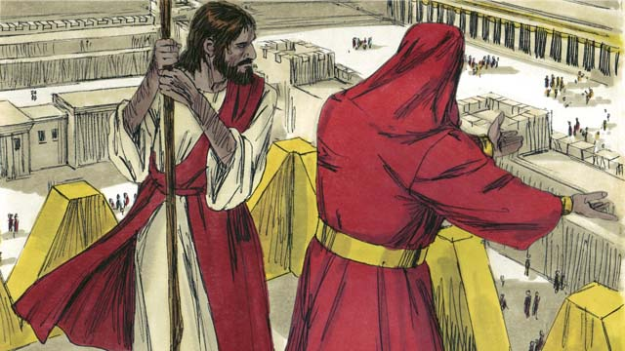
Then Satan took Jesus to the highest point on the Temple and said, “If you are the Son of God, throw yourself down, because it is written, ‘God will command his angels to carry you so your foot does not hit a stone.’”
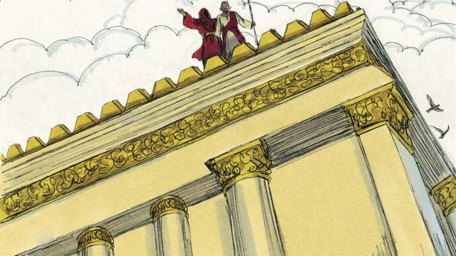
But Jesus replied to Satan by quoting from the Scriptures. He said, “In God’s Word, he commands his people, ‘Do not test the Lord your God.’”
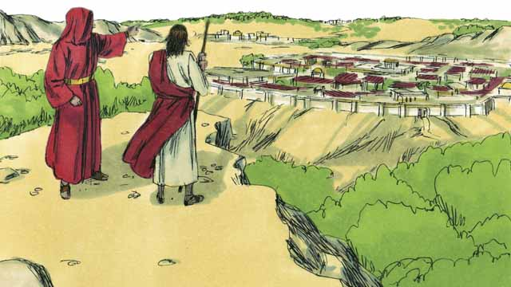
Then Satan showed Jesus all the kingdoms of the world and all their glory and said, “I will give you all this if you bow down and worship me.”
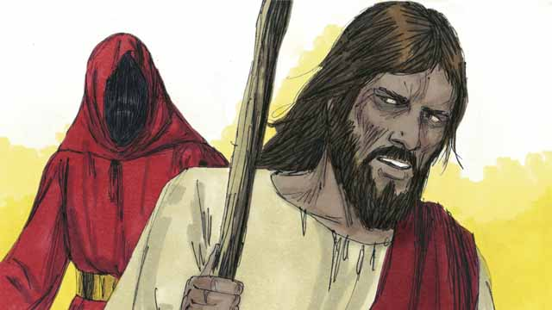
Jesus replied, “Get away from me, Satan! In God’s word he commands his people, ‘Worship only the Lord your God and only serve him.’”
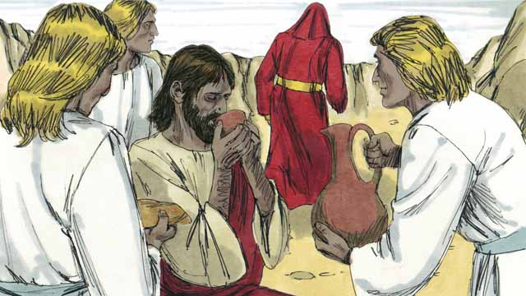
Jesus did not give in to Satan’s temptations, so Satan left him. Then angels came and took care of Jesus.
A Bible story from: Matthew 4:1-11; Mark 1:12-13; Luke 4:1-13

26. Jesus Starts His Ministry
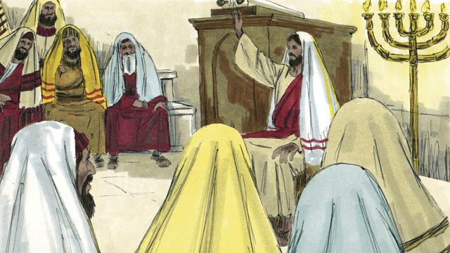
After overcoming Satan’s temptations, Jesus returned in the power of the Holy Spirit to the region of Galilee where he lived. Jesus went from place to place teaching. Everyone spoke well of him.
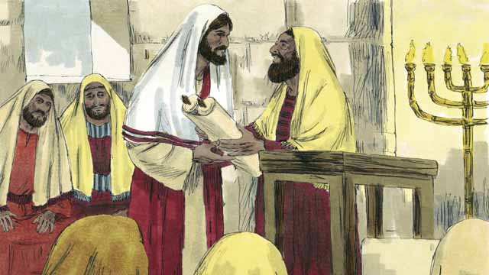
Jesus went to the town of Nazareth where he had lived during his childhood. On the Sabbath, he went to the place of worship. They handed him the scroll of the prophet Isaiah so that he would read from it. Jesus opened up the scroll and read part of it to the people.
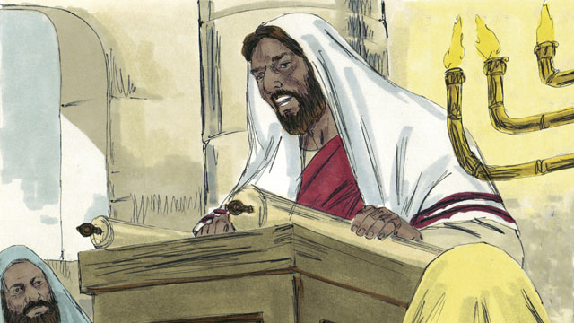
Jesus read, “God has given me his Spirit so that I can proclaim good news to the poor, freedom to captives, recovery of sight for the blind, and release to the oppressed. This is the year of the Lord’s favor.”
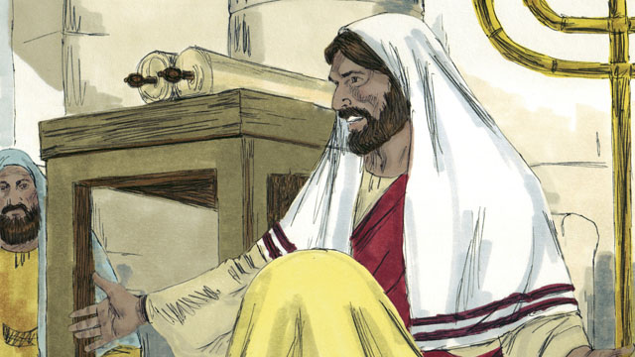
Then Jesus sat down. Everybody watched him closely. They knew the passage of scripture that he had just read referred to the Messiah. Jesus said, “The words I just read to you are happening right now.” All the people were amazed. “Isn’t this the son of Joseph?” they said.
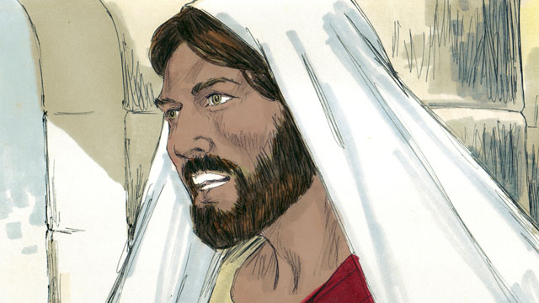
Then Jesus said, “It is true that no prophet is accepted in his own hometown. During the time of the prophet Elijah, there were many widows in Israel. But when it did not rain for three and a half years, God did not send Elijah to help a widow from Israel, but rather to a widow from a different nation.”
Jesus continued saying, “And during the time of the prophet Elisha, there were many people in Israel with skin diseases. But Elisha did not heal any of them. He only healed the skin disease of Naaman, a commander of Israel’s enemies.” The people who were listening to Jesus were Jews. So when they heard him say this, they were furious at him.
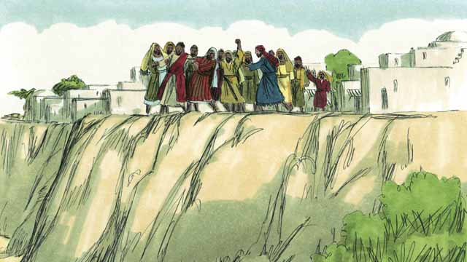
The people of Nazareth dragged Jesus out of the place of worship and brought him to the edge of a cliff to throw him off of it in order to kill him. But Jesus walked through the crowd and left the town of Nazareth.
Then Jesus went throughout the region of Galilee, and large crowds came to him. They brought many people who were sick or handicapped, including those who could not see, walk, hear, or speak, and Jesus healed them.
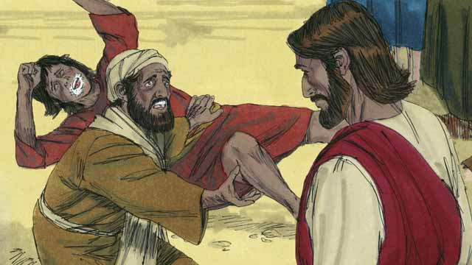
Many people who had demons in them were brought to Jesus. At Jesus’ command, the demons came out of the people, and often shouted, “You are the Son of God!” The crowds of people were amazed and worshiped God.
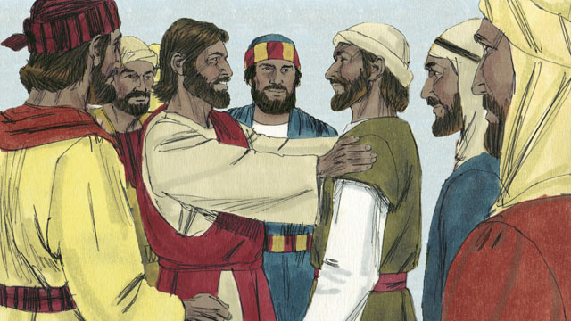
Then Jesus chose twelve men who were called his apostles. The apostles traveled with Jesus and learned from him.
A Bible story from: Matthew 4:12-25; Mark 1:14-15, 35-39; 3:13-21; Luke 4:14-30, 38-44

27. The Story of the Good Samaritan
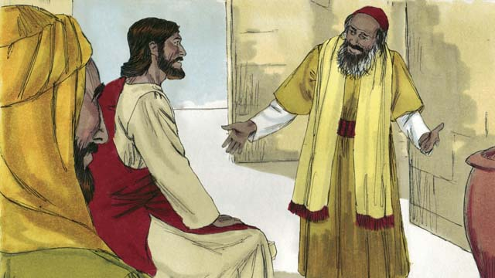
One day, an expert in the Jewish law came to Jesus to test him, saying, “Teacher, what must I do to inherit eternal life?” Jesus answered, “What is written in God’s law?”
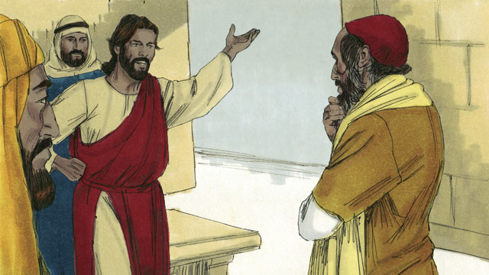
The law expert replied that God’s law says, “Love the Lord your God with all your heart, soul, strength, and mind. And love your neighbor as yourself.” Jesus answered, “You are correct! Do this and you will live.”
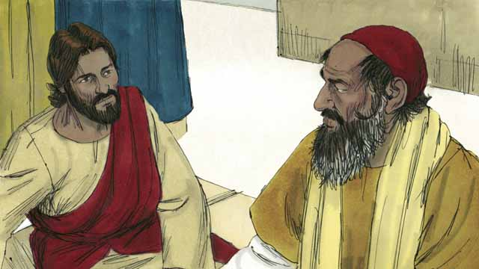
But the law expert wanted to prove that he was righteous, so he asked, “Who is my neighbor?”
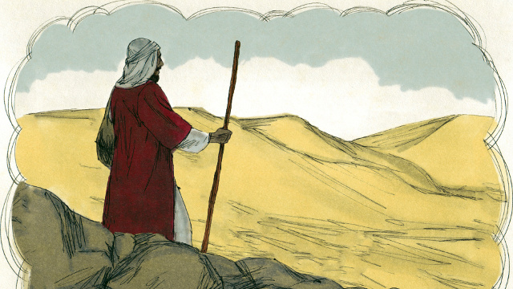
Jesus answered the law expert by telling a story. “There was a Jewish man who was traveling along the road from Jerusalem to Jericho.”
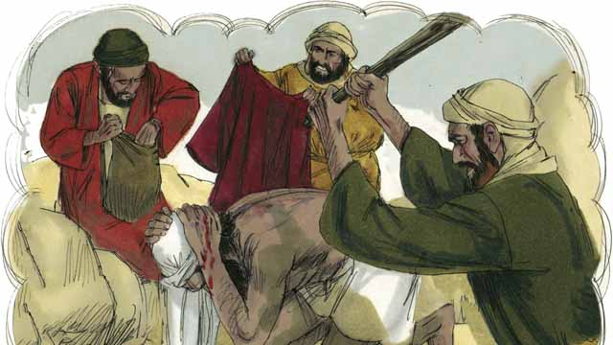
“While the man was traveling, he was attacked by a group of robbers. They took everything he had and beat him until he was almost dead. Then they went away.”
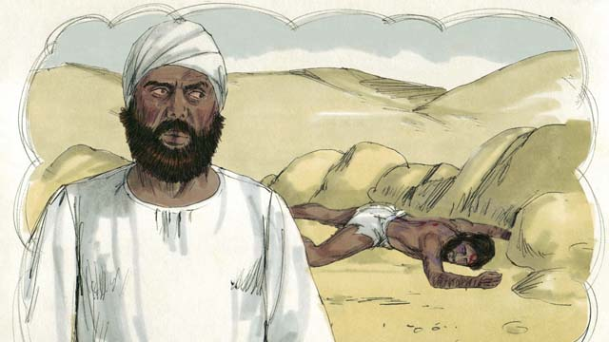
“Soon after that, a Jewish priest happened to walk down that same road. When this religious leader saw the man who had been robbed and beaten, he moved to the other side of the road, ignored the man who needed help, and kept on going.”
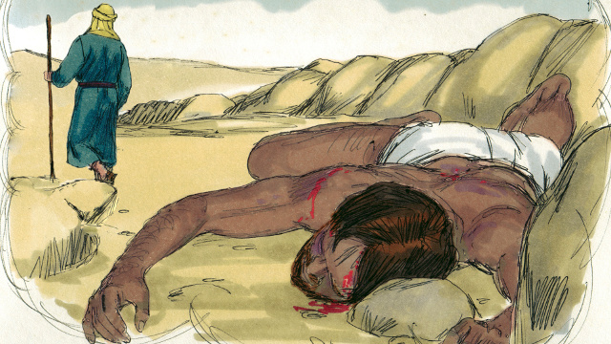
“Not long after that, a Levite came down the road. (Levites were a tribe of Jews who helped the priests at the Temple.) The Levite also crossed over to the other side of the road and ignored the man who had been robbed and beaten.”
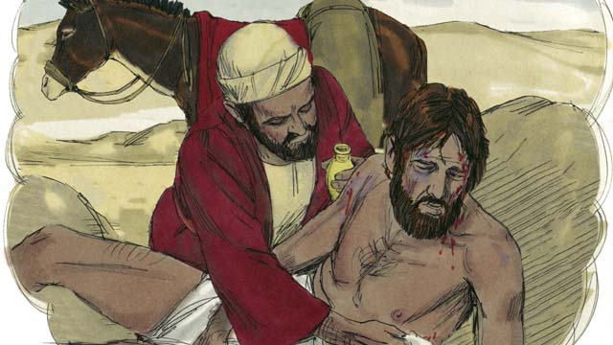
“The next person to walk down that road was a Samaritan. (Samaritans were the descendants of Jews who had married people from other nations. Samaritans and Jews hated each other.) But when the Samaritan saw the Jewish man, he felt very strong compassion for him. So he cared for him and bandaged his wounds.”
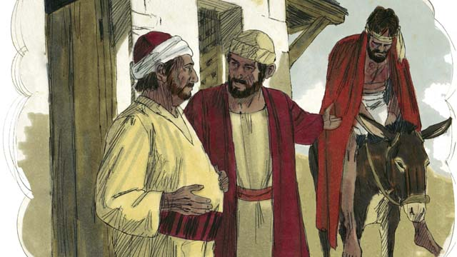
“The Samaritan then lifted the man onto his own donkey and took him to a roadside inn where he took care of him.”
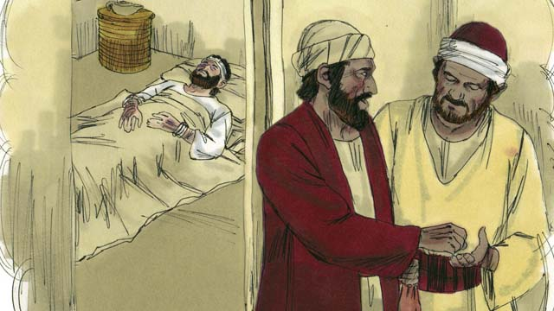
“The next day, the Samaritan needed to continue his journey. He gave some money to the person in charge of the inn and said, ‘Take care of him, and if you spend any more money than this, I will repay those expenses when I return.’”
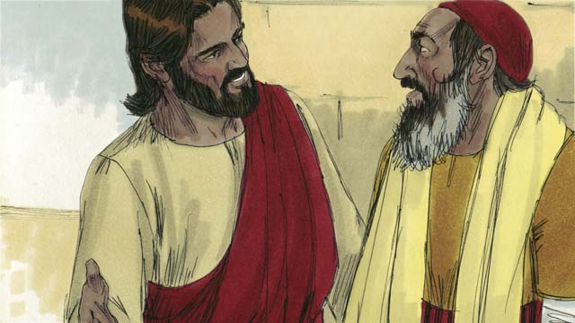
Then Jesus asked the law expert, “What do you think? Which one of the three men was a neighbor to the man who was robbed and beaten?” He replied, “The one who was merciful to him.” Jesus told him, “You go and do the same.”
A Bible story from: Luke 10:25-37

28. The Rich Young Ruler
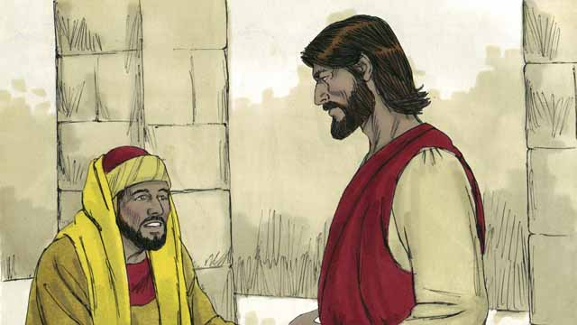
One day, a rich young ruler came up to Jesus and asked him, “Good teacher, what must I do to have eternal life?” Jesus said to him, “Why do you call me ‘good’? There is only one who is good, and that is God. But if you want to have eternal life, obey God’s laws.”
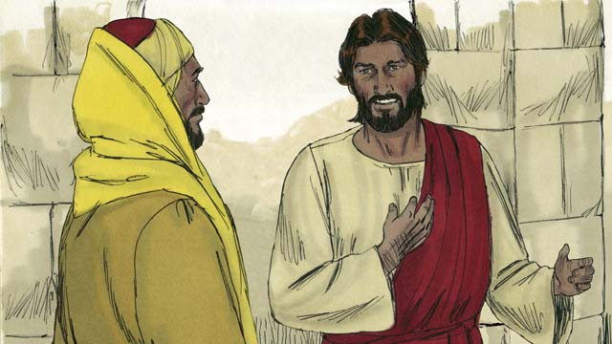
“Which ones do I need to obey?” he asked. Jesus replied, “Do not murder. Do not commit adultery. Do not steal. Do not lie. Honor your father and mother, and love your neighbor as you love yourself.”
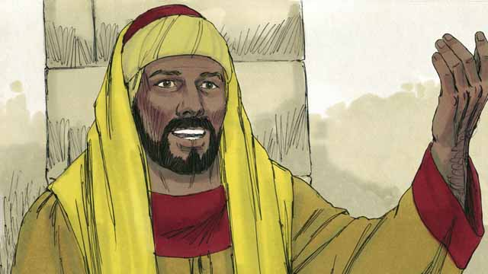
But the young man said, “I have obeyed all these laws ever since I was a boy. What do I still need to do in order to live forever?” Jesus looked at him and loved him.
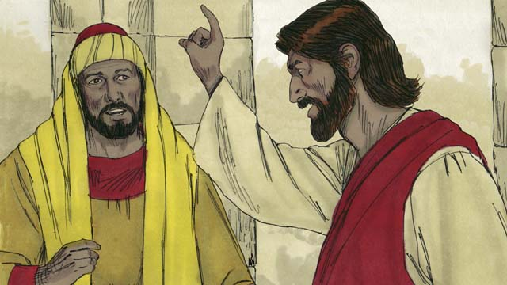
Jesus answered, “If you want to be perfect, then go and sell everything you own and give the money to the poor, and you will have treasure in heaven. Then come and follow me.”
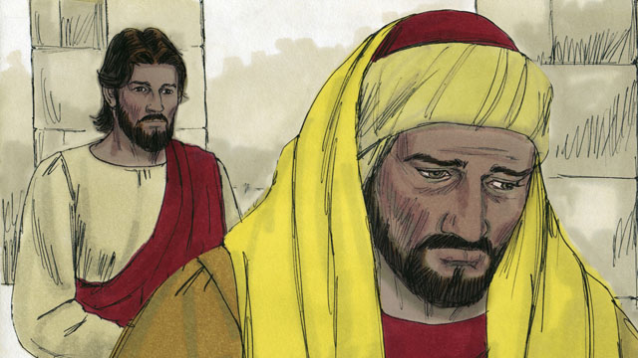
When the young man heard what Jesus said, he became very sad, because he was very rich and did not want to give away all the things he possessed. He turned and went away from Jesus.
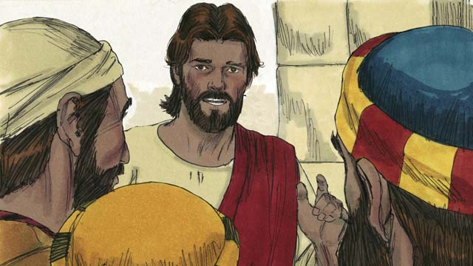
Then Jesus said to his disciples, “It is extremely hard for rich people to enter into the kingdom of God! Yes, it is easier for a camel to go through the eye of a needle than for a rich man to enter the kingdom of God.”
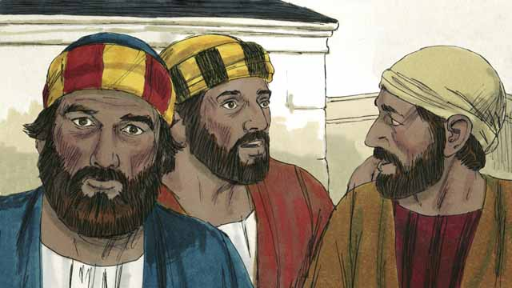
When the disciples heard what Jesus said, they were shocked and said, “Then who can be saved?”
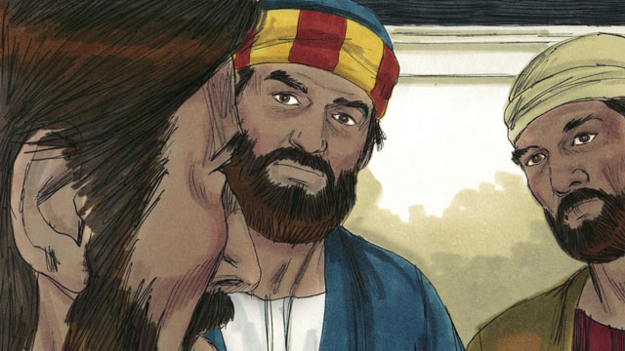
Jesus looked at the disciples and said, “With people this is impossible, but with God, all things are possible.”
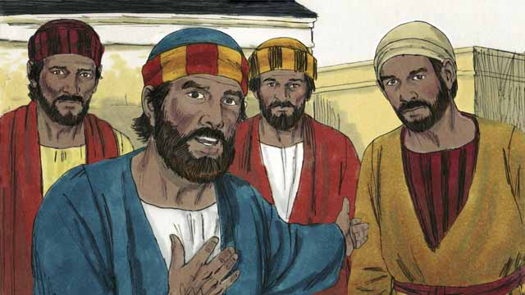
Peter said to Jesus, “We have left everything and followed you. What will be our reward?”
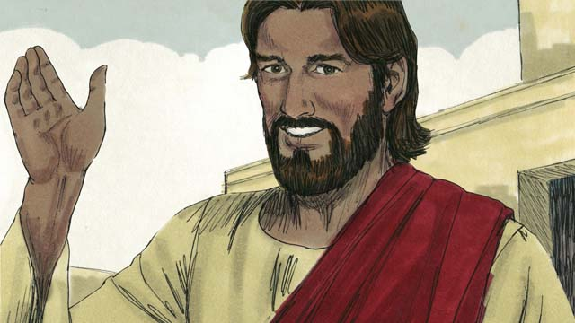
Jesus answered, “Everyone who has left houses, brothers, sisters, father, mother, children, or property for my sake, will receive 100 times more and will also receive eternal life. But many who are first will be last, and many who are last will be first.”
A Bible story from: Matthew 19:16-30; Mark 10:17-31; Luke 18:18-30

29. The Story of the Unmerciful Servant
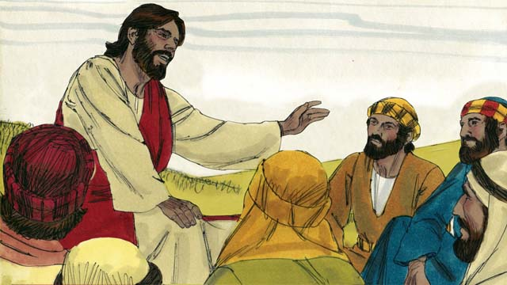
One day, Peter asked Jesus, “Master, how many times should I forgive my brother when he sins against me? Up to seven times?” Jesus said, “Not seven times, but seventy times seven!” By this, Jesus meant that we should always forgive. Then Jesus told this story.
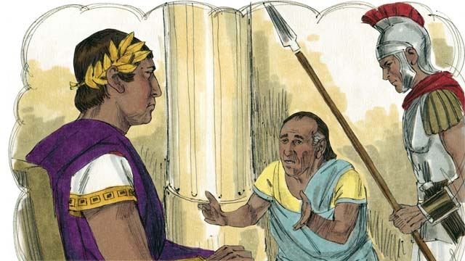
Jesus said, “The kingdom of God is like a king who wanted to settle accounts with his servants. One of his servants owed a huge debt worth 200,000 years’ wages.”
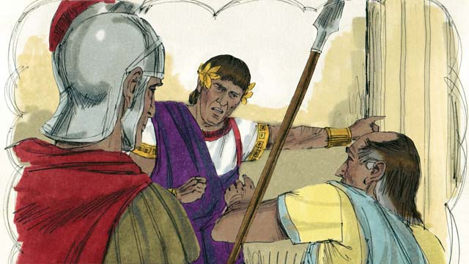
“Since the servant could not pay the debt, the king said, ‘Sell this man and his family as slaves to make payment on his debt.’”
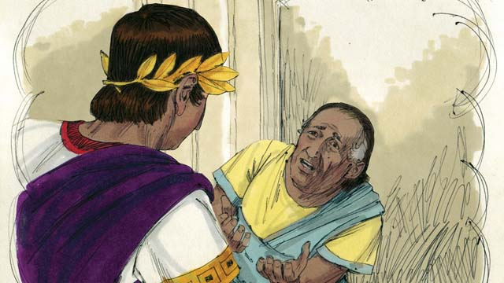
“The servant fell on his knees before the king and said, ‘Please be patient with me, and I will pay the full amount that I owe you.’ The king felt pity for the servant, so he canceled all of his debt and let him go.”
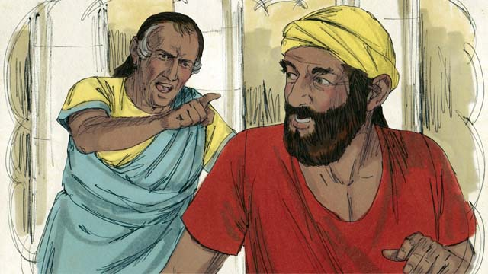
“But when the servant went out from the king, he found a fellow servant who owed him a debt worth four months’ wages. The servant grabbed his fellow servant and said, ‘Pay me the money that you owe me!’”
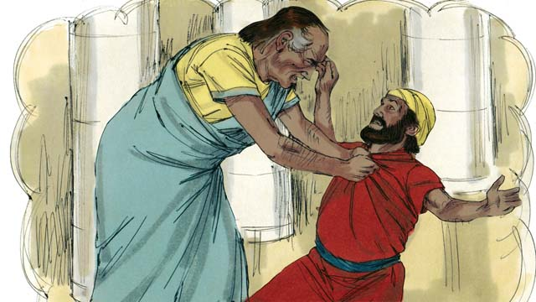
“The fellow servant fell on his knees and said, ‘Please be patient with me, and I will pay the full amount that I owe you.’ But instead, the servant threw his fellow servant into prison until he could pay the debt.”
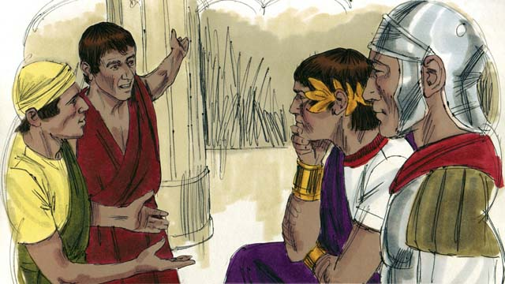
“Some other servants saw what had happened and were greatly disturbed. They went to the king and told him everything.”
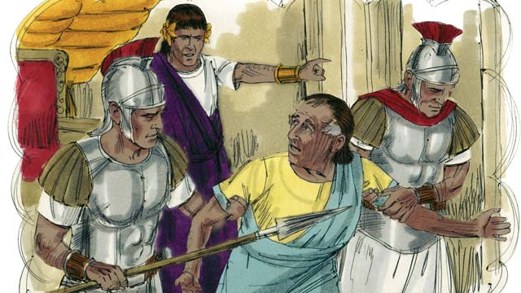
“The king called the servant and said, ‘You wicked servant! I forgave your debt because you begged me. You should have done the same.’ The king was so angry that he threw the wicked servant into prison until he could pay back all of his debt.”
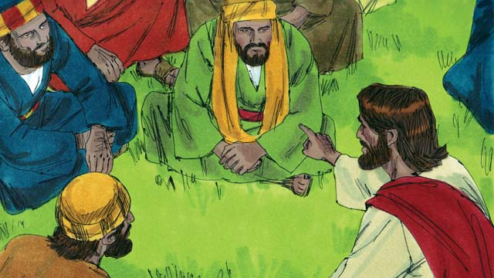
Then Jesus said, “This is what my heavenly Father will do to every one of you if you do not forgive your brother from your heart.”
A Bible story from: Matthew 18:21-35

30. Jesus Feeds Five Thousand People
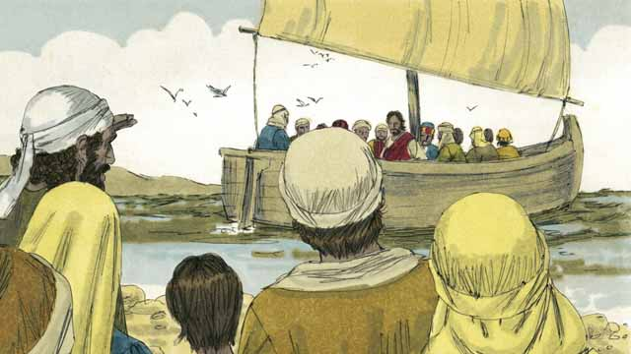
Jesus sent his apostles to preach and to teach people in many different villages. When they returned to where Jesus was, they told him what they had done. Then Jesus invited them to go with him to a quiet place across the lake to rest for a while. So, they got into a boat and went to the other side of the lake.
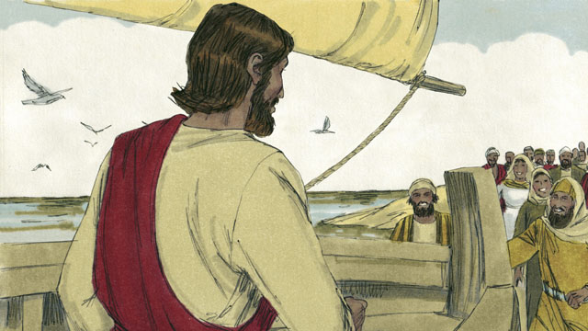
But there were many people who saw Jesus and the disciples leave in the boat. These people ran along the shore of the lake to get to the other side ahead of them. So when Jesus and the disciples arrived, a large group of people was already there, waiting for them.
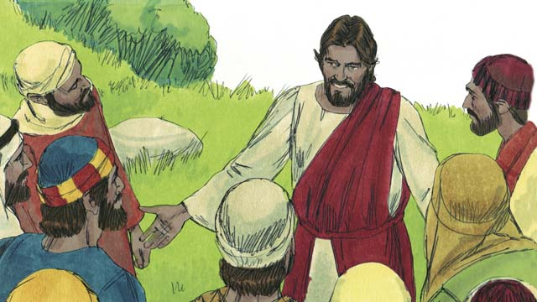
The crowd had over 5,000 men in it, not counting the women and children. Jesus felt great compassion towards the people. To Jesus, these people were like sheep without a shepherd. So he taught them and healed the people among them who were sick.
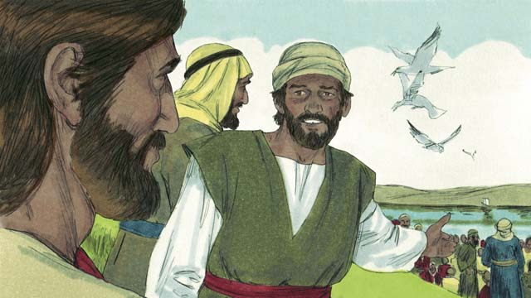
Late in the day, the disciples told Jesus, “It is late and there are no towns nearby. Send the people away so they can go get something to eat.”
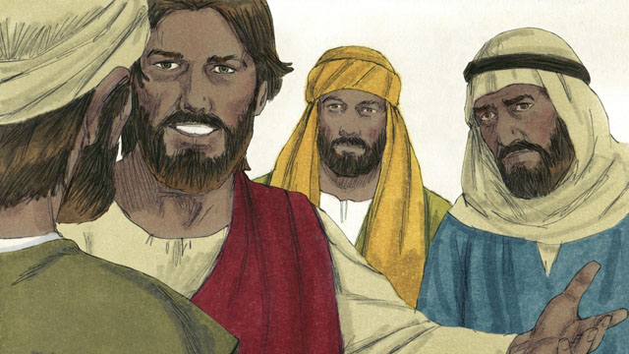
But Jesus said to the disciples, “You give them something to eat!” They responded, “How can we do that? We only have five loaves of bread and two small fish.”
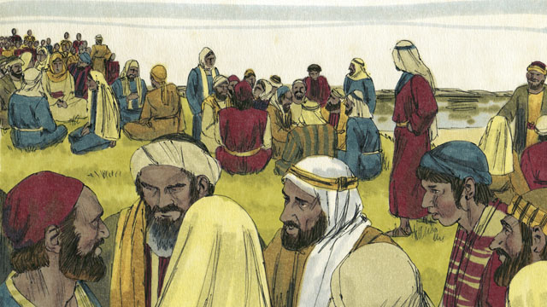
Jesus told his disciples to tell the people in the crowd to sit down on the grass, in groups of fifty people each.
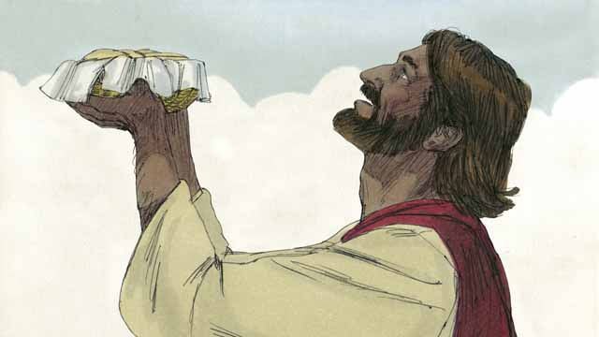
Then Jesus took the five loaves of bread and the two fish, looked up to heaven, and thanked God for the food.
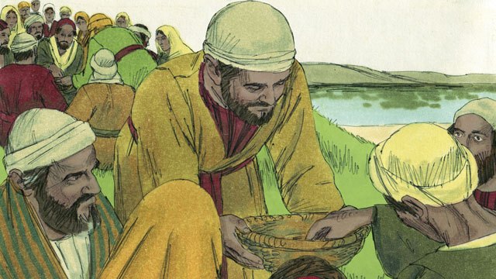
Then Jesus broke the bread and the fish into pieces. He gave the pieces to his disciples to give to the people. The disciples kept passing out the food, and it never ran out! All the people ate and were satisfied.
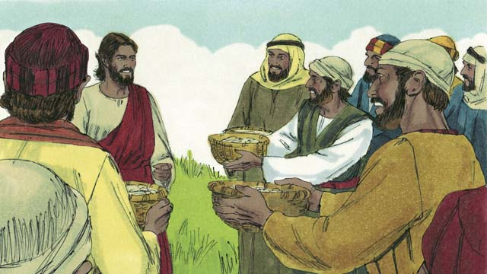
After that, the disciples collected the food that had not been eaten and it was enough to fill twelve baskets! All the food came from the five loaves of bread and two fish.
A Bible story from: Matthew 14:13-21; Mark 6:31-44; Luke 9:10-17; John 6:5-15

31. Jesus Walks on Water
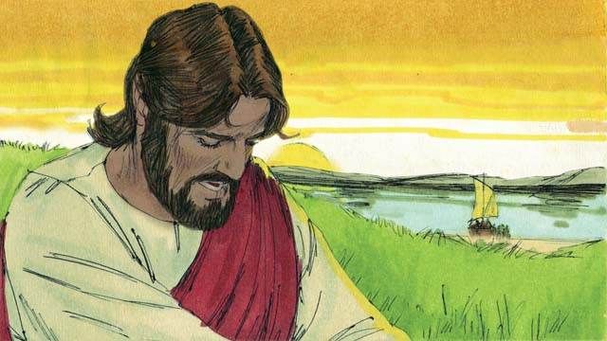
Then Jesus told the disciples to get into the boat and sail to the other side of the lake while he dismissed the crowd. After Jesus had sent the crowd away, he went up on a mountainside to pray. Jesus was there all alone, and he prayed until late at night.
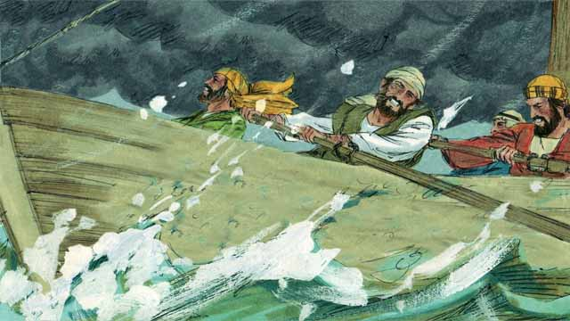
Meanwhile, the disciples were rowing their boat, but by late in the night they had only reached the middle of the lake. They were rowing with great difficulty because the wind was blowing hard against them.
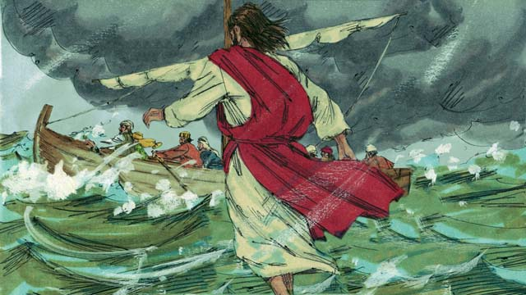
Then Jesus finished praying and went to the disciples. He walked on top of the water across the lake toward their boat!
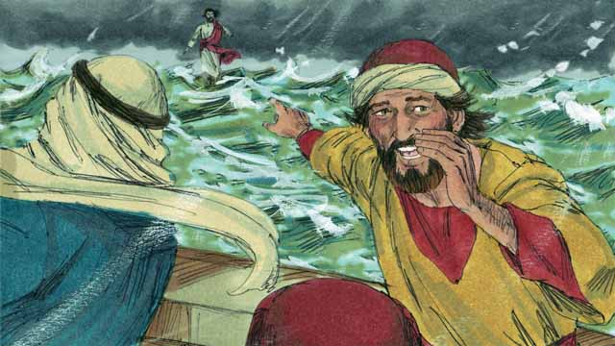
The disciples were very afraid when they saw Jesus, because they thought they were seeing a ghost. Jesus knew that they were afraid, so he called out to them and said, “Do not be afraid. It is I!”
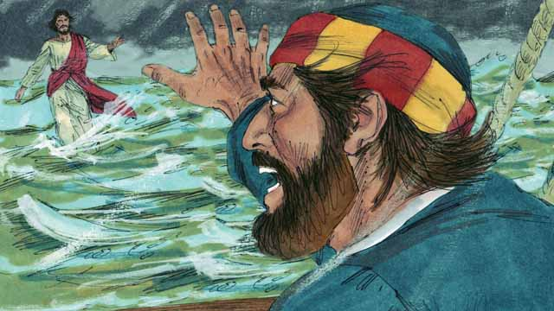
Then Peter said to Jesus, “Master, if it is you, command me to come to you on the water.” Jesus told Peter, “Come!”
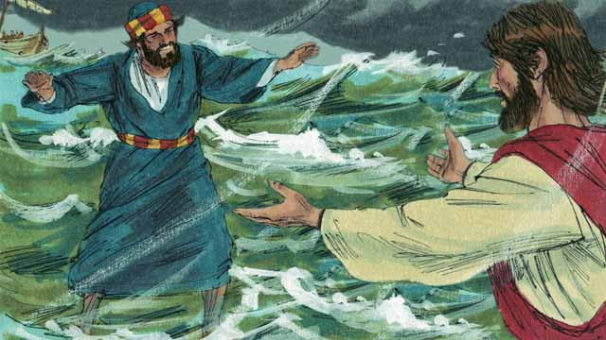
So, Peter got out of the boat and started walking to Jesus on the surface of the water. But after walking a short distance, he turned his eyes away from Jesus and began to look at the waves and to feel the strong wind.
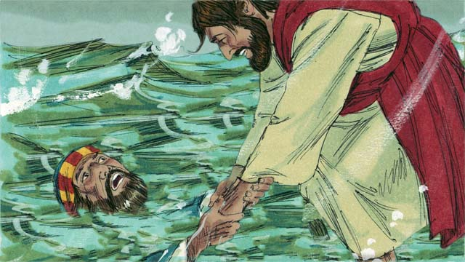
Then Peter became afraid and began to sink in the water. He cried out, “Master, save me!” Jesus reached out right away and grabbed him. Then he said to Peter, “You man of little faith, why did you doubt?”
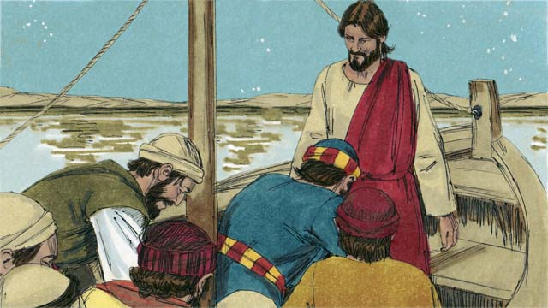
When Peter and Jesus got into the boat, the wind immediately stopped blowing and the water became calm. The disciples were amazed. They worshiped Jesus, saying to him, “Truly, you are the Son of God.”
A Bible story from: Matthew 14:22-33; Mark 6:45-52; John 6:16-21

32. Jesus Heals a Demon-Possessed Man & a Sick Woman
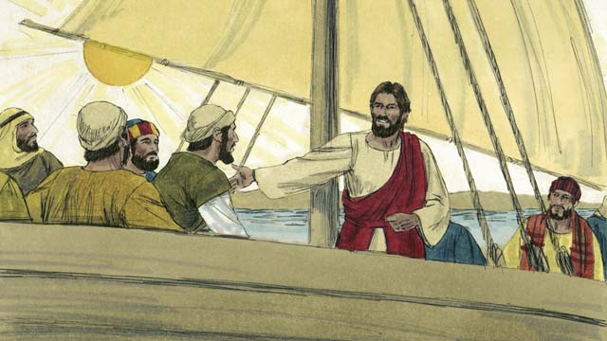
One day, Jesus and his disciples went in a boat across the lake to the region where the Gerasene people lived.
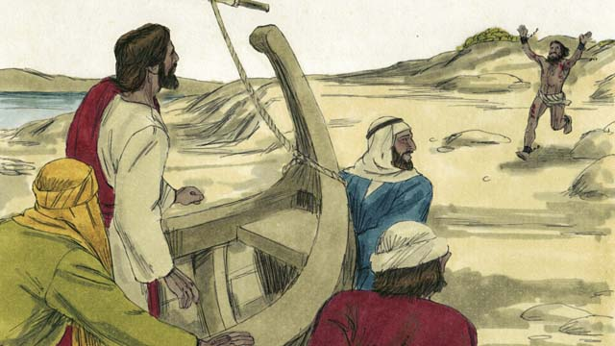
When they reached the other side of the lake, a demon-possessed man came running up to Jesus.
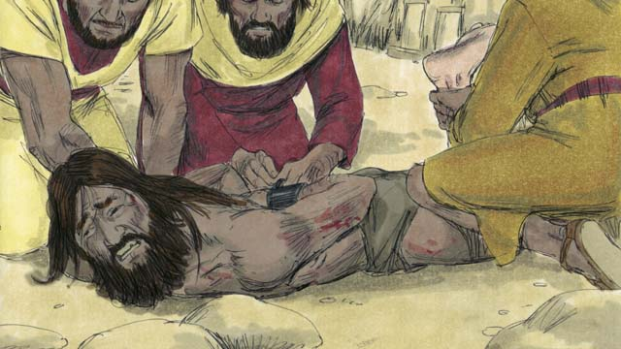
This man was so strong that nobody could control him. People had even fastened his arms and legs with chains, but he kept breaking them.
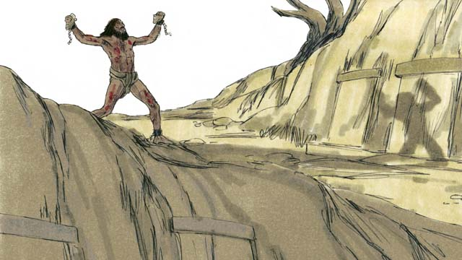
The man lived among the tombs in the area. This man would scream all day and all night. He did not wear clothes and cut himself repeatedly with stones.
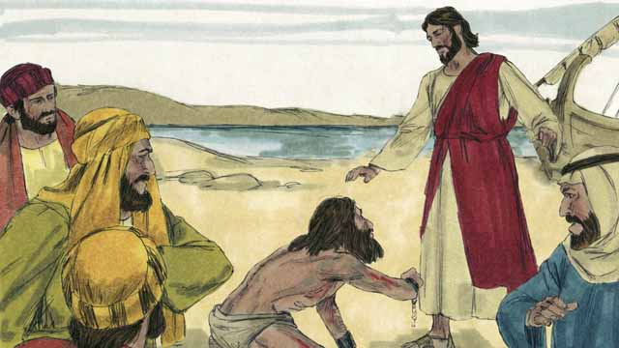
When the man came to Jesus, he fell on his knees in front of him. Jesus said to the demon, “Come out of this man!”
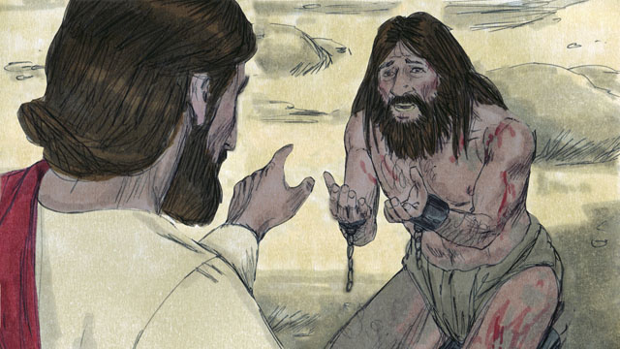
The man with the demon cried out in a loud voice, “What do you want with me, Jesus, Son of the Most High God? Please do not torture me!” Then Jesus asked the demon, “What is your name?” He replied, “My name is Legion, because we are many.” (A “legion” was a group of several thousand soldiers in the Roman army.)
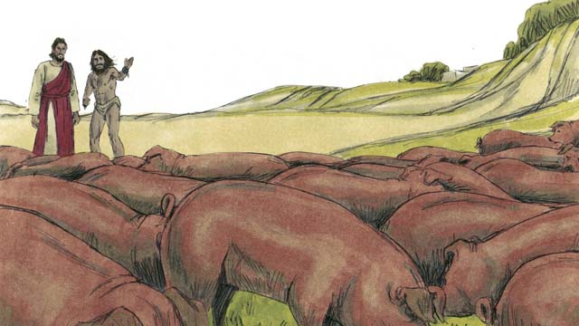
The demons begged Jesus, “Please do not send us out of this region!” There was a herd of pigs feeding on a nearby hill. So, the demons begged Jesus, “Please send us into the pigs instead!” Jesus said, “Go!”
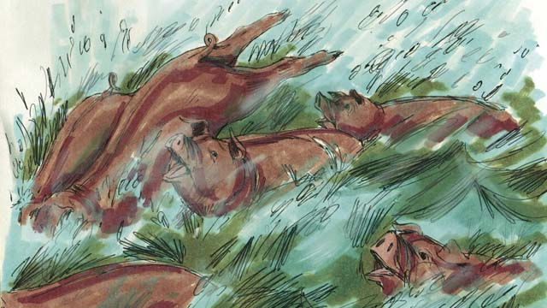
The demons came out of the man and entered the pigs. The pigs ran down a steep bank into the lake and drowned. There were about 2,000 pigs in the herd.
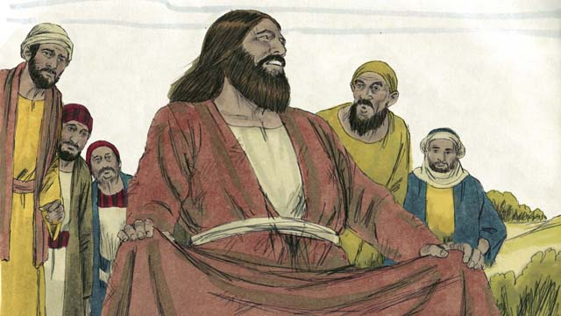
When the people who took care of the pigs saw what happened, they ran into the town and told everyone that they met what Jesus had done. The people from the town came and saw the man who used to have the demons. He was sitting calmly, wearing clothes, and acting like a normal person.
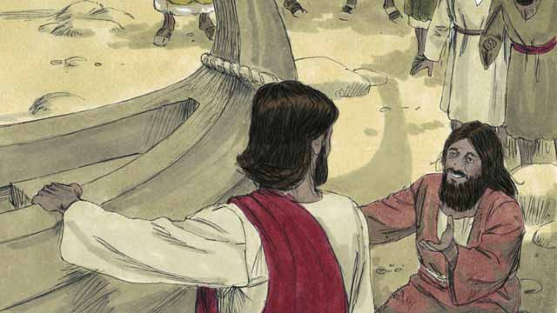
The people were very afraid and asked Jesus to leave. So Jesus got into the boat and prepared to leave. The man who used to have the demons begged to go along with Jesus.
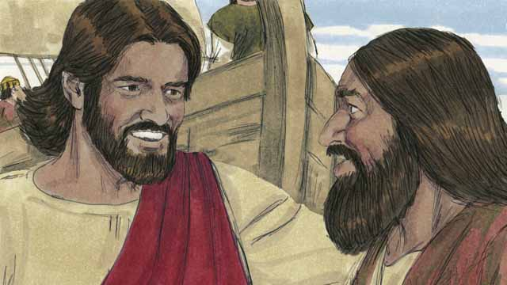
But Jesus said to him, “No, I want you to go home and tell your friends and family about everything that God has done for you and how he has had mercy on you.”
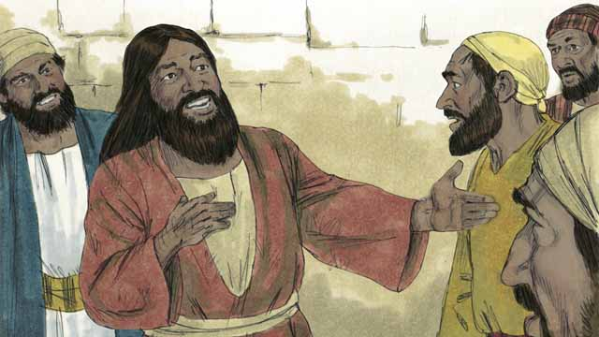
So the man went away and told everyone about what Jesus had done for him. Everyone who heard his story was filled with wonder and amazement.
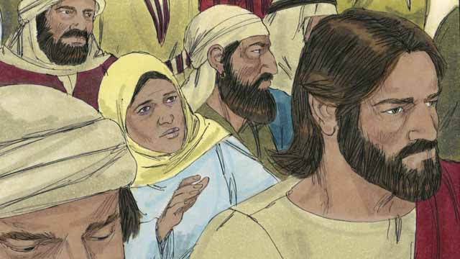
Jesus returned to the other side of the lake. After he arrived there, a large crowd gathered around him and pressed in on him. In the crowd was a woman who had suffered from a bleeding problem for twelve years. She had paid all of her money to doctors so they would heal her, but she only got worse.
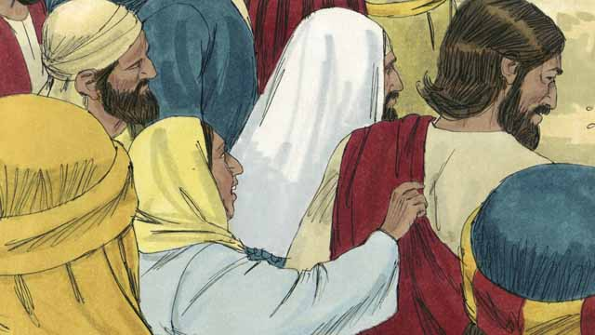
She had heard that Jesus had healed many sick people and thought, “I’m sure that if I can just touch Jesus’ clothes, then I will be healed, too!” So she came up behind Jesus and touched his clothes. As soon as she touched them, the bleeding stopped!
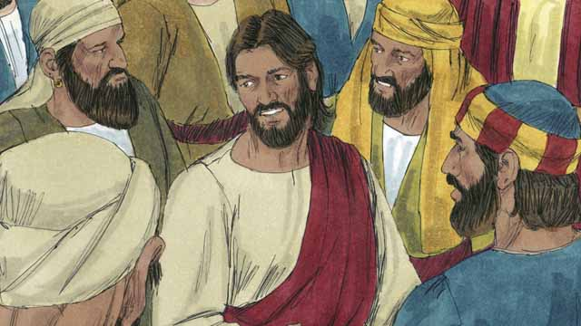
Immediately, Jesus realized that power had gone out from him. So he turned around and asked, “Who touched me?” The disciples replied, “There are many people crowding around you and bumping into you. Why did you ask, ‘Who touched me?’”
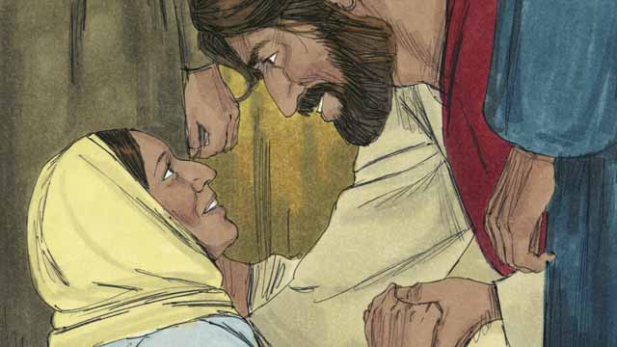
The woman fell on her knees before Jesus, shaking and very afraid. Then she told him what she had done, and that she had been healed. Jesus said to her, “Your faith has healed you. Go in peace.”
A Bible story from: Matthew 8:28-34; 9:20-22; Mark 5:1-20; 5:24b-34; Luke 8:26-39; 8:42b-48

33. The Story of the Farmer
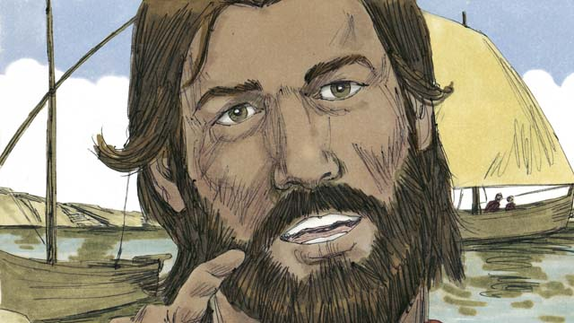
One day, Jesus was teaching a very large crowd of people near the shore of the lake. So many people came to hear him that Jesus got into a boat at the edge of the water in order to have enough space to speak to them. He sat in the boat and taught the people.
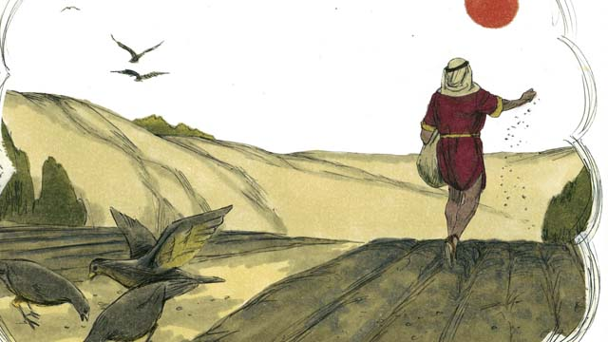
Jesus told this story. “A farmer went out to plant some seed. As he was spreading the seeds by hand, some seeds happened to fall on the path, and the birds came and ate all of those seeds.”

“Other seeds fell on rocky ground, where there was very little soil. The seeds in the rocky ground sprouted quickly, but their roots were not able to go deep into the soil. When the sun came up and it got hot, the plants withered and died.”

“Still other seeds fell among thorn bushes. Those seeds began to grow, but the thorns choked them out. So the plants that grew from the seeds in the thorny ground did not produce any grain.”

“Other seeds fell into good soil. These seeds grew up and produced 30, 60, or even 100 times as much grain as the seed that had been planted. He who has ears, let him hear!”
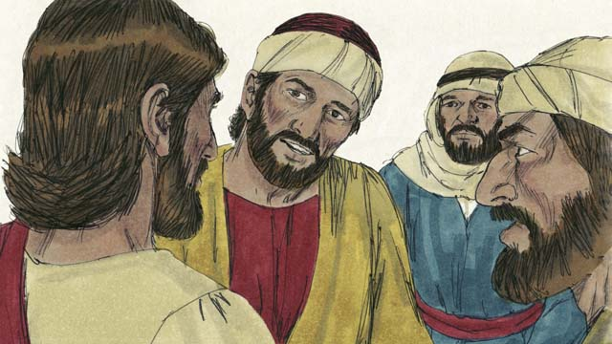
This story confused the disciples. So Jesus explained, “The seed is the word of God. The path is a person who hears God’s word, but does not understand it, and the devil takes the word away from him.”
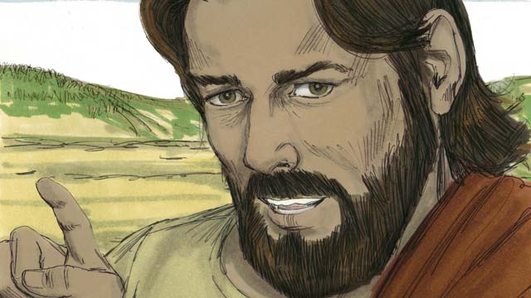
“The rocky ground is a person who hears God’s word and accepts it with joy. But when he experiences hardship or persecution, he falls away.”
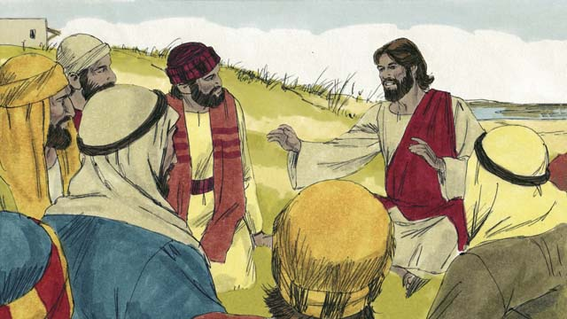
“The thorny ground is a person who hears God’s word, but as time passes, the cares, riches, and pleasures of life choke out his love for God. As a result, the teaching he heard does not produce fruit.”
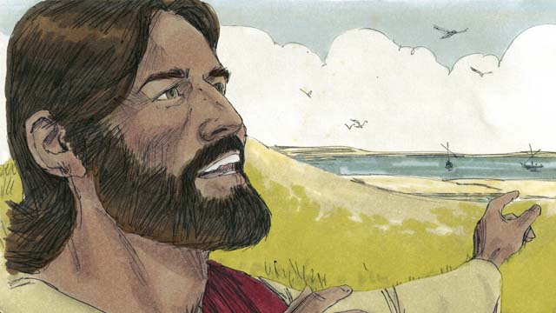
“But the good soil is a person who hears the word of God, believes it, and produces fruit.”
A Bible story from: Matthew 13:1-8, 18-23; Mark 4:1-8, 13-20; Luke 8:4-15

34. Jesus Teaches Other Stories
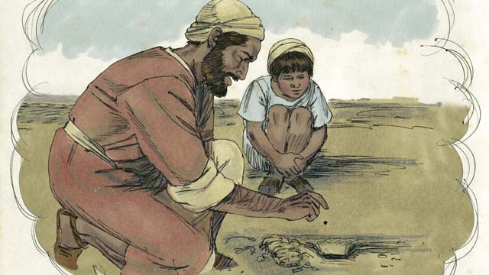
Jesus told many other stories about the kingdom of God. For example, he said, “The kingdom of God is like a mustard seed that someone planted in his field. You know that the mustard seed is the smallest seed of all.”
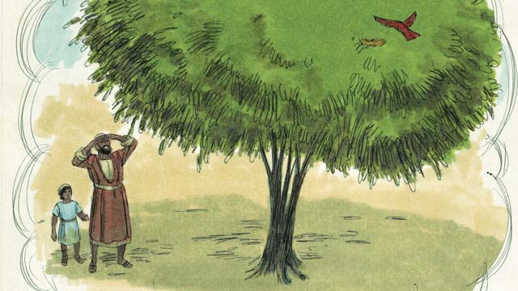
“But when the mustard seed grows, it becomes the largest of all of the garden plants, big enough that even the birds come and rest in its branches.”
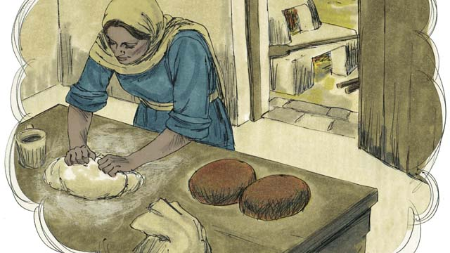
Jesus told another story, “The kingdom of God is like yeast that a woman mixes into some bread dough until it spreads throughout the dough.”
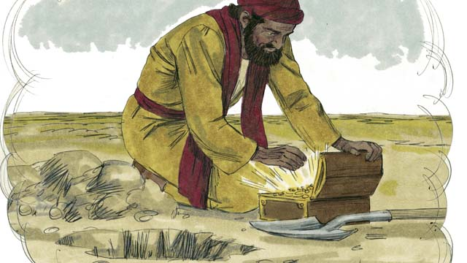
“The kingdom of God is also like treasure that someone hid in a field. Another man found the treasure and then buried it again. He was so filled with joy that he went and sold everything he had and used the money to buy that field.”
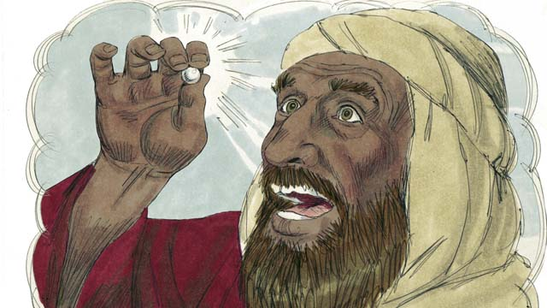
“The kingdom of God is also like a perfect pearl of great value. When a pearl merchant found it, he sold all that he had and used the money to buy it.”
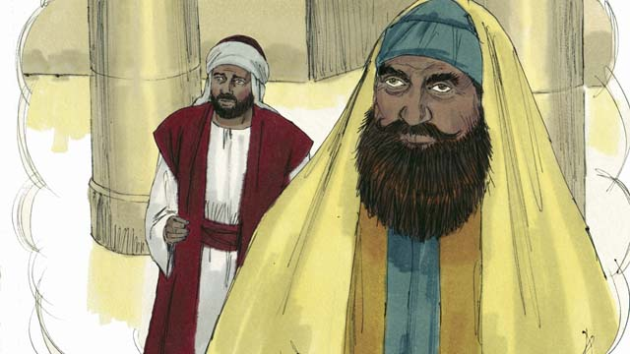
Then Jesus told a story to some people who trusted in their own good deeds and despised other people. He said, “Two men went to the Temple to pray. One of them was a tax collector, and the other was a religious leader.”
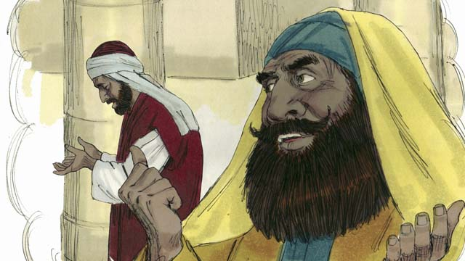
“The religious leader prayed like this, ‘Thank you, God, that I am not a sinner like other men—such as robbers, unjust men, adulterers, or even like that tax collector.’”
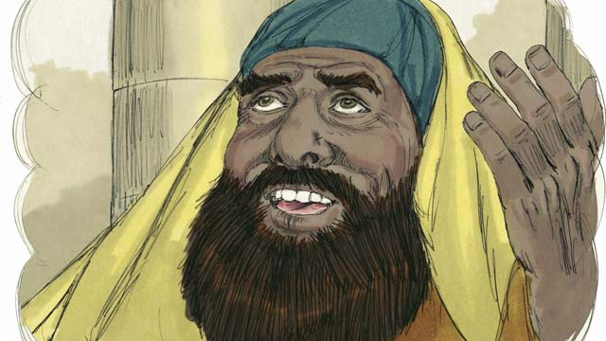
“‘For example, I fast two times every week and I give you ten percent of all the money and goods that I receive.’”
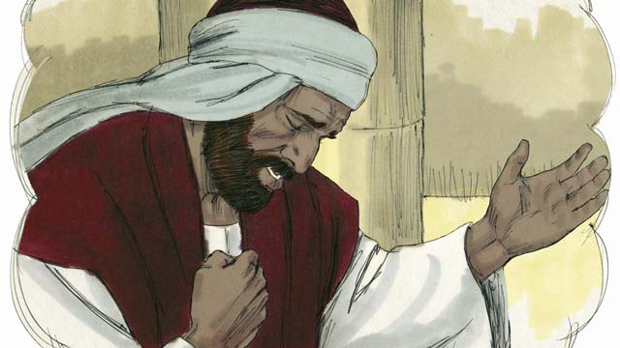
“But the tax collector stood far away from the religious leader, and did not even look up to heaven. Instead, he pounded on his chest with his fist and prayed, ‘God, please be merciful to me because I am a sinner.’”
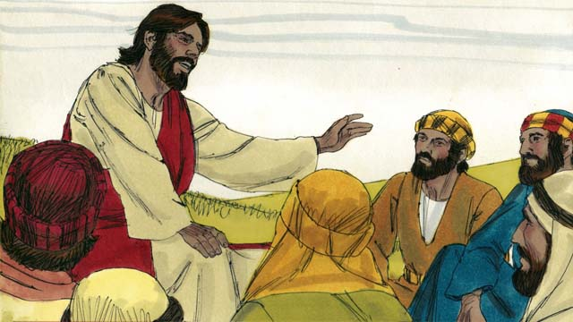
Then Jesus said, “I tell you the truth, God heard the tax collector’s prayer and declared him to be righteous. But he did not like the religious leader’s prayer. God will humble everyone who is proud, and he will lift up whoever humbles himself.”
A Bible story from: Matthew 13:31-33, 44-46; Mark 4:30-32; Luke 13:18-21; 18:9-14

35. The Story of the Compassionate Father
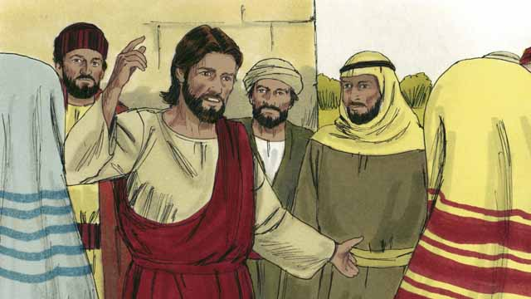
One day, Jesus was teaching many tax collectors and other sinners who had gathered to hear him.
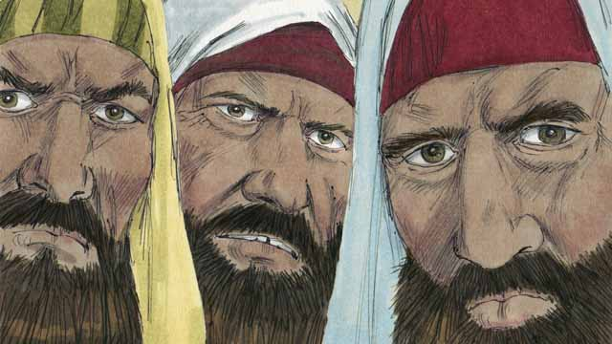
Some religious leaders who were also there saw Jesus treating these sinners as friends, and they began to criticize him to each other. So Jesus told them this story.
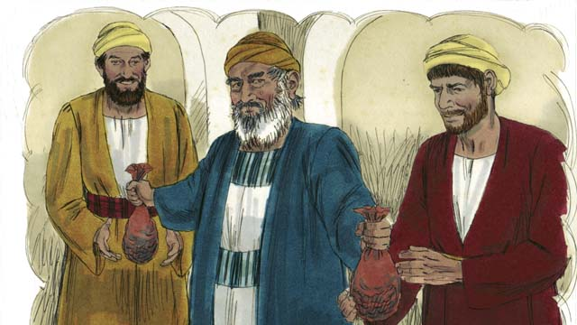
“There was a man who had two sons. The younger son told his father, ‘Father, I want my inheritance now!’ So the father divided his property between his two sons.”
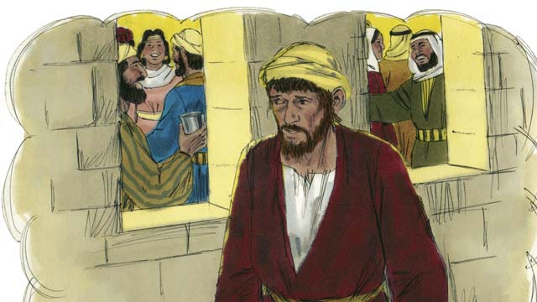
“Soon the younger son gathered all that he had and went far away and wasted his money in sinful living.”
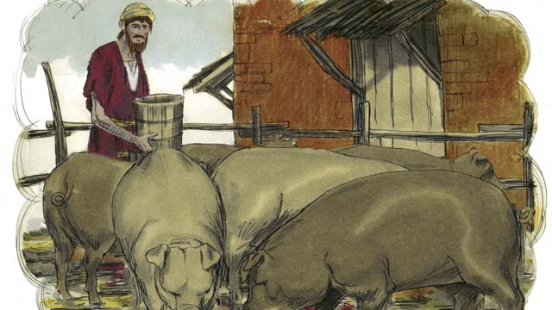
“After that, a severe famine happened in the land where the younger son was, and he had no money to buy food. So he took the only job he could find, feeding pigs. He was so miserable and hungry that he wanted to eat the pigs’ food.”
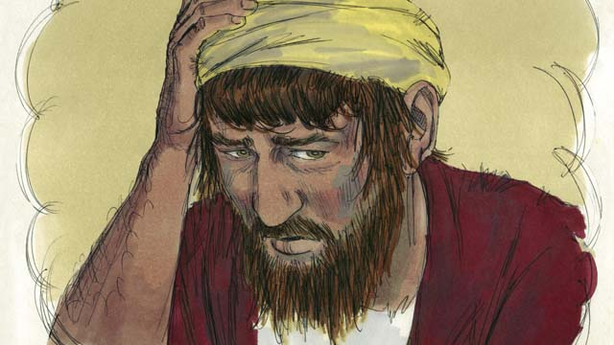
“Finally, the younger son said to himself, ‘What am I doing? All my father’s servants have plenty to eat, and yet here I am starving. I will go back to my father and ask to be one of his servants.’”
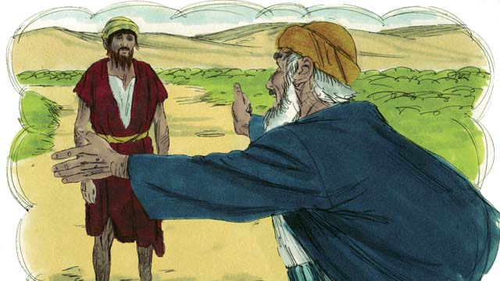
“So the younger son started back towards his father’s home. When he was still far away, his father saw him and felt compassion for him. He ran to his son and hugged him and kissed him.”
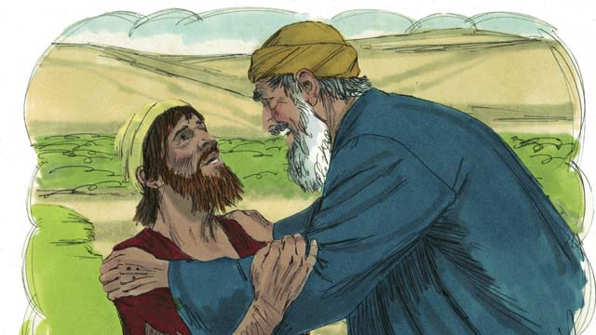
“The son said, ‘Father, I have sinned against God and against you. I am not worthy to be your son.’”
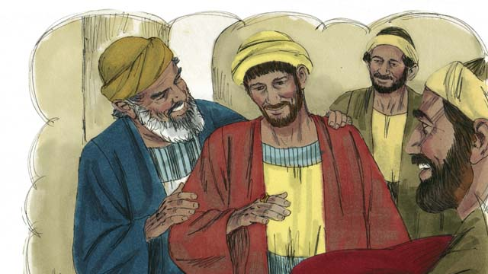
“But his father told one of his servants, ‘Go quickly and bring the best clothes and put them on my son! Put a ring on his finger and put sandals on his feet. Then kill the best calf so we can have a feast and celebrate, because my son was dead, but now he is alive! He was lost, but now he is found!’”
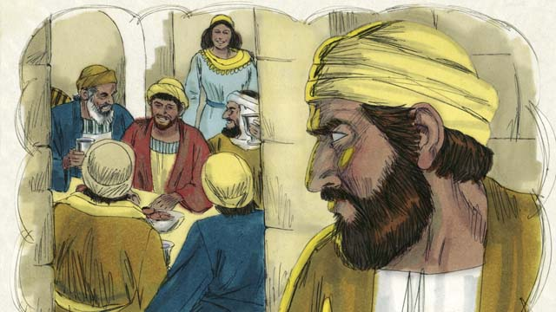
“So the people began to celebrate. Before long, the older son came home from working in the field. He heard the music and dancing and wondered what was happening.”
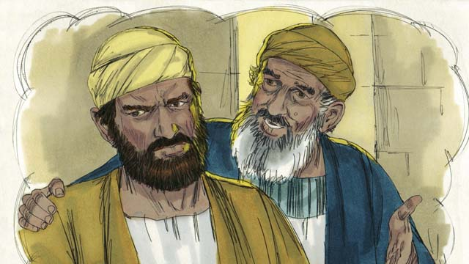
“When the older son found out that they were celebrating because his brother had come home, he was very angry and would not go into the house. His father came out and begged him to come and celebrate with them, but he refused.”
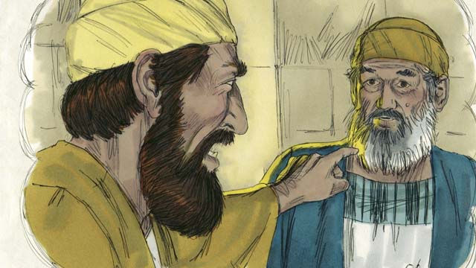
“The older son said to his father, ‘All these years I have worked faithfully for you! I never disobeyed you, and still you did not even give me one small goat so I could celebrate with my friends. But when this son of yours who consumed your money in sinful behavior came home, you killed the best calf for him!’”
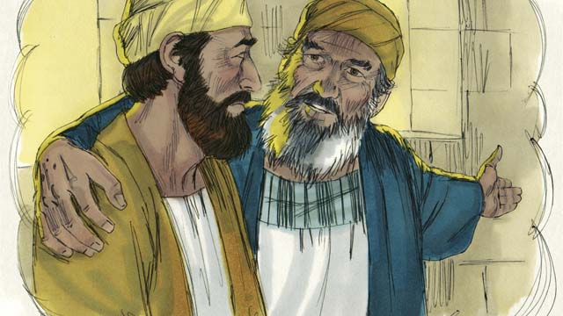
“The father answered, ‘My son, you are always with me, and everything I have is yours. But it is right for us to celebrate, because your brother was dead, but now is alive. He was lost, but now is found!’”
A Bible story from: Luke 15:11-32

36. The Transfiguration
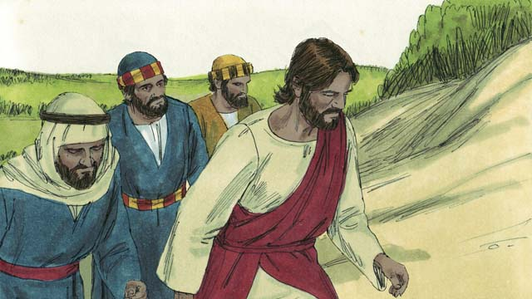
One day, Jesus took three of his disciples, Peter, James, and John with him. (The disciple named John was not the same person who baptized Jesus.) They went up on a high mountain by themselves to pray.
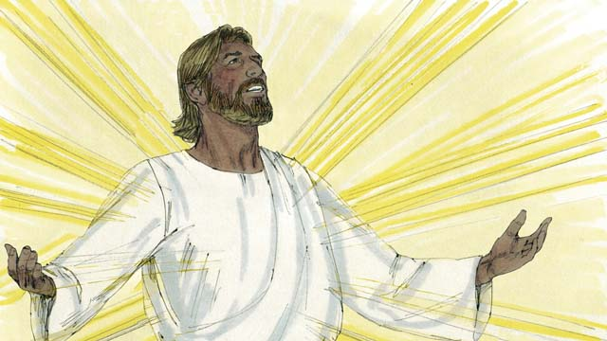
As Jesus was praying, his face became as bright as the sun and his clothes became as white as light, whiter than anyone on earth could make them.
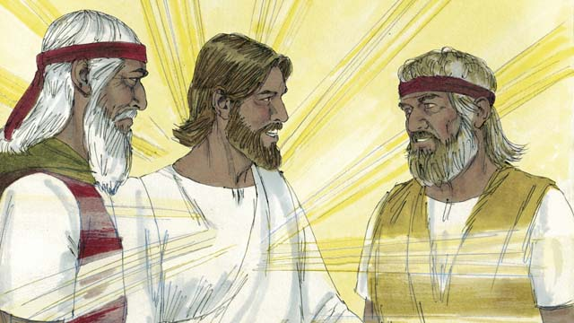
Then Moses and the prophet Elijah appeared. These men had lived on the earth hundreds of years before this. They talked with Jesus about his death, which would soon happen in Jerusalem.
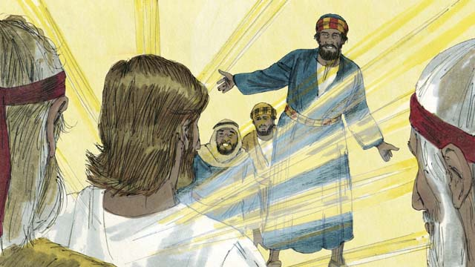
As Moses and Elijah were talking with Jesus, Peter said to Jesus, “It is good for us to be here. Let us make three shelters, one for you, one for Moses, and one for Elijah.” Peter did not know what he was saying.
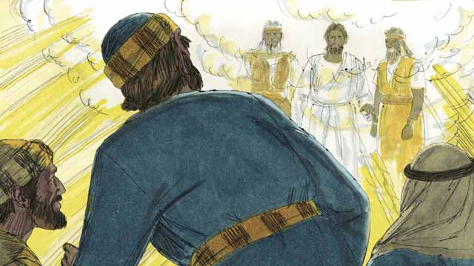
As Peter was talking, a bright cloud came down and surrounded them and a voice from the cloud said, “This is my Son whom I love. I am pleased with him. Listen to him.” The three disciples were terrified and fell on the ground.
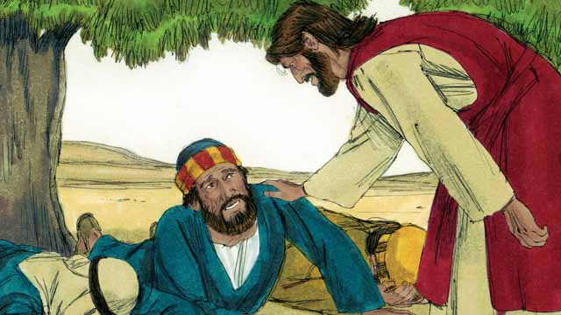
Then Jesus touched them and said, “Do not be afraid. Get up.” When they looked around, the only one still there was Jesus.
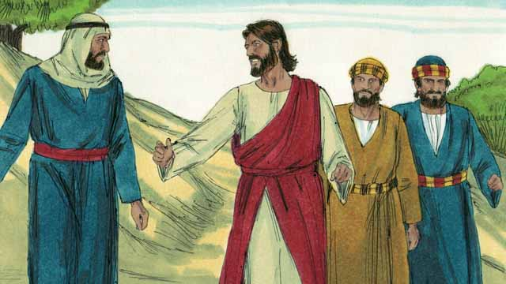
Jesus and the three disciples went back down the mountain. Then Jesus said to them, “Do not tell anyone yet about what happened here. I will soon die and then come back to life. After that, you may tell people.”
A Bible story from: Matthew 17:1-9; Mark 9:2-8; Luke 9:28-36

37. Jesus Raises Lazarus from the Dead
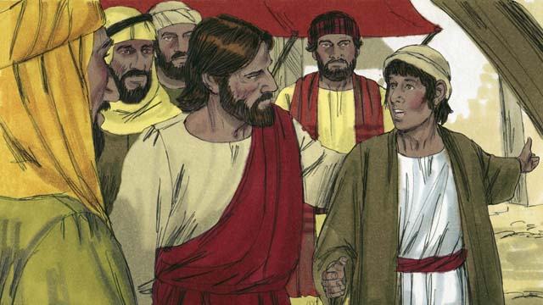
One day, Jesus received a message that Lazarus was very sick. Lazarus and his two sisters, Mary and Martha, were close friends of Jesus. When Jesus heard this news, he said, “This sickness will not end in death, but it is for the glory of God.” Jesus loved his friends, but he waited where he was for two days.
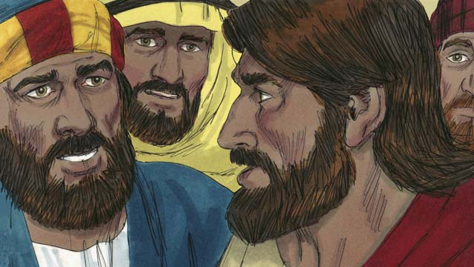
After the two days had passed, Jesus said to his disciples, “Let’s go back to Judea.” “But Teacher,” the disciples answered, “Just a short time ago the people there wanted to kill you!” Jesus said, “Our friend Lazarus has fallen asleep, and I must wake him.”
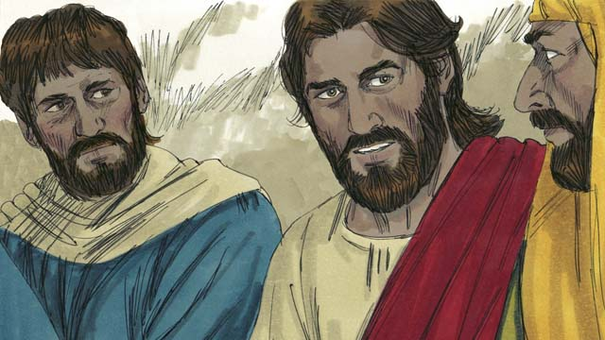
Jesus’ disciples replied, “Master, if Lazarus is sleeping, then he will get better.” Then Jesus told them plainly, “Lazarus is dead. I am glad that I was not there, so that you may believe in me.”
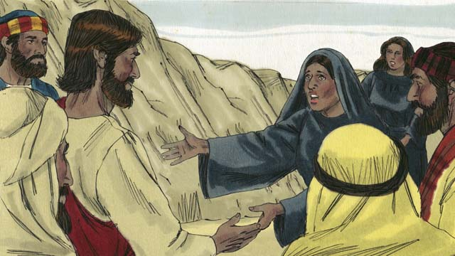
When Jesus arrived at Lazarus’ hometown, Lazarus had already been dead for four days. Martha went out to meet Jesus and said, “Master, if only you had been here, my brother would not have died. But I believe God will give you whatever you ask from him.”
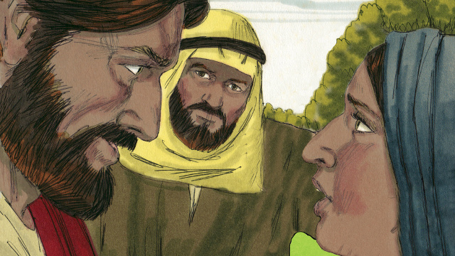
Jesus replied, “I am the Resurrection and the Life. Whoever believes in me will live, even though he dies. Everyone who believes in me will never die. Do you believe this?” Martha answered, “Yes, Master! I believe you are the Messiah, the Son of God.”
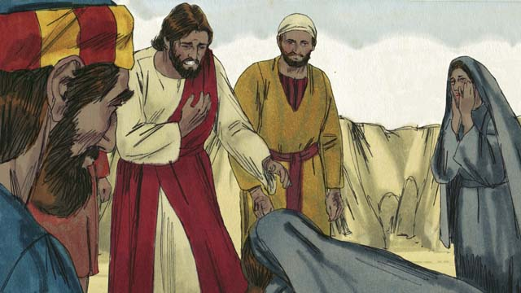
Then Mary arrived. She fell at the feet of Jesus and said, “Master, if only you had been here, my brother would not have died.” Jesus asked them, “Where have you put Lazarus?” They told him, “In the tomb. Come and see.” Then Jesus wept.
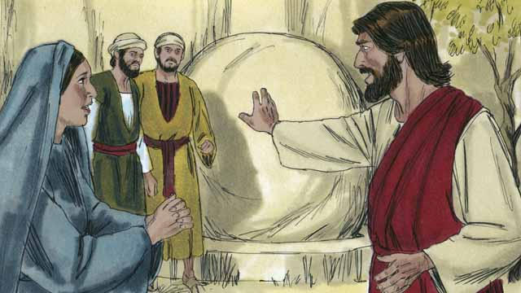
The tomb was a cave with a stone rolled in front of its opening. When Jesus arrived at the tomb, he told them, “Roll the stone away.” But Martha said, “He has been dead for four days. There will be a bad smell.”
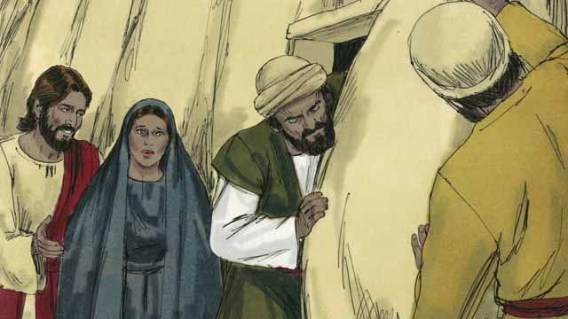
Jesus responded, “Did I not tell you that you would see God’s glory if you believe in me?” So they rolled the stone away.
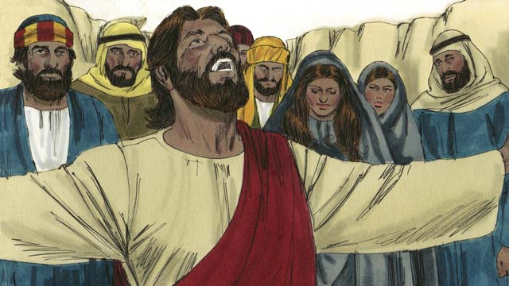
Then Jesus looked up to heaven and said, “Father, thank you for hearing me. I know you always listen to me, but I say this for the sake of all these people standing here, so that they will believe you sent me.” Then Jesus shouted, “Lazarus, come out!”
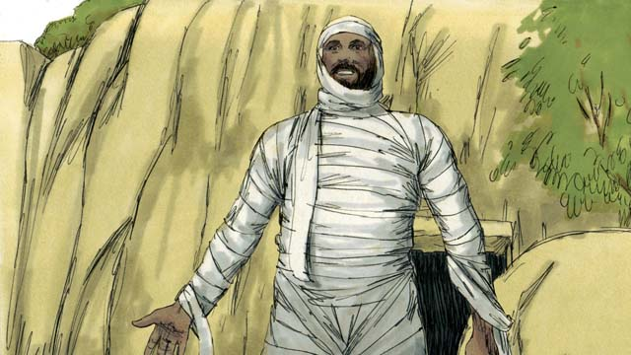
So Lazarus came out! He was still wrapped in grave clothes. Jesus told them, “Help him take off those grave clothes and release him!” Many of the Jews believed in Jesus because of this miracle.
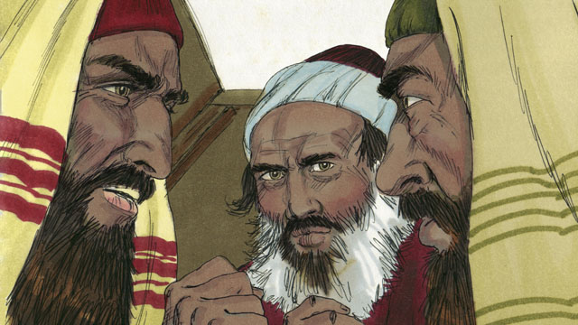
But the religious leaders of the Jews were jealous, so they gathered together to plan how they could kill Jesus and Lazarus.
A Bible story from: John 11:1-46

38. Jesus Is Betrayed
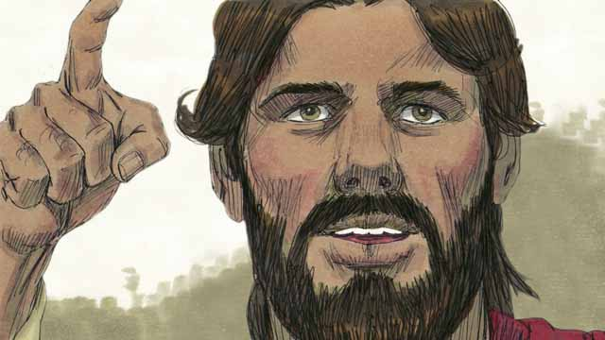
Every year, the Jews celebrated the Passover. This was a celebration of how God had saved their ancestors from slavery in Egypt many centuries earlier. About three years after Jesus first began preaching and teaching publicly, Jesus told his disciples that he wanted to celebrate this Passover with them in Jerusalem, and that he would be killed there.
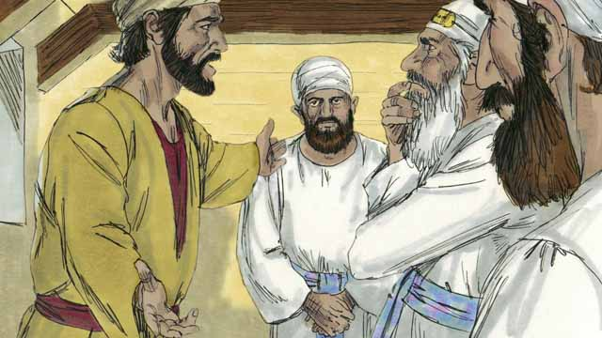
One of Jesus’ disciples was a man named Judas. Judas was in charge of the apostles’ moneybag, but he loved money and often stole money out of the bag. After Jesus and the disciples arrived in Jerusalem, Judas went to the Jewish leaders and offered to betray Jesus to them in exchange for money. He knew that the Jewish leaders denied that Jesus was the Messiah and that they were plotting to kill him.
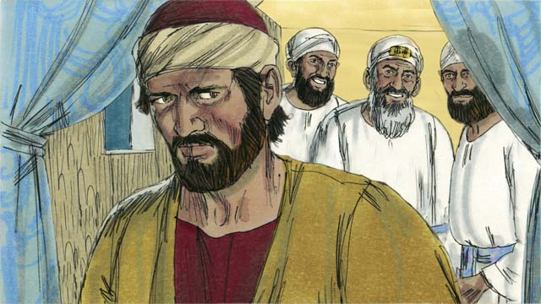
The Jewish leaders, led by the high priest, paid Judas thirty silver coins to betray Jesus. This happened just as the prophets had predicted. Judas agreed, took the money, and went away. He began looking for an opportunity to help them arrest Jesus.
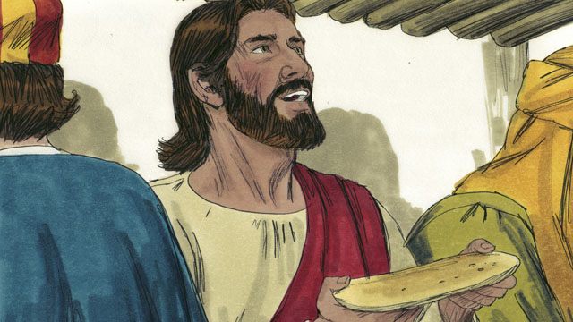
In Jerusalem, Jesus celebrated the Passover with his disciples. During the Passover meal, Jesus took some bread and broke it. He said, “Take and eat this. This is my body, which is given for you. Do this to remember me.” In this way, Jesus said that his body would be sacrificed for them.
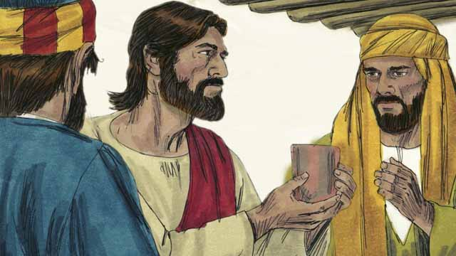
Then Jesus picked up a cup and said, “Drink this. It is my blood of the New Covenant that is poured out for the forgiveness of sins. Do this to remember me every time you drink it.”
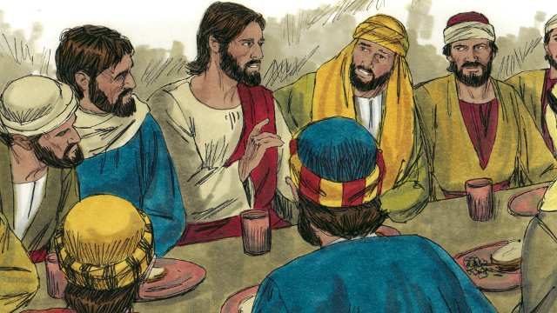
Then Jesus said to the disciples, “One of you will betray me.” The disciples were shocked, and asked who would do such a thing. Jesus said, “The person to whom I give this piece of bread is the betrayer.” Then he gave the bread to Judas.
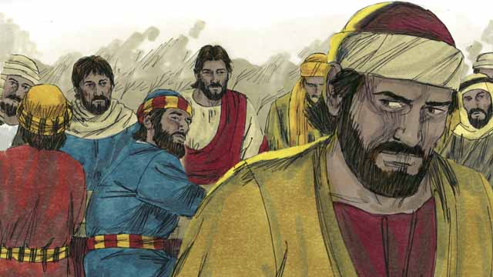
After Judas took the bread, Satan entered into him. Judas left and went to help the Jewish leaders arrest Jesus. It was nighttime.
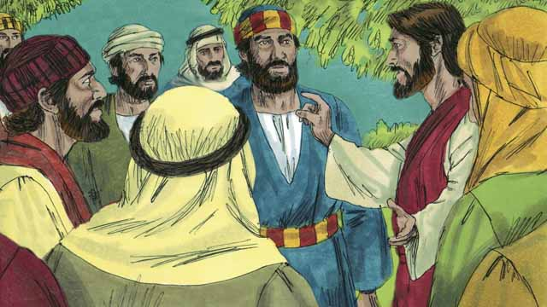
After the meal, Jesus and his disciples walked to the Mount of Olives. Jesus said, “You will all abandon me tonight. It is written, ‘I will strike the shepherd and all the sheep will be scattered.’”
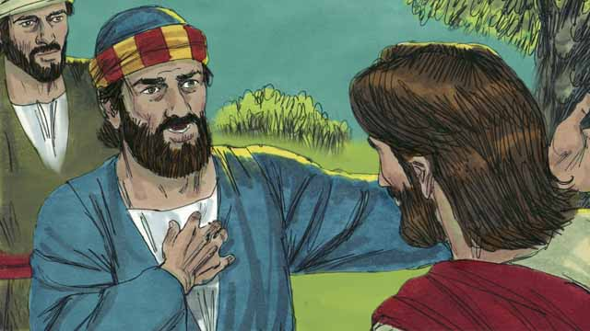
Peter replied, “Even if all the others abandon you, I will not!” Then Jesus said to Peter, “Satan wants to have all of you, but I have prayed for you, Peter, that your faith will not fail. Even so, tonight, before the rooster crows, you will deny that you even know me three times.”
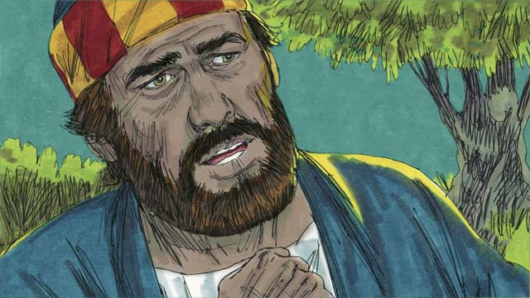
Peter then said to Jesus, “Even if I must die, I will never deny you!” All the other disciples said the same thing.
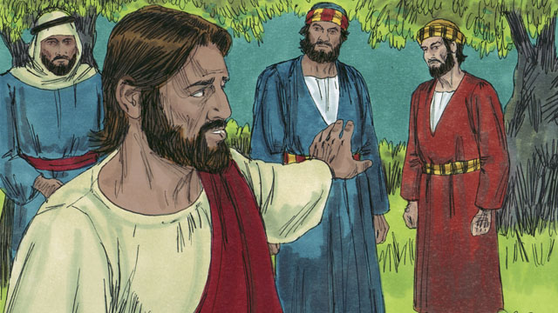
Then Jesus went with his disciples to a place called Gethsemane. Jesus told his disciples to pray that they would not enter into temptation. Then Jesus went to pray by himself.
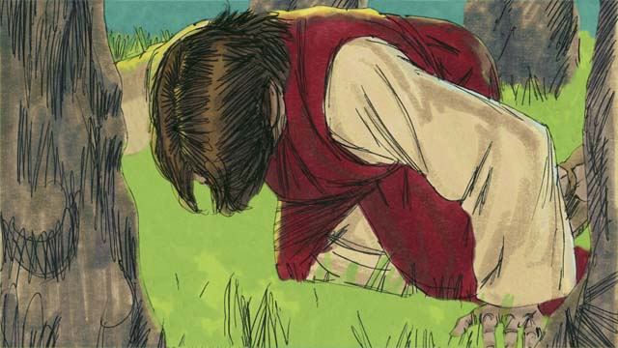
Jesus prayed three times, “My Father, if it is possible, please let me not have to drink this cup of suffering. But if there is no other way for people’s sins to be forgiven, then let your will be done.” Jesus was very troubled and his sweat was like drops of blood. God sent an angel to strengthen him.
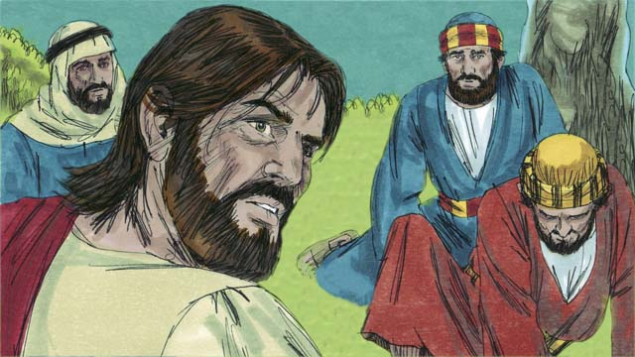
After each time of prayer, Jesus came back to his disciples, but they were asleep. When he returned the third time, Jesus said, “Wake up! My betrayer is here.”
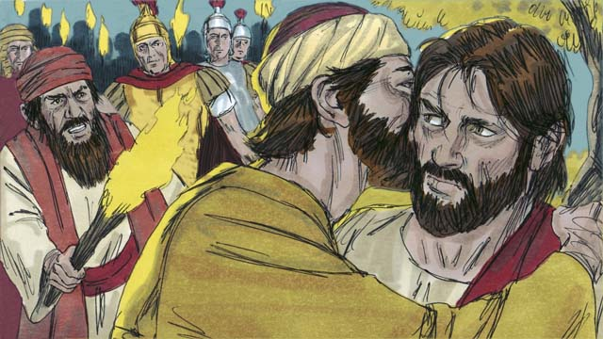
Judas came with the Jewish leaders, soldiers, and a large crowd. They were carrying swords and clubs. Judas came to Jesus and said, “Greetings, Teacher,” and kissed him. This was the sign for the Jewish leaders to know whom to arrest. Then Jesus said, “Judas, do you betray me with a kiss?”
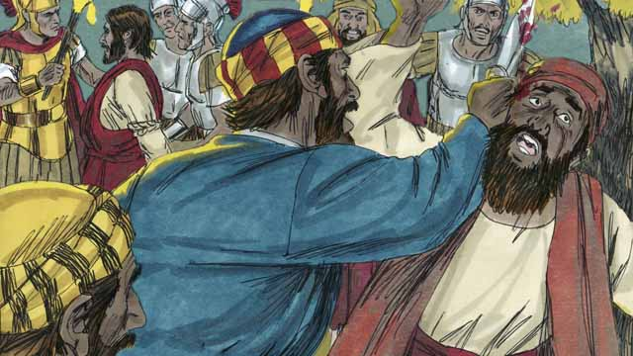
As the soldiers arrested Jesus, Peter pulled out his sword and cut off the ear of a servant of the high priest. Jesus said, “Put the sword away! I could ask the Father for an army of angels to defend me. But I must obey my Father.” Then Jesus healed the man’s ear. After Jesus was arrested, all the disciples ran away.
A Bible story from: Matthew 26:14-56; Mark 14:10-50; Luke 22:1-53; John 12:6; 18:1-11

39. Jesus Is Put on Trial
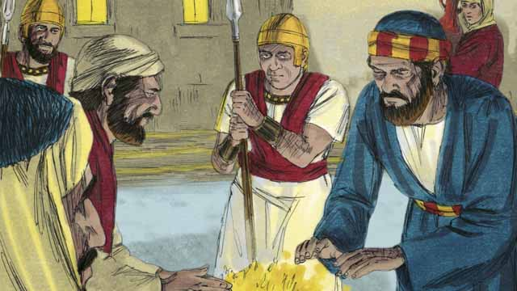
It was now the middle of the night. The soldiers led Jesus to the house of the high priest in order for the high priest to question him. Peter followed far behind them. When Jesus was taken into the house, Peter stayed outside and warmed himself by a fire.
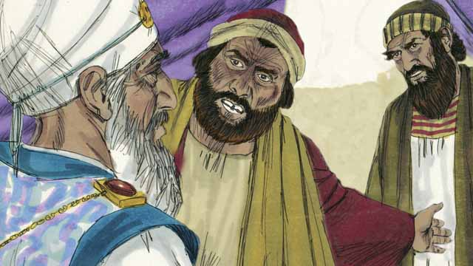
Inside the house, the Jewish leaders put Jesus on trial. They brought many false witnesses who lied about him. However, their statements did not agree with each other, so the Jewish leaders could not prove he was guilty of anything. Jesus did not say anything.
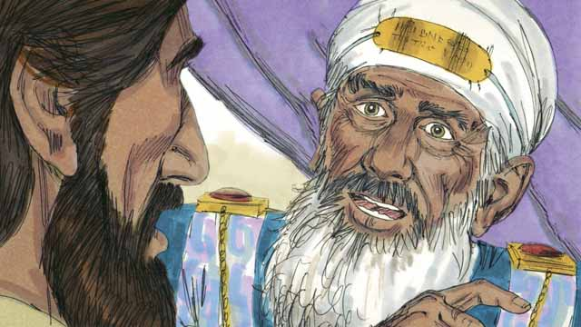
Finally, the high priest looked directly at Jesus and said, “Tell us, are you the Messiah, the Son of the living God?”
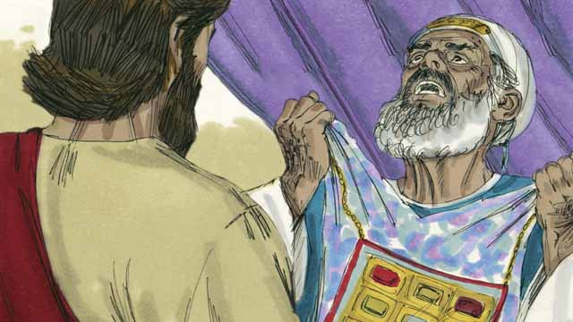
Jesus said, “I am, and you will see me seated with God and coming from heaven.” The high priest tore his clothes in anger and shouted to the other religious leaders, “We do not need any more witnesses! You have heard him say that he is the Son of God. What is your judgment?”
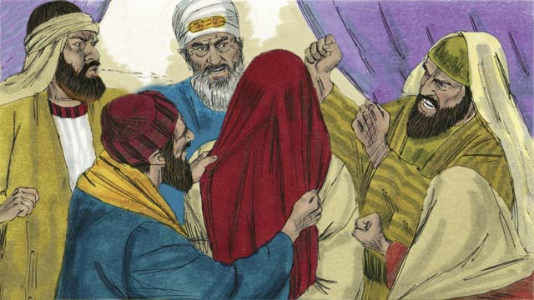
The Jewish leaders all answered the high priest, “He deserves to die!” Then they blindfolded Jesus, spit on him, hit him, and mocked him.
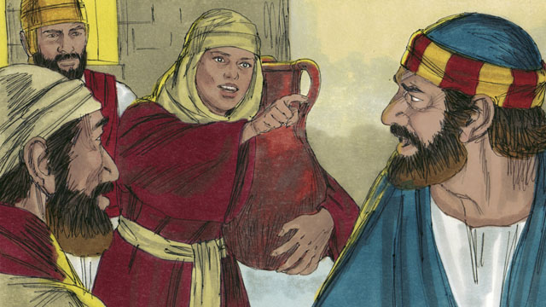
As Peter was waiting outside the house, a servant girl saw him and said to him, “You also were with Jesus!” Peter denied it. Later, another girl said the same thing, and Peter denied it again. Finally, the people said, “We know that you were with Jesus because you both are from Galilee.”
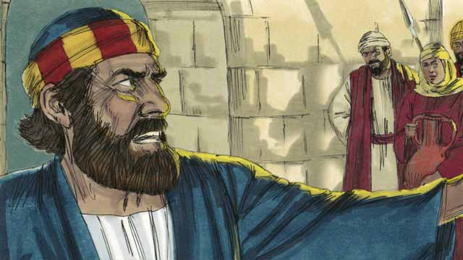
Then Peter vowed, saying, “May God curse me if I know this man!” Immediately, a rooster crowed, and Jesus turned around and looked at Peter.
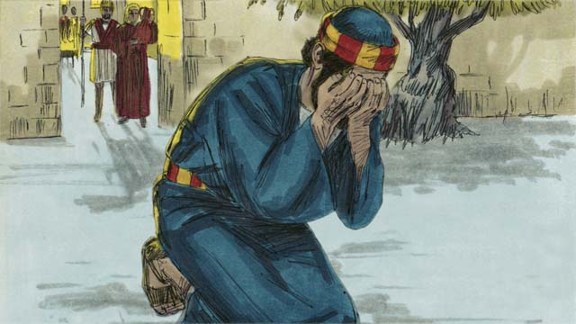
Peter went away and cried bitterly. Meanwhile, Judas, the betrayer, saw that the Jewish leaders had condemned Jesus to die. Judas became full of sorrow and went away and killed himself.
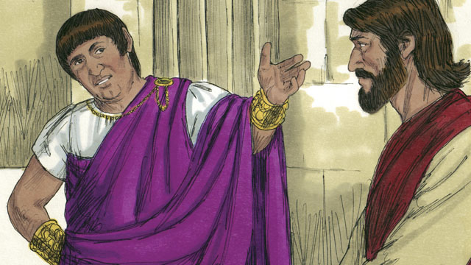
Early the next morning, the Jewish leaders brought Jesus to Pilate, the Roman governor. They hoped that Pilate would condemn Jesus as guilty and sentence him to be killed. Pilate asked Jesus, “Are you the king of the Jews?”
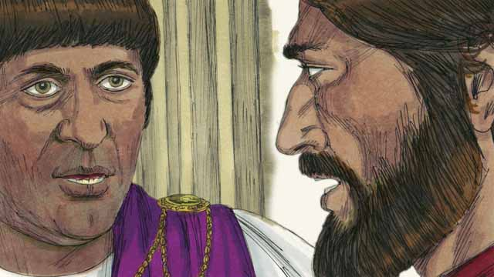
Jesus answered, “You have said so, but my kingdom is not an earthly kingdom. If it were, my servants would fight for me. I have come to earth to tell the truth about God. Everyone who loves the truth listens to me.” Pilate said, “What is truth?”
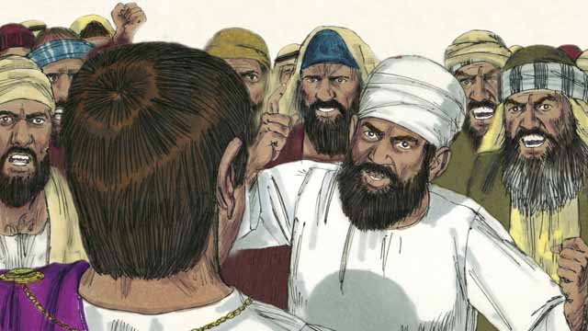
After speaking with Jesus, Pilate went out to the crowd and said, “I find no guilt in this man.” But the Jewish leaders and the crowd shouted, “Crucify him!” Pilate replied, “He is not guilty.” But they shouted even louder. Then Pilate said a third time, “He is not guilty!”
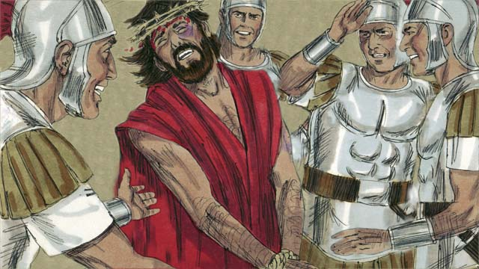
Pilate became afraid that the crowd would begin to riot, so he agreed to have his soldiers crucify Jesus. The Roman soldiers whipped Jesus and put a royal robe and a crown made of thorns on him. Then they mocked him by saying, “Look, the King of the Jews!”
A Bible story from: Matthew 26:57-27:26; Mark 14:53-15:15; Luke 22:54-23:25; John 18:12-19:16

40. Jesus Is Crucified
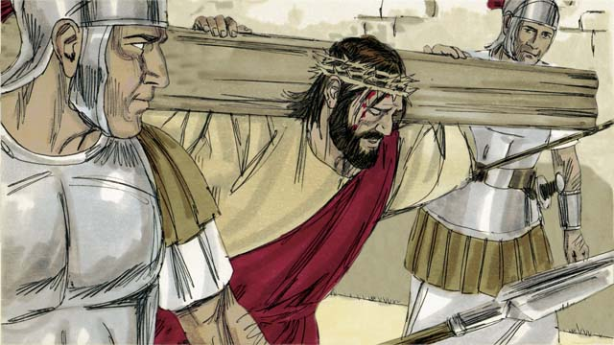
After the soldiers mocked Jesus, they led him away to crucify him. They made him carry the cross on which he would die.
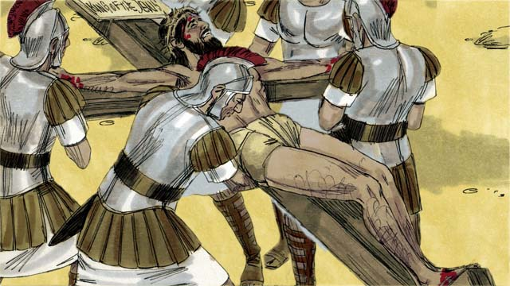
The soldiers brought Jesus to a place called “the Skull” and nailed his hands and feet to the cross. But Jesus said, “Father, forgive them, because they do not know what they are doing.” Pilate commanded that they write, “King of the Jews” on a sign and put it on the cross above Jesus’ head.
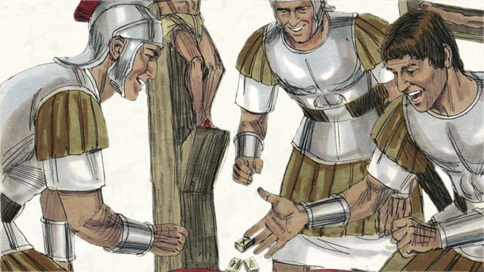
The soldiers gambled for Jesus’ clothing. When they did this, they fulfilled a prophecy that said, “They divided my garments among them, and gambled for my clothing.”
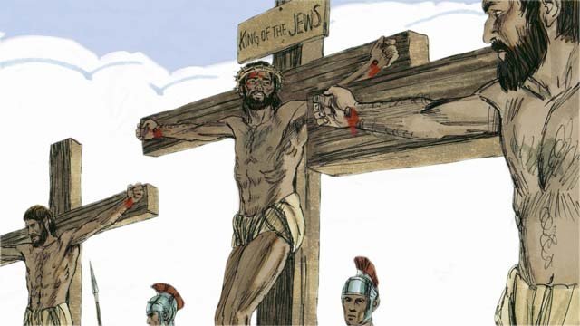
Jesus was crucified between two robbers. One of them mocked Jesus, but the other said, “Do you have no fear of God? We are guilty, but this man is innocent.” Then he said to Jesus, “Please remember me in your kingdom.” Jesus answered him, “Today, you will be with me in Paradise.”
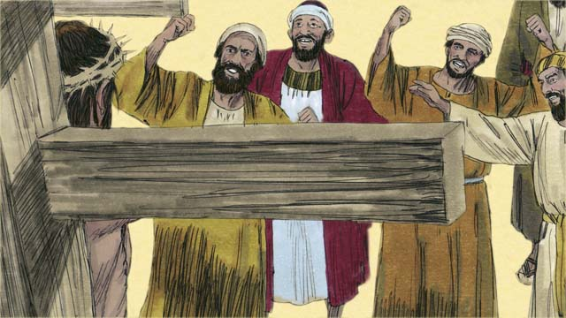
The Jewish leaders and the other people in the crowd mocked Jesus. They said to him, “If you are the Son of God, come down from the cross and save yourself! Then we will believe you.”
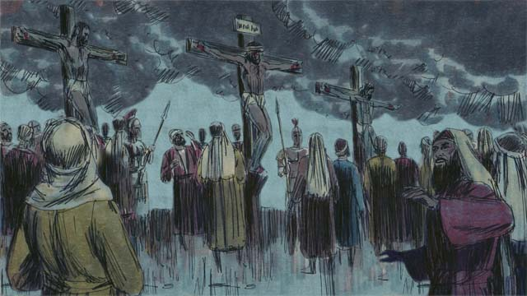
Then the sky over the whole region became completely dark, even though it was the middle of the day. It stayed dark from noon until 3:00 in the afternoon.
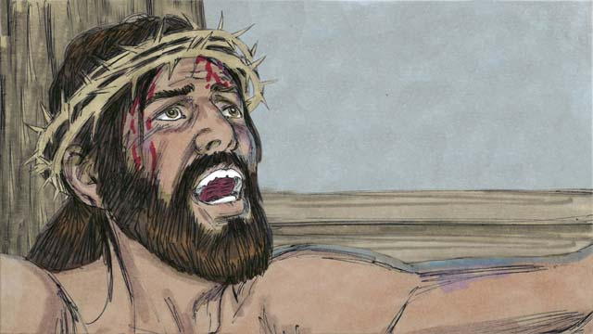
Then Jesus cried out, “It is finished! Father, I give my spirit into your hands.” Then he bowed his head and gave up his spirit. When he died, there was an earthquake and the large curtain that separated the people from the presence of God in the Temple was torn in two, from the top to the bottom.
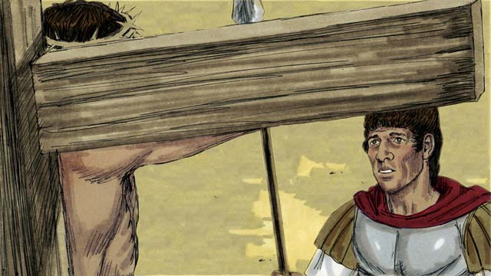
Through his death, Jesus opened a way for people to come to God. When the soldier guarding Jesus saw everything that had happened, he said, “Certainly, this man was innocent. He was the Son of God.”
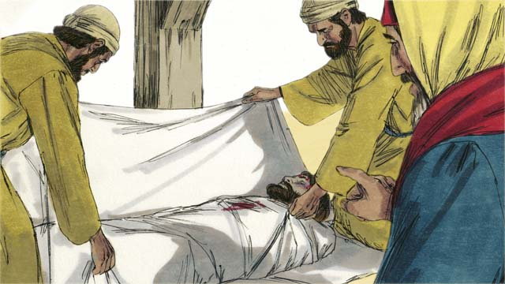
Then Joseph and Nicodemus, two Jewish leaders who believed Jesus was the Messiah, asked Pilate for Jesus’ body. They wrapped his body in cloth and placed it in a tomb cut out of rock. Then they rolled a large stone in front of the tomb to block the opening.
A Bible story from: Matthew 27:27-61; Mark 15:16-47; Luke 23:26-56; John 19:17-42

41. God Raises Jesus from the Dead
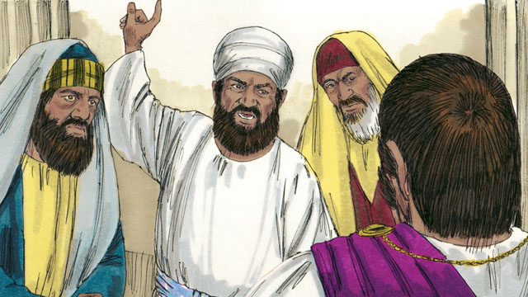
After the soldiers crucified Jesus, the unbelieving Jewish leaders said to Pilate, “That liar, Jesus, said he would rise from the dead after three days. Someone must guard the tomb to make sure that his disciples do not steal the body and then say he has risen from the dead.”
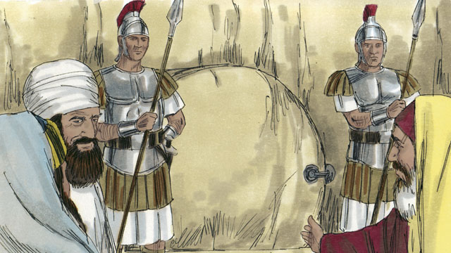
Pilate said, “Take some soldiers and make the tomb as secure as you can.” So they placed a seal on the stone at the entrance of the tomb and put the soldiers there to make sure no one could steal the body.
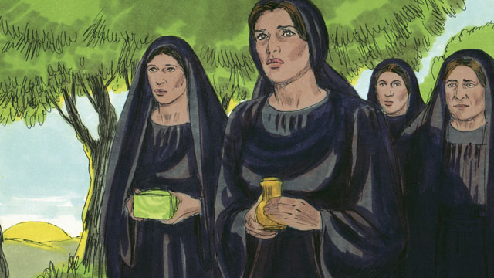
The day after Jesus was buried was a Sabbath day, and the Jews were not permitted to go to a tomb on that day. So very early on the morning after the Sabbath day, several women prepared to go to Jesus’ tomb to put more burial spices on his body.
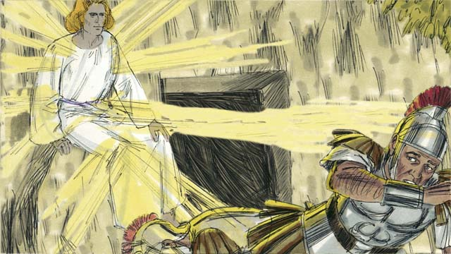
Suddenly, there was a great earthquake. An angel that shone as bright as lightning appeared from heaven. He rolled away the stone that was covering the entrance to the tomb and sat on it. The soldiers guarding the tomb were terrified and fell to the ground like dead men.
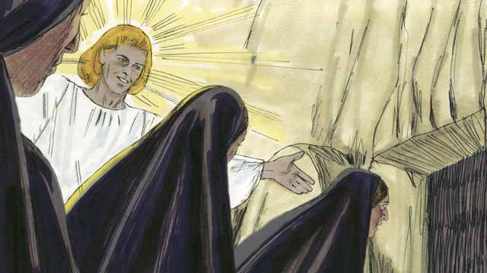
When the women arrived at the tomb, the angel told them, “Do not be afraid. Jesus is not here. He has risen from the dead, just like he said he would! Look in the tomb and see.” The women looked into the tomb and saw where Jesus’ body had been laid. His body was not there!
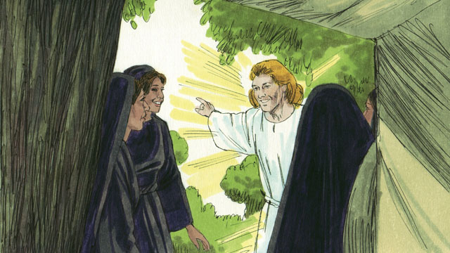
Then the angel told the women, “Go and tell the disciples, ‘Jesus has risen from the dead and he will go to Galilee ahead of you.’”
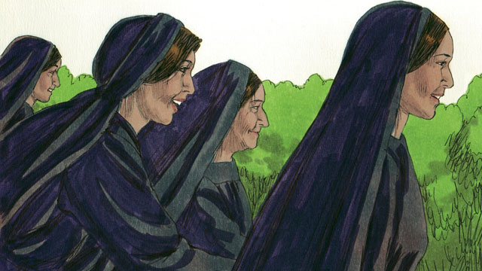
The women were full of fear and great joy. They ran to tell the disciples the good news.
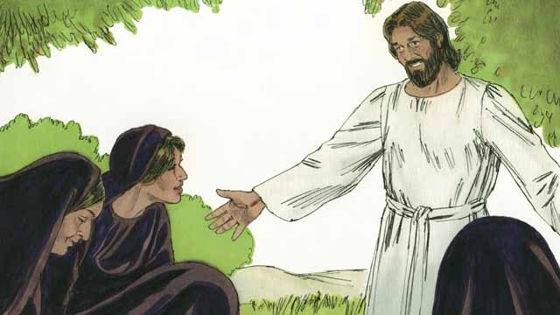
As the women were on their way to tell the disciples the good news, Jesus appeared to them, and they worshiped him. Jesus said, “Do not be afraid. Go and tell my disciples to go to Galilee. They will see me there.”
A Bible story from: Matthew 27:62-28:15; Mark 16:1-11; Luke 24:1-12; John 20:1-18

42. Jesus Returns to Heaven
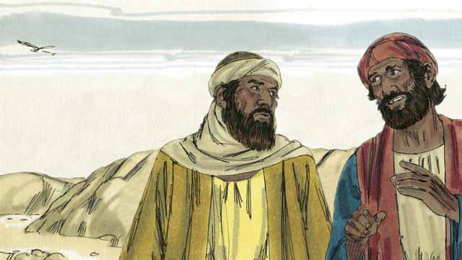
On the day that Jesus was raised from the dead, two of his disciples were going to a nearby town. As they walked, they talked about what had happened to Jesus. They had hoped that he was the Messiah, but then he was killed. Now the women said he was alive again. They did not know what to believe.
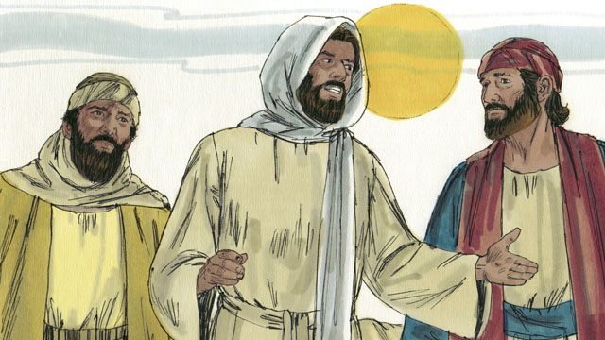
Jesus approached them and started walking with them, but they did not recognize him. He asked what they were talking about, and they told him about all the remarkable things that had happened concerning Jesus during the previous few days. They thought they were talking to a visitor who did not know what had happened in Jerusalem.
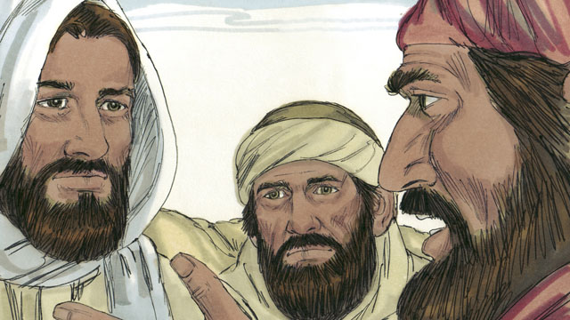
Then Jesus explained to them what God’s word said about the Messiah. He reminded them that the prophets said the Messiah would suffer and be killed, but would rise again on the third day. When they arrived at the town where the two men planned to stay, it was almost evening.
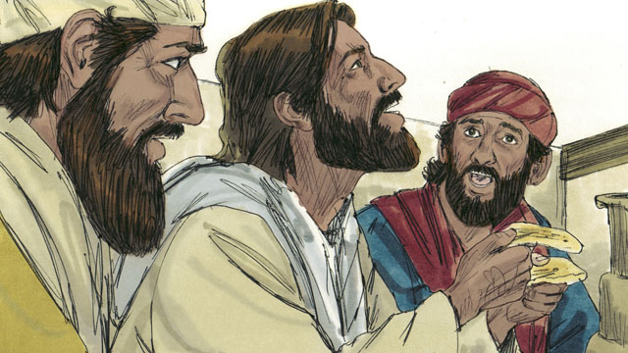
The two men invited Jesus to stay with them, so he did. When they were ready to eat the evening meal, Jesus picked up a loaf of bread, thanked God for it, and then broke it. Suddenly, they recognized that he was Jesus. But at that moment, he disappeared from their sight.
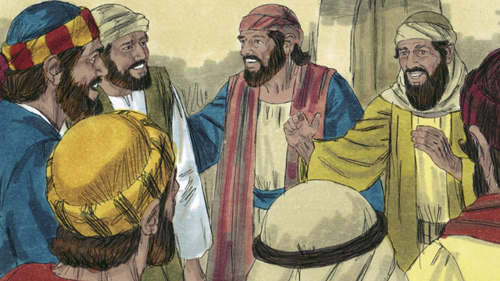
The two men said to each other, “That was Jesus! That is why our hearts were burning when he explained God’s word to us!” Immediately, they went back to Jerusalem. When they arrived, they told the disciples, “Jesus is alive! We have seen him!”
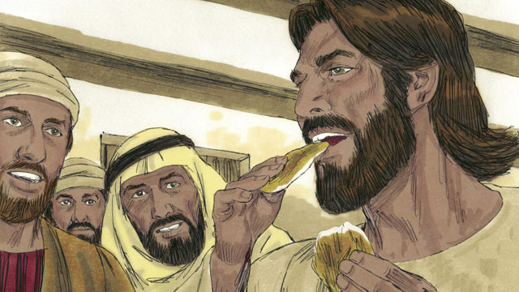
As the disciples were talking, Jesus suddenly appeared in the room with them and said, “Peace to you!” The disciples thought he was a ghost, but Jesus said, “Why are you afraid and doubting? Look at my hands and feet. Ghosts do not have bodies like I do.” To prove that he was not a ghost, he asked for something to eat. They gave him a piece of cooked fish, and he ate it.
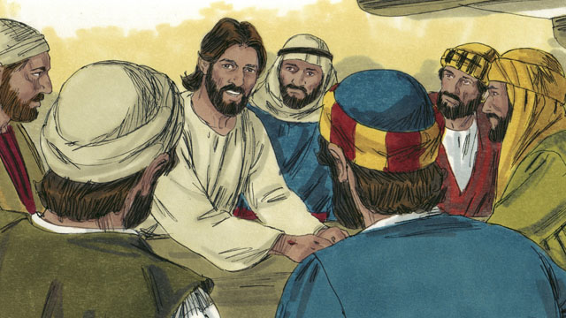
Jesus said, “I told you that everything written about me in God’s word must be fulfilled.” Then he opened their minds so that they could understand God’s word. He said, “It was written long ago that the Messiah would suffer, die, and rise from the dead on the third day.”
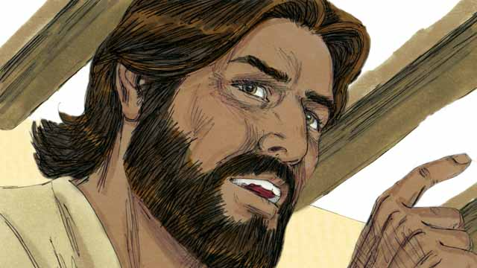
“It was also written in the scriptures that my disciples will proclaim that everyone should repent in order to receive forgiveness for their sins. They will do this starting in Jerusalem, and then go to all people groups everywhere. You are witnesses of these things.”
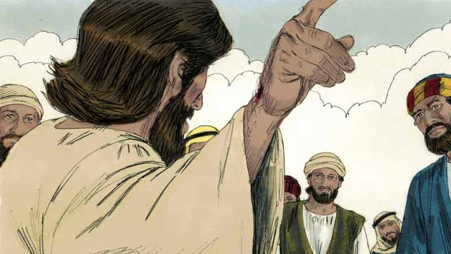
During the next forty days, Jesus appeared to his disciples many times. Once, he even appeared to more than 500 people at the same time! He proved to his disciples in many ways that he was alive, and he taught them about the kingdom of God.
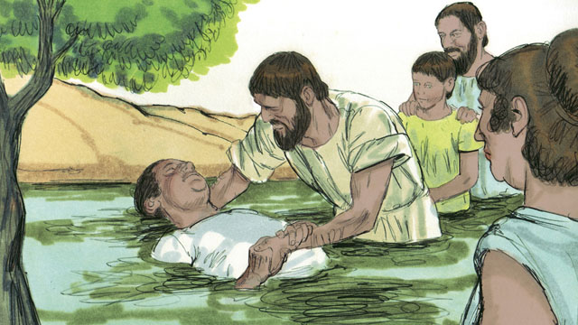
Jesus said to his disciples, “All authority in heaven and on earth has been given to me. So go, make disciples of all people groups by baptizing them in the name of the Father, the Son, and the Holy Spirit, and by teaching them to obey everything I have commanded you. Remember, I will be with you always.”
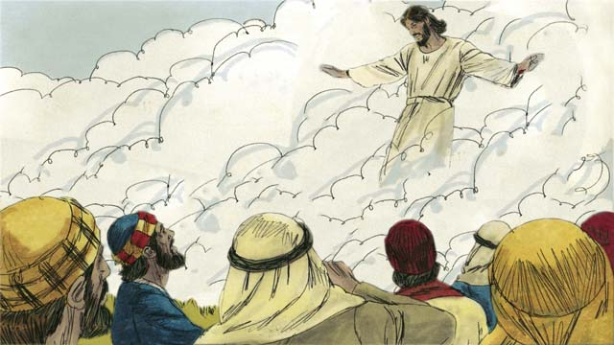
Forty days after Jesus rose from the dead, he told his disciples, “Stay in Jerusalem until my Father gives you power when the Holy Spirit comes on you.” Then Jesus went up to heaven, and a cloud hid him from their sight. Jesus sat down at the right hand of God to rule over all things.
A Bible story from: Matthew 28:16-20; Mark 16:12-20; Luke 24:13-53; John 20:19-23; Acts 1:1-11

43. The Church Begins
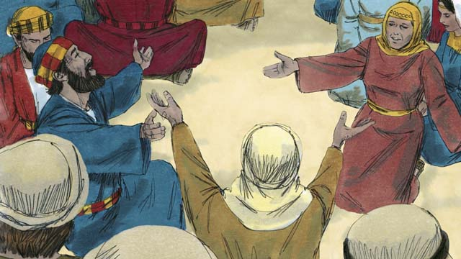
After Jesus returned to heaven, the disciples stayed in Jerusalem as Jesus had commanded them to do. The believers there constantly gathered together to pray.
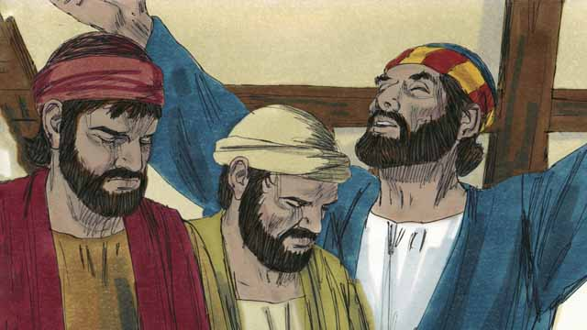
Every year, 50 days after the Passover, the Jews celebrated an important day called Pentecost. Pentecost was a time when the Jews celebrated the harvest. Jews came from all over the world to Jerusalem to celebrate Pentecost together. This year, the time for Pentecost came about a week after Jesus had gone back to heaven.
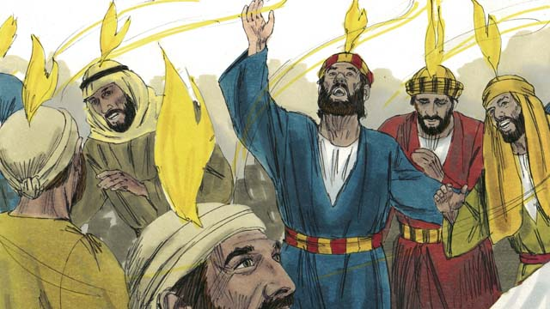
While the believers were all together, suddenly the house where they were was filled with a sound like a strong wind. Then something that looked like flames of fire appeared over the heads of all the believers. They were all filled with the Holy Spirit and they began to speak in other languages.
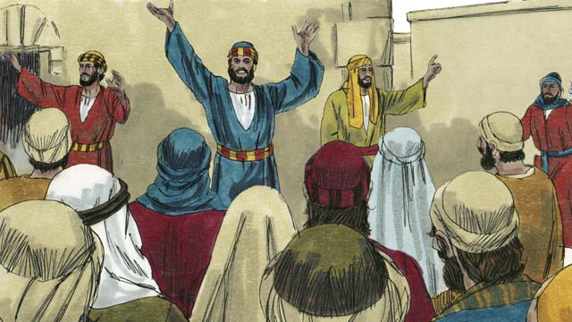
When the people in Jerusalem heard the noise, a crowd came to see what was happening. When the people heard the believers proclaiming the wonderful works of God, they were astonished that they were hearing these things in their own native languages.
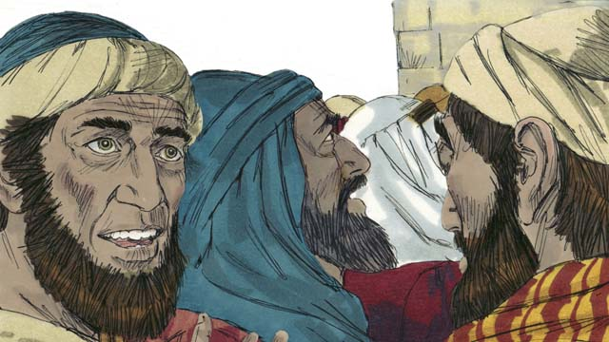
Some of the people accused the disciples of being drunk. But Peter stood up and said to them, “Listen to me! These people are not drunk! This fulfills the prophecy made by the prophet Joel in which God said, ‘In the last days, I will pour out my Spirit.’”
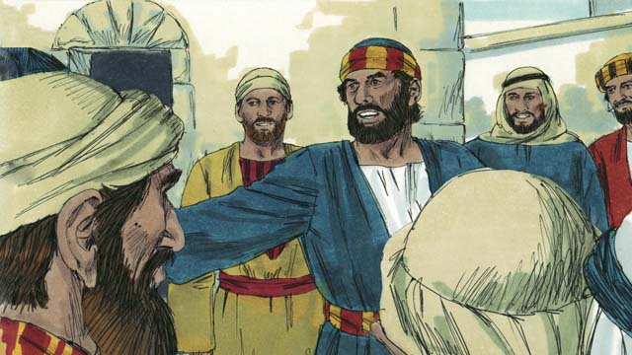
“Men of Israel, Jesus was a man who did many mighty signs and wonders by the power of God, as you have seen and already know. But you crucified him!”
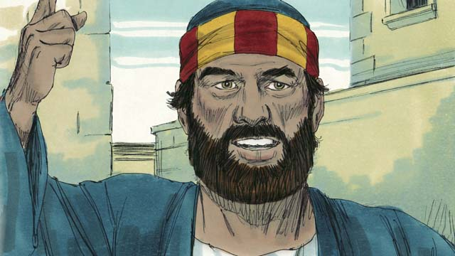
“Although Jesus died, God raised him from the dead. This fulfills the prophecy which says, ‘You will not let your Holy One rot in the grave.’ We are witnesses to the fact that God raised Jesus to life again.”
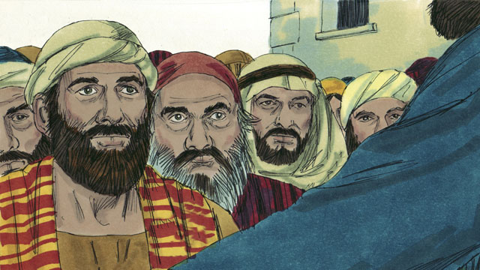
“Jesus is now exalted to the right hand of God the Father. And Jesus has sent the Holy Spirit just as he promised he would do. The Holy Spirit is causing the things that you are now seeing and hearing.”
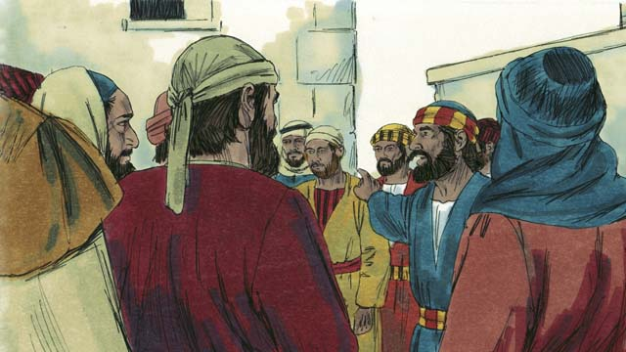
“You crucified this man, Jesus. But know for certain that God has caused Jesus to become both Lord and Messiah!”
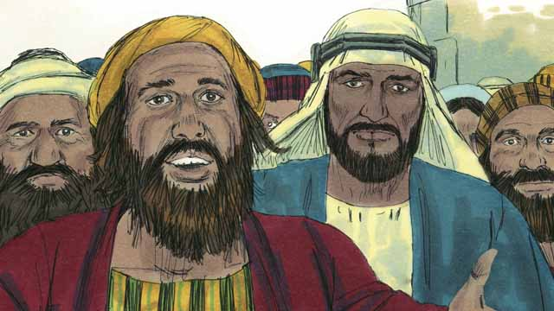
The people listening to Peter were deeply moved by the things that he said. So they asked Peter and the disciples, “Brothers, what should we do?”
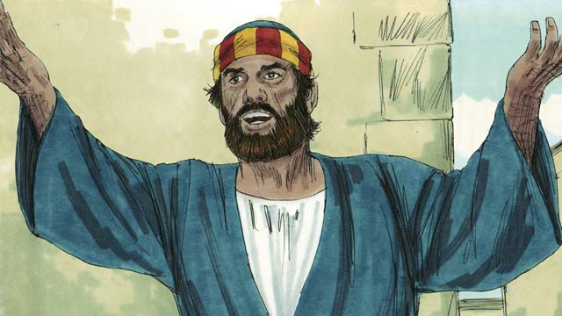
Peter answered them, “Every one of you should repent and be baptized in the name of Jesus Christ so that God will forgive your sins. Then he will also give you the gift of the Holy Spirit.”
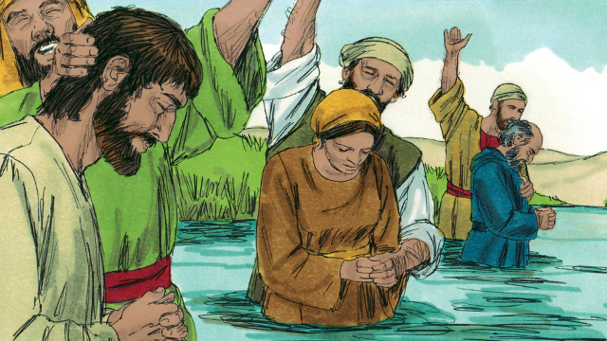
About 3,000 people believed what Peter said and became disciples of Jesus. They were baptized and became part of the church at Jerusalem.
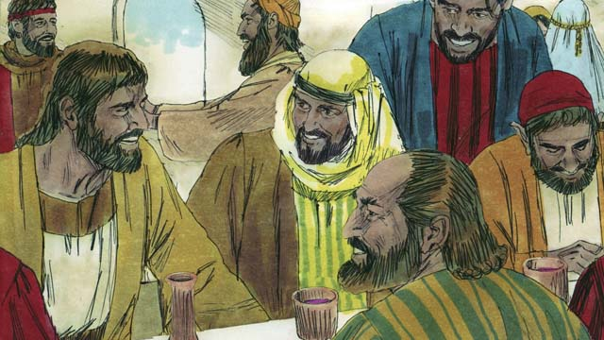
The disciples continually listened to the teaching of the apostles, spent time together, ate together, and prayed with each other. They enjoyed praising God together and they shared everything they had with each other. Everyone thought well of them. Every day, more people became believers.
A Bible story from: Acts 2

44. Peter and John Heal a Beggar
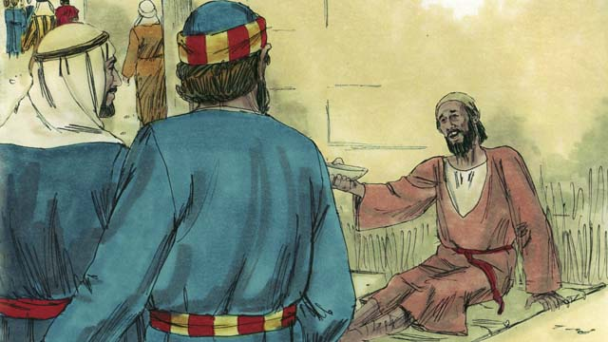
One day, Peter and John were going to the Temple. As they approached the Temple gate, they saw a crippled man who was begging for money.
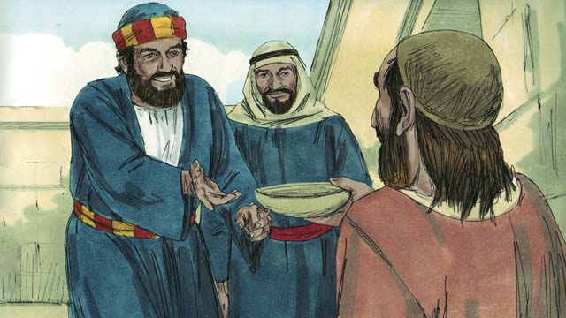
Peter looked at the lame man and said, “I do not have any money to give you. But I will give you what I do have. In the name of Jesus, get up and walk!”
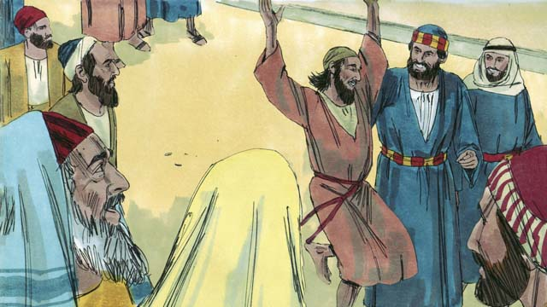
Immediately, God healed the lame man, and he began to walk and jump around, and to praise God. The people in the courtyard of the Temple were amazed.
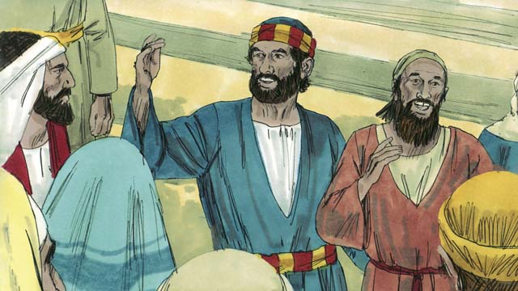
A crowd of people quickly came to see the man who was healed. Peter said to them, “Why are you amazed that this man is healed? We did not heal him through our own power or goodness. Rather, it is the power of Jesus and the faith that Jesus gives that healed this man.”
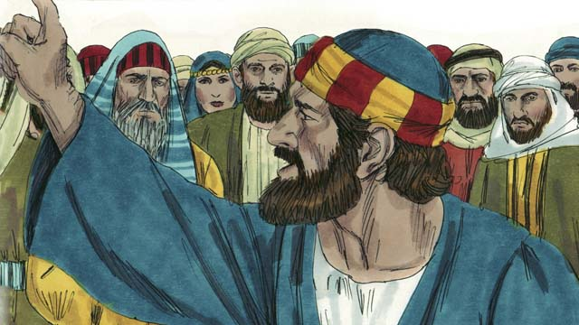
“You are the ones who told the Roman governor to kill Jesus. You killed the author of life, but God raised him from the dead. Although you did not understand what you were doing, God used your actions to fulfill the prophecies that the Messiah would suffer and die. So now, repent and turn to God so that your sins will be washed away.”
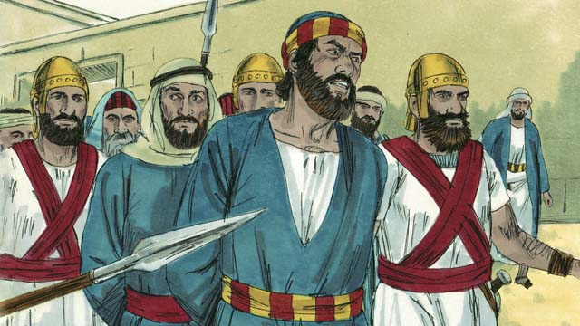
The leaders of the Temple were very upset by what Peter and John were saying. So they arrested them and put them into prison. But many of the people believed Peter’s message, and the number of men who believed in Jesus grew to about 5,000.
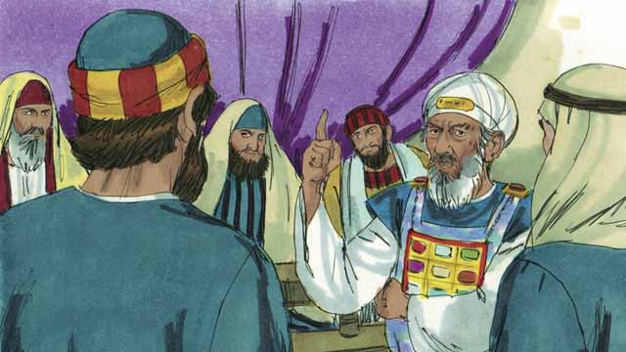
The next day, the Jewish leaders brought Peter and John to the high priest and the other religious leaders. They asked Peter and John, “By what power did you heal this crippled man?”
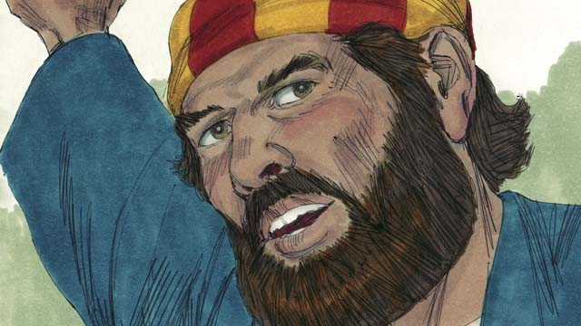
Peter answered them, “This man stands before you healed by the power of Jesus the Messiah. You crucified Jesus, but God raised him to life again! You rejected him, but there is no other way to be saved except through the power of Jesus!”
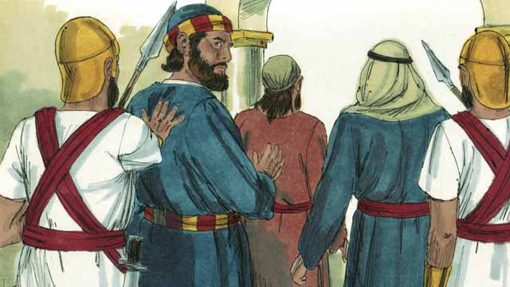
The leaders were shocked that Peter and John spoke so boldly because they could see that these men were ordinary men who were uneducated. But then they remembered that these men had been with Jesus. After they threatened Peter and John, they let them go.
A Bible story from: Acts 3:1-4:22

45. Philip and the Ethiopian Official
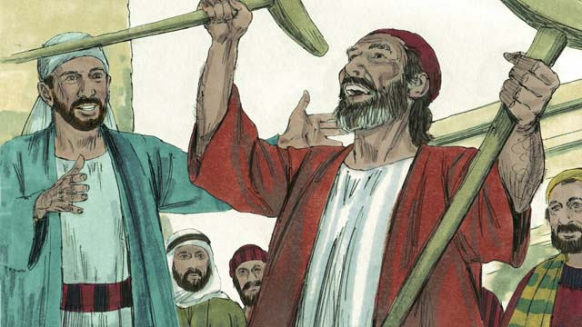
One of the leaders in the early Church was a man named Stephen. He had a good reputation and was full of the Holy Spirit and of wisdom. Stephen did many miracles and reasoned persuasively that people should believe in Jesus.
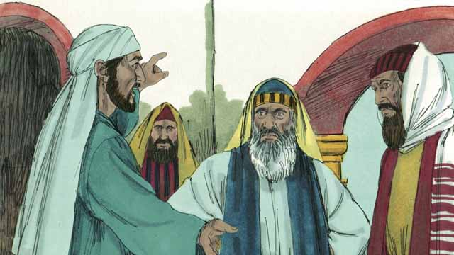
One day, when Stephen was teaching about Jesus, some Jews who did not believe in Jesus began to argue with Stephen. They became very angry and lied about Stephen to the religious leaders. They said, “We heard him speak evil things about Moses and God!” So the religious leaders arrested Stephen and brought him to the high priest and the other leaders of the Jews, where more false witnesses lied about Stephen.
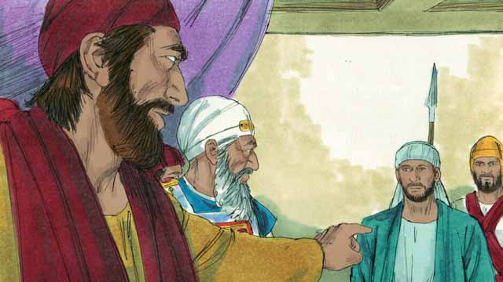
The high priest asked Stephen, “Are these things true?” Stephen replied by reminding them of many of the great things God had done from the time of Abraham to the time of Jesus, and how God’s people continually disobeyed him. Then he said, “You stubborn and rebellious people always reject the Holy Spirit, just as your ancestors always rejected God and killed his prophets. But you did something worse than they did! You killed the Messiah!”
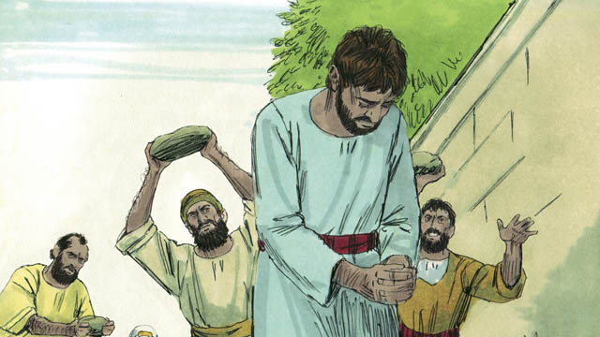
When the religious leaders heard this, they were so angry that they covered their ears and yelled loudly. They dragged Stephen out of the city and threw stones at him in order to kill him.
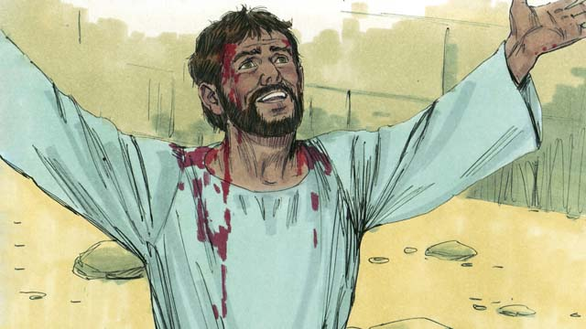
As Stephen was dying, he cried out, “Jesus, receive my spirit.” Then he fell to his knees and cried out again, “Master, do not count this sin against them.” Then he died.
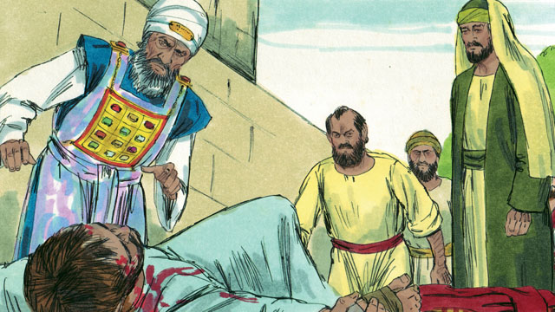
A young man named Saul agreed with the people who killed Stephen and guarded their robes while they threw stones at him. That day, many people in Jerusalem started persecuting the followers of Jesus, so the believers fled to other places. But in spite of this, they preached about Jesus everywhere they went.
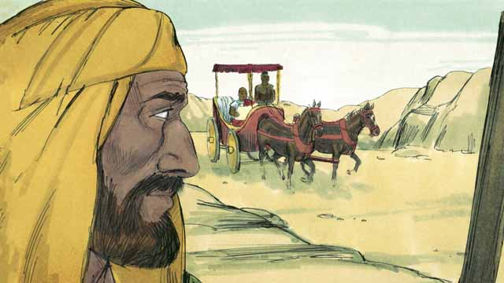
A disciple of Jesus’ named Philip was one of the believers who fled from Jerusalem during the persecution. He went to Samaria where he preached about Jesus and many people were saved. Then one day, an angel from God told Philip to go to a certain road in the desert. As he walked along the road, Philip saw an important official from Ethiopia riding in his chariot. The Holy Spirit told Philip to go and talk to this man.
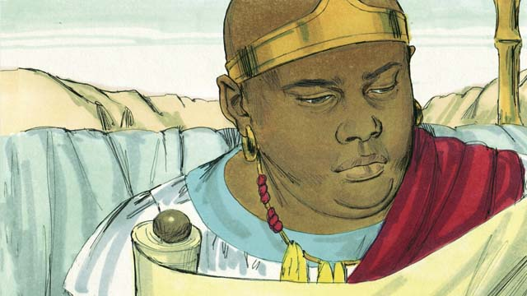
When Philip approached the chariot, he heard the Ethiopian reading from what the prophet Isaiah wrote. The man read, “They led him like a lamb to be killed, and as a lamb is silent, he did not say a word. They treated him unfairly and did not respect him. They took his life away from him.”
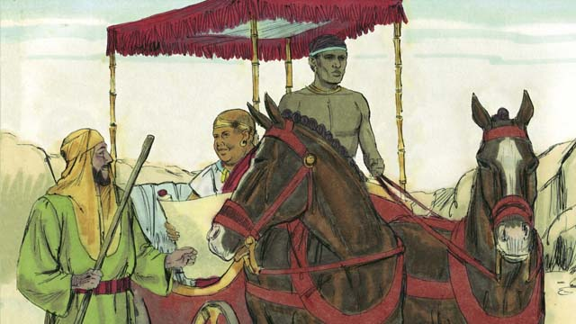
Philip asked the Ethiopian, “Do you understand what you are reading?” The Ethiopian replied, “No. I cannot understand it unless someone explains it to me. Please come and sit next to me. Was Isaiah writing about himself or someone else?”
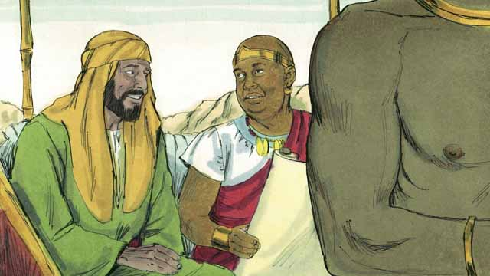
Philip explained to the Ethiopian man that Isaiah was writing about Jesus. Philip also used other scriptures to tell him the good news about Jesus.
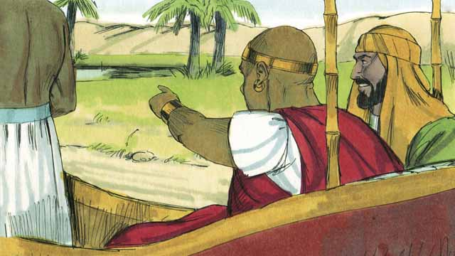
As Philip and the Ethiopian traveled, they came to some water. The Ethiopian said, “Look! There is some water! May I be baptized?” And he told the driver to stop the chariot.
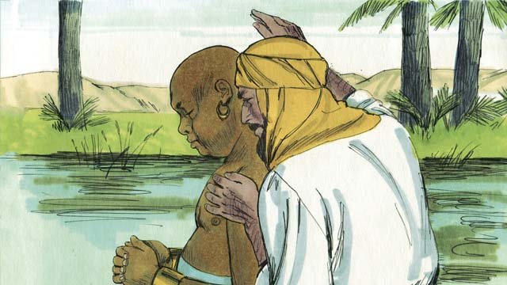
So they went down into the water, and Philip baptized the Ethiopian. After they came up out of the water, the Holy Spirit suddenly carried Philip away to another place where he continued telling people about Jesus.
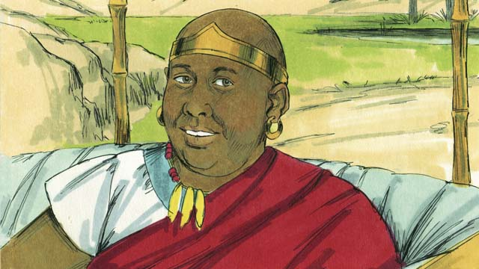
The Ethiopian continued traveling toward his home, happy that he knew Jesus.
A Bible story from: Acts 6:8-8:5; 8:26-40

46. Paul Becomes a Christian
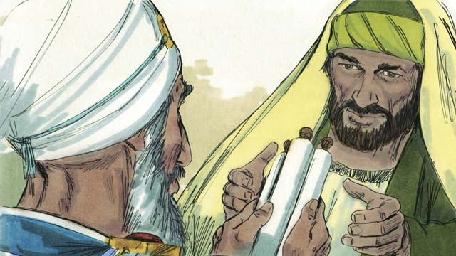
Saul was the young man who guarded the robes of the men who killed Stephen. He did not believe in Jesus, and so he persecuted the believers. He went from house to house in Jerusalem to arrest both men and women and to put them in prison. The high priest gave Saul permission to go to the city of Damascus to arrest Christians there and to bring them back to Jerusalem.
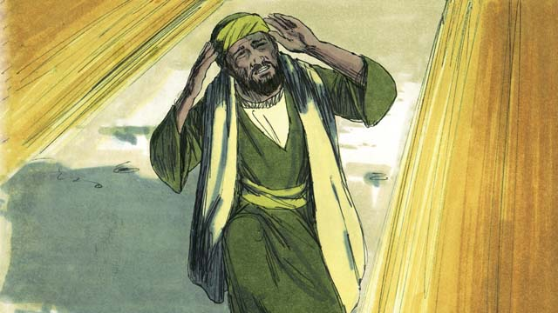
While Saul was on his way to Damascus, a bright light from heaven shone all around him, and he fell to the ground. Saul heard someone say, “Saul! Saul! Why do you persecute me?” Saul asked, “Who are you, Master?” Jesus replied to him, “I am Jesus. You are persecuting me!”
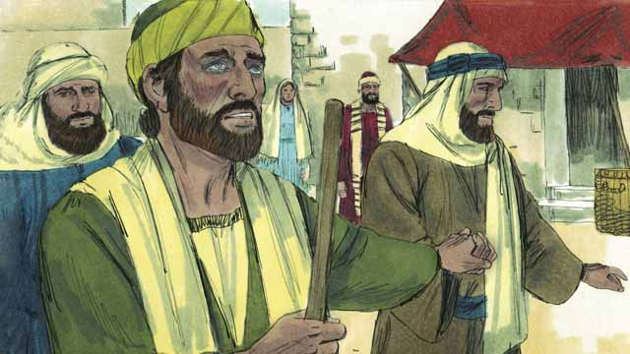
When Saul got up, he could not see. His friends had to lead him into Damascus. Saul did not eat or drink anything for three days.
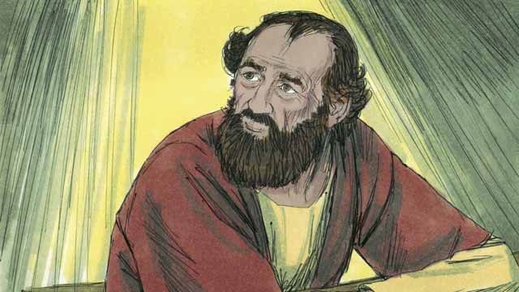
There was a disciple in Damascus named Ananias. God said to him, “Go to the house where Saul is staying. Place your hands on him so that he can see again.” But Ananias said, “Master, I have heard how this man has persecuted the believers.” God answered him, “Go! I have chosen him to declare my name to the Jews and to people from other people groups. He will suffer many things for my name.”
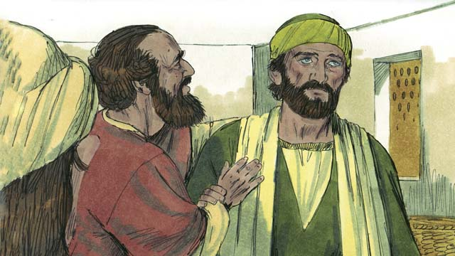
So Ananias went to Saul, placed his hands on him, and said, “Jesus, who appeared to you on your way here, sent me to you so that you can regain your sight and be filled with the Holy Spirit.” Saul immediately was able to see again, and Ananias baptized him. Then Saul ate some food and his strength returned.
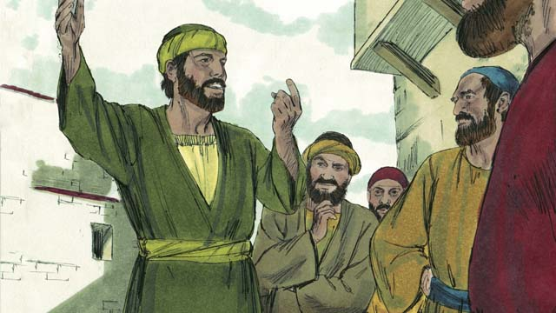
Right away, Saul began preaching to the Jews in Damascus, saying, “Jesus is the Son of God!” The Jews were amazed that the man who had tried to destroy the believers now also believed in Jesus! Saul reasoned with the Jews, proving that Jesus was the Messiah.
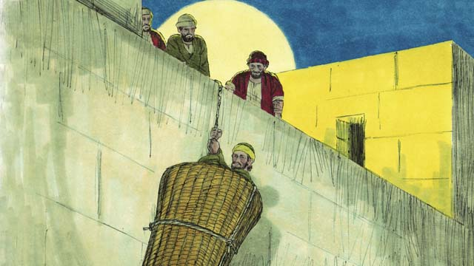
After many days, the Jews made a plan to kill Saul. They sent people to watch for him at the city gates in order to kill him. But Saul heard about the plan, and his friends helped him escape. One night they lowered him over the city wall in a basket. After Saul escaped from Damascus, he continued to preach about Jesus.
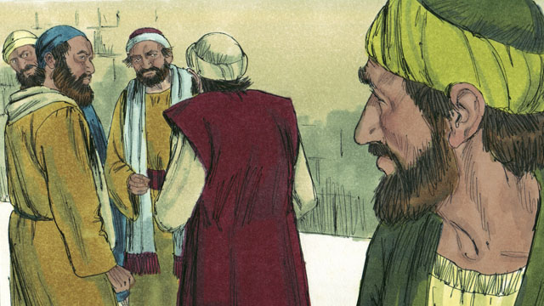
Saul went to Jerusalem to meet with the disciples, but they were afraid of him. Then a believer named Barnabas took Saul to the apostles and told them how Saul had preached boldly in Damascus. After that, the disciples accepted Saul.
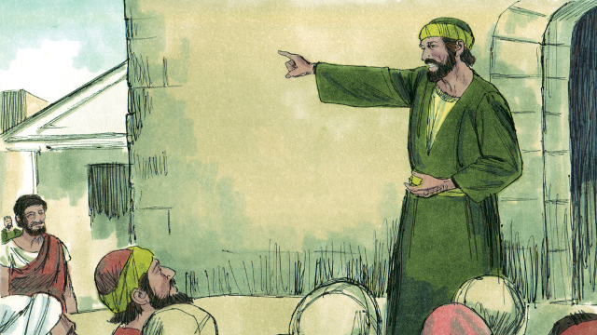
Some believers who fled from the persecution in Jerusalem went far away to the city of Antioch and preached about Jesus. Most of the people in Antioch were not Jews, but for the first time, very many of them also became believers. Barnabas and Saul went there to teach these new believers more about Jesus and to strengthen the church. It was at Antioch that believers in Jesus were first called “Christians.”
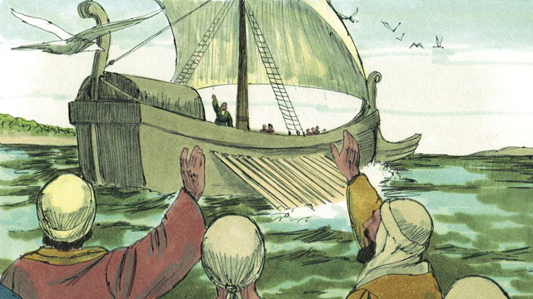
One day, while the Christians at Antioch were fasting and praying, the Holy Spirit said to them, “Set apart for me Barnabas and Saul to do the work I have called them to do.” So the church in Antioch prayed for Barnabas and Saul and placed their hands on them. Then they sent them out to preach the good news about Jesus in many other places. Barnabas and Saul taught people from different people groups, and many people believed in Jesus.
A Bible story from: Acts 8:3; 9:1-31; 11:19-26; 13:1-3

47. Paul and Silas in Philippi
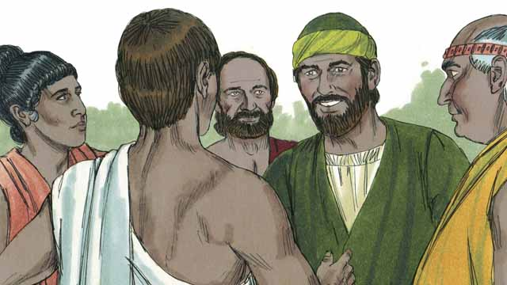
As Saul traveled throughout the Roman Empire, he began to use his Roman name, “Paul.” One day, Paul and his friend Silas went to the town of Philippi to proclaim the good news about Jesus. They went to a place by the river outside the city where people gathered to pray. There they met a woman named Lydia who was a merchant. She loved and worshiped God.
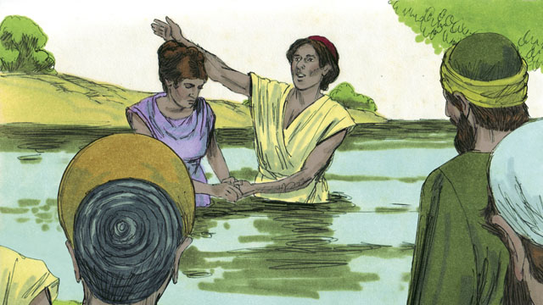
God opened Lydia’s heart to believe the message about Jesus, and she and her family were baptized. She invited Paul and Silas to stay at her house, so they stayed with her and her family.
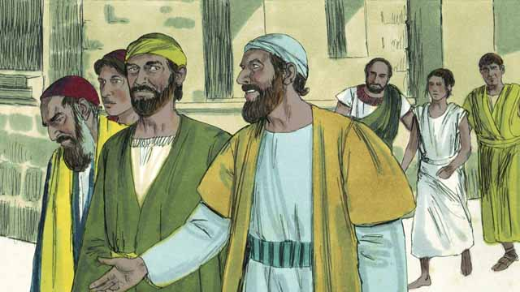
Paul and Silas often met with people at the place of prayer. Every day as they walked there, a slave girl possessed by a demon followed them. By means of this demon she predicted the future for people, so she made a lot of money for her masters as a fortuneteller.
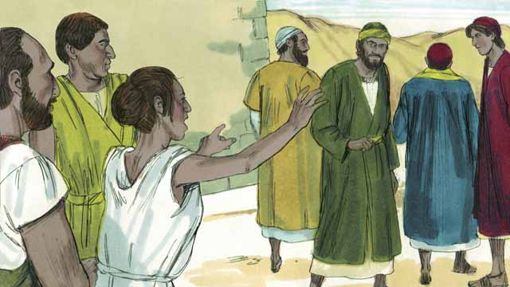
The slave girl kept yelling as they walked, “These men are servants of the Most High God. They are telling you the way to be saved!” She did this so often that Paul became annoyed.
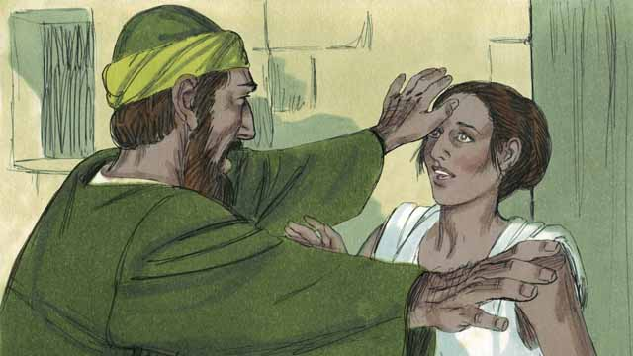
Finally one day when the slave girl started yelling, Paul turned to her and said to the demon that was in her, “In the name of Jesus, come out of her.” Right away the demon left her.
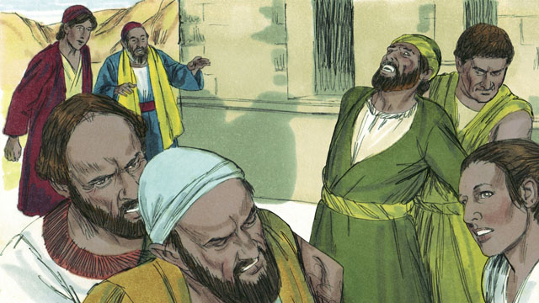
The men who owned the slave girl became very angry! They realized that without the demon, the slave girl could not tell people the future. This meant that people would no longer pay her owners money so that she would tell them what would happen to them.
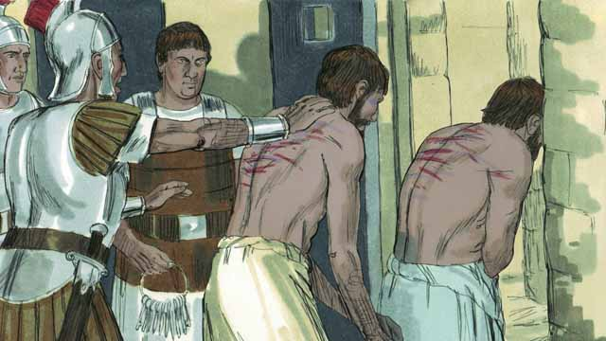
So the owners of the slave girl took Paul and Silas to the Roman authorities, who beat them and threw them into jail.
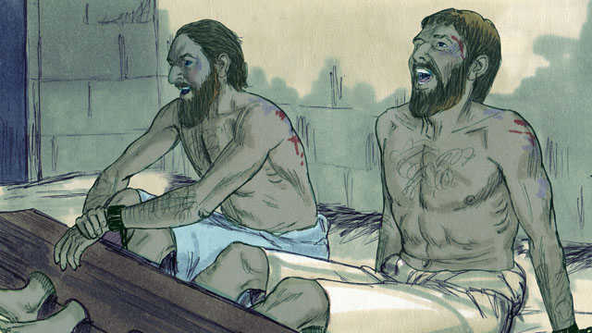
They put Paul and Silas in the most secure part of the prison and even locked up their feet. Yet in the middle of the night, they were singing songs of praise to God.
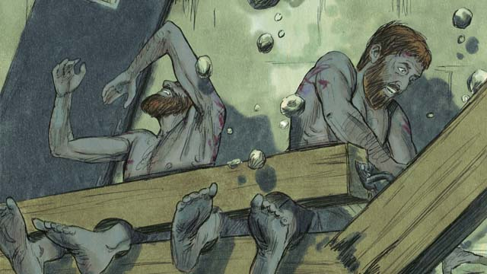
Suddenly, there was a violent earthquake! All the prison doors flew open, and the chains of all the prisoners fell off.
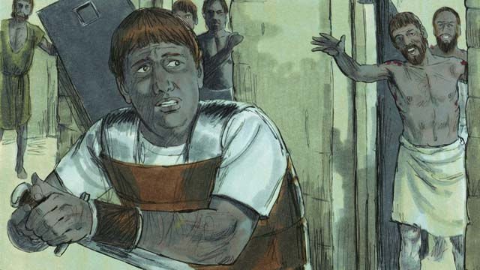
The jailer woke up, and when he saw that the prison doors were open, he was terrified! He thought all the prisoners had escaped, so he planned to kill himself. (He knew the Roman authorities would kill him if he allowed the prisoners to escape.) But Paul saw him and yelled, “Stop! Do not hurt yourself. We are all here.”
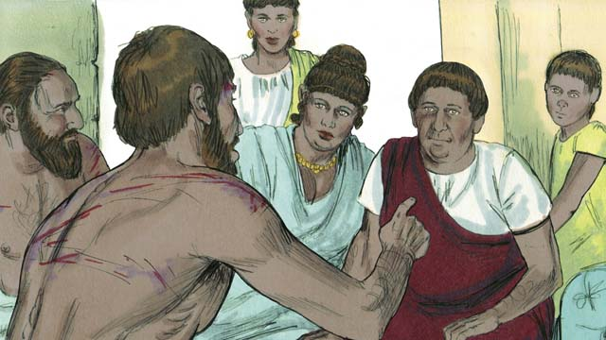
The jailer trembled as he came to Paul and Silas and asked, “What must I do to be saved?” Paul answered, “Believe in Jesus, the Master, and you and your family will be saved.” Then the jailer took Paul and Silas into his home and washed their wounds. Paul preached the good news about Jesus to everyone in his house.
The jailer and his whole family believed in Jesus and were baptized. Then the jailer gave Paul and Silas a meal and they rejoiced together.
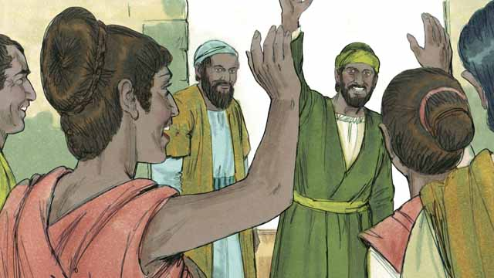
The next day the leaders of the city released Paul and Silas from prison and asked them to leave Philippi. Paul and Silas visited Lydia and some other friends and then left the city. The good news about Jesus kept spreading, and the Church kept growing.
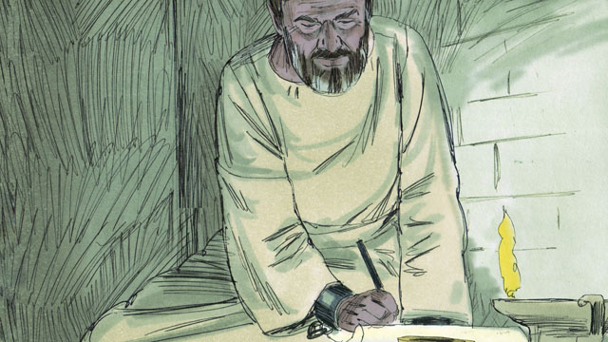
Paul and other Christian leaders traveled to many cities, preaching and teaching people the good news about Jesus. They also wrote many letters to encourage and teach the believers in the churches. Some of these letters became books of the Bible.
A Bible story from: Acts 16:11-40

48. Jesus Is the Promised Messiah
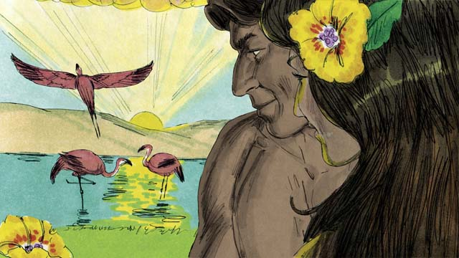
When God created the world, everything was perfect. There was no sin. Adam and Eve loved each other, and they loved God. There was no sickness or death. This was the way God wanted the world to be.

Satan spoke through the snake in the garden in order to deceive Eve. Then she and Adam sinned against God. Because they sinned, everyone on earth gets sick and everyone dies.
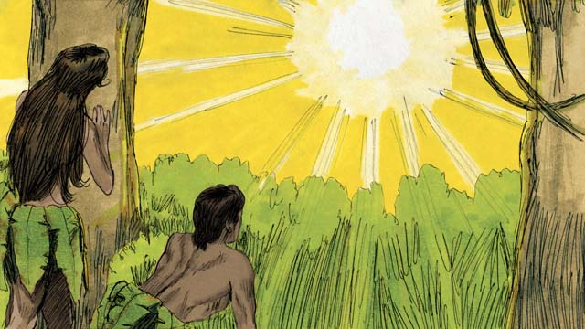
Because Adam and Eve sinned, something even more terrible happened. They became enemies of God. As a result, every person since then has been born with a sinful nature and is also an enemy of God. The relationship between God and people was broken by sin. But God had a plan to restore that relationship.
God promised that one of Eve’s descendants would crush Satan’s head, and Satan would wound his heel. This meant that Satan would kill the Messiah, but God would raise him to life again, and then the Messiah will crush the power of Satan forever. Many years later, God revealed that Jesus is the Messiah.
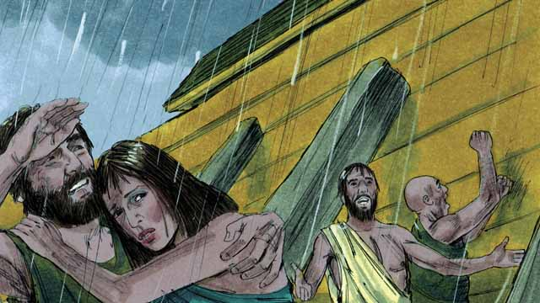
When God destroyed the whole earth by the flood, he provided the boat to save the people who believed in him. In the same way, everyone deserves to be destroyed because of their sins, but God provided Jesus to save everyone who believes in him.
For hundreds of years, priests continually offered sacrifices to God for people to show the punishment that they deserved for their sins. But those sacrifices could not take away their sin. Jesus is the Great High Priest. Unlike other priests, he offered himself as the only sacrifice that could take away the sin of all the people in the world. Jesus was the perfect high priest because he took the punishment for every sin that anyone has ever committed.
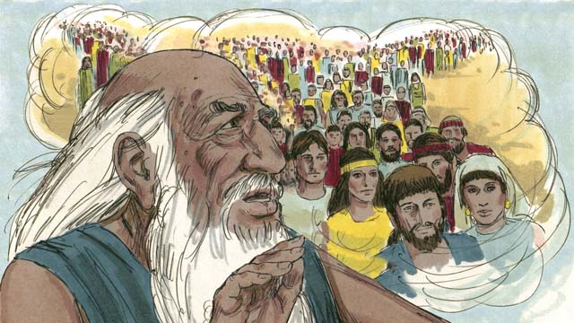
God told Abraham, “All the people groups of the earth will be blessed through you.” Jesus was a descendant of Abraham. All the people groups are blessed through him, because everyone who believes in Jesus is saved from sin, and becomes a spiritual descendant of Abraham.
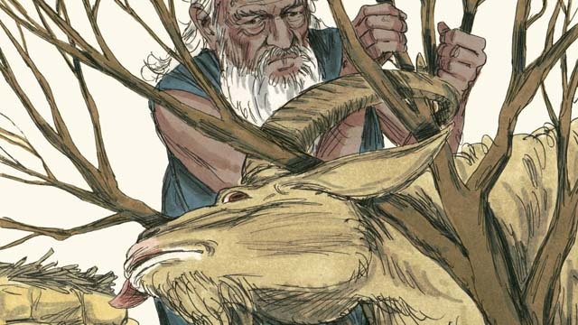
When God told Abraham to offer his son, Isaac, as a sacrifice, God provided a lamb for the sacrifice instead of his son, Isaac. We all deserve to die for our sins! But God provided Jesus, the Lamb of God, as a sacrifice to die in our place.
When God sent the last plague on Egypt, he told each Israelite family to kill a perfect lamb and spread its blood on the tops and sides of their door frames. When God saw the blood, he passed over their houses and did not kill their firstborn sons. This event is called the Passover.
Jesus is our Passover Lamb. He was perfect and sinless and was killed at the time of the Passover celebration. When anyone believes in Jesus, the blood of Jesus pays for that person’s sin, and God’s punishment passes over that person.
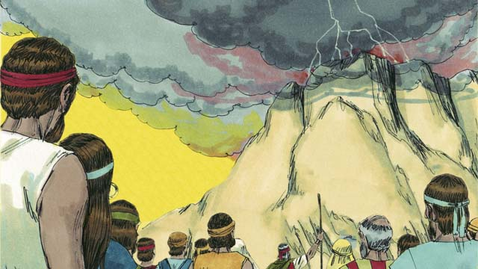
God made a covenant with the Israelites, who were his chosen people. But God has now made a New Covenant that is available to everyone. Because of this New Covenant, anyone from any people group can become part of God’s people by believing in Jesus.
Moses was a great prophet who proclaimed the word of God. But Jesus is the greatest prophet of all. He is God, so everything he did and said were the actions and words of God. That is why Jesus is called the Word of God.
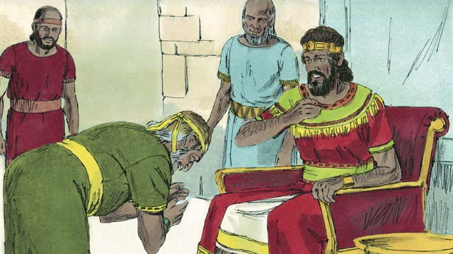
God promised King David that one of his descendants would rule as king over God’s people forever. Because Jesus is the Son of God and the Messiah, he is that special descendant of David who can rule forever.
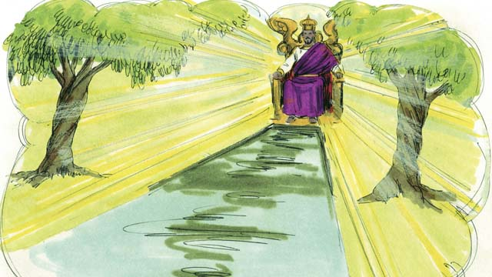
David was the king of Israel, but Jesus is the king of the entire universe! He will come again and rule his kingdom with justice and peace, forever.
A Bible story from: Genesis 1-3, 6, 14, 22; Exodus 12, 20; 2 Samuel 7; Hebrew 3:1-6, 4:14-5:10, 7:1-8:13, 9:11-10:18; Revelation 21

49. God’s New Covenant
An angel told a virgin named Mary that she would give birth to God’s Son. So while she was still a virgin, she gave birth to a son and named him Jesus. Therefore, Jesus is both God and human.
Jesus did many miracles that prove he is God. He walked on water, calmed storms, healed many sick people, drove out demons, raised the dead to life, and turned five loaves of bread and two small fish into enough food for over 5,000 people.
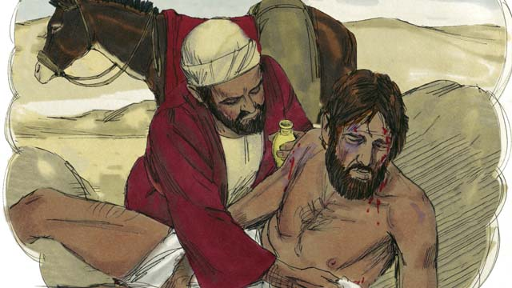
Jesus was also a great teacher, and he spoke with authority because he is the Son of God. He taught that you need to love other people the same way you love yourself.
He also taught that you need to love God more than you love anything else, including your wealth.
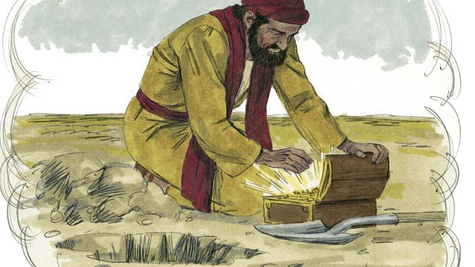
Jesus said that the kingdom of God is more valuable than anything else in the world. The most important thing for anyone is to belong to the kingdom of God. To enter into God’s kingdom, you must be saved from your sin.
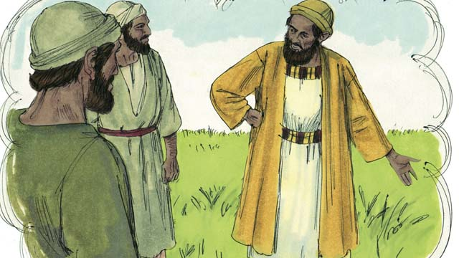
Jesus taught that some people will receive him and be saved, but others will not. He said that some people are like good soil. They receive the good news of Jesus and are saved. Other people are like the hard soil of a path, where the seed of God’s word does not enter and does not produce any harvest. Those people reject the message about Jesus and will not enter into his kingdom.
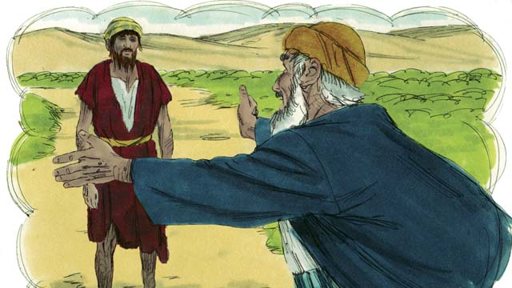
Jesus taught that God loves sinners very much. He wants to forgive them and to make them his children.
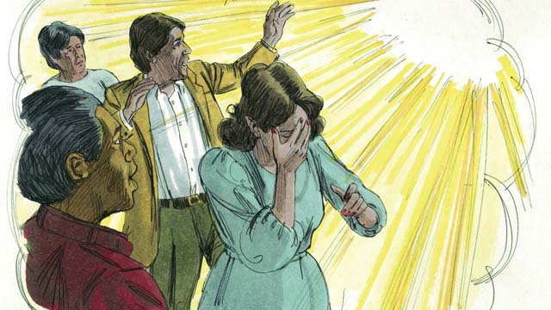
Jesus also told us that God hates sin. When Adam and Eve sinned, it affected all of their descendants. As a result, every person in the world sins and is separated from God. Therefore, everyone has become an enemy of God.
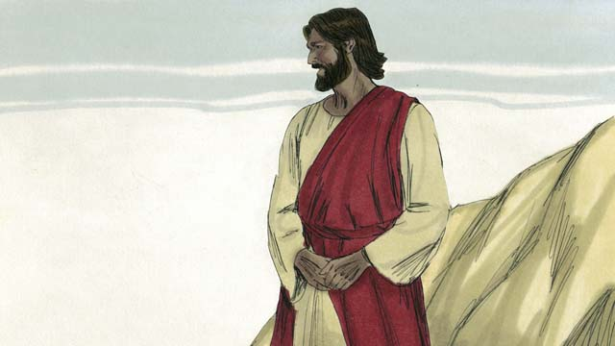
But God loved everyone in the world so much that he gave his only Son so that whoever believes in Jesus will not be punished for his sins, but will live with God forever.
Because of your sin, you are guilty and deserve to die. God should be angry with you, but he poured out his anger on Jesus instead of on you. When Jesus died on the cross, he received your punishment.
Jesus never sinned, but he chose to be punished and to die as the perfect sacrifice to take away your sins and the sins of every person in the world. Because Jesus sacrificed himself, God can forgive any sin, even terrible sins.
Good works cannot save you. There is nothing you can do to have a relationship with God. Only Jesus can wash away your sins. You must believe that Jesus is the Son of God, that he died on the cross instead of you, and that God raised him to life again.
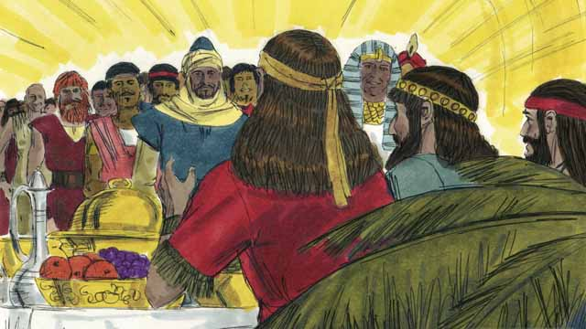
God will save everyone who believes in Jesus and receives him as their Master. But he will not save anyone who does not believe in him. It does not matter if you are rich or poor, man or woman, old or young, or where you live. God loves you and wants you to believe in Jesus so he can have a close relationship with you.
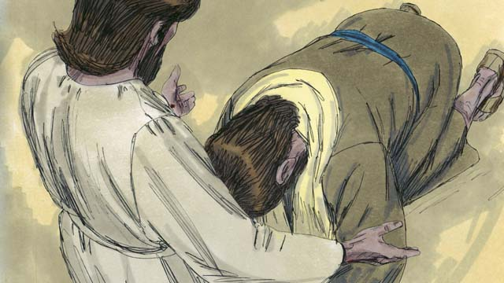
Jesus invites you to believe in him and to be baptized. Do you believe that Jesus is the Messiah, the only Son of God? Do you believe that you are a sinner and that you deserve for God to punish you? Do you believe that Jesus died on the cross to take away your sins?
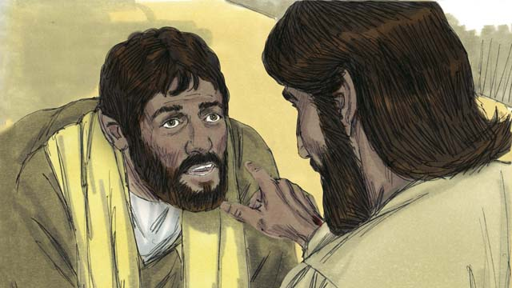
If you believe in Jesus and what he has done for you, you are a Christian! God has taken you out of Satan’s kingdom of darkness and put you into God’s kingdom of light. God has taken away your old, sinful ways of doing things and has given you new, righteous ways of doing things.
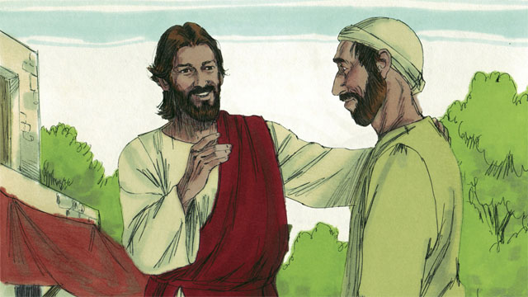
If you are a Christian, God has forgiven your sins because of what Jesus did. Now, God considers you to be a close friend instead of an enemy.
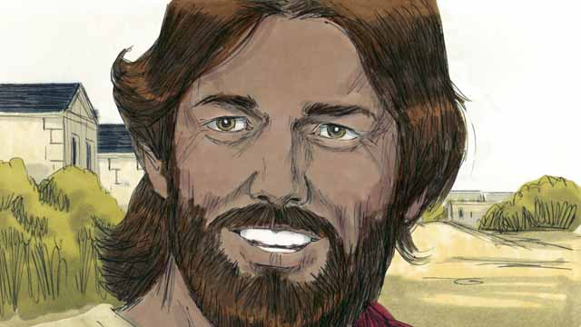
If you are a friend of God and a servant of Jesus the Master, you will want to obey what Jesus teaches you. Even though you are a Christian, you will still be tempted to sin. But God is faithful and says that if you confess your sins, he will forgive you. He will give you strength to fight against sin.
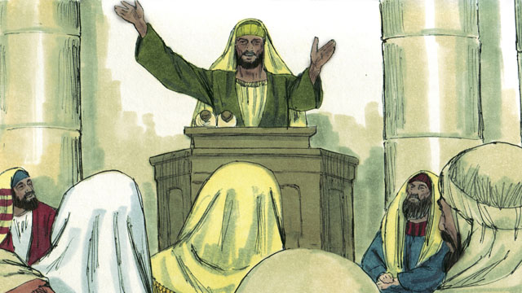
God tells you to pray, to study his word, to worship him with other Christians, and to tell others what he has done for you. All of these things help you to have a deeper relationship with him.
A Bible story from: Romans 3:21-26, 5:1-11; John 3:16; Mark 16:16; Colossians 1:13-14; 2 Corinthians 5:17-21; 1 John 1:5-10

50. Jesus Returns
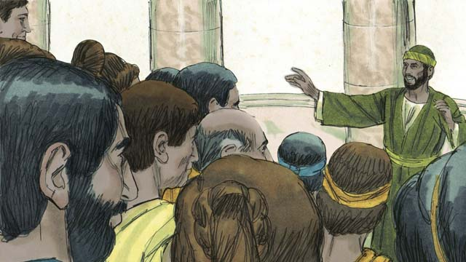
For almost 2,000 years, more and more people around the world have been hearing the good news about Jesus the Messiah. The Church has been growing. Jesus promised he would return at the end of the world. Though he has not yet come back, he will keep his promise.
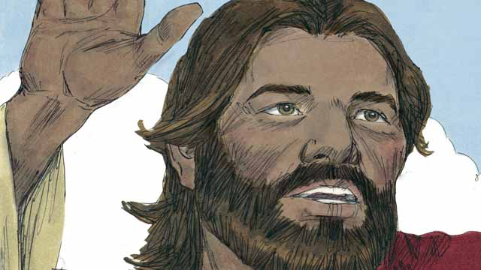
As we wait for Jesus to return, God wants us to live in a way that is holy and that honors him. He also wants us to tell others about his kingdom. When Jesus was living on earth he said, “My disciples will preach the good news about the kingdom of God to people everywhere in the world, and then the end will come.”

Many people groups still have not heard about Jesus. Before he returned to heaven, Jesus told Christians to proclaim the good news to people who have never heard it. He said, “Go and make disciples of all people groups!” and, “The fields are ripe for harvest!”
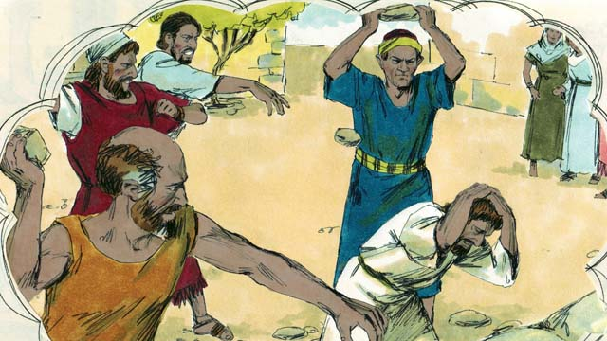
Jesus also said, “A servant is not greater than his master. Just as the authorities of this world have hated me, they will torture and kill you because of me. Although in this world you will suffer, be encouraged because I have defeated Satan, the one who rules this world. If you remain faithful to me to the end, then God will save you!”
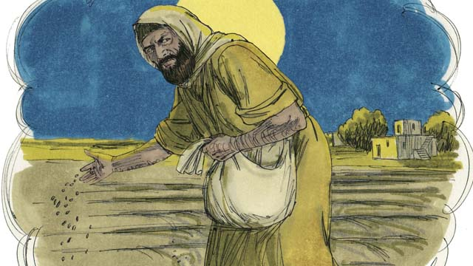
Jesus told his disciples a story to explain what will happen to people when the world ends. He said, “A man planted good seed in his field. While he was sleeping, his enemy came and planted weed seeds along with the wheat, and then he went away.”
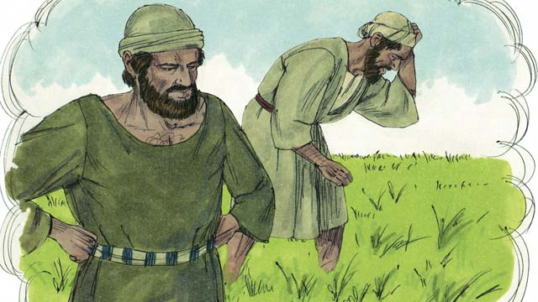
“When the plants sprouted, the servants of the man said, ‘Master, you planted good seed in that field. So why are there weeds in it?’ The master answered, ‘An enemy must have planted them.’”
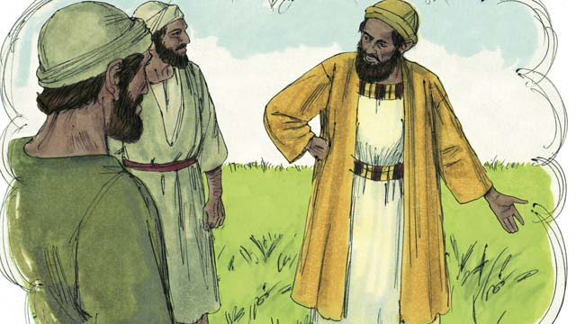
“The servants responded to their master, ‘Should we pull out the weeds?’ The master said, ‘No. If you do that, you will pull out some of the wheat as well. Wait until the harvest and then gather the weeds into piles to be burned, but bring the wheat into my barn.’”
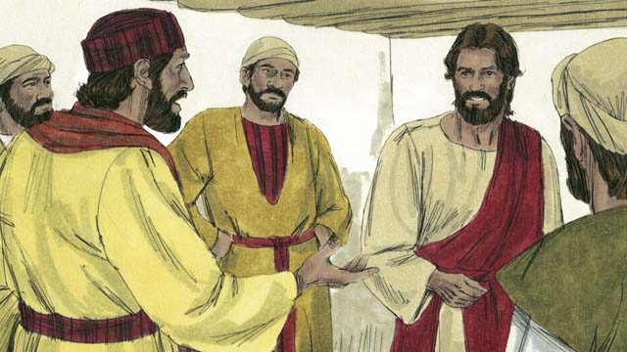
The disciples did not understand the meaning of the story, so they asked Jesus to explain it to them. Jesus said, “The man who planted the good seed represents the Messiah. The field represents the world. The good seed represents the people of God’s kingdom.”
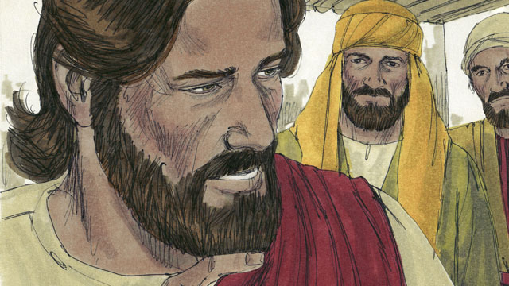
“The weeds represent the people who belong to the evil one. The enemy who planted the weeds represents the devil. The harvest represents the end of the world, and the harvesters represent God’s angels.”
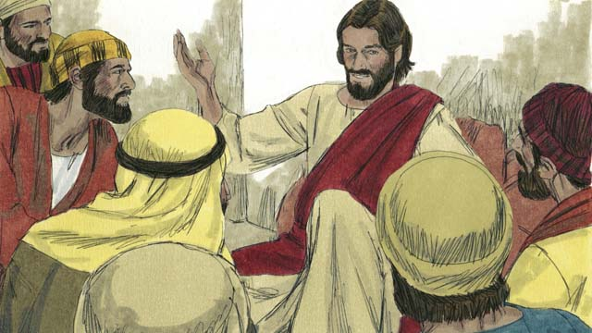
“When the world ends, the angels will gather together all the people who belong to the devil and throw them into a raging fire, where they will cry and grind their teeth in terrible suffering. Then the righteous ones will shine like the sun in the kingdom of God their Father.”
Jesus also said that he would return to earth just before the world ends. He will come back the same way that he left, that is, he will have a physical body and will come on the clouds in the sky. When Jesus returns, every Christian who has died will rise from the dead and meet him in the sky.
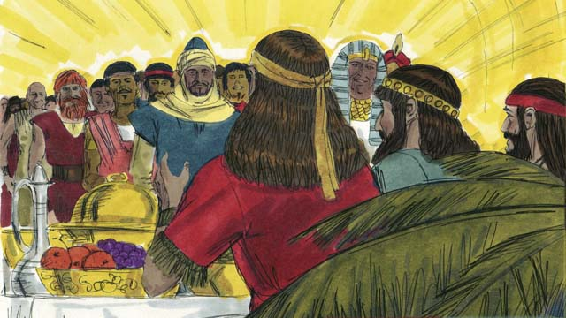
Then the Christians who are still alive will rise up into the sky and join with the other Christians who rose from the dead. They will all be with Jesus there. After that, Jesus will live with his people in perfect peace and unity forever.
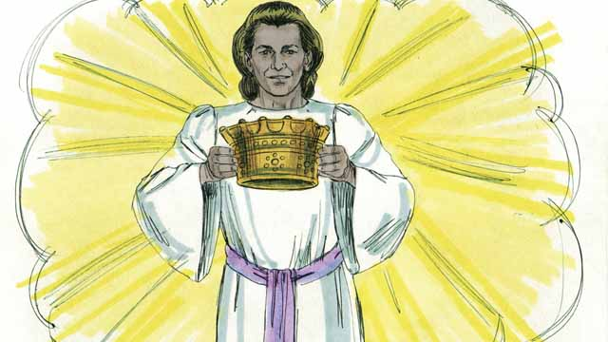
Jesus promised to give a crown to everyone who believes in him. They will live and reign with God in perfect peace forever.
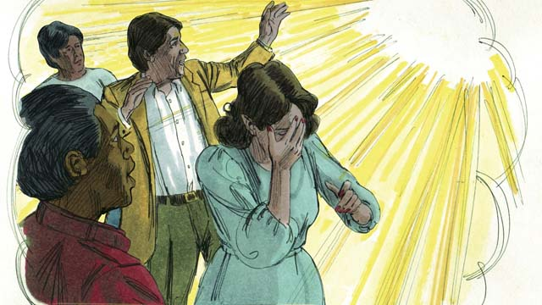
But God will judge everyone who does not believe in Jesus. He will throw them into hell, where they will weep and grind their teeth in anguish forever. A fire that never goes out will continually burn them, and worms will never stop eating them.
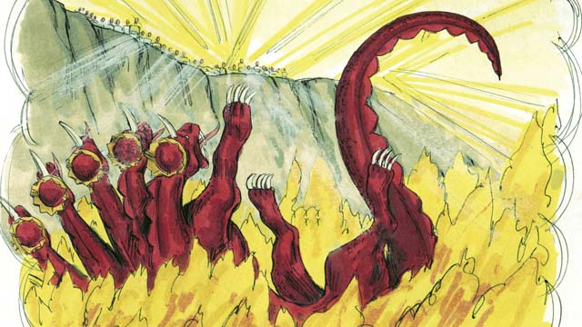
When Jesus returns, he will completely destroy Satan and his kingdom. He will throw Satan into hell where he will burn forever, along with everyone who chose to follow him rather than to obey God.
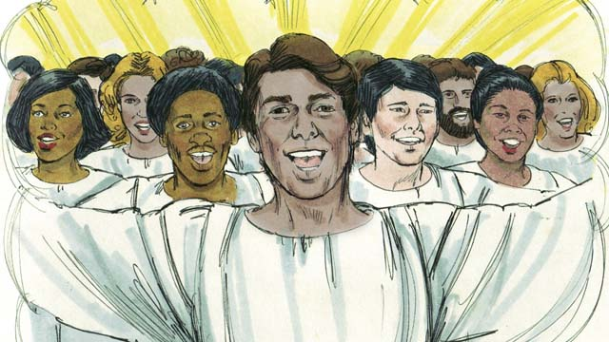
Because Adam and Eve disobeyed God and brought sin into this world, God cursed it and decided to destroy it. But some day God will create a new heaven and a new earth that will be perfect.
Jesus and his people will live on the new earth, and he will reign forever over everything that exists. He will wipe away every tear and there will be no more suffering, sadness, crying, evil, pain, or death. Jesus will rule his kingdom with peace and justice, and he will be with his people forever.
A Bible story from: Matthew 24:14; 28:18; John 15:20, 16:33; Revelation 2:10; Matthew 13:24-30, 36-42; 1 Thessalonians 4:13-5:11; James 1:12; Matthew 22:13; Revelation 20:10, 21:1-22:21

Get Involved!
We want to make this visual mini-Bible available in every language of the world and you can help! This is not impossible—we think it can happen if the whole body of Christ works together to translate & distribute this resource.

Share Freely
Give as many copies of this book away as you want, without restriction. All digital versions are free online, and because of the open license we are using, you can even republish Open Bible Stories commercially anywhere in the world without paying royalties! Find out more at http://openbiblestories.com.

Extend!
Get Open Bible Stories as videos and mobile phone applications in other languages at http://openbiblestories.com. On the website, you can also get help translating Open Bible Stories into your language.

