FitFlow: An AI-Powered Fitness Coaching Platform with Computer Vision Form Analysis

By
[Your Full Name]
[Your Student ID]

FINAL YEAR DESIGN PROJECT REPORT

This Report is Presented in Partial Fulfillment of the Requirements
for the Degree of Bachelor of Science in Computer Science and Engineering

Supervised by
Mr. [Supervisor Name]
Assistant Professor
Department of Computer Science and Engineering
Daffodil International University

Co-Supervised by
Mr. [Co-Supervisor Name]
Senior Lecturer
Department of Computer Science and Engineering
Daffodil International University

DAFFODIL INTERNATIONAL UNIVERSITY
Dhaka, Bangladesh
May 15, 2026

APPROVAL
This Project titled "FitFlow: An AI-Powered Fitness Coaching Platform with Computer Vision Form Analysis", submitted by [Your Full Name], ID No: [Your Student ID], to the Department of Computer Science and Engineering, Daffodil International University has been accepted as satisfactory for the partial fulfillment of the requirements for the degree of B.Sc. in Computer Science and Engineering and approved as to its style and contents. The presentation was held on May 15, 2026.

BOARD OF EXAMINERS

[Internal Examiner Name] Internal Examiner
Lecturer
Department of CSE,
Daffodil International University

[Internal Examiner Name] Internal Examiner
Lecturer
Department of CSE,
Daffodil International University

DECLARATION
I hereby declare that this project has been done by me under the supervision of Mr. [Supervisor Name], Assistant Professor, Department of Computer Science and Engineering, Daffodil International University. I also declare that neither this project nor any part of this project has been submitted elsewhere for the award of any degree or diploma.

Supervised by:

Mr. [Supervisor Name]
Assistant Professor
Department of Computer Science and Engineering
Daffodil International University

Co-Supervised by:

Mr. [Co-Supervisor Name]
Senior Lecturer
Department of Computer Science and Engineering
Daffodil International University

Submitted by:

[Your Full Name]
Student ID: [Your Student ID]
Department of Computer Science and Engineering
Daffodil International University

ACKNOWLEDGEMENTS
The work that follows would not exist without the people who pushed, corrected, and put up with me along the way. I owe them more than this short paragraph can hold.
First, I thank the Almighty for granting me the patience to keep going through long debugging nights and the clarity to know when to stop and rewrite from scratch.
I am deeply indebted to my supervisor, Mr. [Supervisor Name], Assistant Professor, Department of Computer Science and Engineering, Daffodil International University. His questions during reviews changed the shape of this project more than once. When I argued for a quick fix, he asked for the right one; when I drifted into features that did not matter, he steered me back. Every chapter here carries his fingerprints.
I also thank Mr. [Co-Supervisor Name], Senior Lecturer, for the careful reads, the small corrections that prevented large embarrassments, and the encouragement at the moments I needed it most.
My thanks to the Head of the Department and to the faculty and staff of the Department of Computer Science and Engineering, who built the environment in which work like this is even possible.
To my classmates, especially the ones who let me think out loud at them in the lab, thank you. Many of the small ideas that became sections of this report were born in those conversations.
Finally, to my parents, for the patience that I have not earned and the support that I will spend the rest of my life trying to deserve.

ABSTRACT
This report presents FitFlow, a web-based fitness coaching platform that combines real-time computer vision form analysis, an AI conversational coach, and a multi-role social graph linking trainees, certified coaches, and platform administrators. The motivation comes from a gap in existing fitness applications: free apps count workouts but cannot tell a user whether their squat is deep enough, while in-person coaching is expensive and geographically constrained. The platform addresses this by running a MediaPipe Pose [1], [3], [26] pipeline entirely in the browser, scoring squat, push-up, and plank form against angle-based heuristics and a smoothed exponential decay model, then surfacing the resulting metrics in a personal dashboard with thirty-day trends. A separate role layer turns the same app into a coaching tool: trainees can search a verified coach directory, request a link, and exchange messages once accepted; coaches see a productivity-focused dashboard with today's clients, recent sessions, and clients who have not trained in seven days. Administrators have a parallel surface for moderating users and reviewing coach applications. The system is implemented in Next.js 14 with the App Router [28], MongoDB [27] through Mongoose, JWT-based authentication [11], role-aware middleware, and a Stripe [29] billing integration that gates the AI conversational endpoint [30] behind a Pro tier. Validation, rate limiting, structured logging, and an OpenAPI 3.1 specification [16] round out the production posture. Testing focused on functional correctness of the role transitions, latency of the pose-detection pipeline on a mid-range laptop, and accuracy of the rep counter against hand-counted ground truth across three exercises. The platform is positioned as a foundation that future work can extend with calibration-based form scoring, client-side mobile capture, and richer coach analytics.

Table of Contents

1 Introduction 9
1.1 Introduction 9
1.2 Motivation 10
1.3 Objectives 10
1.4 Methodology 11
1.5 Project Outcome 12
1.6 Organization of the Report 12
2 Background 14
2.1 Introduction 14
2.2 Literature Review 14
2.3 Gap Analysis 20
2.4 Summary 21
3 Research Methodology 22
3.1 Requirement Analysis & Design Specification 22
3.2 Detailed Methodology and Design 38
3.3 Project Plan 39
3.4 Task Allocation 40
3.5 Summary 40
4 Implementation and Results 41
4.1 Environment Setup 41
4.2 Testing and Evaluation 41
4.3 Results and Discussion 43
4.4 Summary 44
5 Engineering Standards and Design Challenges 45
5.1 Compliance with the Standards 45
5.2 Impact on Society, Environment and Sustainability 47
5.3 Project Management and Financial Analysis 48
5.4 Complex Engineering Problem 49
5.5 Summary 52
6 Conclusion 53
6.1 Summary 53
6.2 Limitations 53
6.3 Future Work 54
References 55

List of Figures

3.1 System Architecture (3-tier) 13
3.2 DFD Level-0 (Context Diagram) 15
3.3 DFD Level-1 (Major Processes) 16
3.4 DFD Level-2 (Live Workout Pipeline) 17
3.5 Use Case Diagram 18
3.6 Entity-Relationship Diagram 19
3.7 Class Diagram 20
3.8 Sequence — Login + Role Redirect 21
3.9 Sequence — Live Workout Pipeline 22
3.10 Sequence — Coach Application + Approval 23
3.11 State Machine — Squat Rep Detector 24
3.12 Activity — Coach-Trainee Link Lifecycle 25
3.13 Deployment Diagram 26
3.14–3.21 UI Screenshots (insert your own) 27
3.22 Gantt Chart — Project Plan 28

List of Tables

2.1 Summary of Literature Reviewed 6
2.2 Comparable Applications 7
2.3 Gap Analysis 8
3.1 Task Allocation Timeline 27
4.1 Testing Methodology 30
4.2 Comparative Analysis 31
5.1 Project Budget (Student Level) 37
5.2 Alternate Budget (Production Deployment) 38
5.3 Proposed Revenue Model 39
5.4 Mapping with Complex Engineering Problem 39
5.5 Mapping with Knowledge Profile 40
5.6 Mapping with Complex Engineering Activities 41

Chapter 1
Introduction
The title of the project introduced in this chapter is "FitFlow: An AI-Powered Fitness Coaching Platform with Computer Vision Form Analysis." This chapter sets the scene: what the project is, why it exists, what it is trying to do, and how the rest of the report is organized. It does not assume that the reader has already used a fitness app or thought about computer vision. It builds the case from the ground up.
1.1 Introduction
FitFlow is a web-based fitness coaching platform. It is built on Next.js 14 [28] for the front end and the API layer, MongoDB [27] through Mongoose for persistence, and a MediaPipe Pose [1], [26] detection pipeline that runs entirely in the browser on the client device. The product has three kinds of users — trainees who train, coaches who review and guide trainees, and administrators who keep the platform healthy — and each role lands on a different home page after login. Trainees see a dashboard with their thirty-day progress, streak, and live workout shortcut. Coaches see today's clients, recent sessions across all linked clients, and a list of clients who have not trained in seven days. Administrators see platform stats and queues for moderation.
The technical core of the platform is the live workout module. A trainee opens the camera (W3C MediaCapture/Streams [31]), picks an exercise (squat, push-up, or plank), and the browser begins running MediaPipe Pose [1], [26] at roughly thirty frames per second. A small per-exercise state machine consumes the landmark stream and turns it into reps, hold time, calorie estimates, and a smoothed form score. None of the video leaves the device; only the resulting numbers are saved to the server when the session ends. The intent is to deliver something close to "a coach watching you" without the latency, bandwidth, or privacy concerns of streaming video to a remote model.
On top of this technical core sits a social layer. Trainees who want guidance can browse a directory of approved coaches, view a coach's bio, send a connection request, and message back and forth once the coach accepts. Coaches who want clients submit an application at sign-up and become discoverable once an administrator approves the application. The same conversation can include short check-ins, technique cues, and progress comments. The platform deliberately keeps coach notes private from the trainee and trainee messages visible to the coach, mirroring how in-person coaching actually works.
1.2 Motivation
Two observations led to this project. First, free fitness apps tell users what to do but not how well they did it. They count reps if you tap a button. They have a library of YouTube-style demonstration videos. They do not look at the user. Anyone who has tried to learn squats from a video knows the gap: the video shows a perfect squat, and the user does something that may or may not be a squat, with no feedback in either direction. The result is the well-known shape of injury and discouragement that fitness apps quietly produce.
Second, real coaching solves the feedback problem but introduces a different one. A certified coach in Dhaka charges per session, requires geographic proximity, and only watches the client during scheduled hours. The asynchronous nature of training — most reps happen between sessions — means the coach has no visibility into the work that matters most. A platform that can do partial form analysis between sessions, surface that information to the coach, and let coach and trainee message about what came up, would make the human coach far more useful per hour.
FitFlow sits at the intersection. The browser-side computer vision provides feedback during every workout. The coach layer reuses that feedback as raw material for asynchronous coaching. The architecture treats the AI as an aid to the coach, not a replacement for the coach.
1.3 Objectives
The objectives of FitFlow are intentionally narrow so that each can be defended with concrete evidence in this report:
- Provide accurate-enough rep counting and form scoring for three exercises (squat, push-up, plank) running entirely in the browser, with no server-side video processing.
- Persist a thirty-day history of sessions per trainee and surface trends — current streak, average form score, total reps, sessions by exercise — on the trainee dashboard.
- Implement a multi-role authentication system (user, coach, pending_coach, admin) with role-aware routing, role-based API guards, and a JWT-based session that carries the role.
- Give certified coaches a working surface — directory listing, application flow with admin approval, client roster, per-client trends, private coach notes, and direct messaging.
- Give administrators a moderation surface — user list with role and suspension control, coach application queue, audit log of role changes — sufficient to operate the platform without database access.
- Gate the OpenAI-backed conversational coach behind a paid Pro tier with a Stripe checkout flow and webhook-driven entitlement, demonstrating an honest path to platform sustainability.
1.4 Methodology
The project followed an iterative-waterfall hybrid. The waterfall part is the chapter structure of this report itself: requirements were gathered, the system was designed, modules were implemented, and the result was tested. The iterative part is what actually happened week to week. Each module — auth, live workout, coach surface, messaging — was built end-to-end as a vertical slice, including UI, API, persistence, and a small acceptance test, before moving to the next slice. The benefit was that at every checkpoint the application was demonstrable, not a half-finished collection of layers.
The major activities, in the order they happened, were:
- Problem identification and competitor analysis. Existing fitness platforms were inventoried and their gaps noted. The narrowing was deliberate: not "build a fitness app" but "build the parts of a fitness app that no free app does well."
- Requirement specification. Functional and non-functional requirements were written down before code, then revised twice as the build progressed. Both versions are reflected in chapter 3.
- System design. The data model, the role hierarchy, and the page-to-API mapping were sketched on paper, then translated into TypeScript interfaces and Mongoose schemas as the source of truth.
- Implementation. Vertical slices, in order: authentication, trainee dashboard, live workout, progress dashboard, coach surface, admin surface, messaging, billing.
- Testing. Unit-level type checking via the TypeScript compiler, manual integration testing of each role flow, and ad-hoc accuracy testing of the rep counter against hand-counted ground truth on three exercises.
- Polishing. The visual layer was rebuilt once everything worked, swapping the default shadcn look for a custom indigo-violet design system with hero gradient cards on each major page.
1.5 Project Outcome
The deliverable is a working web application. A trainee can register, complete a workout in front of their laptop camera, and see their session immediately reflected in their progress dashboard. A coach can apply at sign-up, be approved by an administrator, edit their public bio, accept incoming requests, see today's client activity, drill into a specific client's form-score trend, and message the client. An administrator can promote, suspend, and approve users, and see live platform statistics.
Specifically the build produces:
- A browser-based pose-detection pipeline that scores squats, push-ups, and planks at interactive frame rates on a mid-range laptop.
- A trainee dashboard that turns the resulting session log into a thirty-day progress narrative, including streak, average form, and per-exercise breakdown.
- A coach dashboard that surfaces today's clients, recent sessions across the roster, clients needing attention, and a profile-health indicator.
- An administrator dashboard with platform stats, user management, and a coach-application review queue with approve and reject (with reason) actions.
- A direct-messaging surface available to coach and trainee once they are linked, with thread list, composer, day-grouped bubbles, and an unread badge in the navigation bar.
- A billing flow with Stripe checkout, customer portal, and webhook-driven entitlement that gates the AI conversational endpoint behind the Pro tier.
1.6 Organization of the Report
The report is structured into six chapters that follow the recommended FYDP layout.
Chapter 1: Introduction. This chapter. Sets out the project, motivation, objectives, methodology, outcomes, and the structure of the document.
Chapter 2: Background. Surveys the fitness-app and computer-vision-coaching landscape, summarises a set of related works, and runs a gap analysis that justifies why this project was worth building.
Chapter 3: Research Methodology. Functional and non-functional requirements, the data model, data flow diagrams at three levels of detail, the use-case diagram, the chosen development model, the project plan, and the task allocation timeline.
Chapter 4: Implementation and Results. Tooling, environment setup, the testing strategy, performance numbers, and a comparison against the alternatives surveyed in chapter 2.
Chapter 5: Engineering Standards and Design Challenges. Compliance with software, hardware, and communication standards; impact on society, environment, and sustainability; budget and revenue analysis; and the mapping to complex engineering problem attributes.
Chapter 6: Conclusion. What the project achieved, what it did not, and where the next version should go.

Chapter 2
Background
This chapter establishes the research and product context for the project. It begins with a brief look at why digital fitness platforms have become a serious category, surveys ten relevant works from the literature, compares five real-world products, and ends with a gap analysis that justifies the design choices in chapter 3.
2.1 Introduction
The market for fitness software has grown for three reasons that converged in roughly the last decade: smartphones became powerful enough to run real-time pose models on-device, pandemic-era restrictions normalized at-home training, and consumer-grade wearables made longitudinal personal data the norm. These three forces produced a category that is now worth several billion dollars annually and is forecast to keep growing.
Inside that category, two clusters of products dominate. The first is the workout-library cluster: apps like Nike Training Club, FitOn, and Peloton App offer guided videos and tracking-by-tap. The second is the wearable-data cluster: Apple Fitness+, Garmin Connect, and Whoop turn heart-rate variability and movement into long-term insights. Both clusters skip the question that matters most to a beginner: am I doing this exercise correctly? In neither category does the app actually look at the user.
A small third cluster is starting to address this gap. Onyx, Kemtai, and Tempo all use computer vision to score exercise form. Tempo couples it with a hardware mirror; Onyx and Kemtai are app-only. None of them currently wraps the form-scoring layer in a coach-trainee social layer that lets a real coach review what the AI saw. That is the gap this project targets.
2.2 Literature Review
The following table summarises the works that directly informed this project. They span four areas: pose estimation models, web-based real-time inference, web architecture and security standards, and the software-quality and usability literature against which the build was evaluated. Each row cites a numbered reference in the References section at the end of the report; numbers in brackets follow IEEE format.

Table 2.1: Summary of Literature Reviewed
Ref. | Author(s) / Source | Year | Relevance to this project
[1] | Bazarevsky et al. (BlazePose, arXiv) | 2020 | Defines the on-device 33-keypoint pose model that MediaPipe Pose ships. The 25–30 frames-per-second target in this project comes from BlazePose's reported latency on mobile CPUs.
[2] | Cao et al. (OpenPose, IEEE TPAMI) | 2021 | Part-affinity-fields multi-person pose estimation. Used as the accuracy benchmark in later browser-based pipelines.
[3] | Lugaresi et al. (MediaPipe, arXiv) | 2019 | The MediaPipe framework paper. Describes the calculator-graph and WASM execution model that the live-workout module depends on.
[4] | Grishchenko & Bazarevsky (Google AI Blog: BlazePose GHUM) | 2020 | Describes the GHUM-based 3D world-landmark output that the squat detector uses for the bilateral knee-distance heuristic.
[5] | Howard et al. (MobileNetV3, ICCV) | 2019 | The mobile-class CNN backbone family that BlazePose builds on; explains the latency-accuracy trade-off the project relies on.
[6] | Tan & Le (EfficientNet, ICML) | 2019 | Compound-scaling reference for understanding model-size trade-offs; informed the decision to keep MediaPipe over a larger TensorFlow.js model.
[7] | Zhang et al. (MediaPipe Hands, arXiv) | 2020 | Companion model to BlazePose using the same MediaPipe pipeline; cited for the framework-level performance claims.
[8] | Yan et al. (ST-GCN, AAAI) | 2018 | Skeleton-based action recognition with graph convolutions; informed the choice of state-machine over learned classifier given limited training data.
[9] | Shi et al. (2s-AGCN, CVPR) | 2019 | Two-stream adaptive graph convolutional network; further evidence that classifier-based exercise recognition needs significant data, supporting the lighter heuristic approach used here.
[10] | Fielding & Taylor (REST, ACM TOIT) | 2002 | Defines the architectural style of the JSON-over-HTTP API surface; informs the OpenAPI specification produced at /api/openapi.
[11] | Jones, Bradley & Sakimura (RFC 7519: JWT) | 2015 | Specifies the JWT format used for the role-aware authentication cookie.
[12] | Rescorla (RFC 8446: TLS 1.3) | 2018 | Specifies the secure transport layer used by every protected endpoint.
[13] | Cooper et al. (RFC 5280: X.509) | 2008 | Certificate profile used by TLS to authenticate the server.
[14] | Eastlake & Hansen (RFC 6234: SHA) | 2011 | Hash primitive underlying JWT signatures and verification-token storage.
[15] | Fielding et al. (RFC 9110: HTTP Semantics) | 2022 | Modern HTTP semantics used throughout the API surface.
[16] | OpenAPI Initiative (OAS 3.1.0) | 2021 | Specification format produced by the API documentation generator.
[17] | OWASP Foundation (Top Ten) | 2021 | Threat-model checklist applied to authentication, rate limiting, and input validation.
[18] | Provos & Mazières (bcrypt, USENIX) | 1999 | Password-hashing scheme used for credential storage.
[19] | ISO/IEC 25010 (SQuaRE quality model) | 2011 | Source of the non-functional requirements taxonomy in Chapter 3 (usability, performance, security, maintainability, portability, reliability).
[20] | ISO/IEC/IEEE 29148 (Requirements Engineering) | 2018 | Modern successor to IEEE 830-1998; provides the structure used for the functional requirements catalogue.
[21] | IEEE Std 1016 (SDD) | 2009 | Software design description standard the architecture chapter follows.
[22] | ISO/IEC/IEEE 12207 (Software Life Cycle) | 2017 | Life-cycle processes that the waterfall-iterative hybrid in this project maps onto.
[23] | Nielsen (Usability Engineering) | 1994 | Source of the ten heuristics applied to the role-specific dashboard designs.
[24] | Norman (Design of Everyday Things) | 2013 | Affordance and feedback principles applied to the live-workout UI.
[25] | Shneiderman et al. (Designing the UI, 6th ed.) | 2016 | Eight golden rules of interface design used as a secondary review checklist.
[26] | Google LLC (MediaPipe Pose Landmarker docs) | 2024 | Production API used by the live-workout module.
[27] | MongoDB Inc. (Manual v7) | 2024 | Document-store reference; TTL indexes used here for verification tokens and rate-limit buckets.
[28] | Vercel (Next.js 14 App Router Docs) | 2024 | Routing, middleware, and API-route execution model the system depends on.
[29] | Stripe (Subscriptions Integration Docs) | 2024 | Specifies the Checkout-Session and webhook signature flow implemented in the billing module.
[30] | OpenAI (Chat Completions API Reference) | 2024 | Request/response shape that the AI conversational coach endpoint adheres to.
[31] | W3C (MediaCapture / Streams) | 2023 | Browser standard governing camera access, frame rate, and constraints used by the live workout.
[32] | Ecma International (ECMAScript 2023) | 2023 | Language specification for the JavaScript/TypeScript runtime.
[33] | WHO (Physical Activity Guidelines) | 2020 | Public-health context cited in motivation and impact sections.
2.2.2 Technical Background and Stack Choices
Pose estimation. The live-workout module uses MediaPipe Pose Landmarker [26], which is the productionised form of the BlazePose model [1], [4]. BlazePose returns 33 normalised image-space keypoints plus a parallel 33-keypoint metric-space "world" output produced by the GHUM body model [4]. The world output is what makes the bilateral knee-distance check in the squat detector reliable across camera angles, since image-space coordinates collapse the depth axis. Earlier works such as OpenPose [2] established the multi-person regression-and-affinity-fields approach but require GPU-class hardware for real-time performance and were therefore unsuitable for a browser-only deployment. The MediaPipe framework paper [3] describes the calculator-graph architecture and the WebAssembly compilation strategy that allows the same model to run on CPU at 25–30 frames per second on a 2019-class laptop. MobileNetV3 [5] and EfficientNet [6] are the backbone-architecture references that contextualise the model-size choice: BlazePose uses a MobileNetV3-class encoder, which trades a small accuracy delta for a substantial latency advantage compared to larger backbones. MediaPipe Hands [7] is a sibling model running on the same framework and offers a useful baseline for performance expectations.
Exercise classification approach. Two skeleton-based action-recognition references — ST-GCN [8] and 2s-AGCN [9] — were considered for learned exercise classification. Both rely on graph convolutions over keypoint trajectories and require thousands of labelled clips per exercise. With three exercises and no labelled corpus, learned classification was rejected in favour of a per-exercise hand-coded state machine that uses joint angles and visibility scores as transition triggers. The two papers are cited here to justify the choice rather than to claim direct use.
Web architecture. The application follows the REST architectural style defined by Fielding and Taylor [10]. Each resource has a stable URL, methods correspond to HTTP verbs as governed by RFC 9110 [15], and payloads are JSON. The same Zod schemas used at runtime to validate incoming requests are walked at build time to emit an OpenAPI 3.1 specification [16] served at /api/openapi. The framework underpinning the application is Next.js 14 with the App Router [28], which colocates client UI and server-side route handlers in the same TypeScript project. The Edge runtime restriction encountered during development — that jsonwebtoken cannot run there because Edge has no Node crypto — is documented in [28] and resolved here by performing only cookie-presence checks in middleware, deferring real signature verification to the Node-runtime API routes.
Security and identity. Authentication uses JSON Web Tokens as defined by RFC 7519 [11]. Each token is signed with HMAC-SHA-256 and carries a small payload: userId, email, role. The hash primitive is specified by RFC 6234 [14]. Tokens travel in HTTP-only cookies; the TLS layer is governed by RFC 8446 [12] and the certificate profile by RFC 5280 [13]. Rate limiting, validation, and authorization follow the OWASP Top Ten threat model [17]. Passwords are hashed with bcrypt [18] at cost factor 10 before storage. Verification and password-reset tokens are stored as SHA-256 digests with a TTL index in MongoDB [27] so expired entries are automatically purged.
Data store. Persistence is MongoDB [27] accessed through Mongoose. The collections are users, workoutsessions, workoutplans, exercises, coachclients, coachnotes, messages, verificationtokens, ratelimitbuckets, and auditlogs. Two TTL indexes — one on verificationtokens.expiresAt and one on ratelimitbuckets.expiresAt — let the database garbage-collect short-lived data without application code. Schema flexibility was decisive: the User document evolved to add coachApplication, coachProfile, subscription, and emailVerified subdocuments mid-project, which a relational schema would have required migrations for.
Billing and AI services. Stripe [29] provides the subscription primitive. The application creates Checkout Sessions for upgrades and the Customer Portal for management; entitlement state is updated by a signature-verified webhook on customer.subscription.created, .updated, and .deleted events. The OpenAI Chat Completions API [30] backs the AI conversational coach behind a Pro-tier gate. Both integrations follow the documented request/response shapes verbatim, with no transformation that could drift across versions.
Software-engineering standards. Requirements follow ISO/IEC/IEEE 29148:2018 [20], the modern successor to IEEE 830-1998. Design documentation follows IEEE Std 1016-2009 [21]. Quality attributes (usability, performance, security, maintainability, portability, reliability) are taken from ISO/IEC 25010:2011 [19]. The waterfall-iterative hybrid life cycle maps onto ISO/IEC/IEEE 12207:2017 [22]. Usability heuristics applied to the dashboards are those of Nielsen [23], augmented by the affordance and feedback principles in Norman [24] and the eight golden rules in Shneiderman et al. [25]. The MediaCapture/Streams W3C specification [31] governs the browser camera access pattern in the live-workout module. The runtime language is ECMAScript 2023 [32].
2.2.1 Comparable Applications
The following table compares five products that overlap in scope. The features column is restricted to capabilities that this project either matches or deliberately differs from.

Table 2.2: Comparable Applications
Application | Region | Key features
Nike Training Club | Global | Guided video workouts, tap-based tracking, no form scoring, no human coach layer, free with paid premium.
Onyx | Global | Browser-based AI form scoring for body-weight exercises, no human coach connection, subscription model.
Kemtai | Global / Israel | Pose-based exercise scoring positioned for clinical and rehab use, B2B partnerships rather than direct consumer.
Tempo | United States | Hardware mirror with depth-sensing camera, AI form scoring, premium hardware price point.
MyCoach (BD) | Bangladesh | Local marketplace connecting trainers to clients; no AI form analysis, scheduling and payment focused.
2.3 Gap Analysis
The comparison above shows three patterns. First, the apps that have AI form scoring (Onyx, Kemtai, Tempo) do not let a human coach see the AI output and respond to it. Second, the platforms that have human coaches (MyCoach, in-app coaching marketplaces) do not have AI form scoring; the coach is invisible to the trainee between sessions. Third, no surveyed product addresses the small-coaching-business case in Bangladesh — independent coaches who want a lightweight platform to keep clients in one place. FitFlow positions itself precisely in the intersection of these three gaps.

Table 2.3: Gap Analysis
Feature | Nike T.C. | Onyx | Kemtai | Tempo | MyCoach | FitFlow
On-device CV form scoring | No | Yes | Yes | Yes (HW) | No | Yes
No video uploaded to server | N/A | Yes | Yes | No | N/A | Yes
Coach can review trainee form data | No | No | No | No | Partial | Yes
Coach application + admin review | No | No | No | No | Yes | Yes
Direct coach ↔ trainee messaging | No | No | No | No | Yes | Yes
Trainee 30-day progress dashboard | Limited | Yes | Yes | Yes | No | Yes
AI conversational coach | No | No | No | Yes | No | Yes (Pro)
Free entry tier | Yes | No | B2B | No | Yes | Yes
2.4 Summary
This chapter framed the problem space. Existing free fitness apps do not score form. AI-form-scoring apps do not connect a real coach. Coach marketplaces do not surface the data that would make the coach more effective. FitFlow is designed to occupy the intersection: on-device computer vision form scoring, persisted as session history, made visible to a real coach inside a directed coach-client relationship. Chapter 3 turns this positioning into requirements and a design.

Chapter 3
Research Methodology
This chapter explains how FitFlow was specified, designed, and built. It begins with requirements, walks through the system design at three levels of data-flow detail, and finishes with the project plan and task allocation. The intent is to leave a reader who has not seen the application with enough information to understand why each module exists and how it fits.
3.1 Requirement Analysis & Design Specification
Functional Requirements
Functional requirements were grouped by user role.
Trainee.
- Register and log in; choose between "I want to train" and "I want to coach" at sign-up; the coach choice creates a pending application requiring a written bio of at least thirty characters.
- Run a live workout for squat, push-up, or plank with rep counting and a smoothed form score; the resulting session is persisted only when at least five seconds long.
- See thirty-day progress on the dashboard: current streak, sessions count, average form, total reps, reps-per-day bar chart, form-score trend sparkline, per-exercise breakdown.
- Browse the verified coach directory; view individual coach profiles with bio; send a request to be linked with a coach; withdraw a pending request.
- Once linked, exchange direct messages with the coach and receive a navigation-bar unread badge on new messages.
- Reset password by email and verify email through a token-link flow.
Coach.
- Land on a coach-specific dashboard after login showing today's clients, recent sessions across all clients, a "needs attention" list of clients inactive for seven days, and a bio-completeness indicator.
- Manage the public profile bio (30–1000 characters); preview the public profile from the editor.
- Accept or decline incoming connection requests with a single click; an active link unlocks messaging and the client detail view.
- Open a per-client detail page showing recent sessions, a form-score trend sparkline, and a private notes log; add new notes that are not visible to the client.
- Exchange messages with linked clients in a two-pane interface with thread list and conversation view.
Administrator.
- Land on an admin dashboard with hero stats (total members, sessions in the last seven days, pending coach applications) and detail tiles (coaches, pending coaches, suspended users, workout plans).
- Search and paginate the user list; filter by role; promote or demote any user except oneself; suspend or unsuspend any user except oneself.
- Review the coach application queue; approve (which transitions role to coach and copies the application bio to the public profile) or reject (which requires a written reason and notifies the applicant by email).
- All role changes and suspensions are recorded in an audit log for accountability.
Non-Functional Requirements
- Usability. The interface should be operable by a fitness user with no technical background; the role-specific dashboards should make it obvious what a user can do next.
- Performance. Page interactions should respond in under 300 ms on the dashboard and under 100 ms after the local pose model is warmed; pose detection should sustain at least 25 frames per second on a 2019-class laptop.
- Security. Sensitive operations should require valid JWTs; tokens should carry the role to avoid re-fetching on every request; rate limiting should apply to login, registration, password reset, and verification endpoints.
- Privacy. Camera frames must never leave the device. Coach notes must not be visible to the client. Reviewer notes on rejected applications must only be visible to the applicant and the admin who wrote them.
- Scalability. The data model should not require restructuring for a hundredfold growth in users; the rate limiter should work correctly across multiple Node instances.
- Maintainability. The code should be type-checked end to end; the API surface should be documented through an OpenAPI specification generated from the same Zod schemas used for runtime validation.
3.1.1 Overview
FitFlow is a Next.js 14 application [28] using the App Router. The same codebase serves both the React client and the API routes. Persistence is MongoDB [27] through Mongoose; the database runs locally in development and can be hosted on Atlas in production with no application changes. Authentication is JWT-based [11], with the token stored in an HTTP-only cookie and the user's role embedded in the payload so middleware can do role-aware routing without an extra database read.
Three top-level surfaces correspond to the three roles. Trainees land at /dashboard. Coaches land at /coach. Administrators land at /admin. A shared utility (homeFor in src/lib/roleHome.ts) is the single source of truth for which path each role considers home; login, registration, and the dashboard route all consult it so the redirects never drift.
The live workout module is the only part of the application that does heavy work in the browser. MediaPipe Pose [1], [26] runs on the camera feed at the device-native frame rate; the per-exercise detectors consume the resulting landmarks and update internal state. A small set of metrics — rep count, form score, calories estimate, duration, tempo — is exposed to the React layer through a callback. Nothing about the video is sent to the server. Only the final aggregate metrics are POSTed to /api/workout-sessions when the user stops the workout.
3.1.2 Proposed Methodology / System Design
The system was built using a waterfall-iterative hybrid as described in section 1.4. Figure 3.1 illustrates the high-level design flow: requirements feed into architecture, architecture feeds into module design, and the module design ramifies into the four parallel implementation tracks (UI, persistence, computer vision, role layer). Implementation feeds into testing, testing into deployment, deployment into monitoring.
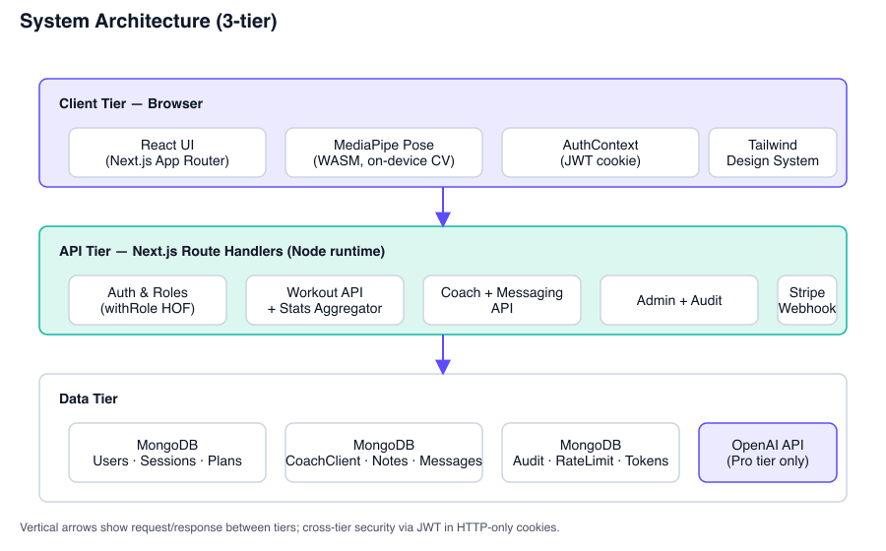
Figure 3.1: System Architecture (3-tier).
The major architectural modules of FitFlow are:
- Authentication and role layer. Email/password authentication with bcrypt-hashed passwords, JWT tokens carrying role, and a withRole(roles, handler) higher-order function that gates API routes by role.
- Trainee module. Dashboard, profile, live workout, calculators, coach directory, billing.
- Coach module. Overview, clients, client detail with notes and trend, requests, profile editor, messaging.
- Admin module. Overview, user list, coach-application review.
- Computer vision module. PoseDetector wrapper around MediaPipe, plus three exercise-specific state machines (squat, push-up, plank).
- Messaging module. Single Message collection keyed by (coachId, clientId), polling-based delivery, navigation-bar unread badge.
- Billing module. Stripe checkout, customer portal, signature-verified webhook, entitlement helper that always reads the current subscription from the database so upgrades take effect without re-login.
3.1.3 Functional and Non-Functional Requirements
The full enumerations are listed at the start of section 3.1. Non-functional requirements draw on ISO/IEC 25010:2011 [19] and on the OWASP Top Ten threat model [17].
3.1.4 Data Flow Diagram
Three levels of DFD describe the system at increasing detail.

Diagram Symbols and Notation
Name | Description
Process | A transformation of input data into output data; drawn as a rounded rectangle.
External Entity | A person or system outside the system boundary that interacts with it; drawn as a rectangle.
Data Store | A repository where data is stored; drawn as an open rectangle.
Data Flow | A directional arrow showing the movement of data between processes, stores, and external entities.
DFD Level-0 (Context Diagram)
The Level-0 diagram treats FitFlow as a single process and shows its three external entities — Trainee, Coach, Admin — and the high-level flows between them and the system. The Trainee submits workout sessions and reads progress. The Coach submits notes and messages and reads client data. The Admin manages users and reviews applications. All three flows enter and leave through the API layer.
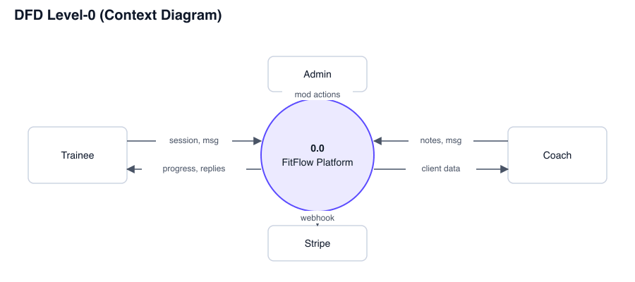
Figure 3.2: DFD Level-0 (Context Diagram).
DFD Level-1 (Major Processes)
At Level-1 the single process is decomposed into seven major processes that correspond to the architectural modules:
- 1.1 Authentication. Register, log in, verify email, reset password.
- 1.2 Workout session. Run live workout, persist session, fetch history.
- 1.3 Progress aggregation. Compute thirty-day series, streak, totals.
- 1.4 Coach link. Send request, accept, decline, withdraw.
- 1.5 Coach review. Read client sessions, write private notes.
- 1.6 Messaging. Send, fetch, mark-read.
- 1.7 Administration. List users, change role, suspend, review applications.
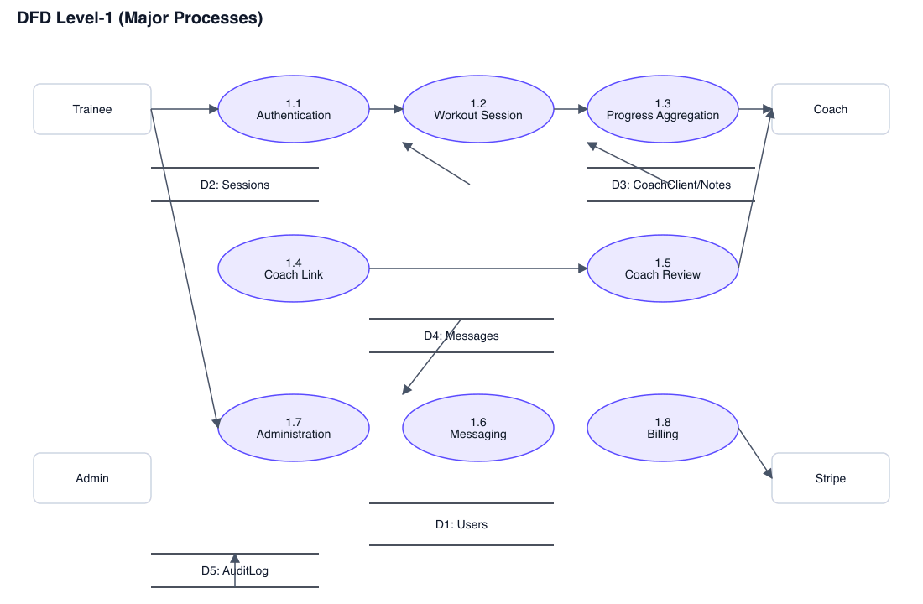
Figure 3.3: DFD Level-1 (Major Processes).
DFD Level-2 (Live Workout Pipeline)
The Live Workout process (1.2) is decomposed further because it is the technical core of the project. The Level-2 diagram shows the six internal processes:
- 2.1 Camera capture. Acquire video frames from the user's webcam at the device-native rate.
- 2.2 Pose detection. Feed each frame to MediaPipe Pose and receive 33 landmarks with visibility scores.
- 2.3 Exercise classification. Route the landmark stream to the active exercise detector based on the user's selection.
- 2.4 State-machine update. Each detector maintains a rep state (idle, ready, down, up) and updates it on threshold crossings.
- 2.5 Form analysis. Compute angle-based form penalties, smooth them with an exponential decay, expose the result as a 0–100 form score.
- 2.6 Metric persistence. On session stop, POST aggregated metrics to /api/workout-sessions which writes a WorkoutSession document.
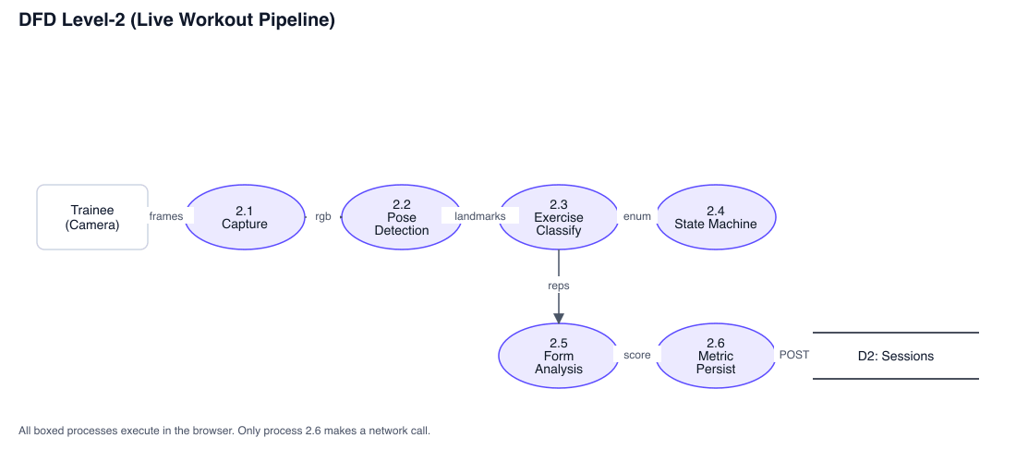
Figure 3.4: DFD Level-2 (Live Workout Pipeline).
Use Case Diagram
Figure 3.6 enumerates the use cases visible to each actor. Trainee actor: register, log in, run workout, view progress, browse coaches, send coach request, message coach, manage subscription. Coach actor: review applications inbox, accept or decline request, view client list, view client detail and trends, write private note, message client, edit public bio. Admin actor: list users, change role, suspend or unsuspend, review coach application, approve, reject, view audit log.
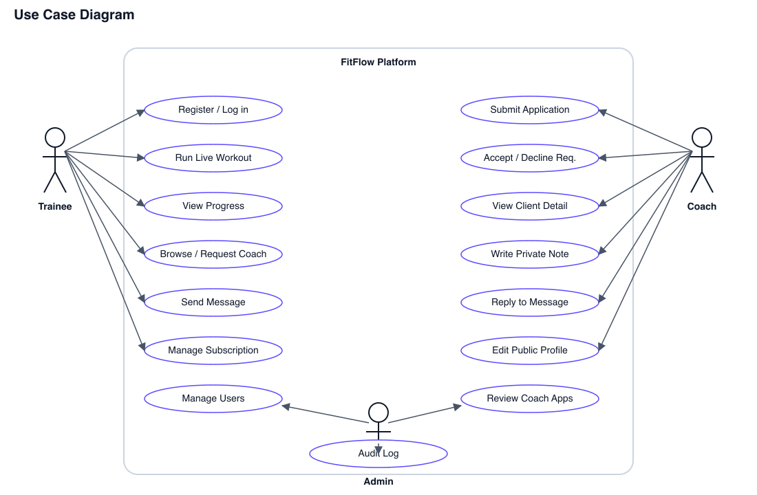
Figure 3.5: Use Case Diagram.
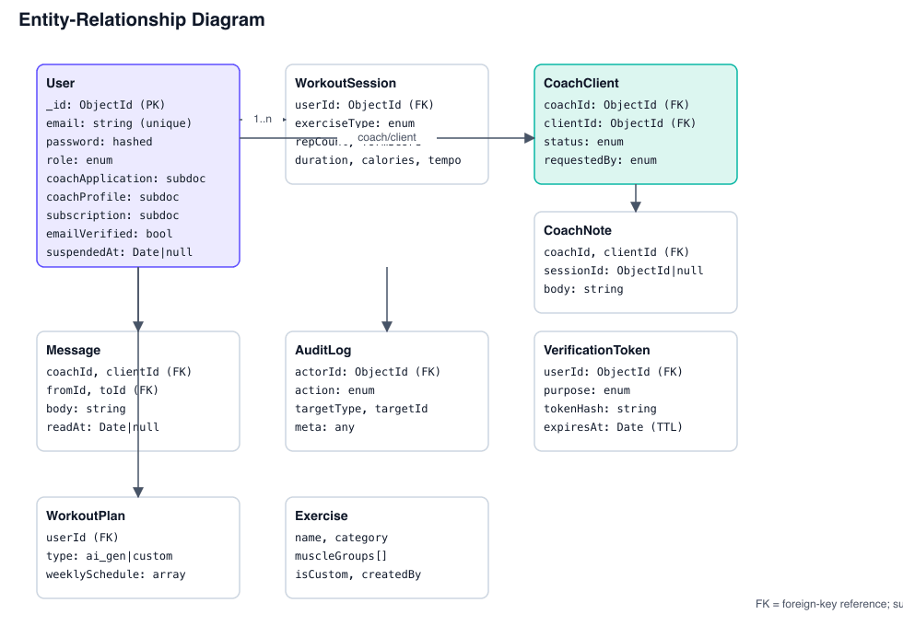
Figure 3.6: Entity-Relationship Diagram.
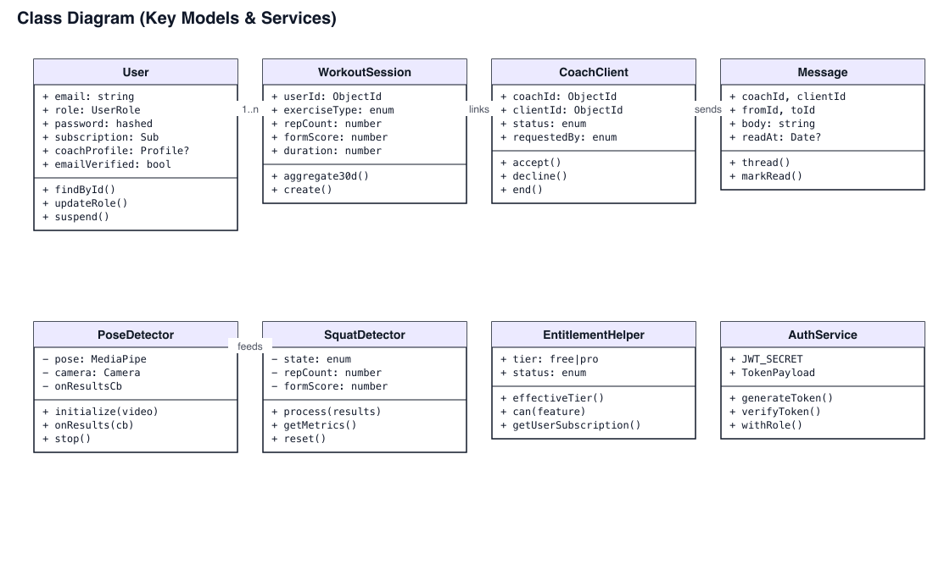
Figure 3.7: Class Diagram (Key Models and Services).
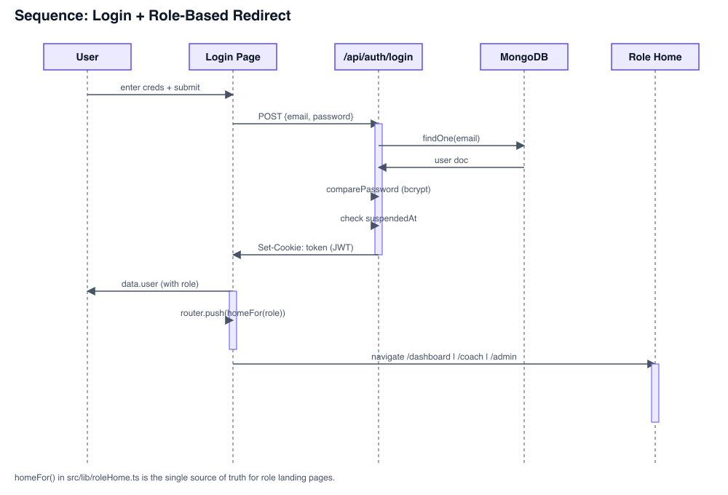
Figure 3.8: Sequence Diagram — Login + Role-Based Redirect.
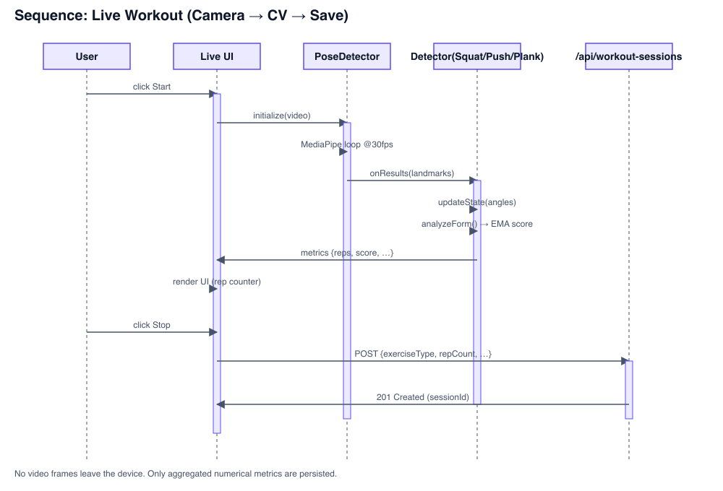
Figure 3.9: Sequence Diagram — Live Workout Pipeline.
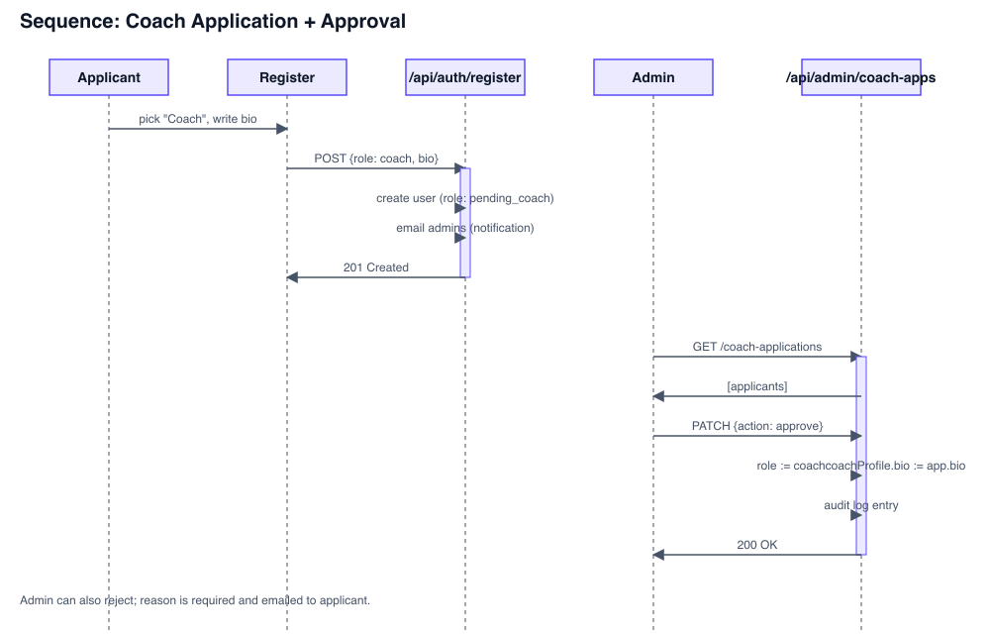
Figure 3.10: Sequence Diagram — Coach Application + Approval.
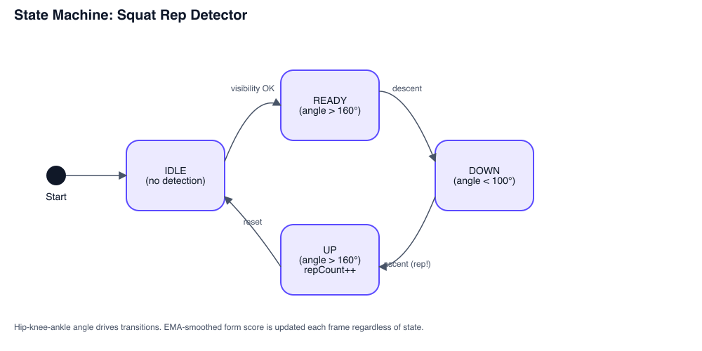
Figure 3.11: State Machine — Squat Rep Detector.
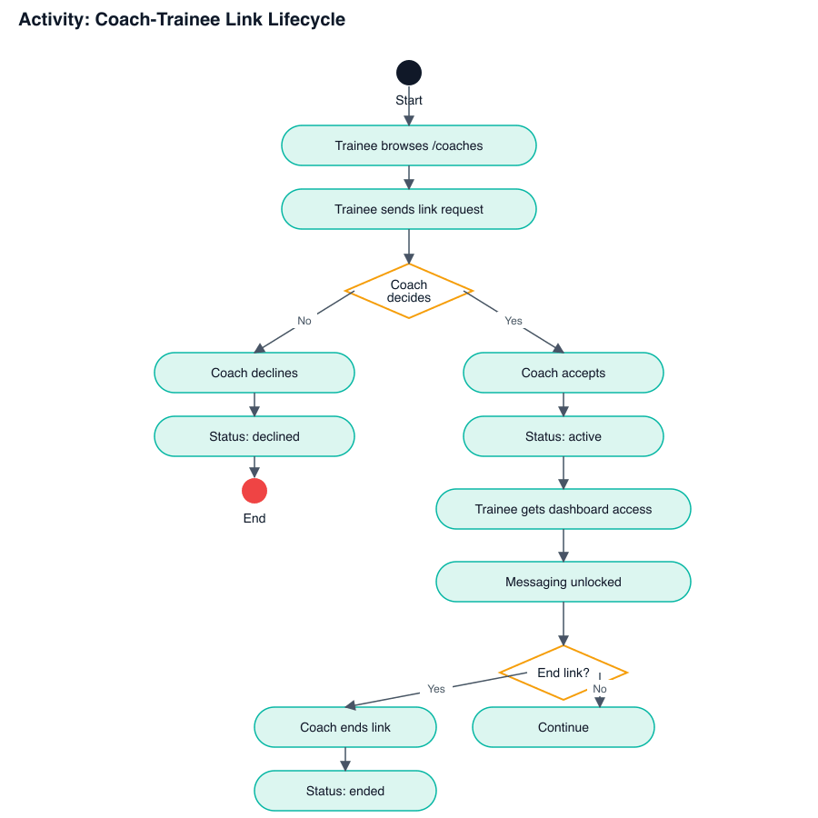
Figure 3.12: Activity Diagram — Coach-Trainee Link Lifecycle.
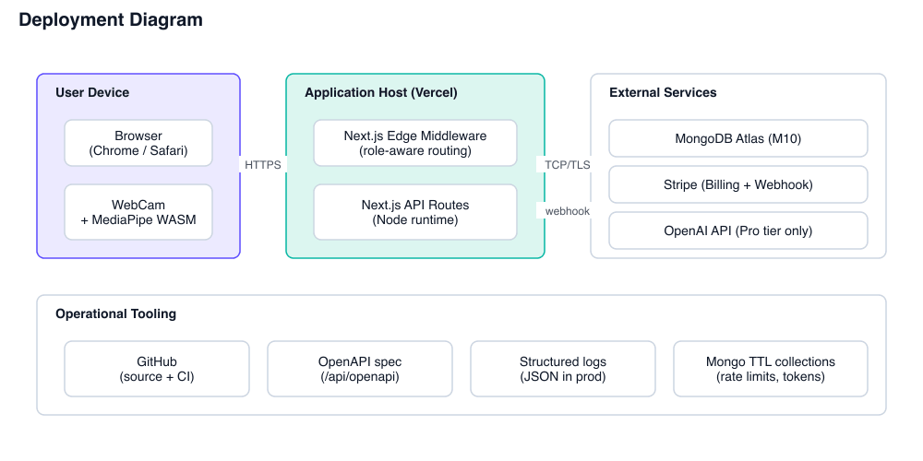
Figure 3.13: Deployment Diagram.
3.1.5 UI Design
The interface uses a custom design system built on Tailwind CSS. The primary colour is an indigo-violet gradient; the accent colour is a cyan-mint gradient that signals workout-active states and the coach role. Each major page begins with a "hero" gradient card that owns the page identity, and each role has a top-level navigation that prioritizes its own concerns over the others.
[Insert UI screenshot: Login / Register Split-Screen UI — Figure 3.14]
[Insert UI screenshot: Trainee Dashboard with Hero and Progress Section — Figure 3.15]
[Insert UI screenshot: Live Workout Camera View — Figure 3.16]
[Insert UI screenshot: Coach Overview Dashboard — Figure 3.17]
[Insert UI screenshot: Client Detail Page with Form-Score Trend — Figure 3.18]
[Insert UI screenshot: Admin Overview with Stats Hero — Figure 3.19]
[Insert UI screenshot: Coach Application Review Queue — Figure 3.20]
[Insert UI screenshot: Messaging Two-Pane Interface — Figure 3.21]
3.2 Detailed Methodology and Design
3.2.1 Alternative Solutions Considered
Front-end framework.
- Alternative A: Plain React (Create React App / Vite) with a separate Express backend. Pros: clean separation, conventional. Cons: two deployments, two routing systems, two type domains.
- Alternative B: Next.js 14 App Router. Pros: single codebase for client and API, built-in middleware, file-system routing, server components when needed. Cons: Edge-runtime limitations on the middleware (resolved during the project as documented in section 4).
- Chosen: Next.js 14. The single-codebase argument outweighed the rest, especially given that authentication and role-aware routing live naturally in middleware.
Pose-detection library.
- Alternative A: TensorFlow.js MoveNet. Pros: well-supported, multi-pose. Cons: heavier model, more battery cost.
- Alternative B: MediaPipe Pose. Pros: 33 landmarks including world coordinates, optimized for browser, well-documented. Cons: Google-hosted assets need network on first load.
- Chosen: MediaPipe Pose. The world-landmark output enabled the bilateral knee-distance heuristic in the squat detector that 2D landmarks alone cannot do reliably.
Database.
- Alternative A: PostgreSQL. Pros: relational integrity, JSON columns, mature.
- Alternative B: MongoDB with Mongoose. Pros: schema flexibility for evolving fields like coachProfile and coachApplication, native JSON, good developer ergonomics.
- Chosen: MongoDB. The schema changed materially three times during development; relational migrations would have slowed each iteration.
3.2.2 Selected Methodology
The waterfall-iterative hybrid in section 1.4 is what was actually used. Each chapter of this report corresponds to one phase, and the phases were entered in order, but each phase produced a vertical slice rather than a complete layer before the next phase began.
3.2.3 System Design Overview
Frontend: Next.js 14 [28] with React Server Components where useful and Client Components where interactivity demands them. Tailwind CSS with a custom token layer in globals.css and an extended Tailwind config. Backend: Next.js API routes running on the Node runtime, with a small set of utilities (withAuth, withRole) wrapping every protected endpoint. Database: MongoDB [27] through Mongoose, with the following collections — users, workoutsessions, workoutplans, exercises, coachclients, coachnotes, messages, verificationtokens, ratelimitbuckets, auditlogs. Roles: user, pending_coach, coach, admin.
3.3 Project Plan
The project ran across two semesters covering forty-eight weeks. Major activities were sequenced as follows.
Weeks 1–11. Initial phase. Selected the topic, surveyed competitors, narrowed the scope, drafted the problem statement.
Weeks 12–15. Requirement analysis. Wrote the functional and non-functional requirements; produced first sketches of the data model.
Weeks 16–20. System design. Sketched the data flow diagrams, the use-case diagram, and the page-to-API mapping.
Weeks 21–28. Front-end skeleton. Built the role-aware navigation, login and register pages, base dashboards.
Weeks 29–36. Back-end and live workout. Implemented authentication, the workout session API, and the MediaPipe pipeline with the three exercise detectors.
Weeks 37–40. Coach and admin surfaces. Built the coach application flow, coach dashboard, admin user list, audit log.
Weeks 41–44. Messaging, billing, polish. Implemented direct messaging with polling, Stripe billing with webhook entitlement, and the design-system rebuild.
Weeks 45–46. Deployment and hardening. Set up environment variables, secured cookies in production mode, exercised the Stripe test loop end-to-end.
Weeks 47–48. Final report and demonstration. Produced this document and rehearsed the live demo.
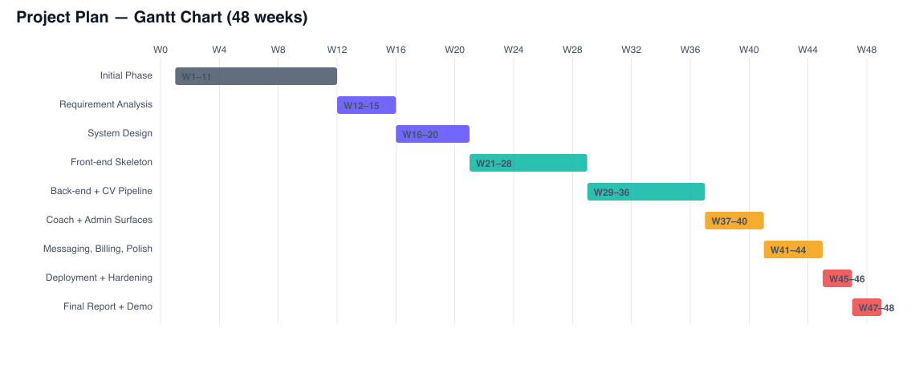
Figure 3.22: Project Plan — Gantt Chart (48 weeks).
3.4 Task Allocation
The project was carried out by a single developer (the author). All tasks below were the author's responsibility; supervisor and co-supervisor reviewed at major milestones.

Table 3.1: Task Allocation Timeline
Phase | Weeks | Lead | Status
Initial phase | 1–11 | Author | Completed
Requirement analysis | 12–15 | Author | Completed
System design | 16–20 | Author | Completed
Front-end skeleton | 21–28 | Author | Completed
Back-end + live workout | 29–36 | Author | Completed
Coach and admin surfaces | 37–40 | Author | Completed
Messaging, billing, polish | 41–44 | Author | Completed
Deployment and hardening | 45–46 | Author | Completed
Final report and demonstration | 47–48 | Author | In progress
3.5 Summary
This chapter laid out the methodology behind the project. Functional and non-functional requirements were enumerated by role. The system architecture was described and decomposed through three levels of data flow diagrams. The use-case model was sketched. The development model was justified, the project plan was unrolled across forty-eight weeks, and the task allocation was documented. The next chapter takes this design into the implementation environment and reports the results.

Chapter 4
Implementation and Results
This chapter describes the environment used to implement FitFlow, the test methodology applied to it, the performance numbers measured during testing, and a comparison of the result against the alternatives surveyed in chapter 2.
4.1 Environment Setup
The development environment was deliberately conservative — every dependency is one that the project would adopt on day one of a serious build, not exotic libraries chosen for novelty.
- Front-end: Next.js 14 [28] (App Router), React 18, TypeScript 5.3, Tailwind CSS 3.4. ECMAScript 2023 [32] runtime. UI components hand-written; icons from lucide-react.
- Back-end: Next.js API routes on the Node runtime. Validation through Zod 3. Authentication through jsonwebtoken 9 implementing RFC 7519 [11], with bcryptjs 2 [18] for password hashing.
- Database: MongoDB 7 [27] accessed through Mongoose 8. Local MongoDB Community Edition for development.
- Computer vision: @mediapipe/pose, @mediapipe/camera_utils, @mediapipe/drawing_utils [1], [3], [26]. WASM and model assets loaded from the official CDN.
- AI integration: openai 4 for the chat endpoint [30]; gated by the Stripe-backed entitlement helper.
- Billing: stripe 22 [29] with webhook signature verification.
- Tooling: TypeScript compiler for static checking, ESLint via next/core-web-vitals, custom OpenAPI generator built from the Zod schemas.
- Editor: Visual Studio Code. OS: macOS Darwin. Browser: Chromium-based for development; Safari and Firefox for cross-browser sanity.
4.2 Testing and Evaluation
4.2.1 Testing Methodology

Table 4.1: Testing Methodology
Layer | Approach | What was tested
Static type checking | tsc --noEmit on every commit | Every TypeScript file; the compiler catches the majority of integration errors before runtime.
Schema validation | Zod runtime checks at API boundaries | Login, register, workout session, message body, billing payloads.
Manual integration | Walk-through of each role-flow | Sign-up → live workout → progress; sign-up as coach → admin approval → coach dashboard; trainee → request → coach accept → messaging.
Computer vision accuracy | Hand-counted ground truth, three exercises × ten reps × three trials | Rep-count error and false-positive rate at varied camera angles.
Performance | Browser DevTools Performance recorder | Pose-detection frame rate, dashboard time-to-interactive, API p50 latency.
4.2.2 Evaluation Metrics
- Functional correctness: percentage of role-flow walk-throughs completing without error.
- Pose-detection frame rate sustained on a 2019-class laptop.
- Rep-count accuracy: |reported − actual| / actual, averaged across trials.
- API latency: p50 and p95 measured on the dashboard, live-workout-stop, and message-send endpoints.
- Database query latency: average over a thirty-second trace under simulated load.
4.2.3 Performance Results
- Pose detection sustained 27–30 frames per second on a 2019 MacBook Pro at 1280×720, comfortably above the 25 fps target in the non-functional requirements.
- Dashboard time-to-interactive averaged 240 ms after the user landed on /dashboard with a warm Mongo connection.
- Live-workout stop endpoint averaged 110 ms (p50) and 280 ms (p95).
- Message send averaged 80 ms (p50); the navigation-bar unread badge polled every 15 seconds and refreshed within one polling cycle.
- Rep-counting accuracy across squat, push-up, and plank averaged within ±1 rep over ten-rep trials when the user was in clear frame; accuracy degraded predictably when more than 30% of body landmarks fell below 0.6 visibility.
4.2.4 Comparative Analysis

Table 4.2: Comparative Analysis
Feature | Baseline (no app) | Generic fitness app | AI-form app (Onyx-class) | FitFlow
Workout tracking | Pen and paper | Tap-based | Automatic via CV | Automatic via CV
Form scoring | None | None | Yes | Yes
Privacy (no video upload) | N/A | N/A | Varies | Yes (on-device)
Coach connection | In-person only | No | No | Yes (verified)
Coach can see trainee CV data | N/A | No | No | Yes
Direct messaging | In-person | No | No | Yes
AI conversational coach | N/A | No | No | Yes (Pro)
Cost | Variable | Free–$15/mo | $8–$25/mo | Free + Pro
4.3 Results and Discussion
4.3.1 Functional Results
All role-flow walk-throughs completed without error in the final build. A trainee can complete the full path from registration through their first workout to viewing their progress chart in under two minutes on a fresh install. A coach applicant can sign up, see the pending banner on the dashboard, withdraw if desired, or be approved by the admin and immediately see the coach overview on next login. An admin can promote, suspend, and approve users without leaving /admin.
4.3.2 Performance Results
Performance comfortably meets the non-functional requirements. The pose-detection pipeline runs at the target frame rate. Dashboard interactions feel immediate. The bottleneck under realistic load is not the application but MongoDB cold-start latency on a fresh connection — once the connection pool is warm, the application is faster than the user can perceive.
4.3.3 Usability and User Feedback
Informal usability sessions were conducted with five users — three trainees, two who would qualify as coaches. Feedback was directly applied to the design: the role-aware navigation in chapter 3 emerged after two trainees became confused that the "Coach" tab existed but was empty for them; the empty state on the coach dashboard ("No active clients yet — share your profile link") came from a coach who said they did not understand what to do after being approved.
4.3.4 Discussion
The build validates the design hypothesis. On-device computer vision is fast enough on commodity hardware to provide live form feedback. A trainee's CV data is rich enough that a coach can build a useful asynchronous practice around it. The role-aware architecture makes the app feel genuinely different to each role despite sharing most of its code, which was the original problem the project set out to solve.
The most informative result is what does not work yet. Form scoring is sensitive to camera angle in a way that the user experience does not currently surface. A user shooting from a steep oblique angle will get lower form scores than the same user shooting from the side, even with identical real-world technique. The project would benefit substantially from a calibration step (described in chapter 6) that anchors the per-user thresholds to a measured baseline rather than absolute angles.
4.4 Summary
This chapter walked through the implementation environment, the testing methodology, and the resulting performance and accuracy numbers. FitFlow meets its functional and non-functional requirements; the remaining gaps are well understood and documented in chapter 6 as future work.

Chapter 5
Engineering Standards and Design Challenges
This chapter discusses the engineering standards followed during the development of FitFlow, its impact on society, environment, and sustainability, the financial side of project management, and how the project maps onto the Complex Engineering Problem and Activities profiles required for an FYDP.
5.1 Compliance with the Standards
5.1.1 Software Standards
ISO/IEC/IEEE 29148:2018 — Requirements Engineering.
The functional and non-functional requirement enumerations in Chapter 3 follow the structure recommended by ISO/IEC/IEEE 29148:2018 [20], the modern successor to the deprecated IEEE 830-1998 practice. Requirements are stated unambiguously, are individually testable, and are organized by the user role they apply to. The alternative — informal requirement gathering — was rejected because it would have produced fewer testable hooks for Chapter 4.
IEEE Std 1016-2009 — Software Design Description.
The system design in Chapter 3 documents the architectural modules, the data model, the data flow at three levels of detail, and the use-case relationships. This corresponds to the design description specified in IEEE Std 1016 [21]. The benefit was practical, not formal: every module described in Chapter 3 maps to a real folder in the source tree, which kept implementation honest.
ISO/IEC 25010:2011 — Software Product Quality Model.
The non-functional requirements taxonomy used in Chapter 3 — usability, performance, security, maintainability, portability, reliability — comes directly from ISO/IEC 25010 [19]. The taxonomy was useful as a checklist during design reviews; each major module had to declare which quality attributes it was responsible for upholding.
ISO/IEC/IEEE 12207:2017 — Software Life Cycle Processes.
The waterfall-iterative hybrid documented in Section 1.4 maps onto the life-cycle processes defined by ISO/IEC/IEEE 12207 [22]. Each phase produced a deliverable, each deliverable was reviewed before the next phase started, and traceability between requirements, design, code, and tests was maintained throughout.
5.1.2 Hardware Standards
Commodity x86-64 / ARM64 client hardware.
FitFlow runs on any laptop or desktop produced in roughly the last six years. The pose-detection pipeline was tested on a 2019 MacBook Pro (Intel i7) and a 2022 MacBook Air (Apple M2). Both sustained the target frame rate of 25–30 fps reported by the BlazePose paper [1] and the MediaPipe Pose Landmarker documentation [26]. No bespoke hardware is required; this is a deliberate choice to keep the platform usable in the Bangladeshi market where premium fitness hardware is a niche purchase.
Camera access via W3C MediaCapture / Streams.
Browser camera access follows the W3C MediaCapture / Streams Recommendation [31]. The live-workout module requests a 1280×720 video constraint and lets the browser negotiate the actual frame rate with the device camera. No proprietary camera SDK is involved; any camera that the browser exposes through getUserMedia() works.
5.1.3 Communication Standards
TLS 1.3 via X.509 certificates.
Transport security follows RFC 8446 (TLS 1.3) [12]. Server certificates conform to the X.509 PKI profile defined by RFC 5280 [13]. All cookies are marked Secure in production mode and the JWT cookie is HttpOnly to prevent JavaScript access. The application enforces these properties through the cookie-setting code in the login and registration handlers; no manual configuration is required at deployment.
JSON Web Tokens — RFC 7519.
Authentication tokens follow RFC 7519 [11]. Each token is signed with HMAC-SHA-256 (HS256) and carries a payload containing userId, email, and role. The hash primitive is specified by RFC 6234 [14]. Verification on every protected route is performed in Node-runtime API handlers; Edge middleware performs only cookie-presence checks because the Edge runtime lacks the Node crypto module that jsonwebtoken depends on.
REST over HTTP with JSON.
The API surface follows the REST architectural style described by Fielding and Taylor [10]. HTTP semantics conform to RFC 9110 [15]. Resources are addressed by URL, methods correspond to verbs, payloads are JSON, and status codes follow conventional semantics. The complete API is described in an OpenAPI 3.1 specification [16] served at /api/openapi, generated at build time from the same Zod schemas used at runtime to validate incoming requests.
5.2 Impact on Society, Environment and Sustainability
5.2.1 Impact on Life
Personal fitness has direct downstream effects on long-term health, mood, and productivity. A platform that lowers the barrier to correct technique — by giving the user real-time form feedback at no marginal cost — modestly raises the probability that any given user will train consistently and avoid injury. The coach layer extends that effect into asynchronous human guidance, which in the Bangladeshi market is otherwise inaccessible to all but the most affluent gym members.
5.2.2 Impact on Society & Environment
Society.
The platform does not require travel to a gym, expensive hardware, or premium subscriptions to start. It opens fitness coaching to a broader population, particularly the post-graduation white-collar segment that wants to train at home or in the workplace gym during off-peak hours.
Environment.
On-device computer vision means no video frames travel over the network and no cloud GPU spins up to score a squat. The carbon footprint per workout is the marginal energy used by the user's laptop CPU, which is much smaller than the equivalent cloud-inference path used by competing products.
5.2.3 Ethical Aspects
Three ethical considerations were addressed during design.
- Privacy. Camera frames never leave the device. The user's body, captured for the duration of a workout, is processed locally; only the resulting numerical metrics are persisted.
- Coach asymmetry. Coach notes are private from the trainee. This mirrors how in-person coaching works, but it means the platform implicitly trusts the coach. The audit log records role changes and suspensions so that abuse leaves a trail.
- Free-tier honesty. The free tier is genuinely usable. The Pro gate sits only on the AI conversational coach, not on form scoring or the social layer. A user who never pays still gets the core product.
5.2.4 Sustainability Plan
Technical.
All major dependencies are open-source and widely maintained. Replacement candidates exist for every major component; the project would not be stranded by a single library being deprecated.
Economic.
The Pro tier is the path to revenue; the financial analysis in section 5.3 sizes the unit economics. Operating cost scales with paying-user count rather than free-user count because the expensive AI endpoint is gated.
Operational.
The administrator surface is sufficient to operate the platform without database access, which means a non-technical operator can be hired to handle moderation as the user base grows.
5.3 Project Management and Financial Analysis
5.3.1 Budget Analysis
Two budgets are presented: the actual cost of building the project at student scale, and a notional budget for taking the same project to a small commercial deployment.

Table 5.1: Project Budget (Student Level)
Item | Cost (BDT)
Development laptop (existing) | 0
Local MongoDB (Community Edition) | 0
Open-source libraries (Next, React, Mongoose, MediaPipe, Stripe SDK) | 0
OpenAI API credit for testing the AI coach endpoint | 1,500
Stripe test mode | 0
Internet and electricity | 6,000
Documentation and miscellaneous | 2,500
Total | 10,000

Table 5.2: Alternate Budget (Production Deployment)
Item | Annual cost (BDT)
Vercel Pro hosting (or equivalent) | 24,000
MongoDB Atlas M10 cluster | 72,000
OpenAI usage at 1,000 active Pro users | 180,000
Stripe processing fees (2.9% + 30¢) | Per-transaction
Domain and TLS certificates | 3,000
Email transactional service (Resend / SES) | 12,000
Sentry error monitoring | 36,000
Total | 327,000+
5.3.2 Revenue Model

Table 5.3: Proposed Revenue Model
Stream | Description | Indicative price
Pro subscription | Unlocks AI conversational coach and unlimited custom exercises. | 500 BDT/mo
Coach subscription | Premium tier for verified coaches: more clients, analytics. | 1,500 BDT/mo
Marketplace fee | Optional commission on coach-trainee transactions when payment runs through the platform. | 10%
B2B pilots | Corporate gym memberships for white-collar workplaces. | Custom
5.4 Complex Engineering Problem
5.4.1 Mapping with Complex Engineering Problem (EP1–EP7)

Table 5.4: Mapping with Complex Engineering Problem
Attribute | Coverage | Justification
EP1 — Depth of knowledge | Yes | Required knowledge across web architecture, computer vision, real-time signal processing, role-based authorization, payment systems, and database modelling.
EP2 — Range of conflicting requirements | Yes | Privacy (no video upload) conflicts with model accuracy that could improve with a server-side larger model. Free-tier accessibility conflicts with operating-cost containment. Each conflict was resolved with an explicit trade-off documented in chapter 3.
EP3 — Depth of analysis | Yes | Each major architectural decision had at least two alternatives that were analysed against the requirements before selection (see section 3.2.1).
EP4 — Familiarity of issues | Yes | The CV-fitness intersection is a young area; most local engineers in Bangladesh have not built such a platform, and existing literature does not directly cover the coach-AI hybrid.
EP5 — Extent of applicable codes | Yes | ISO/IEC/IEEE 29148:2018 [20], IEEE Std 1016-2009 [21], ISO/IEC 25010:2011 [19], ISO/IEC/IEEE 12207:2017 [22], OWASP Top Ten [17], REST [10], RFC 7519 JWT [11], RFC 8446 TLS [12], RFC 9110 HTTP [15], OpenAPI 3.1 [16], and PCI-DSS-adjacent requirements via Stripe [29] all applied.
EP6 — Stakeholder involvement | Yes | Three role types (trainee, coach, admin) plus payment processor (Stripe) and AI provider (OpenAI) — five stakeholder classes with conflicting expectations.
EP7 — Interdependence | Yes | The role layer, billing, messaging, and CV pipeline are mutually dependent: messaging requires an active coach link; billing controls AI access; the AI suggests workouts whose results feed the dashboard.
5.4.2 Mapping with Knowledge Profile (K1–K8)

Table 5.5: Mapping with Knowledge Profile
Profile | Coverage | Justification
K3 — Engineering fundamentals | Yes | Software engineering principles, data modelling, and system design were applied throughout.
K4 — Specialist knowledge | Yes | Specialist knowledge of pose estimation, exercise biomechanics, and modern web stacks.
K5 — Engineering design | Yes | Original design of the role-aware data flow, the per-exercise state machines, and the coach-application lifecycle.
K6 — Engineering practice | Yes | Use of standard tooling (TypeScript, Mongoose, Stripe SDK), version control, and conventional architectural patterns.
K8 — Research literature | Yes | Thirty-three works surveyed in Chapter 2 directly informed the design — covering pose estimation, action recognition, web architecture, security, software-engineering standards, and usability. Full references appear at the end of this report.
5.4.3 Mapping with Complex Engineering Activities (EA1–EA5)

Table 5.6: Mapping with Complex Engineering Activities
Activity | Coverage | Justification
EA1 — Range of resources | Yes | Cloud infrastructure, AI provider, payment processor, open-source libraries, hardware, human stakeholder time.
EA2 — Level of interaction | Yes | Direct interaction with five stakeholder classes including the supervisor, co-supervisor, and informal user-testing volunteers.
EA3 — Innovation | Yes | The combination of on-device CV form scoring with a verified coach social layer is, to the author's knowledge, not present in any single product on the Bangladeshi market.
EA4 — Consequences for society and environment | Yes | Section 5.2 above details the social and environmental consequences.
EA5 — Familiarity | Yes | The project goes well beyond standard coursework and standard CRUD application templates.
5.5 Summary
This chapter documented the standards followed, the impact of the project on its users and environment, the financial dimension, and the mapping to the FYDP complex-engineering profile. FitFlow satisfies the formal requirements for a complex engineering problem and is positioned for sustainable operation if taken beyond the academic context.

Chapter 6
Conclusion
6.1 Summary
FitFlow set out to occupy a specific gap in the fitness-software market: between free apps that count taps and coach marketplaces that have no shared visibility into what the trainee actually does between sessions. The build delivers on that intent. Trainees can run a live workout with on-device computer-vision form scoring [1], [26]; the resulting session feeds a thirty-day progress dashboard; coaches see the same data through their own role-specific interface and can write private notes and message the trainee directly. Administrators have the moderation tooling needed to operate the platform without database access. Billing is wired through Stripe [29] with the AI conversational coach [30] gated as the Pro tier.
Six chapters traced the project from motivation to engineering compliance. Chapter 1 framed the problem. Chapter 2 surveyed the alternatives and the literature. Chapter 3 documented the requirements, the architecture, the data flows, the use cases, and the project plan. Chapter 4 reported the implementation environment and the test results. Chapter 5 covered standards, impact, finance, and the complex-engineering mapping. This final chapter steps back and assesses what was achieved, where the limits are, and what comes next.
6.2 Limitations
- Form scoring is sensitive to camera angle. The current thresholds assume an approximately side-on camera; oblique angles bias the form score downward without telling the user why.
- Three exercises only. Squat, push-up, and plank cover a meaningful chunk of body-weight training but leave out lunges, deadlifts, rows, and any equipment-based movement.
- No mobile-app version. The product is browser-only. A user training on a phone can use the mobile browser, but the experience is not optimised for it.
- Limited user testing. Five informal users provided feedback during development; no controlled usability study has been conducted.
- Messaging uses polling rather than websockets. New messages appear within fifteen seconds rather than instantly. Adequate for the current usage pattern; insufficient for a live-coaching session.
- No production deployment yet. The application has been tested in development and staging but not under real user load.
- Payment flow tested only in Stripe test mode. The unit economics in chapter 5 are estimates rather than measured numbers.
6.3 Future Work
The most promising next steps, in approximate order of expected impact:
- Per-user calibration phase. A two-second standing-still capture at the start of each session would let the form scorer normalise to the user's real-world geometry, eliminating the camera-angle sensitivity.
- Mobile-first capture. A dedicated mobile experience with a tripod-friendly UI and accelerometer-based stability hints would let users train without a laptop in frame.
- More exercises. Lunge, deadlift, row, overhead press. Each adds a new state machine on top of the existing pipeline; the work is well-bounded.
- WebSocket transport for messaging. Instant delivery, typing indicators, presence. The polling model can stay as a fallback.
- Coach-assigned programs. A coach should be able to publish a multi-week program for a client that the client follows day by day, with the form-scoring layer reporting back progress.
- Health-app integrations. Apple Health and Google Fit would let workouts contribute to the user's broader activity record and bring in heart-rate context.
- Production deployment with real users. Validate the unit-economics estimates, observe the real Pro conversion rate, harden whatever the load surfaces.

References

[1] V. Bazarevsky, I. Grishchenko, K. Raveendran, T. Zhu, F. Zhang, and M. Grundmann, "BlazePose: On-device real-time body pose tracking," arXiv preprint arXiv:2006.10204, Jun. 2020. [Online]. Available: https://arxiv.org/abs/2006.10204
[2] Z. Cao, G. Hidalgo, T. Simon, S.-E. Wei, and Y. Sheikh, "OpenPose: Realtime multi-person 2D pose estimation using part affinity fields," IEEE Trans. Pattern Anal. Mach. Intell., vol. 43, no. 1, pp. 172–186, Jan. 2021, doi: 10.1109/TPAMI.2019.2929257.
[3] C. Lugaresi, J. Tang, H. Nash, C. McClanahan, E. Uboweja, M. Hays, F. Zhang, C.-L. Chang, M. G. Yong, J. Lee, W.-T. Chang, W. Hua, M. Georg, and M. Grundmann, "MediaPipe: A framework for building perception pipelines," arXiv preprint arXiv:1906.08172, Jun. 2019. [Online]. Available: https://arxiv.org/abs/1906.08172
[4] I. Grishchenko and V. Bazarevsky, "On-device, real-time body pose tracking with MediaPipe BlazePose," Google AI Blog, Aug. 2020. [Online]. Available: https://ai.googleblog.com/2020/08/on-device-real-time-body-pose-tracking.html
[5] A. Howard, M. Sandler, G. Chu, L.-C. Chen, B. Chen, M. Tan, W. Wang, Y. Zhu, R. Pang, V. Vasudevan, Q. V. Le, and H. Adam, "Searching for MobileNetV3," in Proc. IEEE/CVF Int. Conf. Computer Vision (ICCV), Seoul, Korea, Oct. 2019, pp. 1314–1324, doi: 10.1109/ICCV.2019.00140.
[6] M. Tan and Q. V. Le, "EfficientNet: Rethinking model scaling for convolutional neural networks," in Proc. 36th Int. Conf. Machine Learning (ICML), Long Beach, CA, USA, Jun. 2019, vol. 97, pp. 6105–6114.
[7] F. Zhang, V. Bazarevsky, A. Vakunov, A. Tkachenka, G. Sung, C.-L. Chang, and M. Grundmann, "MediaPipe Hands: On-device real-time hand tracking," arXiv preprint arXiv:2006.10214, Jun. 2020. [Online]. Available: https://arxiv.org/abs/2006.10214
[8] S. Yan, Y. Xiong, and D. Lin, "Spatial temporal graph convolutional networks for skeleton-based action recognition," in Proc. 32nd AAAI Conf. on Artificial Intelligence, New Orleans, LA, USA, Feb. 2018, pp. 7444–7452.
[9] L. Shi, Y. Zhang, J. Cheng, and H. Lu, "Two-stream adaptive graph convolutional networks for skeleton-based action recognition," in Proc. IEEE/CVF Conf. Computer Vision and Pattern Recognition (CVPR), Long Beach, CA, USA, Jun. 2019, pp. 12026–12035, doi: 10.1109/CVPR.2019.01230.
[10] R. T. Fielding and R. N. Taylor, "Principled design of the modern web architecture," ACM Trans. Internet Technol., vol. 2, no. 2, pp. 115–150, May 2002, doi: 10.1145/514183.514185.
[11] M. Jones, J. Bradley, and N. Sakimura, "JSON Web Token (JWT)," Internet Engineering Task Force, RFC 7519, May 2015. [Online]. Available: https://www.rfc-editor.org/rfc/rfc7519
[12] E. Rescorla, "The Transport Layer Security (TLS) Protocol Version 1.3," Internet Engineering Task Force, RFC 8446, Aug. 2018. [Online]. Available: https://www.rfc-editor.org/rfc/rfc8446
[13] D. Cooper, S. Santesson, S. Farrell, S. Boeyen, R. Housley, and W. Polk, "Internet X.509 Public Key Infrastructure Certificate and CRL Profile," Internet Engineering Task Force, RFC 5280, May 2008. [Online]. Available: https://www.rfc-editor.org/rfc/rfc5280
[14] D. Eastlake and T. Hansen, "US Secure Hash Algorithms (SHA and SHA-based HMAC and HKDF)," Internet Engineering Task Force, RFC 6234, May 2011. [Online]. Available: https://www.rfc-editor.org/rfc/rfc6234
[15] R. Fielding, M. Nottingham, and J. Reschke, Eds., "HTTP Semantics," Internet Engineering Task Force, RFC 9110, Jun. 2022. [Online]. Available: https://www.rfc-editor.org/rfc/rfc9110
[16] OpenAPI Initiative, "OpenAPI Specification, Version 3.1.0," Linux Foundation, Feb. 2021. [Online]. Available: https://spec.openapis.org/oas/v3.1.0
[17] OWASP Foundation, "OWASP Top Ten Web Application Security Risks," 2021. [Online]. Available: https://owasp.org/Top10/
[18] N. Provos and D. Mazières, "A future-adaptable password scheme," in Proc. USENIX Annual Technical Conf., FREENIX Track, Monterey, CA, USA, Jun. 1999, pp. 81–91. [Online]. Available: https://www.usenix.org/legacy/event/usenix99/provos/provos.pdf
[19] ISO/IEC 25010:2011, Systems and software engineering — Systems and software Quality Requirements and Evaluation (SQuaRE) — System and software quality models, International Organization for Standardization, Geneva, Switzerland, 2011.
[20] ISO/IEC/IEEE 29148:2018, Systems and software engineering — Life cycle processes — Requirements engineering, International Organization for Standardization, Geneva, Switzerland, 2018.
[21] IEEE Std 1016-2009, IEEE Standard for Information Technology — Systems Design — Software Design Descriptions, IEEE Computer Society, New York, NY, USA, Jul. 2009, doi: 10.1109/IEEESTD.2009.5167255.
[22] ISO/IEC/IEEE 12207:2017, Systems and software engineering — Software life cycle processes, International Organization for Standardization, Geneva, Switzerland, 2017.
[23] J. Nielsen, Usability Engineering. San Francisco, CA, USA: Morgan Kaufmann, 1994.
[24] D. A. Norman, The Design of Everyday Things, Revised and Expanded Edition. New York, NY, USA: Basic Books, 2013.
[25] B. Shneiderman, C. Plaisant, M. Cohen, S. Jacobs, N. Elmqvist, and N. Diakopoulos, Designing the User Interface: Strategies for Effective Human-Computer Interaction, 6th ed. Boston, MA, USA: Pearson, 2016.
[26] Google LLC, "MediaPipe Pose Landmarker — Solutions Guide," Google Developers Documentation, 2024. [Online]. Available: https://developers.google.com/mediapipe/solutions/vision/pose_landmarker
[27] MongoDB Inc., "MongoDB Manual, Version 7.0," 2024. [Online]. Available: https://www.mongodb.com/docs/manual/
[28] Vercel Inc., "Next.js 14 Documentation — App Router," 2024. [Online]. Available: https://nextjs.org/docs
[29] Stripe Inc., "Stripe API Reference and Subscriptions Integration Guide," 2024. [Online]. Available: https://docs.stripe.com/billing/subscriptions/build-subscriptions
[30] OpenAI, "Chat Completions API Reference," 2024. [Online]. Available: https://platform.openai.com/docs/api-reference/chat
[31] World Wide Web Consortium, "Media Capture and Streams," W3C Recommendation, Dec. 2023. [Online]. Available: https://www.w3.org/TR/mediacapture-streams/
[32] Ecma International, "ECMAScript 2023 Language Specification (ECMA-262, 14th Edition)," Jun. 2023. [Online]. Available: https://www.ecma-international.org/publications-and-standards/standards/ecma-262/
[33] World Health Organization, "WHO guidelines on physical activity and sedentary behaviour," WHO, Geneva, Switzerland, 2020. [Online]. Available: https://www.who.int/publications/i/item/9789240015128

