# Feature List

* Main menu interface: Start (goes to planet explorer map), Highscores, Settings, …
* Planet Explorer (map) interface: Level system (from one planet to the other)
* Animations (background + objects)
* Collectibles (eggs) each map + Score tracking
* 3 step travel system
  + 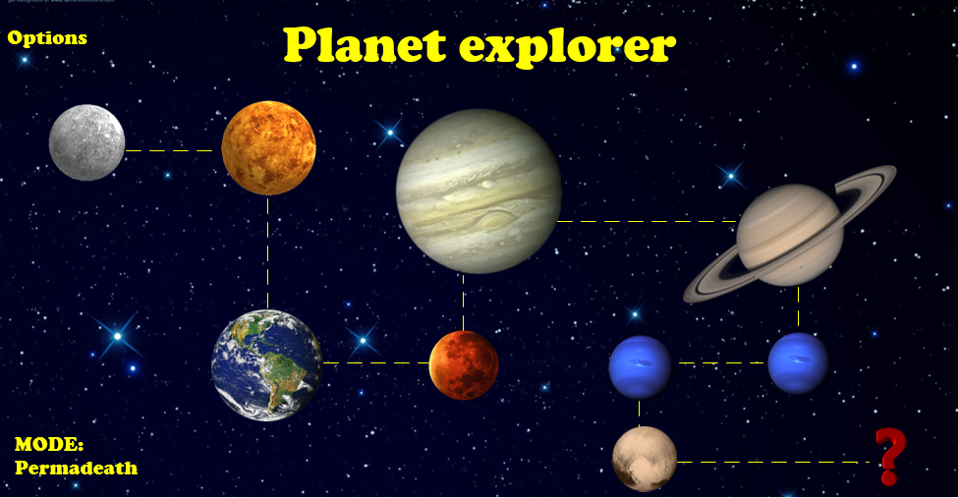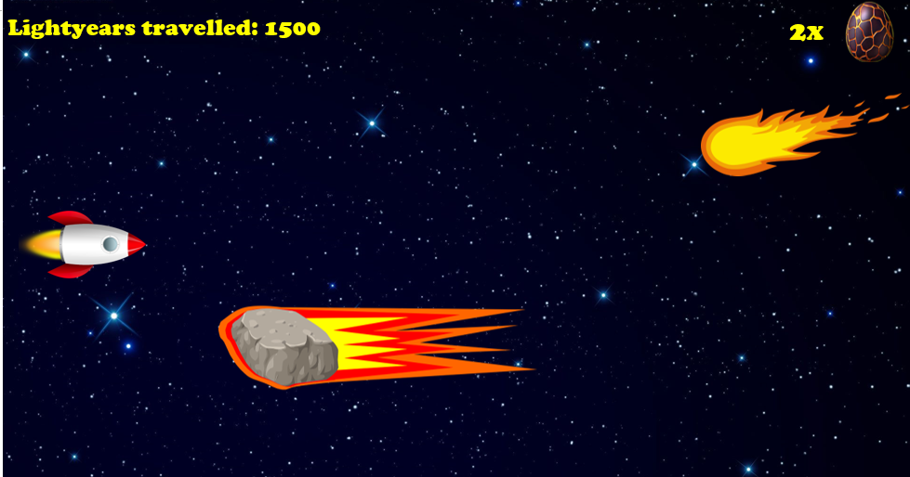Launching from the current planet
  + Going through space
  + Landing on the current planet
* Random events: Meteors, Enemy Aliens
* Positive/Negative boosts: Able to shoot, Faster/Slower dodging, Point Multiplier/Divider
* Modes: Normal (campaign), Permadeath (campaign), Normal (infinite), Permadeath (infinite)
  + Difficulties: Easy, Normal, Hard