

|  |
| --- |
| Web Design Report |
|  |
| S46267445  DECO1400  Authored by: Erik Flink |

Contents

Introduction 3

Site map 3

Prototypes 4

Template 4

Home Page 4

Portfolio and gallery 5

Project 5

About me 6

Contact me 6

Flows 7

Nielsen’s Usability Heuristics 7

Visibility of system status 7

Match between system and the real world 7

Consistency and standards 7

Error prevention 8

Recognition rather than recall 8

Flexibility and efficiency of use 8

Aesthetic and minimalist design 8

Assisting users in error resolution 8

Providing help and resources 8

Conclusion 8

# Introduction

I will craft an engaging portfolio website for an architecture student, designed to exhibit their talents, ingenuity, and design principles to a wider audience. This online portfolio will also function as a digital resume, showcasing the student's finest work and offering prospective clients or employers insight into their aesthetic and methodology.

The intended audience encompasses potential clients, employers, and fellow professionals within the architectural field. As I create this website, my goal will be to showcase the student's architectural projects and cultivate their personal brand as an ambitious, up-and-coming architect. Recognizing the increasing importance of online visibility and digital marketing in today's business environment, this portfolio website will serve as a powerful tool for students to differentiate themselves and demonstrate their distinct design sensibilities within the competitive world of architecture. Furthermore, the website will act as a platform for sharing insights and viewpoints on contemporary industry trends, increasing their visibility and engagement with the target audience.

# Site map

A well-designed sitemap is crucial for web designers and developers to plan and organize a website effectively. This sitemap for a student architect's portfolio includes a main page with four subpages: a portfolio page, a gallery page, a contact page, and an about page. The main page functions as the website's entry point, introducing the student architect and their work while directing visitors to the subpages. The portfolio page comprehensively displays the student's projects, with options to delve into individual pages containing further details about each endeavour. Finally, the gallery page presents a curated collection of images and photographs of the student's work. Meanwhile, the contact page features a contact form for visitors to connect with the student architect, and the about page offers biographical and educational background information. Altogether, the sitemap for the student architect's portfolio website establishes a well-structured and informative platform that highlights the student's capabilities for prospective clients and employers.

Figure 1 Site map

# Prototypes

The low fidelity prototype for the architecture student's portfolio website was initially developed through a series of hand-drawn sketches, allowing for rapid visualization and iteration of the website's layout and essential features, ensuring a strong foundation for the final design. Building upon this groundwork, the high-fidelity prototype was produced using Figma, which facilitated precise design control and efficient iteration based on feedback, ultimately resulting in a visually appealing and user-friendly website design. The color palette employed for the website consists of whites, blues, grays, and black, maintaining a professional appearance while providing an elegant and visually cohesive experience for users.

### Template

### The website features a consistent navigation bar and footer on each page. The navigation bar displays the student's name and tagline, reflecting their architectural philosophy, while hyperlinks allow for easy transitions between pages. The About hyperlink utilizes a dropdown menu, revealing the About Me and Contact Me options, ensuring a streamlined appearance without sacrificing accessibility. The footer contains hyperlinks to the student's social media profiles, encouraging further engagement with their work and personal brand.

Figure 2.1 low fidelity header, footer and dropdown menu

### Home Page

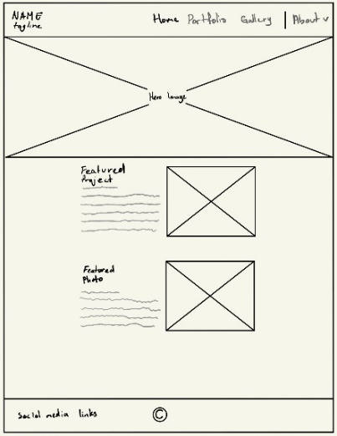The home page features a large, high-quality hero image that captures the essence of the student's work, placed at the top of the page. This image instantly engages visitors and sets the tone for the rest of the website. Below the hero, a featured project section highlights one of the student’s most outstanding projects. This section includes a title and description with a visually appealing call-to-action image adjacent to it, which redirects users to the corresponding portfolio project page. Underneath this is a featured photo, to give users an idea of the student's design aesthetic and entice them to explore the website further.

Figure 3.3 high fidelity home page with dropdown menu

Figure 3.2 high fidelity home page

Figure 4.1 low fidelity home page

### Portfolio and gallery

The Portfolio and gallery page utilizes a grid layout to display thumbnail images of each project or photo. When users hover their mouse over the image, the title becomes visible, providing context of the thumbnail. For the portfolio page, users can click on a thumbnail to be directed to an individual project detail page that contains more in-depth information and additional images, whereas the Gallery serves as a visual showcase without additional details. The grid layout ensures a visually appealing presentation while making it easy for users to explore the student's work.

Figure 4.1 low fidelity portfolio and gallery

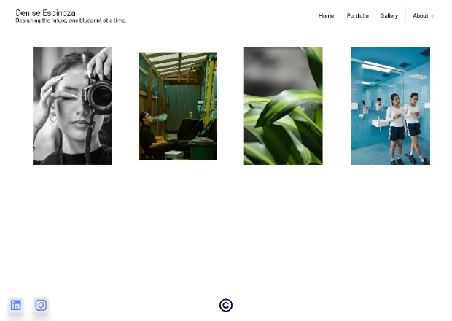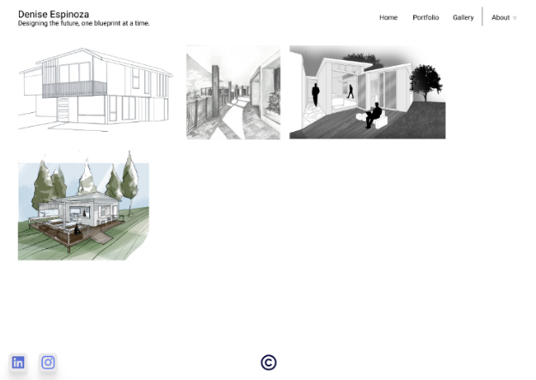

Figure 4.3 high fidelity gallery page

Figure 4.2 high fidelity portfolio page

The grid layout for both the portfolio (left) and gallery (right) sections, initially planned as modular, has been modified to adopt a masonry grid style. This change accommodates the need for varying image sizes to preserve their intended aspect ratios, ensuring a more visually coherent and appealing presentation of the student's work.

### Project

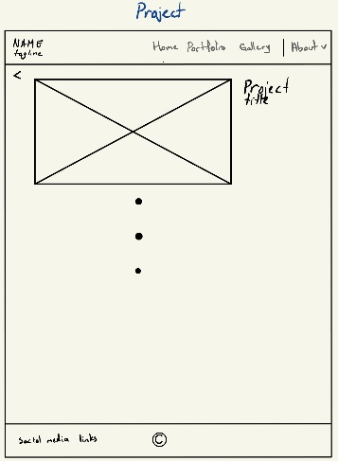The Project page features a scrollable image gallery, while the project title remains fixed in position as the user scrolls, ensuring continuous context. Additionally, an arrow icon is placed at the top left of the screen, offering users an alternative way to return to the Project page. This design choice enhances the user experience and interface by providing a more intuitive navigation option, catering to diverse browsing preferences and ensuring a seamless, engaging interaction with the student's work.

Figure 5.2 high fidelity project page

Figure 5.1 low fidelity project page

### About me

The About Me page features a professional photo of the student alongside a concise biography that highlights their educational background, design philosophy, and career goals. This design choice improves user experience and interface by providing a visually appealing, informative, and personalized glimpse into the student's life and work, fostering a deeper connection with the target audience.

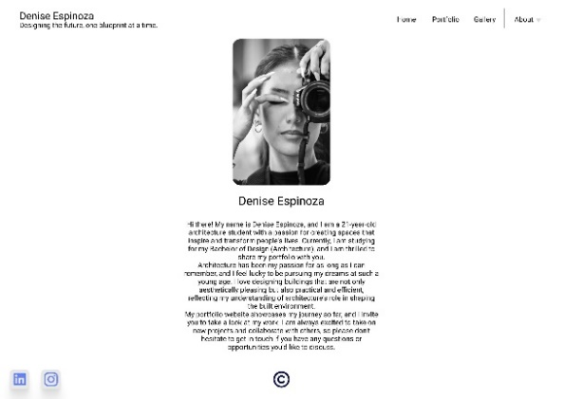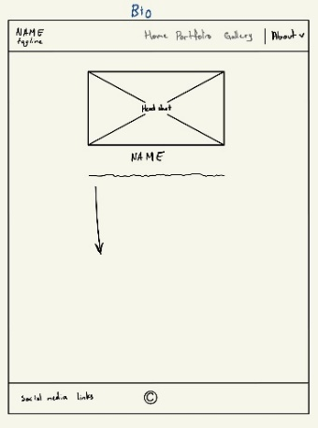

Figure 6.2 high fidelity about me page

Figure 6.1 low fidelity About me page

### Contact me

The Contact Me page incorporates a contact form with fields for the user's name, email address, and message, streamlining communication between users and the student. An image placed beside the form enhances the page's visual appeal, creating a more inviting environment. Additionally, the student's professional email address is displayed below the image, offering an alternative contact method for users who prefer not to use the form. This design approach improves user experience and interface by providing multiple communication options in an aesthetically pleasing and user-friendly layout.

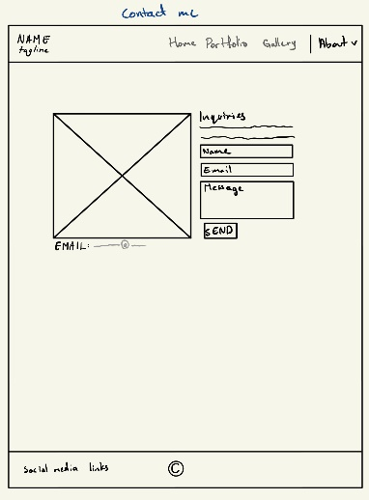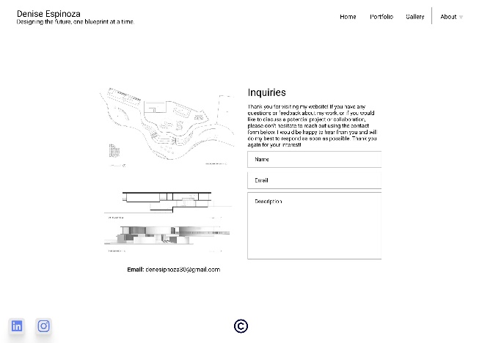

Figure 7.1 low fidelity contact me page

Figure 7.2 high fidelity contact me page

### Flows:

Figure 8.1 Website prototype flow

The website's flow and navigation are demonstrated in the interactive prototype, which can be explored using the following link: <https://www.figma.com/proto/lrU07EMgu8hDc29SLuJ7qK/DECO1400?node-id=0-1&scaling=min-zoom&starting-point-node-id=4%3A13>

# Nielsen’s Usability Heuristics

### Visibility of system status

The eye-catching hero image on the homepage immediately engages users, and hover effects on Portfolio and Gallery thumbnails offer feedback, ensuring users always know their interactions with the website. The current page is emphasized by bold text on the navigation bar, allowing users to easily identify their location within the site. Additionally, interactive buttons offer visual or tactile feedback, further enhancing the user experience.

### Match between system and the real world

The website uses familiar terminology and design elements, such as the navigation bar, footer, and dropdown menus, creating a user experience that aligns with visitors' real-world understanding of similar sites.

User control and freedom

Simple navigation between pages using the navigation bar, back arrows, and dropdown menus grants users the freedom to explore the site without feeling lost or restricted.

### Consistency and standards

The uniform application of the navigation bar, footer, and color scheme throughout the site ensures a professional and cohesive appearance, making navigation easy and intuitive for users.

### Error prevention

Straightforward navigation and visual feedback, like hover effects on clickable items, minimize user errors and guarantee a smooth browsing experience.

### Recognition rather than recall

Displaying project titles when hovering over thumbnails and using clear labels for navigation elements reduces the cognitive load on users, allowing them to concentrate on the student's work without taxing their memory.

### Flexibility and efficiency of use

The website accommodates various user preferences and browsing habits by offering multiple navigation options, such as dropdown menus and back arrows, creating a comfortable and efficient user experience.

### Aesthetic and minimalist design

The color palette of whites, blues, grays, and black, along with the grid layout for Portfolio and Gallery sections, results in a visually appealing and minimalist design that showcases the student's work without unnecessary distractions.

### Assisting users in error resolution

Incorporating clear error messages and guidance, like form validation on the Contact Me page, allows users to quickly identify and resolve issues they encounter while browsing the site.

### Providing help and resources

While the website has been designed with user-friendliness in mind, providing readily available support and guidance, such as an FAQ section or tooltips, would ensure that visitors have access to additional assistance when needed. However, given the website's straightforward and intuitive design, incorporating these features has not been deemed necessary at this time.

# Conclusion

In conclusion, the architecture student's portfolio website has been meticulously designed to emphasize their unique talents, design principles, and personal brand, ensuring they stand out in the competitive architectural field. By prioritizing user experience and interface, the website offers seamless navigation and a visually appealing, engaging platform for prospective clients, employers, and fellow professionals to explore the student's work. Adhering to Nielsen's usability heuristics, the website is both intuitive and user-friendly, catering to diverse preferences and fostering a deeper connection with the target audience. As a powerful tool for self-promotion and networking in the digital age, the portfolio website effectively showcases the student's architectural prowess and positions them for future success within the industry.