|  |  |
| --- | --- |
|  | EUROPEAN COMMISSION  Directorate-General for Internal Market, Industry, Entrepreneurship and SMEs  Single Market for Public Administrations  **Innovative and E-Procurement** |

Commission Implementing Regulation establishing standard forms for the publication of notices in the field of public procurement ("eForms")  
 – public feedback explanatory note

## Introduction

The Commission proposes a major update to the public procurement standard forms. This update aims to significantly improve the usefulness of data on European procurement for all users: companies, governments and citizens. The Implementing Regulation on eForms will replace [Implementing Regulation 2015/1986](http://eur-lex.europa.eu/legal-content/EN/TXT/?uri=uriserv:OJ.L_.2015.296.01.0001.01.ENG).

Before launching the official procedure with the EU countries’ Advisory Committee on Public Contracts, we would welcome public feedback on this proposal.

This note describes the context of the proposal. Annex I explains how to give feedback. Annex II highlights new policy-relevant information proposed in the act.

## Process

Given the technical complexity of the file, we have based the proposal on [extensive stakeholder engagement](http://ec.europa.eu/growth/tools-databases/newsroom/cf/itemdetail.cfm?item_id=8997). A first consultation took place from Nov. 2016 to Jan. 2017 and the Commission discussed its results with the EU countries’ experts in the Economic and Statistical Working Group (ESWG) on 8 April 2017. A second consultation took place from June to October 2018 and we went over the state of play at a joint meeting of the ESWG and the Commission Government Experts Group on Public Procurement (EXPP) on 10th Dec. 2018.

In the second consultation, more than 200 issues and 500 comments were raised and exchanged [via an online forum](https://github.com/eForms/eForms/blob/master/README.md) and six webinars were held. More than 30 people, coming mainly from national administrations and covering more than half of EU countries, contributed and raised over 200 issues, which resulted in approximately 100 changes in the proposal. This was followed by further technical work by the Commission. Overall, thanks to the contributions of the participants, these discussions have led to a mature and technically strong proposal.

The indicative timing for eForms is the following:

* Public feedback on the draft Implementing Regulation (Feb. – Mar. 2019)
* Draft Implementing Regulation translated into all EU official languages (April 2019)
* Approval by Member States in the Advisory Committee on Public Procurement and adoption by the European Commission (May - June 2019)
* Publication of the technical standard for electronic exchange of notices by the Publication Office of the EU. Start of implementation in Member States (June 2020)
* Optional use in Member States (June 2022)
* Mandatory use in Member States (June 2023)

## Policy context

eForms are one of the actions in the Communication on Making Public Procurement work for and in Europe and the Communication on Upgrading the Single Market, where the European Commission has committed to "facilitate the collection, consolidation, management and analysis of procurement data, supporting Member States’ efforts towards better governance in public procurement [because] governance of procurement systems needs to be improved to ensure efficiency, transparency and integrity.” [1]

## Purpose

The main purpose of the new eForms is to meet the needs of a diverse set of stakeholders involved in the publication and use of procurement data, while complying with the applicable provisions of the directives. Overall, these needs can be grouped into three goals: improving access to business opportunities for companies (esp. SMEs), good governance of public spending, and low costs of publishing (incl. low administrative burden). These reflect the procurement directives' core principles of equal treatment, non‑discrimination, transparency, proportionality, and competition.

Concretely, eForms will bring many improvements large and small, such as:

* Improving the accuracy of information by defining the meaning of each field.
* Simplifying the forms by removing unnecessary differences and confusing concepts.
* Making forms more user-friendly and understandable by giving Member States the freedom to use the field labels that work in their national contexts.
* Simplifying the legal framework: from 22 types of forms to just 6 from 150 pages of legislation to 25.
* Lowering administrative burden by improving consistency and removing duplication with other standards and tools such as the ESPD.
* Giving more freedom to buyers by allowing them to specify more information (e.g. selection criteria) at the level of lots instead of the level of notices.
* Helping improve governance by making structured buyer and seller identifiers mandatory and including a limited number of policy relevant fields (e.g. on green, social, and innovative procurement).
* Balancing transparency and competition by adding the option to, in justified cases, mark fields in contract award notices as not intended for publication.
* Supporting the (voluntary) publication of below-threshold notices in the TED format by including fields relevant for below-threshold procurement.
* Simplifying the forms by updating the process for publishing corrections of notices.
* Enabling better identification of business opportunities in the EU by introducing an EU wide procurement procedure identifier.

## Support measures

One of the important goals of the new Implementing Regulation is to give more freedom and flexibility to Member States, e-procurement systems and buyers in how they get the most benefits from the standard forms. However, this does not mean that Member States will be left alone with more implementation work. The Commission will provide various support tools to help Member States with implementation.

In particular:

* The Commission will prepare guidance on implementing the standard forms and will maintain a collaborative platform for the exchange of best practices and discussion of issues.
* Member States will have access to models (including labels) used in the TED and eNotices applications (in all languages), which they can reuse and build on in their own form filling and notice displaying tools.
* Member States will have access to a new version of the eNotices application, currently under preparation by the Publications Office. The Publications Office will provide the forms and a series of services (APIs) that 3rd parties can re-use and integrate in their applications; this will make the development of their own applications faster and easier.
* The Commission will propose funds for the implementation of eForms in the Connecting Europe Facility 2019 and 2020 work programs. (The final allocation of money is approved by Member States in the Telecom Configuration of the CEF Coordination Committee).
* The Publications Office and the European Commission will provide technical support (e.g. mapping between current forms and future forms; test environments).

## Future updates

In the future, after the adoption of this regulation, the Implementing Regulation on standard forms should be amended more often than in the past (e.g. every one or two years instead of every four[2]). However, these changes should consist of minor "bug-fixing" changes, not major reforms. This more agile approach is appropriate for an IT environment, which eForms are unavoidably part of, and will avoid the current situation where problems often go unsolved for years. Such an approach also corresponds well with the flexibility given by the advisory procedure, an administratively light procedure, which is used for adopting the act.

It is worth emphasizing that, currently, besides infrequent legal changes, there are also twice-per-year technical changes which are done to the IT implementation of the standard forms. This process is led by the Publications Office of the EU, in cooperation with the national e-senders. Aligning the processes of legal and technical changes more closely will lead to higher quality of both. Both of these processes will also be part of a broader governance framework, building on the Publications Office's current work with eSenders, which will ensure that needs and problems are accurately and rapidly collected and resolved.

Besides allowing technical improvement to the standard forms, this responsive approach to legislation will also allow Member States to innovate in the area of data while respecting the Directives' provision that "Notices published at national level shall not contain information other than that contained in the notices dispatched to the Publications Office of the European Union."[3] Specifically, Member States will be able to add fields at national level, because these will then be added (as optional) also at the EU level[4]. Thus, equal treatment for companies will be ensured while Member States will be able to innovate for the sake of competition and transparency.

The fact that such fields will be optional at EU level means that for other Member States, their addition into the Implementing Regulation will not imply additional costs, as nothing will need to be changed in their software systems.Annex I – Submitting feedback

You may submit feedback in two ways:

* Using [ec.europa.eu/info/law/better-regulation/initiatives_en](https://ec.europa.eu/info/law/better-regulation/initiatives_en).
* Using [github.com/eForms/eForms](https://github.com/eForms/eForms/blob/master/README.md).

GitHub is a particularly useful tool for this complex project, because it allows discussing issues one by one, enables exchanges between all participants, and helps keep track of different topics easily and transparently.

**If possible, please submit your feedback via GitHub.**

The files for feedback are:

* Draft Implementing Regulation (for adoption)
* Draft Annex to the Implementing Regulation (for adoption)
* Spreadsheet version of the draft Annex to the Implementing Regulation   
  (We recommend using this easier-to-read file to read the Annex.   
  To benefit from functionalities such as filtering and zooming, we also strongly suggest reading the document on a computer, not printing it out.)

Additionally, we offer the following files for technical feedback (on GitHub only):

* Draft codelists (lists of codes that must be used as replies to certain fields established in the Annex; used in technical implementation)
* Preliminary draft business rules (lists of rules applied to notices to ensure their quality, consistency, etc.; used in technical implementation)

### Using GitHub

1. Go to [github.com/eForms/eForms](https://github.com/eForms/eForms/blob/master/README.md), click "Sign up" and follow the instructions. For easier communication, we suggest using your name and surname as "Username".
2. Again at [github.com/eForms/eForms](https://github.com/eForms/eForms/blob/master/README.md), you can download the consultation documents in the bottom left. In the top right, you can choose your email notification settings.
3. If you would like to comment (e.g. to suggest a change), click "Issues". There, you can open new issues by clicking on "New issue". Also, you can comment on issues already opened by others by scrolling or searching.

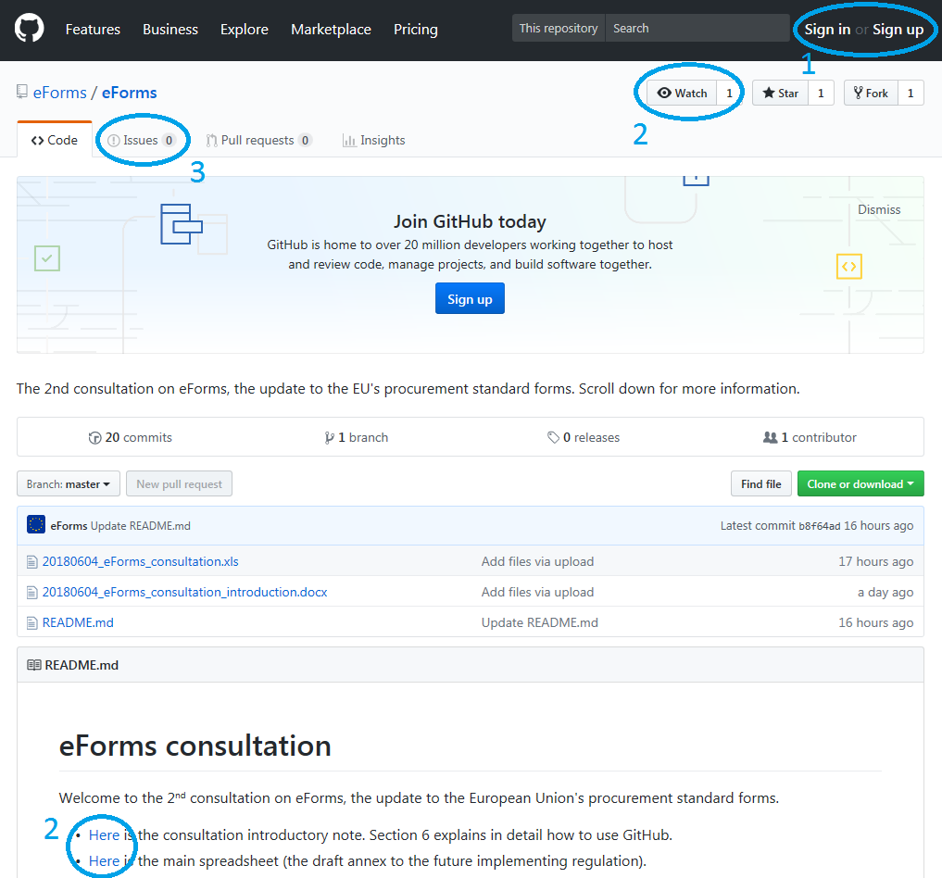

How to name your issue?

To ensure readability, the title of each issue must clearly identify the topic of the issue. In particular, this means including in the title the following information.

1. ID (the first column of the spreadsheet concerning the Annex or Rules) and Name (for the Annex or codelist) to be discussed, e.g. "BT-01 (Legal Basis);"
2. Name of the column to be discussed (e.g. "Description," or "PIN only D81;")
3. Short summary of the issue (e.g. "Typo", "Inconsistent with other BTs", "rename")
4. Document being commented (if other than the Annex):

* [ACT]
* [CODELIST]
* [RULE]

For example, a title could be "BT-01 (Legal Basis); Description; Typo" or “Activity Authority; defence listed twice; [CODELIST]” or “BR-33; Description; wrong business term identifier; [RULE].”

If your issue does not fit the instructions above (e.g. because it is more general), just follow them as far as possible.

**Before opening a new issue**, look whether someone else has not opened it already. You can do this, for example, by writing the ID number in the search bar (if you specify "in:title", your search will be more accurate). For example, if you wanted to search for the issue mentioned in the box above, you would search for "BT-01 in:title".

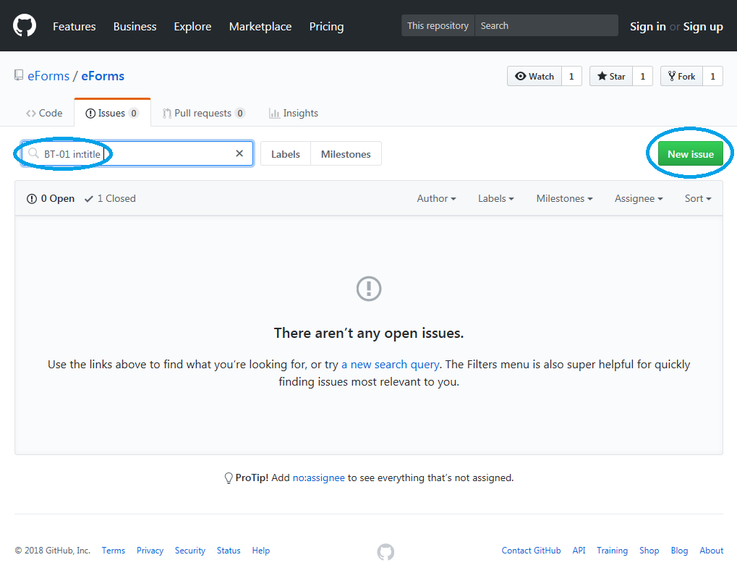

(To ensure the consultation is easy to read, please note we may format the submitted issues.)

## Annex II – New policy fields

As requested by participants of the public procurement Economical and Statistical Working Group on 10th December, this Annex provides an overview of new, possibly mandatory policy fields proposed for eForms. The Commission will include fields in the Implementing Regulation as mandatory, optional or remove them altogether depending on the EU countries’ vote in the Advisory Committee on Public Procurement.

Fields will be introduced as mandatory only when they gain the support of the simple majority of EU countries.

Fields will be included as optional[5] as long as they are supported by at least one country (or there is a clear use by the European Commission, who uses the same standard forms). This is because in the digital age, optional fields do not imply any costs for countries that do not use them. Furthermore, as explained in section 5, above, notices at national level cannot contain more information than notices on TED and the Commission does not want to “block” national developments.

Fields should be chosen based on a careful comparison of their **costs** and **benefits**.

### General Considerations on Costs and Benefits

* Costs and benefits of collecting information largely fall on different entities. The costs are largely concentrated. Overwhelmingly, they are born by buyers (who fill in notices) and e-procurement providers (who provide the technical infrastructure). Furthermore, ministries responsible for public procurement deal with “administrative” costs of receiving complaints from buyers and e-procurement providers if something goes wrong, the forms are too long, etc.

On the contrary, benefits are dispersed –good information about procurement could be considered a “public good”. Beneficiaries include companies, other buyers and any others re-users of the data such as business intelligence companies, citizens, NGOs, academics[6], etc. Moreover, besides public procurement ministries who can better take care of national procurement, they also include sectoral ministries responsible for particular topics (e.g. green procurement, trade).

To balance correctly the costs and benefits, the Commission recommends having inclusive discussions at national level, where **all the relevant stakeholders are around the table** and agree on the overall priorities.

* If all EU countries collect certain data, it becomes more useful for everyone. For example, benefits can come from benchmarking (e.g. on green procurement) or from ensuring that home companies have access to certain information from abroad (e.g. on electronic signatures). Furthermore, many procurement procedures are paid for by EU funds, the efficient spending of which is a matter of interest for all EU countries.
* Buyers spend months of work on preparing procurement documents, evaluating bids, etc. Significant sums are involved (€144,000 for the lowest threshold). By contrast, filling in a form takes around 20 minutes. In this context, the cost of filling an additional field may be considered as limited. On the other hand, experience shows that as the number of fields increases, the quality of information goes down. In other words, a reasonable balance needs to be maintained.
* As more and more fields are automatically filled in thanks to the progressing digitalisation of procurement and a new generation form-filling systems, the overall burden on buyers in this area is likely to significantly decrease. Not all fields require the same effort to fill in. Most fields can be filled in automatically - some cannot.
* There are alternatives to collecting policy-relevant information through standard forms. For example, there can be surveys within e-procurement systems. Their main advantage is flexibility – questions can be changed regardless of procurement law. Their main disadvantage is that to bring the same quality of information as standard forms, they need to duplicate a large portion of the standard forms existing “infrastructure”. In particular, if their results are to be comparable across EU countries, they need a forum where shared descriptions are agreed; if they are to be easily accessible, they need to be included in e-procurement systems; if they are to be mandatory for buyers, they need appropriate regulation (esp. to be included in private e-procurement systems).

In the table below, we list new policy fields suggested for eForms by the Commission as mandatory. We include their name and description (the remaining information are available in the Regulation’s Annex) as well as considerations about their costs and benefits. The fields are listed in the same order as in the Annex (i.e. not in the order of importance).

Policy fields I (general)

| **Name** | **Description** | **Considerations** |
| --- | --- | --- |
| *Winner Owner Nationality (BT-706)* | ”The nationality (or nationalities) of the beneficiary owner(s) of the winner(s), as published in the register(s) established by anti-money laundering legislation. If such a register does not exist (e.g. in case of non-EU contractors) then equivalent information from other sources. ” | Structured information on who controls the suppliers of EU governments would improve the:   * negotiation of EU’s trade agreements; * security of the EU, e.g. in the context of the dependency on Chinese owned suppliers of IT infrastructure, Russian owned suppliers (potentially covered by economic sanctions); * understanding of the benefits that the public procurement single market brings to individual Member States.   The cost of submitting this information should be small, because the information will be freely publicly available (by 2020) under the latest Anti-Money Laundering Directive[7] and thus can be prefilled automatically. |
| *Winner Listed (BT-746)* | ”The nationality (or nationalities) of the beneficiary owner(s) of the winner(s) is not published in the register(s) established by anti-money laundering legislation, because the winner is listed on a regulated market (e.g. a stock exchange) that ensures adequate transparency in line with anti-money laundering legislation.” *(Response: yes/no)* | This field would cover the cases not catered for by the field above. |
| *Received Participation Requests (BT-152)* | ”Number of requests to participate received. All requests to participate received must be counted, regardless of whether they are admissible or inadmissible. ” | This field would enable comparing the impacts of single and multiple-stage procedures (in particular open and restricted) on competition. More appropriate use of these procedures could significantly help solve procurement’s competition problems.  The costs of submitting this information should be minimal, because electronic submission is mandatory and the number of requests to participate can be automatically prefilled from eSubmission modules. |
| *Received Tenders SME (BT-148)* | ”Number of tenders received from small and medium enterprises (SMEs). […]” | These fields on received tenders are already mandatory for most types of notices. We suggest adding them for the light regime.  This would enable evaluating the impacts of the Directives on this market, esp. to understand cross-border interest.  The costs of submitting this information should be minimal, because electronic submission is mandatory and these fields can be automatically prefilled from eSubmission modules. |
| *Received Tenders EU (BT-147)* | ”Number of tenders received from tenderers registered in other European Economic Area countries. […]” |
| *Received Tenders Non EU (BT-723)* | ”Number of tenders received from tenderers registered in countries outside of the European Economic Area. […]” |
| *Received Tenders Inadmissible (BT‑741)* | ”Number of tenders received that were found inadmissible. A tender is found inadmissible where it has been verified that it has been submitted by a tenderer who has been excluded or who did not meet the selection criteria, or when it is not in conformity with the technical specifications, or is irregular (e.g. it was received late, having an abnormally low price or cost), unacceptable or unsuitable.” | Inadmissible tenders represent wasted time and opportunities – of companies and buyers. Consequently, this information would help identify low professionalism and address it. Furthermore, inadmissible tenders may indicate collusion[8].  The costs of submitting this information should be small, because it is just one (already collected) number. Furthermore, the information can automatically come from e-evaluation modules. |
| *Received Tenders Unverified (BT‑742)* | ”Number of tenders received for which it has not been verified if they are admissible or inadmissible (e.g. because award criteria have been evaluated for all tenders and admissibility is checked only for the winning tender).” | This field would cover the cases not catered for by the field above. |
| *Review Requests (BT-712)* | ”Number of tenderers that requested the buyer to review the award decision.” | This field measures the use of Art. 1(5) of Directives 89/665/EEC and 92/13/EEC (“the review Directives”).  Complaints indicate potential problems with professionalism, can explain slow procurement procedures, and can help evaluate the costs for buyers stemming from the need to respond to such requests.  The costs of submitting this information should be small, because it is just one (already collected) number. |
| *Strategic procurement (BT‑06)* | “A technical specification, award criterion, or contract performance condition aims to reduce the environmental impacts of the procurement, fulfil social objectives and/or buy an innovative work, supply or service. “ | This field would bring basic information on so-called green, social and innovative procurement. It relies on self-evaluation by buyers and does not provide a more detailed definition because no EU-wide definitions are currently available. |
| *Accessibility (BT‑754)* | “The use of accessibility criteria for persons with disabilities in the technical specifications.” | Art. 42(1) of Directive 2014/24/EU obliges buyers to include accessibility considerations in technical specifications, unless duly justified.  This field would help monitor the extent to which duly justified exceptions are being used. This is particularly relevant in the context of the recently adopted European Accessibility Act. |

Justifications

A particular type of policy fields are justifications. In many cases, the Directive sets out special cases that require justifications, but it does not specify where these justifications should be included. Since preparing a justifications takes the same effort regardless of where it is published, it seems the most reasonable to include justifications in the notices, because they contribute to the transparency of procurement also vis-à-vis citizens. Furthermore, several of the justifications below are codes and can consequently be analysed to understand, for example, what are the most common reasons for not publishing information about awarded contracts.

Policy fields II (justifications)

|  |  |  |
| --- | --- | --- |
| **Name** | **Description** | **Considerations** |
| *Award Criteria Order Justification (BT-733)* | “Justification for only indicating the award criteria's order of importance, not their weighing.” | According to Rec. 90 (last paragraph) of Directive 2014/24/EU, instead of indicating the weighing of award criteria, buyers should be permitted “in duly justified cases for which they must be able to give reasons” to indicate the order of importance.  Anecdotally, this provision seems to be used extremely rarely. This field would bring more transparency to the use of this provision and help prevents its misuse.  Given the minimal use of this provision, the costs linked to filling this field should be minimal. |
| *Documents Restricted Justification (BT‑707)* | “The justification for restricting access to certain procurement documents.”  *(codelist only)* | This field would bring more transparency to the use of the provision on restricting access to procurement documents and help prevent its misuse. |
| *Submission Nonelectronic Justification (BT‑19)* | “Justification for electronic submission of tenders not being possible.”  *(codelist only)* | This field would bring more transparency to the use of the provision on restricting access to procurement documents and help prevent its misuse. |
| *Unpublished Justification Code (BT-197)* | “Justification for not immediately publishing a field. “  *(codelist only)* | The mechanism for not publishing fields is based on Art. 50(4) of Directive 2014/24/EU.  This provision was not reflected in Implementing Regulation 2015/1986, i.e. it was not possible to mark fields as unpublished. Furthermore, we are aware that the interpretation of this provision has been very different in the past. For example, while many countries never use this provision, in other countries it was used to not publish the value of notices in up to 80% of procedures.  Consequently, we believe transparency on how this provision is used is necessary. This will allow the development of a more harmonized approach as well as avoid its misuse. |
| *Unpublished Justification Description (BT‑196)* | “Justification for not immediately publishing a field and for the choice of a later date at which it can be published. “ |
| *Accessibility Justification (BT‑755)* | “Justification for not including accessibility criteria even though the procurement is intended for use by natural persons.” | Art. 42(1) of Directive 2014/24/EU does not provide any guidance on what is a duly justified case. |

Codelists

Some policy purposes are also covered by new codes.

Policy fields III (new codes)

| **Name** | **Description** | **Considerations** |
| --- | --- | --- |
| *Micro, small, medium, large codes*  *in the codelist for*  *Winner Size (BT‑165)* | *“The size of the winner (e.g. micro enterprise, small enterprise, medium enterprise).”*   * *Micro* * *Small* * *Medium* * *Large* | Currently, information is collected at the general SME level (covering, for example, companies with 5 employees as well as companies with 205 employees). Information that is more granular would allow catering to the different needs of the different types of SMEs.  The costs of submitting this information should be small. The information should be automatically prefilled from data in national or regional business registries. Alternatively, it can be submitted by the company itself (e.g. as part of the ESPD) to the buyer, who then (automatically or manually) puts it in the notice. |
| *Procurement Service Provider  code*  *in the codelist for*  *Organisation Role (BT-08)* | *Art. 2(17) of Dir. 2014/24/EU:*  *‘procurement service provider’ means a public or private body which offers ancillary purchasing activities on the market;*  *Art. 2(15) of Dir. 2014/24/EU:*  *‘ancillary purchasing activities’ means activities consisting in the provision of support to purchasing activities, in particular in the following forms:*  *(a) technical infrastructure enabling contracting authorities to award public contracts or to conclude framework agreements for works, supplies or services;*  *(b) advice on the conduct or design of public procurement procedures;*  *(c) preparation and management of procurement procedures on behalf and for the account of the contracting authority concerned;* | Procurement service providers (PSP) help buyers procure. Besides central purchasing bodies, procurement service providers are often consulting companies specialized in procurement, law, EU funds or a particular sector (construction, IT, etc.)  This field would fill an important information gap on the extent to what procurement is done and influenced by other organisations than the buyer. For example, in some countries, practitioners estimate that up to 50% of procurement procedures are actually done/influenced by private consultancies and law firms. Unfortunately, there is no data to confirm or verify such claims - even though this could have significant implications for policy makers. For example:   * From a professionalisation point of view, if external organisations often play a role, then training individual buyers may be less important. On the other hand, perhaps there should be certifications, reviews, or ratings for PSPs. * If PSPs seldom play a role, perhaps there is space for improving professionalisation through better support from (private or public) procurement expert centres.   Where external organisations often play a role, it might also be worth paying more attention to the prevention of conflict of interest (as mentioned in 2014/24/EU Art. 24, paragraph 2). |

1. <http://eur-lex.europa.eu/legal-content/EN/TXT/?uri=COM%3A2015%3A550%3AFIN>, p. 13, p.59 (shortened)
2. The current update is planned for April 2019. In the past, the implementing regulation has been updated in November 2015, August 2011, and September 2005.
3. Article 52(2) of Directive 2014/24/EU, Article 72(2) of Directive 2014/25/EU and Article 32(5) of Directive 2009/81/EC. The Article may cause legal uncertainty in particular depending on the interpretation of “notice” (e.g. what information from national contract registers may be seen as a notice) and whether this Article is read literally or teleologically (e.g. whether it should apply only to information which could plausibly lead to unequal competition).
4. This approach replaces the “extensions” approach discussed in previous versions of the consultation. Fields marked as “extensions” have been added as optional fields in the current proposal (if they have been sufficiently mature) or will be revisited in future updates of the standard forms (if they require more reflections).
5. Optional fields can be made mandatory in individual countries, regions or IT systems.
6. In fact, [Tenders Electronic Daily data](https://data.europa.eu/euodp/en/data) is the most popular dataset on the EU Open Data portal.
7. Buyers should use these registries regardless of the field on winner nationality, as they are useful as a reference point to comply with the Directives’ provisions on exclusion grounds, in particular the last paragraph of Art. 57 of Directive 2014/24/EU.
8. See e.g. OECD, “Detecting bid rigging in public procurement” (point 6), URL: <http://www.oecd.org/competition/cartels/42594486.pdf>