**Minimum Viable Product Wiki**

**Purpose**

The purpose of this page is to provide an overview of our team eGT-GSA Minimum Viable Product.

**Evidence & Artifacts**

**Attachment E: Criteria #11- Iterative, Agile Approach**

**About Catalyst**

Catalyst is a tool to help researchers easily explore and interact with OpenFDA drug labeling & adverse events data. We named the tool Catalyst because we believe by making this data more accessible we could help inspire and spark insight on trends for specific events & outcomes. We looked at the OpenFDA API as our competition, and imagined a scenario where a researcher is looking to identify unusual correlations between a particular symptom and substance. Alternatively, that same researcher is investigating by symptoms to explore which drugs have the highest incidence of that outcome. We thought we could help researchers easily understand this data by building core analytics around the datasets of labeling & adverse events.

**Our Story**

To develop the MVP we facilitated a number of sessions early in the codeathon to define and prioritize features including a challenge brainstorming session/design studio.

**Design Studio**

To kick-off the codeathon & in parallel to sprint-0 infrastructure work, our Agile Coach facilitated a design studio to rapidly refine our challenge statement and to identify key features, basic mock-ups, and user personas.

Below are the artifacts from the session:

**Challenge Statement Exercise & Dot Voting**

Our basic challenge was to develop and deploy a simple app using OpenFDA datasets to search, explore, and interact with data on drug labeling, adverse events, and recalls, but generated many ideas upfront in 20 mins!

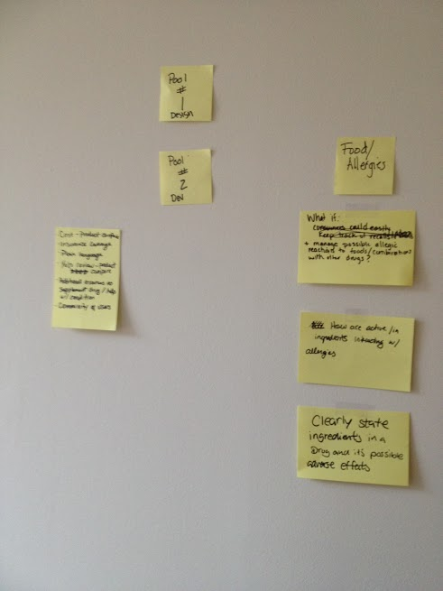

Figure 1 Challenge Statement Exercise

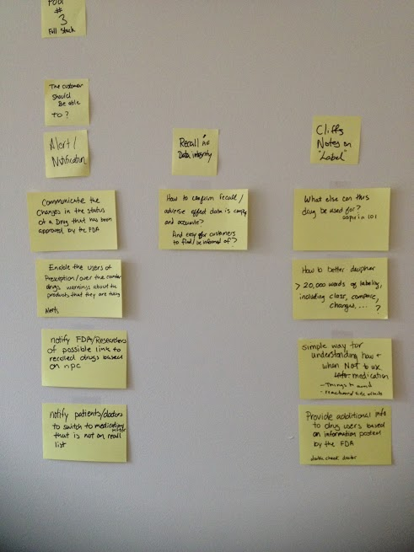

Figure 2 Challenge Statement Exercise

**User Personas**

Initially we intended develop the app for the public. But during our exercise de-brief, we learned members on our team have worked with the drug labeling data before and expressed particular frustrations with using the drug labeling and adverse events data. So we pivoted, and our key user persona for the challenge would be journalists and researchers conducting research on medication recalls and/or adverse events.

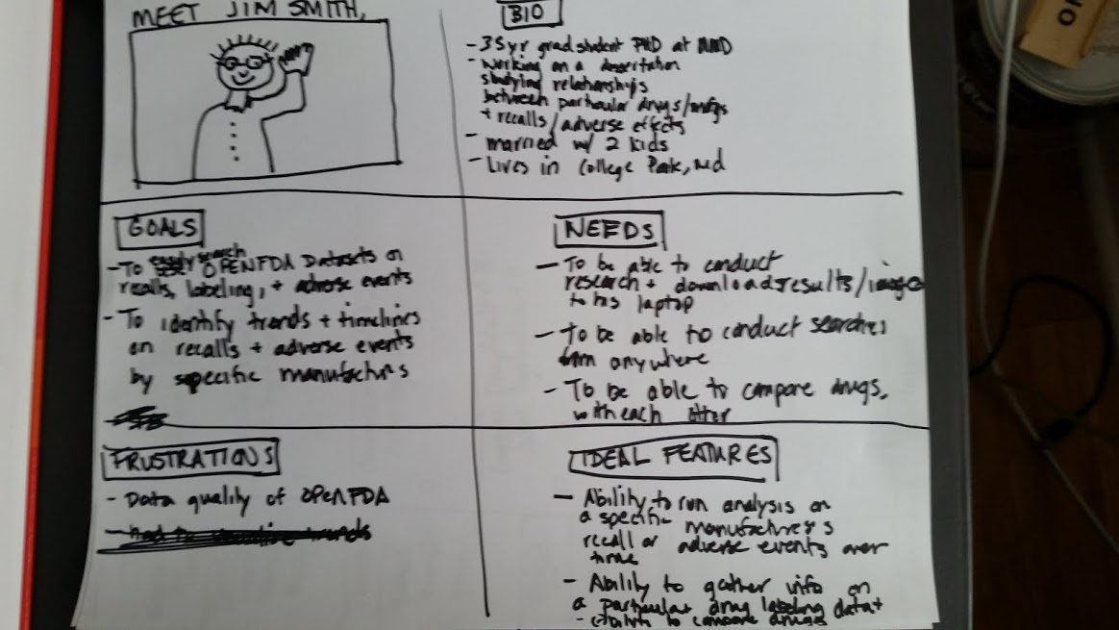

Figure 3 User Persona

**Feature Map**

We developed feature maps identifying our core capabilities for app:

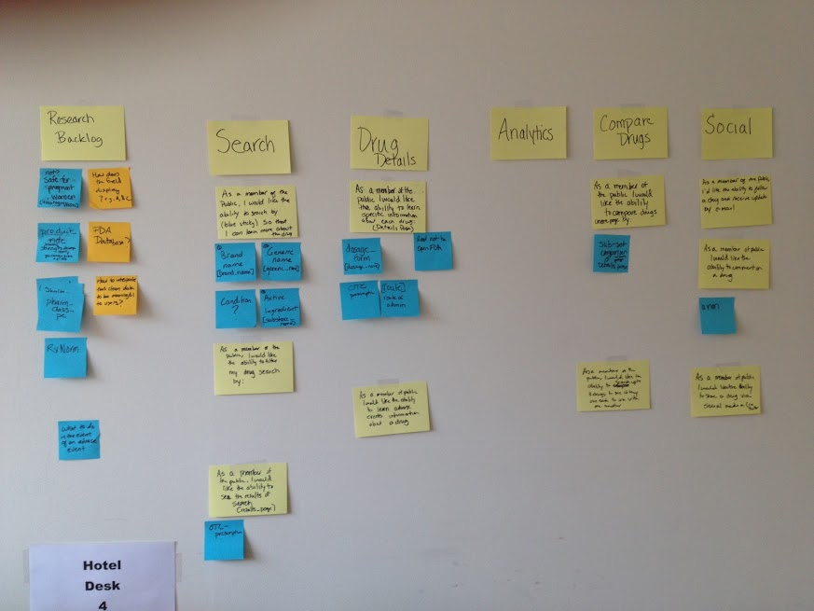

Figure 4 Feature Map – Before

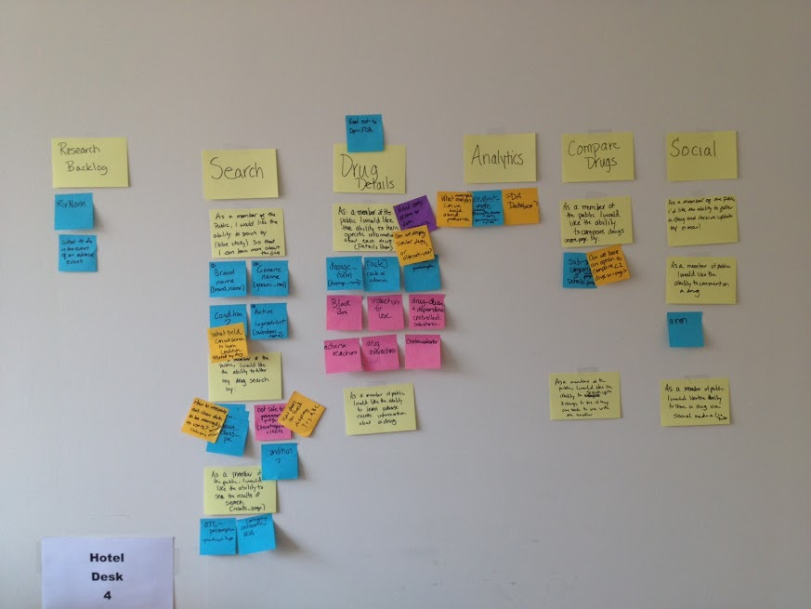

Figure 5 Feature Map - After

**MVP Definition**

Using the feature map, we held a session offline with our team and in the end, we identified our core MVP functionality focused on faceted search, analytics, and compare around adverse events with recalls as a stretch goal.

**User Interviews**

During the day, our Product Manager also conducted interviews to elicit feedback on the design, flow, usability, and contents of the prototype and presented the user feedback at the demo and/or grooming sessions to then, prioritize and submit the feedback as stories in GitHub.

**Mock-ups**

Below are sample mock-ups we developed:

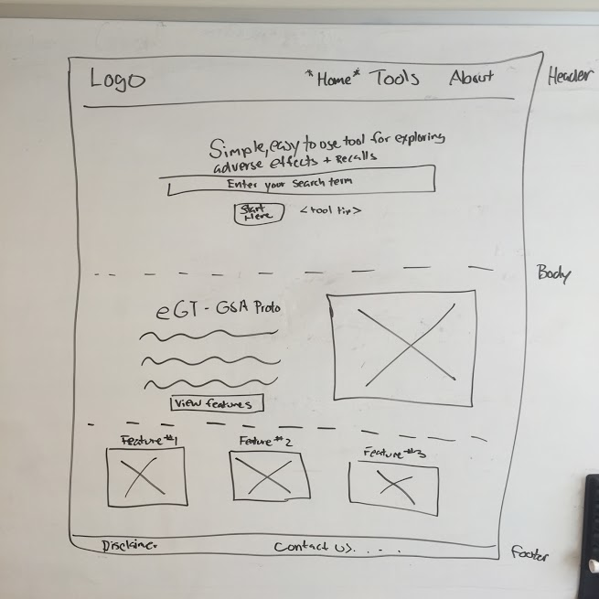

Figure 6 Homepage Mock-up

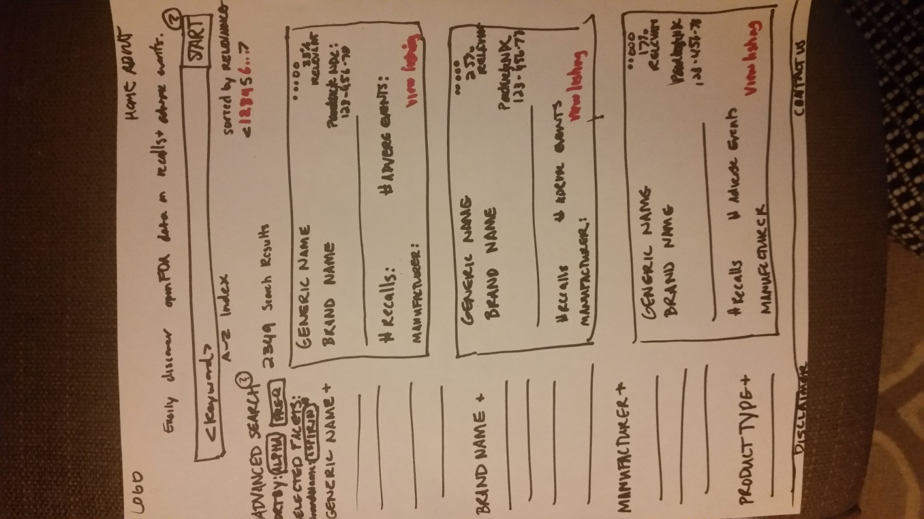

Figure 7 - Search Results Mock-up