**Product Backlog**

**Purpose**

The purpose of this wiki is to document evidence on iterative agile approach by showcasing our product backlog.

**Evidence & Artifacts**

**Attachment E: Criteria #3 – Iterative Agile Approach**

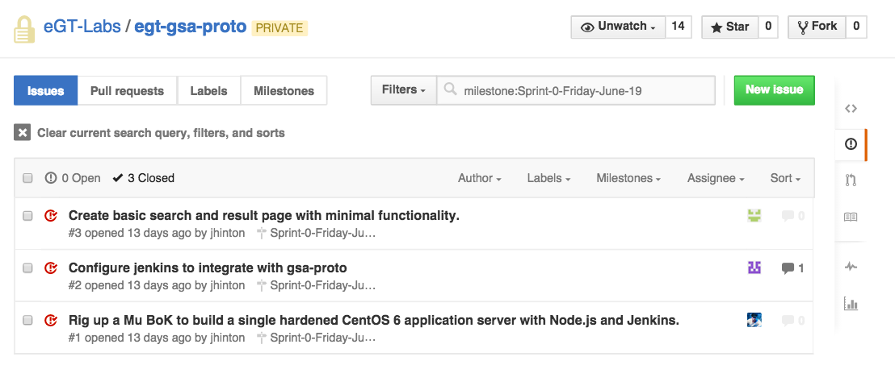

Figure 1 Sprint-0 Backlog

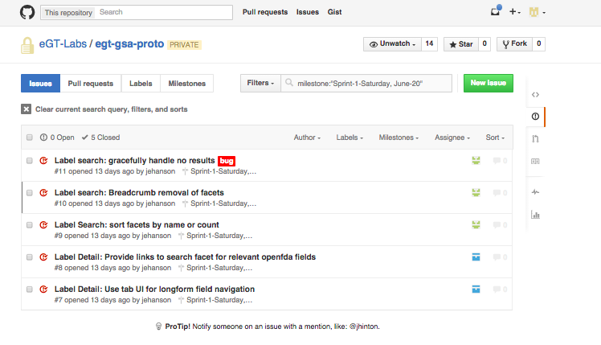

Figure 2 - Sprint-1 Backlog

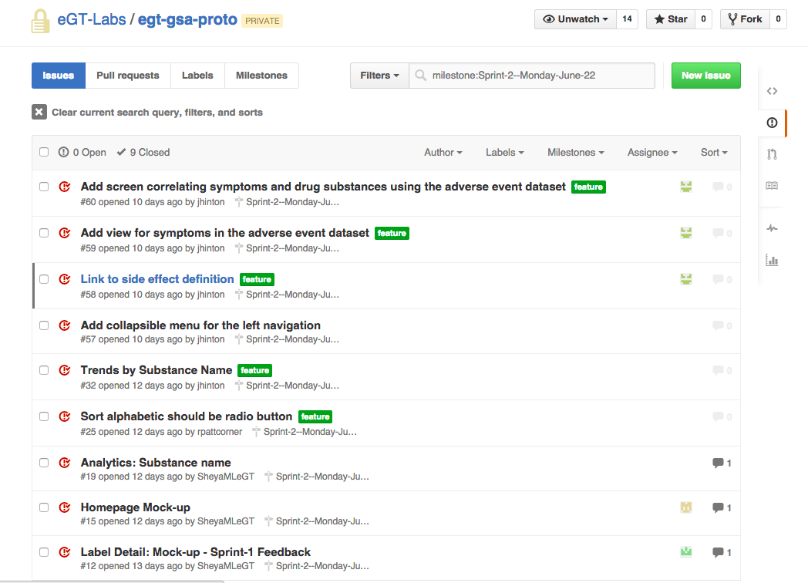

Figure 3 - Sprint-2 Backlog

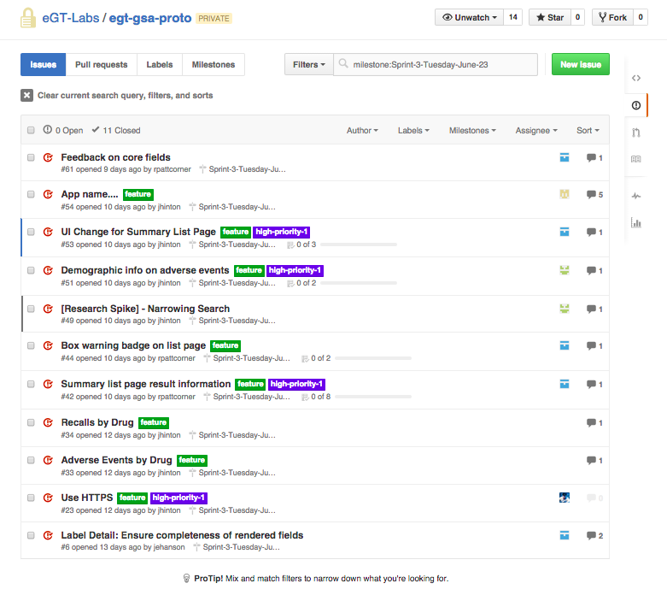

Figure 4 - Sprint-3 Backlog

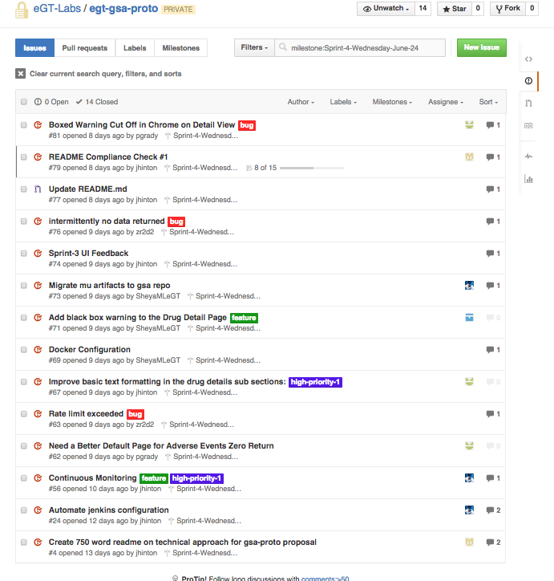

Figure 5- Sprint-4 Backlog

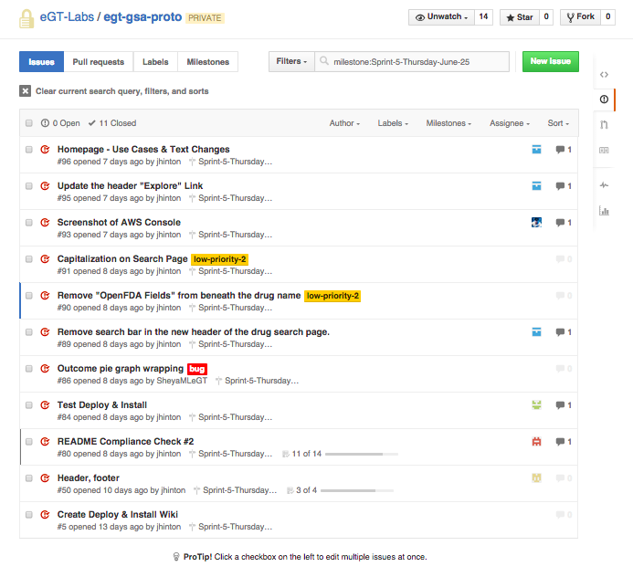

Figure 6 - Sprint-5 Backlog

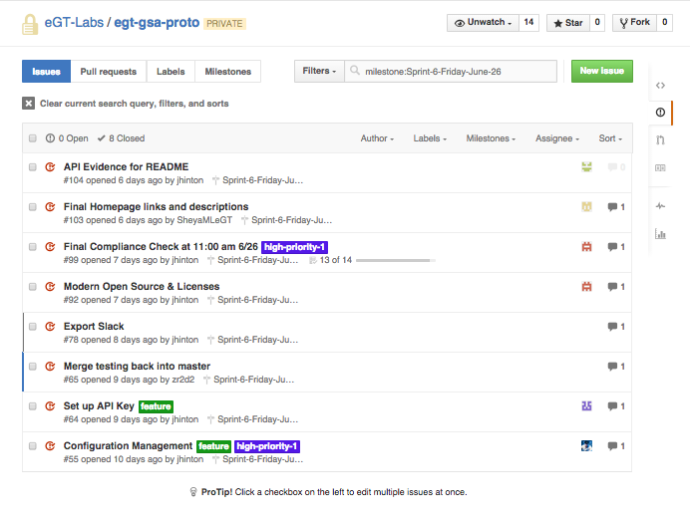

Figure 7 - Sprint-6-Backlog