**Workflow for Auto Assignment formatting from Chat**

**1-Go to Chrome browser and input the URL** <https://chat.openai.com/>

**2-Insert the User Name:** rehanahmed.writersclub@gmail.com

**3-Insert the Password:** Hamza123*

**4- Go to the chat link** [**https://chatgpt.com/g/g-mkkIgZkCJ-academic-writing-coach/c/672dd95f-69bc-8012-bc1e-9366cf35d853**](https://chatgpt.com/g/g-mkkIgZkCJ-academic-writing-coach/c/672dd95f-69bc-8012-bc1e-9366cf35d853)

**5- Copy the First 1000 words from the Section to the New Word Document**

**6- Copy the 2nd 1000 words from the Section to the New Word Document**

**7- Copy the 3rd 1000 words from the Section to the New Word Document**

**8-Combine all the references in the bottom of the document.**

**9- Sort the References in the Ascending Order**

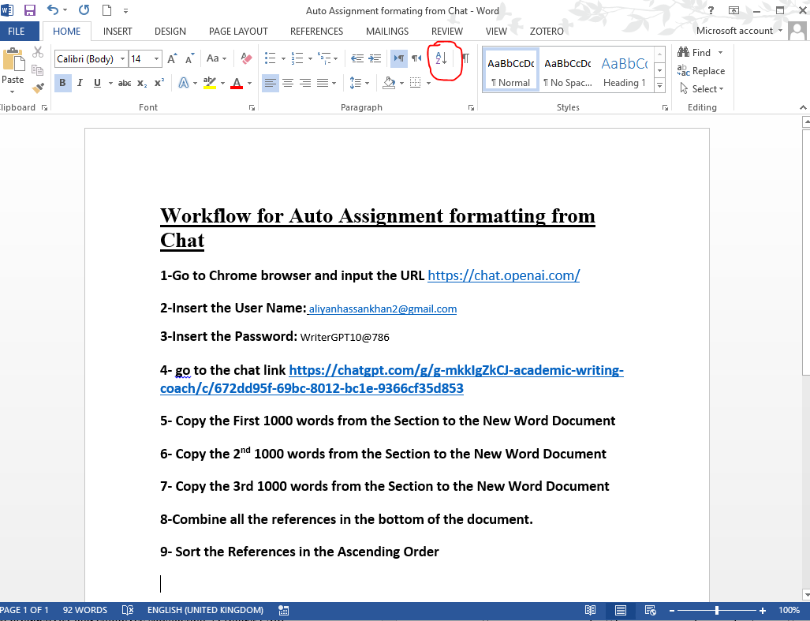

**10- Format the Document according to the following requirements**

### Page layout, paragraph and font

* **Page size**: A4
* **Orientation**: portrait
* **Paragraph alignment**: left (left-justified)
* **Line spacing**: Option 1: Microsoft Word Standard Setting for Normal text, i.e. Line spacing: multiple at 1.15, Spacing before paragraph: 0 pt, Spacing after paragraph: 10 pt; Option 2: Line spacing double
* **Font**: Calibri, Times New Roman or Arial, size 12
* **Headings**: Level 1 – bold, upper case, left aligned; Level 2 – bold, sentence case, left aligned
* **Page numbering**: all pages must be consecutively numbered in the bottom right corner

umar.com.khansqa