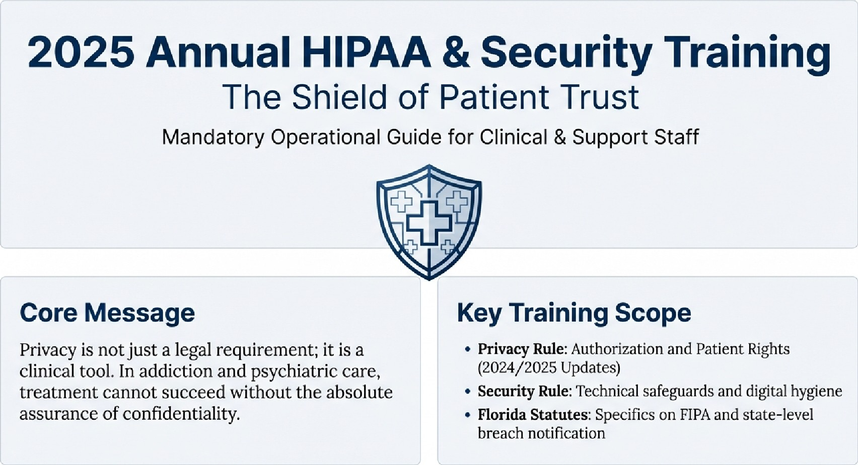
Legal Notice: This material covers federal mandates and Florida-specific regulations. Completion and attestation are required for all staff.

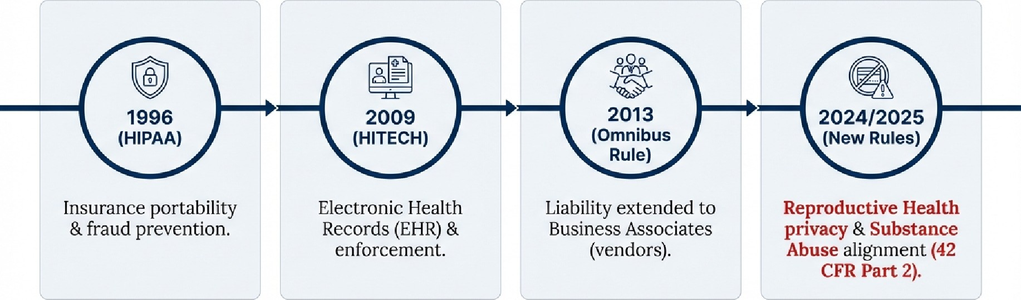
Trust is the Foundation of Recovery
The Clinical Reality: If patients do not trust us with their data, they will not trust us with their history. In psychiatric and addiction care, a breach does not just embarrass a patient; it can destroy their recovery and livelihood.
Defining the Asset: What is Protected Health Information (PHI)?
Definition: PHI is any information that relates to past, present, or future health/payment AND can identify the individual.
Direct Identifiers  Name, SSN, Telephone/Fax numbers, Email addresses. | Service Identifiers  Medical Record Numbers, Health Plan Beneficiary numbers,  Account numbers. | A WARNING:  Even "hallway talk" or a patient's presence in a specific clinic (like addiction recovery) constitutes PHI and must be protected.
Biometric & Visual  Full-face photos, Fingerprints, Voiceprints. |  | Technical & Dates  IP Addresses, Web URLs, Device Serial Numbers. All dates (admission, birth, death) except year alone.

The Two Pillars.• Privacy vs. Security

The Privacy Rule
The Who & why
- Focus: Authorization and Rights.
- Definition: Controls WHO is authorized to access patient information and under WHAT circumstances.
- Managed by: Policies, Procedures, and the Notice of Privacy Practices (NPP).
The Security Rule
The How
- Focus: Technical Safeguards for ePHI.
- Definition: The ability to control access and protect information from accidental or intentional intrusion.
- Managed by: Encryption, Passwords, Firewalls, and Physical Locks.

Key Takeaway: Privacy is the policy; Security is the lock on the door.
The Patient's Bill of Rights & The NPP

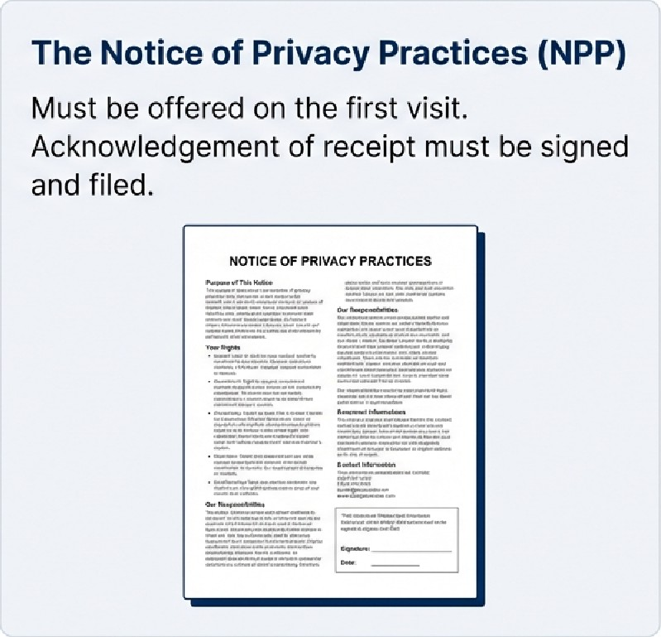
Patient Rights Checklist
g • Access: Right to inspect and copy medical records.
• Amendment: Right to request corrections to records.
g • Accounting: Right to know who has seen their data.
g • Restriction: Right to ask for limits on data usage.
g • Confidentiality: Right to request alternative communication methods.
The Golden Rule: Minimum Necessary
Use or disclose only the specific amount of PHI necessary to accomplish the immediate task. Distinguish "Need to Know" from "Nice to Know".

Operational Scenarios
Scenario | Verdict
Doctors/Nurses sharing full history for care?  Billing sending full clinical notes when only a diagnostic code is needed? | Allowed  X Violation  X Violation  X MAJOR VIOLATION (Termination Offense)
Discussing a patient by name in a crowded waiting room?
Accessing a colleague's or family member's record out of curiosity?
"Every action you take with patient information has a ripple effect."

CRITICAL UPDATE: 2024/2025 NEW LAW
Reproductive Health Privacy
The New Mandate (Dec 2024 Deadline)
PHI related to lawful reproductive health care cannot be used or disclosed for investigating or imposing liability on any person seeking or providing such care.
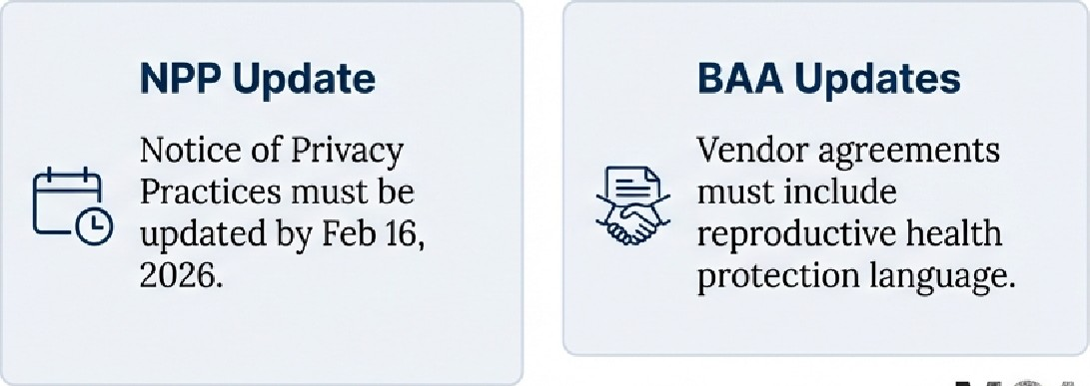
Attestation
Requirement
Must obtain signed attestation confirming requests are NOT for prohibited purposes (even from law enforcement).
MCA
Maryland Chiropractic Association
The Florida Layer: FIPA & State Statutes
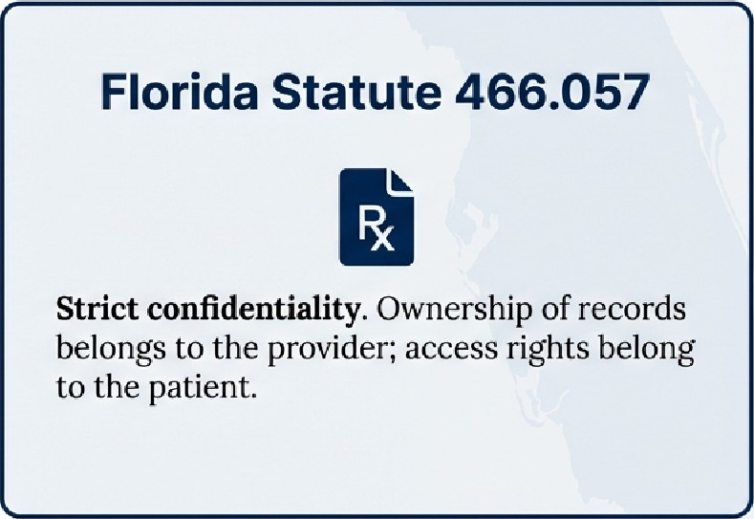
FIPA (Florida Information
Protection Act)
- Broader Scope: Personal info includes User Name/Email + Password/Security Answer.
- Stricter Notification: HIPAA allows 60 days. Florida requires notification to the Dept. of Legal Affairs within 30 DAYS.


Digital Hygiene: Keys to the Castle
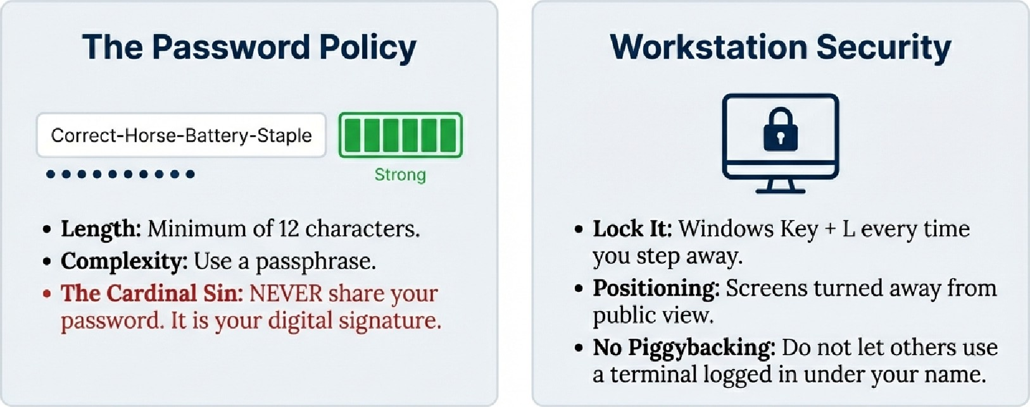
MCA
Maryland Chiropractic Association

The Danger Zones: Email, Texting & Cloud

Email  A Do not use personal Gmail, Yahoo, or Hotmail for PHI. Use encrypted organization email ONLY. |  | Cloud Storage  A Prohibited unless an enterprise account with a BAA is in place. |  | Texting  A Standard SMS is NOT secure. Use approved secure messaging apps only.
Device Control
- Encryption: All mobile devices with ePHI must be encrypted.
- BYOD: No patient photos on personal phones,
- USB Drives: Clinic-issued and encrypted only.
The Human Firewall: Responding to
Social Engineering
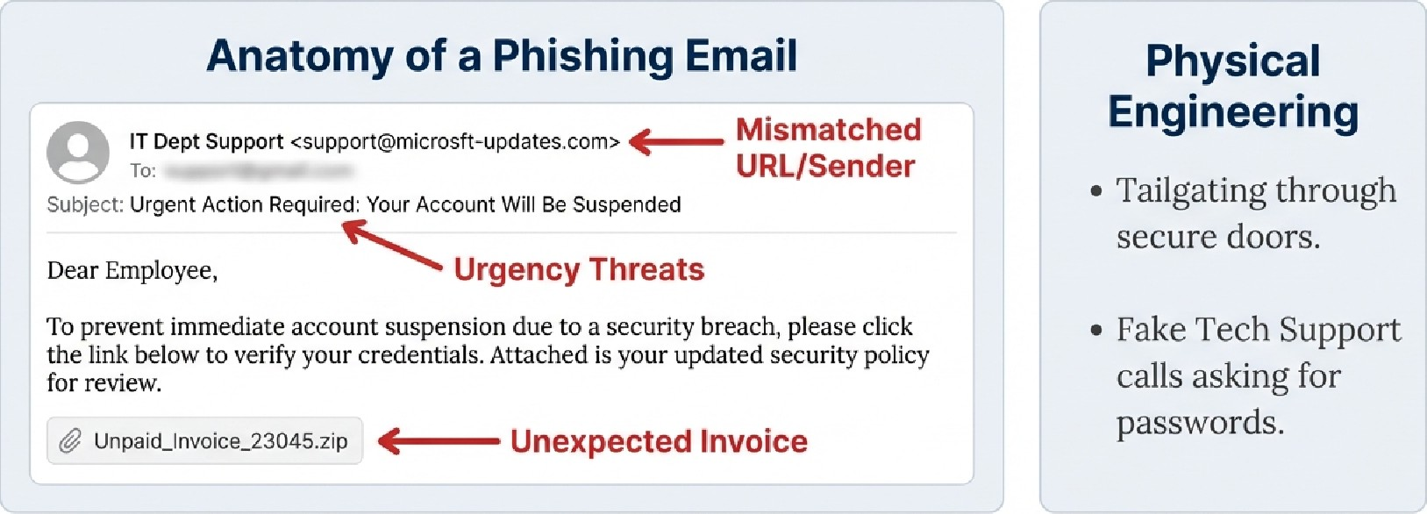
If suspicious: Do NOT forward. Call IT immediately. MCA AssociationMarylandChiroprastic
Partners in Compliance: Business Associates (BA)
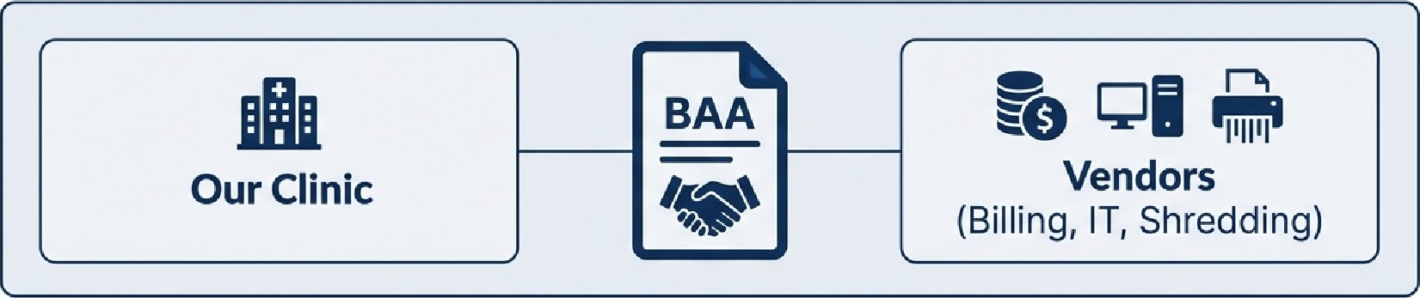
Who is a BA? Any vendor that creates, receives, maintains, or transmits PHI on our behalf.
The Rule: No PHI can be shared until a Business Associate Agreement (BAA) is signed. This legally binds them to HIPAA/FIPA standards.

Staff Responsibility Warning
! Do not sign up for free online tools (e.g., "Free PDF Converter") to process patient data. They are likely not compliant.
MCA

Anatomy of a Breach
Definition: An impermissible use or disclosure under the Privacy Rule that compromises the security or privacy of the PHI.
The Presumption of Guilt: Under the Omnibus Rule, any impermissible use is PRESUMED TO BE A BREACH unless we can prove there is a low probability of compromise.
Risk Assessment Factors
3.
Nature/Extent of PHI Who received it? Was it viewed/acquired? Mitigation extent
Examples listed at the bottom: Lost laptop = Breach. Fax to wrong number = Breach. Gossip = Breach.

Response & Responsibility: Reporting Protocols
Emergency Contact Card
PRIVACY OFFICER: Sol-la Ahmed
PHONE: 727-440-5612
EMAIL: s_ahmed@apcare.net
o The Protocol: See Something, Say Something. Do not investigate yourself. Do not hide it.
Non-Retaliation Policy: Reports can be made anonymously. No retaliation for good faith reporting.
Sanctions: Violations result in tiered sanctions, from retraining to termination.
N%LM

Final Attestation & Next Steps
MANDATORY ACTION:
- Complete the training quiz.
- Sign and date the attestation statement.
- Submit certificate to
HR/Front Desk immediately.
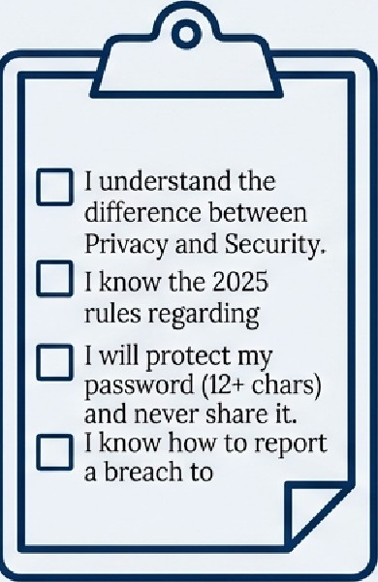
I understand the difference between Privacy Privacy and Security.
I know the 2025 rules regarding Reproductive Health privacy.
I will protect my password (12+ chars) and never share it.
 I know how to report a breach to SoHa Ahmed.
Compliance protects everyone: The Patient, The Clinic, and You. MCA
NotebookLM

