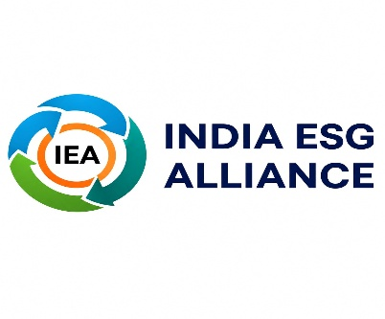
CONCEPT NOTE
India ESG Alliance
A One-Stop Solution Platform for ESG, Sustainability and Responsible Business Growth
FROM COMPLIANCE TO CAPABILITY
FROM SUSTAINABILITY TO COMPETITIVENESS
FROM ESG ACTION TO SUSTAINABLE BUSINESS GROWTH

Dr. Sanjaya Pradhan
Director, India ESG Alliance
August 2026

CONTEXT
India is entering a new phase of growth where ESG is increasingly becoming a driver of revenue, market access and business competitiveness — not merely a compliance requirement. Sustainable products, responsible supply chains, resource efficiency, climate resilience, strong governance and credible ESG performance are creating opportunities for businesses to win new customers, enter global value chains, strengthen buyer and investor confidence, access emerging sources of finance and develop new markets.
For MSMEs and mid-sized enterprises in particular, ESG readiness is increasingly influencing their ability to retain customers, qualify as suppliers, access export markets and participate in large corporate value chains. At the same time, businesses face a fragmented ESG ecosystem of frameworks, experts, technology providers and service providers, making it difficult to identify and implement the right solutions.
India ESG Alliance bridges this gap by connecting businesses with the knowledge, expertise, technology and implementation support required to convert ESG investments into measurable outcomes in revenue growth, market access, operational efficiency, resilience and long-term enterprise value.

India ESG Alliance (IEA) addresses this emerging gap by providing an integrated, multi-stakeholder and digital-first ecosystem for ESG, sustainability and responsible business growth.

IEA brings together knowledge, capacity building, diagnostics, advisory, technology, reporting, assessment, research, innovation and partnerships through a connected platform. It enables organizations to move from understanding ESG requirements to building internal capability, implementing solutions, strengthening data and reporting systems, improving sustainability performance and translating ESG into business value.

The fundamental proposition of IEA is that ESG creates greater value when it moves beyond compliance and becomes part of business strategy, competitiveness and long-term growth.
ESG AS A BUSINESS IMPERATIVE
The evolution of ESG in India reflects a broader shift in how businesses approach sustainability, competitiveness and growth. As regulatory expectations strengthen and global markets demand greater transparency in environmental performance, labour practices, governance and responsible sourcing, ESG is increasingly influencing relationships with customers, investors, lenders and global buyers across the value chain, including MSMEs and exporters.
IEA operates at this intersection of ESG and business performance — shifting the focus from “How do we comply with ESG?” to “How can ESG help us grow a stronger, more competitive and future-ready business?”
BUILDING AN INTEGRATED ESG ECOSYSTEM
India already has a growing network of ESG professionals, consultants, technology companies, academic institutions, industry associations, auditors, financial institutions and development organizations. The challenge lies not in the absence of capabilities but in connecting these capabilities effectively.
India ESG Alliance functions as a connective platform within this ecosystem. An organization can engage with IEA at different stages of its ESG journey — accessing foundational knowledge and leadership programmes when beginning its journey, undertaking diagnostics to understand current maturity, engaging specialised experts and implementation partners to close identified gaps, strengthening ESG data and reporting systems, and exploring sustainability, innovation and business-growth solutions as maturity develops.

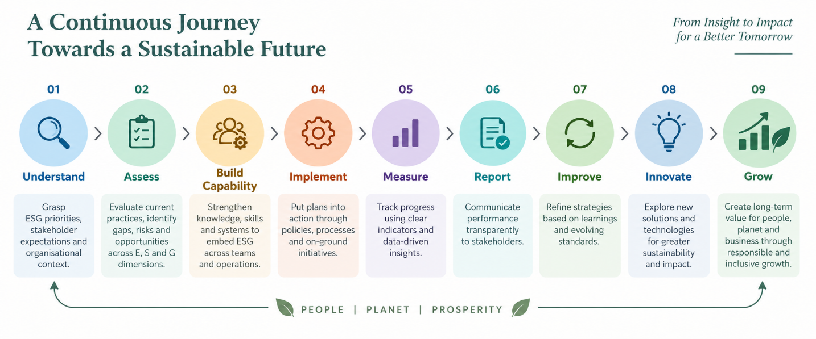

The value of this model lies in continuity. ESG is treated not as a one-time exercise or standalone report, but as a continuous process of organizational improvement. IEA therefore operates beyond the conventional boundaries of a training provider, consulting organization or reporting support agency — bringing these capabilities together through an ecosystem model that connects business demand with knowledge, expertise, technology and implementation.
ENABLING BUSINESSES THROUGH KNOWLEDGE AND CAPABILITY
Effective ESG adoption begins with organizational understanding and leadership commitment. IEA provides structured learning and capability-building programmes for boards, CXOs, senior leadership, functional teams, MSMEs and ESG professionals.
Its learning ecosystem includes Board and CXO ESG Leadership programmes, foundational ESG programmes, sector-specific learning, thematic workshops, webinars, roundtables and practitioner-oriented programmes. The focus remains strongly application-oriented — connecting ESG concepts with regulatory developments, materiality, governance, risk management, data systems, sustainability performance and business value.
This approach enables ESG to move beyond the sustainability function and become a shared organizational responsibility involving leadership, finance, operations, procurement, human resources, risk and business teams.
FROM ESG ASSESSMENT TO ACTION
Understanding an organization's current ESG position is critical to effective action. IEA provides ESG diagnostics and maturity assessments that examine organizational policies, governance systems, environmental and social practices, data availability, reporting readiness and other relevant ESG dimensions. The assessment process converts identified gaps into practical priorities and improvement pathways.
This creates a structured transition from assessment to action, enabling organizations to identify what requires immediate attention, where internal capability needs strengthening, and where external expertise or technology can accelerate implementation. IEA also supports organizations with compliance-readiness, data verification and internal audit facilitation — strengthening the systems that underpin credible ESG performance and disclosure.
STRENGTHENING ESG DATA AND REPORTING
Credible ESG performance depends on credible information.
As businesses face increasing expectations around sustainability disclosures, the quality of ESG data, documentation and governance becomes increasingly important. IEA supports organizations with BRSR and BRSR Core, global framework alignment, reporting gap analysis, ESG documentation, data-system design and technology-enabled reporting solutions.
The focus extends beyond preparing an ESG report. IEA works with organizations to strengthen the systems through which ESG information is generated, collected, documented, governed and verified — enabling ESG reporting to become part of organizational management rather than an annual compliance exercise. For organizations participating in international value chains, the approach also supports alignment with relevant global sustainability expectations and market requirements.
CONNECTING SUSTAINABILITY WITH BUSINESS GROWTH
A defining feature of the India ESG Alliance approach is its focus on connecting sustainability with business performance:
— Environmental sustainability can create opportunities for energy and resource efficiency.
— Stronger social practices can contribute to workforce productivity, employee retention and stakeholder confidence.
— Effective governance can strengthen decision-making, transparency and risk management.
— Responsible supply-chain practices can enhance business relationships and market access.

IEA connects organizations with specialised experts, solution providers and technology partners to translate these opportunities into practical action — through expert clinics, advisory support, innovation initiatives, pilot projects and technology-enabled solutions.
The objective is not simply to improve ESG scores or reporting quality. It is to help organizations create measurable value through responsible business practices.
MAKING ESG ACCESSIBLE TO MSMES
MSMEs represent a critical part of India's industrial, employment and supply-chain ecosystem — their ESG transition is therefore essential to the broader sustainability of India's economy. However, MSMEs frequently face constraints in accessing specialised expertise, technology, finance and ESG systems, and multiple frameworks and complex reporting requirements can further increase the perceived cost of ESG adoption.
IEA addresses this challenge through practical, affordable and sector-relevant ESG solutions designed around the realities of MSMEs — connecting ESG adoption with outcomes that matter directly to businesses: operational efficiency, responsible supply-chain participation, buyer readiness, export competitiveness, risk reduction, stronger governance and access to relevant expertise and technology.
This positions ESG not as an additional compliance burden but as a pathway to competitiveness, resilience and sustainable growth for MSMEs.
A DIGITAL PLATFORM CONNECTING THE ESG ECOSYSTEM
The digital platform is the connective infrastructure of India ESG Alliance. It brings together businesses, MSMEs, experts, technology providers, knowledge institutions, government agencies, investors and development organizations through a common ecosystem.
Businesses access ESG knowledge, diagnostics, learning, experts, reporting resources, technologies, research and implementation solutions. Experts and solution providers gain structured opportunities to connect with organizations seeking ESG capabilities. Government and development organizations gain an ecosystem platform for designing and implementing scalable programmes.
The digital ecosystem also creates the foundation for continuously expanding IEA's knowledge base, expert network, sector intelligence and solution marketplace. In this model, technology provides scale, experts provide depth, research provides evidence, partnerships provide reach and implementation provides measurable impact.
A PLATFORM FOR GOVERNMENT, INDUSTRY AND DEVELOPMENT PARTNERS
The complexity of India's ESG transition requires collaboration across institutions. IEA works with government institutions on ESG capacity building, MSME transition, industry engagement, sustainability programmes and ecosystem development.
— Corporates — access to ESG knowledge, diagnostics, experts, reporting solutions, advisory and innovation.
— MSMEs — practical pathways for ESG readiness and sustainable competitiveness.
— Development organizations and funding institutions — an implementation platform for scalable programmes across ESG, climate action, MSME development and sustainable business growth.
— Academic institutions and think tanks — opportunities for applied research, knowledge partnerships, case development and policy dialogue.
— Technology companies and specialised solution providers — access to an expanding ecosystem of enterprises seeking ESG solutions.

Through this multi-stakeholder approach, IEA connects policy, knowledge, business and implementation within a common ecosystem.
RESEARCH, KNOWLEDGE AND THOUGHT LEADERSHIP
IEA combines implementation with research and knowledge creation. It undertakes applied research, sector studies, knowledge development and stakeholder consultations, while creating platforms for interaction among industry, government, academia, investors and practitioners.
The research agenda focuses on emerging issues relevant to Indian businesses, including ESG readiness, responsible supply chains, climate risks, sustainability performance, ESG skills, data systems, sector-specific materiality and sustainable business models. By translating global ESG developments into India-relevant business knowledge, IEA contributes to a more informed and practical ESG ecosystem — strengthening its role as a knowledge partner for businesses, policymakers, development organizations and industry institutions.
CREDIBILITY, QUALITY AND TRUST
Trust is central to ESG.
IEA operates through an institutional governance structure comprising leadership, an Advisory Council, expert networks and professional management. Its ecosystem is supported by defined engagement processes, quality assurance, expert review and conflict-of-interest safeguards. The emphasis on credibility extends across knowledge, training, assessment, partnerships and implementation.

CREDIBILITY · EXPERTISE · QUALITY · INDEPENDENCE · PRACTICAL IMPACT

This enables the Alliance to function as a trusted interface between businesses and the wider ESG ecosystem.

CREATING VALUE ACROSS THE ESG ECOSYSTEM
The value proposition of India ESG Alliance extends across the entire stakeholder landscape:

STAKEHOLDER | WHAT IEA DELIVERS
Corporates | Strengthens ESG capability, reporting, risk management, sustainability performance and long-term competitiveness.
MSMEs | Creates accessible pathways to ESG readiness, responsible supply-chain participation, market opportunities and sustainable growth.
Government & Development Partners | Provides a credible platform for scalable ESG, climate and enterprise-development programmes.
Industry Associations | Provides sector-specific knowledge, capability-building and member engagement solutions.
Experts & Technology Providers | Creates a structured ecosystem connecting specialised solutions with business demand.
Academic & Knowledge Institutions | Creates opportunities for applied research, knowledge partnerships and policy dialogue.

Through these relationships, IEA contributes to an ecosystem where ESG performance, business competitiveness and sustainable economic growth reinforce one another.
CONCLUSION
India's ESG transition is moving rapidly from awareness towards implementation, accountability and business value. Businesses increasingly require an integrated partner that connects knowledge, expertise, technology, assessment, reporting, implementation and innovation.
India ESG Alliance provides this integrated ecosystem.

Through its one-stop digital platform, IEA enables organizations to understand ESG, assess their readiness, build capabilities, access expertise and technology, implement solutions, strengthen data and reporting, improve sustainability performance and translate responsible business practices into long-term value.

ESG with Business Growth / Sustainability with Competitiveness / Responsible Business with Long-Term Value

— For corporates, IEA is a trusted ESG and sustainable business partner.
— For MSMEs, it is a gateway to ESG readiness and competitiveness.
— For government and funding organizations, it is an ecosystem and implementation platform.
— For experts, technology providers and knowledge institutions, it is a platform for collaboration, innovation and market engagement.

The India ESG Alliance therefore represents more than an ESG service provider. It represents a connected institutional ecosystem that enables businesses and institutions to navigate ESG, strengthen sustainability performance and build more resilient, responsible and competitive organizations.

One-Stop Digital Ecosystem for ESG,
Sustainability & Responsible Business Growth

Dr. Sanjaya Pradhan
Director, India ESG Alliance
indiaesgalliance@gmail.com
Unit No. 8, P3, J Wing, Rustomjee Azziano Road,
Majhiwada, Thane West, Maharashtra – 400601, India
Thank you

