Stated assumptions:
1. I decided to build voltage monitor system using RTOS. I have two tasks:
First one: The ADC is sampling at a rate of 1 sample per 1 msec. And with every ADC sample conversion DMM_Update_Voltage function is called. This function only count number of samples and adds them together. So when...
… second one is called every 100 msec it makes display refreshed and it display on LCD the mean value of collected samples using Display_Update_SetOverload and Display_Update_SetVoltage functions.
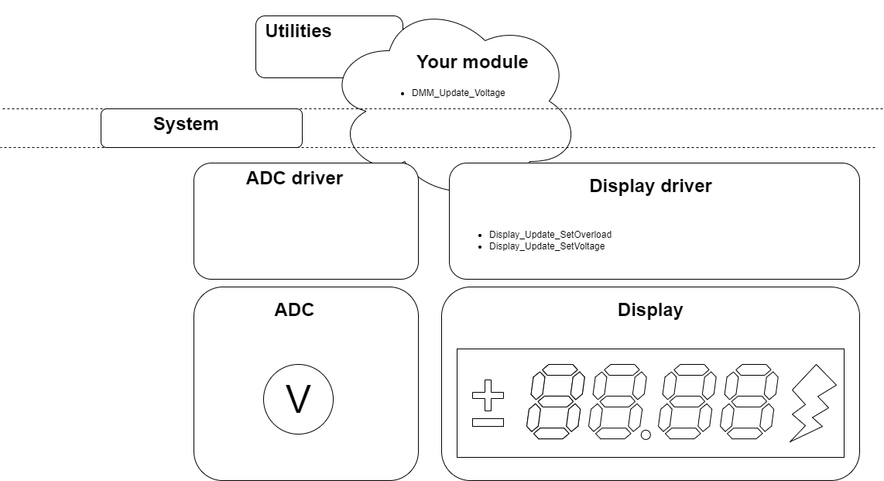
I have been provided with interface for display and ADC but to check my code I simulate receiving ADC samples and also converting it’s value to mV. Knowing that device has adjust read value with a linear calibration and reading shows an +120mV offset error and a 1.02 gain error.

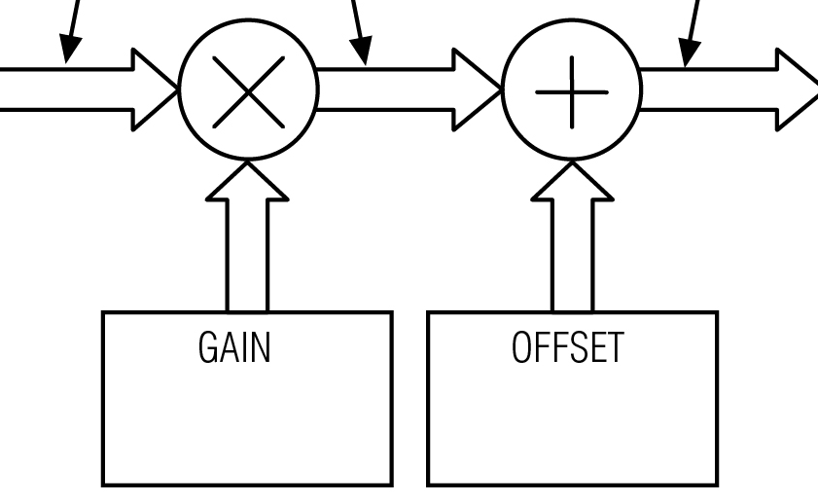

2. User Requirements: display voltage range of -10V to +10 V with 10mV resolution. And indicate if there is any overload. But with 12bit ADC (0 - 4095) and 4 mV resolution we are able to measure between -8.31V to + 8.39V. To be able to measure in larger range we have two options: switch 12 bit ADC to 16 bit ADC or min resolution 5 mV. The function which I wrote to simulate ADC_read check if ADC is 12 bit or 16 bit.
Information:
- I build package on "Debian GNU/Linux bookworm/sid". If you want to build it by yourself you should place FreeRTOS folder wherever you want and export variable:
export FREERTOS_PATH=(path)/FreeRTOS
- Main program is build using makefile, and tests using cmake.
- It contains src folder with sources files, include folder with headers files, test folder with source file for testing the code and build folders (build and build_Test in which are already build packages for my system.
Conclusion:
You can also make this program without using RTOS only with DMM_Update_Voltage function for example using interrupts from ADC.

Krzaczkowska Ewa

