COMPUTER VISION AND COGNITIVE SYSTEMS HOMEWORK1
FIND PAINTINGS

Damiano Caprari, Matteo Pulega, Marco Dalai
Master Degree in Computer Engineering
Dipartimento di Ingegneria Enzo Ferrari
Università di Modena e Reggio Emilia
{189652, 85755, 187466}@studenti.unimore.it

Abstract

In this paper we will explain the methodology used to extract paintings from frames taken from a museum. Our approach is based on the capability of extract the connected components which represents the objects of the frame, construct a mask to isolate each component and then compute some indices that are significant for the discrimination.

1. INTRODUCTION
The aim of our work is to detect paintings inside frames captured in a museum. Since it’s an indoor situation, the luminance condition is not variable. But images presented a large illumination gradient with which we have to deal.
We tried to remove the distortion caused by the cameras in order to obtain straight lines even at the borders of the image.
Once found the components inside the image, we isolate one component at time and then we analyse the characteristics of the portion of the image to be able to tell paintings and other objects apart. In particular, since we know that all paintings are rectangular, we exploited some geometrical properties that helped us to crop them away of the frame.

2. RELATED WORKS
In order to be able to detect the paintings inside the image, we exploited some algorithms that were useful considering our approach.
Here we will present a list and then we will explain them, leaving for the approach section the explanation on how we use them:
- Hough Transform-based Radial Distortion Correction (HTRDC)
- Adaptive Threshold
- Optimized Block-based Connected Components Labeling with Decision Trees
- Canny Edge Detection
- Probabilistic Hough Transform for straight lines detection
- Totally Arbitrary 3D Texture Mapping

2.1 HOUGH TRANSFORM-BASED RADIAL DISTORTION CORRECTION
Radial distortion is a very big problem for our approach because it can make straight lines appear as curves. This is very bad since we use straight lines detection to find the 4 sides of the picture.
To correct the radial distortion we implemented the HTRDC algorithm which uses the Hough Transform for straight lines in order to find the best distortion coefficient k that will be used to correct the image.
The resulting image will be cropped since not all original coordinates will be mapped in the undistorted image (Figure 1).
This is an iterative method which will stop when the range of k in which to search is lower than a fixed threshold. Since we have some prior knowledge, we narrow the range from 0 to 1*10-4, causing the algorithm to converge faster.
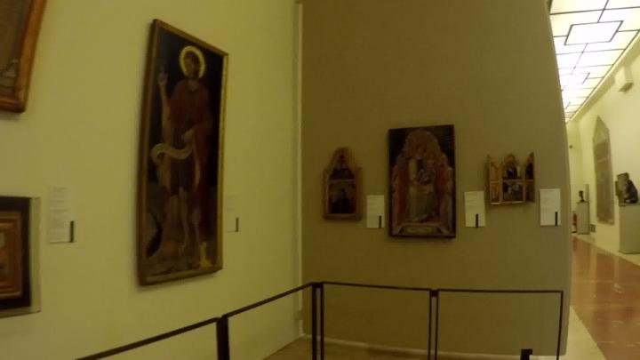
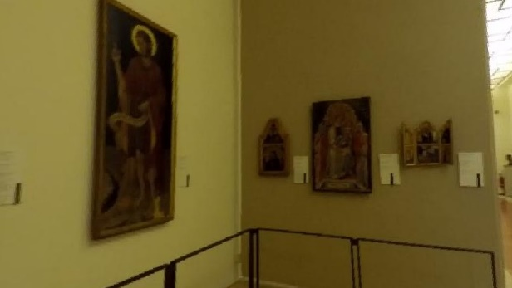
Figure 1 Above there is the distorted photo. Below is the same frame after the application of the HTRDC algorithm

2.2 OPTIMIZED BLOCK-BASED CONNECTED COMPONENTS LABELING WITH DECISION TREES
In order to obtain the connected components in the image, we used the Optimized Block-based Connected Components Labeling with Decision Trees. We made this choice because this algorithm is faster compared to the Haralick algorithm and perform better in identifying the components. This algorithm is implemented inside the opencv library, so we used this implementation.
The reason why this algorithm is faster is because it models the neighbourhood exploration with a Decision Table that will be converted into Optimal Decision Trees which allow to generate the code.

2.3 PROBABILISTIC HOUGH TRANSFORM FOR STRAIGHT LINES DETECTION
Probabilistic Hough Transform is an optimization of the Hough Transform. It takes into account only a random subset of the points. The only thing we must be careful of is to lower the threshold since it uses fewer points.

2.4 TOTALLY ARBITRARY 3D TEXTURE MAPPING
Once found the rectangle enclosing the picture, we need to rectify it. Due to the perspective, this sometimes leads to picture that have a dimension that is too tiny, therefore we need a method the adjust the size of the enclosing rectangle to obtain a good approximation of the size, based on the perspective.
This algorithm tries to find a good approximation of the size of the rectangle through recursion.
First of all we need to find the 4 vertices of the rectangle, and we will name them from A to D starting from top left corner and moving anticlockwise. Through the intersection of lines AC and BD we find the center of the rectangle O. After that we have to compute the two vanishing points of the rectangle, we will call them V1 and V2. V1 can be computed as the intersection between lines BC and AD, while V2 can be computed as the intersection between AB and CD. Now we need to find the center of each edge of the rectangle as it would appear in 3D. This requires again lines intersection and we will name this points from i1 to i4:
- i1 is the intersection between lines AB and OV1;
- i2 is the intersection between lines BC and OV2;
- i3 is the intersection between lines CD and OV1;
- i4 is the intersection between lines AD and OV2.
With those new points we can construct 4 small rectangles, we will name them from R1 to R4:
- R1 is (A, i1, O, i4);
- R2 is (i1, B, i2, O);
- R3 is (O, i2, C, i3);
- R4 is (i4, O, i3, D).
Now we select one rectangle and we recursively apply the same procedure. When we find a rectangle small enough and then we multiply 2N times each measure of the rectangle to obtain the real measures of the rectangle in 3D (Figure 2).

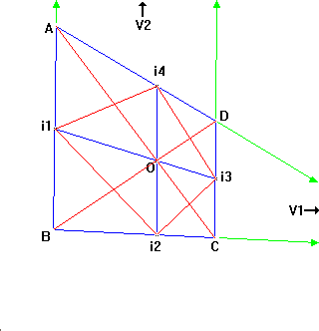
Figure 2 Computation of the rectangle size using perspective

3. APPROACH
In this section we will explain the approach and how we put together what we saw in section 2 to obtain images containing only paintings.
Since the image is distorted, the first thing we do is to apply the HTRDC method to obtain the radial distortion and correct the image. Pictures were taken with different cameras, so we do not know a priori with which camera the photo is taken and we do not have all the cameras, so we can not compute the intrinsic and all the extrinsic parameters, but with this method we can at least compute the radial distortion. Moreover, this method does not require the knowledge of the camera since it is completely based on the information provided by the image, so we can insert it in the execution of the program to compute the radial distortion on-line.
Once we have obtained the undistorted version of the image, we convert it into the grayscale version. This grayscale is blurred using a Gaussian Kernel with a strong standard deviation to delete the details of the paintings and of paintings’ frames.
Even though we are in an indoor situation, pictures present a strong illumination gradient, therefore images cannot be assumed bimodal. Because of this we can not apply Otsu Binarization, but we decided to use an adaptive threshold. The adaptive threshold leaves some details of the items, to reduce this noise we apply some morphological operations in order to obtain thinner components.
After that, we compute the connected components of the image and, for each component, we compute the convex hull, which will be filled to form a mask of the entire component.
At this point we do not know if the component is actually a painting or some other item presents in the museum. To discriminate them we use an entropy-based method. We extract the component from the colored image using its mask, and then we compute the histogram. Histogram of paintings will be variegated, therefore their entropy will be high compared to information labels or statues. We computed a lower threshold below which we are sure that the component is not a painting, and an upper threshold above which we are sure that the component is a painting. We have a gray region in which we are not sure if the component is a painting or not, to overcome this problem we used the mean of the grayscale block. Paintings will have a low mean since they are mostly black, so we used the same criteria used with the entropy.
Once we are sure that the component is a painting, we compute its characteristics. In images we could have both regular paintings, paintings that are completely contained inside the image, and part of paintings. We saw that, if the the painting is not fully contained in the image, it is located on one of the four border of the image. Therefore, if we sum vertically and horizontally the component mask, if there is a painting on borders the sum at the borders will be different from zero. So components which have this characteristics are marked as paintings parts. For those we draw a 4 pixel black border in order to have always 4 sides.
Now we can search for the corners of the painting. To obtain that we first apply the Canny algorithm to compute the borders of the mask,…

