Quick-start: SmartEMF

author : Paul Schiffner, Adrian Zwenger
revision : v0.1
last updated : 2021-04-07
Table of Contents
1 The SmartEMF code-generator 3
1.1 Package-structure and core components explained 3
The emfcodegenerator package 3
The emfcodegenerator.inspectors package 3
emfcodegenerator.inspectors.util 4
The emfcodegenerator.creators package 5
emfcodegenerator.creators.util 6
The emfcodegenerator.util package 8
emfcodegenerator.util.collections 8
The emfcodegenerator.notification package 9
Notification Merging 9
1.2 Important classes and selected methods 10
EMFCodeGenerationClass 10
EMFCodeGenerator 10
EGenericTypeProcessor 11
AbstractObjectFieldInspector 13
AttributeInspector 14
ReferenceInspector 15
EOperationInspector 16
1.3 How does the generator work in general? 17
2 Runtime dependencies – emfcodegenerator.util 20
2.1 How are containment relationships managed? 20
MinimalSObjectContainer 20
SmartEMF Collections 20
SmartObject 21
3 Persistence 22
3.1 How does loading and saving XMI files work? 22
3.2 How can the loading/saving process be configured? 22
3.3 How does notification cascading work? 22

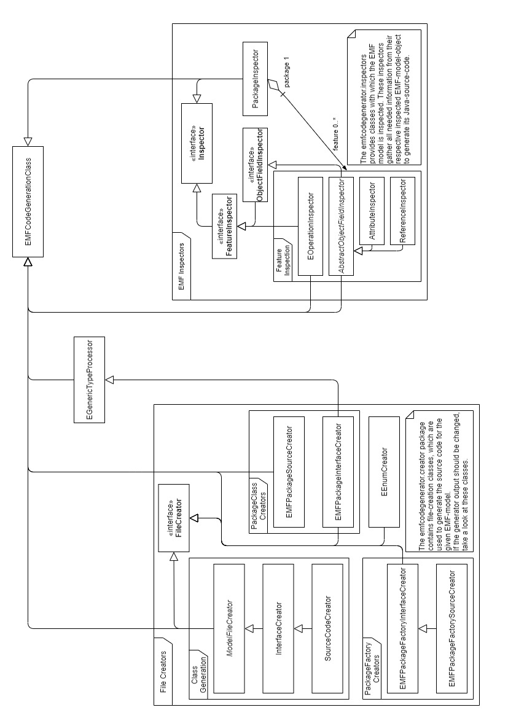

The SmartEMF code-generator

The goal of this section is to give the reader a general understanding of the newly implemented code-generator aiming to replace the EMF-code-generator. How it is implemented and specifics will not be covered. For specifics check out the Java-Doc and the commented source-code.
Only classes which are needed for code-generation are covered.
For information on meta-model persistence read the respective documentation.

Package-structure and core components explained
The code-generator is contained in the emfcodegenerator package which itself contains all classes needed for code-generation and by the generated code during runtime. These are logically grouped into sub-packages.

The emfcodegenerator package
This package contains the generator class itself and some base-classes needed by the sub-packages.
Package contents:
EcoreGenmodelParser | A wrapper-class which reads the EMF-meta-model.
EGenericTypeProcessor | A class providing functionality needed to process EGenericType’s and ETypeParameter’s.
EMFCodeGenerationClass | The super-class of all code-generator classes providing shared functionality like import handling.
EMFCodeGenerator | The actual code-generator.
MultiplicityEnum | An Enum enumerating the multiplicity of EStructuralFeature’s
TestMain | A class containing the main method to start the generator for test purposes.

The emfcodegenerator.inspectors package

The inspectors package contains classes which are used to inspect the given EMF-model and attain information needed for code generation. The package itself contains interfaces and the util sub-package contains the implemented classes.

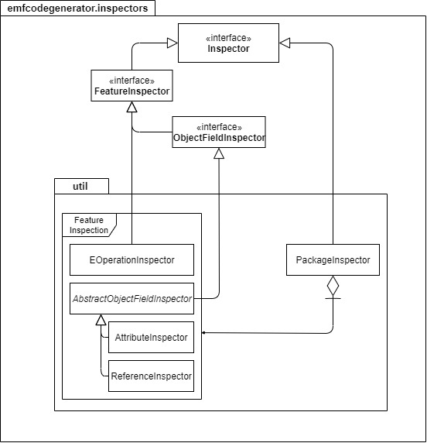Figure 1: inspectors-package structure and inheritance diagram
Package contents:
Inspector | Interface describing common methods.
FeatureInspector | Interface for Inspectors inspecting EStructuralFeature’s.
ObjectFieldInspector | Interface for Inspectors inspecting EReference’s or EAttribute’s.
InspectedObjectType | Enumerates what is inspected.

emfcodegenerator.inspectors.util
This package contains the implemented inspectors.
EAttribute’s are inspected with the AttributeInspector and EReference’s with the ReferenceInspector class. Both classes inherit from the AbstractObjectFieldInspector.
These two Inspector’s provide basic information about these features such as:
- the designated variable name
- the imports which are needed in the generated source code-code
- if they ought to be stored as an object or contained in some sort of collection
- etc.
Some code-snippets, which are needed when initializing the meta-model, are generated with them as well.

EOperation’s are inspected with the EOperationInspector class which provides similar functionality to the AbstractObjectInspector.

EPackages are inspected with the PackageInspector, which parses all package content and retains (and creates missing) Inspectors for all EStructuralFeature in said package.

The emfcodegenerator.creators package
The creators-package contains interfaces and classes which describe how a SmartEMF code-generating class has to look like to work with the rest of the generator. Fully implemented creators are located in the util sub-package
Package contents:
FileCreator | General interface describing the methods any creator must implement to initialize the creator and write the generated code to a file.
ModelFileCreator | Abstract class which offers base functionality for all code-generating classes which generate code for EClasses
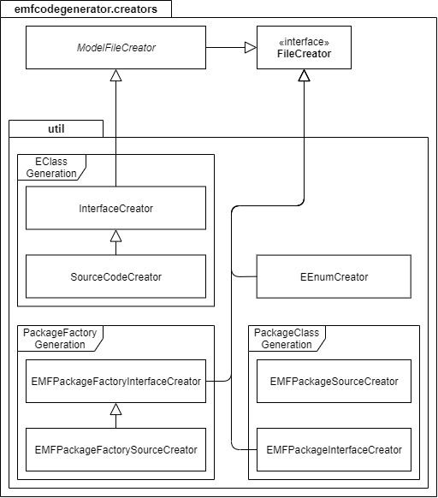Figure 2: creators-package structure and inheritance diagram

emfcodegenerator.creators.util
EMF generated code can be categorized into 4 different groups which are source code for classes, enums, packages and package-factories. As the goal of SmartEMF is to be somewhat compatible with the original EMF the output of the generator is to be similar.
An EMF-meta-model code-package always contains interfaces and enums in its root and implementation files in a sub-package called “impl”. All files in the “impl”-package have the suffix “Impl” appended to their name. Furthermore, each package contains a “package-class” which is used to initialize the package content for runtime and offers an interface to the packages content. A “package-factory” is contained as well, with which runtime-instances of the package-contents can be created.
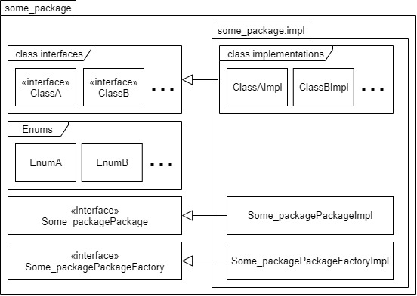Figure 3: package structure of generated code

Classes are generated with the InterfaceCreator, which creates the interface, and the SourceCodeCreator.
EENumCreators are used to generate the model-code for EEnums.

The EMFPackageInterface and EMFPackageSourceCreator are used to create the needed files for the package-class.

EMFPackageFactoryInterface and EMFPackageFactorySourceCreator are used to create the package-factory.

The emfcodegenerator.util package
The util-package contains dependencies which the generated code needs during runtime as it is here where the generated code diverges from the original EMF code.

Package contents:
MinimalSObjectContainer | Interface which all classes need to implement to be compatible with the SmartEMF-framework.  It defines needed methods for containment features to work correctly.
SmartObject | Base class which implements the original EObject-EMF-interface for EMF-compatibility. All generated SmartEMF-classes inherit from this class.  Because this class does not implement the InternalEObject interface, many internal EMF classes cannot be used with SmartObjects.

emfcodegenerator.util.collections
One of the main goals of reimplementing parts of the EMF-framework was to exchange Collection behaviour. This package contains said Collections and other needed definitions.
The discerning feature of these SmartEMF Collections compared to regular Java-Collections is, that they implement the MinimalSObjectContainer-interface and support EMF-Notifications. Thus enabling them to be used for containment-relationships, their management and broadcasting Notifications if needed.

The emfcodegenerator.notification package
The notification-package contains runtime dependencies that the generated code needs for EMF notification compatibility.
Package contents:
SmartEMFNotification | This class implements the Notification and NotificationChainWorkaround interfaces. All notifications that the generated classes send are of this type. It supports notification merging and chaining. When a notification is added to the chain, it will be merged if possible.
NotificationList | This class implements the NotificationChain interface. It is used to collect notifications without merging them.
NotificationChainWorkaround | Interface that allows Xtend code to implement the original NotificationChain interface – this is necessary because dispatch is an Xtend keyword and can’t be a method name

Chaining means that notifications are accumulated and dispatched with a single method call.
Merging means that similar notifications that happen immediately after one another are aggregated.
Notification cascading can be configured by the XtendXMIResource for its contents.

Notification Merging
SmartEMFNotifications can be merged if the following conditions are met:
- They represent events that happen to the same EObject and the same EStructuralFeature
- Their types are compatible
Notifications are automatically merged when using aggregate collection operations like addAll.

Important classes and selected methods

EMFCodeGenerationClass
This class offers base import management. Needed imports are saved as Strings.

Set<String> get_needed_imports() | Returns a Set with the needed imports.
String <E> create_import_name_for_ereference_or_eclass(E e_obj) | Returns the import String for a given EReference or EClass.
void add_import_as_String(String import_string) | Adds a given String as an import.
void add_import_as_String(Collection<String> import_strings) | Adds all Strings in Collection as an import.

EMFCodeGenerator

Contains the main-control-flow for code-generation. It creates a new EcoreGenmodelParser for the given XMI-files, initializes all PackageInspectors and creates FileCreators for all EClasses during construction.

void generate_all_model_code() | Generates all model-code.

EGenericTypeProcessor

This class offers the functionality to traverse ETypeParameter’s and EGenericType’s and their respective bounds. This is needed to create parametrized EAttribute’s, EReference’s and for the return value, generic-type parameter, input parameters and parametrized exceptions of EOperation’s.
Not only is the String representation and the needed imports for those elicited, but the needed EMF-framework initialization code to set their bounds for the can be generated with this as well.

LinkedList<EGenericType> traverse_generic_bounds(EGenericType type, LinkedList<EGenericType> bounds_list) | Recursively parses the EGenericType bound/parameter tree and saves the tree as a flattened, top-down version with its root positioned as last element in the passed List.  Check the Java-Doc for proper usage instructions.
LinkedList<EGenericType> traverse_generic_bounds_for_eoperations(...) | Same as above. Traversal is tweaked to work with EOperations.
LinkedList<EGenericType> traverse_generic_bounds_for_object_fields(…) | Same as above. Tweaked for EAttribute’s and EReference’s.
String get_eclassifier_getter_command_for_egenerictype(EGenericType generic_type) | Creates the needed Getter-call to create an EClassifier for a given EGenericType.
String create_egeneric_type_bound_set_up_command(...) | Creates the command needed to initialize a given EGenericType with its bounds.  Like above variations of this method exist. Check out the Java-Doc and source-code for usage and differences.

usage pseudo code:
- Create a sorted Collection for Strings containing commands to create needed variables
- Create a sorted Collection for Strings containing commands which operate with those variables
- store all ETypeParameter’s from all EClass's in package to a list
- iterate over list
  - Generate the ETypeParameter creation command and add it to chosen code-block.
  - iterate over all EBounds of current EtypeParameter
    - LinkedList = traverse_generic_bounds(bound, new LinkedList<EGenericType>())
    - iterate backwards trough LinkedList
      - Create the command to create the bound. Add it to the first collection.
      - Create the set-up command for the bound with create_egeneric_type_bound_set_up_command(…) and save it to the second Collection.
- Add all entries of the first Collection in order to the chosen code-block
- Add all entries of the second Collection in order to the chosen code block

sample class declarations:
public class classA<z extends myinterface<myinterface<? extends MyClass>>,b>
public abstract class myinterface<p>
public class classE<a extends myinterface<myinterface<? extends EClass>>,z>

sample output:

//Create type parameters for all EClasses
ETypeParameter myinterfaceEClass_p = addETypeParameter(myinterfaceEClass, "p");
ETypeParameter classAEClass_z = addETypeParameter(classAEClass, "z");
ETypeParameter classAEClass_b = addETypeParameter(classAEClass, "b");
ETypeParameter classEEClass_a = addETypeParameter(classEEClass, "a");
ETypeParameter classEEClass_z = addETypeParameter(classEEClass, "z");
//Set Bounds for the type parameters
EGenericType generic_bound_9 = createEGenericType(MyPackage.getMyClass());
EGenericType generic_bound_10 = createEGenericType();
EGenericType generic_bound_11 = createEGenericType(MyPackage.getmyinterface());
EGenericType generic_bound_12 = createEGenericType(MyPackage.getmyinterface());
EGenericType generic_bound_13 = createEGenericType(ecorePackage.getEClass());
EGenericType generic_bound_14 = createEGenericType();
EGenericType generic_bound_15 = createEGenericType(MyPackage.getmyinterface());
EGenericType generic_bound_16 = createEGenericType(MyPackage.getmyinterface());
generic_bound_10.setEUpperBound(generic_bound_9);
generic_bound_11.getETypeArguments().add(generic_bound_10);
generic_bound_12.getETypeArguments().add(generic_bound_11);
classAEClass_z.getEBounds().add(generic_bound_12);
generic_bound_14.setEUpperBound(generic_bound_13);
generic_bound_15.getETypeArguments().add(generic_bound_14);
generic_bound_16.getETypeArguments().add(generic_bound_15);
classEEClass_a.getEBounds().add(generic_bound_16);

AbstractObjectFieldInspector
This class offers shared functionality needed by AttributeInspector’s and ReferenceInspector’s.

ArrayList<String> generate_needed_generic_types_for_init_code() | Generates the code which is needed to initialize the EStructuralFeature’s ETypeParameter’s and EGenericType’s for the EMF-model. This code needs to be added to the Package-class in the initializePackageContents() method.

AttributeInspector
This class inspects EAttribute’s.

void generate_init_code_for_package_class(EcoreGenmodelParser gen_model) | Generates the command which is needed to create the EAttribute in the EMF-model. Code generated by AbstractObjectFieldInspector.generate_needed_generic_types_for_init_code() is added to the beginning of the newly generated code.  This code needs to be added to the Package-class in the initializePackageContents() method.
private void init(EStructuralFeature e_feature) | Is called by constructor and gathers basic information like Attribute type and default value.  Check here if anything of those is incorrect.  It throws an Exception if the attribute is not changeable and no default value was provided. In case of a literal/primitive with missing default value exceptions are thrown. If it is an object and not a tuple, exceptions are raised as well.

The following is a sample of what is generated by generate_init_code_for_package_class(…) for a class called MyClass with a String attribute called MyString
initEAttribute(
getMyClass_MyString(),
ecorePackage.getEString(),
"stuff",
null,
0,
1,
MyPackage.MySubPackage.MyClass.class,
!IS_TRANSIENT,
!IS_VOLATILE,
IS_CHANGEABLE,
!IS_UNSETTABLE,
!IS_ID,
IS_UNIQUE,
!IS_DERIVED,
IS_ORDERED
);

ReferenceInspector
This class inspects EReference’s.

void generate_init_code_for_package_class(EcoreGenmodelParser gen_model) | Generates the command which is needed to create the EReference in the EMF-model. Code generated by AbstractObjectFieldInspector.generate_needed_generic_types_for_init_code() is added to the beginning of the newly generated code.  This code needs to be added to the Package-class in the initializePackageContents() method.
private void init(EStructuralFeature e_feature) | Is called by constructor and gathers basic information like the EReference-target.  Check here if anything of those is incorrect.  It throws an Exception if the reference is not changeable

The following is a sample of what is generated by generate_init_code_for_package_class(…) for a class MyClass with a mono-directional reference to OtherClass called my_reference.
Code which would be generated by AbstractObjectFieldInspector.generate_needed_generic_types_for_init_code() is left out.

InitEReference(
getMyClass_my_reference(),
this.getOtherClass(),
null,
"my_reference",
null,
0,
32,
MyClass.class,
!IS_TRANSIENT,
!IS_VOLATILE,
IS_CHANGEABLE,
IS_COMPOSITE,
!IS_RESOLVE_PROXIES,
IS_UNSETTABLE,
IS_UNIQUE,
!IS_DERIVED,
IS_ORDERED
);

EOperationInspector
This class inspects EOperation's.

void generate_init_code_for_package_class(EcoreGenmodelParser gen_model) | Generates the commands which are needed to create the EOperation in the EMF-model. It traverses the EGenericTypes and ETypeParameters of the return value, parameter list and exception list and sets them up. Due to the somehow different handling of those parameters in EMF, this method is very complex. If this should be reworked reading the comments left in the source-code is highly advised.
HashMap<String,String> get_method_implementation(String IDENTION) | Returns a HashMap. The key is the methods declaration and the value its implementation.  Currently generating EOperations behaviour is not supported. If this should change, add the code as the value of the HashMap entry.  The IDENTION-String is used to indent lines of code.

How does the generator work in general?
A good place to start are the interfaces of the code-generator. They define the basic actions all implementing classes offer. Afterwards continue reading documentation in the implementation.
Another great way to find out how the generator works is to backtrack from the methods which write to a file or initializes the Creator.

In general the generator functions as follows:
- The EcoreGenmodelParser traverses the given meta-model:
  - Inspectors are created for:
    - EAttributes
    - EReferences
  - PackageInspectors are constructed
    - AttributeInspectors and ReferenceInspectors are added
- The EMFCodeGenerator generates the code for all Packages:
  - Initialize the PackageInspector
    - gather all missing Inspectors
    - elicit cross package dependencies
    - elicit dependencies created by inheritance
    - generate code snippets needed in the package-class
  - Create FileCreators for all Classes in the package
    - Create a Creator for the classes interface
    - Create a Creator for the classes implementation
- The interfaces for all classes is generated by the InterfaceCreator
  - The Creator is initialized:
    - Method declarations are constructed
  - Content is written to specified file
- The classes source code is generated by the SourceCodeCreator:
  - The Creator is initialized:
    - Needed methods are generated
    - Needed data-fields are generated
  - Content is written to specified file.
- Interface for the PackageFactory is generated by EMFPackageFactoryInterfaceCreator.xtend
  - The Creator is initialized:
    - Create method-declarations for all classes which will return a constructed class instance instances
    - Create data-field entries
  - Interface is written to specified file.
- Implementations for the PackageFactory is generated by EMFPackageFactorySourceCreator.xtend:
  - The Creator is initialized:
    - Create method implementations
    - Create data-field entries
  - Interface is written to specified file.
- Interface for the PackageClass is generated by EMFPackageInterfaceCreator.xtend:
  - The Creator is initialized:
    - Create Getter-method-declarations for all
      - EClasses
      - EAttributes
      - EReferences
      - EOperations
      - EDataTypes
      - EEnums
which will return the meta-model instance of said elements
    - Create data-field entries for all
      - EClasses
      - EAttributes
      - EReferences
      - EOperations
      - EDataTypes
      - EEnums
which will store an int ID for said meta-model elements
  - Create the Literals sub-interface
    - Create a date field for all:
      - EClasses
      - EAttributes
      - EReferences
      - EOperations
      - EDataTypes
      - EEnums
which are assigned the elements getter-method via a static implemented instance of this interface.
  - Interface is written to specified file.
- Implementations for the PackageClass is generated by EMFPackageSourceCreator.xtend:
  - The Creator is initialized:
    - Create data-field entries for all:
      - EClasses
      - EAttributes
      - EReferences
      - EOperations
      - EDataTypes
      - EEnums
meta-model elements.
    - Implement all methods declared by EMFPackageInterfaceCreator.xtend
    - Construct methods needed by EMF to load the meta-model:
      - public static PackageClass init()
        - initializes the package and all other packages of the meta-model
      - public void createPackageContents()
        - creates all meta-model elements
      - public void initializePackageContents()
        - initializes and builds the meta-model elements
  - Implementation is written to specified file.

Runtime dependencies – emfcodegenerator.util
The util package mostly contains code which is needed during model runtime. It contains the shared super-class of all generated code, collections and other dependencies needed for containment relationships or notifications.

How are containment relationships managed?
Containment references are implemented by having a link from the container to the contained element implemented as a data-field. The contained element stores the container as a data-field.
As there is no de-constructor in Java, containments are resolved by deleting all links between the elements and thus deleting all references to the contained element. This would normally lead to the Java garbage-collector deleting the objects.

MinimalSObjectContainer
The MinimalSObjectContainer interface specifies the needed methods which all classes intending to work with SmartEMF must implement. Not only does it contain methods intended to keep compatibility with the original EMF, but also specifies methods internally used in SmartEMF to resolve containments.
abstract def EObject eContainer() | Returns the container object, or null.  An object is contained by another object if it appears in the contents of that object.
abstract def EStructuralFeature eContainingFeature() | Returns the EReference which describes the containment-relationship the object is or null.
def abstract void reset_containment() | Method used internally by SmartEMF.  It resets the containment feature and thus sets the eContainer and the eContainingFeature to null.
def abstract void set_containment(EObject container, EStructuralFeature feature) | Method used internally to set a containment with given values.
def abstract boolean is_containment_object() | Returns true if this object is currently contained by another.

SmartEMF Collections
The newly implemented Collections are just that. Fitting Collections according to their specification (ordered + unique) and offer the new Notification-system as well as a way to handle containments with multiple contained elements.
This is achieved by managing the added and removed objects. Take a look at the MinimalSObjectContainerCollection interface which all SmartEMF-Collections must implement.

SmartObject
The SmartObject is SmartEMF’s alternative to EMF’s implementation of an EObject.
It does not support all EMF features, however it supports the newly implemented Notification-system and implements MinimalSObjectContainer.

Persistence
The persistence package consists of the class XtendXMIResource and various helper classes and interfaces. Additionally, cascading add-notifications can be enabled for an XtendXMIResource’s contents.
Package contents:
XtendXMIResource | A simplified resource implementation that serializes to XMI and works with SmartObjects. Ignores save options. Can enable notification cascading for its contents.
SmartEMFXMIHandler | A version of XMIHandler does not depend on objects implementing InternalEObject. However, if they don't, it can't handle proxies.
SmartEMFXMILoad | A version of XMILoadImpl that uses SmartEMFXMIHandler instead of SAXXMIHandler.
XMIRoot | An interface representing the root element of an XMI file. It may either be a top-level object or an auxiliary node containing multiple top-level objects.

How does loading and saving XMI files work?
XtendXMIResource behaves like XMIResourceImpl in EMF, except for the following differences:
- loading from an org.w3c.dom.Node is not supported
- saving with non-default options is not supported
- SmartObjects can be used without crashing
- when generating SmartObjects from an XMI file, proxy resolution is not supported
The code for loading models from XMI files is almost identical to that in EMF, but the methods that depend on internal interfaces were overridden with versions that also work with SmartObjects, albeit sometimes with less features.
The code for saving is simplified and only supports the most commonly used features. It is much smaller than the EMF implementation and does not handle many special cases that EMF supports – adding these features would depend on implementing additional features in SmartObject.

How can the loading/saving process be configured?
The following properties can be set that change how the resource behaves:

useZip | Compresses the output, default: false
encoding | Encoding of the generated files. Non-ASCII encodings may not behave correctly. Default: “ASCII”
indentation | Indentation string, default: “ “

How does notification cascading work?
Remove-notifications are always cascaded. Add-notification cascading for SmartObjects is disabled by default, but can be enabled by calling XtendXMIResource.setCascade(true). This only affects the contents of that resource – any object that is not part of it behaves like a normal EObject.

