History function

History

Class that handles adding, getting and resetting history entries that are saved in a Vector. Also enables navigating forwards and backwards in the history.

HistoryMenu

Class that is used for setting up a JMenu that consists of HistoryMenuEntry classes. When a new tree is build using the transport panel’s drag’n drop, a new history folder is created in the HistoryMenu. All actions considering selecting relations and displaying the selected relations are saved up to MAXIMUM_MENU_ENTRIES. The maximum amount of history folders is represented by MAXIMUM_MENUS.
When the mouse cursor hovers over a HistoryMenuEntry, a HistoryPopup is displayed next to it that displays a screenshot of the former state of the MatrixBrowserPanel.

HistoryMenuEntry

This class consists of mementos of the MatrixBrowserPanel, the two tree views and the relation pane. It is used to save the state of these components in order to restore the state when needed.

HistoryMenuEntry.PopupListener

A derived MouseAdapter that is used to display the HistoryPopup at the right position when the mouse cursor enters the HistoryMenuEntry component.

HistoryPopup

HistoryPopup displays a JPopup menu with a screenshot of the relation pane. A JPopup menu was used instead of a JToolTip in order to influence the display location of the screenshot.

HistoryEntry

A HistoryEntry consists of three mementos: one for each tree view and one for the relation pane. The mementos save critical information of these three components that are needed to restore a former state of the components.

AbstractTreeView.AbstractTreeViewMemento

Memento used to save the scrollbar position, the editable state, the expanded paths and the state of the filter menu.

DefaultRelationPane.DefaultRelationPaneMemento

Memento used to save the screenshot, the visible relation Vector, and the hash sets of the two tree views.

MatrixBrowserPanel.MatrixBrowserPanelMemento

Memento used to save the editable state, the two tree views, the tree manager, the root nodes of both tree views, and their expanded paths.

The next figure demonstrates the history functionality:

From the menu NEW HISTORY, the second tree transfer (i.e. the second drag’n drop operation from the transport panel) is selected and within it, the second entry of the history is chosen (Entry 2).
To give the user the ability to quickly navigate between the entries and to know where he is navigating to, a screen shot of the former state of the MatrixBrowserPanel is shown with a red border. The screen shot is shown only if the mouse cursor hovers over one of the entries and disappears otherwise.

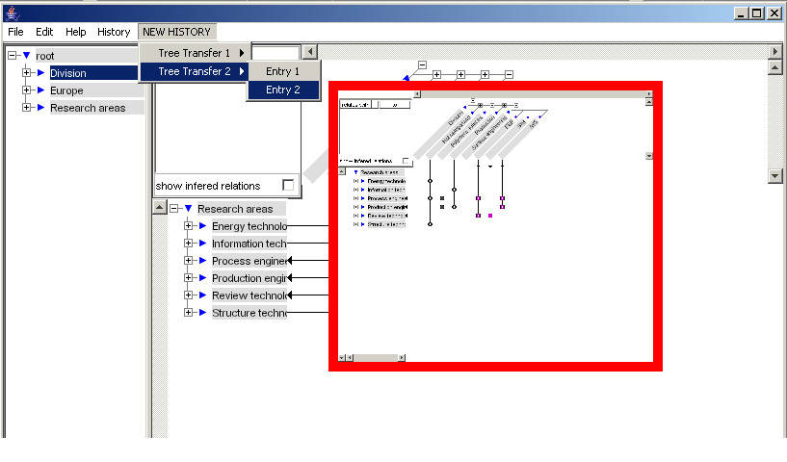
Figure 1: History item selected and screenshot displayed

