MatrixBrowser Help Page

This Page should give you a short introduction how to use MatrixBrowser and into the interactive features.

Introduction

MatrixBrowser represents a novel approach for visualizing and exploring large networked information structures that may represent, for instance, linked information resources such as complex organizational structures or metadata networks such as ontologies. An interactive matrix display is used for showing relations between concepts and concept hierarchies are displayed by well known tree widgets along the two axes of a matrix.

Design Prinicples

The central idea of the MatrixBrowser is to map the underlying graph structure to a highly interactive adjacency matrix (Figure 1). Adjacency matrices are a well-understood alternative graph representation where the nodes of the network are shown along the horizontal and vertical axes of a matrix. Both the direction of an association (for directed graphs) as well as different types of associations are visualized by using arrows and graphical symbols shown inside the cells. This can be done in conjunction with other techniques such as tool tip descriptions of different association types. Displaying all nodes on both axis of the matrix is the simplest possibility the MatrixBrowser provides to represent a network. As an extension of this standard matrix model is that MatrixBrowser provides mechanisms for presenting hierarchical information structures directly as interactive tree widgets. This “Windows Explorer”-like technique is widely known and intuitive to use. Information networks typically contain hierarchical substructures that may either be based on merely syntactic properties of the graph or on the semantic types of the relations, e.g. subClassOf relationships. These are extracted automatically by MatrixBrowser.

In MatrixBrowser, the user can flexibly place such hierarchical substructures along both axes and explore them with the familiar expand/collapse procedure. In this way, the information shown in the matrix can be better structured and the amount of visually displayed material reduced.

As a result of using tree widgets as axes of the matrix, not all concepts and relations are visible all the time. MatrixBrowser allows using expand/collapse functions not only for the trees but also for the cells. If the explicit relations in the net are not visible because their super ordinate concepts are in a collapsed state, an interactive symbol is shown, that can be clicked for expanding/collapsing the associated trees. With these techniques, the user can flexibly drill-down into the network or condense parts of it.

A table in the upper left corner of the matrix shows all of the neighbors and their relations in the net of a node, which is selected in one of the two hierarchies. So not only the context of a node within the hierarchies but also in the net can be seen easily.

Interactive behaviour and what you see

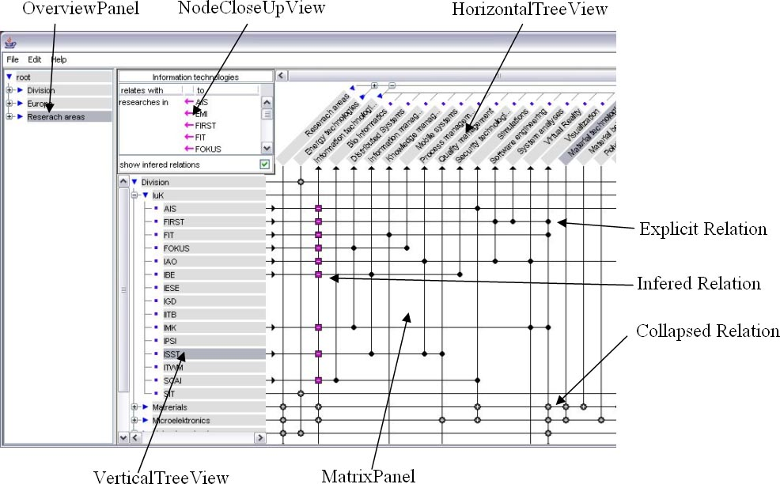

Overview Panel

The overview panel shows always the main tree of the network. Everything is placed under a sometime virtual root node. Subsets of nodes can be placed by drag&drop mechanisms on the matrix axes (horizontal and vertical tree view). Also, the main tree can be explored by collapsing and expanding nodes.

HorizontalTreeView and VerticalTreeView (Axes)

The subsets of nodes displayed on the axes of the matrix can either be those parts of a network that represent hierarchical substructures or the results of queries or filtering mechanisms. Hierarchies placed along the axes can be explored directly by expanding and collapsing their interactive trees. This familiar and effective kind of exploration works both on the horizontal and the vertical axis. The flexible methods to show user defined subsets of the information source on the axes enables the user to reduce, increase and navigate on the displayed part of the networked data.

MatrixPanel

The relations shown in the cells of the matrix for two currently selected sets of nodes are always consistent with the current interactive state of the axes. In order to achieve this consistency in the visualization, a number of issues need to be solved. The first issue concerns the visibility of relations for nodes that are currently not displayed in the tree because their super ordinate nodes are in a collapsed state. A second issue arises for transitive relations where the relations between two nodes can be propagated up or down in the hierarchy this node is part of. For example, in a scenario representing the organizational structure of a company linked to the different locations of the units, a unit located in a particular city is also located in the country and the continent that city lies in. Whether or not such inferences are made, depends on the type of the relations in the hierarchy, that is to say if they are transitive or not. The transitivity of a relation can be derived by rules in the underlying ontology and the use of suitable inference mechanisms. The visualization engine, however, is able to deal with all the different cases. For this purpose, MatrixBrowser provides different interactive types of relations in the cells of the matrix. If a cell of the matrix is marked, it can represent one of the following cases:
- An explicit relation represents a link explicitly specified between two nodes in the underlying graph. This link may also be semantically typed.
- A hidden relation is an indicator that an explicit relation is located somewhere lower in the hierarchy of the nodes, but is currently not visible because a super ordinate node has been collapsed.
- An implicit relation is a relation that has been derived from the underlying graph by some inference mechanism. Implicit relations can be either of an inheritance type, where a relation is propagated downward in a hierarchy, or of a generalization type where the propagation works upward. In the latter case, a cell marked with this type indicates that by expanding the axial node hierarchies, the explicit relation that was the source of the inference can be found somewhere lower in the hierarchy.
- An equality relation represents a link between nodes in case they are the same but member of different hierarchies.
These different types of relations are indicated through different symbols shown in the cells. Both hidden and implicit relations (generalizations) can be expanded just like nodes in a tree widget by clicking on them (both are marked with a ‘+’ sign). Through a tight coupling between cells and hierarchies shown on the axes, expanding a relation also expands the nodes that belong to that relation. In this way, the user can flexibly explore the information structure both by selecting and filtering those parts of the complete graph to be shown in the matrix and by interactively drilling down from high-level concepts to lower-level nodes and relations.

NodeCloseUpView

The close-up view of a node in the left upper corner of the MatrixBrowser enables the user to explore the immediate neighborhood of a currently selected node. In this display, all nodes directly linked with the selected node are shown as well as their connecting relations.

