## Tender diagram

Class diagram in package 'epo'

1. According to Directive 2014/24/EU, the term Economic Operators can also refer to a sole Economic Operator or to a group of Economic Operators (Economic Operator Group), e.g. Consortium, Joint Venture, other;
2. In a Procurement Procedure, a Tender is submitted (and hence linked to a specific Procurement Procedure) by either one sole Economic Operator, a member of a group (e.g., the lead of an Economic Operator Group) or a Service Provider acting on behalf of one of them (disjoint axioms).
3. One Tender may attach one or more "Tender Documents" (e.g. the Financial Tender, the Technical Tender, Technical annexes and specifications, etc.; see the Diagram "Documents");
4. In Procurement Procedures divided into Lots, one Economic Operator may present one Tender that specifies to which Lots it applies.

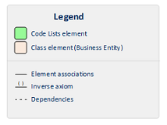

13. Tender

Version 1.0

estaromi created on 21/03/2018. Last modified 14/05/2018



1. Tender