## eProcurement Ontology - OP Domain Model

### *Accelerated Procedure diagram*

Class diagram in package 'epo'

1. When a Procurement Procedure has to be accelerated, either because a Prior Information Notice (PIN) to reduce the time limits was published or due to a state of urgency a justification must be provided (use of Accelerated Procedure Justification Type).
2. In a case of state of urgency, further justification might be necessary (Accelerated Procedure Further Justification property), e.g. the description of the urgency.

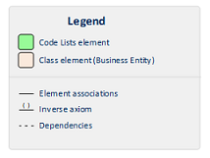

Accelerated Procedure

Version 1.0

06/02/2018. Last modified 29/05/2018



1. Accelerated Procedure

### *Award Criterion diagram*

Class diagram in package 'epo'

1. Award Criteria are used to identify the most economically advantageous Tenders. They may include the best price-quality ratio, including qualitative, environmental and/or social aspects, linked to the subject-matter of the public contract in question.
2. Thus, an Award Criterion needs to be codified as lowest, most economic tender, mixed or other (for non-objective / qualitative criteria - see Criteria Taxonomy).
3. Award Criterion is a class that specialises Criterion. The specialisation consists in providing a property to link the Criterion to Lot.
4. Award Criterion and Award Criterion Property, both need to link to Lot.
5. This is why the class Award Criterion needs to provide specialised sub-classes for the Criterion Property Group and Criterion Property, as well as the properties linking them.



Award Criterion

Version 1.0

28/05/2018. Last modified 31/05/2018



1. Award Criterion

### *Contract Award Notice diagram*

Class diagram in package 'epo'

1. Procuring Entities intending to award a Contract shall make known their intention by means of Contract Notices.
2. Instances of Contract Notices are Procurement Documents particular to one Procurement Procedure.
3. The information contained in the Contract Notice may cover:

(I) Data resulting from the study of the Procurement Procedure (class Procedure Statistics). E.g. Number of tenders received, number of request for participation received, variants awarded, etc.



Contract Award Notice

Version 1.0

29/05/2018. Last modified 06/06/2018



1. Contract Award Notice

### *Criterion diagram*

Class diagram in package 'epo'

* Criterion is a generic business-agnostic class. This eProcurement ontology (ePO) uses this as a base class to extend Award Criterion, Exclusion Grounds and Selection Criterion (see the rest of diagrams about criteria for details).
* A Criterion is a broad condition that needs to be fulfilled for evaluation purposes. E.g. Has the Economic Operator been convicted of corruption?; Average turnover of the Economic Operator for the past three years; the Most Economic and Advantageous Tender.
* All Criteria are codified via a Criteria Taxonomy. Thus, the examples above have an associated code as exclusion, selection and award criteria (see Criteria Taxonomy). You will notice that this ePO does not specialise the criterion sub-model for the Exclusion Grounds criteria, whilst Selection and Award criteria do extend the classes and properties of Criterion. The reason is that Exclusion Grounds do not add any additional property and the other two need to link the Criterion and Criterion Property classes to Lot.
* In general, Criteria are evaluated using a pass/fail method, meaning that the Tenderer or the Tender meets or does not meet the Criterion. However, selection and award criteria may be weighted (see Evaluation Method Type).
* A Criterion may contain sub-criteria. Thus, the exclusion criteria defined in the European Directives may be further detailed in national sub-criteria, e.g. national professional misconduct-related criteria.
* The broad condition of a Criterion is broken down into simpler elements named "Criterion Property", which are always grouped into Criterion Property Groups.
* A Criterion Property can be:

(I) A REQUIREMENT: rule or restriction issued by the Procuring Entity that the Tenderer or its Tender needs to comply with or conform to; or

(II) A QUESTION: a specific datum that in response to a question asked by the Procuring Entity, needs to be provided by the Tenderer; or

(III) A CAPTION: an additional information provided by the Procuring Entity to clarify the criterion (see also diagram Evaluation Result).

* Criterion Property Groups are solely used to put together sequences of questions that are logically linked. The figure below illustrates this: 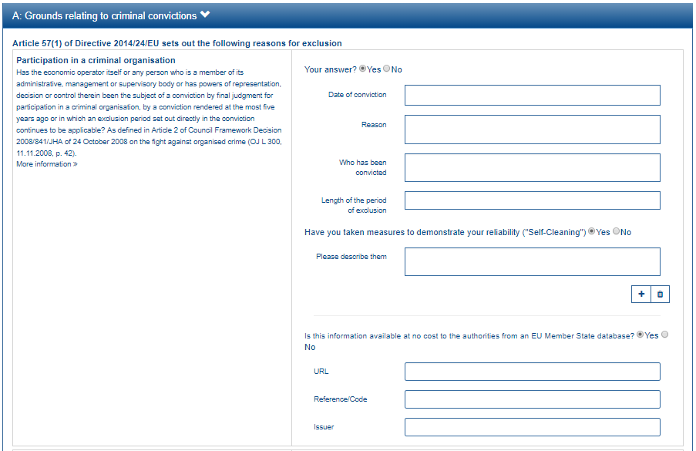
* As illustrated in the figure above, Criterion Property Groups are a convenient way of organising questions that follow a previous question that needs to be answered with a yes / no response. Thus, if the Tenderer has been convicted of participation in a criminal organisation (as in the example above), it will have to provide the date of conviction, the reason, who was convicted, for how long, and all these data are logically presented together. For this specific purpose, it is necessary to specify which is the Criterion Group Property Type to determine how to process the group of properties.
* Complex criteria with many properties may structure these properties into groups and subgroups of properties (Criterion Property Group and "hasPropertySubgroup"). Hence the nesting of groups into subgroups. This also explains why a group may not contain properties (Criterion Property, with cardinality 0..n) but subgroups of properties (Criterion Property Group).
* REQUIREMENT and QUESTION properties (see Criterion Property Type) are associated to a Value. E.g. The Procuring Entity requires a minimum turnover (REQUIREMENT) of 100,000€ (Value); the Tenderer provides three periods and amounts (Values) in response to a QUESTION of the type "Which was your yearly turnover for last 3 years?".
* This is well illustrated in the figures below: 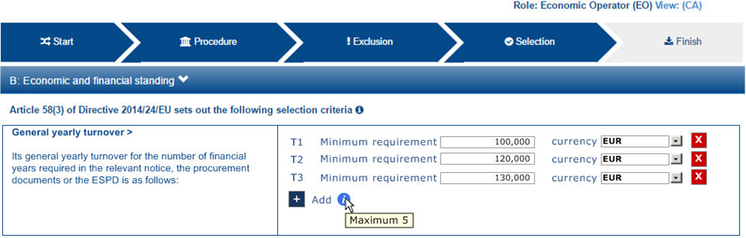 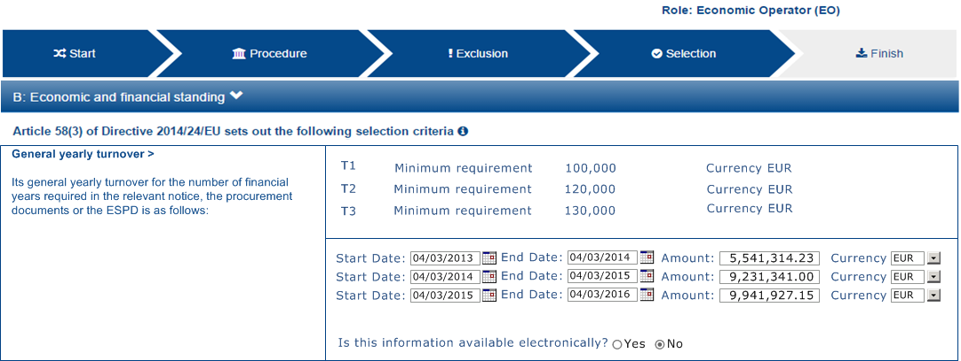
* Implementations of this ontology should ensure that the values provided by the Economic Operator are consistent with the type of values expected by the Procuring Entity. E.g. if the Procuring Entity is expecting an amount and a period to express a turnover, the response cannot be a quantity without a currency nor one date or a description.
* The responses to one Criterion may be supported by one or more evidences (property "provide evidence"). This evidence might have to be based on a template specified by the Procuring Entity (property "base on evidence template"). The fact that one individual of an evidence is linked to one Criterion does not preclude the possibility of linking this same individual (or instance) to other Criteria.
* In the domain of public procurement, exclusion grounds, selection criteria and award criteria are normally based on a specific legal framework (see class Legislation).



Criterion

Version 1.0

07/02/2018. Last modified 31/05/2018



1. Criterion

### *Documents diagram*

Class diagram in package 'epo'

1. Any Document can be seen as particular expression and manifestation of a Work, as defined in the IFLA Library Reference Model (LRM). Thus a Notice, for example, could be a "Work" expressed in French and received as an XML file (i.e. manifested as an XML). See [IFLA LRM](https://www.ifla.org/files/assets/cataloguing/frbr-lrm/ifla-lrm-august-2017.pdf) ontology for more details.
2. The ePO sees Documents as aggregators of the business domain data. In other words, the content of a Document are individuals that exist in the data graphs. As such (aggregators of individuals) they are ideal artefacts for the interoperability.
3. In the scope of the e-Notification and e-Access time, we can identify "Procurement Documents", whilst during the e-Submission, the Tenderer prepares and sends "Tender Documents".
4. Procurement Documents are prepared by the Procuring Entity and are always particular to a Procurement Procedure.
5. The very first activity in a Procurement Procedure consist in issuing Calls for Competition, which are typically notified through Prior Information Notices (PIN) or Contract Notices (CN).
6. Three main groups of Notices can be distinguished: Prior Information Notice (and variants of it), Contract Notice and Contract Award Notice.
7. Beware that Prior Information Notices are drafted prior to the existence of the Procurement Procedure and in some cases may refer to more than one Procurement Procedure.
8. Thus Prior Information Notices (PIN) announce Procurement Projects. Because at PIN publication the Procurement Procedures do not exist yet, the PINs normally cannot refer to one or more Procurement Procedures.
9. Contract Notices (CN) announce the initiation of Procurement Procedures. If the CN follows a PIN previously published, the CN should refer to that PIN.
10. Contract Award Notices (CAN) in turn announce the resolution about the awarding of the Contract(s). They should always refer to the Contract Notice previously published.
11. In restricted procedures the need of limiting the number of candidates to a short list may appear and for these cases Invitations to Tender are forward to each one of the candidates. Candidates interested in participating may submit a Request for Participation. The Invitation to Tender may refer to the Notices previously published in the context of the Procurement Procedure.
12. At tendering time, the Tenderer submits its own Tender Documents, which normally encompass a Financial Tender and a Technical Tender among other possible annexes and additional documents.
13. Contracts can experience minor modifications (Contract Modification), otherwise they may carry out new Procurement Procedures. Each modification has to be duly identified (see Contract Modification Type) and justified. These Modifications are to be published via Contract Modification Notices.



Documents

Version 1.0

21/03/2018. Last modified 30/05/2018



1. Documents

### *Economic Operator diagram*

Class diagram in package 'epo'

1. One Economic Operator is either the Tenderer (the submitter of the Tender) or the Winner of the contract.
2. When the Economic Operators are members of a group ("group of"), they play different roles, e.g. Consortia, Joint ventures, Undertaking (EO Group code type).
3. One Economic Operator may rely on 3rd parties; e.g. Economic Operator subcontracts other Economic Operators.
4. Economic Operators may be pre-qualified in a national Pre-Qualification System (PQS), which is an “Organization”.
5. When guarantees are required by the Procuring Entity, Economic Operators may have to provide Financial Account (e.g. a bank account data).



Economic Operator

Version 1.0

07/02/2018. Last modified 29/05/2018



1. Economic Operator

### *Evaluation Result diagram*

Class diagram in package 'epo'

1. One of the activities that takes place in the Procurement Procedure life-cycle is the awarding of a contract to one or more Economic Operators that have submitted a Tender (Tenderer). The awarded Tenderer(s) are the "Winner(s)".
2. Thus, the Contract refers also to the Tender(s).
3. The Contract may attach other Procurement Documents and other types of Documents.
4. The object of the Contract and additional data that where stated in the Procurement Project are also placed in the contract Purpose (e.g. Subject Matter, Place of Performance, Total Magnitude Quantity, etc.).
5. Similarly, the values of the Procurement that where initially estimated in the Procurement Project are set in the Procurement Value class.
6. The awards result from an assessment performed by an Evaluation Board. The results are held in an Evaluation Result class.
7. In the case of contest design competitions, the board is formed by a Jury, which decision may be binding for the Procuring Entity (see Evaluation Board Code Type).
8. Not later than 30 days after the conclusion of the Contract or Framework Agreement, the Procuring Entity shall send a Contract Award Notice on the results of the Procurement Procedure.
9. The Contract, in turn, does also refer to the Awarding Results of the Procurement Procedure and the signatory parties (Procuring Entities and Winners).
10. The link of all this information about the Evaluation Result and the Contract to the Procurement Procedure is mainly done through the Tender Evaluation Terms, which define the conditions and Criteria that need to be met by the Tenderers. (For details about the Criteria, see "Criterion diagram").



Evaluation Result

Version 1.0

21/03/2018. Last modified 06/06/2018



1. Evaluation Result

### *Lots diagram*

Class diagram in package 'epo'

1. A Lot is one of the parts into which a Procurement Procedure can be divided, thus grouping groups goods, services or works by type, purpose, technique, etc.
2. One or more lots may aim at one Contract. Therefore, Contracts will refer to those Lots.
3. When preparing the Procurement, Lots may be grouped. The Procuring Entity may then compare the Tenders submitted for "groups of lots" with those for individual Lots and evaluate which option best fulfils the Award Criteria. If a Lot which uses a Technique (e.g. a framework agreement, electronic auction) is grouped with one which does not, the resulting Lot may or may not use the relevant Technique.
4. Tenderers prepare their Tender for one or more Lots (Tender applies to Lot). Remember that Procurement Procedures not divided into Lots is a Procurement Procedure with one Lot.
5. The Procuring Entity apply Selection and Award Criteria to one or more Lots.



Lots

Version 1.0

14/02/2018. Last modified 31/05/2018



1. Lots

### *Procurement Procedure diagram*

Class diagram in package 'epo'

1. Procurement Procedures are lawful, organised and scheduled administrative tasks allowing one or more Procuring Entities the acquisition of works, supplies or services by means of a public contract.
2. Pay heed to the fact that the Procuring Procedure is not directly linked to the Contract. Instead, this connection is made through the Procuring Entities involved in the Procedure. There are different reasons for this: e.g. if no Tenders are submitted for a Procedure, no Contract is issued, which also entails that the link could not be established through the Tender.
3. Different types of Procurement Procedures may be instantiated according to the EU Legislation (see Procurement Procedure Type and class Legislation).
4. Some Procurement Procedures apply specific legal regimes and instruments for the awarding of certain services or the acquisition of designs (see Procurement Regime Type).
5. Procurement Procedures are divided in one or more Lots (see diagram Lots).
6. Procurement Procedures usually generate, collect or refer to different documents. Two of the most relevant groups of this Documents are Procurement Documents and Tender Documents (see diagram Documents).
7. All Procurement Procedures are conducted by at least one Procuring Entity, in some cases Procuring Entities carry out join procurements (see diagram Procuring Entity).
8. Procurement Procedures may need to refer to certain types of organisations responsible for the management or control of a number of aspects of the procedure, e.g. environmental party, tax party.
9. In some types of Procurement Procedures (e.g. restricted, competitive with negotiation, other), Procuring Entities may limit the number of candidates meeting the selection criteria. When this is the case, certain information must be notified by the Procuring Entity, e.g. expected maximum and minimum number of candidates, justification / description of the limitation, etc (Tender Short List).



Procurement Procedure

Version 1.0

02/02/2018. Last modified 06/06/2018



1. Procurement Procedure

### *Procurement Project diagram*

Class diagram in package 'epo'

1. Every public purchase has an inception and preparation phase that ends up with the definition and characterisation of a project (Procurement Project).
2. Procurement Projects may be instantiated as a Procurement Procedure or as Lots. Hence instances of Procuring Project, either Procurement Procedures or Lots, have some common properties (therefore, they are disjoint).
3. Procurement Projects are prepared having in mind a very specific Purpose. You may think of the purpose as the "Contract Object", where aspects such as the subject-matter of the contract, the place of performance, contract nature, estimated duration, and other elements are specified.
4. The Project also estimates the values of the Procurement. These estimations are later on confirmed or finally established and reflected in the Contract and the Contract Award Notice.
5. The Project also foresees the use of at least one Technique to be implemented by the instantiated Procurement Procedure or Lots (see Technique Type).
6. The Procurement Project may count on funds by other institutions (Funds Identification).



Procurement Project

Version 1.0

21/03/2018. Last modified 04/06/2018



1. Procurement Project

### *Procurement Terms diagram*

Class diagram in package 'epo'

1. Any Procurement Procedure has properties that define the procedure itself on the one hand, but also the "terms" that limit or specify the procurement activity.
2. The Procurement Terms are "conditions or stipulations established by the Procuring Entity limiting what is proposed to be granted or done by the Economic Operator" (see the ePO Glossary definition):

* Subcontract Terms: conditions and stipulations about the works or services that the Economic Operator will be able to rely on 3rd parties.
* Tender Submission Terms: conditions and stipulations about the Tender and how it is required to be submitted.
* Contract Terms: conditions and stipulations that will affect the future contract(s) once awarded.
* Tender Evaluation Terms: conditions and stipulations aimed to evaluate the tenders.
* Notification Terms: conditions and stipulations regarding notification deadlines.
* Procedure Terms: conditions and stipulations determining how the Procuring Entity requires the Economic Operator to execute certain steps of the procedure.



Procurement Terms

Version 1.0

21/03/2018. Last modified 07/06/2018



1. Procurement Terms

### *Procuring Entity diagram*

Class diagram in package 'epo'

1. In any Procurement Procedure, there is at least one Procuring Entity;
2. Procuring Entities are “Organizations”, appropriately identified and described (IDs, Names, Addresses, Contact Points, etc.);
3. Depending on its nature and main activity a Procuring Entity may be identified simply as a Contracting Authority (general procurement) or as a Contracting Entity pursuing the procurement of gas and heat, electricity, water, transport services, ports and airports, postal services and extraction of oil and gas and exploration for, or extraction of, coal or other solid fuels. A Contracting Entity may in turn be a Contracting Authority, a Public Undertaking or entities with special or exclusive rights (Procuring Entity Type code list);
4. For some Procurement Procedures, a Procuring Entity can join other Procuring Entities (Joint Procurement)
5. In these cases, the Procuring Entities participating in the Joint Procurement may adopt one role (Procuring Entity Role Type code list), e.g. the lead of the group.
6. Procuring Entities are in general responsible for the management of the procurement procedure and the management of the purchase, but this is not always the case as the purchase may be relied on another Procuring Entity (see property "buys through" and code list "Procuring Entity Role Type").



Procuring Entity

Version 1.0

21/03/2018. Last modified 06/06/2018



1. Procuring Entity

### *Selection Criterion diagram*

Class diagram in package 'epo'

1. Selection Criteria aim at ensuring that a candidate or tenderer has the legal and financial capacities and the technical and professional abilities to perform the contract to be awarded (see ePO Glossary for the difference between Candidate and Tenderer).
2. Thus, a Selection Criterion is to be classified using the Criteria Taxonomy (e.g. CRITERION.SELECTION.ECONOMIC_FINANCIAL_STANDING.TURNOVER.GENERAL_YEARLY, CRITERION.SELECTION.ECONOMIC_FINANCIAL_STANDING.TURNOVER.SPECIFIC_AVERAGE, etc.).
3. Selection Criterion is a class that specialises Criterion. The specialisation consists in providing a property to link the Criterion to Lot.
4. Selection Criterion and Selection Criterion Property, both need to link to Lot.
5. This is why the class Selection Criterion needs to provide specialised sub-classes for the Criterion Property Group and Criterion Property, as well as the properties linking them.



Selection Criterion

Version 1.0

28/05/2018. Last modified 31/05/2018



1. Selection Criterion

### *Tender diagram*

Class diagram in package 'epo'

1. The term Economic Operators can refer to a sole Economic Operator or to a group of Economic Operators (Economic Operator Group), e.g. Consortium, Joint Venture, other. See ePO Glossary for more details.
2. Tenders are submitted by Tenderers, who are Economic Operators.
3. One Tender may attach one or more "Tender Documents" (e.g. the Financial Tender, the Technical Tender, Technical annexes and specifications, etc.; see the Diagram "Documents");
4. In Procurement Procedures divided into Lots, one Economic Operator may present one Tender that specifies to which Lots it applies.
5. Procurement Procedures that are not divided into Lots are considered to have one lot. Hence, the link between the Tender Documents and the Procurement Procedure for which they have been submitted is always the Lot.



Tender

Version 1.0

21/03/2018. Last modified 04/06/2018



1. Tender