
Shapes Demo v0.0.0

User Manual

eProsima
Proyectos y Sistemas de Mantenimiento SL
Ronda del poniente 16 – Bajo K
28760 Tres Cantos Madrid
Tel: + 34 91 804 34 48
info@eProsima.com – www.eProsima.com
Trademarks
eProsima is a trademark of Proyectos y Sistemas de Mantenimiento SL. All other trademarks used in this document are the property of their respective owners.
License
eProsima Fast RTPS is licensed under the terms described in the FASTRTPS_LIBRARY_LICENSE.txt file included in this distribution.
Technical Support
Phone: +34 91 804 34 48
Email: Support@eProsima.com

Contents
1. Introduction. 1
2. Using eProsima Shapes Demo. 2
2.1. Publishing a Shape 3
2.2. Subscribing to a Shape 5
2.3. Other Options. 6
2.4. Endpoints and Output tabs. 7
Figure List
Figure 2.1: eProsima Shapes Demo Main Window 2
Figure 2.2: Publish Menu 3
Figure 2.3: Subscribe Menu 5
Figure 2.4: Options Menu 6
Figure 2.5: Endpoint table example 7
Figure 2.6: Output example 7
Table List

Introduction.
This document presents a brief introduction to eProsima Shapes Demo application. This application can be used as an introduction to the power of eProsima Fast RTPS.
Shapes Demo published and subscribers different moving shapes of different colors and sizes. Each shape is published in its own topic (Square, Triangle or Circle) and a single instance can publish or subscriber to multiple topics at the same time.
This document will briefly introduce the eProsima Shapes Demo application and how to use it. An additional document called Interoperability Troubleshooting is also provided in case the user wants to test our application with other implementations of the RTPS protocol.

Using eProsima Shapes Demo.
This section guides you through the main menus of eProsima Shapes Demo. After the executable is launched you should see a window similar to the one presented in Figure 2.1.
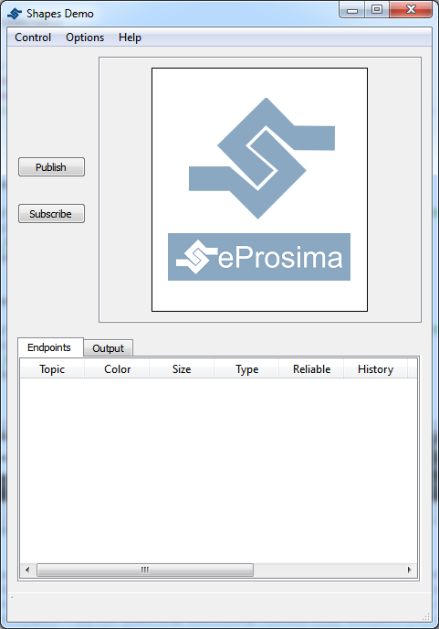Figure 2.1: eProsima Shapes Demo Main Window

As you can see the main window is design for simplicity, with only two buttons situated on the left. There are additional menus that will be explained later.

Publishing a Shape
When the user presses the Publish button a new window appear to allow the user to define what type of Shape and which QoS the want to use in its publication. Figure 2.2 shows an example of the Publication menu.
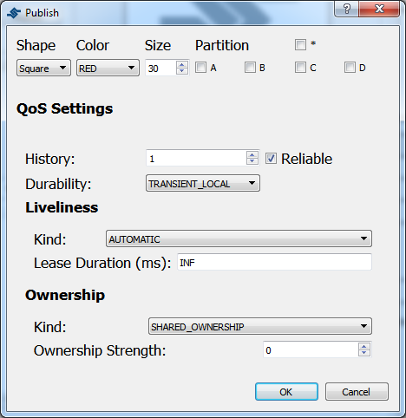Figure 2.2: Publish Menu

There are multiple parameters that the user can define in this menu:
- Shape: This parameter defines the topic where the publication is going to occur. Three different shapes can be published: Square, Circle and Triangle.
- Color: The user can define the color of the Shape. This parameter will be used as key; that is, a way to distinguish between multiple instances of the same shape.
- Size: This parameter allows you to control how big the shape is. The size can vary between 1 and 99.
- Partition: The user can select different partitions to differentiate groups of publishers and subscribers. The user can select between four partitions (A, B, C and D). Additionally the user can select the “*” partition, that will be matched against all other partitions. The user should note, however, that using the “wildcard (*)” partition is not the same as not using any partition. A publisher that uses the wildcard partition will not be matched with a subscriber that uses no partitions.
- Reliable: The user can select to disable the Reliable check-box to use a Best-Effort Publisher.
- History and Durability: The History of the Publishers is set to KEEP_LAST. The user can select the number of samples that the Publisher is going to save. The user can also select whether this History is going to be VOLATILE or TRANSIENT_LOCAL. The latter will send that last stored values to subscribers joining after the Publisher has been created.
- Liveliness: The user can select the Liveliness Qos for the Publisher between three different values: AUTOMATIC, MANUAL_BY_PARTICIPANT and MANUAL_BY_TOPIC. The user can also set the Lease Duration for the Publisher.
- Ownership: The Ownership Qos determines whether the instance (color) of the Topic (Shape) is owned by a single Publisher. If the selected ownership is EXCLUSIVE the Publisher will use the Ownership strength value as the strength of its publication. Only the publisher with the highest strength can publish in the same Topic with the same Key.

Subscribing to a Shape
When the user presses the Subscriber button a new window appear to allow the user to define what type of Shape and which QoS the want to use in its subscription. shows an example of the Publication menu.
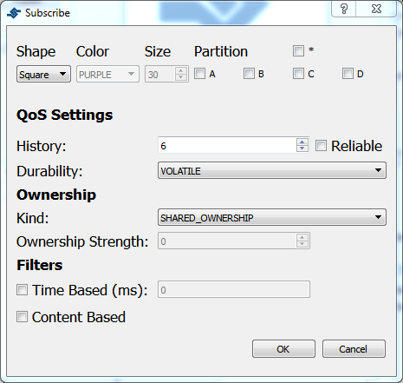Figure 2.3: Subscribe Menu

This menu is very similar to the Publication menu but it has additional elements:
- Time Based Filter: This value can be used by the user to only specify the minimum amount of time (in milliseconds) that the subscriber wants between updates.
- Content Based Filter: This filter draws a rectangle in the shapes window. Only the instances that are included in this rectangle are accepted. The rest of them are ignored. The user can dynamically resize and move this content filter.

Other Options.
The eProsima Shapes Demo application allows the user to define additional options. To see the Options window, please click Options->Preferences in the main bar. Figure 2.4 shows the Options Menu.
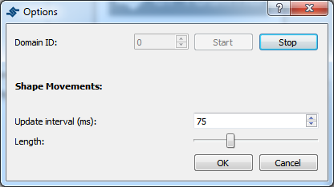Figure 2.4: Options Menu

The user can modify the following settings:
- Domain ID: The user can select different Domain Ids. Shapes Demo instances using different Domain Ids will not communicate. To modify the Domain ID the user needs to stop the participant (thus removing all existing Publishers and Subscribers) and start a new one with the new Domain Id.
- Update interval: This value changes the publication period for all the Publishers.
- Length: This scrollbar allows the user to change how much the Shape moves between two write calls.

Endpoints and Output tabs.
A table including all created endpoints is also provided. An example of this legend is shown in Figure 2.5.
The user can use this table to remove endpoints. Two methods are provided:
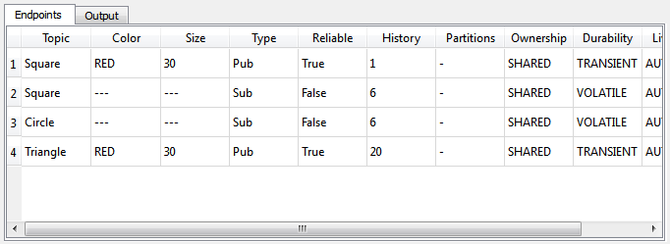Figure 2.5: Endpoint table example
- Right click in an endpoint: An option to remove the endpoint is shown.
- Delete button: When an endpoint is selected the user can remove it by pressing the Delete button on the keyboard.
An example of the output tab is shown in Figure Figure 2.6.
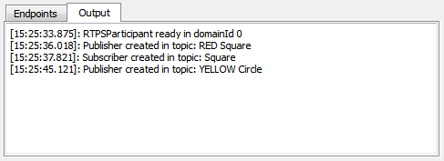Figure 2.6: Output example

