Assignment 2: Design of Experiments and Evaluation of a Given System
Table of contents
Introduction 1
Goal and Limitations 1
Experiment plan 2
Variables 2
KPIs 2
Implementation 3
Current situation and target situation 3
Initial Scenario 3
Station by Station Optimization 4
Evaluation of Results 5
Discussion and Conclusion 5

Figure 1: Model 2
Figure 2: Experiment Matrix 3
Figure 3: Variables 3
Figure 4: KPI 3
Figure 5: Baseline and Maximum Scenario 4
Figure 6: Results of baseline and theoretical maximum 4
Figure 7: Initial Scenario and results 5
Figure 8: Station By Station Reduction 5
Figure 9: Alternative and Final Solution 5
Figure 10: Comparison 6

Introduction
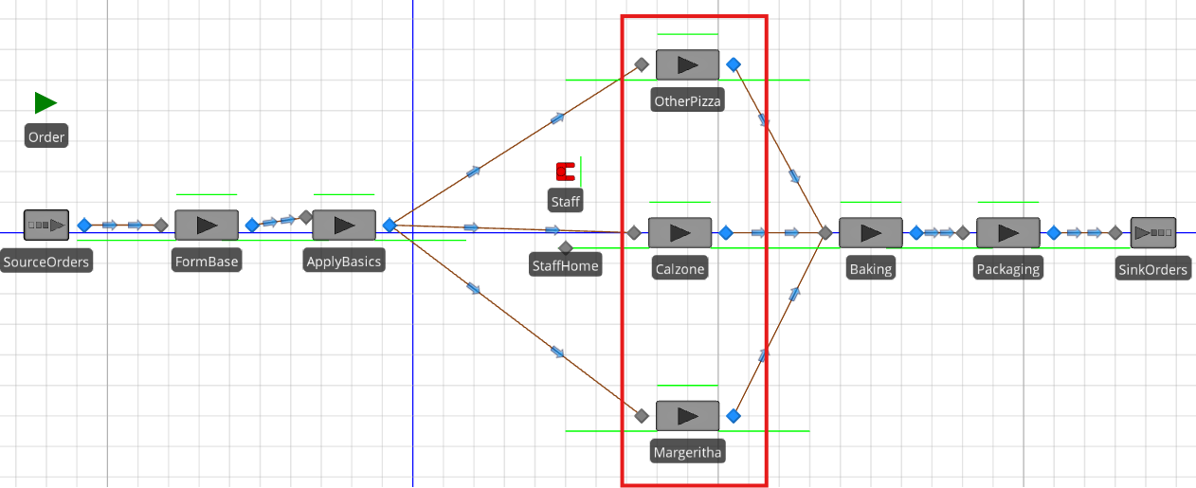
Figure 1: Model
The subject of our experiments is the Model in Figure 1, which consists of the following processes based on a fictional Pizza-Factory and consists of following stations: Form_Base, Apply_Basic (Toppings), special toppings (Margherita, Other, Calzone), Baking and Packaging. We require Staff to man the stations of special toppings (marked in red). The rest of the stations are automated. A table with the number of incoming orders at specific time during the day is given to simulate the demand.

Goal and Limitations
Our goal is to find the optimum combination, in other words minimum possible capacity of each of the automated station and staff in this model, to produce at least 500 Pizzas per day. The purpose is to help the owner of the Pizza Factory to identify and eliminate any other bottle necks in of the automated stations in this production line. Knowing that some orders will come in just before midnight and its production will be only done the next day, but this is acknowledged by the owner and totally fine, since it is a 24/7 production line.

Experiment plan
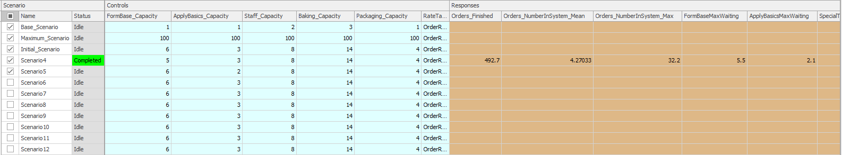
Figure 2: Experiment Matrix
The experiment Matrix (Figure 2) allows us to conduct experiments in multiple scenarios and is split in 3 parts:
- Scenario, where we can index our experiment and see the progress of the simulation
- Controls, where we can define our variables for our experiments
- Responses, here we can define our KPIs and find the final KPI results of our experiments

Variables
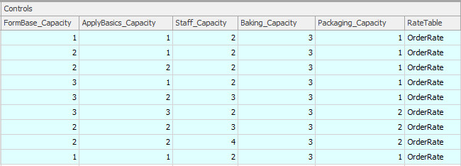
Figure 3: Variables
Since we only need to experiment with the automated stations and staff capacity we define the following variables: FormBase_Capacity, ApplyBasics_Capacity, Staff_capacity, Baking_Capacity, Packaging_Capacity. The 3 Specialty stations are not parameterized since they have infinite capacity, but are dependent on the number of staffs. We can ignore the OrderRate since it is always fix and the same rate of orders is used in all experiments.

KPIs
Figure 4: KPI
Since we want to find the optimum throughput of the system within a day, we measure how many Orders are finished (Orders_Finished), additionally we want to measure the number of simultaneous orders within the system (Orders_NumberInSystem_Mean, Orders_InSystem_Mean) to get another more deterministic indication of the throughput of the system. For each of the measures above, we take the max occurrence to see the behavior of the model during peak-demand time, and also the average for general statement about the system.
Additionally, we measure the max number of orders in the que of each station (FormBaseMaxWaiting, ApplyBasicsMaxWaiting, SpecialToppingMaxWaiting, BakingMaxWaiting, PackagingMaxWaiting) per iteration, to get an indication where the jam is and adjust the parameters. Thereby SpecialToppingMaxWaiting is the averaged sum of all 3 stations.

Implementation

Current situation and target situation
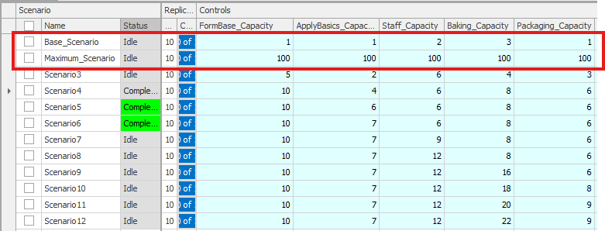
Figure 5: Baseline and Maximum Scenario
For the experiments we setup 1. the Base_Scenario, to confirm and validate the parameters with the real world and to get a base line for the following experiments. 2nd we setup another scenario to get the theoretical maximum for the KPIs, without any bottle necks in the system, we call it the Maximum_Scenario.
Figure 6: Results of baseline and theoretical maximum

Initial Scenario
Now that we have the KPI results from the base line and theoretical optimum, we know what to aim for. To start somewhere, the time for process * 2, the thinking behind is, the longer it takes to process, the more capacity we need, and times 2 as a random factor.
FormBase: 3x2 =6, ApplyBasics: 1.2x2=3, SpecialTopping(for Staff_Capacity): ((6+1)+5/3)x2 =8, Baking: 7x2 =14, Packaging: 2x2=4
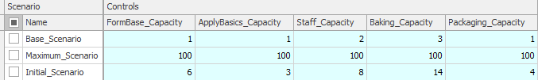
Figure 7: Initial Scenario and results
As expected, after we factor in the time to process, the system compensate slow processing time with additional capacity. And the result shown in (Figure 7: Initial Scenario results) of the initial scenario compared to the maximum scenario looks already promising.

Station by Station Optimization
To see whether this is the real optimum or whether there is another cheaper combination which can achieve the result (>500 Orders per day). We add a series of scenarios with lower capacities.
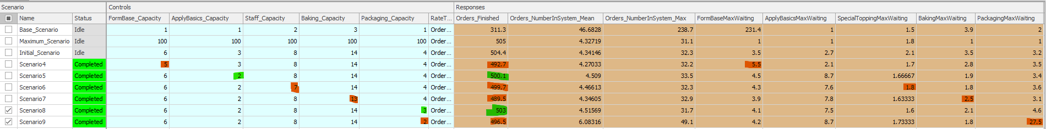

Figure 8: Station By Station reduction and results
In Figure 8: Station By Station Reduction we reduce the capacity of each station by 1 and reset it, if the Order_Finished is below 500, and leave it if it’s at least 500. As you can see, we did this for each station separately and come to the conclusion, that Apply_Basics_Capacity (Scenario 5) and Packaging_Capacity (Scenario8) is overexaggerated, since the Order_Finished is not below 500. For packaging we also confirm it with further reduction (to only a capacity of 2), that 3 is indeed the optimum.
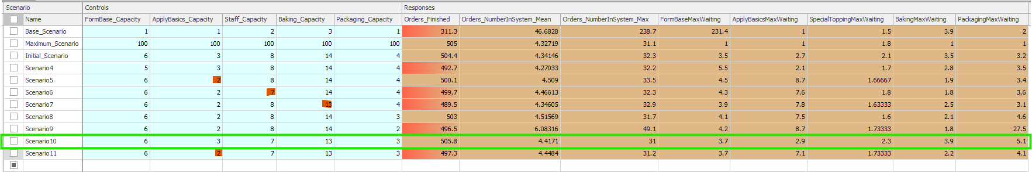

Figure 9: Circle back and Final Solution results
In the last 2 experiments we circle back to check, what if the reduction in Staff and Baking Capacity is actually caused by congestion in ApplyBasics (Scenario5) and we can reduce the capacity of all following stations (Scenario10, Staff and Baking), without impacting the amount of Orders_Finished, if we only increase back ApplyBasics to 3? And indeed we have even a higher number 505 finished Orders. To confirm, we reduce back the ApplyBasics to 2 to see whether our theory is correct (Scenario 11). In the Figure 9: Circle back and Final Solution results we can see, we can see that the reduction has in deed brought the number of finished Orders down to below 500. So the final constellation is FormBase_Capacity:6, ApplyBasics_Capacity:3, Staff_Capacity:7, Baking_Capacity:13, Packaging_Capacity:3 in Scenario 10.

Evaluation of Results
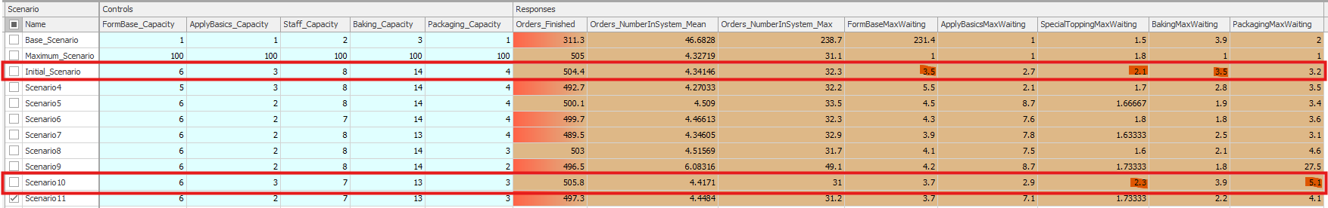

Figure 10: Comparison
In Figure 10: Comparison compare the results, before and after the optimization. We reduced the capacity in terms of Staff, Backing and Packing Station without reducing the Orders_Finished below 500. Although both scenarios (Initial_Scenario and Scenario 10) are similar, the MaxWaiting orders of each station in the model of Scenario 10 varies from 2.3 minutes to 5.1 minutes and in the Initial_Scenario only from 2.1 minutes to 3.5 minutes, which indicates a better load distribution and therefore a more stable production. This confirms that the initial Scenario is in deed the optimum as far as capacity given in whole number allows.

Discussion and Conclusion
Since the target is at least 500 Pizzas per day, and the owner is not concerned with perfect equilibrium but cost, we suggest the following for improvement.
Increase the capacity of the stations in the system as follow:
FormBase:6, ApplyBasics:3, Staff:7, Baking:13, Packaging:3 (_Capacity respectively).
This can save more than the variant before the circle back:
FormBase:6, ApplyBasics:2, Staff:8, Baking:14, Packaging:3 (_Capacity respectively).

