Simulation with Simio
Simio Basics

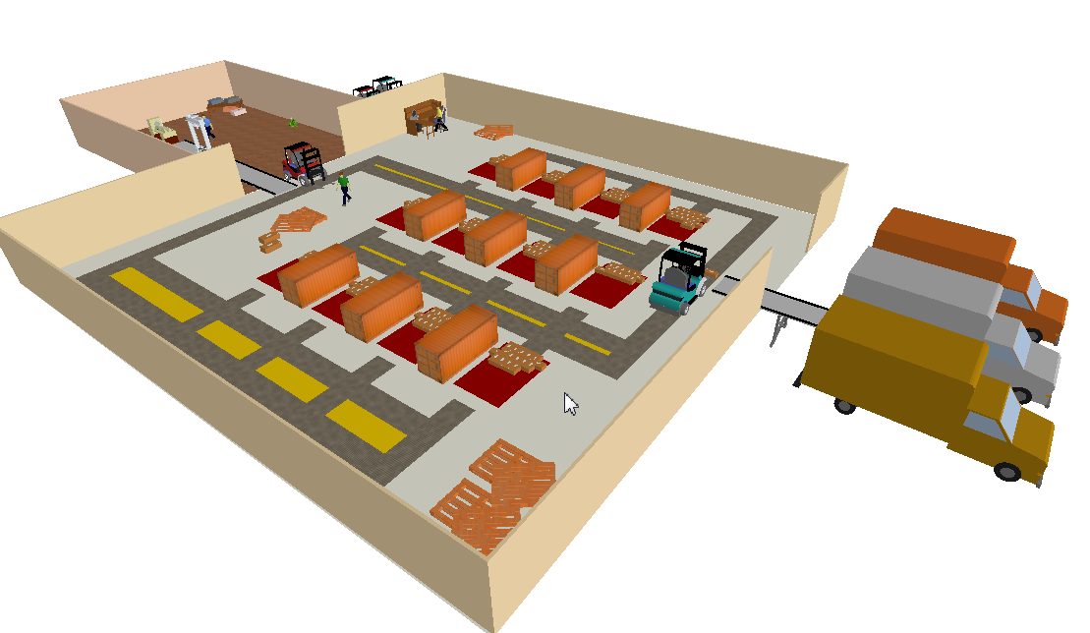

Dr. Lukas Hollenstein, Dr. Tatiana Starostina, Melih Derman, Marco Brunschwiler
28.11.2024, Version 1.4

Zurich University of Applied SciencesLife Sciences and Facility ManagementInstitute of Computational Life SciencesGrüental, P.O. Box CH-8820 WädenswilTel: +41 58 934 54 02
lukas.hollenstein@zhaw.ch

Table of contents
1 Task 1: First model 3
1.1 Objectives 3
1.2 New Elements 3
1.3 Task 3
1.4 Modeling 4
2 Task 2: Faults and set-up time 5
2.1 Objectives 5
2.2 New Elements 5
2.3 Task 5
2.4 Modeling 5
3 Task 3: Resource 7
3.1 Objectives 7
3.2 New Elements 7
3.3 Task 7
3.4 Modeling 7
4 Task 4: Eliminate bottleneck PRESSES 9
4.1 Objectives 9
4.2 New Elements 9
4.3 Task 9
4.4 Modeling 10
5 Task 5: Fix bottleneck HARRY 12
5.1 Objectives 12
5.2 New Elements 12
5.3 Task 12
5.4 Modeling 13
6 Experiments 14
6.1 Objectives 14
6.2 Task 14

Task 1: First Model

Learning objectives
- Create a first working model
- Get to know the main model elements
- Parameterize the model elements
- Animate the utilization of the model elements

New Elements
Model elements | Properties | Further
Source  Sink  Server  TimePath  ModelEntity | Name  Picture  Arrival rate  Input Lot Size  Process duration  Capacity  Transport time  Simulation duration | Animation of the previous average occupancy rate

Task
Parts "A" are processed for 8 hours on one machine "PRESSING" and two parallel machines "DRILLING". Each process step has an input buffer of 10 parts. The parts arrive at the "PRESSING" process step with an input cycle of 50 minutes and an input batch size of 4 parts. The processing time is 10 minutes for PRESSING and 25 minutes for DRILLING. The transport time between the individual process steps is 1 minute each. Parts A are to be animated as a red triangle. The previous average capacity utilization of the PRESSING and DRILLING process steps is to be animated.
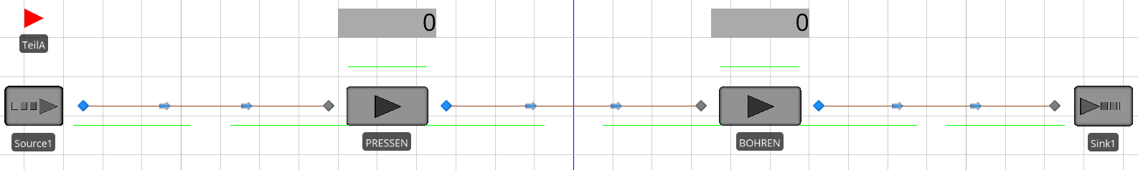
Illustration 7: Task 1 model

Modeling
Start with a new model, File New, and save it right away, File Save as...

In der Facility-View:
Drag a ModelEntity from the 'Project Library' to the 'Facility View' in the bottom left. Name the placed ModelEntity as "PartA". Change its color by simply clicking on its icon, selecting the color in the ribbon bar, and clicking on Part A again.
Drag a Source object into the 'Facility View'. Set the 'Interarrival Time' to 50 minutes and the Entities per Arrival to 4.
Drag a server object into the 'Facility View' and name the placed object as 'PRESSEN'. Set the 'Processing Time' to 10 minutes, the 'Input Buffer' capacity (under 'Buffer Logic') to 10 and the 'Output Buffer' capacity to 0.
Drag a server object into the 'Facility View' and name the placed object as 'DRILL'. Set the 'Processing Time' to 25 minutes, the 'Initial Capacity' to 2, the 'Input Buffer' capacity to 10 and the 'Output Buffer' capacity to 0.
Drag a sink object into the 'Facility View'.
Connect the objects to TimePaths and set their 'Travel Time' to 1 minute.

In der Facility-View im Register ‚Animation‘
Drag two status labels from the 'Animation' tab into the facility views. The animated value can be entered via the "Expression" property. Enter the following expressions:
- PRESSEN. Capacity.ScheduledUtilization
- BOHREN. Capacity.ScheduledUtilization

In der Facility-View im Register ‚Run‘
Click on the 'Ending Type' combo box and set the 'Run Length' to 8 hours. Then start the simulation. Watch the simulation progress.
After the simulation is complete, the following values should be displayed if the model is built correctly:
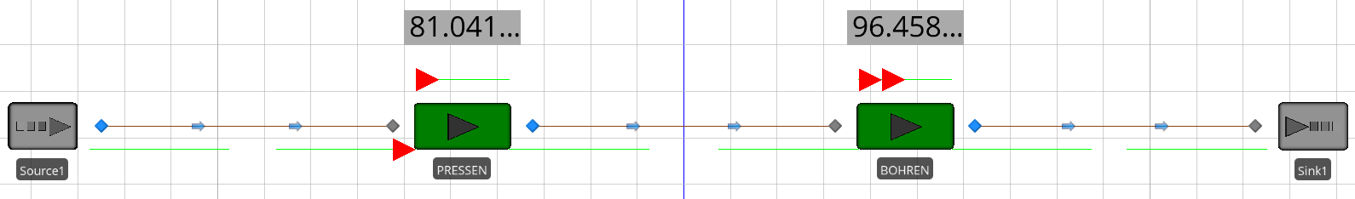
Illustration 8: Model of Task 1 after the end of the simulation

Task 2: Faults and set-up time

Objectives
- Define faults (processing time dependent)
- Define set-up times
- Animating goods in progress

New Elements
Model elements | Properties | Further
none | Failure Type  Uptime Between Failures  Time To Repair | Animation Goods in progress  Animation Count Received  Animation Count Gone Out

Task
Based on task 1, a set-up time of 5 minutes per part is now required for PRESSING. The DRILLING now fails for 30 minutes after 150 minutes of operation. The aim is to animate how many parts have entered at the source where the depression has emerged. In addition, the existing building is to be animated in work between the source and the sink.
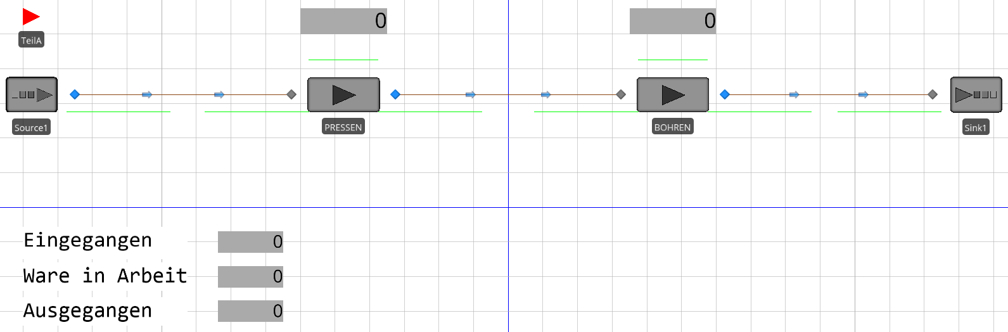
Illustration 9: Task 2 Model

Modeling

In der Facility-View:
Click on the object 'PRESSEN' and add an additional 5 minutes for the setup time to the current 'Processing Time', so it says '10+5' to make it explicit.
Click on the 'DRILL' object and under 'Reliability Logic', select 'Processing Time Based' as the 'FailureType'. Other properties to be set will appear. The 'Uptime Between Failures' is now supposed to be 150 minutes and the 'Time To Repair' is supposed to be 30 minutes.

In der Facility-View im Register ‚Drawing‘:
Drag three 'FloorLabels' into the 'FacilityView'. Then click on the individual labels, select the 'Edit' button in the 'RibbonBar' and enter the following texts: "Received", "Goods in progress", "Outgoing".

In der Facility-View im Register ‚Animation‘:
Drag three status labels from the 'Animation' tab into the facility views. The animated value can be entered via the "Expression" property. Enter the following expressions:
- Source1.OutputBuffer.NumberEntered
- Source1.OutputBuffer.NumberEntered - Sink1.InputBuffer.NumberEntered
- Sink1.InputBuffer.NumberEntered
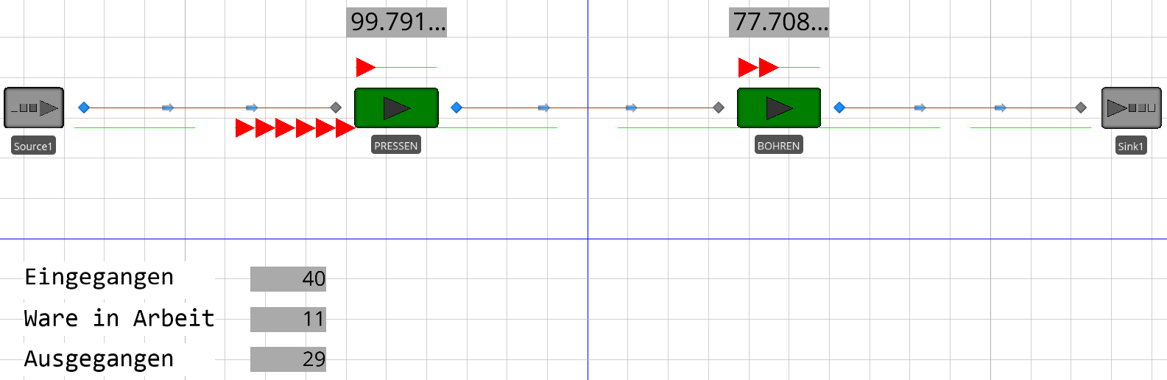
Illustration 10: Model of Task 2 after the end of the simulation

Task 3: Resource

Objectives
- Get to know the model element resource
- Animating Inventory on the Go

New Elements
Model elements | Properties | Further
Resource | Name  Secondary Resource for Processing  Initial Capacity | Animating Inventory on the Go

Task
Building on task 2, a worker 'HARRY' is now needed during the process time for DRILLING. For the two machines of the DRILLING there is only one 'HARRY'.
The stocks on the paths, in the input buffers and the processing stations are now to be animated. These stocks should be animated with a light yellow status label.
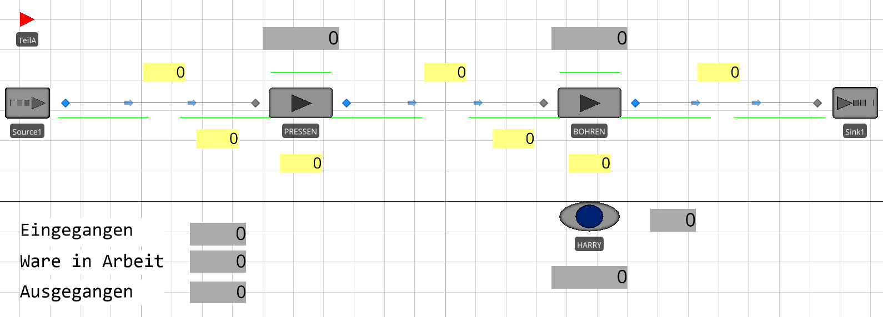
Illustration 11: Task 3 model

Modeling

In der Facility-View:
Drag a 'Resource' object into the 'FacilityView' and name the placed object as 'HARRY'. Make sure that the 'Initial Capacity' of the 'HARRY' is defined as 1.
Click on the 'DRILL' object. Under 'Secondary Resources', select 'HARRY' as 'Resource For Processing' under 'Object Name'.

In der Facility-View im Register ‚Animation‘:
Drag seven status labels from the 'Animation' tab into the facility views. For Backcolor, select a light yellow color. Enter the following expressions:
- TimePath1.Contents
- PRESS. InputBuffer.Contents
- PRESSEN. Processing.Contents
- TimePath2.Contents
- BOHREN. InputBuffer.Contents
- BOHREN. Processing.Contents
- TimePath3.Contents
In addition, place a status label to the right and below HARRY with the expressions
- HARRY. Capacity.Utilized
- HARRY. Capacity.ScheduledUtilization
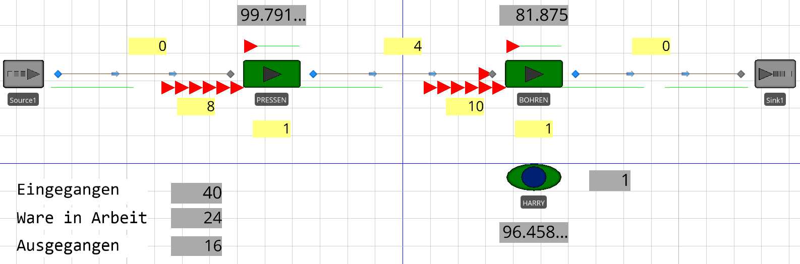
Illustration 12: Task 3 model after the end of the simulation

Task 4: Eliminate bottleneck PRESSES

Objectives
- Identify a bottleneck
- Solve a bottleneck
- Modeling the branching and merging of the material flow

New Elements
Model elements | Properties | Further
Second workstation  TransferNode | Outbound Link Preference  Outbound Link Rule  Selection Weight  Processing Time | Copy-Paste  Animating the Number of Parts Waiting for HARRY

Task
As can be seen in task 3, the PRESSING is a bottleneck. We now want to solve this first bottleneck by investing in a second PRESSEN machine. So now we have a machine PRESSEN1 and a machine PRESSEN2. For didactic reasons, the machine should PRESSEN2 be half as fast as the machine PRESSEN1. InputBuffer and setup time are identical.
PRESSEN2 is to be connected to Source1 and DRILLING in the same way as the PRESSEN1. The material flow is to be divided between PRESSEN1 and PRESSEN2 in a ratio of 2:1.
It will also be animated with an orange status label how many parts are waiting for the HARRY. Now we also want to know how many parts have left the PRESSEN1 and the PRESSEN2 in light blue.
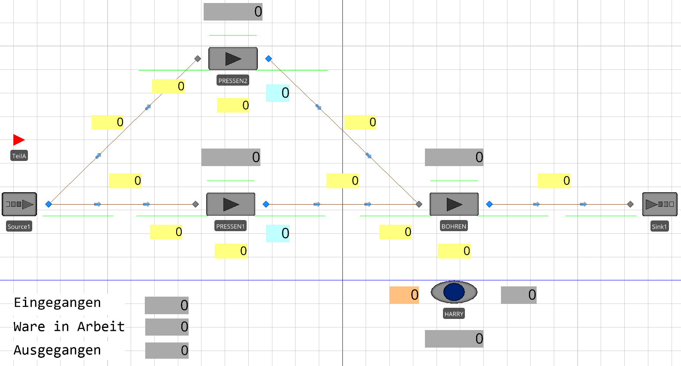
Illustration 13: 4 Task Model

Modeling

In der Facility-View:
Rename the object "PRESSEN" to "PRESSEN1". Then click on the object again and copy it via "Ctrl+C". Paste the copy using "Ctrl+V". Name the copied object as 'PRESSEN2'. Change the 'Processing Time' of the 'PRESSEN2' from 10+5 minutes to 20+5 minutes to set half the processing speed in relation to the 'PRESSEN1 (plus the 5 minutes setup time).
Now connect Source1 to the PRESSEN2 via another TimePath. Then connect the PRESSEN2 via another TimePath. 'The travel time' is one minute, analogous to the other paths.
Now two TimePaths lead away from Source1. Next, the rule must be parameterized according to which the material flow is to be divided between PRESSEN1 and PRESSEN2. This rule is defined on the output node of Source1. So click on the blue node of Source1, i.e. 'Output@Source1'. Set the 'Outbound Link Preference' to 'Available' and the 'Outbound Link Rule' to 'By Link Weight'.
By default, the material flow would now be distributed in a ratio of 1:1. To set a different ratio, click on the 'TimePath1' that leads from 'Source1' to 'PRESSEN1'. Set the 'Selection Weight' to 2. Also, make sure that the 'Selection Weight' of the 'TimePath4' leading from 'Source1' to 'PRESSEN2' is still set to 1. Now the ratio is defined as 2 : 1.

In der Facility-View im Register ‚Animation‘:
Drag another four status labels from the 'Animation' tab into the facility view and give the labels a light yellow color. Enter the following expressions:
- TimePath4.Contents
- PRESSEN2. InputBuffer.Contents
- PRESSEN2. Processing.Contents
- TimePath5.Contents
Drag two more status labels from the 'Animation' tab into the facility view and give the labels a light blue color. Enter the following expressions:
- PRESSEN1. Processing.NumberExited
- PRESSEN2. Processing.NumberExited
Drag another status label from the 'Animation' tab into the facility view and give the labels an orange color. Enter the following expression:
- HARRY. AllocationQueue.NumberWaiting
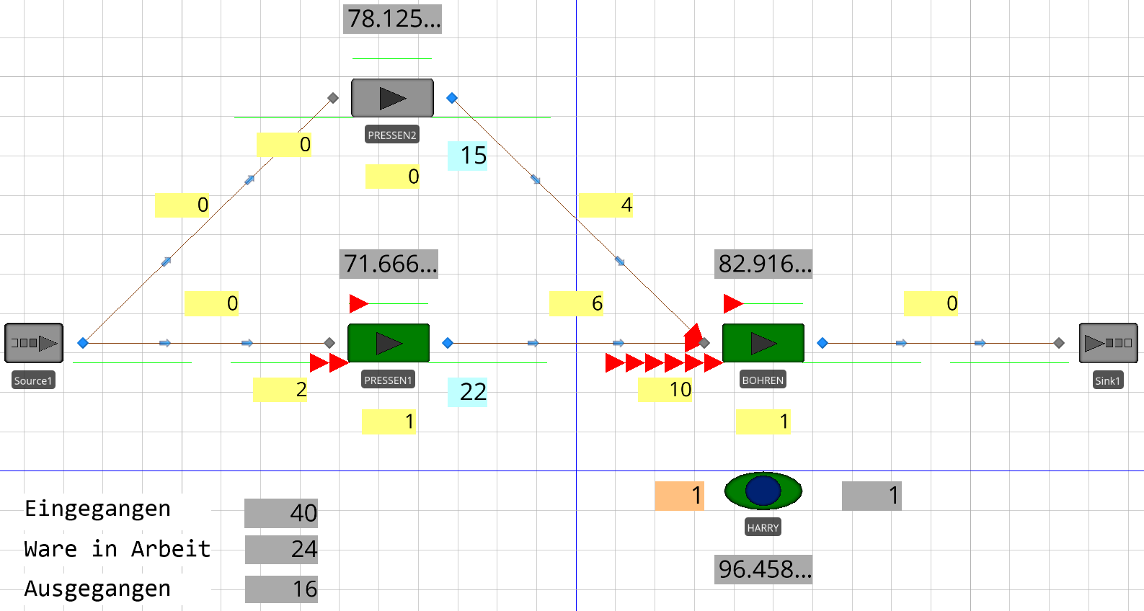
Illustration 14: Model of Task 4 after the end of the simulation

Task 5: Fix bottleneck HARRY

Objectives
- Identify and resolve the next bottleneck
- Define availability
- Explore distributions
- Dealing with requirements that are not directly implemented in the simulation tool (i.e. how do I model something that does not yet exist?)
- Interpret results

New Elements
Model elements | Properties | Further
none | Initial Capacity  Failure Type  Calendar Time Based  Time To Repair | Distributions

Task
As can be seen in task 4, the 'HARRY' remains as a bottleneck. So there are now supposed to be two HARRYs, but they are not available for the entire time. Availability is not a constant value. It is assumed that each 'HARRY' has to do a different activity after 6-10 processed parts (evenly distributed) during a minimum of 5, most often during 10 and a maximum of 13 minutes (triangularly distributed). Then check whether all bottlenecks have now been eliminated. If not, why is that?
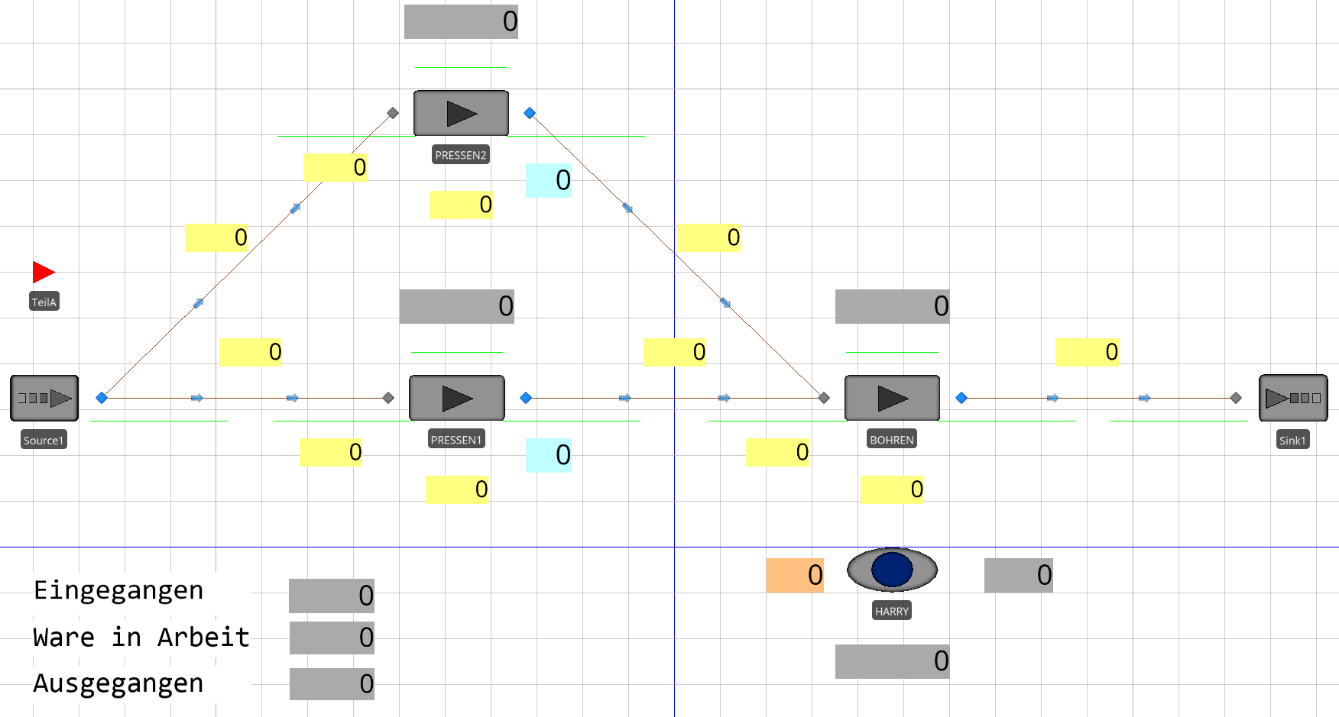
Illustration 15: 5 Task Model

Modeling

In der Facility-View:
Click on the object 'HARRY'. Set the 'Initial Capacity' to 2.
Now look for the 'Availability' property of 'HARRY'. You will see that this property does not exist 1:1. So it is now necessary to consider how to model availability, i.e. to create a concept for it. In principle, there are several ways to do this, although the list is not exhaustive:
- If possible, "abuse" other properties to implement the requirement
- "Programming" user-specific processes (can be called up via e.g. add-on process triggers or event-based)
- Implement the missing functionality in your own module (e.g. by deriving from another module or from scratch).
- and so on.
For our example, we can think of 'unavailability' as a disruption. So we click on the 'HARRY' again and select the option 'Usage Count Based' as the 'Failure Type'. We now have to parameterize the other values as distributions. For this purpose, there is the "Random" function, which provides different distributions. For 'Count Between Failures' we enter the value 'Random.Uniform(6, 10)' and for 'Time To Repair' we enter the value 'Random.Triangular(5, 10, 13)' with unit 'Minutes'.
Now we run the simulation and observe the result. As we can see, there is still a build-up of parts in the input buffer of the 'DRILLING'. However, the average utilization of 'DRILLING' is only about 82.9%, see Illustration 16.
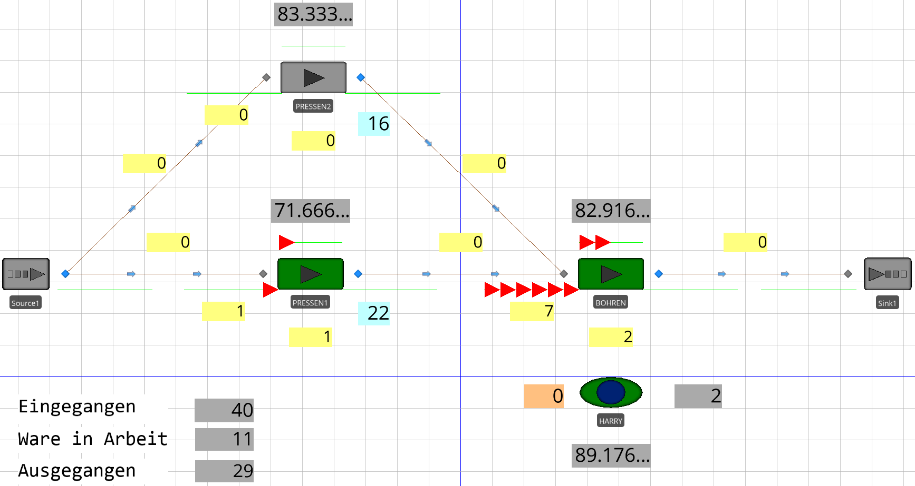
Illustration 16: Model of Task 5 after the end of the simulation
The reason for the backlog, however, is that both aircraft are out of service for 30 minutes each in accordance with a constant rhythm. The disruptions are too frequent or too long, so that the required throughput is not achieved. On closer inspection, both the DRILLING and the HARRY should have no interference in order to achieve the required throughput of 4 parts in 50 minutes.

Experiments
Experiments are used to define a set of scenarios with which the model should run. Each scenario has a set of controls and responses. Since most models contain random components, multiple replications can be performed for each scenario to allow confidence intervals to be calculated.

Objectives
- Properties definieren
- Open a new experiment
- Select Controls
- Define responses
- Run experiments

Task
Use as the source file for this task «Task5-Solution.spfx»
Before you can run experiments, you should store some variables as properties so that they are available in the experiment scheduler. To do this, select "Definitions – Properties" (see Illustration 17) and select "Standard Property". Add two new Real Properties named "ProcessingTimePressen1" with a value of 15 and "ProcessingTimePressen2" with a value of 25.
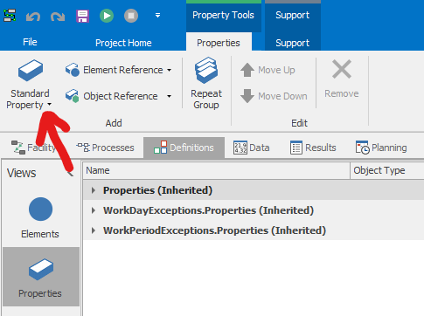
Illustration 17: Add Properties
In a next step, these properties must be stored with the respective servers as process time. To do this, click on the servers and enter the previously defined properties under "ProcessingTime" (see Illustration 18)
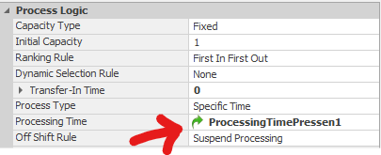
Illustration 18: Add Property to Server
Now we can create a new experiment. To do this, go to "New Experiment" under "Project Home" (Illustration 19).
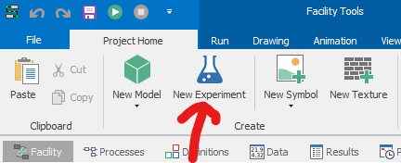
Illustration 19: Create a new experiment
The previously created properties should now be visible as controls in the experiment scheduler. Now we still need key figures for the evaluation. To do this, select "Design – Add Response".
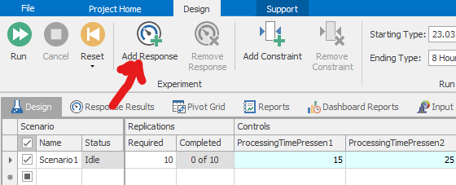
Illustration 20: Defining Scenarios

Now enter "TeilA.Population.NumberInSystem.Average" as the expression and name the response accordingly (Illustration 21).
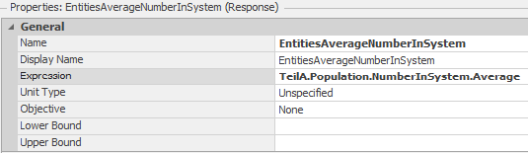
Illustration 21: Defining Responses
Now add another response yourself, which you can use to determine the average number of waiting entities in "Pressen1". Then start the experiment. You can now insert different values for the respective controls and compare the evaluations.
The solution to this task can be found in the file «Task6-Solution.spfx»

