Simulation with Simio
Getting Started

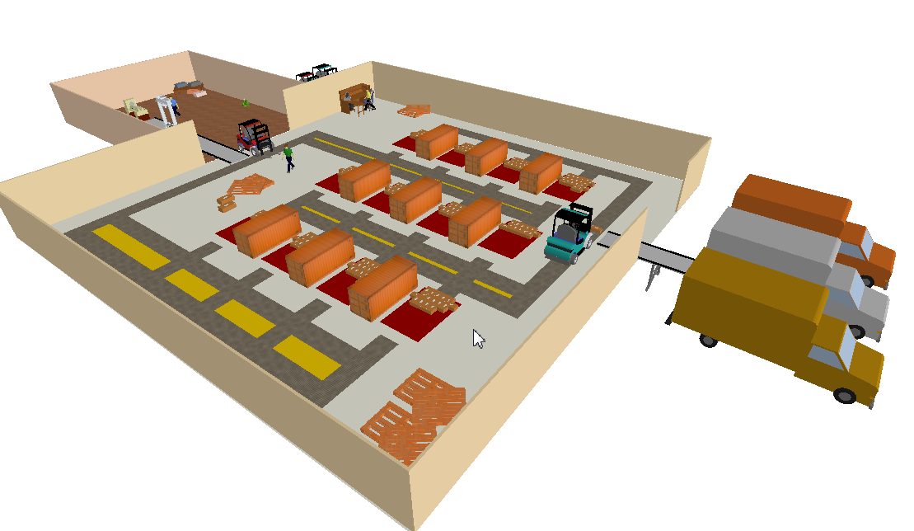

Dr. Lukas Hollenstein, Dr. Tatiana Starostina, Melih Derman, Marco Brunschwiler
11/18/2024, Version 1.4

Zurich University of Applied SciencesLife Sciences and Facility ManagementInstitute of Computational Life SciencesGrüental, P.O. Box CH-8820 WädenswilTel: +41 58 934 54 02
lukas.hollenstein@zhaw.ch

Table of contents
1 Dealing with Simio 3
1.1 Objectives 3
1.2 Get to know the Simio interface 3
1.3 Start demo models 4
1.4 Further modelling help 5

Dealing with Simio

Objectives
- Get to know the Simio interface
- Open and launch demo models
- Get more help

Get to know the Simio interface
The Simio interface consists of several elements (Illustration 1).
- Verschiedene Views: Facility, Processes, Definitions, Data, Results
- Ribbon-Bar: kontext-sensitiv in Abhängigkeit der ausgewählten View.Bsp. Facility-View: Project Home, Run, Drawing, Animation, View, Visibility, Support
- Elements: context-sensitive depending on the selected View.Eg. Facility View: the loaded libraries are displayed with the available model elements.
- Model Browser: Displays the created models and submodels.
- Property View: Displays the currently adjustable properties of the selected element.
- Other views that can be shown/hidden: Trace, Errors, Breakpoints, Watch, Search, Profiles, Properties. These can be shown and hidden in the "Project Home" tab of the ribbon bar.
- Status bar
The Simio interface can be personalized to the user. The basic state can be restored in the ribbon bar in the "Project Home" tab via the "Reset" button.
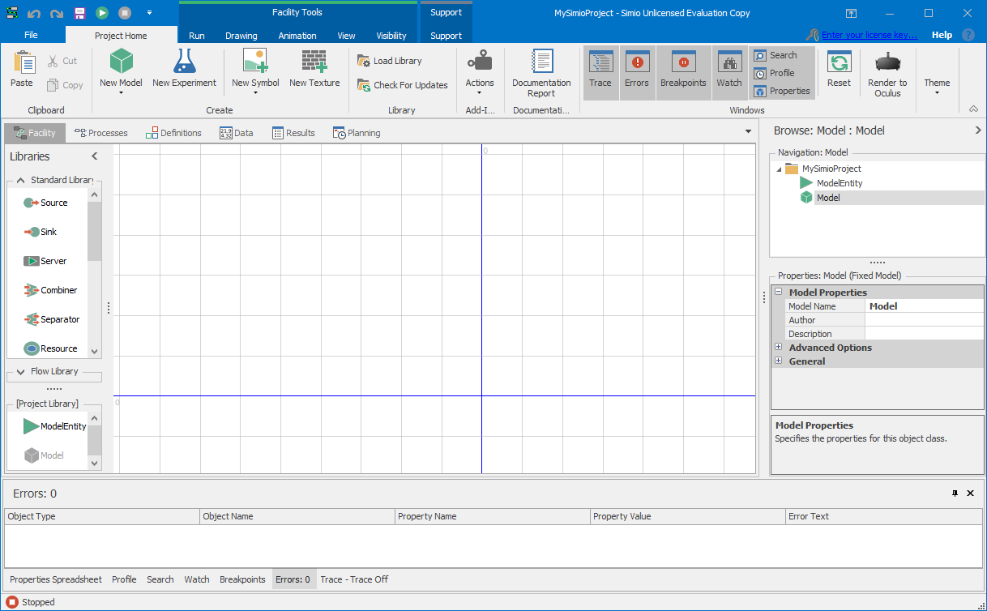
1
2
3
4
5
6
7
Illustration 1: Surface of Simio with superimposed facility view (Fig. from Simio 11.197.19514)

Start demo models
Demo models can be opened in Simio via the ribbon bar in the "Support" tab via the "Examples" button (Illustration 2). Open the "AirportTerminal" demo model.
Switch to the "Run" tab in the ribbon bar and start the simulation via the "Run" button. The simulation is animated in the Facility View:
- The progress of the simulation time can be seen in the status bar.
- In the "Run" tab, the simulation can be paused or paused.
- The simulation speed (Animation Speed) can be adjusted.
The view can be adjusted in the "View" tab, e.g. 2D / 3D view. Use the mouse to
- move the camera (left mouse button),
- Rotate the view (right mouse button) and
- (mouse wheel).
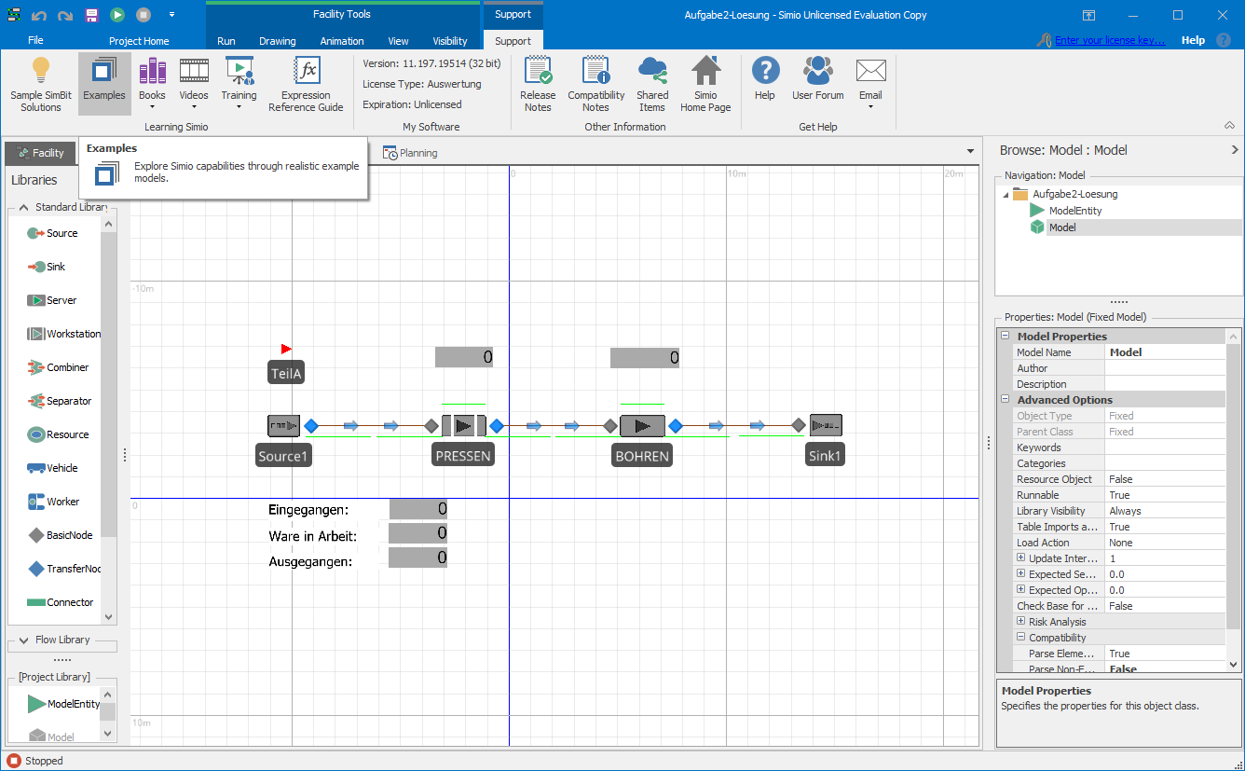
Illustration 2: Open demo model (Fig. from Simio 11.197.19514)
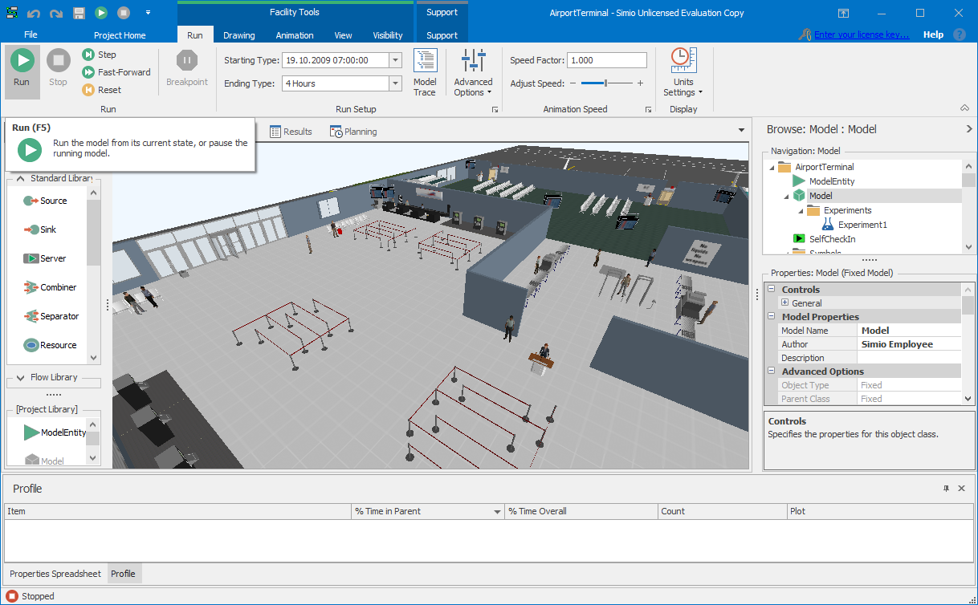
Illustration 3: Start the demo model AirportTerminal (Fig. from Simio 11.197.19514)

Further modelling help
The "Support" tab provides further assistance for model making:
- "Sample SimBit Solutions" show solutions for specific modelling problems.
- "Examples" show demo models.
- «Books» contains various books in PDF format, e.g. Introduction to Simio, Reference Guide, API Reference Guide.
- "Videos" contains links to introductory learning videos.
- And others such as "Help" and "User Forum".

