


Version: 5.1.2
Published date: August 2026
Copyright © 2026 by ESW. All rights reserved. Information contained herein is subject to change without notice.

AB Tasty INTEGRATION GUIDE

SFCC - ESW Cartridge
+
Contents
1 AB Tasty Integration 3
1.1 SFCC Configuration 3
1.2 AB Tasty Test Configuration 3
1.3 Default Tests 6

AB Tasty Integration
The cartridge includes support for AB Tasty integration, allowing retailers to conduct A/B testing and personalization within their storefronts.

SFCC Configuration
The custom preference ESW AB Tasty Script Path in the ESW Retailer Display Configuration contains the script URL for AB Tasty.

The cartridge includes the above script in the header so that AB tasty script is enabled if configured.

AB Tasty Test Configuration
Retailers can define and manage their A/B tests and personalization campaigns directly within the AB Tasty platform. Once configured, these tests and campaigns are seamlessly applied to the storefront, enabling dynamic content adjustments and user experience optimizations.
In the AB tasty platform, select the environment and create tests. In the example below, the configuration steps for one of the test is mention.
Test A: Display Disabled Checkout Button incase restricted products are in cart (Default)
Test B: Hide Checkout Button incase restricted products are in cart

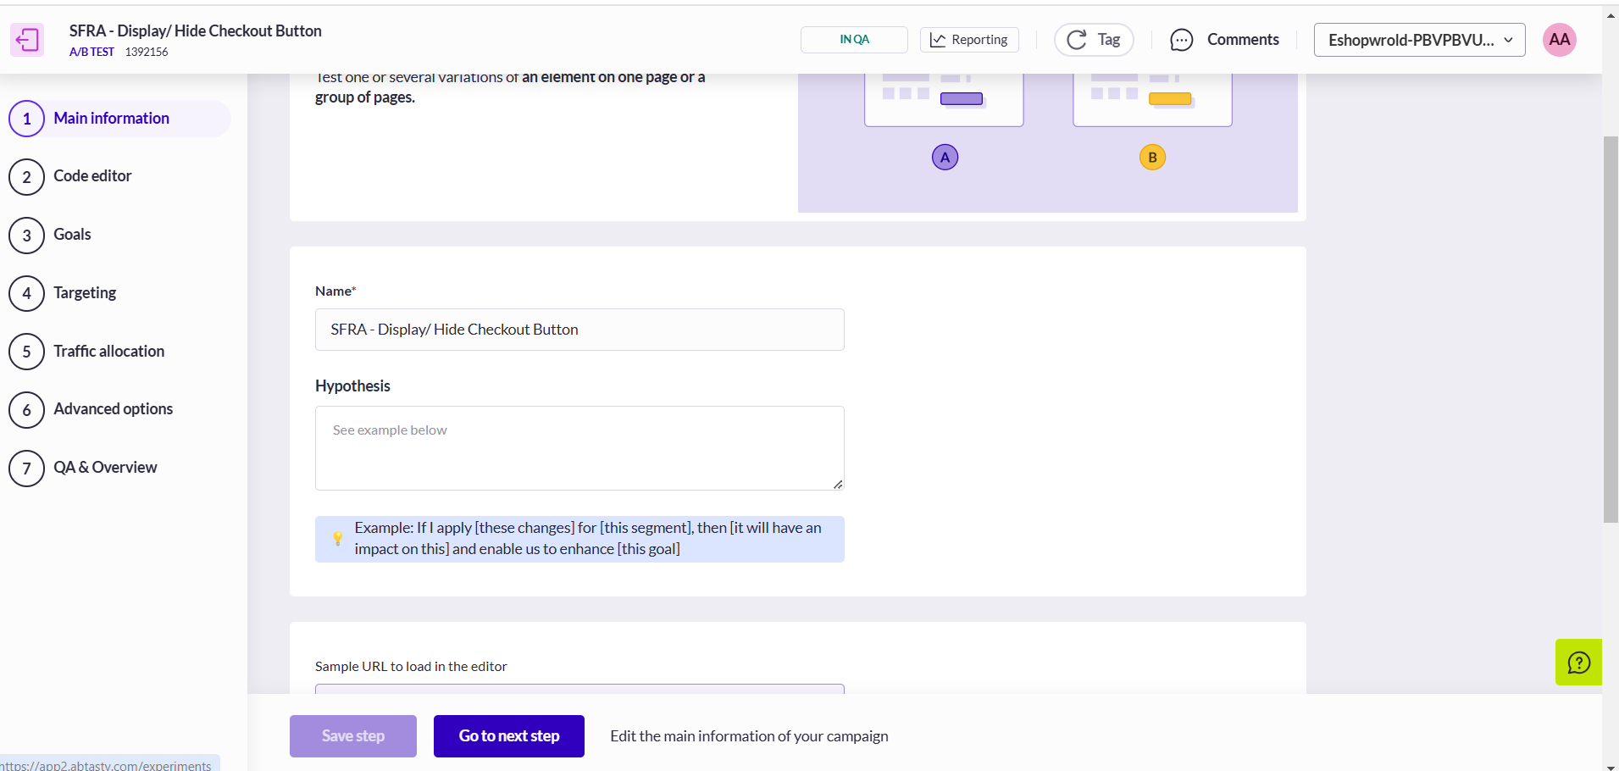

Ensure the URL for the correct environment is configured 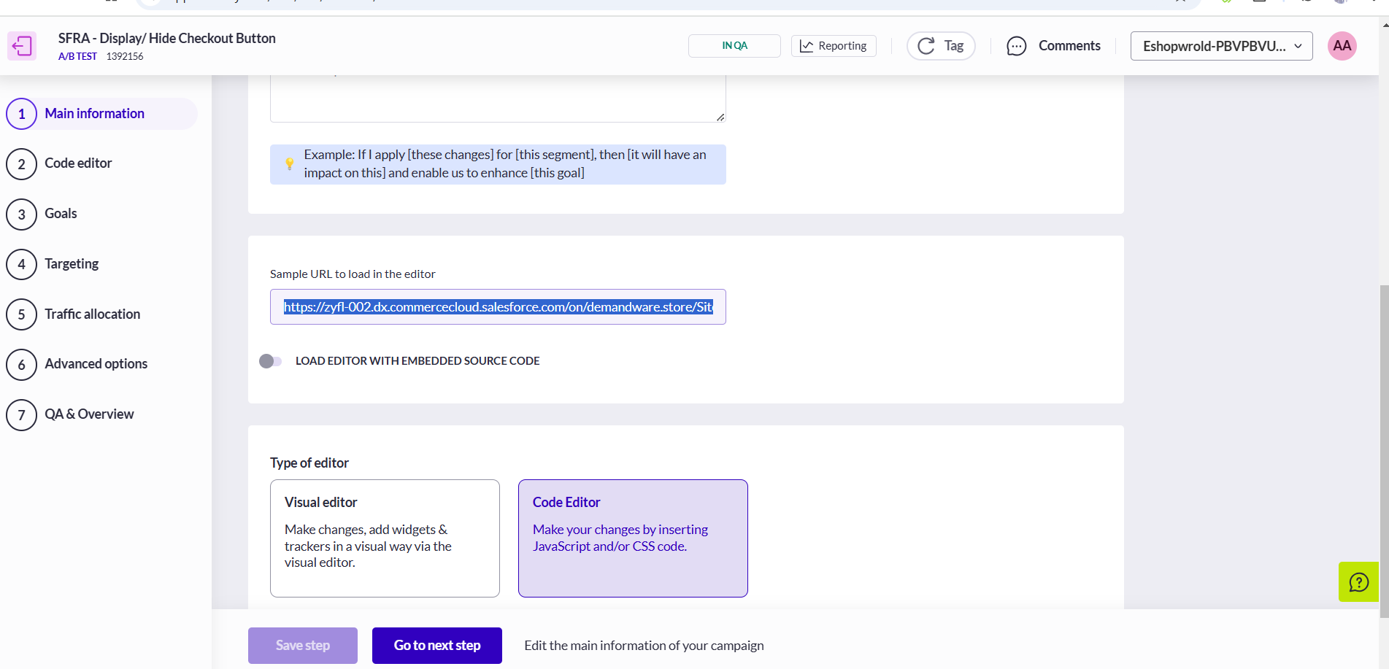

Add code changes for the AB test. In this case, the code logic to hide button was added incase product restriction message is present on the storefront cart page.
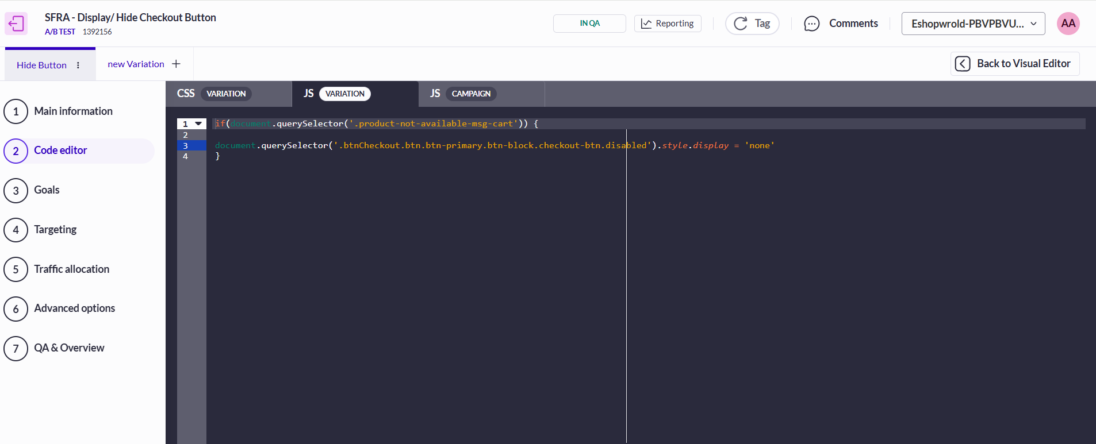

Add Goals and then add Targetting URL. Make sure the Pages where the test will be displayed is a generic site URL to ensure that the test loads.
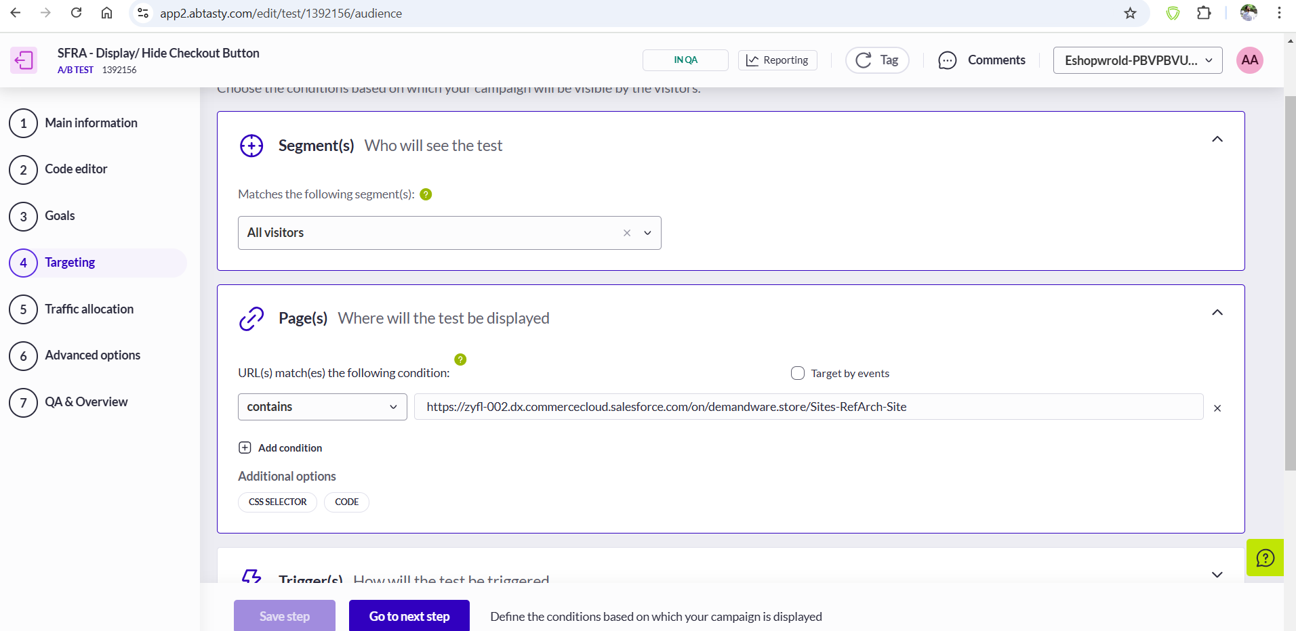

Allocate Traffic. In this example, the 50% of the traffic is allocated to Hide the checkout button and 50% is allocated to disable the button which is the original version.
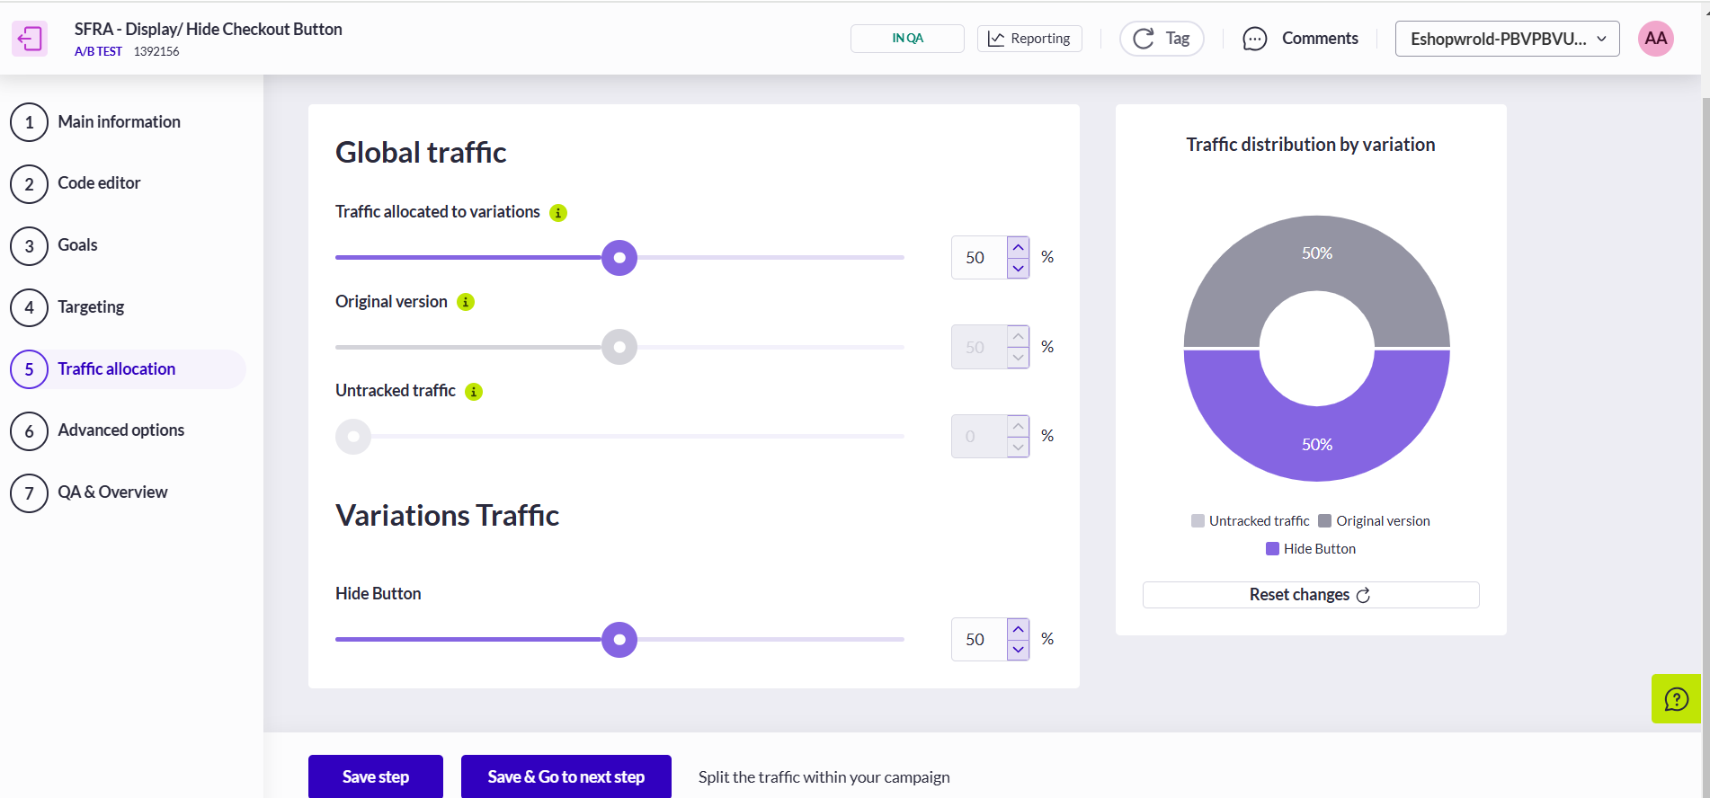

Once Done the campaign can be compiled and published live by clicking on “Open QA Assistant”. 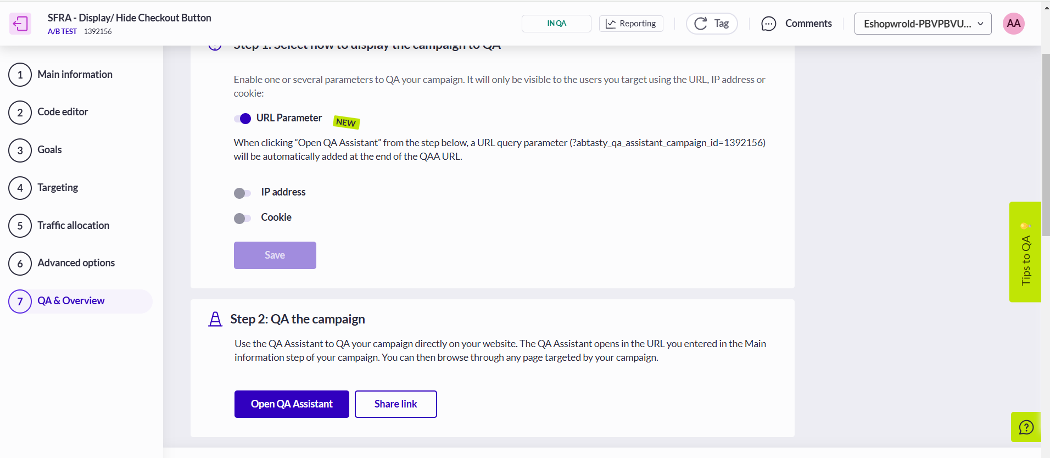

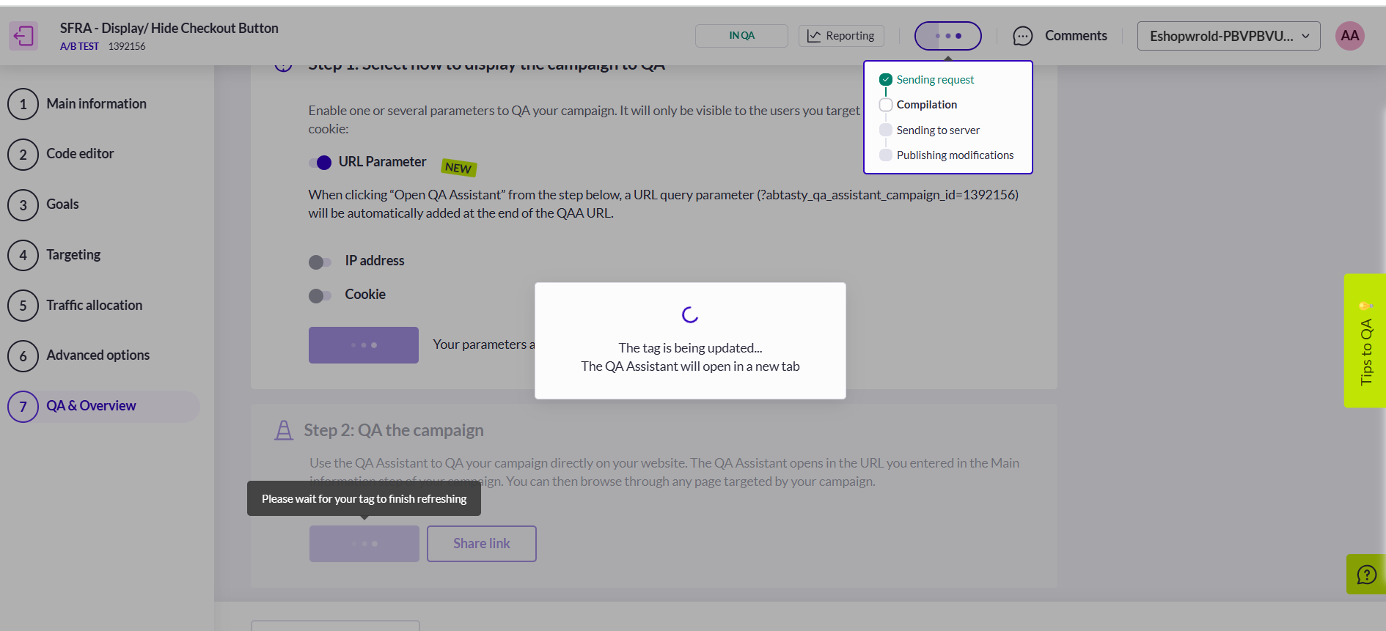

Default Tests
By default, the following A/B test are available and can be shared with the retailer:
- PDP Add to Cart Button Control: This test ensures that the "Add to Cart" button on the PDP is either disabled or hidden for restricted products, based on the traffic allocation.
  - Test A: The Button is visible but disabled.
  - Test B: The Button is hidden
- PLP Add to Cart Quick View Control: This test ensures that the "Add to Cart" button on the PLP quick view is either disabled or hidden for restricted products, based on the traffic allocation.
  - Test A: The Button is visible but disabled
  - Test B: The Button is hidden
- Checkout Button on Cart Page: This test ensures that the "Checkout" button on the Cart Page is either disabled or hidden for restricted products, based on the traffic allocation
  - Test A: The Button is visible but disabled
  - Test B: The Button is hidden
The above tests are available for the SFRA, Site Genesis and the PWA cartridge.

Retailers can further customize the tests and campaigns in the AB Tasty dashboard to align with their specific business needs.

