


SFRA - Code Customization guide

Version: 5.1.2
Published date: August 2026
Copyright © 2026 by ESW. All rights reserved. Information contained herein is subject to change without notice.

SFCC - ESW Cartridge
+

Table of Contents
Table of Contents 2
1 Storefront Reference Architecture 4
Customizing the code 4
1.1 Customizing the template 4
1.1.1 page.isml 4
1.1.2 pageHeader.isml 4
1.1.3 pageFooterESW.isml 5
1.1.4 htmlHead.isml 6
1.1.5 cart.isml 6
1.1.6 cartTotals.isml 7
1.1.7 cartCouponDisplay.isml 8
1.1.8 checkoutButtons.isml 8
1.1.9 main.isml 8
1.1.10 default.isml 9
1.1.11 setPrice.isml 10
1.1.12 productTiles.isml 11
1.1.13 homePageProductSlot.isml 11
1.1.14 cartProductCardProductPrice.isml 12
1.1.15 shippingSummary.isml 13
1.1.16 addToCartGlobal.isml 13
1.1.17 addToCartProduct.isml 14
1.1.18 updateCartProduct.isml 14
1.1.19 productCardProductTotalPrice.isml 15
1.1.20 mobileCountrySelector.isml 16
1.1.21 bundleDetails.isml 17
1.1.22 setDetails.isml 17
1.2 Customizing the controllers 18
1.2.1 Page.js 18
1.2.2 Cart.js 18
1.2.3 Checkout.js 20
1.2.4 CheckoutServices.js 20
1.2.5 Tile.js 20
1.3 Customizing the models 21
1.3.1 priceTotal.js 21
1.3.2 searchPrice.js 22
1.3.3 base.js 24
1.3.4 fullProduct.js 24
1.4 Customizing the scripts and json 24
1.4.1 taxes.js 24
1.4.2 validateBasket.js 25
1.4.3 calculate.js 25
1.4.4 detail.js 27
1.4.5 quickView.js 27

1 Storefront Reference Architecture

Customizing the code

1.1 Customizing the template

1.1.1 page.isml
Path
int_eshopworld_sfra/cartridge/templates/default/common/layout/page.isml
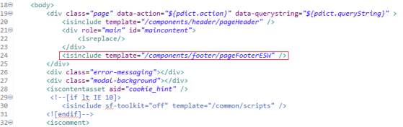
<isinclude template="/components/footer/pageFooterESW" />

1.1.2 pageHeader.isml
Path
int_eshopworld_sfra/cartridge/templates/default/components/header/pageHeader.isml
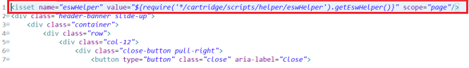
<isset name="eswHelper" value="${require('*/cartridge/scripts/helper/eswHelper').getEswHelper()}" scope="page"/>

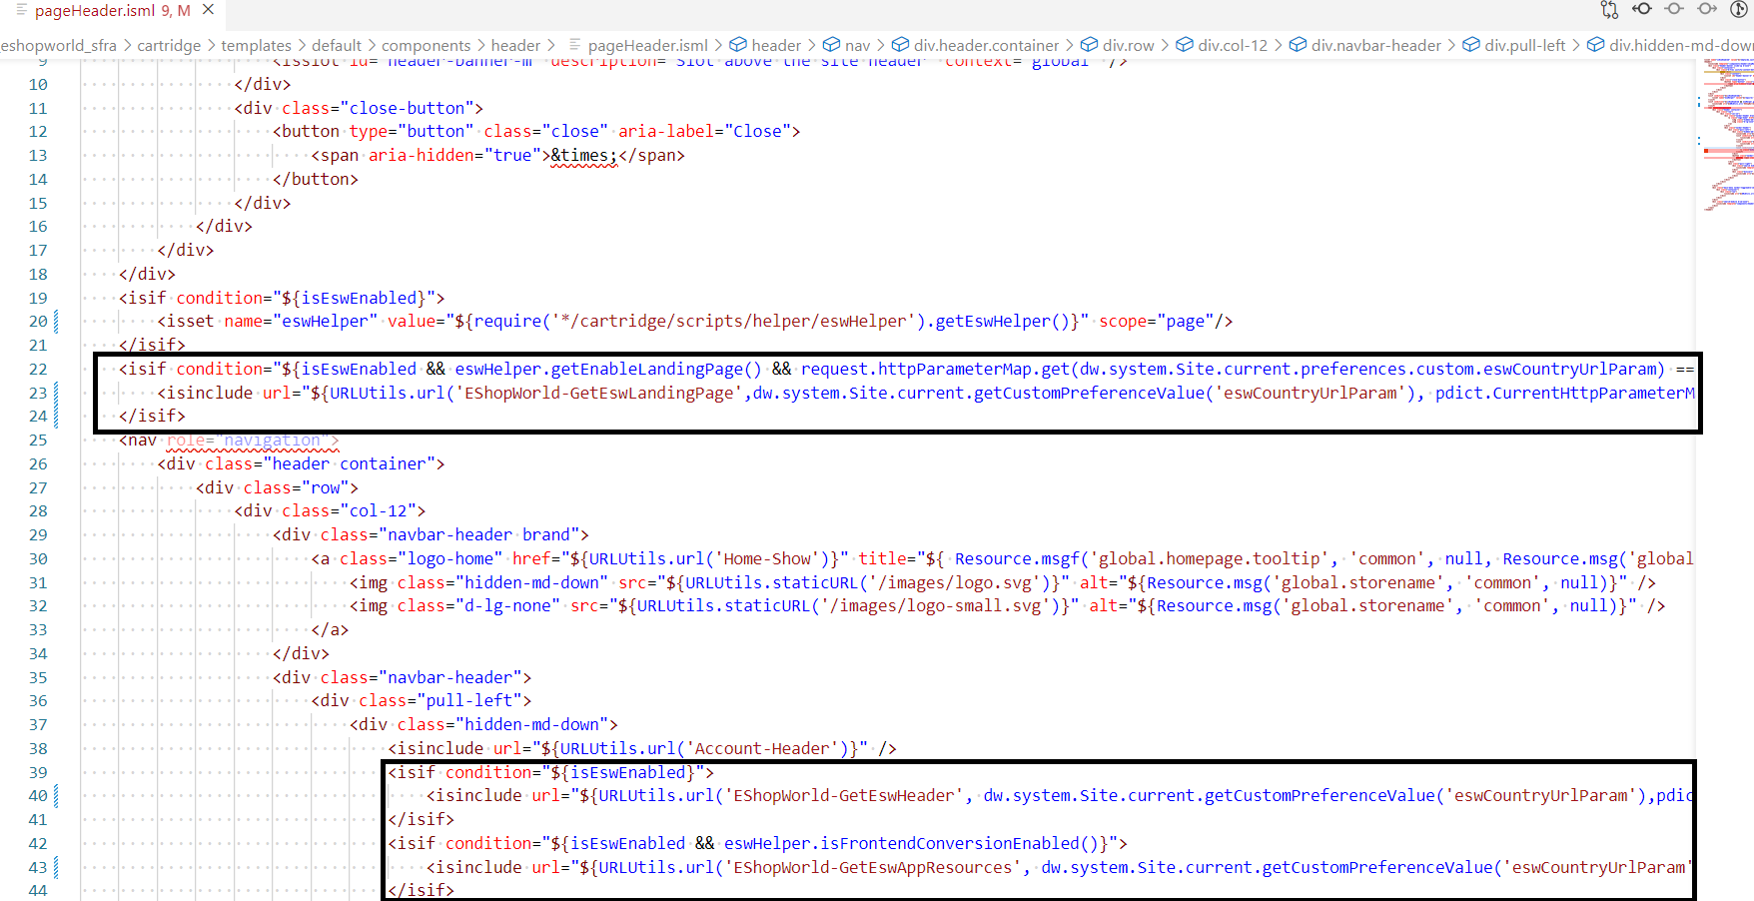
<isif condition="${isEswEnabled && eswHelper.getEnableLandingPage() && request.httpParameterMap.get(dw.system.Site.current.preferences.custom.eswCountryUrlParam) == false}">
<isinclude url="${URLUtils.url('EShopWorld-GetEswLandingPage',dw.system.Site.current.getCustomPreferenceValue('eswCountryUrlParam'), pdict.CurrentHttpParameterMap.get(dw.system.Site.current.getCustomPreferenceValue('eswCountryUrlParam')))}"/>
</isif>

<isif condition="${isEswEnabled}">
<isinclude url="${URLUtils.url('EShopWorld-GetEswHeader', dw.system.Site.current.getCustomPreferenceValue('eswCountryUrlParam'),pdict.CurrentHttpParameterMap.get(dw.system.Site.current.getCustomPreferenceValue('eswCountryUrlParam')))}"/>
</isif>
<isif condition="${isEswEnabled && eswHelper.isFrontendConversionEnabled()}">
<isinclude url="${URLUtils.url('EShopWorld-GetEswAppResources', dw.system.Site.current.getCustomPreferenceValue('eswCountryUrlParam'),pdict.CurrentHttpParameterMap.get(dw.system.Site.current.getCustomPreferenceValue('eswCountryUrlParam')))}"/>
</isif>
<isif condition="${isEswEnabled && eswHelper.isESWSupportedCountry()}">
<i class="eshopworld-loader d-none"></i>
</isif>

1.1.3 pageFooterESW.isml
Path
int_eshopworld_sfra/cartridge/templates/default/components/footer/pageFooterESW.isml
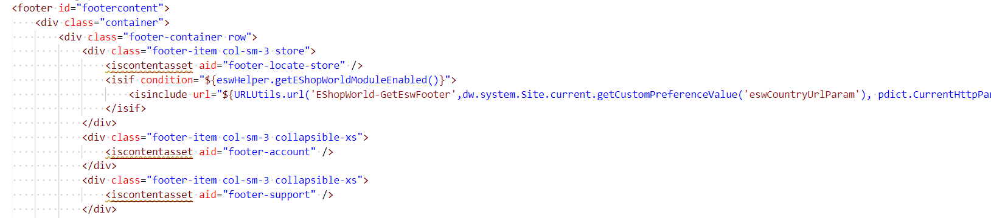
<isif condition="${eswHelper.getEShopWorldModuleEnabled()}">
<isinclude url="${URLUtils.url('EShopWorld-GetEswFooter',dw.system.Site.current.getCustomPreferenceValue('eswCountryUrlParam'), pdict.CurrentHttpParameterMap.get(dw.system.Site.current.getCustomPreferenceValue('eswCountryUrlParam')))}"/>
</isif>

1.1.4 htmlHead.isml
Path
int_eshopworld_sfra/cartridge/templates/default/common/htmlHead.isml
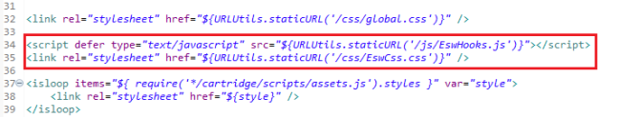
<script defer type="text/javascript" src="${URLUtils.staticURL('/js/EswHooks.js')}"></script>
<link rel="stylesheet" href="${URLUtils.staticURL('/css/EswCss.css')}" />

1.1.5 cart.isml
Path
int_eshopworld_sfra/cartridge/templates/default/cart/cart.isml
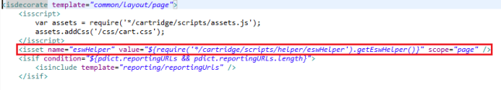
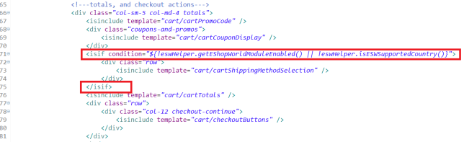
<isset name="eswHelper" value="${require('*/cartridge/scripts/helper/eswHelper').getEswHelper()}" scope="page" />

<isif condition="${!eswHelper.getEShopWorldModuleEnabled() || !eswHelper.isESWSupportedCountry()}">
<div class="row">
<isinclude template="cart/cartShippingMethodSelection" />
</div>
</isif>

1.1.6 cartTotals.isml
Path
int_eshopworld_sfra/cartridge/templates/default/cart/cartTotals.isml
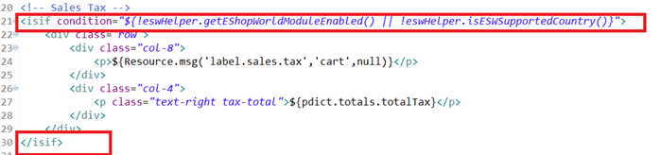
<isif condition="${!eswHelper.getEShopWorldModuleEnabled() || !eswHelper.isESWSupportedCountry()}">
<div class="row">
<div class="col-8">
<p>${Resource.msg('label.sales.tax','cart',null)}</p>
</div>
<div class="col-4">
<p class="text-right tax-total">${pdict.totals.totalTax}</p>
</div>
</div>
</isif>

1.1.7 cartCouponDisplay.isml
Path
/int_eshopworld_sfra/cartridge/templates/default/cart/cartCouponDisplay.isml
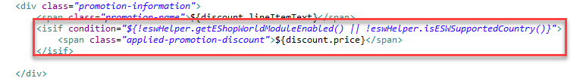
<isif condition="${!eswHelper.getEShopWorldModuleEnabled() || !eswHelper.isESWSupportedCountry()}">
<span class="applied-promotion-discount">${discount.price}</span>
</isif>

1.1.8 checkoutButtons.isml
Path
int_eshopworld_sfra/cartridge/templates/default/cart/checkoutButtons.isml
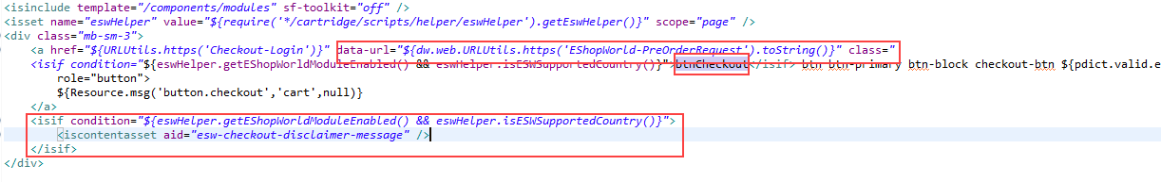
<a href="${URLUtils.https('Checkout-Login')}" data-url="${dw.web.URLUtils.https('EShopWorld-PreOrderRequest').toString()}" class="
<isif condition="${eswHelper.getEShopWorldModuleEnabled() && !!eswHelper.checkIsEswAllowedCountry(request.httpCookies['esw.location'].value)}">btnCheckout</isif> btn btn-primary btn-block checkout-btn ${pdict.valid.error ? 'disabled' : ''}" role="button">

<isif condition="${eswHelper.getEShopWorldModuleEnabled() && eswHelper.isESWSupportedCountry()}">
<iscontentasset aid="esw-checkout-disclaimer-message" />
</isif>

1.1.9 main.isml
Path
int_eshopworld_sfra/cartridge/templates/default/product/components/pricing/main.isml
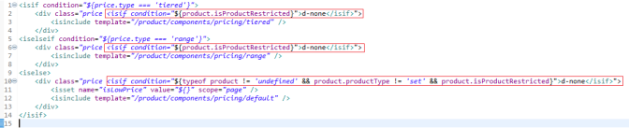
<div class="price <isif condition="${product.isProductRestricted}">d-none</isif>">

<div class="price <isif condition="${product.isProductRestricted}">d-none</isif>">

<div class="price <isif condition="${typeof product != 'undefined' && product.productType != 'set' && product.isProductRestricted}">d-none</isif>">

1.1.10 default.isml
Path
int_eshopworld_sfra/cartridge/templates/default/product/components/pricing/default.isml
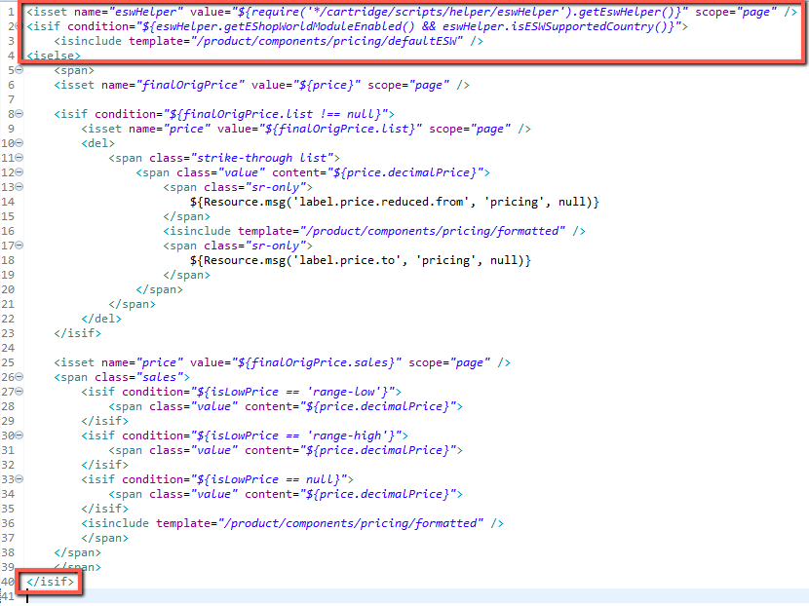
<isset name="eswHelper" value="${require('*/cartridge/scripts/helper/eswHelper').getEswHelper()}" scope="page" />
<isif condition="${eswHelper.getEShopWorldModuleEnabled() && eswHelper.isESWSupportedCountry()}">
<isinclude template="/product/components/pricing/defaultESW" />
<iselse>

...

...

</isif>

1.1.11 setPrice.isml
Path
int_eshopworld_sfra/cartridge/templates/default/product/components/pricing/setPrice.isml
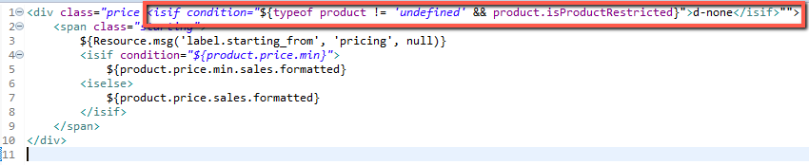
<div class="price <isif condition="${typeof product != 'undefined' && product.isProductRestricted}">d-none</isif>"">
<span class="starting">
${Resource.msg('label.starting_from', 'pricing', null)}
<isif condition="${product.price.min}">
${product.price.min.sales.formatted}
<iselse>
${product.price.sales.formatted}
</isif>
</span>
</div>

1.1.12 productTiles.isml
Path
int_eshopworld_sfra/cartridge/templates/default/search/components/productTiles.isml

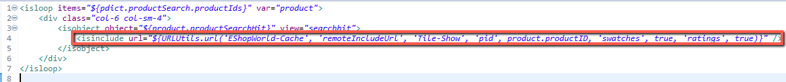

<isinclude url="${URLUtils.url('EShopWorld-Cache', 'remoteIncludeUrl', 'Tile-Show', 'pid', product.productID, 'swatches', true, 'ratings', true)}" />

1.1.13 homePageProductSlot.isml
Path
int_eshopworld_sfra/cartridge/templates/default/slots/product/homePageProductSlot.isml

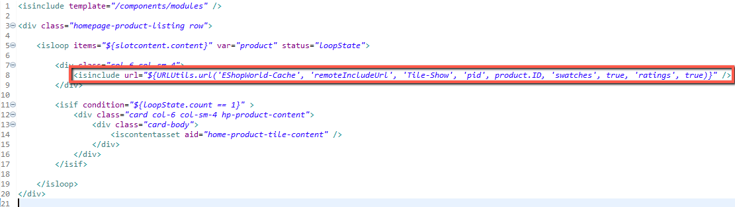
<isinclude url="${URLUtils.url('EShopWorld-Cache', 'remoteIncludeUrl', 'Tile-Show', 'pid', product.ID, 'swatches', true, 'ratings', true)}" />

1.1.14 cartProductCardProductPrice.isml
Path
int_eshopworld_sfra/cartridge/templates/default/cart/productCard/cartProductCardProductPrice.isml
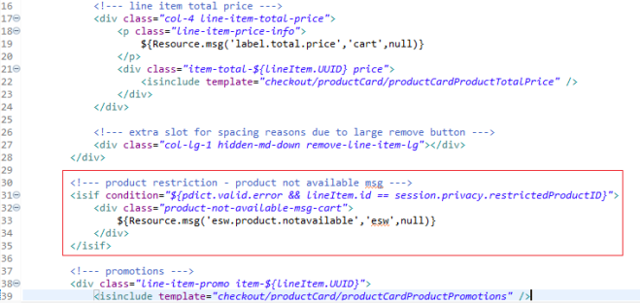
<!--- product restriction - product not available msg --->
<isif condition="${pdict.valid.error && lineItem.id == session.privacy.restrictedProductID}">
<div class="product-not-available-msg-cart">
${Resource.msg('esw.product.notavailable','esw',null)}
</div>
</isif>

1.1.15 shippingSummary.isml
Path
int_eshopworld_sfra/cartridge/templates/default/checkout/shipping/shippingSummary.isml
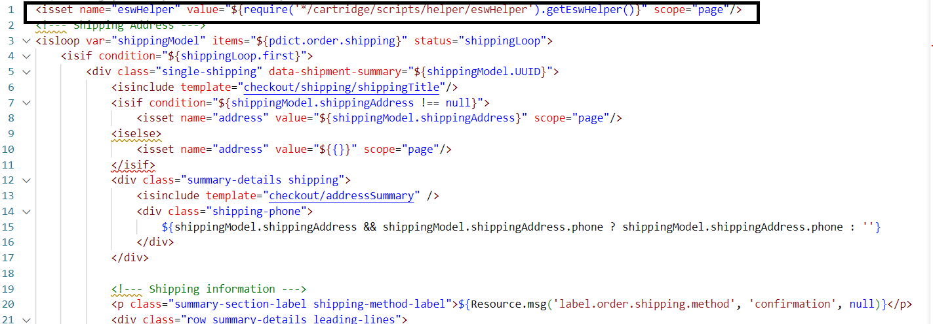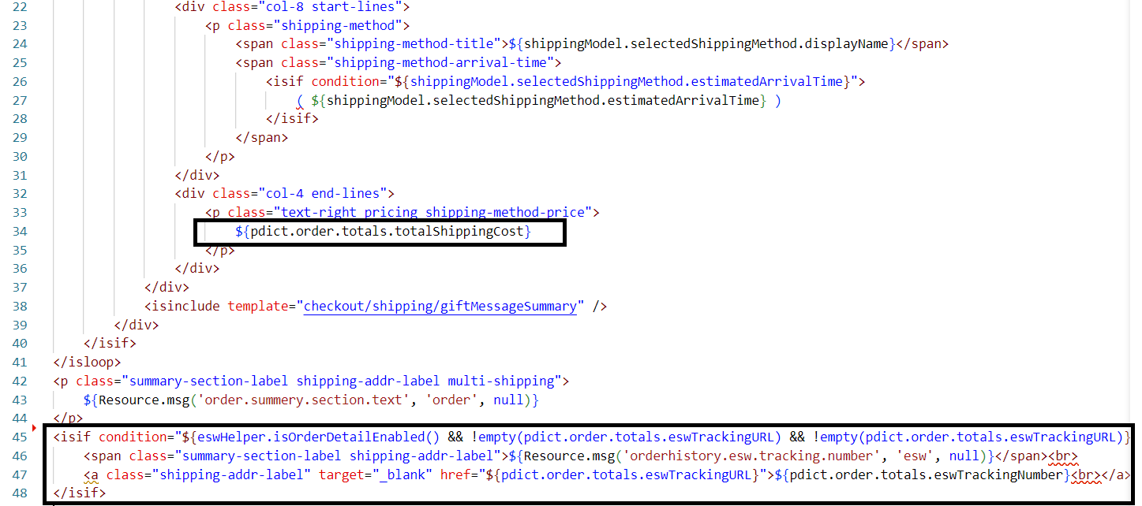
<isset name="eswHelper" value="${require('*/cartridge/scripts/helper/eswHelper').getEswHelper()}" scope="page"/>

<!--- ESW Order/Package Tracking information --->
<isif condition="${eswHelper.isOrderDetailEnabled() && !empty(pdict.order.totals.eswTrackingURL) && !empty(pdict.order.totals.eswTrackingURL)}">
<span class="summary-section-label shipping-addr-label">${Resource.msg('orderhistory.esw.tracking.number', 'esw', null)}</span><br>
<a class="shipping-addr-label" target="_blank" href="${pdict.order.totals.eswTrackingURL}">${pdict.order.totals.eswTrackingNumber}<br></a><br>
</isif>

1.1.16 addToCartGlobal.isml
Path
int_eshopworld_sfra/cartridge/templates/default/product/components/addToCartGlobal.isml
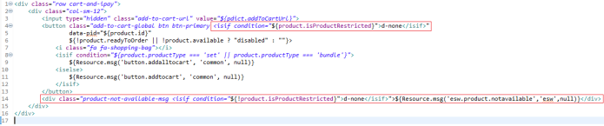
<button class="add-to-cart-global btn btn-primary <isif condition="${product.isProductRestricted}">d-none</isif>"

<div class="product-not-available-msg <isif condition="${!product.isProductRestricted}">d-none</isif>">${Resource.msg('esw.product.notavailable','esw',null)}</div>

1.1.17 addToCartProduct.isml
Path
int_eshopworld_sfra/cartridge/templates/default/product/components/addToCartProduct.isml
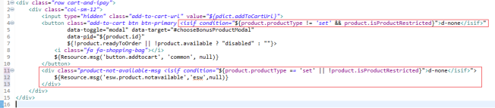
<button class="add-to-cart btn btn-primary <isif condition="${product.productType != 'set' && product.isProductRestricted}">d-none</isif>"

<div class="product-not-available-msg <isif condition="${product.productType == 'set' || !product.isProductRestricted}">d-none</isif>">${Resource.msg('esw.product.notavailable','esw',null)}</div>

1.1.18 updateCartProduct.isml
Path
int_eshopworld_sfra/cartridge/templates/default/product/components/updateCartProduct.isml
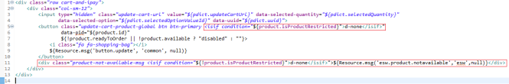
<button class="update-cart-product-global btn btn-primary <isif condition="${product.isProductRestricted}">d-none</isif>"

<div class="product-not-available-msg <isif condition="${!product.isProductRestricted}">d-none</isif>">${Resource.msg('esw.product.notavailable','esw',null)}</div>

1.1.19 productCardProductTotalPrice.isml
Path
int_eshopworld_sfra/cartridge/templates/default/checkout/productCard/productCardProductTotalPrice.isml
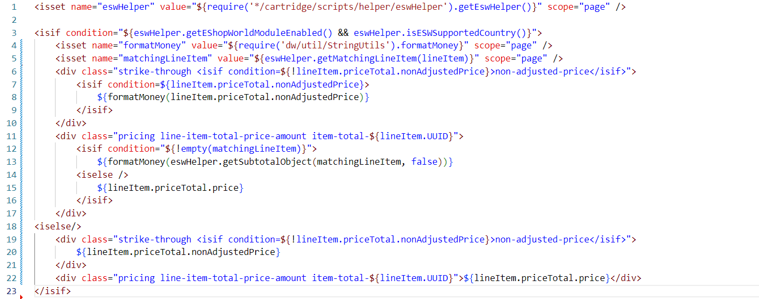
<isset name="isEswEnabled" value="${!empty(dw.system.Site.current.preferences.custom.eswEshopworldModuleEnabled) ? dw.system.Site.current.preferences.custom.eswEshopworldModuleEnabled : false}" scope="page" />

<isif condition="${isEswEnabled}">
<isset name="eswHelper" value="${require('*/cartridge/scripts/helper/eswHelper').getEswHelper()}" scope="page"/>
<isset name="formatMoney" value="${require('dw/util/StringUtils').formatMoney}" scope="page" />
<isset name="matchingLineItem" value="${eswHelper.getMatchingLineItem(lineItem)}" scope="page" />

<div class="strike-through <isif condition=${!lineItem.priceTotal.nonAdjustedPrice}>non-adjusted-price</isif>">
<isif condition=${lineItem.priceTotal.nonAdjustedPrice}>
${formatMoney(lineItem.priceTotal.nonAdjustedPrice)}
</isif>
</div>
<div class="pricing line-item-total-price-amount item-total-${lineItem.UUID}">
<isif condition="${!empty(matchingLineItem)}">
${formatMoney(eswHelper.getSubtotalObject(matchingLineItem, false))}
<iselse>
${lineItem.priceTotal.price}
</isif>
</div>
<iselse>
<div class="strike-through <isif condition=${!lineItem.priceTotal.nonAdjustedPrice}>non-adjusted-price</isif>">
${lineItem.priceTotal.nonAdjustedPrice}
</div>
<div class="pricing line-item-total-price-amount item-total-${lineItem.UUID}">${lineItem.priceTotal.price}</div>
</isif>

1.1.20 mobileCountrySelector.isml
Path
int_eshopworld_sfra/cartridge/templates/default/components/header/mobileCountrySelector.isml

<isset name=”isEswEnabled” value=”${!empty(dw.system.Site.current.preferences.custom.eswEshopworldModuleEnabled) ? dw.system.Site.current.preferences.custom.eswEshopworldModuleEnabled : false}” scope=”page” />
<isif condition=”${isEswEnabled}”>
<isset name=”eswHelper” value=”${require(‘*/cartridge/scripts/helper/eswHelper’).getEswHelper()}” scope=”page”/>
</isif>
<isif condition=”${!isEswEnabled && pdict.localeModel.locale.localeLinks.length > 0}”>
<li class=”menu-item dropdown country-selector d-md-none” data-url=”${URLUtils.url(‘Page-SetLocale’)}”>
<span class=”btn dropdown-toggle” id=”dropdownCountrySelector” data-toggle=”dropdown” aria-haspopup=”true” aria-expanded=”false”>
<I class=”flag-icon flag-icon-${pdict.localeModel.locale.countryCode.toLowerCase()}”></i>
${pdict.localeModel.locale.displayName}
</span>
<div class=”dropdown-menu dropdown-country-selector” aria-labelledby=”dropdownCountrySelector”>
<isloop items=”${pdict.localeModel.locale.localeLinks}” var=”localeLink”>
<a class=”dropdown-item” href=”${‘#’}” data-locale=”${localeLink.localID}” data-currencyCode=”${localeLink.currencyCode}” >
<I class=”flag-icon flag-icon-${localeLink.country.toLowerCase()}”></i>
${localeLink.displayName}
</a>
</isloop>
</div>
</li>
</isif>
<isif condition=”${isEswEnabled && eswHelper.getEnableHeaderBar()}”>
<li class=”menu-item dropdown country-selector d-md-none”>
<isinclude url=”${URLUtils.url(‘EshopWorld-GetEswHeader’)}”/>
</li>
</isif>

1.1.21 bundleDetails.isml
Path
/int_eshopworld_sfra/cartridge/templates/default/product/bundleDetails.isml

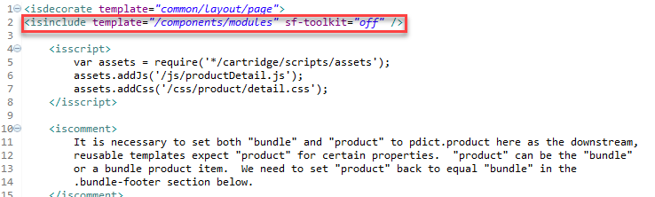
<isinclude template="/components/modules" sf-toolkit="off" />

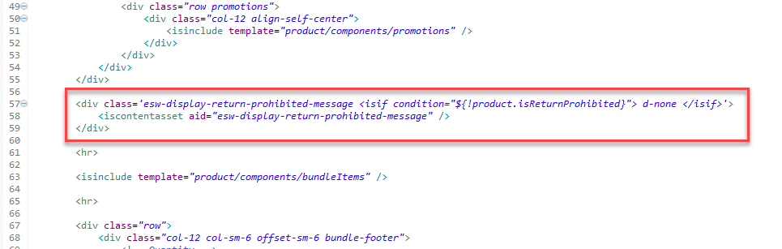
<div class='esw-display-return-prohibited-message <isif condition="${!product.isReturnProhibited}"> d-none </isif>'>
<iscontentasset aid="esw-display-return-prohibited-message" />
</div>

1.1.22 setDetails.isml
Path
/int_eshopworld_sfra/cartridge/templates/default/product/setDetails.isml

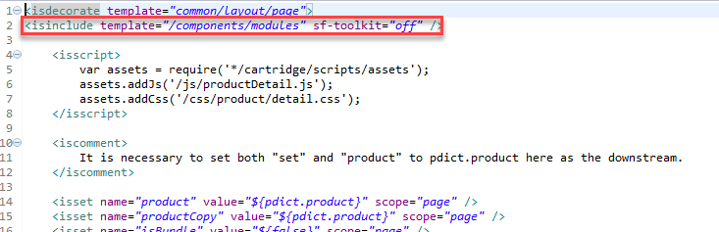
<isinclude template="/components/modules" sf-toolkit="off" />

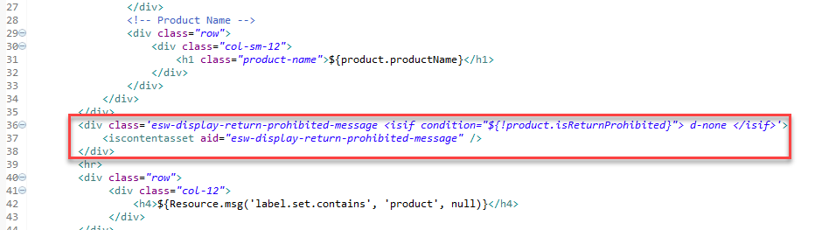
<div class='esw-display-return-prohibited-message <isif condition="${!product.isReturnProhibited}"> d-none </isif>'>
<iscontentasset aid="esw-display-return-prohibited-message" />
</div>

1.1.23 paymentOptionsSummary.isml
Path
/int_eshopworld_sfra/cartridge/templates/default/checkout/billing/paymentOptions/paymentOptionsSummary.isml
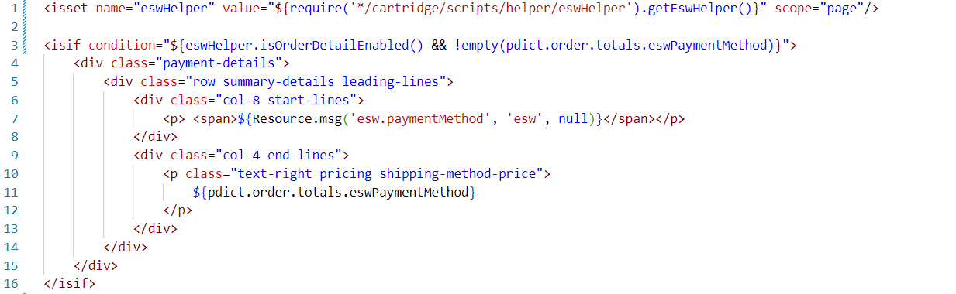

1.2 Customizing the controllers

1.2.1 Page.js
Path
int_eshopworld_sfra/cartridge/controllers/Page.js

1.2.2 Cart.js
Path
int_eshopworld_sfra/cartridge/controllers/Cart.js

1.2.3 Checkout.js
Path
int_eshopworld_sfra/cartridge/controllers/Checkout.js

1.2.4 CheckoutServices.js
Path
int_eshopworld_sfra/cartridge/controllers/CheckoutServices.js

1.2.5 Tile.js
Path
int_eshopworld_sfra/cartridge/controllers/Tile.js

1.3 Customizing the models

1.3.1 priceTotal.js
Path
int_eshopworld_sfra/cartridge/models/productLineItem/decorators/priceTotal.js
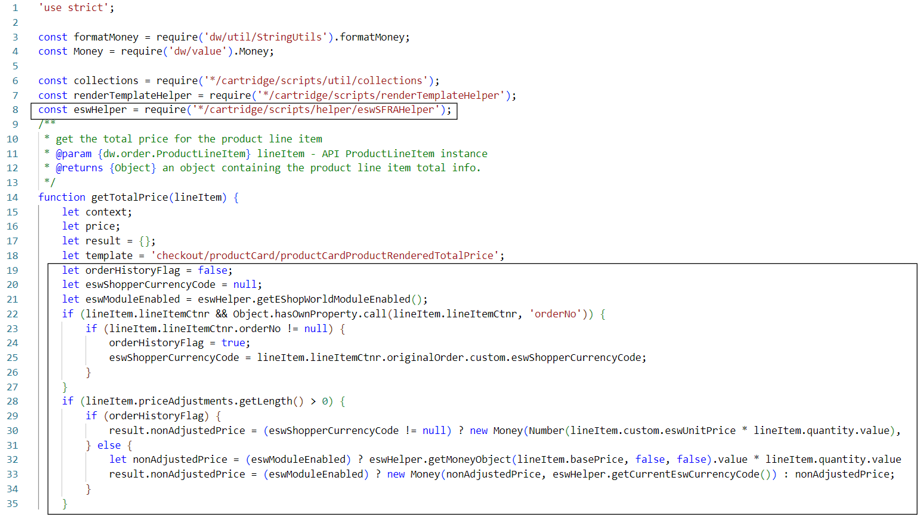
let eswHelper = require('*/cartridge/scripts/helper/eswSFRAHelper');

let orderHistoryFlag = false;
let eswShopperCurrencyCode = null;
let eswModuleEnabled = eswHelper.getEShopWorldModuleEnabled();
if (lineItem.lineItemCtnr && Object.hasOwnProperty.call(lineItem.lineItemCtnr, 'orderNo')) {
if (lineItem.lineItemCtnr.orderNo != null) {
orderHistoryFlag = true;
eswShopperCurrencyCode = lineItem.lineItemCtnr.originalOrder.custom.eswShopperCurrencyCode;
}
}
if (lineItem.priceAdjustments.getLength() > 0) {
if (orderHistoryFlag) {
result.nonAdjustedPrice = (eswShopperCurrencyCode != null) ? new Money(Number(lineItem.custom.eswUnitPrice * lineItem.quantity.value), eswShopperCurrencyCode) : lineItem.getPrice();
} else {
let nonAdjustedPrice = (eswModuleEnabled) ? eswHelper.getMoneyObject(lineItem.basePrice, false, false).value * lineItem.quantity.value : lineItem.getPrice();
result.nonAdjustedPrice = (eswModuleEnabled) ? new Money(nonAdjustedPrice, eswHelper.getCurrentEswCurrencyCode()) : nonAdjustedPrice;
}
}

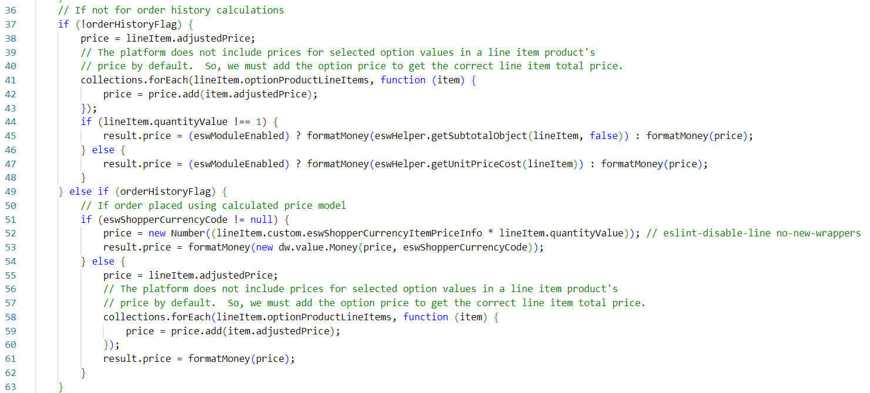
if (!orderHistoryFlag) {
price = lineItem.adjustedPrice;
// The platform does not include prices for selected option values in a line item product's
// price by default. So, we must add the option price to get the correct line item total price.
collections.forEach(lineItem.optionProductLineItems, function (item) {
price = price.add(item.adjustedPrice);
});
if (lineItem.quantityValue !== 1) {
result.price = (eswModuleEnabled) ? formatMoney(eswHelper.getSubtotalObject(lineItem, false)) : formatMoney(price);
} else {
result.price = (eswModuleEnabled) ? formatMoney(eswHelper.getUnitPriceCost(lineItem)) : formatMoney(price);
}
} else if (orderHistoryFlag) {
// If order placed using calculated price model
if (eswShopperCurrencyCode != null) {
price = new Number((lineItem.custom.eswShopperCurrencyItemPriceInfo * lineItem.quantityValue)); // eslint-disable-line no-new-wrappers
result.price = formatMoney(new dw.value.Money(price, eswShopperCurrencyCode));
} else {
price = lineItem.adjustedPrice;
// The platform does not include prices for selected option values in a line item product's
// price by default. So, we must add the option price to get the correct line item total price.
collections.forEach(lineItem.optionProductLineItems, function (item) {
price = price.add(item.adjustedPrice);
});
result.price = formatMoney(price);
}
}

1.3.2 searchPrice.js
Path
int_eshopworld_sfra/cartridge/models/product/decorators/searchPrice.js
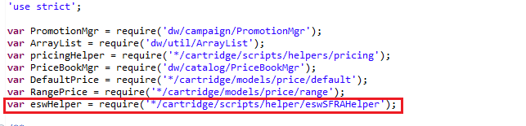
var eswHelper = require('*/cartridge/scripts/helper/eswSFRAHelper');

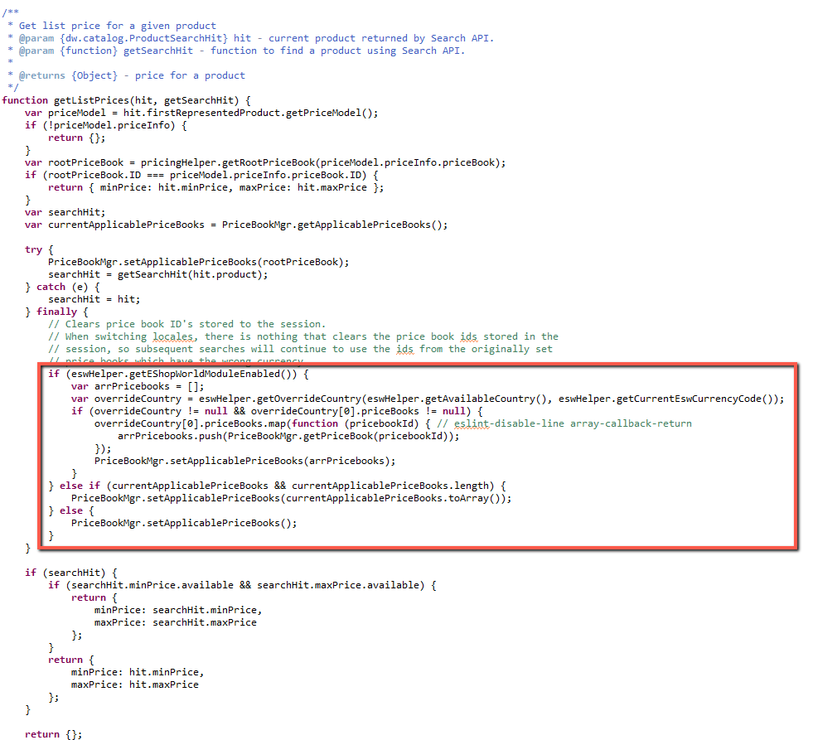
if (eswHelper.getEShopWorldModuleEnabled()) {
var arrPricebooks = [];
var overrideCountry = eswHelper.getOverrideCountry(eswHelper.getAvailableCountry(), eswHelper.getCurrentEswCurrencyCode());
if (overrideCountry != null && overrideCountry[0].priceBooks != null) {
overrideCountry[0].priceBooks.map(function (pricebookId) { // eslint-disable-line array-callback-return
arrPricebooks.push(PriceBookMgr.getPriceBook(pricebookId));
});
PriceBookMgr.setApplicablePriceBooks(arrPricebooks);
}
} else if (currentApplicablePriceBooks && currentApplicablePriceBooks.length) {
PriceBookMgr.setApplicablePriceBooks(currentApplicablePriceBooks.toArray());
} else {
PriceBookMgr.setApplicablePriceBooks();
}

1.3.3 base.js
Path
int_eshopworld_sfra/cartridge/models/product/decorators/base.js

1.3.4 fullProduct.js
Path
int_eshopworld_sfra/cartridge/models/product/decorators/fullProduct.js

1.4 Customizing the scripts and json

1.4.1 taxes.js
Path
int_eshopworld_sfra/cartridge/scripts/hooks/taxes.js

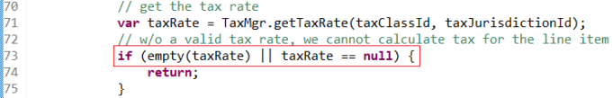
Important: You must include this file in your hooks.json file.

1.4.2 validateBasket.js
Path
int_eshopworld_sfra/cartridge/scripts/hooks/validateBasket.js

Important: You must include this file in your hooks.json file.

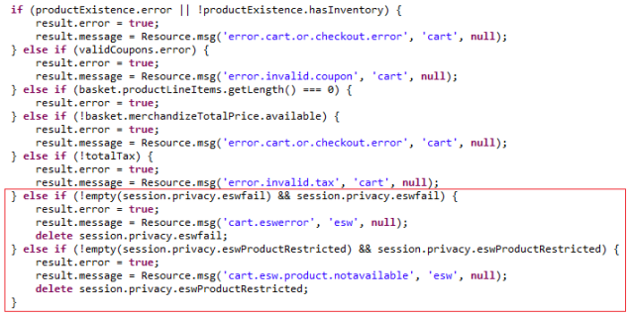
} else if (!empty(session.privacy.eswfail) && session.privacy.eswfail) {
result.error = true;
result.message = Resource.msg('cart.eswerror', 'esw', null);
delete session.privacy.eswfail;
} else if (!empty(session.privacy.eswProductRestricted) && session.privacy.eswProductRestricted) {
result.error = true;
result.message = Resource.msg('cart.esw.product.notavailable', 'esw', null);
delete session.privacy.eswProductRestricted;
}

1.4.3 calculate.js
Path
int_eshopworld_sfra/cartridge/scripts/hooks/cart/calculate.js

You must include this file in your hooks.json file.

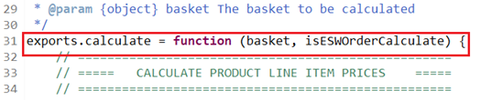
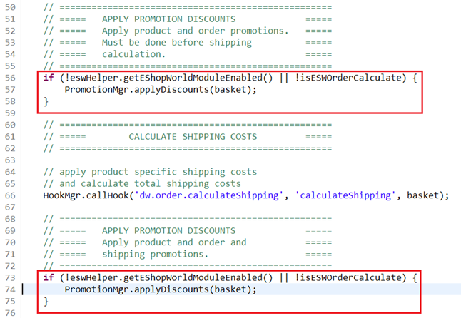
var eswHelper = require('*/cartridge/scripts/helper/eswHelper').getEswHelper();

exports.calculate = function (basket, isESWOrderCalculate) {

if (!eswHelper.getEShopWorldModuleEnabled() || !isESWOrderCalculate) {
PromotionMgr.applyDiscounts(basket);
}

if (!eswHelper.getEShopWorldModuleEnabled() || !isESWOrderCalculate) {
PromotionMgr.applyDiscounts(basket);
}

1.4.4 detail.js
Path
int_eshopworld_sfra/cartridge/client/default/js/product/detail.js

1.4.5 quickView.js
Path
int_eshopworld_sfra/cartridge/client/default/js/product/quickView.js

1.4.6 orderHelpers.js
Path
int_eshopworld_sfra/cartridge/scripts/order/orderHelpers.js

Note: Customization to the following models is extended: fullProduct.js, productTile.js, productSet.js, productBundle.js, detail.js, quickView.js, default.js and totals.js

