


CHECKOUT INTEGRATION GUIDE

Version: 5.1.2
Published date: August 2026
Copyright © 2026 by ESW. All rights reserved. Information contained herein is subject to change without notice.

SFCC - ESW Cartridge
+
Contents
1 Checkout Integration 2
1.1 SFCC Cartridge and ESW Checkout 4
1.1.1 Storefront Workflow 6
1.1.2 Checkout and SFCC 6
1.1.3 ESW Checkout Exit Scenarios 7
2 Checkout Integration Configuration 9
2.1 ESW General Configuration site preferences 9
2.2 ESW Pricing Configuration 11
2.3 ESW Checkout Configuration site preferences 14
2.4 Services 20

Checkout Integration
The ESW Checkout page is displayed when shoppers click Checkout on the Cart page. On the ESW Checkout page, shoppers can enter their delivery address, contact details, and payment details. Shoppers can also select their preferred shipping method. To read more about the ESW Checkout and its features in detail, click here.

SFCC Cartridge and ESW Checkout
Following diagram explains the workflow between the ESW-SFCC cartridge and ESW Checkout. 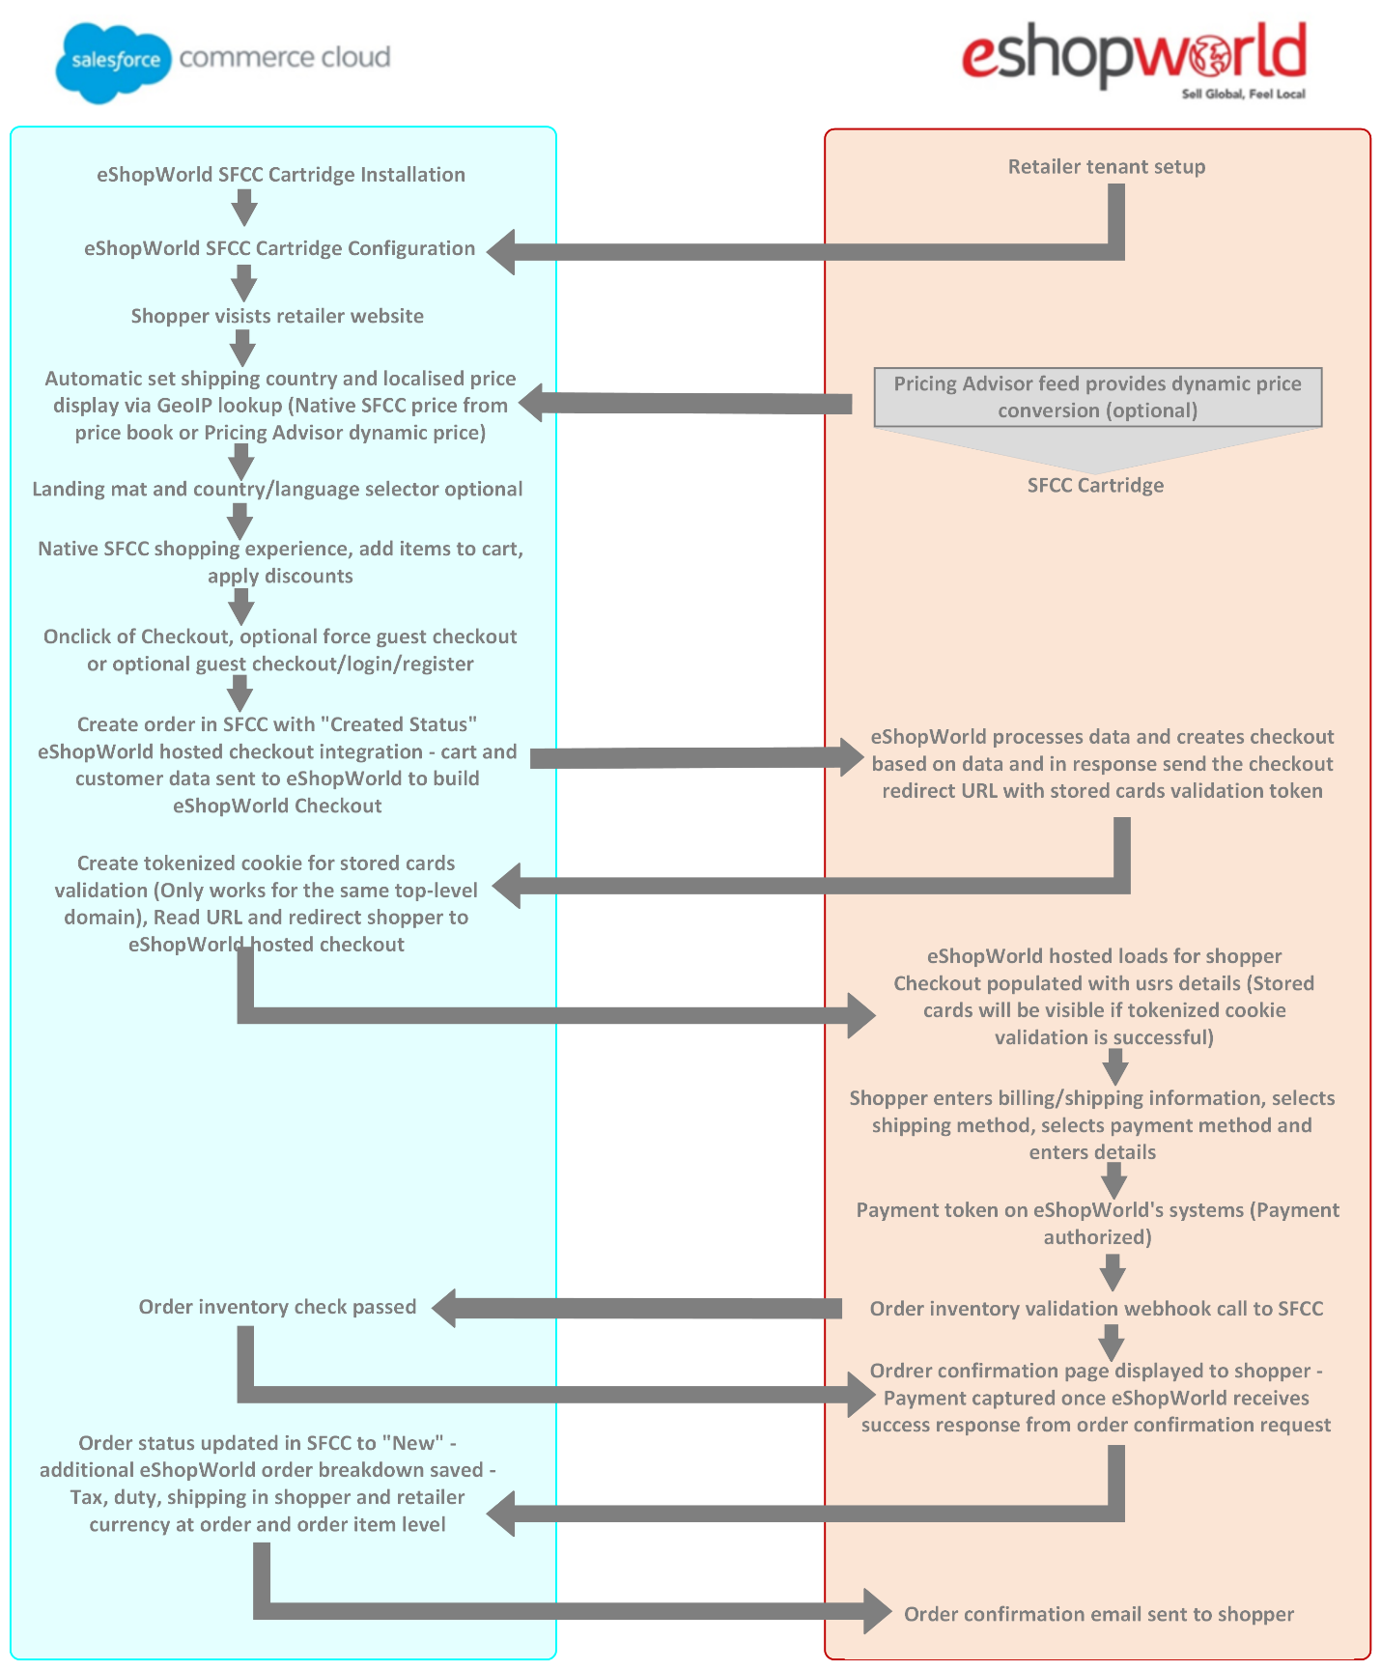

- The retailer installs the ESW SFCC Cartridge and configures it using the tenant details provided by ESW.
- The shopper visits the retailer site where the shopper's country and localized product prices are set automatically through GeoIP lookup. The localized prices are native to SFCC and taken from the price book.
ESW also supports dynamic price conversion through the Pricing Advisor feed. In dynamic price conversion, the product prices are synchronized daily. For information on how Pricing Advisor works, see the Pricing Advisor Overview.
- The shopper adds an item to the cart, applies a discount through SFCC, and clicks Checkout. They are then presented with two checkout options - a forced login and optional guest checkout.
- Checkout disclaimer message under the checkout button can be enabled through “esw-checkout-disclaimer-message” content asset which will be imported in content library on importing site meta data. The checkout disclaimer message can be enabled/disabled through the content asset by turning online flag on or off.
- When the shopper selects either of two checkout options, the order is created in SFCC (Order Status = 'Created'). The cart and shopper data is also sent to ESW in the Checkout API request and the ESW Checkout is created based on the data that is received along with the stored cards validation token. For information on the Checkout API and the valid request data, see ESW Checkout API.
The ESW checkout supports only the valid locales with Language ISO and Country ISO in the Checkout API call, for example, 'en-US' or 'fr-FR'. In SFCC, these locales exist with an underscore ( _ ).
The ESW cartridge replaces the underscore ( _ ) with a hyphen ( - ) in the request. The retailers must ensure that locales are configured correctly with proper Language ISO and Country ISO.
- Stored cards validation token is sent back in response in SFCC which is used to create a cookie to validate and enable the stored cards feature on the checkout for registered shoppers (Only works for same SFCC and ESW checkout top level domain - .retailerurl.com ). A response URL is also sent back to SFCC. This URL redirects the shopper to the ESW hosted checkout. If the shopper is logged in, the checkout page is prepopulated with their details, for instance, address, stored cards after successful tokenized cookie validation.
- On the ESW checkout page, the shopper performs actions, like enters their shipping and billing details, selects a delivery method, selects a payment method, and enters their payment details.
- The payment is authorized and order inventory validation webhook is triggered to SFCC through the ESW system.
- If inventory validation is passed the payment is captured in ESW system and an order confirmation request is sent to SFCC.
- The order status is updated from 'Created' to 'New' in SFCC. The order breakdown is saved, which includes tax, duty, and shipping in the shopper and retailer currency.
- After receiving a success message from SFCC, an order confirmation message is displayed to the shopper on the ESW checkout.

Storefront Workflow
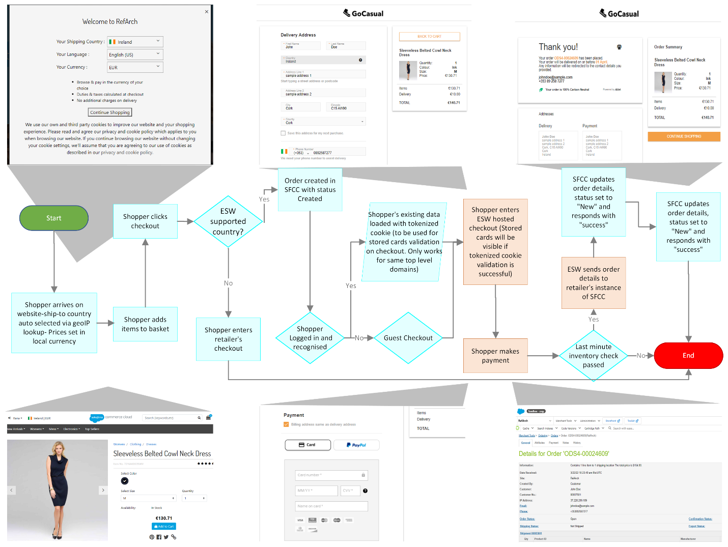

Checkout and SFCC
- Logged-in shoppers: If the shopper is logged in before the cart to checkout redirection, the cartridge transfers the shopper’s default address to the ESW Checkout. On the checkout, the shopper is presented with a checkbox to save address if the shopper is using a new address.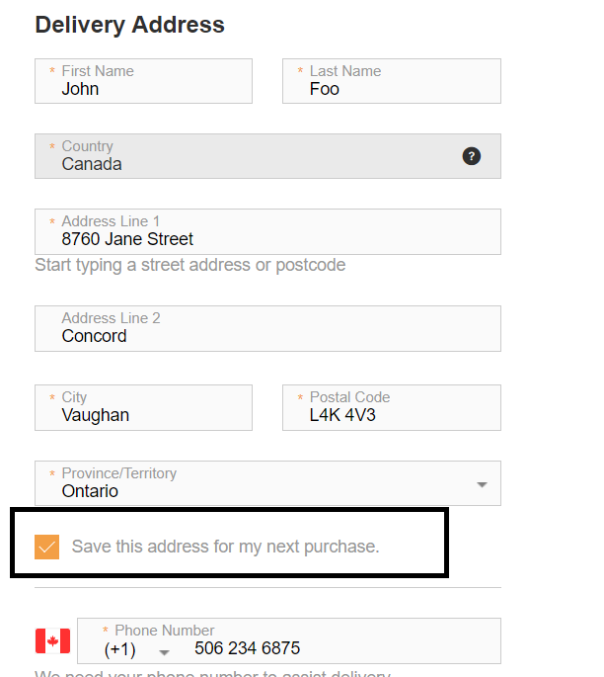
Once the order is placed, the new address is added to the shoppers address book and also marked as default address so it is auto populated on the shopper’s next checkout.
Also the cartridge creates the stored cards validation cookie (Only works for same SFCC and ESW checkout top level domains – .retailersurl.com).
- Guest shoppers: For guest shoppers (that is, shoppers who are not logged in), the ESW cartridge uses faux shopper details to place the order in SFCC. Faux details are then replaced with the actual shopper details once the order is confirmed back into SFCC from the ESW Checkout.

ESW Checkout Exit Scenarios
Following is the list of scenarios where shopper can exit from ESW Checkout.
- Shopper closes the browser: When shopper abandon the ESW checkout page by closing browser tab or window.
  - Cart Retention
    - Yes. Storefront Cart will be repopulated with order items until SFCC storefront session is not expired.
- Shopper clicks browser back button: On clicking browser back button shopper gets redirected to cart page and exits from ESW checkout
  - Cart Retention
    - Yes. Storefront Cart will be repopulated with order items until SFCC storefront session is not expired.
- Shopper allows session to time out: Shopper will see a message they’re being navigated back to cart after session timeout, by default session timeout is set to 20 minutes it is configurable through SFCC configurations as well.
  - Cart Retention
    - Yes. Storefront Cart will be repopulated with order items until SFCC storefront session is not expired.
- Shopper completes checkout successfully: On successful order completion shopper will exit ESW checkout and redirected to order confirmation page.
  - Cart Retention
    - No. Storefront Cart will be destroyed as the order will be placed successfully so cart will be empty in this scenario.
- Shopper clicks the logo in the header: On clicking logo in the header shopper will exit ESW checkout and will be redirected to SFCC storefront.
  - Cart Retention
    - Yes. Shopper will be redirected to the homepage and cart will be repopulated with the order items until SFCC storefront session is not expired.
- Shopper clicks the Back to Cart CTA: On clicking back to cart button shopper will be redirected to cart.
  - Cart Retention
    - Yes. Storefront cart will be repopulated with the order items until SFCC storefront session is not expired.
- Inventory check failure: In case of inventory check feature is enabled and order item(s) inventory is out of stock, during the order confirmation, shopper will be redirected back to cart page.
  - Cart Retention
    - Yes. Storefront cart will be repopulated with the order items with out of stock item error message, until SFCC storefront session is not expired.

Checkout Integration Configuration

ESW General Configuration site preferences
You can use Custom Preferences to manage ESW-specific configurations of the cartridge. You can access Custom Preferences by navigating to Merchant Tools > Site Preferences > Custom Preferences.
The following ESW General Configuration options are present:
- ESW Module Enabled: This is a mandatory attribute. It enables or disables the ESW Module at the site level.
- ESW Allowed Languages: The highlighted values represent languages to be considered as ESW Allowed Languages.
- ESW Base Currency: It sets the default/base currency at the site level.
- Enable Geo Lookup: This option enables or disables the geo IP lookup. If the geo lookup is enabled, the shopper’s current location is determined when they access the site for the first time. If disabled, the country selectors are preselected with the first options from the selectors.
- ESW Retailer Brand Code: This preference indicates the brand code of the current site.
- ESW Client ID for the Authorization Request: Indicates the client ID.
- ESW Client Secret for Authorization Request: Indicates the client secret.
- ESW Basic Auth Enabled: This option enables or disables basic authentication. For Sandbox instance, the option uses the storefront basic authentication. if the storefront is protected, then the storefront credentials (username and password) are used for authentication. For the Production instance, the basic authentication credentials will be provided by the retailer to ESW for order confirmation endpoint basic authentication configuration at the ESW tenant side..
- ESW Basic Authentication User: This option stores the basic authentication username.
- ESW Basic Authentication Password: This option stores the basic authentication password.
- ESW Instance Switcher:
  - If the Sandbox mode is selected, the
  - OrderConfirmationBase64EncodedAuth_TestOnlyand OrderConfirmationUri_TestOnly|EShopWorld-Notify metadata items fields are sent in the preorder call. These two values are used to perform the authentication during order confirmation in the Sandbox environment.
  - If the Production mode is selected, the mentioned metadata item fields are not sent to the preorder call. Also, this selection does not affect other metadata item fields that you might want to pass on to the preorder call.
- ESW Enable Return Prohibition: This option enables or disables the return prohibition feature for the current site.
- ESW Image Type: This option indicates the Image type to be displayed on checkout. By default, it is set to ‘small’ but retailer can customize as well.
- ESW Country URL Parameter: This value represents the optional parameter name for the country code parameter in the URL.
- ESW Enable Tax Information: Tax information will be displayed in order history
- ESW Enable Multiple Shipment: Multiple shipments for the order feature will be enabled when toggle is set to “Yes”.
- ESW Order Status Updates: This value determines whether the retailer wants to synchronize order statuses with ESW.
- ESW Enable Optins: When enabled, this preferences unlocks the granular level control for the marketing opt-ins (Email,SMS,Phone & Post). When disabled, the flow falls back to default behaviour which is Email & SMS opt-in. By Default, this preference will be disabled.
- ESW Override Opt-In Text Fields: This value dictates if the default Opt-in legal hint text will be overridden on the ESW checkout. To override the default legal hint text, the retailers can turn the above preference on and edit the marketing sign text in the file esw.properties. This toggle will only take place if ESW Enable Optins is enabled
- ESW Enable Email Marketing Opt-In: This preference enables/disables the email marketing optin on Site level. By default, it is enabled. This toggle will only take place if ESW Enable Optins is enabled
- ESW Enable SMS Marketing Opt-In : This preference enables/disables the sms marketing optin on Site level. By default, it is disabled. This toggle will only take place if ESW Enable Optins is enabled
- ESW Enable Phone Marketing Opt-In: : This preference enables/disables the Phone marketing optin on Site level. By default, it is disabled. This toggle will only take place if ESW Enable Optins is enabled
- ESW Enable Post Marketing Opt-In: : This preference enables/disables the Post marketing optin on Site level. By default, it is disabled. This toggle will only take place if ESW Enable Optins is enabled

ESW Pricing Configuration
You can use the following Custom Preferences and Custom Objects to manage ESW-specific configurations of the cartridge.
The following ESW Pricing Configuration options are present:

Custom Objects:

- ESW Pricing Advisor Data: The Retailer Pricing feed job fetches Pricing advisor data into the ESW_PA_DATA custom objects. ESW recommends this job to be configured nightly before ESW Retailer Auto Configurator job. The pricing advisor data contains the FX Rates, country adjustments and rounding rules for the ESW Supported countries.
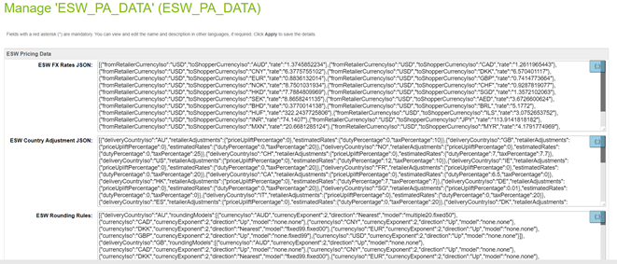

- ESW Fixed Price Model Countries: When the ESW Retailer Auto configurator job is executed the ESW supported countries’ custom object are instantiated. For Fixed price model country the ‘is Fixed Price Model’ needs to be checked manually, by default country will be created with dynamic/calculated pricing model
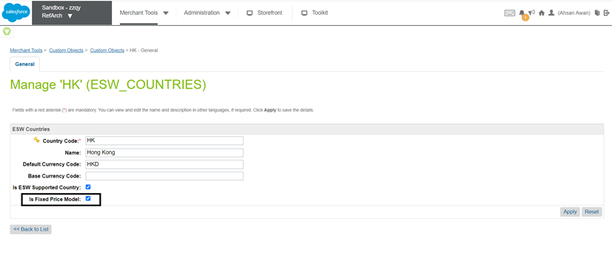

Custom Preferences:
- ESW Fixed List PriceBook Pattern This site preference sets the list price books Id pattern for fixed price model countries. i.e. {countryCode}-list-price-book. Pattern must have {countryCode} string part in this value.
- ESW Fixed Sale PriceBook Pattern This site preference sets the sale price books Id pattern for fixed price model countries. i.e. {countryCode}-sale-price-book. Pattern must have {countryCode} string part in this value.
For Currency Overrides, you must configure the related Shipping Method with the appropriate currency at the SFCC end.
- ESW Enable Multiple FX Rates: Enables or disables the Multiple FX Rates feature for the current site.
- ESW Enable Roundings: Enables or disables the rounding on the prices across all applicable countries for the current site. If the option is enabled, the appropriate rounding models are applied to the prices in the applicable countries.
- ESW Enable Frontend Prices Conversion: Enables or disables the Localized Front-end Prices feature across storefront.
- ESW Price Feed Instance Switcher: Indicates the Price Feed mode for the current site. If you select Production, the Price Feed job uses the Production Price Feed service called EswPriceFeedV3Service.PROD.
- ESW Production Client Secret for Price Feed Authorization Request: Indicates the Production Client Secret key for the Price Feed authorization request. If the ESW Price Feed Instance Switcher is selected as Production, the Price Feed job uses the production client secret while making a call to the ESW Pricing Advisor API.
The following table describes these parameters:
Parameter | Description
countryCode | (Required) The two-letter ISO code of the shopper country.
currencyCode | (Required) The three-letter ISO code of the shopper's local currency.
localListPriceBook | (Required) The price book ID of the local list price.
localSalePriceBook | (Optional) The price book ID of the local sale price.
baseListPriceBook | (Required) The price book ID of the base list price. The price book currency must match the tenant base currency.
baseSalePriceBook | (Required if 'localSalePriceBook' is provided) The price book ID of the base sale price. The price book currency must match the tenant base currency.
applyCountryAdjustments | (Required) Indicates if you want to apply country adjustments while calculating the local price. The values are True or False.
applyRoundingModel | (Required) Indicates if you want to apply the rounding model while calculating the local price. The values are True or False.
- ESW Localized Promotions: A JSON object containing single or multiple base promotion configurations, which can be used to generate localized promotions.
[
{
"basePromoId":"10%offordersover150",
"campaignId":"",
"excludeCurrencies":[
"GBP",
"SEK"
]
},
{
"basePromoId":"Buy5for50",
"campaignId":"Automation",
"excludeCurrencies":""
}
]
Each promotion object contains the following attributes:
Parameter | Description
basePromoId | (Required) The ID of the base promotion configuration.
campaignId | (Optional) The ID of the campaign.  This parameter can be left blank if you want to assign the same ID as the base promotion. However, if you want to assign localized promotions as a separate campaign, you must provide the new campaign ID.  You must also ensure that the campaign ID provided in this parameter is already created because the job only generates localized promotions, not campaigns.
excludeCurrencies | (Optional) The currencies for which you do not want to generate localized promotions.  If no value is provided, localized promotions are generated for all allowed currencies.
- ESW Skip Flagged Product: This flag indicates the inclusion of flagged products' localized prices in the localized pricebook generation. When a product is marked as price freeze, and this option is enabled, the base price will be included in the localized pricebook. If this option is disabled, the prices for price freeze products will be retained as they are.
- ESW Pricing Advisor Version: This preference indicates the pricing advisor version being used by the site. Currently, pricing advisor Version 3 and Version 4 are supported.

ESW Checkout Configuration site preferences
You can use Custom Preferences to manage ESW-specific configurations of the cartridge. You can access Custom Preferences by navigating to Merchant Tools > Site Preferences > Custom Preferences.
The following ESW Checkout Configuration options are present:
- ESW Checkout Service Name: The name of the service that is associated with the Checkout. The value in this field is used for the current site. The service name is set by default once the ESW Auto Configurator Job is executed successfully. For more information, see section 2.5
- *ESW URL Expansion Pairs: This option sets the URL that ESW will redirect to. The following URLs must be set in key|value pair format:
  - ContinueShoppingUrl|Home-Show
  - BaseUrl|Home-Show
  - BackToCartUrl|EShopWorld-GetCart
  - InventoryCheckFailurePageUrl|EShopWorld-GetCart
The above values are set by default once the job ESW Retailer Auto Configurator is executed successfully.

Format | Example
Name of URL|url | ContinueShoppingUrl|Home page URL
*Note: Expansion pairs also support external URLs. For instance, if a retailer provides a complete URL, expansion pairs will be generated using those URLs. For example:
  - ContinueShoppingUrl|https://externalurl.com
  - BaseUrl|https://externalurl.com
  - BackToCartUrl|https://externalurl.com
  - InventoryCheckFailurePageUrl|https://externalurl.com
The BackToCartUrl feature enables you to redirect the shopper to the cart so that the shopper can add or remove the items from their cart. The ‘BACK TO CART’ button on the Checkout page facilitates this functionality:
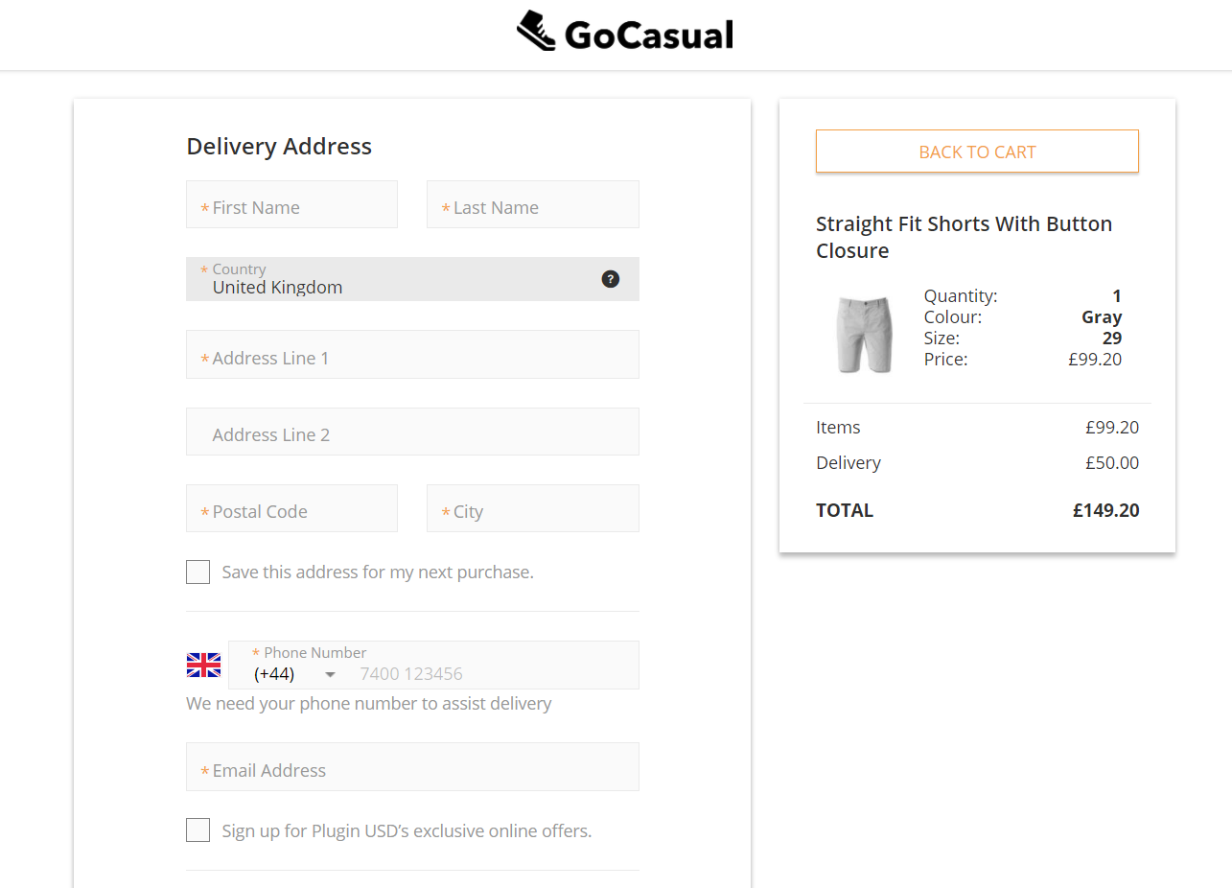
The ContinueShoppingUrl (URL of the home page) and BackToCartUrl (URL of the Cart page) attributes must be sent with all requests:
EShopWorld suggests retailers to add EShopWorld-Home pipeline link to the logo using ESW Checkout UI on tenant side. Checkout logo can’t be configured using expansion pair in pre order request for both staging and production tenants.
- ESW Metadata Items: This option stores the basic authentication URL and the default value. The default value of 1 is stored in the OrderConfirmationBase64EncodedAuth_TestOnly parameter for when basic authentication is not enabled.
The OrderConfirmationUri_TestOnly|EShopWorld-Notify, OrderConfirmationBase64EncodedAuth_TestOnly|1 parameters, InventoryCheckUri_TestOnly|EShopWorld-ValidateInventory
and InventoryCheckBase64EncodedAuth_TestOnly|1 parameters are required for the Sandbox environments only.
The above values are set by default once the job ESW Retailer Auto Configurator is executed successfully.
- ESW Product Line Metadata Items: This option is used for display purposes only and it stores the product line metadata items information that you want to send in the Checkout request. Options include loyalty points, engraving, debossing, gift message, and so on. The information must be stored in the following format:
Format | Example
EswKeyField|ProductLineItemCustomAttributeID | Gift Message|GiftWrapMessage
In the following example, the Gift Message attribute is sent with name in the metadataItems object. For the GiftWrapMessage product line custom attribute, the value is sent with value in the metadataItems object. The metadataItems are sent under Product JSON in the Checkout request.
"cartItems": [ {
………………
………………
“product”: {
…………………………
…………………………
"metadataItems": [ {
"name": "Gift Message",
"value": "Congratulations!"
} ]
},
…………………
…………………
}]
If you want to send any product information under metadataItems in the Checkout request, you can do so by copying the product information in the product line item and by configuring that productLineItem custom attribute ID in this configuration.
- ESW Redirect: This preference indicates from where the shopper (Guest User) will be redirected to ESW Checkout Page. The options are Cart and Login. When the shopper is logged in, the ESW Checkout Redirect will be from the Cart page. The preference selection is ignored.
  - If the Cart option is selected, the ESW Checkout Redirect will happen from the Cart page, and the pre order request will be sent.
  - If the Login option is selected, the following behaviour will be on the storefront:
    - Logged in user will be redirected to ESW Checkout from the Cart page, and the preorder request will be sent
    - Not logged in user will be redirected to the Login page where:
      - The user can navigate to ESW Checkout as guest directly from login page and the preorder request will be sent.
      - The user can log in (enter existing credentials) on the login page and navigate to ESW Checkout from the login page; the preorder request will be sent.
      - The user can select to Create Account on the Login page and in this case the user will be redirected to the account page. Right after creating new account, redirect to ESW Checkout will not happen automatically and user will be on own profile page. The user should navigate to mini cart / shopping cart from where redirect to ESW Checkout will be happen and the preorder request will be sent.
Login value is set by default once the job ESW Retailer Auto Configurator is executed successfully
- ESW Override Shipping: This option sets the shipping override for specific countries. It allows you to override the shipping prices for a shipping method. In the following example, ID represents the shipping method IDs. 001 is the POST shipping method and 002 is the EXP2 shipping method. Shipping methods are sent as per the order in ID array.
  - For the UK, the EXP2 shipping method is sent first and then POST.
  - For the US, the POST shipping method is sent first and then EXP2.
  - For NL, only the POST shipping method is sent.
[
{
"countryCode": "GB",
"shippingMethod": {
"ID": ["002", "001"]
}
},
{
"countryCode": "US",
"shippingMethod": {
"ID": ["001","002"]
}
},
{
"countryCode": "NL",
"disableConversion": "true",
"shippingMethod": {
"ID": ["001"]
}
}
]
- The shipping method names must be POST or EXP2. This naming rule is required by ESW. However, the ID can be any value.
- If optional attribute disableConversion is set to “true” for any country then it means no shipping cost conversion will happen into local currency and this attribute mainly use for dynamic/ calculated country where shipping methods configure in base currency.
- If ESW Override Pricebook under ESW Pricing Configuration is configured for a country, then the shipping methods matching the override pricebook currency must be configured in ESW Override Shipping.
- ESW Use Delivery Contact Details for Payment: This option allows you to select the default behavior of the Billing address same as delivery address field on the ESW Checkout.
- ESW Update Order Payment Status to Paid After Successful Order Confirmation: This option allows you to change the order payment status to Paid after successful order confirmation.
- ESW Russian Data Storage Url: This option allows retailers to process and store the Russian shoppers pre-order and checkout data via a dedicated endpoint. This endpoint route and store the Russian shoppers data via Russian hosted servers to ensure the Russian data compliance. This Url value will be provided by ESW onboarding team.
- ESW Checkout Session Timeout: This allows retailers to control the session time out duration on the ESW checkout. Retailers can set the session time out value in minutes in this preference and on ESW checkout page session will be alive for this duration in minutes.
- ESW Top Level Domain: This allows retailers to configure top level domain for Stored Card feature. ESW plugin will created shopper access token cookie on this site preference value.
- Enable ESW Inventory Check: This allows retailers to enable/disable inventory check feature during the order confirmation webhook call before placing the order.
- Enable ESW Checkout Shoppers Registration: To configure if ESW checkout shopper's registration is enabled or not

- ESW Customer Meta Data: This preference indicates the key|value pairs for esw customer metadata.

- ESW Basket Meta Data: The preference indicates the key|value for esw basket metadata.

- is ESW Multiple Addresses Enabled: Feature toggle that enables multiple addresses on the checkout feature.
- ESW Enable Order Confirmation Success Page: This feature is controlled by this site level preference that acts as a master switch to on or off the feature.
- ESW Order Confirmation Success URL: The URL of the success page, it can be an empty value, a controller path or an absolute URL
- ESW Override Opt-In Text Fields: This value dictates if the default Opt-in legal hint text will be overridden on the ESW checkout.

- ESW Enable Email Marketing Opt-In: This preference enables/disables the email marketing optin on Site level. By default, it is enabled.

- ESW Enable SMS Marketing Opt-In : This preference enables/disables the sms marketing optin on Site level. By default, it is disabled.

- ESW Enable Phone Marketing Opt-In: : This preference enables/disables the Phone marketing optin on Site level. By default, it is disabled.

- ESW Enable Post Marketing Opt-In: : This preference enables/disables the Post marketing optin on Site level. By default, it is disabled.

Services
The following services are being used for this functionality. The cartridge automatically generates the URL if they are not set already.
EswOAuthService: This service is used to get the authentication token from ESW. This token is used by other ESW services and APIs, such as Price Feed, Checkout, and Package.
EswCheckoutV3Service: Add this service to a particular service. In this example, the Checkout API URL is configured. This service is used to send the Checkout request to ESW.
For multiple sites using the common Sandbox, you must configure multiple services for sites that use the ESW Checkout service. The service name must be added to the ESW Checkout Service Name custom preference. This value sets by default once the retailer runs the ESW Retailer Auto Configurator Job. The examples of the service names are ESWCheckoutV3Service.SG and ESWCheckoutV3Service.SFRA.

