


CHECKOUT METADATA INTEGRATION GUIDE

Version: 5.1.2
Published date: August 2026
Copyright © 2026 by ESW. All rights reserved. Information contained herein is subject to change without notice.

SFCC - ESW Cartridge
+
Contents
1 Checkout Metadata Integration Configuration 3
1.1 Checkout metadata Integration Configuration site preferences 3
1.2 Testing Sandbox/Staging Environment 3
1.2.1 Customer-Level Metadata 3
1.2.2 Basket-Level Metadata 4
1.2.3 Product Line Metadata 5

Checkout Metadata Integration Configuration

Checkout metadata Integration Configuration site preferences
You can use Custom Preferences to manage ESW-specific configurations of the cartridge. You can access Custom Preferences by navigating to Merchant Tools > Site Preferences > Custom Preferences > ESW Checkout Configuration. The following option is present ESW Checkout Configuration group.
- ESW Customer Meta Data: This preference indicates the key|value pairs for esw customer metadata.
- ESW Basket Meta Data: The preference indicates the key|value for esw basket metadata.
- ESW Product Line Metadata Items: This preferences indicates the key|value pair for the product lineitem metadata

Testing Sandbox/Staging Environment
The recommended approach is to test this feature for basket-level and Customer level custom attributes.

Customer-Level Metadata
- In the business manager, add the metadata custom attributes at the customer profile level.
- In the following snapshot can see the similarities.

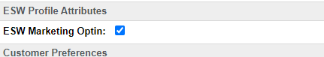

- For customer metadata items, in the business manager, add the customer metadata preference under ESW in the checkout configuration group with values in key|value format for the metadata custom attributes.
- Similar is configured for product line item metadata in the checkout preference group.

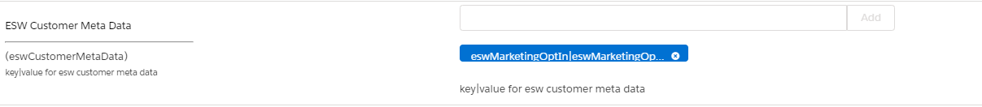

- Validate customer-level data items in the preOrder being passed to EWS checkout under the contactDetails.
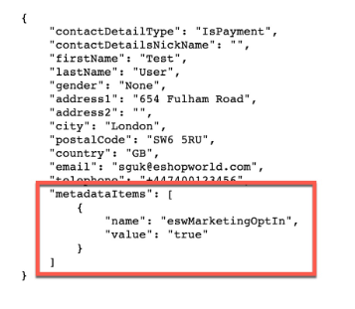
Note: To validate customer metadata, it’s needed to be logged in.

Basket-Level Metadata

- In the business manager, add the metadata custom attributes at the basket level custom attributes.
- For Basket level metadata items, in the business manager, add the basket metadata preference under the ESW checkout configuration group with values in key|value format for the metadata custom attributes.
  - Similar is configured for product line item metadata in the checkout preference group.

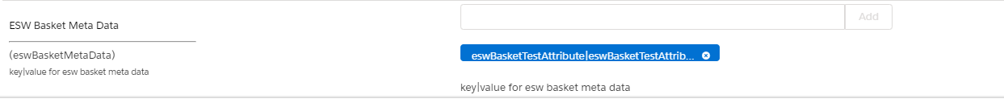
  - Validate basket level metadata items in the preOrder being passed to EWS checkout under the shopperCheckoutExperience.

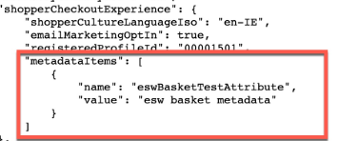

Product Line Metadata
To add metadata please follow the below instructions:
- Go to “Merchant Tools > Site Preferences > Custom Site Preference Groups > ESW Checkout Configuration” and add mapping configuration for “ESW Product Line Metadata Items” in format without quotes “WholesaleItems|eswWholeSalePrice”
  - This key value mapping pair contains WholesaleItems which will be displayed as key in preorder then pipe sign is the separator and eswWholeSalePrice is the ID of line/product level custom attribute which contains the actual value.
Here is the configuration screen from business manager where this can be configured. 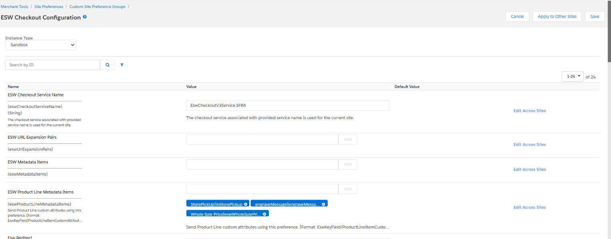
This Whole Sale Price key and eswWholeSalePrice attribute value (23.00) can be seen in the preorder as shown: 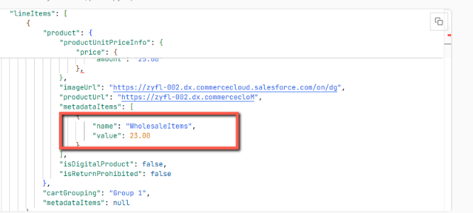
This metadata will be available in the order confirmation under product line item metadata which then can be stored in SFCC as per the requirements.

